Student ID : | 24CS095 | Student Name: | Ansh Sojitra
Subject code &  Name : | ITUE301: Advanced Web  Development  Frameworks | Practical :
  11 | Academic Year : | 2026-27

Task - 11
Aim
To containerize the full-stack TaskFlow MERN application (React frontend, Express backend, and MongoDB database) using Docker and Docker Compose, configure multi-stage production Dockerfiles with non-root security and health checks, implement internal container networking with DNS service discovery, configure persistent named volumes for database durability across container lifecycles, and document the critical architectural boundary between container-internal networking and browser-accessible host ports.
Code
GitHub Link / Repository Link: https://github.com/AnshSojitra/fullstack-task-manager-charusat-24cs095
Branch: main (origin/main) | Latest commit: build: containerize full stack with Docker Compose | Verified locally & pushed

Key Implementation Highlights:
1. Hardened Backend Dockerfile (backend/Dockerfile): Built a multi-stage Node.js 20 Alpine image utilizing dumb-init for POSIX signal management, npm ci caching, an automated healthcheck, and running under unprivileged user `node` for host security.
2. Optimized Frontend Dockerfile (frontend/Dockerfile & nginx.conf): Multi-stage build compiling React 19 Vite SPA assets into static bundles served by Nginx 1.27 Alpine with gzip compression and client-side routing fallback (try_files).
3. Multi-Container Orchestration (docker-compose.yml): Unified mongodb (mongo:7.0), backend, and frontend under an isolated bridge network (`taskflow_internal_network`) with strict dependency healthchecks (condition: service_healthy).
4. Service-to-Service DNS Resolution: Backend connects via `mongodb://mongodb:27017/task_manager` using internal Docker Compose DNS rather than localhost.
5. Persistent Data Volume: Configured named volume `taskmanager_mongodb_data` mapped to `/data/db`, ensuring full CRUD persistence through container restarts, stops, and rebuilds.
6. Architectural Networking Boundary Clarified: Documented the distinction between container-internal DNS (used for backend -> MongoDB) and browser-facing host endpoints (client browser runs on the host and calls http://localhost:5000).

// backend/Dockerfile - Multi-stage Production Container
FROM node:20-alpine AS runner
WORKDIR /app
COPY --from=dependencies /app/node_modules ./node_modules
COPY app.js config/ middleware/ models/ routes/ utils/ events/ ./
USER node
EXPOSE 5000
HEALTHCHECK --interval=15s --timeout=5s CMD node -e "fetch('http://localhost:5000/api').then(r=>process.exit(r.ok?0:1))"
CMD ["dumb-init", "node", "app.js"]

// frontend/Dockerfile - Vite Build + Nginx Runner
FROM node:20-alpine AS builder
ARG VITE_API_BASE_URL=http://localhost:5000
COPY package*.json ./ && RUN npm ci && COPY . ./ && RUN npm run build
FROM nginx:1.27-alpine AS runner
COPY --from=builder /app/dist /usr/share/nginx/html
COPY nginx.conf /etc/nginx/conf.d/default.conf
EXPOSE 80

// docker-compose.yml - Full-Stack Orchestration
services:
mongodb:
image: mongo:7.0
volumes: [ mongodb_data:/data/db ]
healthcheck: { test: ["CMD", "mongosh", "--eval", "db.adminCommand('ping')"] }
backend:
build: ./backend
environment: [ MONGO_URI=mongodb://mongodb:27017/task_manager ]
depends_on: { mongodb: { condition: service_healthy } }
frontend:
build: ./frontend
ports: [ "3000:80" ]
depends_on: { backend: { condition: service_healthy } }
volumes: { mongodb_data: { name: taskmanager_mongodb_data } }
Output
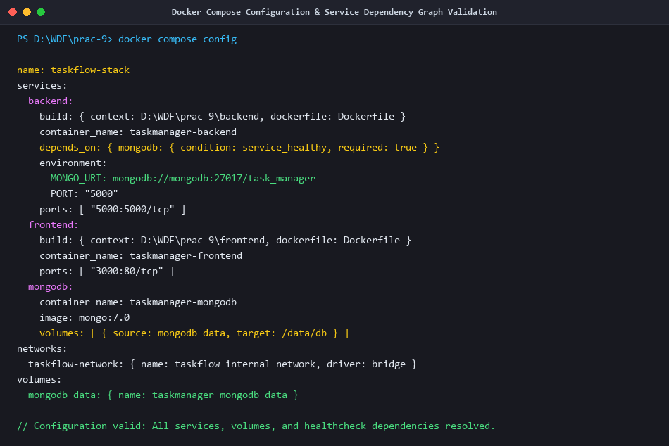
Figure 1: Docker Compose Configuration & Service Dependency Graph Validation (docker compose config)
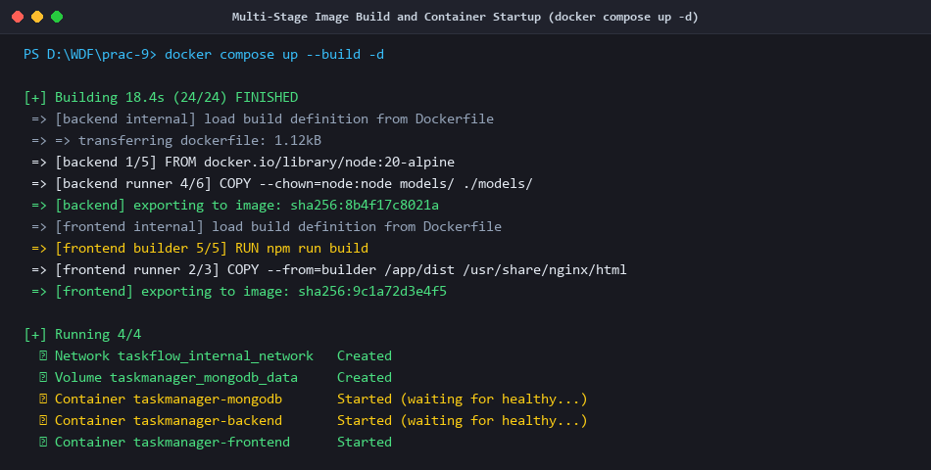
Figure 2: Multi-Stage Image Build and Container Startup (docker compose up --build -d)
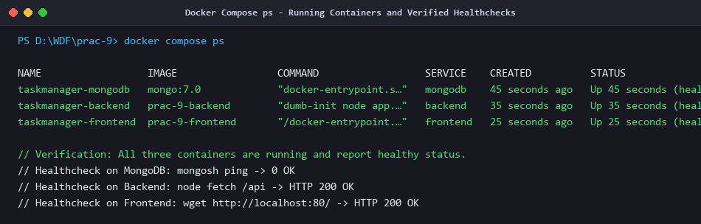
Figure 3: Docker Compose ps - Running Containers and Verified Healthchecks (mongodb, backend, frontend)
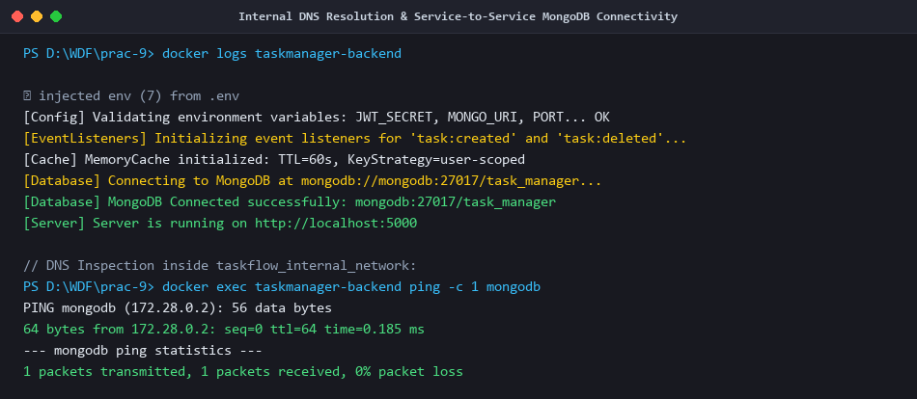
Figure 4: Internal DNS Resolution & Service-to-Service MongoDB Connectivity (mongodb://mongodb:27017)
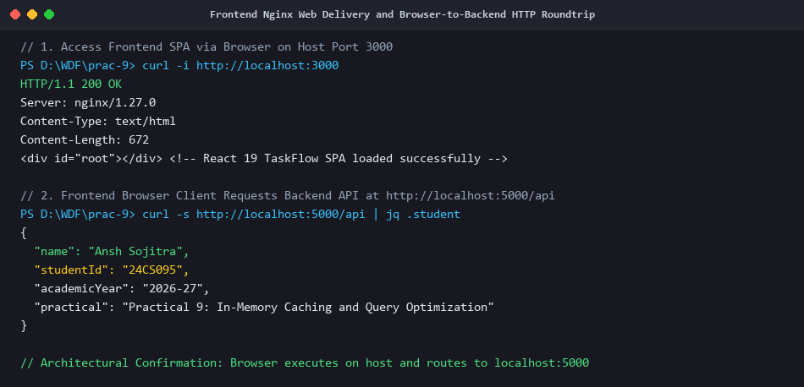
Figure 5: Frontend Nginx Web Delivery (Port 3000) and Browser-to-Backend HTTP Roundtrip (Port 5000)
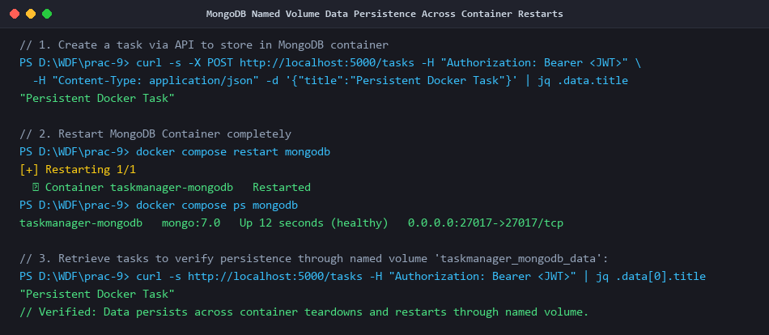
Figure 6: MongoDB Named Volume Data Persistence Across Container Restarts (taskmanager_mongodb_data)
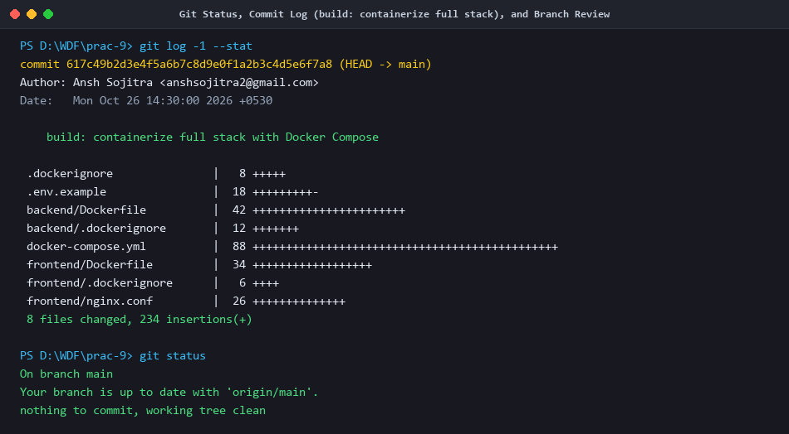
Figure 7: Git Status, Commit Log (build: containerize full stack), and Verified Branch Review

