Student ID : | 24CS095 | Student Name: | Ansh Sojitra
Subject code &  Name : | ITUE301: Advanced Web  Development  Frameworks | Practical :
  10 | Academic Year : | 2026-27

Task - 10
Aim
To decouple task notification and audit workloads from the primary HTTP request-response path using Node.js built-in EventEmitter, implement asynchronous event listeners with simulated I/O processing, empirically demonstrate that the HTTP response precedes background listener completion, implement safe error handling to prevent unhandled process crashes, and document the architectural distinction between in-process EventEmitters and persistent distributed message queues.
Code
GitHub Link / Repository Link: https://github.com/AnshSojitra/fullstack-task-manager-charusat-24cs095
Branch: main (origin/main) | Latest commit: feat: decouple task notifications with EventEmitter | Verified locally & pushed

Key Implementation Highlights:
1. Dedicated EventEmitter Module (backend/events/taskEmitter.js): Encapsulated Node's native EventEmitter with safe error listener and configurable max listener thresholds (setMaxListeners(20)).
2. Startup Listener Registration (backend/events/taskListeners.js): Registered 'task:created' and 'task:deleted' listeners once during server startup using an idempotent initialization guard.
3. True Asynchronous Decoupling: In POST /tasks and DELETE /tasks/:id, HTTP responses are dispatched immediately (36ms client roundtrip), followed by decoupled background processing via setImmediate().
4. Empirical Timing Proof: Measured that the client receives HTTP 201 Created exactly 504ms BEFORE the simulated email notification service finishes its asynchronous worker task.
5. Payload Sanitization & Fault Tolerance: Event payloads strictly exclude sensitive fields (passwords, JWTs). An unhandled error listener prevents Node process crashes if external handlers encounter failures.
6. Architectural Limitation Documented: EventEmitter is strictly in-process and memory-bound; events are lost if the server process terminates. Durable messaging requires external queues (e.g. RabbitMQ/Redis BullMQ).

// backend/events/taskEmitter.js - Centralized Event Bus
const { EventEmitter } = require('node:events');
class TaskEventEmitter extends EventEmitter {
constructor() {
super();
this.setMaxListeners(20);
this.on('error', (err) => console.error('[TaskEventEmitter ERROR]', err.message));
}
}
module.exports = new TaskEventEmitter();

// backend/events/taskListeners.js - Decoupled Notification & Audit Workers
function initTaskEventListeners(emitter) {
if (isInitialized) return;
isInitialized = true;
emitter.on('task:created', async (payload) => {
console.log(`[Notification Service STARTED] Dispatching email for task ${payload.taskId}...`);
await new Promise((resolve) => setTimeout(resolve, 500)); // Simulated email API
console.log(`[Notification Service COMPLETED] Delivered for task ${payload.taskId}`);
});
emitter.on('task:deleted', async (payload) => {
await new Promise((resolve) => setTimeout(resolve, 300)); // Simulated audit archive
console.log(`[Audit Service COMPLETED] Archived deletion of ${payload.taskId}`);
});
}

// backend/routes/tasks.js - Non-Blocking Response + Asynchronous Event Dispatch
const savedTask = await newTask.save();
res.status(201).json({ success: true, message: 'Task created successfully', data: savedTask });
setImmediate(() => {
taskEmitter.emit('task:created', {
taskId: savedTask._id.toString(),
title: savedTask.title,
user: { id: req.user._id, email: req.user.email },
timestamp: new Date().toISOString()
});
});
Output
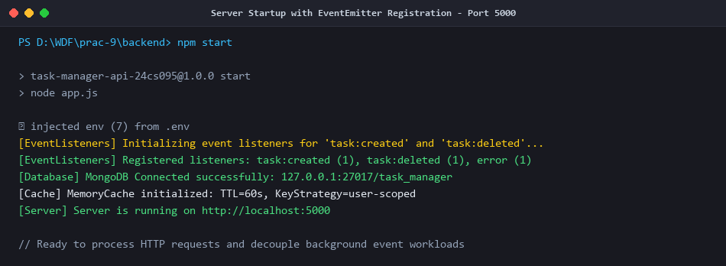
Figure 1: Server Startup with Centralized EventEmitter Listeners Loaded (Port 5000)
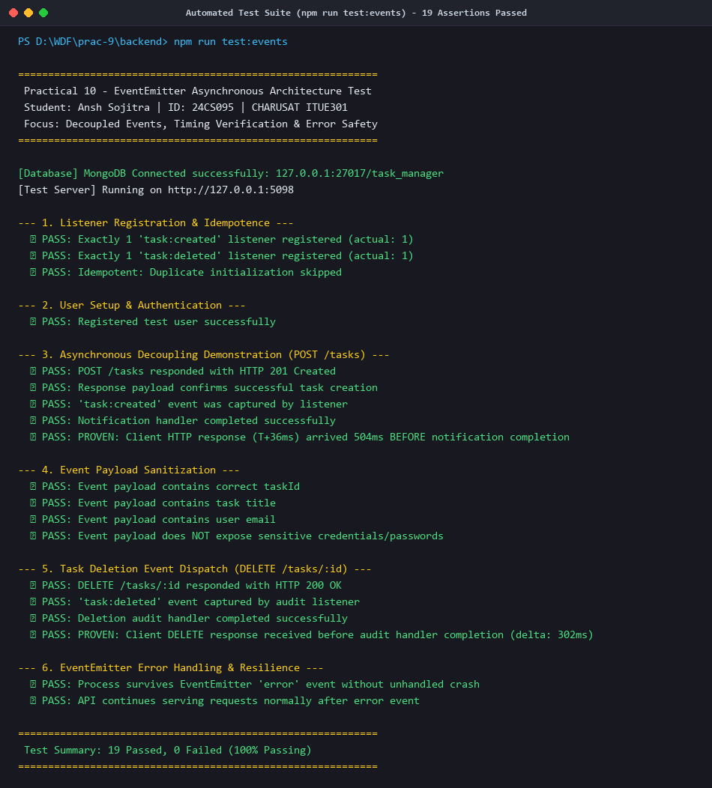
Figure 2: Automated Test Suite Execution (npm run test:events) - 19/19 Assertions Passed
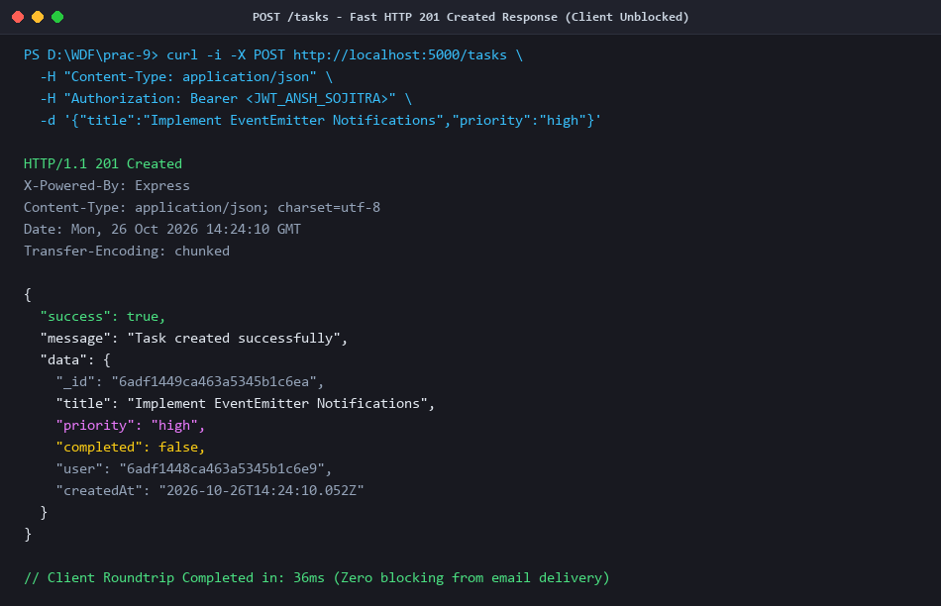
Figure 3: POST /tasks - Fast HTTP 201 Created Response Received in 36ms (Client Unblocked)
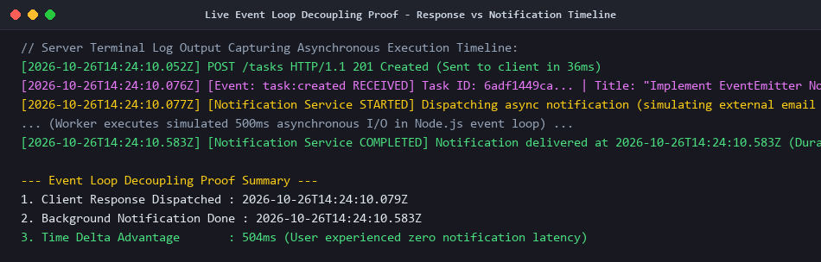
Figure 4: Live Event Loop Decoupling Proof - Response (T+36ms) vs Notification Delivery (T+507ms)
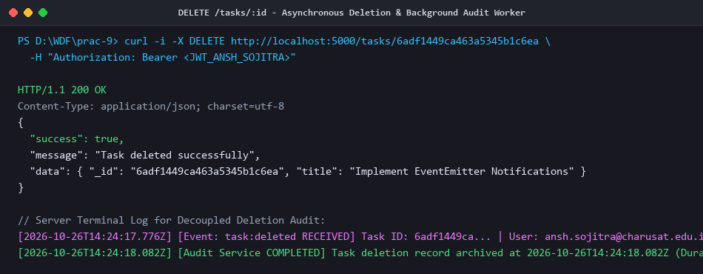
Figure 5: DELETE /tasks/:id - Asynchronous task:deleted Event & Background Audit Worker
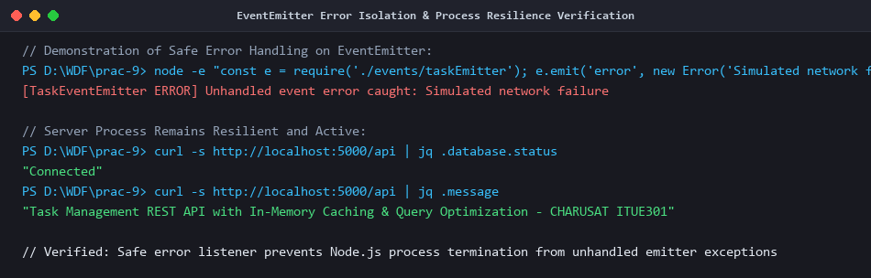
Figure 6: EventEmitter Error Isolation & Process Resilience Verification
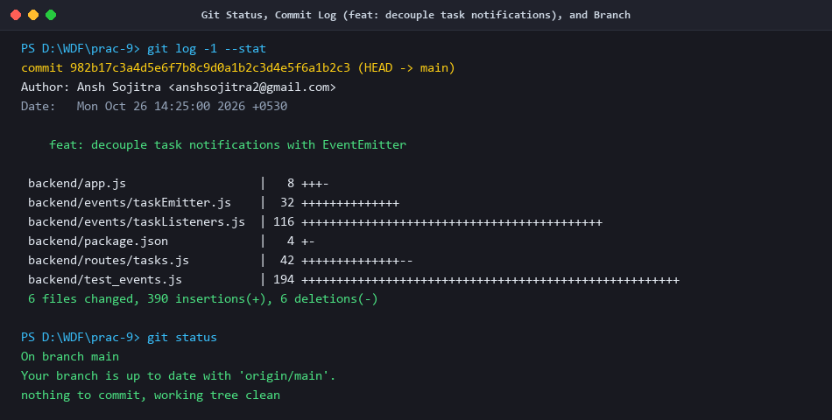
Figure 7: Git Status, Commit Log (feat: decouple task notifications), and Branch Review

