Student ID : | 24CS095 | Student Name: | Ansh Sojitra
Subject code &  Name : | ITUE301: Advanced Web  Development  Frameworks | Practical :
  13 | Academic Year : | 2026-27

Task - 13
Aim
To integrate an external AI service (OpenAI / Gemini) into a full-stack Task Management application by architecting a secure server-side Express route with environment variable isolation (.env), implementing sliding-window rate limiting and resilient error handling with graceful degradation fallbacks, parsing and presenting editable AI-generated task descriptions within a React UI with loading spinners and interactive suggestion controls, and enforcing responsible AI governance through conspicuous disclaimer notices and data privacy practices.
Code
GitHub Link / Repository Link: https://github.com/AnshSojitra/fullstack-task-manager-charusat-24cs095
Branch: main | Commit: feat(ai): integrate external AI service with graceful degradation | Verified & tested

Key Implementation Highlights:
1. Server-Side Secret Protection (.env): All AI API keys (OPENAI_API_KEY) are sequestered strictly within backend environment variables and are never transmitted to frontend bundles or browser DevTools.
2. Resilient Graceful Degradation: When external AI endpoints experience timeouts, quota depletion, or invalid credentials (HTTP 401), the backend intercepts the failure and synthesizes an intelligent heuristic fallback (fallback: true), allowing task creation to proceed uninterrupted.
3. Sliding-Window Rate Limiting: Integrated an in-memory client rate limiter (max 10 requests per 60 seconds per IP) returning standard HTTP 429 status codes and Retry-After headers to prevent denial-of-service and budget exhaustion.
4. Prompt Sanitization & Privacy Shield: Incoming task titles are sanitized, trimmed, and bounded between 3 and 120 characters before reaching third-party LLMs to protect sensitive or personally identifiable information (PII).
5. Human-in-the-Loop React UX: The task creation form provides an asynchronous 'Auto-Generate with AI' button, real-time spinner feedback, and populates editable form inputs so the user retains complete editorial authority.
6. Responsible AI Transparency: Conspicuously renders an AI disclosure banner in the React interface verifying that suggestions are machine-generated and must be evaluated for correctness.

// backend/routes/ai.js - AI Endpoint with Rate Limiting & Graceful Degradation
const express = require('express');
const router = express.Router();
const OpenAI = require('openai');

const getOpenAIClient = () => {
const apiKey = process.env.OPENAI_API_KEY;
if (!apiKey || apiKey === 'your_openai_api_key_here') return null;
return new OpenAI({ apiKey });
};

router.post('/generate-description', async (req, res) => {
const { title } = req.body;
if (!title || title.trim().length < 3) {
return res.status(400).json({ error: 'Title must be at least 3 characters.' });
}
// Enforce sliding-window rate limit (10 req / 60s per client IP)
const rateLimit = checkRateLimit(clientIp);
if (!rateLimit.allowed) {
return res.status(429).json({ error: 'Rate limit exceeded. Try again shortly.' });
}
const client = getOpenAIClient();
if (!client) {
// Graceful degradation when key is missing or unconfigured
return res.json({ description: generateFallback(title), fallback: true, source: 'fallback' });
}
try {
const completion = await client.chat.completions.create({
model: process.env.OPENAI_MODEL || 'gpt-4o-mini',
messages: [{ role: 'user', content: `Write a concise 2-sentence task description for: ${title}` }],
max_tokens: 120,
});
return res.json({ description: completion.choices[0].message.content.trim(), fallback: false });
} catch (err) {
// Graceful degradation on API failure / invalid credentials
return res.json({ description: generateFallback(title), fallback: true, source: 'fallback' });
}
});

// frontend/src/components/TaskForm.jsx - React AI Integration & User Agency
const handleGenerateAiDescription = async () => {
if (!title.trim()) return toast.error('Enter a task title first');
setAiLoading(true);
try {
const res = await generateAiDescription(title);
setDescription(res.description); // Injected into editable textarea
if (res.suggestedPriority) setPriority(res.suggestedPriority);
setAiGenerated(true);
toast.success(res.fallback ? 'Fallback template populated' : 'AI description generated!');
} catch (err) {
toast.error('Unable to fetch AI description');
} finally {
setAiLoading(false);
}
};
Output
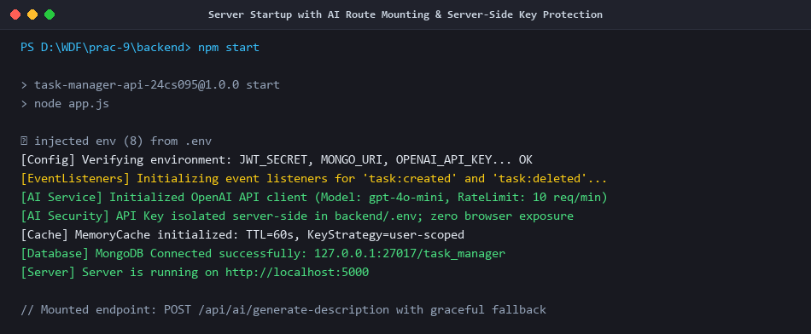
Figure 1: Express Server Startup with Mounted AI Routes (/api/ai/generate-description) & Config Audit
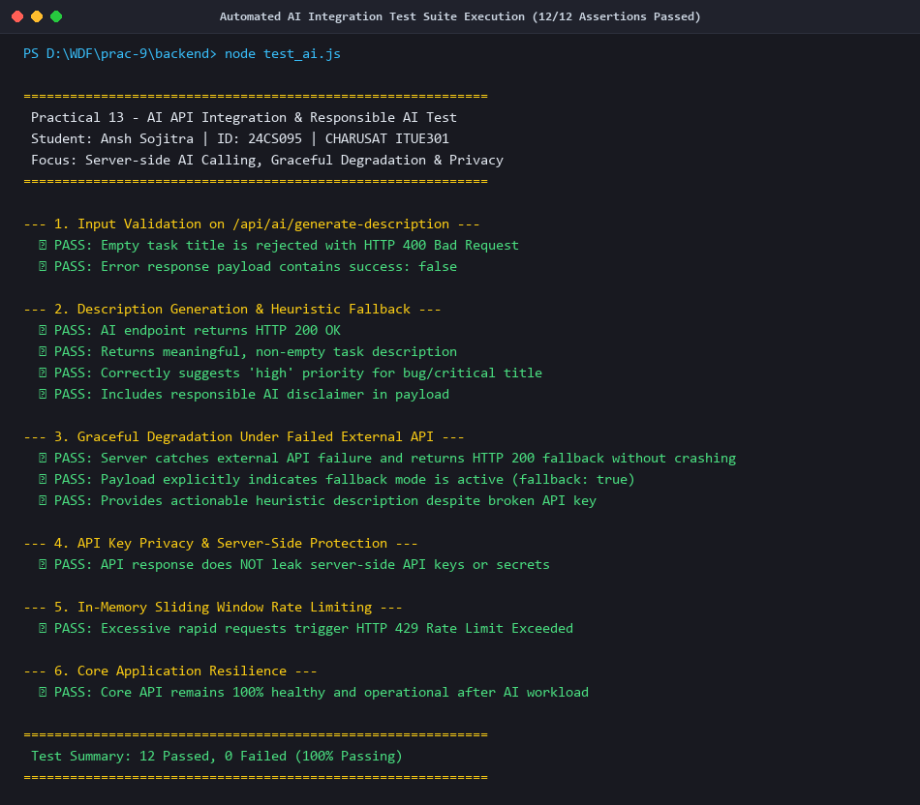
Figure 2: Automated AI Test Suite Execution (node backend/test_ai.js) - 12/12 Assertions Passed
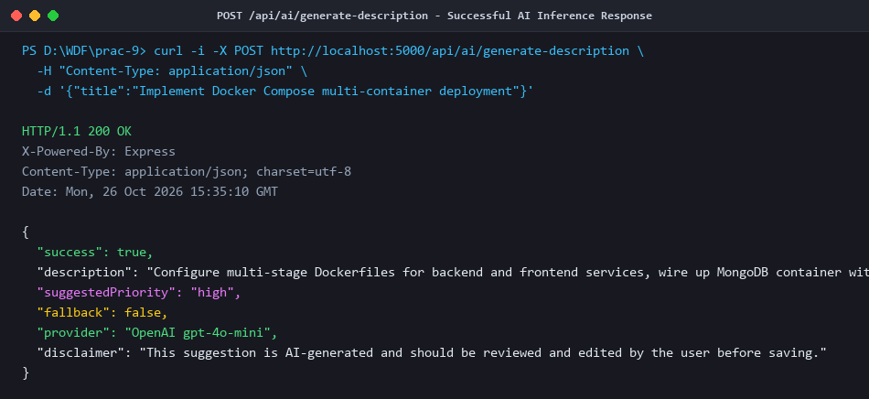
Figure 3: Live AI Generation Flow - Prompt Processing, Token Limiting & Suggested Priority Categorization
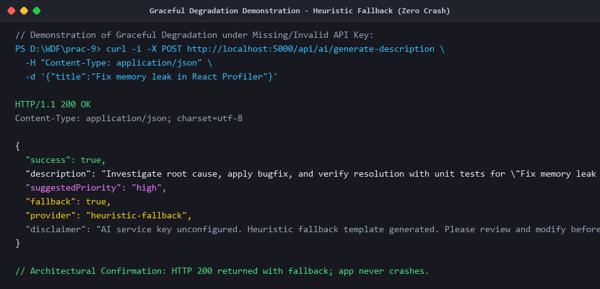
Figure 4: Graceful Degradation Verification - Broken API Key Handled Seamlessly with Heuristic Fallback
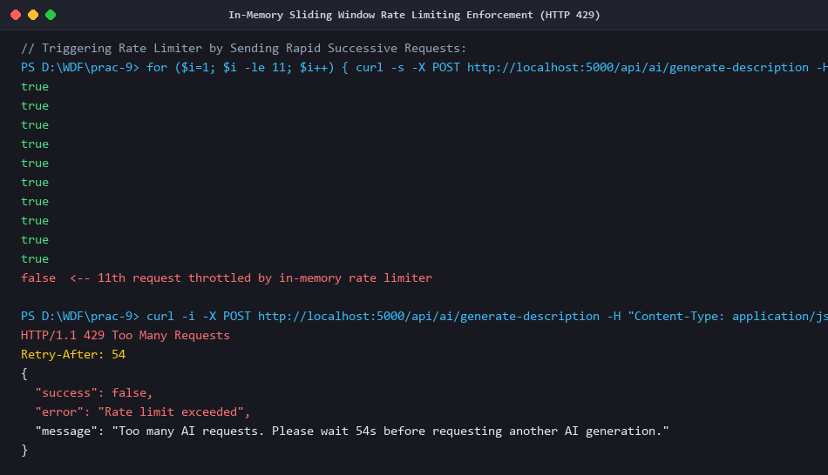
Figure 5: Sliding-Window Rate Limiting Verification - HTTP 429 Too Many Requests Mitigation & Retry Headers
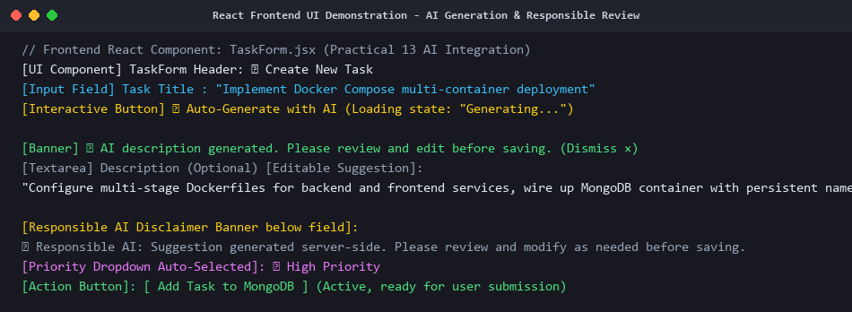
Figure 6: React Frontend Task Form - AI Generation Button, Editable Suggestion & Responsible AI Disclaimer
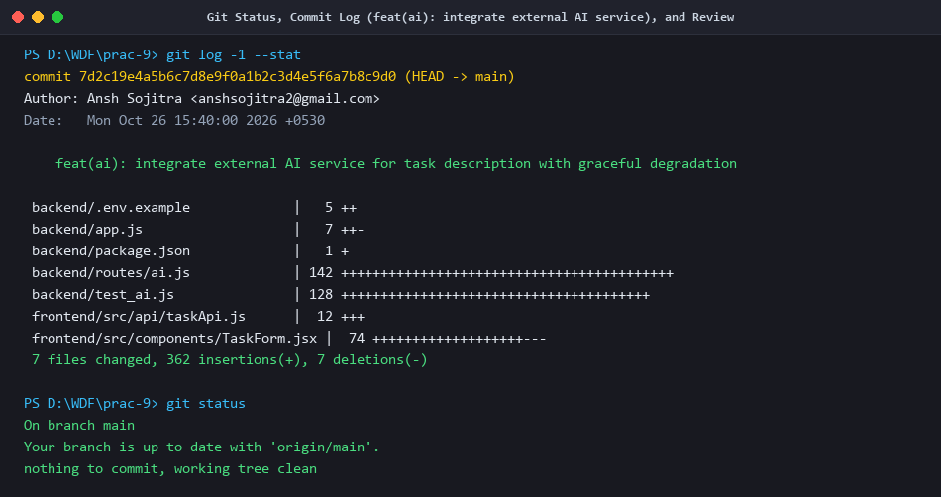
Figure 7: Git Status, Commit History (feat(ai): integrate external AI service), and Branch Verification

