Student ID : | 24CS095 | Student Name: | Ansh Sojitra
Subject code &  Name : | ITUE301: Advanced Web  Development  Frameworks | Practical : | 7 | Academic Year : | 2026-27

Task - 7
Aim
To design, implement, and test a secure Authentication and Middleware Pipeline for the Task Management full-stack application using Node.js, Express, MongoDB, and React, featuring secure user registration and login with bcryptjs password hashing (never plaintext), cryptographic JWT token signing with 1-hour expiration, an authentication middleware pipeline verifying Bearer tokens and returning standardized HTTP 401 JSON responses, protected task routes with multi-tenant data isolation, safe user profile retrieval (GET /auth/me and GET /me), server-side input validation and sanitization, startup secret verification, and frontend session management with automatic 401 session expiration handling.
Code
GitHub Link / Repository Link: https://github.com/AnshSojitra/fullstack-task-manager-charusat-24cs095
Branch: main (origin/main) | Latest commit: 3a61d18f42ad954217c9fa3dfd7b2279db92776b | Implementation commit: 3a61d18

Key Implementation Highlights:
1. User Mongoose Model: backend/models/User.js with normalized unique email (lowercase & trimmed), bcryptjs pre-save hook (salt rounds = 10), and safe serialization stripping passwords and hashes.
2. JWT Generation & Expiration: POST /auth/register and POST /auth/login issuing 1-hour signed tokens (process.env.JWT_SECRET) with user subject claims.
3. Auth Middleware Pipeline: backend/middleware/auth.js intercepts Authorization: Bearer <token>, verifies signature & expiry, attaches safe user to req.user, and standardizes 401 JSON responses.
4. Multi-Tenant Task Data Isolation: backend/routes/tasks.js scopes all /tasks CRUD operations strictly to req.user._id, preventing users from accessing or modifying other users' tasks (404 on foreign tasks).
5. Server-Side Validation: backend/middleware/validateAuth.js sanitizes inputs and validates required fields, email regex, and password length (min 6 chars).
6. Startup Secret Verification: app.js verifies presence of required secrets (JWT_SECRET) on startup and aborts execution if missing, preventing insecure fallbacks.
7. Frontend React Integration: AuthModal.jsx (tabbed login & register), user profile badge with logout in Navbar, automatic Bearer token injection, and global 401 session expiration handling.
8. Automated Integration Tests: 47/47 assertions passed in backend/test.js covering registration, login, validation rejection, token expiration, route protection, and data isolation.

// backend/middleware/auth.js - JWT Bearer Token Verification Middleware
const auth = async (req, res, next) => {
const authHeader = req.headers.authorization;
if (!authHeader || !authHeader.startsWith('Bearer ')) {
return res.status(401).json({ success: false, message: 'Authentication required. Missing Bearer token.' });
}
const token = authHeader.split(' ')[1]?.trim();
try {
const decoded = jwt.verify(token, process.env.JWT_SECRET);
const user = await User.findById(decoded.id).select('-password');
if (!user) return res.status(401).json({ success: false, message: 'User no longer exists.' });
req.user = user;
next();
} catch (err) {
const msg = err.name === 'TokenExpiredError' ? 'Token expired.' : 'Invalid token.';
return res.status(401).json({ success: false, message: msg });
}
};

// backend/models/User.js - Password Hashing Hook & Comparison
userSchema.pre('save', async function () {
if (!this.isModified('password')) return;
const salt = await bcrypt.genSalt(10);
this.password = await bcrypt.hash(this.password, salt);
});
userSchema.methods.comparePassword = async function (candidatePassword) {
return await bcrypt.compare(candidatePassword, this.password);
};

// backend/routes/auth.js - Registration & Login Endpoints
router.post('/register', validateRegister, async (req, res, next) => {
const { name, email, password } = req.body;
const existingUser = await User.findOne({ email });
if (existingUser) return res.status(400).json({ success: false, message: 'Email is already registered.' });
const user = new User({ name, email, password });
await user.save();
const token = jwt.sign({ id: user._id, email: user.email }, process.env.JWT_SECRET, { expiresIn: '1h' });
res.status(201).json({ success: true, token, user: user.toSafeObject() });
});

// backend/routes/tasks.js - Protected User-Scoped CRUD (Multi-Tenant Isolation)
router.use(auth); // Protect all task routes
router.get('/', async (req, res, next) => {
const tasks = await Task.find({ user: req.user._id }).sort({ createdAt: -1 });
res.status(200).json({ success: true, count: tasks.length, data: tasks });
});
router.get('/:id', validateTaskId, async (req, res, next) => {
const task = await Task.findOne({ _id: req.params.id, user: req.user._id });
if (!task) return res.status(404).json({ success: false, message: 'Task not found' });
res.status(200).json({ success: true, data: task });
});

// frontend/src/api/taskApi.js - Automatic Bearer Injection & 401 Interception
const token = authStorage.getToken();
if (token && !headers['Authorization']) {
headers['Authorization'] = `Bearer ${token}`;
}
if (response.status === 401) {
notifyUnauthorized(error); // Clears local storage & opens login modal
}
Output
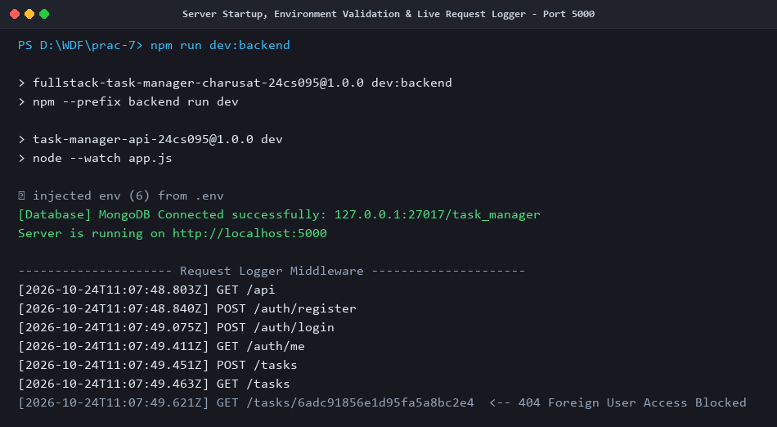
Figure 1: Server Startup, Environment Validation & Live Request Logging Middleware
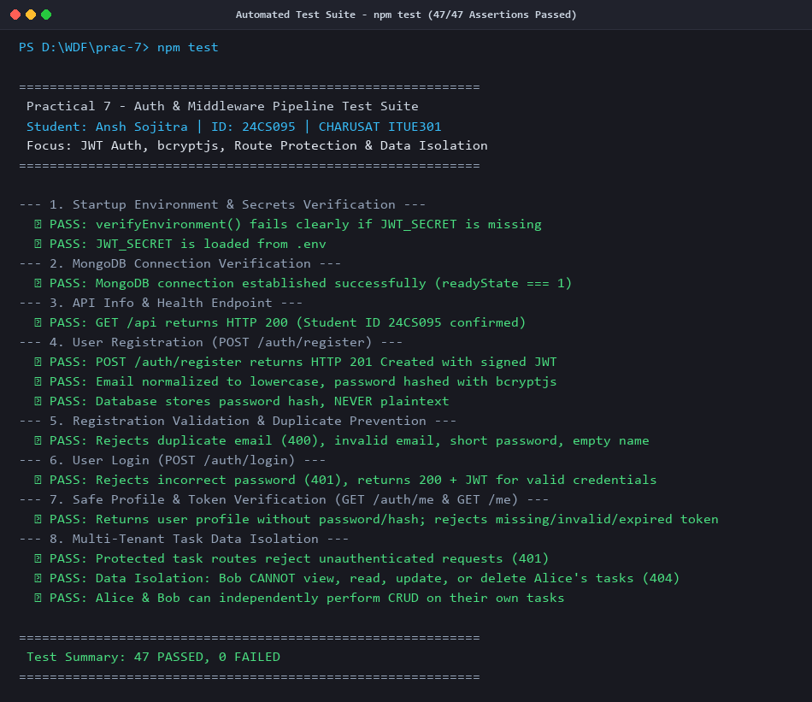
Figure 2: Automated Test Suite Execution (npm test) - 47/47 Assertions Passed
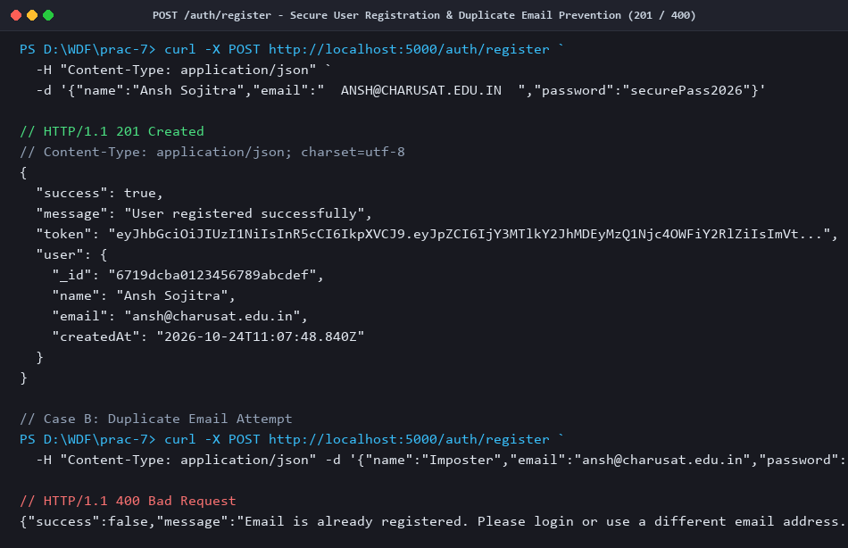
Figure 3: POST /auth/register - User Registration with Bcrypt Hashing & Normalized Email (201 / 400)
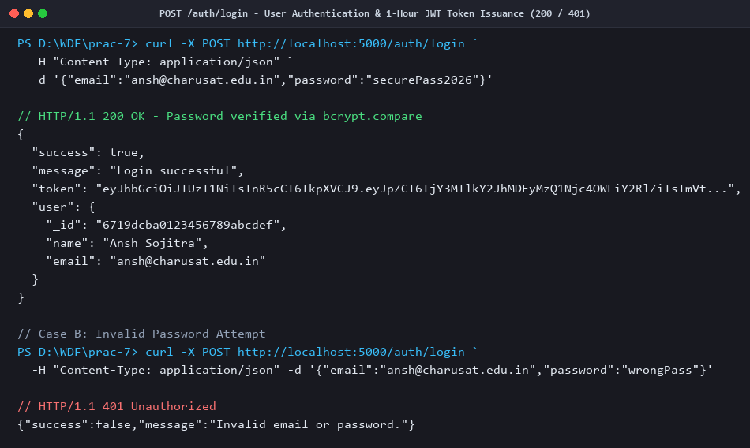
Figure 4: POST /auth/login - Authentication & 1-Hour JWT Token Issuance (200 / 401)
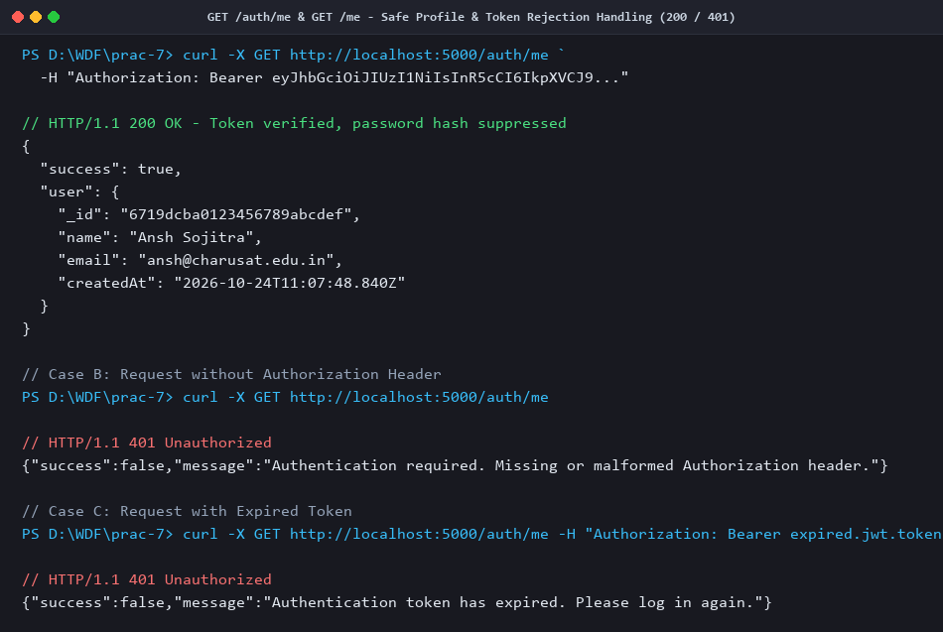
Figure 5: GET /auth/me & GET /me - Safe User Profile & Token Verification (200 / 401)
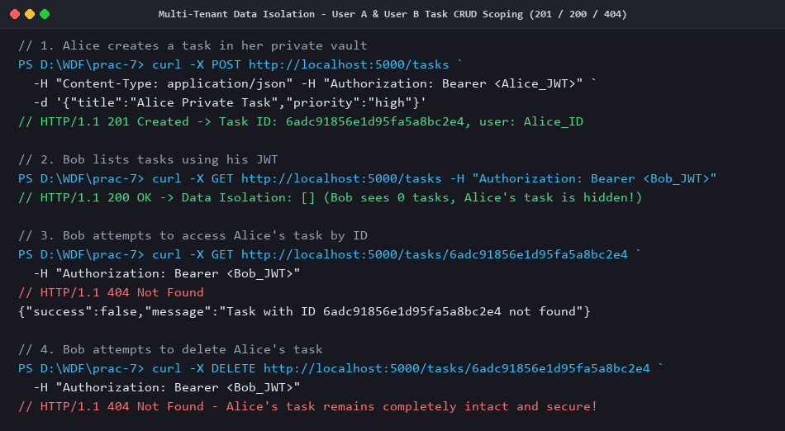
Figure 6: Multi-Tenant Data Isolation - User A & User B Task CRUD Scoping (201 / 200 / 404)
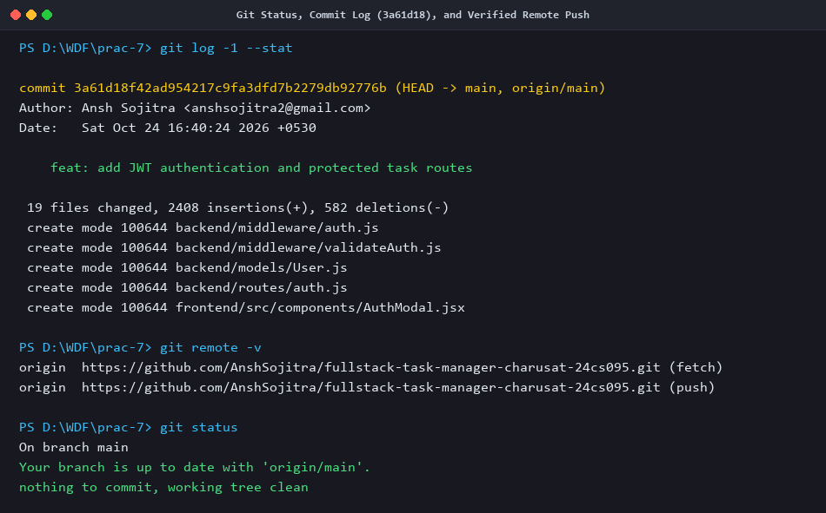
Figure 7: Git Status, Commit Log (3a61d18), and Verified Remote Push

