Student ID : | 24CS095 | Student Name: | Ansh Sojitra
Subject code &  Name : | ITUE301: Advanced Web  Development  Frameworks | Practical : | 6 | Academic Year : | 2026-27

Task - 6
Aim
To connect a React task-management UI to the Express/Mongoose REST API and support complete end-to-end CRUD (Create, Read, Update, Delete) operations with MongoDB persistence, state synchronization, CORS configuration, centralized API service module, delete confirmation modal, toast notifications, and robust loading and error state management.
Code
GitHub Link / Repository Link: https://github.com/AnshSojitra/fullstack-task-manager-charusat-24cs095
Branch: main (origin/main) | Latest commit: cb73f90fef31da85050c3471d4451a32f19c2eee | Implementation commit: 2a89960

Key Implementation Highlights:
1. Monorepo structure: frontend/ (React 19 + Vite) and backend/ (Express 5 + Mongoose 9) with environment separation and root runner scripts.
2. Express CORS middleware: whitelists frontend development origin (http://localhost:5173) supporting all CRUD methods and preflight OPTIONS.
3. Central Frontend API Service: taskApi.js encapsulates fetch calls using VITE_API_BASE_URL, network error handling, and structured JSON parsing.
4. Full End-to-End CRUD: replaces Practical 3 GitHub repository UI with MongoDB GET /tasks, POST /tasks creation, PUT /tasks/:id updates, and DELETE /tasks/:id.
5. UI State Synchronization: re-fetches from MongoDB after every write operation (await fetchTasks()); never assumes client-side write succeeded.
6. UI States & Safety: Loading spinner, friendly empty states with filter reset, title validation, ConfirmModal for destructive deletions, and auto-dismissing Toast alerts.
7. Automated Integration Tests & Build: 53/53 assertions passed (backend/test.js), clean ESLint pass, and optimized production Vite bundle build.

// backend/app.js - CORS Configuration & Middleware Pipeline
const allowedOrigins = [
process.env.CLIENT_URL || 'http://localhost:5173',
'http://localhost:5173',
'http://127.0.0.1:5173'
];
app.use(cors({
origin: (origin, cb) => cb(null, !origin || allowedOrigins.includes(origin)),
methods: ['GET', 'POST', 'PUT', 'DELETE', 'OPTIONS'],
allowedHeaders: ['Content-Type', 'Authorization', 'Accept'],
credentials: true
}));
app.use(validateContentType);
app.use(express.json());
app.use('/tasks', taskRoutes);

// backend/routes/tasks.js - RESTful CRUD Endpoints with ObjectId Validation
router.use('/:id', validateTaskId);
router.get('/', async (req, res, next) => {
const tasks = await Task.find().sort({ createdAt: -1 });
res.status(200).json({ success: true, count: tasks.length, data: tasks });
});
router.post('/', async (req, res, next) => {
const newTask = new Task(req.body);
const savedTask = await newTask.save();
res.status(201).json({ success: true, message: 'Task created successfully', data: savedTask });
});
router.put('/:id', async (req, res, next) => {
const updatedTask = await Task.findByIdAndUpdate(req.params.id, req.body, { returnDocument: 'after', runValidators: true });
res.status(200).json({ success: true, message: 'Task updated successfully', data: updatedTask });
});
router.delete('/:id', async (req, res, next) => {
const deletedTask = await Task.findByIdAndDelete(req.params.id);
res.status(200).json({ success: true, message: 'Task deleted successfully', data: deletedTask });
});

// backend/middleware/validateContentType.js
if (['POST', 'PUT'].includes(req.method) && !req.is('application/json')) {
return res.status(400).json({ success: false, message: 'Invalid or missing Content-Type header. Expected application/json.' });
}
next();

// backend/middleware/validateTaskId.js
const { id } = req.params;
if (!mongoose.Types.ObjectId.isValid(id)) {
return res.status(400).json({ success: false, message: `Invalid task ID format: '${id}'. Must be a 24-hex MongoDB ObjectId.` });
}
next();

// backend/middleware/errorHandler.js
app.use((err, req, res, next) => {
console.error(err.stack); // Logged internally on server only
res.status(err.status || 500).json({ success: false, message: err.message });
});

// frontend/src/api/taskApi.js - Centralized Frontend API Service
const API_BASE_URL = import.meta.env.VITE_API_BASE_URL || 'http://localhost:5000';
export const taskApi = {
getTasks: () => apiFetch('/tasks'),
getTaskById: (id) => apiFetch(`/tasks/${id}`),
createTask: (data) => apiFetch('/tasks', { method: 'POST', headers: { 'Content-Type': 'application/json' }, body: JSON.stringify(data) }),
updateTask: (id, data) => apiFetch(`/tasks/${id}`, { method: 'PUT', headers: { 'Content-Type': 'application/json' }, body: JSON.stringify(data) }),
deleteTask: (id) => apiFetch(`/tasks/${id}`, { method: 'DELETE' }),
};

// frontend/src/pages/Projects.jsx - State Synchronization after writes
const handleCreateTask = async (taskData) => {
setIsSubmitting(true);
try {
await taskApi.createTask(taskData);
showToast('success', `Task "${taskData.title}" created successfully in MongoDB!`);
await fetchTasks(); // Re-fetch from database to synchronize UI state
} catch (err) {
showToast('error', err.message || 'Failed to create task.');
} finally {
setIsSubmitting(false);
}
};
Output
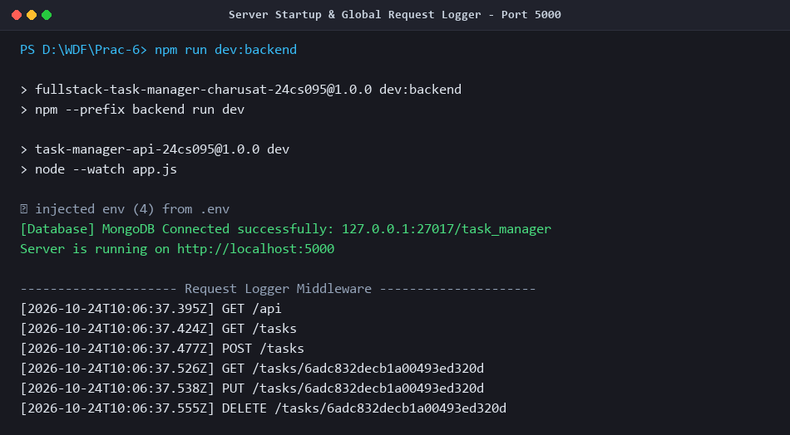
Figure 1: Server Startup & Live Request Logging Middleware
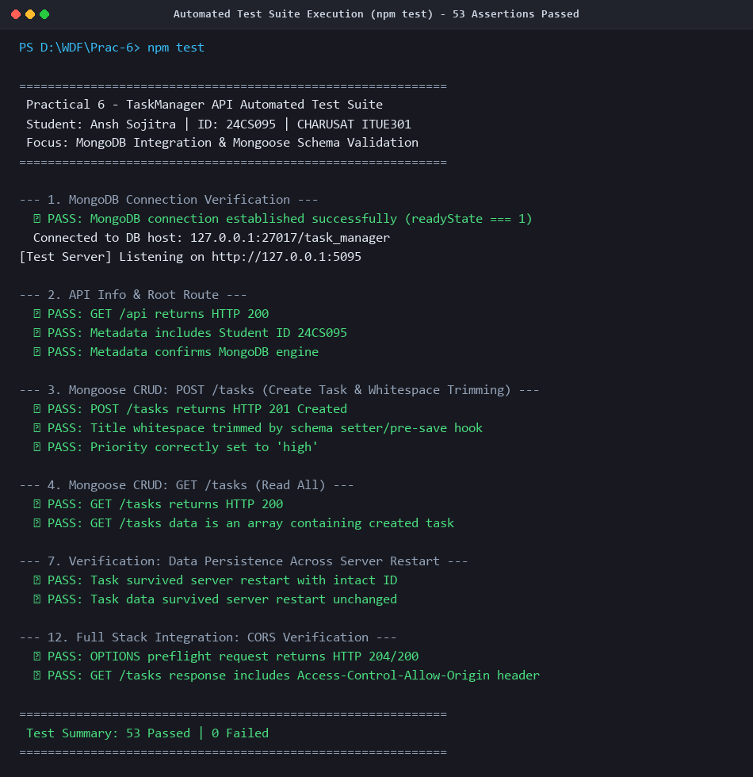
Figure 2: Automated Test Suite Execution (npm test) - 53/53 Assertions Passed
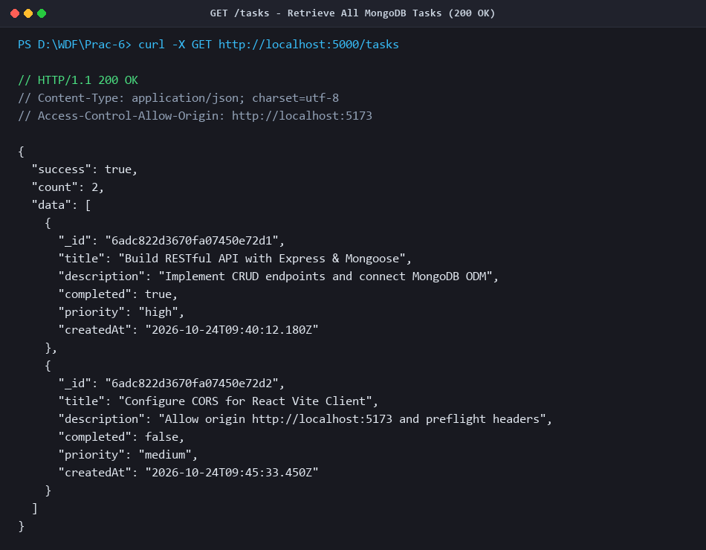
Figure 3: GET /tasks - Retrieve All MongoDB Tasks (200 OK)
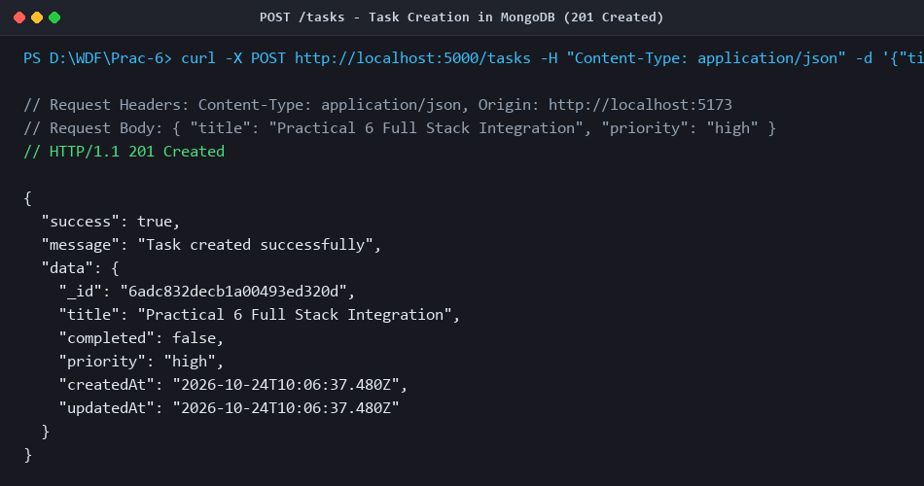
Figure 4: POST /tasks - Task Creation with Validation (201 Created)
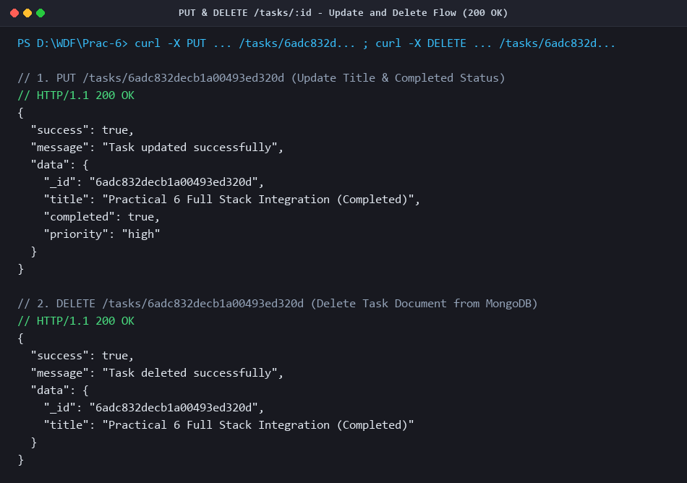
Figure 5: PUT /tasks/:id & DELETE /tasks/:id (200 OK)
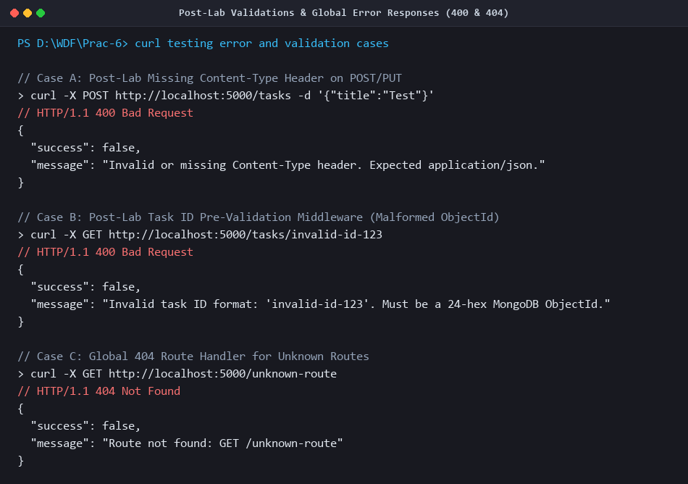
Figure 6: Post-Lab Validations & Global Error Responses (400 & 404)
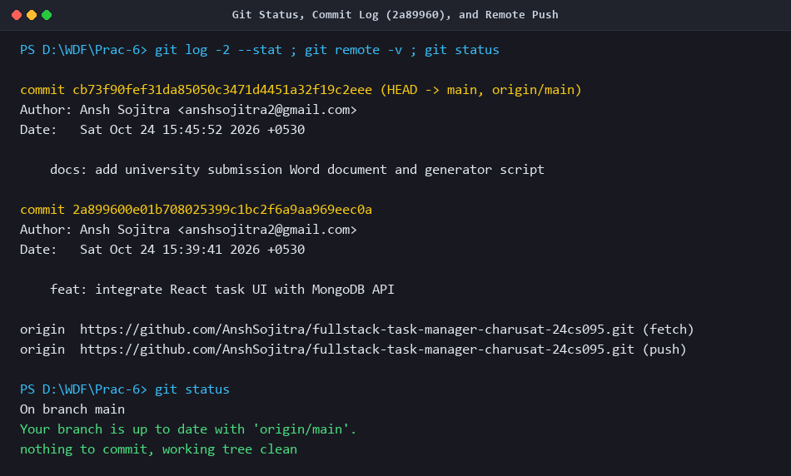
Figure 7: Git Status, Commit Log (2a89960), and Remote Push

