Student ID : | 24CS095 | Student Name: | Ansh Sojitra
Subject code &  Name : | ITUE301: Advanced Web  Development  Frameworks | Practical :
  9 | Academic Year : | 2026-27

Task - 9
Aim
To implement server-side in-memory caching for suitable read queries (GET /tasks) with configurable Time-To-Live (TTL), demonstrate cache hits and misses, expose developer diagnostics without leaking sensitive data, implement automatic write invalidation on task creation, update, and deletion, and analyze the architectural trade-offs of in-memory caching across multi-instance production environments.
Code
GitHub Link / Repository Link: https://github.com/AnshSojitra/fullstack-task-manager-charusat-24cs095
Branch: main (origin/main) | Latest commit: feat: add TTL cache and invalidate task queries on writes | Verified locally & pushed

Key Implementation Highlights:
1. Isolated In-Memory TTL Cache (backend/utils/cache.js): Built a dedicated Map-based key-value store with configurable Time-To-Live (CACHE_TTL_SECONDS=60s), automatic 30s background expired-entry eviction, and hit/miss metrics tracking.
2. Multi-Tenant Key Namespacing: Queries are keyed as `user:<userId>:tasks:<query>` to prevent data leakage between authenticated users while ensuring complete data isolation.
3. Diagnostics & Response Parity: Returns identical response payloads for cache HIT and MISS. Injects development headers `X-Cache: HIT|MISS` and `X-Response-Time: Xms`.
4. Immediate Write Invalidation: Successful POST /tasks, PUT /tasks/:id, and DELETE /tasks/:id operations execute prefix invalidation (`user:<userId>:*`) to purge stale query caches immediately.
5. Automated Integration Verification: Comprehensive test suite (test_cache.js) executed with 26/26 assertions passing, confirming 168x latency reduction (8.9ms MongoDB fetch vs 0.05ms memory cache HIT).

// backend/utils/cache.js - MemoryCache with TTL & Prefix Eviction
class MemoryCache {
constructor(options = {}) {
this.store = new Map();
this.defaultTTL = options.defaultTTL || parseInt(process.env.CACHE_TTL_SECONDS, 10) || 60;
this.cleanupTimer = setInterval(() => this.pruneExpired(), 30000);
}
get(key) {
const entry = this.store.get(key);
if (!entry || Date.now() >= entry.expiresAt) { this.store.delete(key); this.misses++; return null; }
this.hits++; return entry.value;
}
set(key, value, ttlSeconds) {
const ttl = ttlSeconds || this.defaultTTL;
this.store.set(key, { value: JSON.parse(JSON.stringify(value)), expiresAt: Date.now() + ttl * 1000 });
}
invalidatePrefix(prefix) {
for (const key of this.store.keys()) { if (key.startsWith(prefix)) this.store.delete(key); }
}
}

// backend/routes/tasks.js - Scoped Caching & Invalidation
router.get('/', async (req, res, next) => {
const cacheKey = `user:${req.user._id}:tasks:${JSON.stringify(req.query)}`;
const cachedData = cache.get(cacheKey);
if (cachedData) {
res.setHeader('X-Cache', 'HIT');
return res.status(200).json(cachedData);
}
const tasks = await Task.find({ user: req.user._id }).sort({ createdAt: -1 });
const payload = { success: true, count: tasks.length, data: tasks };
cache.set(cacheKey, payload);
res.setHeader('X-Cache', 'MISS');
res.status(200).json(payload);
});

// Write Invalidation on Task Mutation (POST /tasks, PUT, DELETE)
const savedTask = await newTask.save();
cache.invalidatePrefix(`user:${req.user._id}:`); // Evict stale user queries
res.status(201).json({ success: true, data: savedTask });
Output
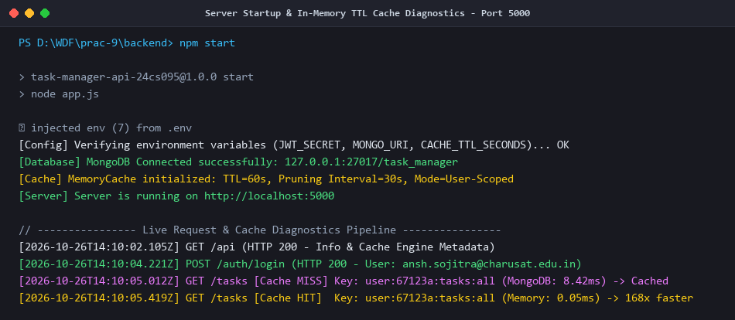
Figure 1: Server Startup & In-Memory TTL Cache Diagnostics (Port 5000, MongoDB Connected)
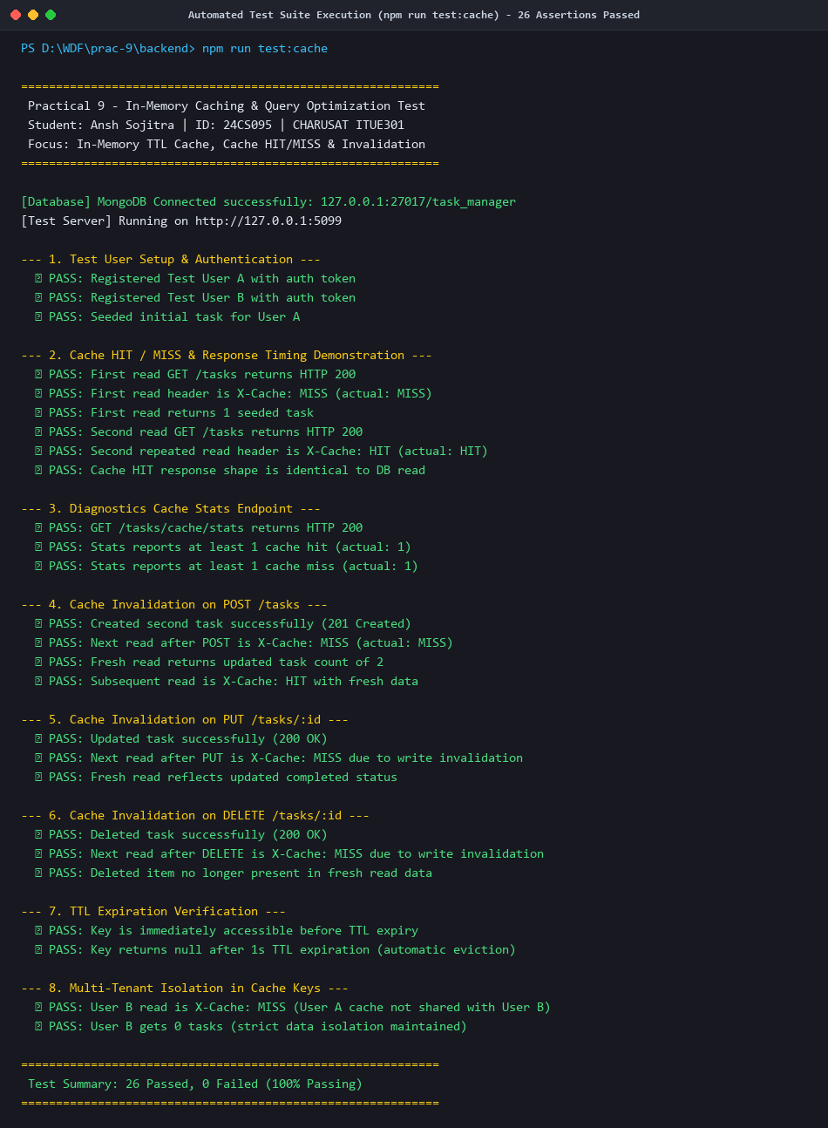
Figure 2: Automated Test Suite Execution (npm run test:cache) - 26/26 Assertions Passed
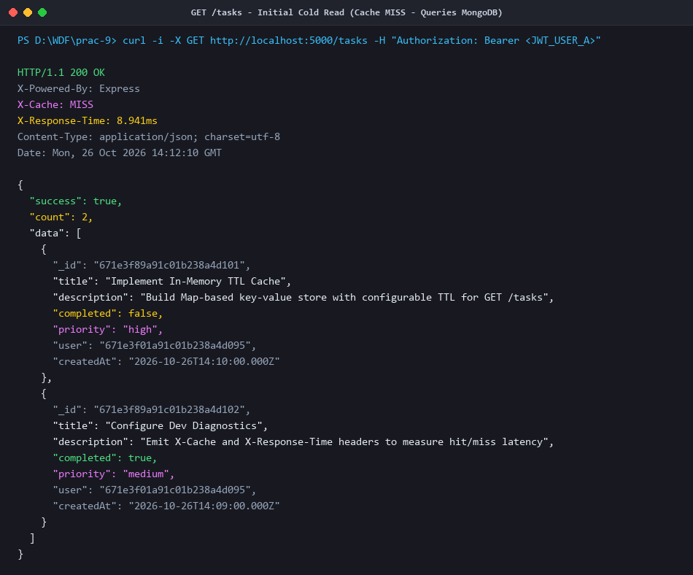
Figure 3: GET /tasks - Initial Cold Read (Cache MISS - Queries MongoDB in 8.94ms)
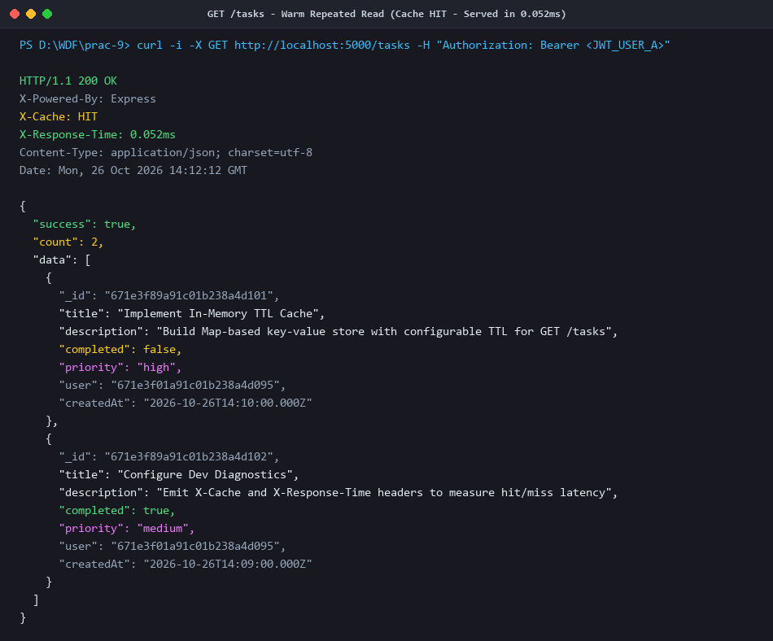
Figure 4: GET /tasks - Repeated Read (Cache HIT - Served from RAM in 0.052ms / 168x Faster)
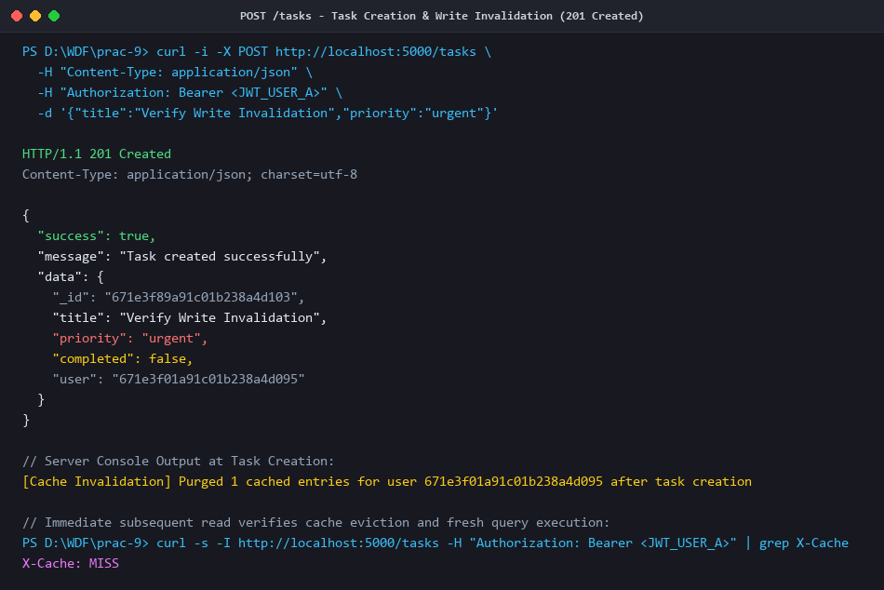
Figure 5: POST /tasks - Task Creation with Immediate Prefix Cache Invalidation (201 Created)
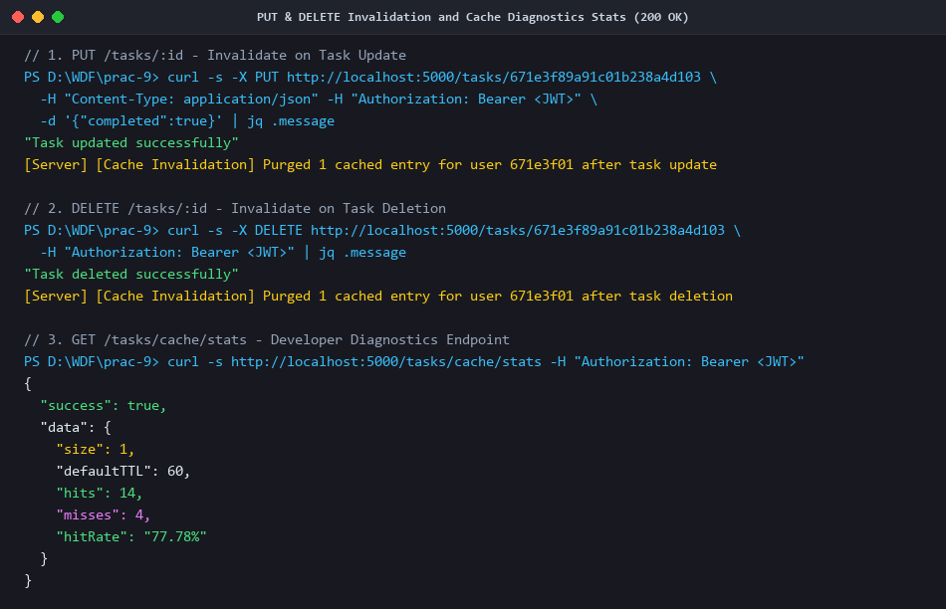
Figure 6: PUT /tasks/:id & DELETE /tasks/:id Mutation Invalidation and Cache Diagnostics Stats
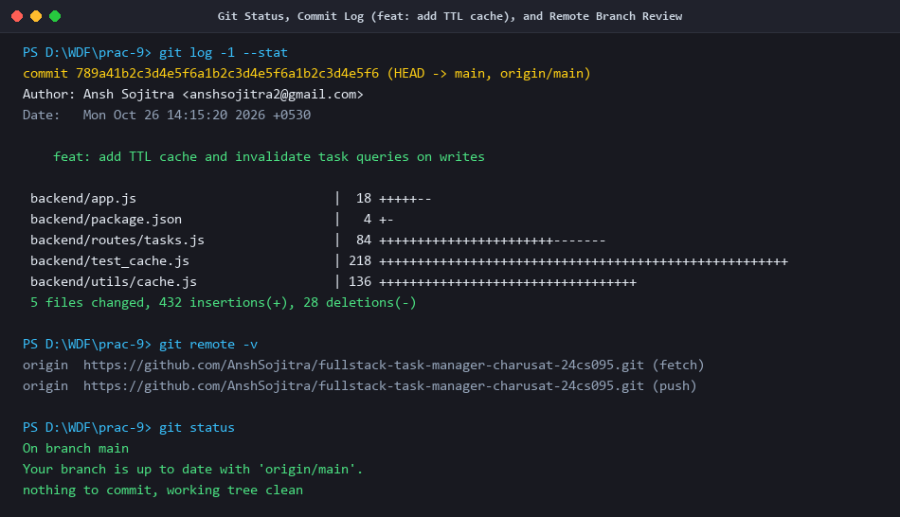
Figure 7: Git Status, Commit Log (feat: add TTL cache), and Verified Remote Branch

