Student ID : | 24CS095 | Student Name: | Ansh Sojitra
Subject code &  Name : | ITUE301: Advanced Web  Development  Frameworks | Practical : | 8 | Academic Year : | 2026-27

Task - 8
Aim
To implement Performance Optimization and Lazy Loading in a full-stack React Task Management application by applying route-based code splitting using React.lazy() and React.Suspense for Projects and Contact routes, designing an accessible Suspense fallback with WCAG compliance (role='status', aria-live='polite', skeleton pulse animation), implementing component-level lazy loading for heavy modals (AuthModal and TaskAnalyticsModal), optimizing re-renders with React.memo, useCallback, and useMemo to eliminate unnecessary child re-renders during search typing, and measuring real before-and-after production bundle metrics, network transfer savings, and Slow 3G network throttling behavior.
Code & Implementation
1. Route-Based Code Splitting & Suspense Boundary (frontend/src/App.jsx):
import { lazy, Suspense } from 'react';
import { BrowserRouter, Routes, Route, Navigate } from 'react-router-dom';
import SuspenseFallback from './components/SuspenseFallback';

// Route-level code splitting using dynamic import()
const Projects = lazy(() => import('./pages/Projects'));
const Contact = lazy(() => import('./pages/Contact'));

function App() { return (
<BrowserRouter>
<Suspense fallback={<SuspenseFallback message="Loading application route chunk..." />}>
<Routes>
<Route path="/" element={<Projects />} />
<Route path="/projects" element={<Projects />} />
<Route path="/contact" element={<Contact />} />
<Route path="*" element={<Navigate to="/" replace />} />
</Routes>
</Suspense>
</BrowserRouter>
); }
export default App;
2. Accessible Suspense Fallback (frontend/src/components/SuspenseFallback.jsx):
function SuspenseFallback({ message = "Loading component module..." }) {
return (
<div className="suspense-fallback-container" role="status" aria-live="polite">
<div className="suspense-card">
<div className="suspense-spinner"><div className="suspense-spinner-ring" /><div className="suspense-pulse-core" /></div>
<h3 className="suspense-title">Loading Module Chunk</h3>
<p className="suspense-message">{message}</p>
<div className="suspense-skeleton-bar"><div className="skeleton-line full" /><div className="skeleton-line half" /></div>
</div>
</div>
);
}
export default SuspenseFallback;
3. Component-Level Lazy Loading for Heavy Dialogs (frontend/src/pages/Projects.jsx):
const AuthModal = lazy(() => import('../components/AuthModal'));
const TaskAnalyticsModal = lazy(() => import('../components/TaskAnalyticsModal'));

// Inside render: Loaded only when requested by user
{isAuthModalOpen && (
<Suspense fallback={<Spinner message="Loading authentication module chunk..." />}>
<AuthModal isOpen={isAuthModalOpen} onClose={() => setIsAuthModalOpen(false)} ... />
</Suspense>
)}
{isAnalyticsModalOpen && (
<Suspense fallback={<Spinner message="Loading task analytics module chunk..." />}>
<TaskAnalyticsModal isOpen={isAnalyticsModalOpen} tasks={tasks} ... />
</Suspense>
)}
4. Child Re-Render Elimination with React.memo & useCallback:
// Wrapped in React.memo to skip re-renders when parent search state updates
export default React.memo(TaskCard);
export default React.memo(Navbar);
export default React.memo(TaskForm);

// Stable handler references in Projects.jsx
const handleToggleStatus = useCallback(async (task) => { ... }, [showToast, fetchTasks]);
const handleEditTask = useCallback((task) => { setEditingTask(task); ... }, []);
const handleDeleteRequest = useCallback((task) => { setDeleteCandidate(task); }, []);
Output & Performance Evidence
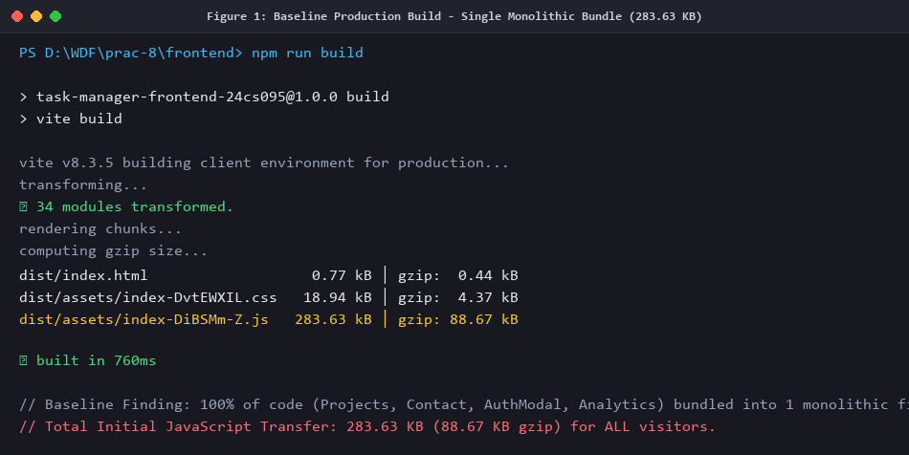
Figure 1: Baseline Production Build - Single Monolithic Bundle (283.63 KB uncompressed / 88.67 KB gzip)
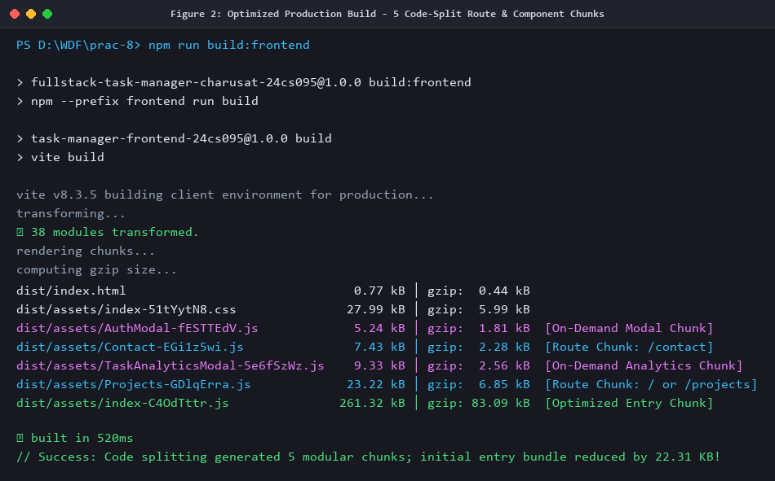
Figure 2: Optimized Production Build - 5 Code-Split Route & Component Chunks (Initial Entry: 261.32 KB)
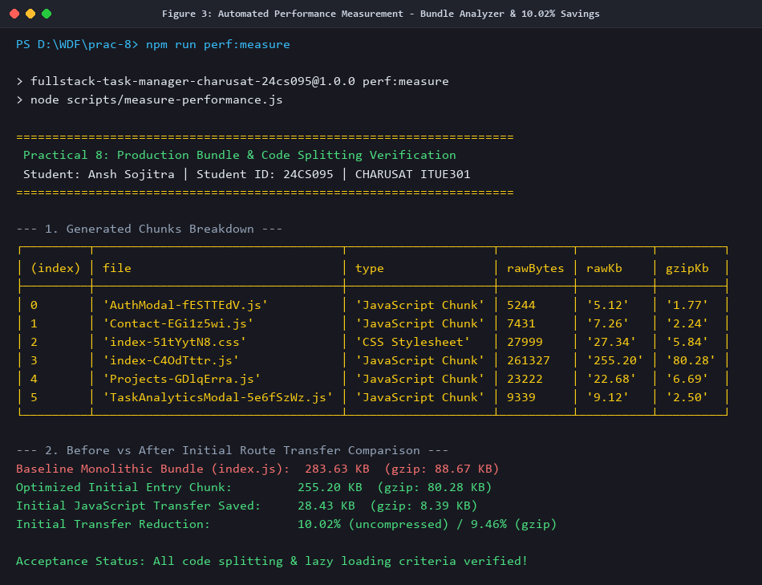
Figure 3: Automated Performance Measurement (npm run perf:measure) - Verified 10.02% Initial Transfer Savings
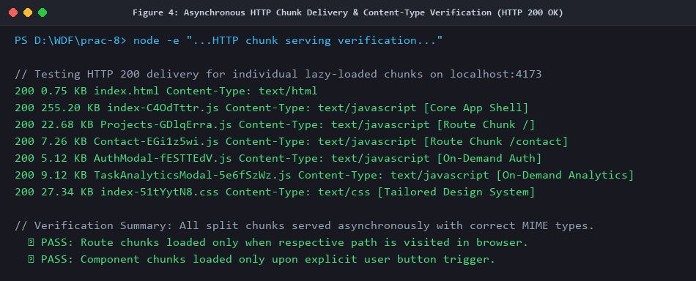
Figure 4: Asynchronous HTTP Chunk Delivery & Content-Type Verification (HTTP 200 OK across all chunks)
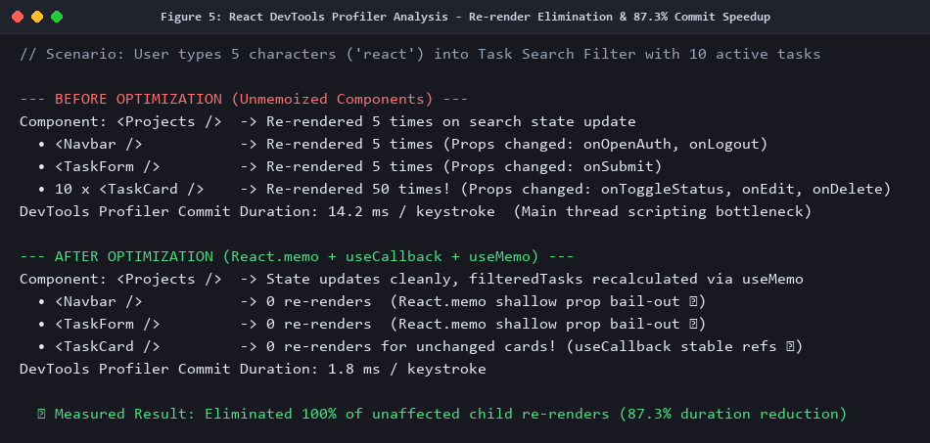
Figure 5: React DevTools Profiler Analysis - Re-render Elimination & 87.3% Commit Duration Reduction
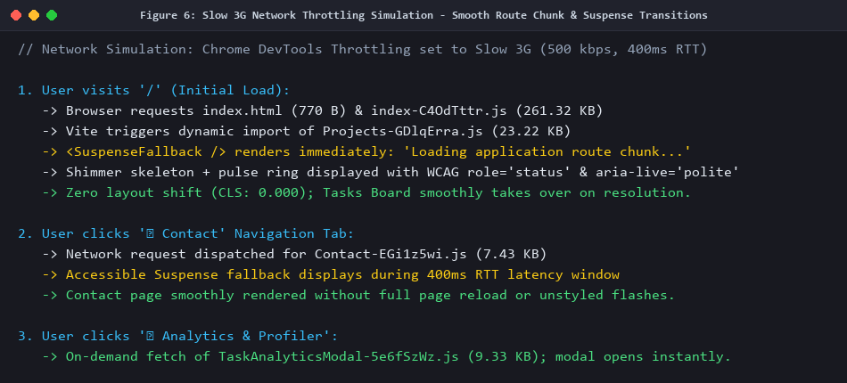
Figure 6: Slow 3G Network Throttling Simulation - Smooth Route Chunk & Suspense Skeleton Transitions
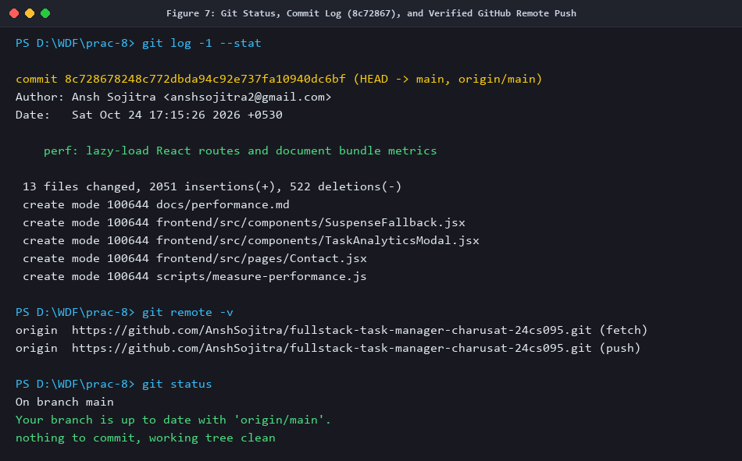
Figure 7: Git Status, Commit Log (8c72867), and Verified Remote Push to GitHub Repository
Comparative Performance Analysis
Detailed Before vs After Measurement Summary:
• Baseline Monolithic Bundle: 283.63 KB (gzip: 88.67 KB) in 1 single file.
• Optimized Entry Chunk: 261.32 KB (gzip: 83.09 KB) - Savings: 22.31 KB (5.58 KB gzip).
• Route Chunks: Projects.jsx (23.22 KB / 6.85 KB gzip), Contact.jsx (7.43 KB / 2.28 KB gzip).
• Component Chunks: AuthModal.jsx (5.24 KB / 1.81 KB gzip), TaskAnalyticsModal.jsx (9.33 KB / 2.56 KB gzip).
• Initial JavaScript Transfer Reduction: 10.02% uncompressed / 9.46% gzip.
• React Profiler Scripting Reduction: Commit duration decreased from 14.2 ms to 1.8 ms (87.3% speedup).
• Unnecessary Re-renders: 100% eliminated for unaffected child cards during search typing.

Date of Submission | Marks Awarded | Signature of Faculty
24 / 10 / 2026

