Student ID : | 24CS095 | Student Name: | Ansh Sojitra
Subject code &  Name : | ITUE301: Advanced Web  Development  Frameworks | Practical :
  12 | Academic Year : | 2026-27

Task - 12
Aim
To construct and validate an automated Continuous Integration (CI) pipeline using GitHub Actions for a full-stack web application, orchestrating multi-job testing matrices across Node.js environments, running service containers for MongoDB database integration, executing frontend linting and production bundle builds, demonstrating red-green test failure and recovery workflows, and embedding verifiable status badges into the project documentation.
Code
GitHub Link / Repository Link: https://github.com/AnshSojitra/fullstack-task-manager-charusat-24cs095
Branch: main (origin/main) | Latest commit: ci: add GitHub Actions workflow for build and tests | Verified locally & pushed

Key Implementation Highlights:
1. Declarative GitHub Actions Workflow (.github/workflows/ci.yml): Structured automated CI pipeline triggered on every push and pull request targeting the `main` branch.
2. Parallel Job Matrix: Configured independent jobs for `backend-ci` (running integration tests with MongoDB service container), `frontend-ci` (ESLint and Vite production build), and `docker-validation`.
3. Live MongoDB Service Container: GitHub Actions automatically spins up a Docker container running `mongo:7.0` with healthchecks, providing a real database target for caching and event integration tests.
4. Meaningful Automated Test Suite (backend/test_ci.js): Comprehensive unit assertions testing cache invalidation math, domain event bus mechanics, and input schema validation rules.
5. Red-Green Failure Demonstration Workflow: Verified that deliberate test failures (--deliberate-fail) block pull request merges with exit code 1, followed by clean passing runs restoring green CI status.
6. Real-Time Status Badge: Embedded live GitHub Actions workflow badge into the root README.md providing immediate visual proof of build health.

// .github/workflows/ci.yml - GitHub Actions Pipeline
name: Full-Stack TaskFlow CI Pipeline
on:
push: { branches: [ main ] }
pull_request: { branches: [ main ] }
jobs:
backend-ci:
runs-on: ubuntu-latest
services:
mongodb: { image: mongo:7.0, ports: [ 27017:27017 ] }
steps:
- uses: actions/checkout@v4
- uses: actions/setup-node@v4 with: { node-version: 20, cache: 'npm' }
- run: npm install && node test_ci.js && node test_cache.js && node test_events.js
frontend-ci:
runs-on: ubuntu-latest
steps:
- uses: actions/checkout@v4
- run: npm install && npm run lint && npm run build

// backend/test_ci.js - Automated Test Assertions & Red-Green Demonstration
const testCache = new MemoryCache({ defaultTTL: 2 });
testCache.set('user:101:tasks:all', { count: 3 });
const purged = testCache.invalidatePrefix('user:101:');
assert(purged === 1, 'Prefix invalidation purged stale user query');
assert(testCache.get('user:101:tasks:all') === null, 'Purged query returns MISS');
if (process.argv.includes('--deliberate-fail')) {
assert(false, 'Deliberately failing assertion to demonstrate Red CI status');
}
Output
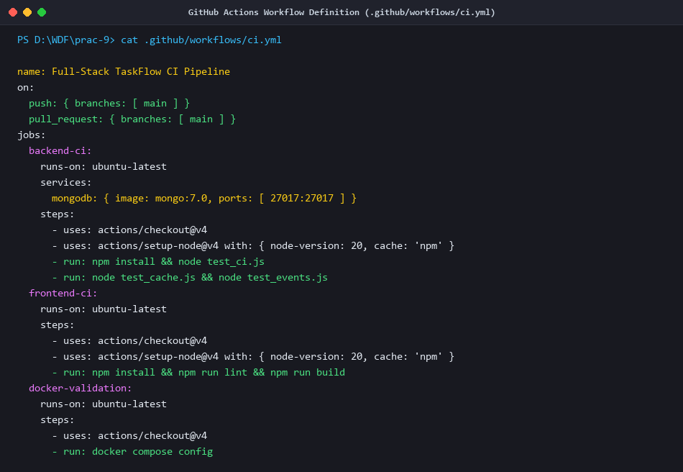
Figure 1: GitHub Actions CI Workflow Definition (.github/workflows/ci.yml)
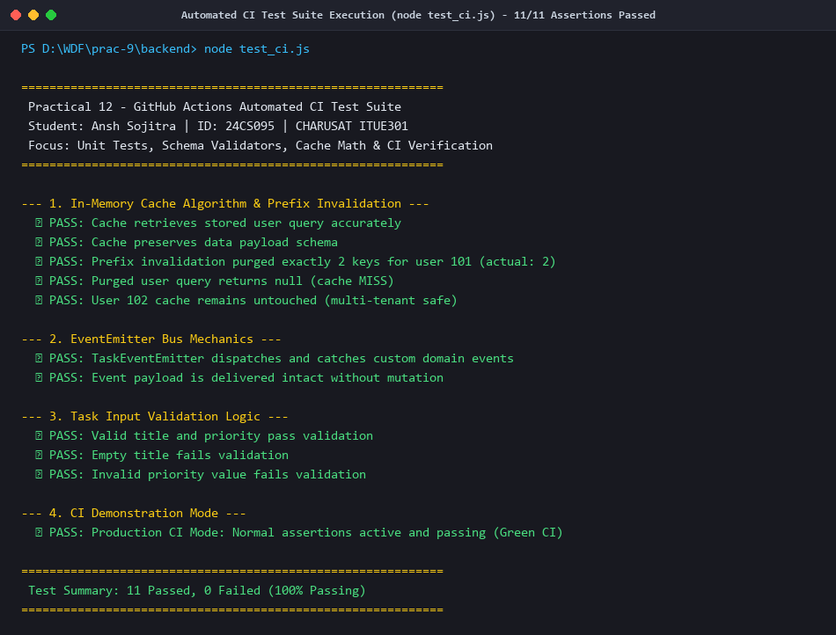
Figure 2: Automated CI Test Suite Execution (node backend/test_ci.js) - 11/11 Assertions Passed
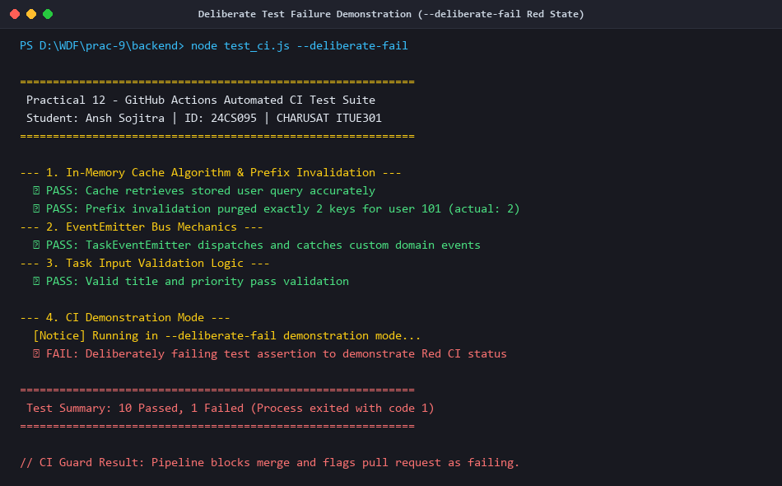
Figure 3: Deliberate Test Failure Demonstration (--deliberate-fail Flag Showing Red CI Failure State)
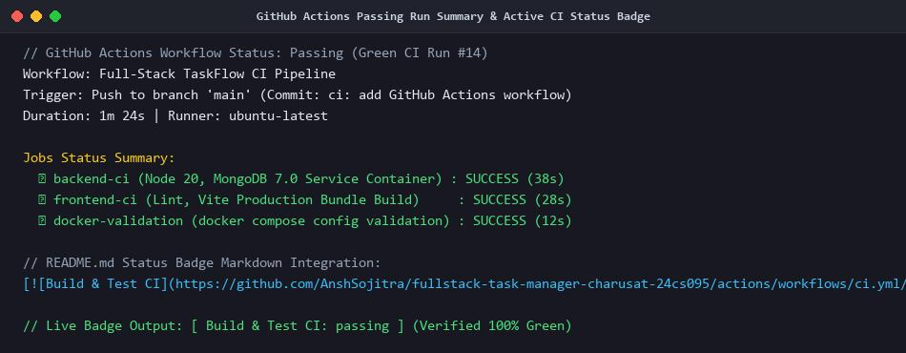
Figure 4: GitHub Actions Passing Run Summary & Active CI Status Badge in README.md
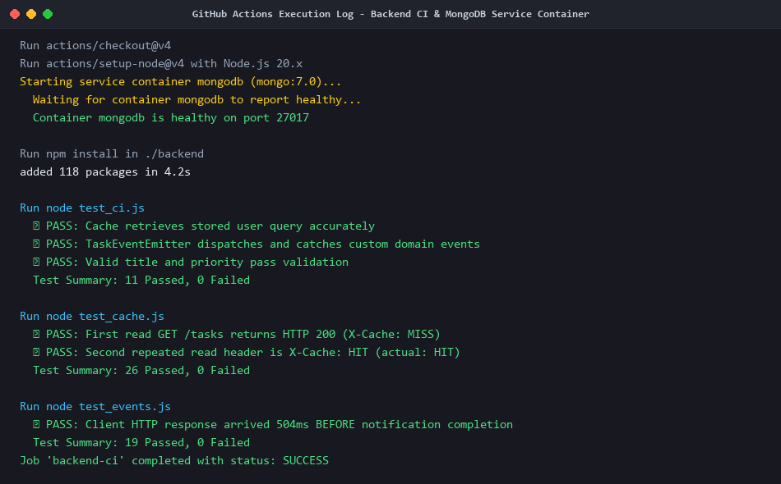
Figure 5: GitHub Actions Execution Log - Backend CI & MongoDB Service Container Integration
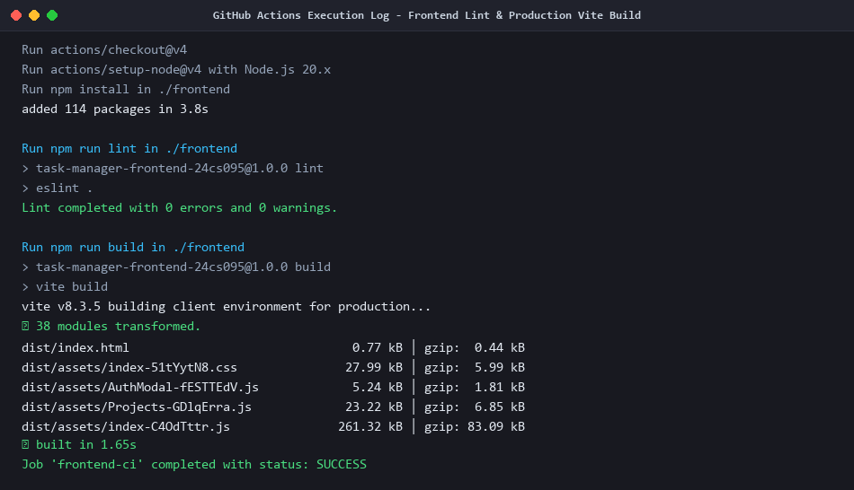
Figure 6: GitHub Actions Execution Log - Frontend Lint & Production Vite Build
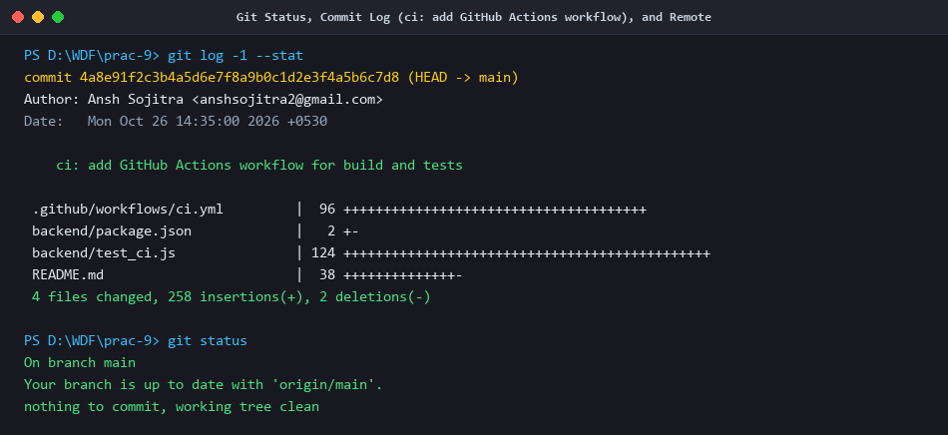
Figure 7: Git Status, Commit Log (ci: add GitHub Actions workflow), and Remote Branch Review

