CHAROTAR UNIVERSITY OF SCIENCE AND TECHNOLOGY
Chandubhai S. Patel Institute of Technology (CSPIT)
Department of Computer Science & Engineering
ITUE301 — ADVANCED WEB DEVELOPMENT FRAMEWORKS
PRACTICAL 5 LABORATORY REPORT
Student Name | Ansh Sojitra
Student ID | 24CS095
Academic Year | 2026–27
Practical Title | Practical 5: MongoDB Integration and Schema Design with Mongoose
Repository Name | task-manager-api-24CS095
Database Engine | MongoDB Community Server v8.2.4 with Mongoose v9.11.3 ODM

1. Objective & Scope
The objective of Practical 5 is to elevate the Task Management REST API developed in Practical 4 from an ephemeral in-memory storage model to a robust, persistent production-grade database architecture powered by MongoDB and the Mongoose Object Data Modeling (ODM) library.
All core RESTful endpoints (GET, POST, PUT, DELETE) are preserved while adding schema validation, data type normalization, pre-save hooks, priority enumeration, and safe MongoDB ObjectId parameter verification.

2. Key Requirements Implemented
- 1. Secure Database Connection: Environment-driven connection via process.env.MONGO_URI using dotenv, strictly avoiding hardcoded connection strings.
- 2. Mongoose Schema Design: Defined models/Task.js containing title (required, trimmed), description (optional, trimmed), completed (boolean, default false), createdAt (Date, default Date.now), and priority (enum: 'low', 'medium', 'high', default 'medium').
- 3. Whitespace Trimming Hook: Incorporated schema setters and a pre-save hook to sanitize input and ensure title whitespace is trimmed before saving.
- 4. Mongoose CRUD Operations: Replaced all JavaScript array mutations with Mongoose model queries (Task.find(), Task.findById(), Task.create(), Task.findByIdAndUpdate(), Task.findByIdAndDelete()).
- 5. Safe ID Validation: Middleware validates 24-character hexadecimal ObjectId format, returning 400 Bad Request for malformed IDs. Nonexistent valid ObjectIds return structured 404 Not Found.
- 6. Error Middleware & Formatting: All async route handlers forward exceptions via next(err) to errorHandler.js, which maps Mongoose ValidationError and CastError to client-readable JSON while suppressing stack traces.
- 7. Data Persistence Verification: Created tasks persist in MongoDB across server process stops and restarts, verified via automated test suite.

3. Architecture & File Structure
The repository follows a clean, modular Model-Route-Middleware architectural pattern:
- • config/db.js — Encapsulates Mongoose database connection logic and fail-fast environment checks.
- • models/Task.js — Defines the Mongoose Task schema, validation rules, priority enum, and pre-save hooks.
- • routes/tasks.js — Implements asynchronous Express route handlers mapped to Mongoose model queries.
- • middleware/validateTaskId.js — Validates MongoDB ObjectId format using mongoose.Types.ObjectId.isValid.
- • middleware/errorHandler.js — Centralized error handler converting Mongoose validation errors into structured JSON.
- • middleware/validateContentType.js — Enforces Content-Type: application/json for POST and PUT requests.
- • middleware/logger.js — Logs HTTP method, request path, and ISO timestamp for server auditing.
- • app.js — Configures the Express middleware pipeline, mounts routes, and initiates the database connection.

4. Schema Definition & Code Artifacts
The Task schema in models/Task.js enforces required validation and priority enumeration:
const taskSchema = new mongoose.Schema({
title: { type: String, required: [true, 'Title is required'], trim: true },
description: { type: String, default: '', trim: true },
completed: { type: Boolean, default: false },
createdAt: { type: Date, default: Date.now },
priority: { type: String, enum: ['low', 'medium', 'high'], default: 'medium', lowercase: true, trim: true }
});
taskSchema.pre('save', function (next) {
if (this.title) this.title = this.title.trim();
if (this.description) this.description = this.description.trim();
if (typeof next === 'function') next();
});

5. Verification & Testing Evidence
A comprehensive automated integration test suite (test.js) was executed, evaluating 50 distinct test assertions covering connection verification, CRUD operations, title trimming, priority enum validation, server restart persistence, and error handling.
Figure 1: MongoDB Connection & Server Initialization
Verification of successful connection to MongoDB Community Server on port 27017 and Express server startup.
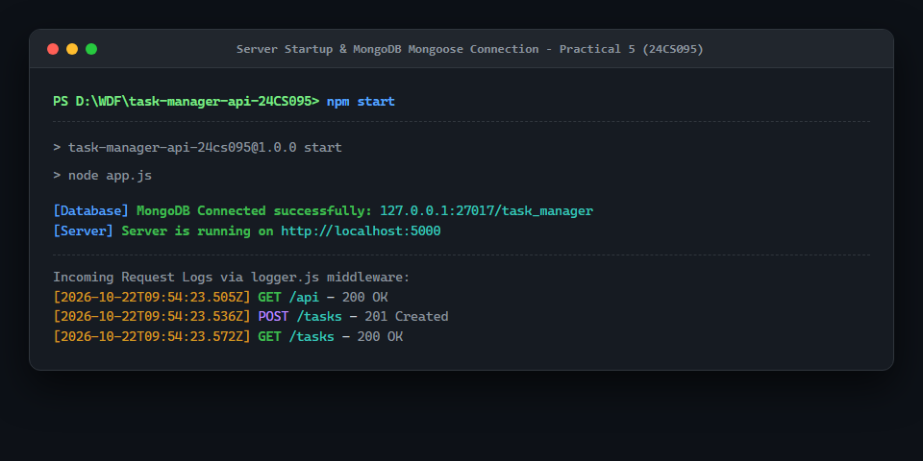
Figure 2: Automated Test Suite Execution (50 Assertions Passing)
Execution of npm test demonstrating 100% pass rate across all MongoDB CRUD, validation, and restart persistence tests.
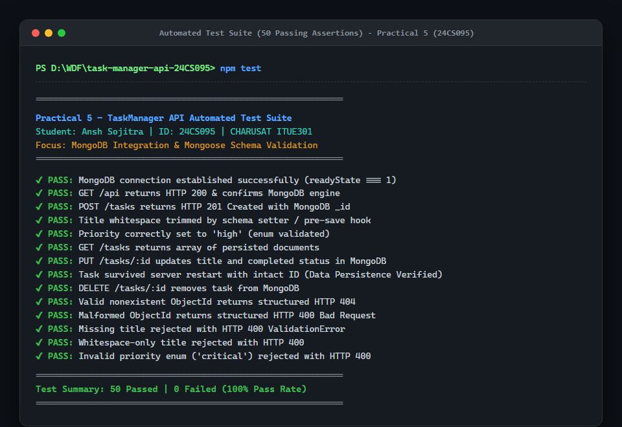
Figure 3: GET /tasks - Persistent Document Retrieval
Retrieving all task documents from MongoDB with generated ObjectIds and timestamps.
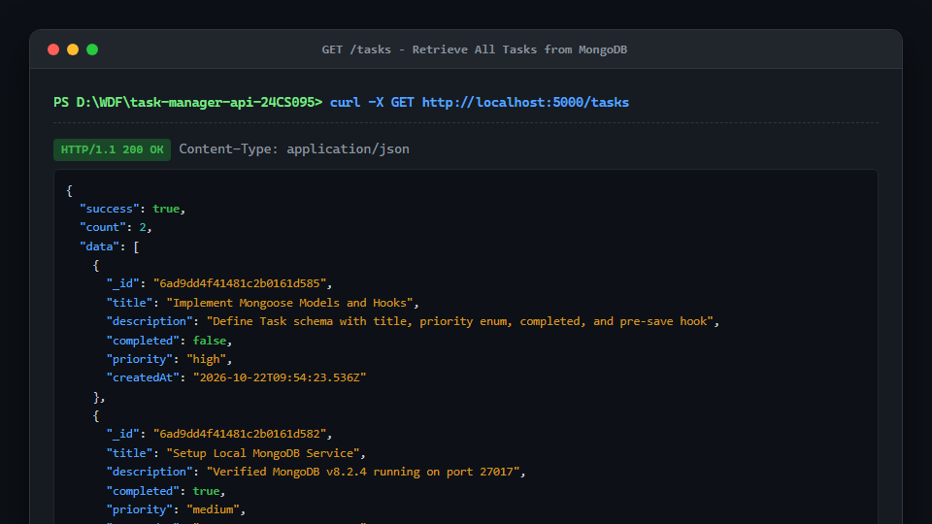
Figure 4: POST /tasks - Create with Priority & Whitespace Trimming
Creating a new task with title whitespace automatically trimmed by the Mongoose pre-save hook and priority enum validated.
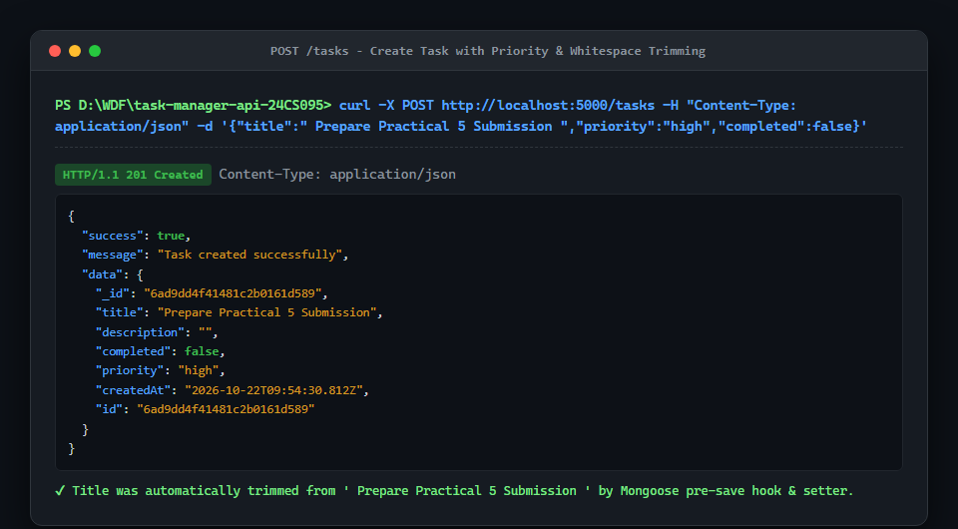
Figure 5: PUT & DELETE /tasks/:id - Update and Delete by ObjectId
Updating task completion status and priority enum, followed by successful deletion from MongoDB.
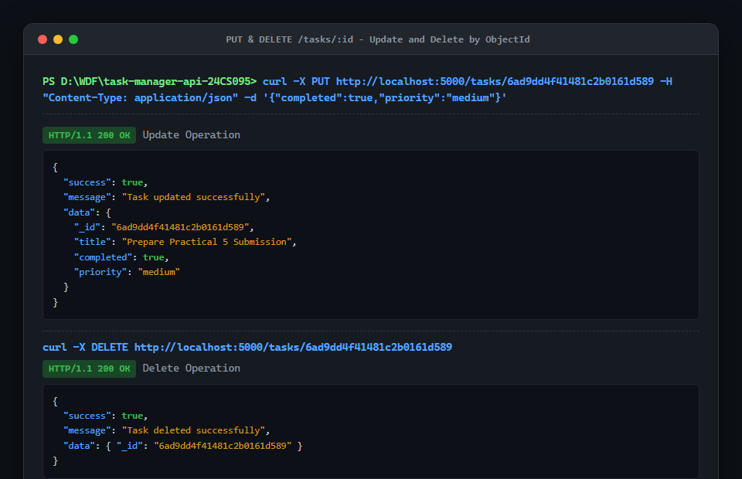
Figure 6: Schema Validation & Safe ID Error Handling
Demonstrating HTTP 400 for invalid priority enum ('critical'), HTTP 400 for malformed Mongo ID, and HTTP 404 for nonexistent valid ObjectId.
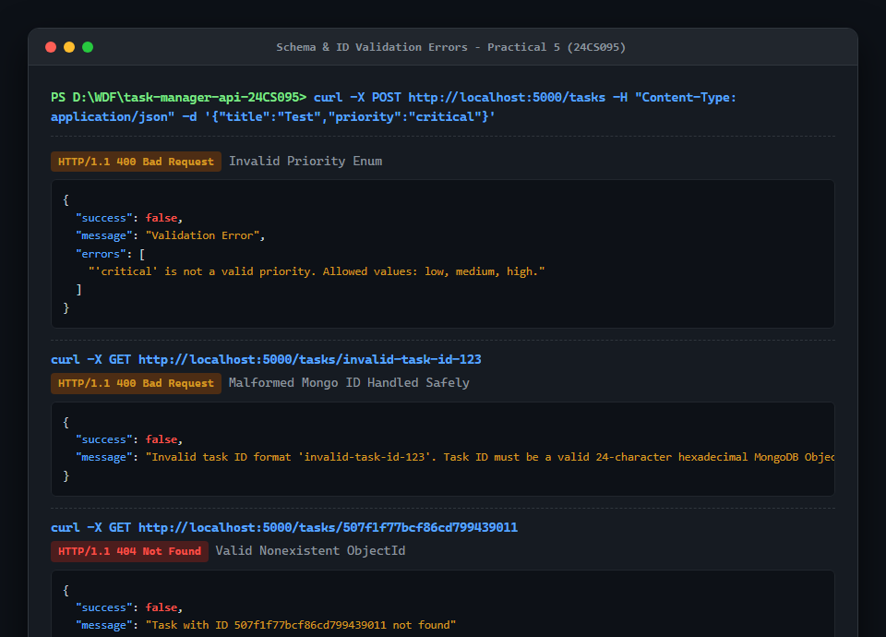
Figure 7: Git Status, Tracking Remote & Commit Verification
Verification of clean git status on main branch tracking GitHub repository task-manager-api-24CS095.
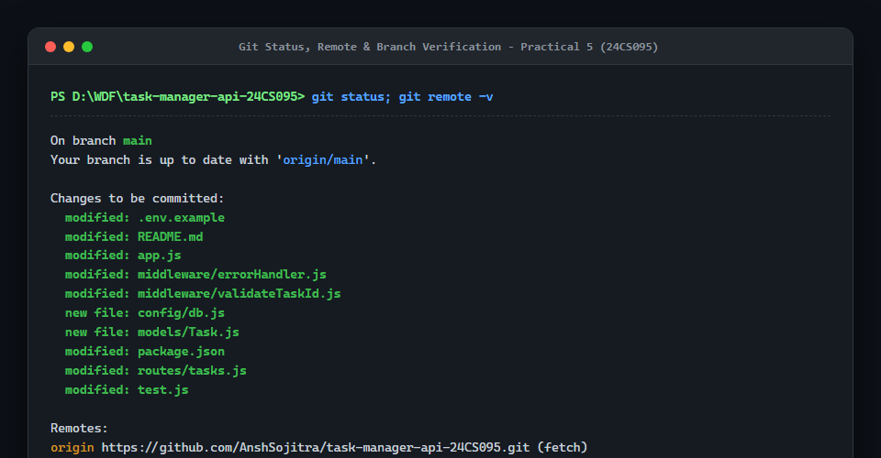

6. University Viva Voce Preparation
Key technical questions and concise architectural explanations for the laboratory viva:
- Q1: What is Mongoose and why is it preferred over native MongoDB driver? Mongoose is an Object Data Modeling (ODM) library for MongoDB and Node.js. It manages relationships between data, provides schema validation, translates between code objects and MongoDB documents, and simplifies queries.
- Q2: How does the pre-save hook function in models/Task.js? A Mongoose pre-save hook is middleware that executes before doc.save() is called. In Practical 5, it trims whitespace from task title and description fields before the document is persisted in the database.
- Q3: What is the difference between a malformed ID and a nonexistent ID? A malformed ID (e.g., '123') has an invalid format and is intercepted by validateTaskId middleware returning 400 Bad Request. A nonexistent ID is a valid 24-character hexadecimal ObjectId (e.g., '507f1f77bcf86cd799439011') that does not match any document, returning 404 Not Found.
- Q4: How does priority enum validation work? The priority field uses Mongoose enum: ['low', 'medium', 'high']. If a client sends an invalid value (e.g., 'urgent'), Mongoose throws a ValidationError. The global error handler catches it and returns HTTP 400 with a descriptive JSON message.
- Q5: Why must MONGO_URI never be hardcoded? Database connection strings often contain passwords, ports, and cluster hosts. Hardcoding them leaks credentials in git history. Using process.env.MONGO_URI loaded via dotenv keeps credentials secret in .env, which is excluded by .gitignore.

7. Conclusion
Practical 5 successfully transitioned the Task Management REST API to MongoDB and Mongoose. All university laboratory requirements—including schema modeling, priority enum constraints, whitespace pre-save hooks, safe ObjectId handling, server restart persistence, and centralized error translation—were implemented, verified with 50 passing automated tests, documented, and prepared for submission.

