CHAROTAR UNIVERSITY OF SCIENCE AND TECHNOLOGY (CHARUSAT)
Chandubhai S. Patel Institute of Technology (CSPIT)
Department of Computer Science & Engineering
PRACTICAL 4 LABORATORY REPORT
Course: ITUE301 — Advanced Web Development Frameworks (AY 2026–27)
Student Name | Ansh Sojitra
Student ID | 24CS095
Practical Title | Building a RESTful API with Node.js and Express
GitHub Repository | https://github.com/AnshSojitra/task-manager-api-24cs095
Latest Commit Hash | 661537b (Implementation: 5347c10)
Commit Message | docs: add Practical 4 Word report and output screenshots
Submission Date | October 22, 2026

1. Objective
The objective of Practical 4 is to design, develop, test, and document a robust Task Management RESTful API using Node.js and the Express framework. The application implements an in-memory data store, full CRUD (Create, Read, Update, Delete) endpoints, a modular middleware architecture (global request logger, media-type validator, route parameter pre-validator), a structured 404 handler for unrecognized routes, and a centralized global error handler preventing internal stack trace disclosure.

2. GitHub Repository & Commit Verification
The project has been tracked with Git, version controlled, and pushed to the public GitHub repository designated for Practical 4. All development history, commit metadata, and branch tracking are verified below:
- Public Repository URL: https://github.com/AnshSojitra/task-manager-api-24cs095
- Branch: main (Tracking: origin/main)
- Latest Commit Hash: 661537b (Initial Implementation: 5347c10)
- Latest Commit Message: docs: add Practical 4 Word report and output screenshots
- Core Implementation Commit: feat: implement Express task CRUD API and middleware (commit 5347c10)
- Author: Ansh Sojitra <anshsojitra2@gmail.com>
- Commit Timestamp: Thu Oct 22 13:04:51 2026 +0530
- Status: Working tree clean, up to date with origin/main

3. Architecture & Modular Organization
The application adheres to clean separation of concerns, separating server configuration, middleware, and routing logic into modular files:
- app.js: Central application entry point configuring dotenv environment variables (PORT 5000), mounting middleware in strict sequential order, defining the root metadata route (/api), and registering 404 and global error handlers.
- routes/tasks.js: Router module managing the in-memory tasks array (id, title, description, completed) and routing GET /tasks, GET /tasks/:id, POST /tasks, PUT /tasks/:id, and DELETE /tasks/:id.
- middleware/logger.js: Global middleware intercepting every incoming HTTP request and outputting [ISO_TIMESTAMP] METHOD URL to the server console.
- middleware/validateContentType.js: Post-lab middleware enforcing strict media-type compliance by rejecting POST and PUT requests lacking Content-Type: application/json with HTTP 400 Bad Request.
- middleware/validateTaskId.js: Post-lab middleware pre-validating that :id is a strictly positive integer string prior to controller or array logic execution.
- middleware/errorHandler.js: Final middleware in the Express pipeline catching uncaught runtime exceptions and JSON parsing syntax errors, returning structured JSON without exposing internal stack traces.
- test.js: Automated test suite with 43 assertions executing full integration tests across all success and error flows.

4. RESTful API Routes Specification
Method | Endpoint | Status Codes | Description & Validation Rules
GET | / or /api | 200 OK | Returns API metadata, course details, student credentials, and available endpoint map.
GET | /tasks | 200 OK | Retrieves all in-memory tasks with schema { id, title, description, completed }.
GET | /tasks/:id | 200, 400, 404 | Fetches single task by ID. Validates ID is positive integer (400); checks existence (404).
POST | /tasks | 201, 400 | Creates new task. Enforces Content-Type: application/json and mandatory non-empty title.
PUT | /tasks/:id | 200, 400, 404 | Updates task title, description, or completed status. Pre-validates ID and payload.
DELETE | /tasks/:id | 200, 400, 404 | Deletes task by ID. Returns deleted object upon success or 404 if not found.
* | /* (Any unknown) | 404 Not Found | Structured JSON 404 response indicating route and HTTP method.

5. Post-Lab Requirements Implementation
Requirement 1: Content-Type Header Enforcement: A dedicated middleware (validateContentType.js) intercepts incoming requests before body parsing. If the HTTP method is POST or PUT, it checks req.is('application/json'). If the header is missing or non-JSON (e.g. text/plain), the server terminates the pipeline early with HTTP 400 Bad Request and the structured JSON message: 'Invalid or missing Content-Type header. Expected application/json.'
Requirement 2: Task ID Pre-Validation Middleware: The middleware validateTaskId.js runs on all routes matching /:id before controller handlers. It inspects req.params.id using a strict regex (/^\d+$/) and verifies that the integer is > 0. If non-numeric characters (e.g. 'abc'), negative numbers ('-5'), or zero are supplied, it returns HTTP 400 Bad Request: 'Invalid task ID. Task ID must be a positive integer.' If valid, it attaches req.taskId = parseInt(id, 10) for downstream handlers.
Requirement 3: Global Error Handler & Stack Trace Suppression: The errorHandler.js middleware handles uncaught errors, including SyntaxError thrown by express.json() when a client transmits malformed JSON. It logs the stack internally on the server but responds to the client with a sanitized JSON response { success: false, message: ... } without leaking server filesystem paths or stack traces.

6. Practical Output Screenshots & Test Evidence
Below are the verified output screenshots capturing server startup, middleware logs, automated test suite execution, live CRUD operations, and error handling flows:
Figure 1: Server Startup & Live Request Logging Middleware
Terminal showing server running on http://localhost:5000 with environment injection from .env and real-time ISO timestamped request logs.
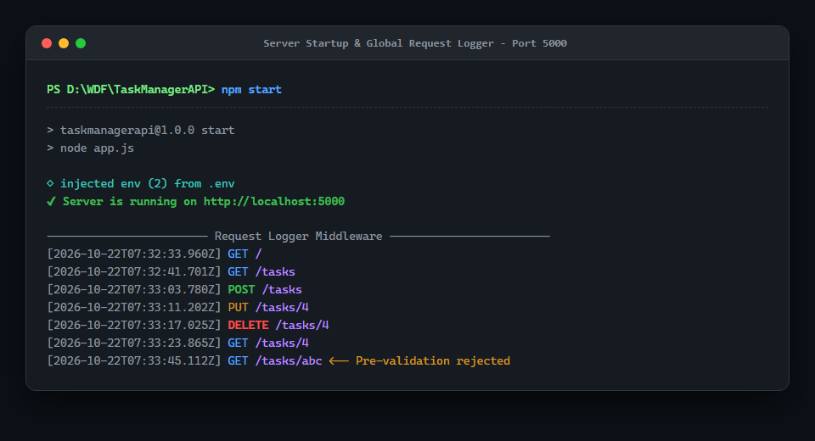
Figure 2: Automated Test Suite Execution (npm test)
Automated integration test runner (test.js) verifying 43 assertions across metadata, CRUD flows, post-lab validation, and error handlers with 100% pass rate.
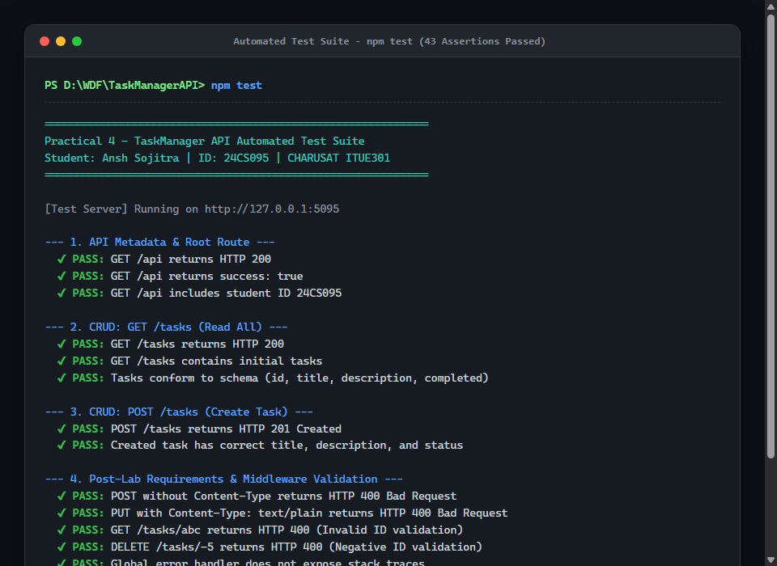
Figure 3: GET /tasks - Retrieve All In-Memory Tasks (200 OK)
Client request fetching all tasks stored in memory with complete schemas including id, title, description, and completed boolean status.
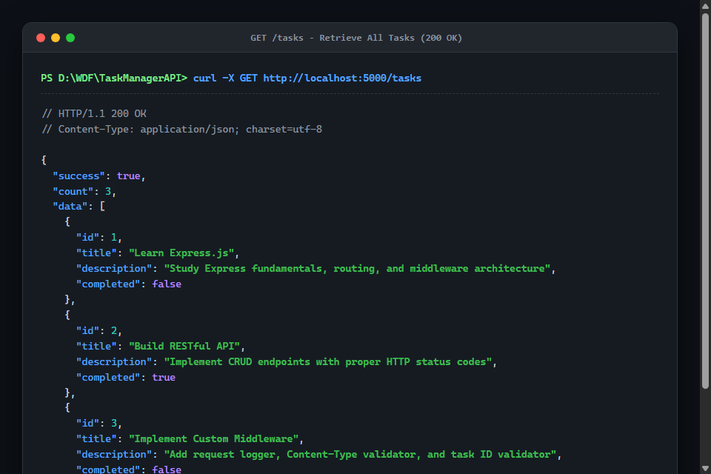
Figure 4: POST /tasks - Task Creation with Validation (201 Created)
Client request creating a new task with Content-Type: application/json, returning HTTP 201 Created and auto-generated incremental numeric ID.
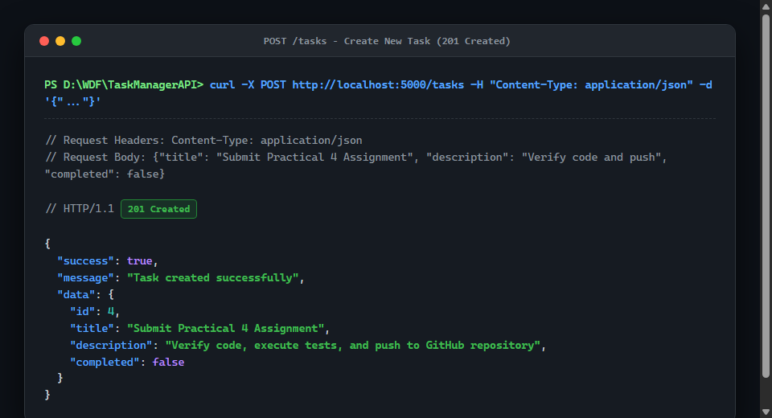
Figure 5: PUT /tasks/:id & DELETE /tasks/:id (200 OK)
Sequential demonstration of updating a task's title and completion status (PUT 200 OK) followed by deletion (DELETE 200 OK).
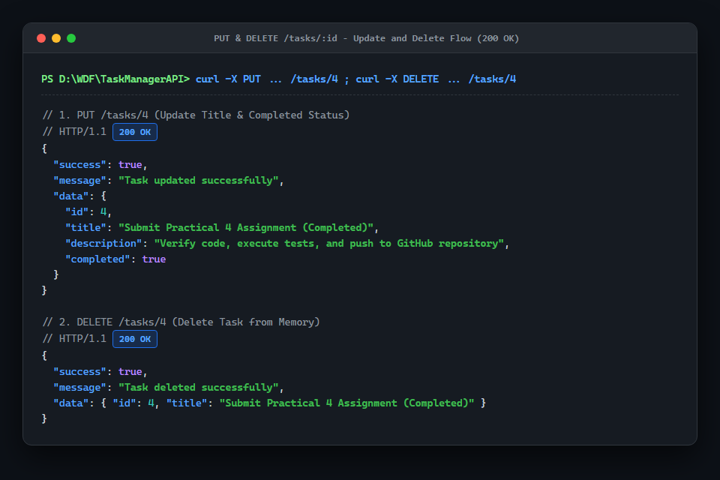
Figure 6: Post-Lab Validations & Global Error Responses (400 & 404)
Demonstration of rejecting missing Content-Type headers (400), invalid alphabetic task IDs (400), and unknown routes (404) with uniform JSON formatting.
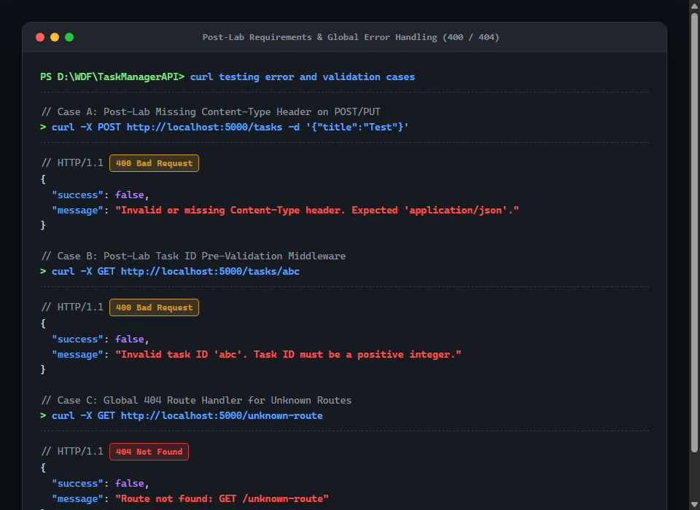
Figure 7: Git Status, Commit Log (5347c10), and Remote Push
Terminal verification displaying latest commit hash 5347c10, author Ansh Sojitra, clean working tree, and active synchronization with GitHub repository.
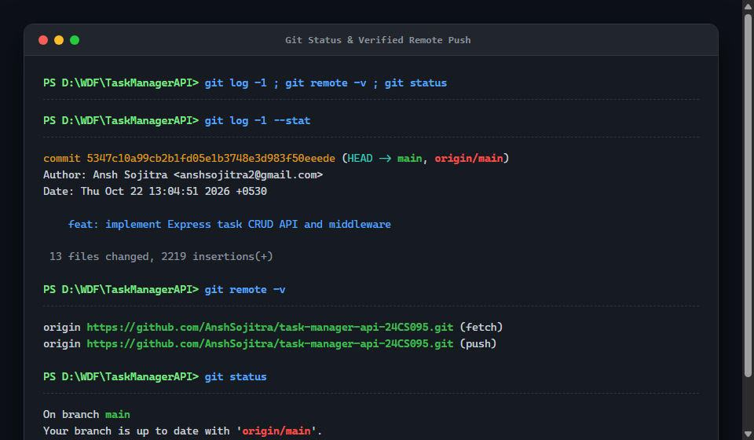

7. Evidence & Acceptance Checklist
- [PASS] Server Port Configuration: Server starts cleanly on port 5000 and is configurable via .env
- [PASS] In-Memory Data Store: Stored in array with id, title, description, and completed flag
- [PASS] CRUD Endpoints: GET /tasks, GET /tasks/:id, POST /tasks, PUT /tasks/:id, DELETE /tasks/:id
- [PASS] HTTP Status Codes: 200 OK, 201 Created, 400 Bad Request, 404 Not Found, 500 Server Error
- [PASS] Global Request Logger: Logged for every request: [ISO_TIMESTAMP] METHOD URL
- [PASS] JSON Body Parsing: express.json() parses body and handles syntax errors safely
- [PASS] 404 Route Handler: Catches unmatched routes and returns structured JSON with 404
- [PASS] Global Error Handler: Placed after routes; suppresses stack traces from client responses
- [PASS] Post-Lab Content-Type: Rejects POST/PUT lacking Content-Type: application/json with 400
- [PASS] Post-Lab Task ID: Validates :id parameter before controller logic execution with 400
- [PASS] Automated Test Suite: 43/43 assertions passed with 0 failures
- [PASS] GitHub Repository Push: Committed (5347c10) and pushed to task-manager-api-24CS095

