# Name of experiment - Dynamic simulation of drone (unmanned air vehicle) through MATLAB/SIMULINK

**Aim** – To study the dynamic simulation of 2D drone model in MATLAB Simulink.

**Software required** – MATLAB Simulink

**Procedure** – First obtain the mathematical model of a generic 2D drone, which is as follows,

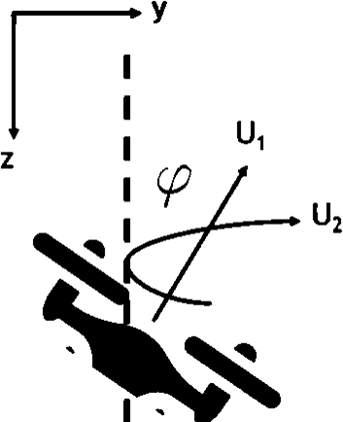𝑧¨ = 𝑔 −

𝑢1

𝑚

cos 𝜙

𝑦¨ =

𝑢1

𝑚

sin 𝜙

𝑢2

Figure 1 – 2D drone

𝜙¨ =

𝐼𝑥𝑥

Where 𝑢1and 𝑢2 are force and moment inputs. And the figure shows the usual co-ordinates and the Euler angles. Take *g* = 9.81m/s2, *m* = 0.2 kg and 𝐼𝑥𝑥 = 0.1 kgm2

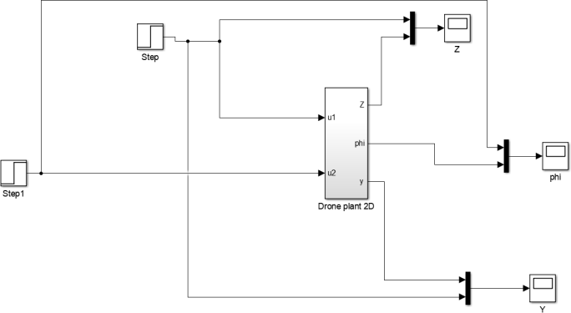

Figure 2 – Uncontrolled 2D drone plant in MATLAB Simulink

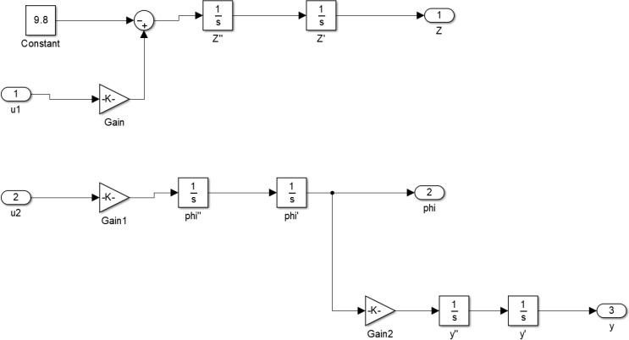

Figure 3 – Subsystem model

Make the Simulink model for the above mathematical 2D drone.

Give the step inputs to the force and moments and observe the transient responses of the z, y and the angle 𝜙.

Once the uncontrolled 2D drone plant is ready, a suitable PID controller can be designed to control the drone with step inputs (as shown in Figure 4).

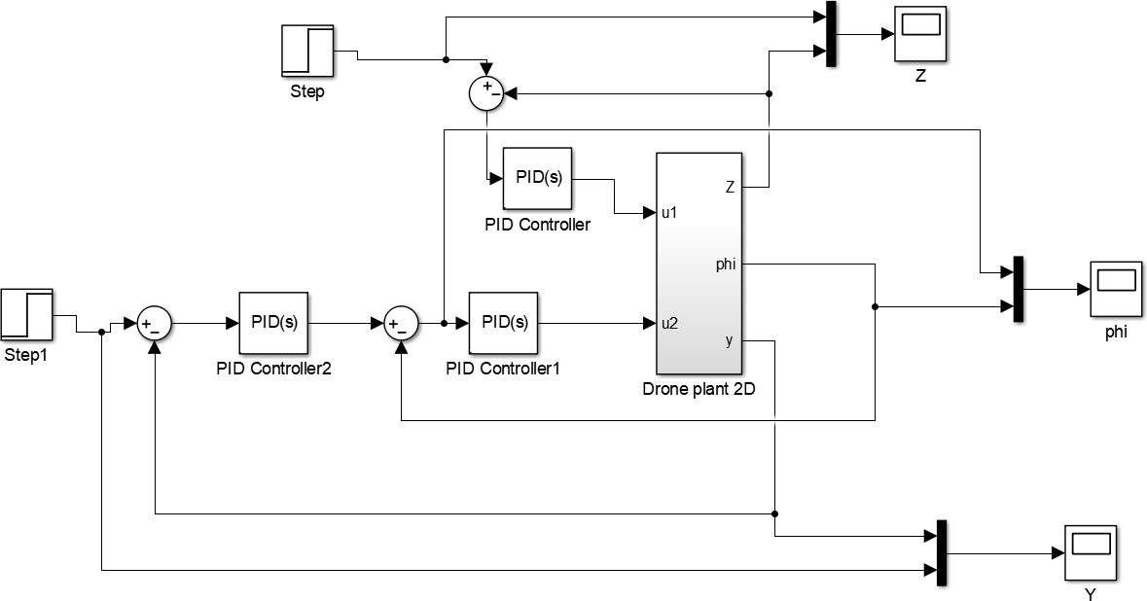

Figure 4 – Controlled 2D drone plant in MATLAB Simulink

# Uncontrolled 2D Drone Plant:

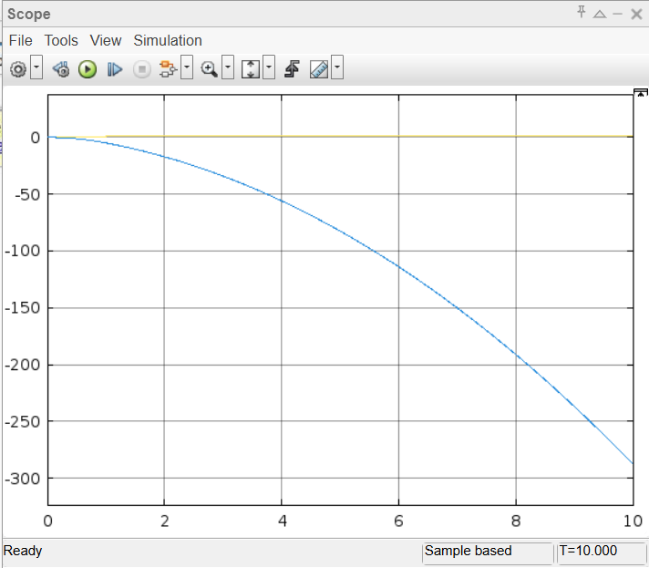

This graph shows u1 vs z. It shows that with increase in the force u1, the value of z decreases. Thus, the drone moves upwards.

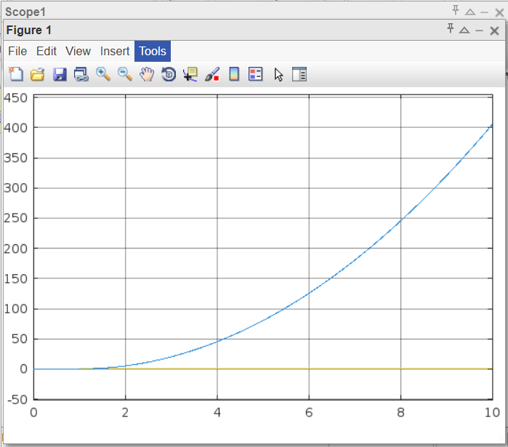

This graphs is for u2 vs phi. It shows that with increase in the torque u2, the value of phi increases.

Thus, the drone rotates.

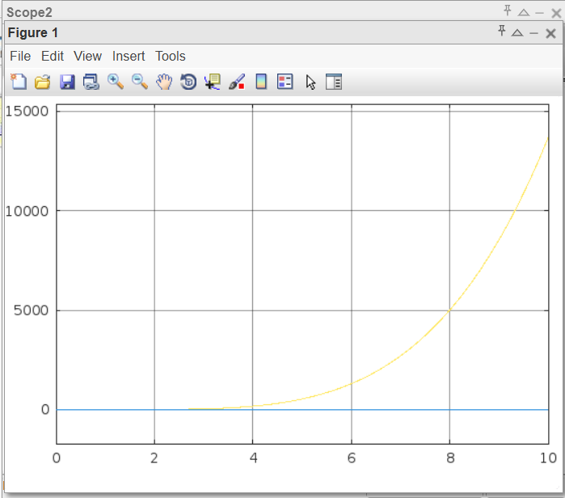

This graphs is for u1 vs y. It shows that with increase in the force u1, the value of y increases. Thus, the drone moves in the right direction.

# Controlled 2D Drone Plant:

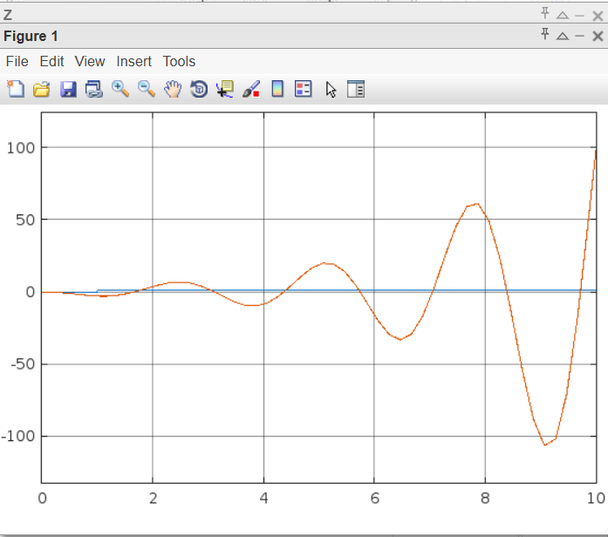

This graph shows the vertical position of the drone over time when a PID controller is applied to regulate altitude using force u1

. 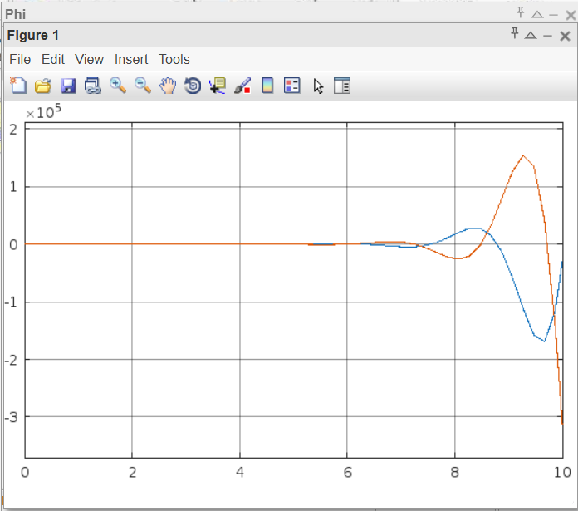

This graph depicts the angular position of the drone with a PID controller maintaining its stability

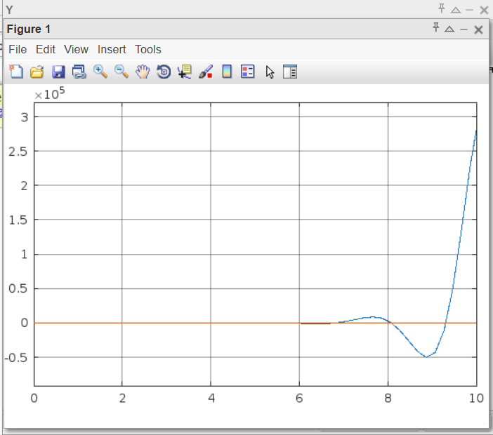

This graph depicts the horizontal position over time with the PID controller stabilizing y through proper force and moment inputs