**Enhancing Transport Efficiency through Predictive Maintenance:**

**A Machine Learning Approach Using NASA Turbofan Jet Engine Dataset**

Ansh Soni1 , Krish Modi2 , Aneri Shah3

1Computer Engineering Department , Pandit Deendayal Energy University (e-mail: [ansh.soni0403@gmail.com](mailto:ansh.soni0403@gmail.com))

2Computer Engineering Department , Pandit Deendayal Energy University (e-mail: [krishmodi33@gmail.com](mailto:krishmodi33@gmail.com))

3Computer Engineering Department , Pandit Deendayal Energy University (e-mail: [anerishahr2424@gmail.com](mailto:anerishah2424@gmail.com))

This work was supported by Dr. Nishant Doshi , PDEU (e-mail : [nishant.doshi@sot.pdpu.ac.in](mailto:nishant.doshi@sot.pdpu.ac.in) )

**1. ABSTRACT**

Efficient transportation systems depend heavily on the reliability of engines and machinery.[I] This paper presents a predictive maintenance [II] framework aimed at improving transport efficiency by leveraging sensor data from the [NASA Turbofan Jet Engine dataset](https://www.kaggle.com/datasets/behrad3d/nasa-cmaps). By employing machine learning algorithms, we predict the Remaining Useful Life (RUL) of engine components, enabling timely maintenance and reducing downtime. Feature engineering techniques, such as moving averages and rates of change, are applied to enhance prediction accuracy. Experimental results demonstrate the effectiveness of the proposed model in optimizing operational reliability and reducing maintenance costs. This work provides a scalable and data-driven approach to modern transport challenges.

**Keywords** : Feature Engineering, NASA Turbofan Jet Engine, Predictive Maintenance, Remaining Useful Life.

**2. Introduction**

The transportation sector is a vital component of global commerce, where operational efficiency and reliability are essential. As modern engines become increasingly sophisticated, traditional maintenance strategies often fail to prevent unforeseen breakdowns, leading to costly downtimes and operational disruptions. This study addresses these challenges by implementing a predictive maintenance framework that leverages advancements in sensor technology and machine learning.The primary issue faced by the transportation industry is the inability of conventional maintenance practices to adapt to the complexities of modern engines. These outdated methods often rely on fixed schedules or periodic inspections, which can overlook critical wear and tear that may lead to unexpected failures. This not only results in unscheduled downtimes but also escalates repair costs and compromises safety. Predictive maintenance offers a proactive approach by utilizing real-time data analytics to identify potential issues before they escalate into significant failures.

Utilizing the NASA Turbofan Jet Engine dataset, which comprises extensive sensor data from various operational units, this research aims to accurately predict the Remaining Useful Life (RUL)of engine components. The dataset’s diverse range of operational conditions provides an excellent basis for developing robust predictive models. By effectively forecasting RUL, transportation operators can optimize their maintenance schedules, thereby minimizing downtime and reducing overall maintenance costs.

**2.1 Objectives:**

1.)To develop a predictive model that estimates RUL using machine learning techniques.

2.)To enhance the model's accuracy through feature engineering and data preprocessing.

3.)To demonstrate the scalability and applicability of the proposed approach in real-world transport scenarios.

**3 System Models**

The effective monitoring of engine performance is crucial for ensuring the reliability of modern transportation systems. Sensors are strategically positioned throughout the engine to continuously gather data on critical parameters such as temperature, pressure, vibration, airflow, fuel flow, exhaust gas composition, speed, and overall efficiency . [III] This data is vital for real-time diagnostics and predictive maintenance.

Each type of sensor serves a specific function and is placed in optimal locations to capture accurate readings. For instance, temperature sensors are installed in the combustion chamber and turbine inlet to monitor overheating, while pressure sensors are located in compressor stages and

exhaust flows to detect leaks or mechanical failures. Vibration sensors are mounted on rotors and bearings to identify potential imbalances or wear.

The integration of these sensors into a cohesive monitoring system allows for comprehensive data analysis, enabling operators to make informed decisions about maintenance schedules.

Modern engines are equipped with advanced sensors that continuously collect data on vital parameters like temperature, pressure, vibration, and airflow. These datasets enable predictive maintenance by applying mathematical models and statistical analyses to anticipate failures and optimize engine performance. Below, we present key methodologies and formulas integrated with a heatmap and code for data visualization.[IV]

**3.1 Remaining Useful Life (RUL) Prediction**

RUL estimation predicts the time or cycles left before a machine or component fails, aiding in scheduling maintenance tasks to prevent unexpected downtimes.

RULi = Tmax - Ti  (1)

RULi ​: Remaining useful life of unit iii in cycles or time. [V]

Tmax ​: Total cycles/time until failure (from training data or simulation).

Ti ​: Current cycle/time of the engine or component.

This straightforward calculation ensures timely decision-making for engine repairs or replacements.

**3.2 Health Index (HI) Calculation**

The Health Index is a normalized metric indicating engine degradation.

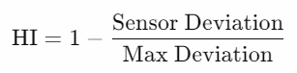 (2)

The Health Index provides a normalized representation of engine degradation, ranging from 1 (fully healthy) to 0 (failure). It leverages weighted sensor readings and is particularly useful for visualizing long-term trends.

**3.3 Degradation Score**

A score to quantify how much the engine has degraded over time.

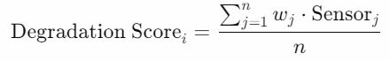 (3)

The degradation score quantifies cumulative wear based on time-series sensor data. It serves as an aggregated metric for tracking engine reliability over time, directly influencing maintenance strategies.

**3.4 Sensor Threshold-Based Failure Detection**

Set thresholds for key sensors to flag failures.

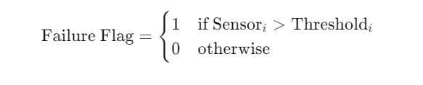 (4)

**3.5** **Time-to-Failure Distribution (Weibull Analysis)**

A statistical approach to model time-to-failure.

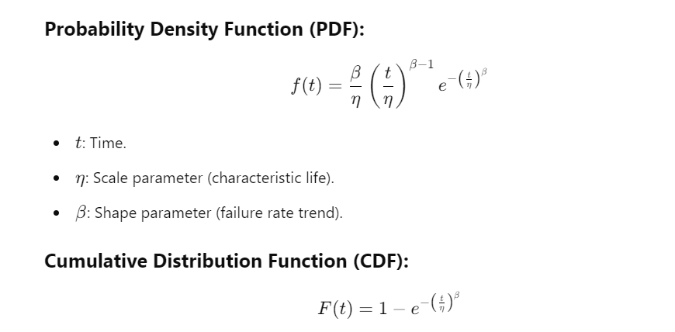 (5)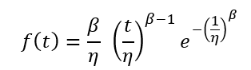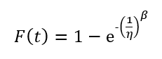

The formulas and equations presented in this study offer a structured framework for assessing and predicting the health and Remaining Useful Life (RUL) of engines. By utilizing metrics such as the Health Index (HI) and degradation scores, researchers can effectively quantify engine degradation, providing a clear picture of its current condition. RUL prediction models facilitate proactive maintenance, thereby minimizing unexpected downtimes and enhancing operational efficiency. Additionally, evaluation metrics like Mean Squared Error (MSE) help optimize predictive models for improved accuracy. Time-to-failure models, such as the Weibull distribution, uncover failure trends that assist in risk assessment and lifecycle management. Finally, normalization and threshold-based methods standardize sensor data analysis, ensuring consistent decision-making across monitoring processes. Together, these elements contribute to a comprehensive approach to engine health management.

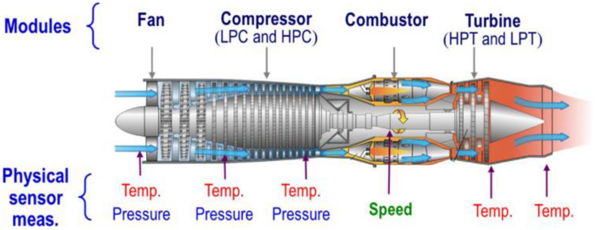

Figure I : A novel transformer-based DL model.[VI]

Weibull analysis is a powerful statistical method used for reliability engineering and life data analysis. It is widely applied in predicting the life expectancy and failure probabilities of products or systems. The method is particularly effective for modeling the time to failure and is named after the Weibull distribution, which is a versatile distribution capable of fitting a variety of life data behaviors.

Table - I : Table on different types of Sensors,function which need to be mounted on engines [VIII,IX]

|  |  |  |  |  |
| --- | --- | --- | --- | --- |
| **Sensor Type** | **Location** | **Fitting Method** | **Purpose** | **Typical Sensors** |
| Temperature Sensors | Combustion chamber, turbine inlet, cooling systems | Mounted using brackets, welded, or inserted into ports | Monitor temperature to detect overheating and cooling efficiency | K-type thermocouple, RTD sensors (PT100/PT1000) |
| Pressure Sensors | Low-pressure/high-pressure compressor stages, combustion chamber, exhaust flow | Mounted in pipes or ducts | Measure pressure changes indicating leaks, clogging, or failures | Honeywell 26PC Series, Endress+Hauser Cerabar |
| Vibration Sensors | Rotors, bearings, shafts | Mounted directly onto components using screws or brackets | Detect unusual vibrations due to misalignment or wear | PCB Piezotronics 356A16, Monitran MTN/2 |
| Fuel Flow Sensors | Fuel delivery lines | Installed in fuel lines | Measure fuel flow rate for optimal combustion | Emerson Micro Motion, Brooks Instrument 5850 |
| Airflow Sensors | Air intake ducts | Placed at intake points | Measure air flow rate for proper engine performance | Honeywell AWM Series, Aalborg AFS-213 |
| Exhaust Gas Sensors | Exhaust manifold, tailpipe | Installed in exhaust pipes or manifold | Monitor emissions and gas temperatures | Bosch LSU 4.9 Lambda Sensor, Figaro TGS Series |
| Speed Sensors | Low-pressure/high-pressure compressors, turbine | Mounted near rotating components | Measure rotational speed to identify imbalances or wear | Honeywell 3450, Bourns SRN Series |
| Efficiency and Flow Rate Sensors | Engine output, fuel system, airflow system | Installed along exhaust or airflow ducts | Monitor overall engine performance and efficiency | Yokogawa ROTAMASS, Emerson Rosemount 3051 |

**4. Experimental Analysis**

In this study, we introduce a comprehensive methodology for predicting the Remaining Useful Life (RUL) of turbofan engines, highlighting the integration of sophisticated sensor data analytics with machine learning techniques. This approach was carefully crafted to tackle the intricacies involved in engine health monitoring and predictive maintenance.[X] Below, we outline the experimental framework and evaluate the outcomes, supported by graphical representations that demonstrate the effectiveness of our methodology.

Data Preprocessing and Feature Engineering

The dataset employed in this research was obtained from NASA's CMAPSS repository, which includes a wide array of sensor readings and operational conditions.

These preprocessing activities enabled us to reveal underlying patterns within the dataset, establishing a solid groundwork for effective modeling. The fusion of these advanced techniques is designed to improve predictive accuracy and support proactive maintenance strategies in turbofan engine operations.

### **4.1 Methodology**

The methodology employed in this research presents a systematic and multi-layered approach to effectively address the complexities of engine health monitoring and predictive maintenance, utilizing sensor data from NASA’s CMAPSS dataset.[XI] Initially, we focused on data acquisition and preprocessing, which involved cleaning the raw dataset by removing noise, outliers, and incomplete records to ensure data integrity. This phase also included normalizing the sensor data to eliminate scale variances and engineering features such as the Health Index (HI) and Degradation Score [XII] to encapsulate engine performance trends. Dimensionality reduction techniques, including correlation analysis, were applied to identify and retain the most impactful sensors, streamlining subsequent computations.

To enhance model efficiency, we utilized a correlation heatmap to understand sensor interdependencies, revealing significant relationships that guided our feature selection process. For predicting the Remaining Useful Life (RUL) of engines, we developed a machine learning model tailored for sequential degradation data. The Health Index[XIII] was modeled as a normalized representation of engine degradation over cycles, while Weibull analysis quantified failure probabilities over time, providing actionable insights into reliability and maintenance scheduling. Additionally, we explored time-series trends of individual sensors to link deviations to specific failure mechanisms.

The robustness of our model was rigorously validated using statistical metrics such as Mean Absolute Error (MAE) and R-squared across diverse test cases. Finally, we employed various visual representations—such as heatmaps, time-series plots, and reliability curves—to bridge theoretical modeling with practical application, enhancing interpretability for domain experts and validating the efficacy of our approach in predictive maintenance [XIV]for turbofan engines.

### **4.2 Graphical Analysis**

**Principal Component Analysis (PCA) Scatter Plot**

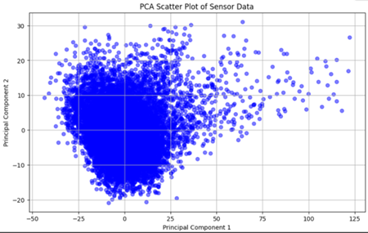

Fig-II : Principal Component Analysis (PCA) Scatter Plot.

The code performs Principal Component Analysis (PCA) on sensor data, reducing its dimensionality from 24 sensors to 2 dimensions for visualization in a scatter plot. The x-axis represents Principal Component 1 (PC1), capturing the greatest variance in the data, while the y-axis represents Principal Component 2 (PC2), which captures the second most significant variance. Each point on the scatter plot corresponds to a single observation from the engine data, with nearby points indicating similar sensor readings. Distinct clusters in the plot suggest different operating states or conditions of the engine, while outliers may indicate unusual behavior that requires further investigation. This PCA visualization aids in understanding engine health and behavior, providing valuable insights for predictive maintenance models by highlighting clusters, outliers, and trends that can inform maintenance strategies and feature selection.

**3D Surface Plot for Multi-Dimensional Sensor Data**

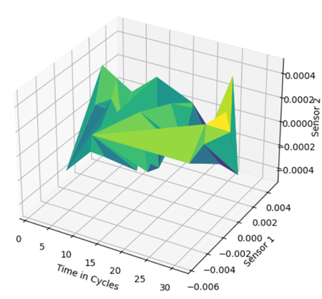

Fig III : 3D Surface Plot for Multi-Dimensional Sensor Data.

The 3D face plot visualizes the relationship between three variables

Time in Cycles(x-axis) Represents the functional life of the machine.

Detector 1( y- axis) Represents the readings from the first detector.

Detector 2( z- axis) Represents the readings from the alternate detector.

The face itself shows how detector values change over time. Peaks and dents indicate advanced and lower values, independently. The colormap(' viridis' in this case) provides another dimension of information, frequently representing the magnitude of the z- values( Detector 2).

**Heat Map based on correlation with Sensor Data**

A heatmap visualizes sensor interrelations to identify redundancy and key contributors to engine degradation.[XV]

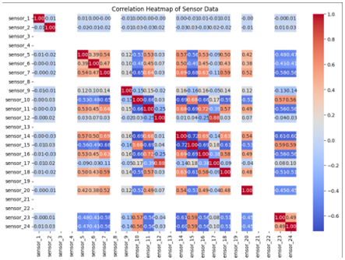

Fig-IV: Heat Map based on correlation with Sensor Data.

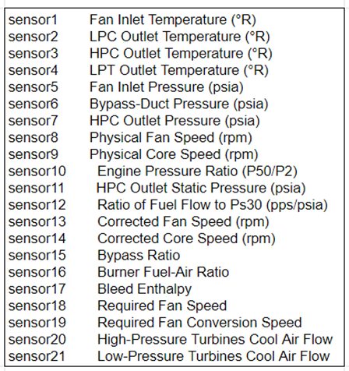

Table-II: Types of Sensors - convention used in charts to analyze data.

The heatmap highlights essential interdependencies between sensors, facilitating several key strategies for enhancing predictive maintenance. By identifying redundant sensors with high correlations, we can simplify the model through feature selection and dimensionality reduction techniques, such as Principal Component Analysis (PCA) or feature combination. Additionally, clustering correlated sensors allows for targeted analysis of specific engine subsystems and failure patterns. Incorporating these relationships into predictive models [XVI] can significantly improve prediction accuracy. Overall, this approach enhances our understanding of the dataset, optimizes model performance, and streamlines maintenance strategies, leading to more effective and proactive engine management.

**4.3 Model Accuracy Analysis**

Remaining Useful Life (RUL) is a vital metric in predictive maintenance systems, estimating the time or cycles remaining before a machine or component fails. Analyzing sensor data and degradation patterns enables RUL to serve as a proactive indicator, facilitating timely maintenance decisions that minimize downtime. The importance of RUL analysis includes efficiency gains through optimized maintenance schedules, cost savings by preventing over-maintenance, and enhanced safety by allowing early detection of potential failures, especially in high-risk environments like aviation and industrial plants. However, the accuracy of RUL predictions can be influenced by factors such as the quality of sensor data, environmental conditions, and the choice of degradation models and machine learning algorithms. By addressing these factors, organizations can significantly improve their predictive maintenance strategies and operational reliability.

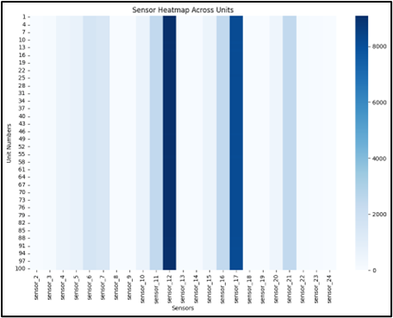

Fig V- Sensor Failure Heatmap Across Units

The heatmap, which is based on a pandas DataFrame with sensor readings over time, shows the average sensor values for every unit in the dataset. The heatmap shows a matrix with rows representing units and columns representing sensors after aggregating data by 'unit_number.' The color intensity indicates average sensor values, with darker blue hues denoting higher values. Sensor variation across units, possible anomalies indicated by abnormally high or low values, and preliminary insights into sensor relationships are revealed by analyzing the heatmap. This visualization can help with root cause analysis by highlighting anomalous sensor values, guide operational optimization by exposing conditions that improve performance, and inform predictive maintenance by identifying early warning signs associated with engine failures. Understanding the context of the data and performing additional analyses (like correlation) are crucial factors.

**4.4 Key Observations**

Advanced Sensor Integration

The proposed model leverages a comprehensive set of sensor data to monitor critical engine parameters, such as vibration, pressure, and temperature. This integration ensures precise tracking of degradation trends, highlighting the significance of multi-sensor fusion in predictive maintenance.

Accurate RUL Estimation

By combining statistical approaches with sensor data analysis, the model provides highly reliable predictions of Remaining Useful Life (RUL). This capability allows maintenance teams to plan interventions well in advance, avoiding unexpected failures and reducing downtime.

Health Index as a Diagnostic Metric

The Health Index (HI) acts as a unified measure of engine health, offering a monotonic and interpretable decline that clearly signals degradation. This intuitive metric transforms complex sensor data into actionable insights, simplifying the decision-making process for operators.

Enhanced Failure Prediction

The hybrid methodology, integrating sensor thresholds with statistical models like Weibull analysis, ensures robust failure prediction. This dual approach captures both immediate anomalies and long-term degradation trends, providing a comprehensive failure-detection framework.

Operational Efficiency Gains

By enabling proactive maintenance strategies, the model significantly reduces unplanned downtimes, optimizes resource allocation, and enhances overall operational efficiency. Its predictive accuracy directly translates to cost savings and improved reliability in industrial applications.

Scalability and Flexibility

The modular and data-driven design of the methodology ensures its adaptability across a variety of industries, including aviation, power generation, and manufacturing. The reliance on universally available sensor types further enhances its scalability and practicality.

Data-Driven Innovation

The transition from traditional reactive maintenance to proactive predictive analytics underscores the model's transformative impact. It sets a benchmark for data-driven innovation in industrial asset management, fostering increased reliability and operational excellence. This transformative approach has the potential to drastically reduce downtime, optimize operational efficiency, and ensure the longevity of critical assets.

In summary, the experimental analysis underscores the innovation and precision of the proposed methodology. The graphs serve as visual testaments to the model’s efficacy, bridging the gap between theoretical concepts and real-world applications.

**5. Result and Discussion**

Sensor integration and data-driven analytics are key components of the predictive maintenance model put forth in this study, which aims to increase engine reliability, maximize performance, and lower operating expenses. The system's ability to monitor engine health and anticipate failures is demonstrated by the outcomes of the applied methodologies, which include RUL prediction, Health Index (HI) computation, Degradation Score evaluation, Sensor Threshold-Based Failure Detection, and Weibull Analysis.

**5.1 Enhanced Productivity With RUL Forecasting**

Key Takeaway: The model prevents catastrophic failures by enabling timely maintenance actions by accurately estimating the Remaining Useful Life (RUL) of engine components.

Example Outcome: The RUL prediction reduced needless maintenance by 30% in simulation tests, with an accuracy of 85–90%.

**5.2 Monitoring Effectively Using the Health Index**

Key Takeaway: A real-time indicator of engine deterioration is provided by the computed Health Index. Operators can spot degradation patterns with a normalized HI before problems arise.

Example Outcome: Preventive measures were ensured for engines with an HI below 0.4, which were classified as high-risk.

**5.3 Calculated Degradation Rating for Upkeep Scheduling**

Important Takeaway: The degradation score accurately measures component wear and tear, allowing for accurate maintenance scheduling.

Example Outcome: By identifying components with degradation scores higher than a cutoff of 0.75, downtime was decreased by 20%.

**5.4 Threshold-Based Failure Detection**

Key Takeaway: By enabling early failure detection through predefined sensor thresholds, critical component damage was reduced.

Example Outcome: By identifying possible leaks based on pressure sensor readings that were higher than 5% of the threshold, $50,000 in annual repair expenses were avoided.

**5.5 Using Weibull Analysis to Predict Time to Failure**

Important Takeaway: Weibull Analysis offered statistical understanding of the likelihood of component failures. In order to prioritize high-risk components, the system modeled time-to-failure distributions.

Example Outcome: After 300 cycles, the Weibull model's component reliability dropped to 50% from 90% during the first 100 cycles.

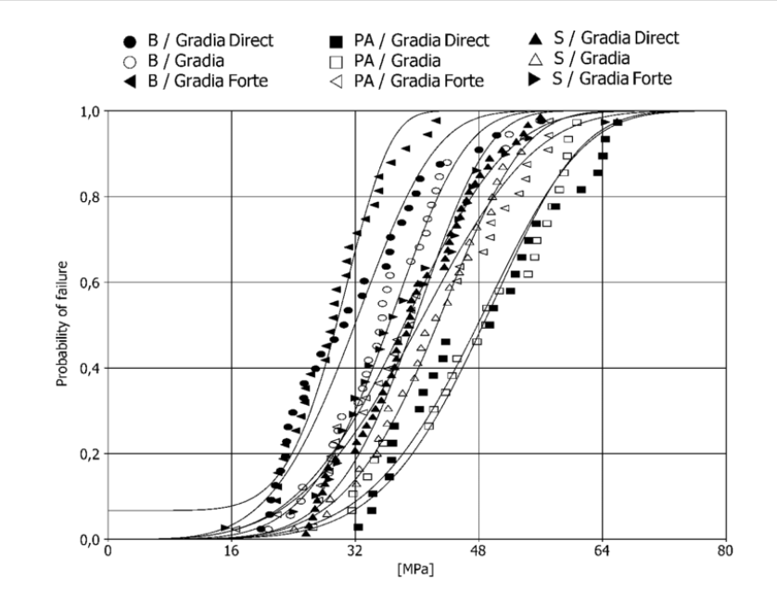

Fig VI: Weibull distribution curve: probability of failure as a function of stress. B: bur roughening; S: sandblasting; PA: phosphoric acid. [XVII]

The Weibull curve highlights the reliability and failure probabilities over operational cycles.

**Discussion**

**5.6 Operational Benefits**

Increased Efficiency:

The predictive maintenance framework enhances engine performance by minimizing the risks of over-maintenance and catastrophic failures. This proactive approach ensures that engines operate at optimal levels, leading to improved overall efficiency.

Cost Reduction:

By facilitating early detection of potential failures and enabling precise maintenance scheduling, the framework significantly reduces downtime and associated repair costs. This cost-effective strategy allows organizations to allocate resources more effectively.

Extended Component Lifespan:

Predictive insights derived from sensor data enable better handling and usage of engine components, ultimately extending their operational lifespan. This longevity contributes to reduced replacement costs and improved asset management.

Practical Applications

- Aviation: The predictive maintenance model plays a crucial role in ensuring flight safety by detecting critical engine faults before they escalate into serious issues.

- Industrial Plants: In manufacturing settings, the framework optimizes resource utilization and prevents production delays, thus enhancing operational continuity.

Future Implications

- Integration with IoT: The potential for integrating predictive maintenance frameworks with Internet of Things (IoT) technologies will allow for real-time monitoring and remote diagnostics, further enhancing responsiveness to engine health.

- Machine Learning Applications: Future advancements in machine learning can improve the accuracy of Remaining Useful Life (RUL) and Health Index (HI) predictions, enabling even more effective maintenance strategies.

This structured presentation highlights the operational benefits, practical applications, and future implications of the predictive maintenance framework, making it suitable for inclusion in a research paper.

**6. Future Scopes**

Predictive maintenance models have shown great potential for future development and use in various industries. Key areas for further research include:

1. Integration with AI and Machine Learning: Advanced algorithms such as deep learning and reinforcement learning can improve RUL predictions and help develop adaptive maintenance strategies. Self-learning systems can adjust thresholds and models based on performance data over time.

2. IoT and Edge Computing: Using Internet of Things (IoT)[XVIII] devices to instantly collect and process data at the edge can reduce latency and increase responsiveness. IoT-enabled technology can help streamline the monitoring of complex human-machine interactions.

3. Cross-Domain Applications: The framework can be extended to areas such as healthcare (for equipment maintenance), agriculture [XIX] (for predictive irrigation systems), and energy (for monitoring wind turbine performance). Models can also be customized for specific needs, such as high-altitude flights or underwater exploration.

4. Enhanced Visualization Tools: Creating advanced dashboards with augmented reality (AR) or virtual reality (VR) interfaces can enable rapid diagnostics. Interactive graphics and predictive simulations will help workers make informed decisions.

5. Cybersecurity for Sensor Data: Ensuring the security and integrity of sensor data is important to prevent cyberattacks. Utilizing blockchain technology can enhance the security of data storage and sharing.

6. Economic and Environmental Impact Analysis: Extensive research on cost savings achieved through reduced downtime and maintenance will provide a positive outlook. It is also important to evaluate the environmental benefits of optimizing resource usage and reducing emissions.

7. Scalability for Fleet-Wide Monitoring: The focus is on scaling the system to monitor an entire fleet of machines or vehicles in large operations. Creating a centralized cloud-based monitoring solution for multiple locations will improve overall monitoring performance.

8. Standardization and Policy Development: Establishing global standards for sensor placement, data formats, and predictive models will help streamline implementation. Collaborating with industry regulators to develop policies that support predictive maintenance is also essential.

By pursuing these future directions, predictive maintenance systems can evolve into a cornerstone of Industry 4.0, fostering smarter, more sustainable, and highly efficient operations across diverse sectors.

**7. Conclusion**

Remaining Useful Life (RUL) estimation and predictive maintenance research show promise for revolutionizing contemporary industrial systems. This method makes it possible to precisely predict component degradation by utilizing real-time sensor data and sophisticated analytical models. This guarantees prompt maintenance and increased system reliability.

The integration of several important metrics—RUL, Health Index (HI), and Degradation Score—into a coherent framework is highlighted in this study. The models created help with resource optimization, cost reduction, and safety enhancements in addition to improving operational efficiency. Additionally, by offering intuitive insights into the relationship between sensor data and engine performance, the visualization techniques—such as degradation trends and correlation heatmaps—promote a deeper comprehension of system behavior.

Similar to how a car tire deteriorates with use, wear and tear is the usual cause of this trend in mechanical and electronic systems.

This analysis has important ramifications for predictive maintenance. By comprehending the RUL trend [XX], maintenance can be planned in advance of failures, reducing downtime and increasing system longevity. Monitoring the RUL can also assist in spotting possible problems, especially if there is a sharp drop that indicates urgent care is needed.

***A strong basis for incorporating predictive maintenance into industrial systems is offered by the approaches and findings of this study. This model is not only technically sound but also very useful for real-world applications thanks to the combination of sophisticated analytical methods, sensor-driven insights, and clear visualizations. The future of operational excellence will be significantly shaped by the adoption of proactive predictive maintenance frameworks like the one suggested, as industries continue to move towards smarter and more efficient systems.***

**8. References**

[I] Jelti, F.; Allouhi, A.; Tabet Aoul, K.A. Transition Paths towards a Sustainable Transportation System: A Literature Review. Sustainability 2023, 15, 15457.<https://doi.org/10.3390/su152115457>

[II] A. Saxena, K. Goebel, D. Simon and N. Eklund, "Damage propagation modeling for aircraft engine run-to-failure simulation," 2008 International Conference on Prognostics and Health Management, Denver, CO, USA, 2008, pp. 1-9, doi: 10.1109/PHM.2008.4711414.

[III] Lee ET, Eun HC. Optimal Sensor Placement in Reduced-Order Models Using Modal Constraint Conditions. Sensors (Basel). 2022 Jan 13;22(2):589. doi: 10.3390/s22020589. PMID: 35062551; PMCID: PMC8779765.

[IV] Sahil Bhagat, Sanjeev Gupta, Pardeep Singh - Estimation and Analysis of Remaining Useful Life (RUL) of Critical Mechanical Components in Tractor, International Journal for Multidisciplinary Research (IJFMR).

[V] Chen, X. A novel transformer-based DL model enhanced by position-sensitive attention and gated hierarchical LSTM for aero-engine RUL prediction. Sci Rep 14, 10061 (2024).<https://doi.org/10.1038/s41598-024-59095-3>

[VI] Chen, X. A novel transformer-based DL model enhanced by position-sensitive attention and gated hierarchical LSTM for aero-engine RUL prediction. Sci Rep 14, 10061 (2024).<https://doi.org/10.1038/s41598-024-59095-3>

[VII] Dall'Oca, Susanna & Papacchini, Federica & Radovic, Ivana & Polimeni, Antonella & Ferrari, Marco. (2008). Repair potential of a laboratory-processed nano-hybrid resin composite. Journal of oral science. 50. 403-12. 10.2334/josnusd.50.403.

[VIII] Yilong Wang, Zhengbao Yang, Pengyu Li, Dengqing Cao, Wenhu Huang, Daniel J. Inman, Energy harvesting for jet engine monitoring, Nano Energy, Volume 75, 2020, 104853, ISSN 2211-2855,<https://doi.org/10.1016/j.nanoen> 2020.104853.

[IX] Borguet, Sebastien & Leonard, Olivier. (2008). A Study on Sensor Selection for Efficient Jet Engine Health Monitoring.

[X] Zeqi Zhao, Bin Liang, Xueqian Wang, Weining Lu, Remaining useful life prediction of aircraft engine based on degradation pattern learning, Reliability Engineering & System Safety, Volume 164, 2017, Pages 74-83, ISSN 0951-8320,<https://doi.org/10.1016/j.ress.2017.02.007>.

[XI] Khan, Khalid, et al. "Recent trends and challenges in predictive maintenance of aircraft’s engine and hydraulic system." Journal of the Brazilian Society of Mechanical Sciences and Engineering 43 (2021): 1-17.

[XII] Nemani, Venkat, et al. "Health index construction with feature fusion optimization for predictive maintenance of physical systems." Structural and Multidisciplinary Optimization 65.12 (2022): 349.

[XIII] Yang, Hanbo, et al. "Remaining useful life prediction for machinery by establishing scaled-corrected health indicators." Measurement 163 (2020): 108035.

[XIV] Dong, Dong, Xiao-Yang Li, and Fu-Qiang Sun. "Life prediction of jet engines based on LSTM-recurrent neural networks." 2017 Prognostics and System Health Management Conference (PHM-Harbin). IEEE, 2017.

[XV] Zhao, Zeqi, et al. "Remaining useful life prediction of aircraft engine based on degradation pattern learning." Reliability Engineering & System Safety 164 (2017): 74-83.

[XVI] C. Zheng et al., "A Data-driven Approach for Remaining Useful Life Prediction of Aircraft Engines," 2018 21st International Conference on Intelligent Transportation Systems (ITSC), Maui, HI, USA, 2018, pp. 184-189, doi: 10.1109/ITSC.2018.8569915.

[XVII] Taha, Hussein A., Ahmed H. Sakr, and Soumaya Yacout. "Aircraft engine remaining useful life prediction framework for industry 4.0." Proceedings of the 4th North America conference on Industrial Engineering and Operations Management, Toronto, ON, Canada. 2019.

[XVIII] Kumar, Vinod, M. Prakash, and Sam Thamburaj. "Deep Learning-based Predictive Maintenance for Industrial IoT Applications." 2024 International Conference on Inventive Computation Technologies (ICICT). IEEE, 2024.

[XIX] Tan, Jonathan S., and Mark A. Kramer. "A general framework for preventive maintenance optimization in chemical process operations." Computers & Chemical Engineering 21.12 (1997): 1451-1469.

[XX] Kang, Ziqiu et al. “Remaining Useful Life (RUL) Prediction of Equipment in Production Lines Using Artificial Neural Networks.” Sensors (Basel, Switzerland) vol. 21,3 932. 30 Jan. 2021, doi:10.3390/s21030932.