BUG REPORT

DEMO WEB SHOP- SOFTWARE TESTING ASSIGNMENT

Website:Demo Web Shop
Tester: Ansh Verma
Test Date: 16/07/2026
Environment: Microsoft Edge Browser, Windows
Scope: Black-box testing

Executive Summary:
Total test case: 21
Total defect found:10
Bug Summary table:

BUg ID | Defect summary | Priority | Severity
BG01 | Weak Password Problem | High | Critical
BG02 | :Invalid username registration. | High | Major
BG03 | Missing receivers and sender mail option. | High | Critical
BG04 | :Input of invalid ZIP Code | Medium | Minor
BG05 | :Estimate shipping functionality with country as India, states not available | High | Major
BG06 | Contact us page accepting invalid username | Low | Minor
BG07 | Acceptance of invalid first and last name in Account/addresses | Medium | Minor
BG08 | Acceptance of invalid ZIP code in Account/addresses | High | Major
BG09 | Acceptance of invalid Phone No. in Account/addresses | High | Major
BG10 | Missing Add to Cart in many places | High | Major

Bug ID: BG01
Defect Summary:Weak Password Problem
Defect Description: The website allows setting up the weak password while registering the user.
Step to reproduce:
Step Details
Navigate to http://demowebshop.tricentis.com/register
Enter Gender
Enter first name
Enter last name
Enter email
Enter password
Click Submit
Test Data
Userid = sv@gmail.com
Pass = password
Gender= Male
First Name= s
Last Name= v

Expected Result: Weak Password, not acceptable
Actual Result: User successfully registerd
Attachment:
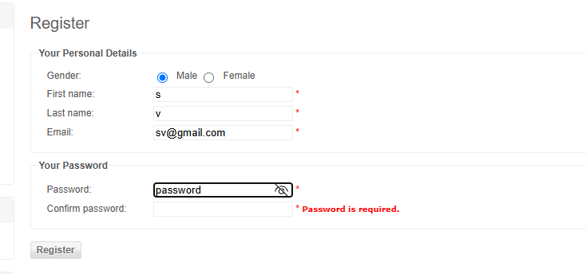

Bug ID: BG02
Defect Summary:Invalid username registration.
Defect Description: The website allows setting up the username with special character i.e. invalid username can be entered
Step to reproduce:
Step Details
Navigate to http://demowebshop.tricentis.com/register
Enter Gender
Enter first name
Enter last name
Enter email
Enter password
Click Submit
Test Data:
Userid = av123@gmail.com
Pass = 123456
Gender= Male
First Name= ""
Last Name= x

Expected Result: Invalid username
Actual Result: User successfully registerd
Attachment:
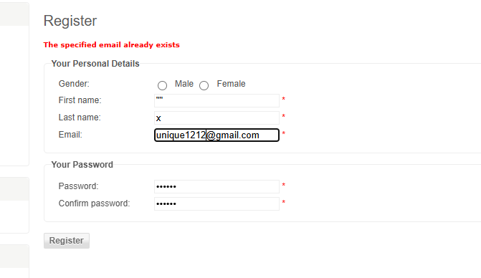

Bug ID: BG03
Defect Summary:Missing receivers and sender mail option.
Defect Description: While adding gift card in add to cart, input boxes for receiver and sender mail is missing, though it available in other gift card.
Step to reproduce:
Step Details
Navigate to https://demowebshop.tricentis.com/5-virtual-gift-card
Enter Recipient's Name
Enter Recipient's Email
Enter Your Name
Enter Your Email
Enter Quantity
Click add to cart
Test Data:
Recipient's Name:s v
Recipient's Email:
Your Name:a v
Your Email:
Quantity: 1

Expected Result: Input box for sender and reciever mail
Actual Result: No input boxes available.
Attachment:
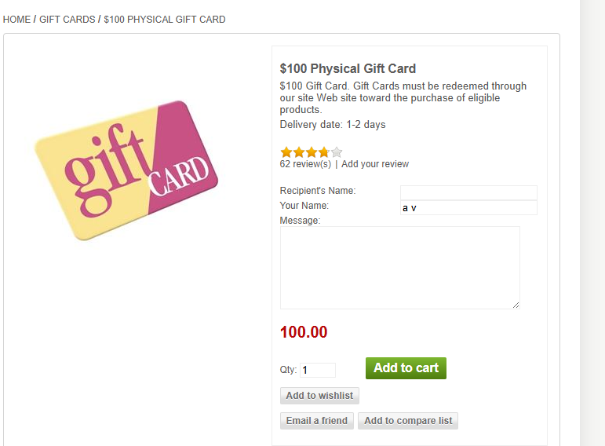

Bug ID: BG04
Defect Summary:Input of invalid ZIP Code
Defect Description: The website allows entering invalid ZIP Code in estimate functionality.
Step to reproduce:
Step Details
Navigate to https://demowebshop.tricentis.com/cart
Enter Country
Enter State
Enter ZIP Code
Test Data:
Country: United States
State / province: Alaska
Zip / postal code: 11111

Expected Result: Invalid ZIP Code.
Actual Result: Successfully shipping estimation
Attachment:
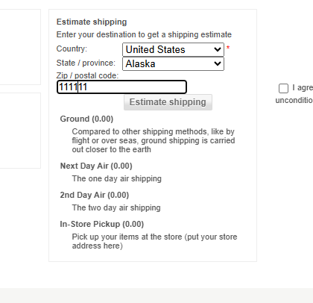

Bug ID: BG05
Defect Summary:Estimate shipping functionality with country as India, states not available
Defect Description: When we select India as country, we can’t see states of India in cascading drop down.
Step to reproduce:
Step Details
Navigate to https://demowebshop.tricentis.com/cart
Enter Country
Enter State
Enter ZIP Code
Test Data:
Country: India
State / province: Uttar Pradesh
Zip / postal code: 201014

Expected Result: All states of India mentioned in dropdown list
Actual Result: No states available
Attachment:
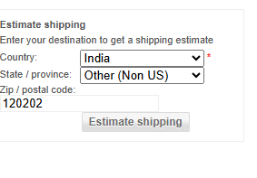

Bug ID: BG06
Defect Summary:Contact us page accepting invalid username
Defect Description: Contact us page accepting the invalid user name i.e.name with special characters can be entered.
Step to reproduce:
Step Details
Navigate to https://demowebshop.tricentis.com/contactus
Enter Name
Enter email
Enter message
Test Data:
Name:""
Email:av123@gmail.com
Message: This for practice purpose

Expected Result: Invalid name
Actual Result: Successful enquiry sent.
Attachment:
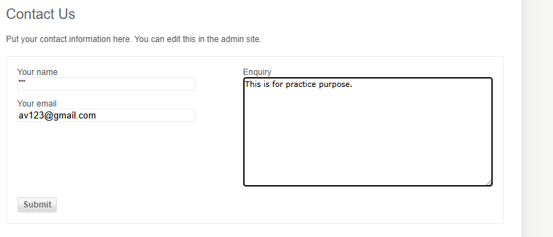
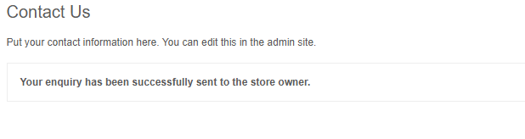

Bug ID: BG07
Defect Summary:Acceptance of invalid first and last name in Account/addresses
Defect Description: Myaccount/address page can accept invalid first and last, special characters can be entered.
Step to reproduce:
Step Details
Navigate to https://demowebshop.tricentis.com/customer/addressadd
Enter first name
Enter last name
Test Data:
First name:""
Last name:**

Expected Result: Invalid name
Actual Result: Successful address added.
Attachment:
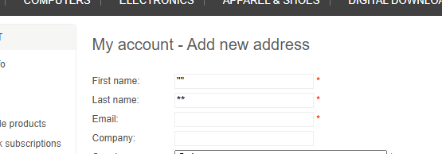

Bug ID: BG08
Defect Summary:Acceptance of invalid ZIP code in Account/addresses
Defect Description: Myaccount/address page can accept invalid ZIP code.
Step to reproduce:
Step Details
Navigate to https://demowebshop.tricentis.com/customer/addressadd
Enter first name
Enter last name
Enter Country
Enter ZIP Code
Test Data:
First name:a
Last name:v
Country: United States
Zip / postal code: 11111

Expected Result: Invalid ZIP code
Actual Result: Successful address added.
Attachment: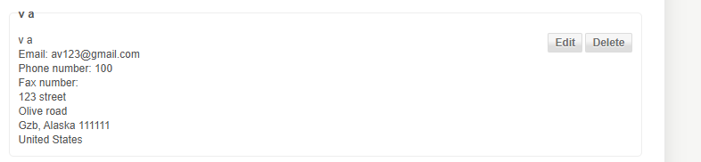

Bug ID: BG09
Defect Summary:Acceptance of invalid Phone No. in Account/addresses
Defect Description: Myaccount/address page can accept invalid ZIP Phone No. , it can even include alphabets and special characters.
Step to reproduce:
Step Details
Navigate to https://demowebshop.tricentis.com/customer/addressadd
Enter first name
Enter last name
Enter Country
Enter ZIP Code
Enter Phone no
Test Data
First name:a
Last name:v
Country: United States
Zip / postal code: 11111
Phone No. : abc123

Expected Result: Invalid Phone No.
Actual Result: Successful address added.
Attachment:
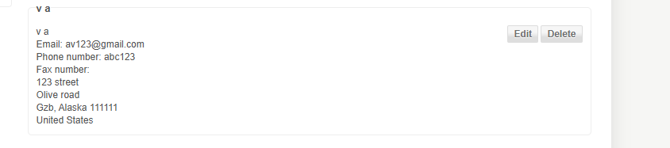

Bug ID: BG10
Defect Summary:"Add to Cart" functionality is missing for multiple products on the Demo Web Shop website.
Defect Description:Several products displayed on the Demo Web Shop website do not have the "Add to Cart" button on their product listing or product details page. This prevents users from adding those products to the shopping cart and completing the purchase flow, resulting in loss of functionality and poor user experience.
Step to reproduce:
Step Details
Navigate to https://demowebshop.tricentis.com/computers
Test Data:
No Test Data

Expected Result: All purchasable products should display an "Add to Cart" button either on the product listing page or product details page, allowing users to add items to the shopping cart.

Actual Result: For several products, the "Add to Cart" button is missing entirely, preventing users from adding those items to the cart.

Attachment: