BUG REPORT
Demo Web Shop — Software Testing Assignment
Website | Demo Web Shop (demowebshop.tricentis.com)
Tester | Ansh Verma
Test Date | 16 July 2026
Environment | Microsoft Edge Browser, Windows
Scope | Black-box Testing
Total Test Cases | 21
Total Defects Found | 10

Executive Summary
Black-box testing was carried out on the Demo Web Shop website using the Microsoft Edge browser on Windows. A total of 21 test cases were executed, resulting in the identification of 10 defects across registration, account management, shipping estimation, and cart functionality. The defects range in severity from Minor to Critical, with a notable concentration of input-validation issues (e.g., weak passwords, invalid ZIP codes, invalid names, and invalid phone numbers being accepted) and one missing-functionality issue (Add to Cart button unavailable for several products).

Bug Summary
Bug ID | Defect Summary | Priority | Severity
BG01 | Weak password accepted during registration | High | Major
BG02 | Invalid username accepted during registration | High | Major
BG03 | Missing sender/receiver email fields on gift card | High | Critical
BG04 | Invalid ZIP code accepted in shipping estimate | Medium | Minor
BG05 | Indian states not listed in shipping estimate dropdown | High | Major
BG06 | Contact Us page accepts invalid username | Low | Minor
BG07 | Invalid first/last name accepted in Account Addresses | Medium | Minor
BG08 | Invalid ZIP code accepted in Account Addresses | High | Major
BG09 | Invalid phone number accepted in Account Addresses | High | Major
BG10 | "Add to Cart" button missing for several products | High | Major

Detailed Defect Reports

BG01 — Weak Password Problem

Priority: High
Severity: Major
Description: The website allows setting up a weak password while registering a user.
Scope — Why the tested password (“password”) is considered weak:
- It is exactly 8 characters, at the site's stated minimum, with no additional length buffer.
- It uses lowercase letters only — no uppercase letter, digit, or special character is present.
- It is one of the most common breached/dictionary passwords (appears on standard “top 10,000 common passwords” lists), so it is trivially guessable.
URL: http://demowebshop.tricentis.com/register
Steps to Reproduce:
1. Navigate to the registration page
2. Enter Gender
3. Enter First Name
4. Enter Last Name
5. Enter Email
6. Enter Password
7. Click Submit
Test Data:
• Email: sv@gmail.com
• Password: password
• Gender: Male
• First Name: saransh
• Last Name: verma

Expected Result: Weak password should not be accepted.
Actual Result: User registered successfully with a weak password.
Attachment:
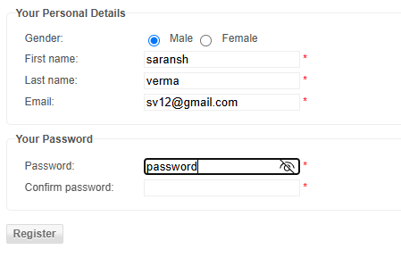

BG02 — Invalid Name(First and Last) Registration
Priority: High
Severity: Major
Description: The website allows First Name and Last Name containing special characters / invalid input to be entered.
Scope — What is considered an invalid First Name and Last Name here:
- An empty/blank value (field left untouched) submitted as a mandatory field.
- Would also include values consisting only of digits or special characters, per the same rule applied in BG07.
URL: http://demowebshop.tricentis.com/register
Steps to Reproduce:
1. Navigate to the registration page
2. Enter Gender
3. Enter First Name
4. Enter Last Name
5. Enter Email
6. Enter Password
7. Click Submit
Test Data:
• Email: unique1290@gmail.com
• Password: 12345678
• Gender: Male
• First Name: "" (invalid)
• Last Name: x

Expected Result: Invalid First and Last Name should be rejected.
Actual Result: User registered successfully with an invalid First and Last name.
Attachment:
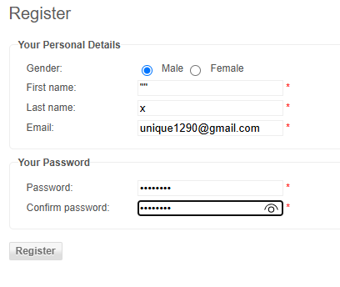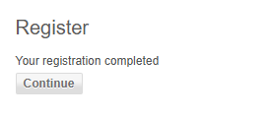

BG03 — Missing Receiver and Sender Mail Option
Priority: High
Severity: Critical
Description: While adding a gift card to the cart, the input fields for receiver and sender email are missing, although they are available on other gift cards.
URL: https://demowebshop.tricentis.com/5-virtual-gift-card
Steps to Reproduce:
1. Navigate to the virtual gift card page
2. Enter Recipient's Name
3. Enter Recipient's Email
4. Enter Your Name
5. Enter Your Email
6. Enter Quantity
7. Click Add to Cart
Test Data:
• Recipient's Name: saransh verma
• Recipient's Email: (field unavailable)
• Your Name: ansh verma
• Your Email: (field unavailable)
• Quantity: 1

Expected Result: Input boxes for sender and receiver email should be present.
Actual Result: No input boxes are available for sender/receiver email.
Attachment:
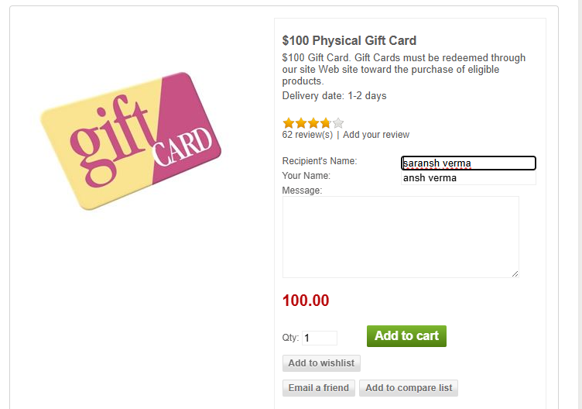

BG04 — Input of Invalid ZIP Code
Priority: Medium
Severity: Minor
Description: The website allows entering an invalid ZIP code in the shipping estimate functionality.
Scope — Why 11111 is invalid for the selected state (Alaska):
- It is numerically well-formed (5 digits), so a simple “is it numeric / 5 digits” check would pass it.
- However, real USPS ZIP codes for Alaska fall in the range 99501–99950; 11111 falls within a New York-area range instead, so it cannot belong to the selected state.
- Minimum expected validation: the ZIP must be 5 numeric digits (US format) AND fall within the valid range/list for the selected state.
URL: https://demowebshop.tricentis.com/cart
Steps to Reproduce:
1. Navigate to the Cart page
2. Enter Country
3. Enter State
4. Enter ZIP Code
Test Data:
• Country: United States
• State / Province: Alaska
• ZIP / Postal Code: 11111

Expected Result: Invalid ZIP code should be rejected.
Actual Result: Shipping estimate is calculated successfully despite the invalid ZIP code.
Attachment:
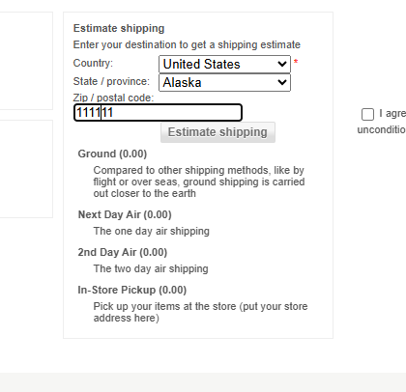

BG05 — Estimate Shipping Functionality — India States Not Available
Priority: High
Severity: Major
Description: When India is selected as the country, its states are not listed in the cascading state dropdown.
URL: https://demowebshop.tricentis.com/cart
Steps to Reproduce:
1. Navigate to the Cart page
2. Enter Country
3. Enter State
4. Enter ZIP Code
Test Data:
• Country: India
• State / Province: Uttar Pradesh
• ZIP / Postal Code: 201014

Expected Result: All Indian states should be listed in the dropdown.
Actual Result: No states are available for selection.
Attachment:
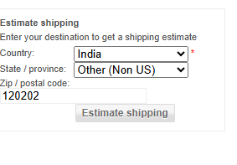

BG06 — Contact Us Page Accepting Invalid Name
Priority: Low
Severity: Minor
Description: The Contact Us page accepts an invalid name, i.e., a name containing special characters can be entered.
Scope — What is considered an invalid Name here:
- A blank/empty submission of the mandatory Name field.
- A value consisting solely of special characters (e.g., @#$%^&*) or digits, with no alphabetic content.
URL: https://demowebshop.tricentis.com/contactus
Steps to Reproduce:
1. Navigate to the Contact Us page
2. Enter Name
3. Enter Email
4. Enter Message
Test Data:
• Name: "" (special characters/blank)
• Email: av123@gmail.com
• Message: This is for practice purposes

Expected Result: Invalid name should be rejected.
Actual Result: Enquiry submitted successfully with an invalid name.
Attachment:
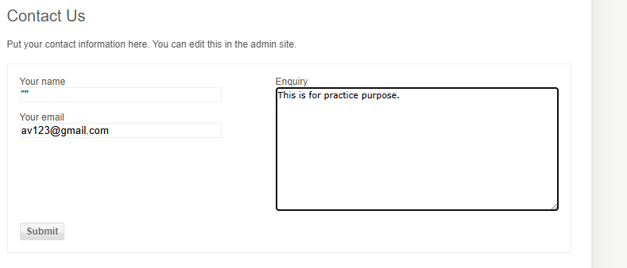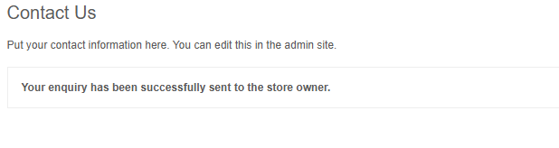

BG07 — Acceptance of Invalid First and Last Name in Account/Addresses
Priority: Medium
Severity: Minor
Description: The My Account / Address page accepts invalid first and last names; special characters can be entered.
Scope — Definition of an invalid name for this test:
- Blank/empty value in a mandatory name field.
- A value made up only of special characters (e.g., **, @, #, %) with no letters.
- (Related, not tested here but recommended for follow-up): values containing digits, e.g. “John123”.
- Expected valid format: alphabetic characters only, optionally including spaces, hyphens, or apostrophes for compound names (e.g., “O'Brien”, “Anne-Marie”).
URL: https://demowebshop.tricentis.com/customer/addressadd
Steps to Reproduce:
1. Navigate to the Add Address page
2. Enter First Name
3. Enter Last Name
Test Data:
• First Name: "" (blank/invalid)
• Last Name: ** (special characters)

Expected Result: Invalid name should be rejected.
Actual Result: Address added successfully with an invalid name.
Attachment:
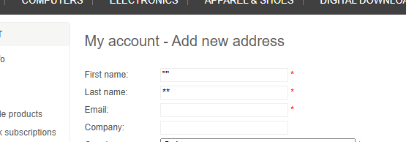

BG08 — Acceptance of Invalid ZIP Code in Account/Addresses
Priority: High
Severity: Major
Description: The My Account / Address page accepts an invalid ZIP code.
URL: https://demowebshop.tricentis.com/customer/addressadd
Steps to Reproduce:
1. Navigate to the Add Address page
2. Enter First Name
3. Enter Last Name
4. Enter Country
5. Enter ZIP Code
Test Data:
• First Name: ansh
• Last Name: verma
• Country: United States
• ZIP / Postal Code: 11111

Expected Result: Invalid ZIP code should be rejected.
Actual Result: Address added successfully with an invalid ZIP code.
Attachment:
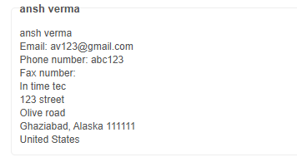

BG09 — Acceptance of Invalid Phone Number in Account/Addresses
Priority: High
Severity: Major
Description: The My Account / Address page accepts an invalid phone number, including alphabets and special characters.
Scope — Definition of an invalid phone number for this test:
- Contains alphabetic characters and/or special characters instead of digits.
Expected valid format: numeric digits only (optionally with a leading “+” and country code), matching the length/format conventions for the selected country.
URL: https://demowebshop.tricentis.com/customer/addressadd
Steps to Reproduce:
1. Navigate to the Add Address page
2. Enter First Name
3. Enter Last Name
4. Enter Country
5. Enter ZIP Code
6. Enter Phone Number
Test Data:
• First Name: ansh
• Last Name: verma
• Country: United States
• ZIP / Postal Code: 11111
• Phone No.: abc123

Expected Result: Invalid phone number should be rejected.
Actual Result: Address added successfully with an invalid phone number.
Attachment:
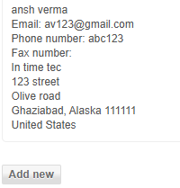

BG10 — Missing "Add to Cart" Button in Multiple Places
Priority: High
Severity: Major
Description: Several products displayed on the Demo Web Shop website do not have the "Add to Cart" button on their product listing or product details page. This prevents users from adding those products to the shopping cart and completing the purchase flow, resulting in loss of functionality and a poor user experience.
URL: https://demowebshop.tricentis.com/computers
Steps to Reproduce:
1. Navigate to the Computers category page
Test Data:
• Test Data: No test data required

Expected Result: All purchasable products should display an "Add to Cart" button, either on the product listing page or the product details page.
Actual Result: For several products, the "Add to Cart" button is missing entirely, preventing users from adding those items to the cart.
Attachment:
