BUG REPORT
Google Maps (Android) — Software Testing Assignment
Application | Google Maps
Tester | Ansh Verma
Test Date | 17 July 2026
Environment | Android 16 OS, Samsung S23, Google Maps 26.21
Scope | Black-box Testing (Functional and Security Testing)
Total Test Cases | 32
Total Defects Found | 5

Executive Summary
Black-box functional and security testing was carried out on the Google Maps Android application. A total of 32 test cases were executed, resulting in the identification of 5 defects related to location permission handling during active navigation, unclear error messaging during connectivity loss, missing input validation guidance on the search field, and search history entries persisting after deletion. The defects range in severity from Low to Medium, with the location-permission issue during active navigation carrying the highest priority due to its potential impact on navigation safety.

Bug Summary
Bug ID | Defect Summary | Priority | Severity
BUG_GMAP_001 | Navigation continues temporarily after location permission is revoked mid-navigation | High | Medium
BUG_GMAP_002 | Unclear error message displayed when internet connectivity is lost | Medium | Low
BUG_GMAP_003 | Blank search field does not display validation guidance | Low | Low
BUG_GMAP_004 | Offline search message does not provide instructions for restoring connectivity | Medium | Low
BUG_GMAP_005 | Deleted search history items continue appearing in search suggestions | Medium | Medium

Detailed Defect Reports

BUG_GMAP_001 — Navigation Continues Temporarily After Location Permission Is Revoked Mid-Navigation
Priority: High
Severity: Medium
Description: When location permission is revoked while navigation is in progress, Google Maps continues showing the previously loaded route for a short period and does not immediately display a clear message asking the user to re-enable location permission.
Steps to Reproduce:
1. Open Google Maps.
2. Start navigation to any destination.
3. Go to device settings and revoke location permission.
Test Data:
• Location Permission: Denied during active navigation

Expected Result: Application should immediately stop navigation and display a message such as: “Location permission has been revoked. Please enable location permission to continue navigation.”
Actual Result: Application continued displaying the previous route temporarily, and no immediate clear error message was shown.
Attachment:
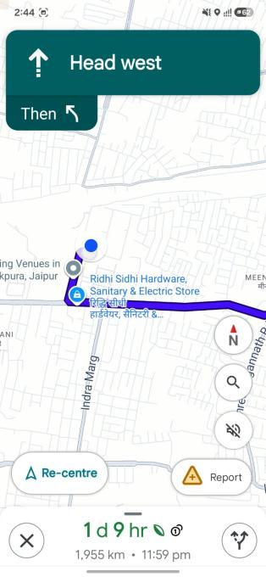

BUG_GMAP_002 — No message Displayed during lost internet connectivity
Priority: Medium
Severity: Low
Description: When internet connectivity is disabled during a location search, the application does not displays a generic message that does clearly explain the reason for the failure or guide the user to restore connectivity.
Scope:
• Observed on Android: no toast, dialog, or message appeared at all when connectivity was lost mid-search — the app gave zero feedback.
• Comparison point: iOS shows an explicit prompt (“Turn on Mobile Data”) in the same scenario, so a clear equivalent is technically achievable on the same underlying feature.
• Defines “clear message” as one that (a) states the failure is due to lost internet connectivity, and (b) tells the user the corrective action — not silence, and not a generic loading/spinner state.
Steps to Reproduce:
1. Open Google Maps.
2. Tap the Search bar.
3. Enter “Taj Mahal.”
4. Disable internet immediately.
Test Data:
• Search Query: Taj Mahal

Expected Result: Application should display: “No Internet Connection. Please enable WiFi or Mobile Data and try again.”
Actual Result: Application displayed a generic error/loading state without clearly explaining that internet connectivity was lost.
Attachment:
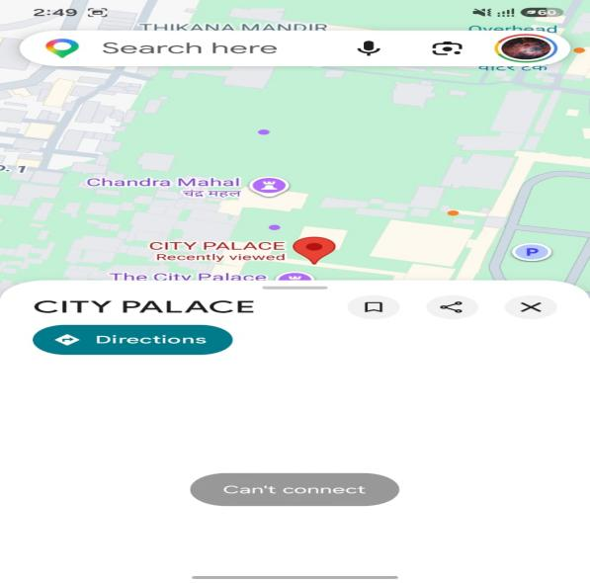

BUG_GMAP_003 — No Validation Guidance displayed
Priority: Low
Severity: Low
Description: The search field does not display any validation guidance when left blank before submission.
Scope:
• Defines “validation guidance” as: a message or prompt shown specifically when the user submits (taps search/enter on) a blank search field — not just placeholder text sitting in the field before typing.
Steps to Reproduce:
1. Open Google Maps.
2. Tap the Search bar and leave it empty.
Test Data:
• Search Field: Blank

Expected Result: Application should display: “Enter a location to search.”
Actual Result: No validation or helper message was displayed when the search field remained empty.
Attachment:
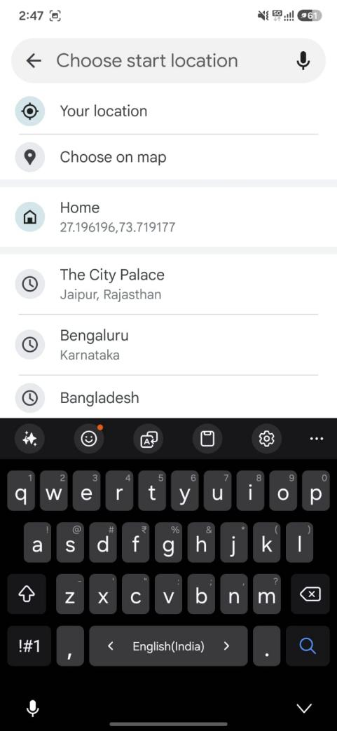

BUG_GMAP_004 — Offline Search Message Does Not Provide Instructions for Restoring Connectivity
Priority: Medium
Severity: Low
Description: When searching for a location while offline and the location is not available in downloaded maps, the application displays a generic offline message without instructing the user on how to enable WiFi or mobile data.
Steps to Reproduce:
1. Open Google Maps.
2. Disable internet.
3. Search for a city that is unavailable offline.
Test Data:
• Search Condition: Location not included in offline maps

Expected Result: Application should display a user-friendly message such as: “Unable to perform search offline. Please enable WiFi or Mobile Data and try again.”
Actual Result: Application displayed a generic offline error message without providing instructions to restore internet connectivity.
Attachment:
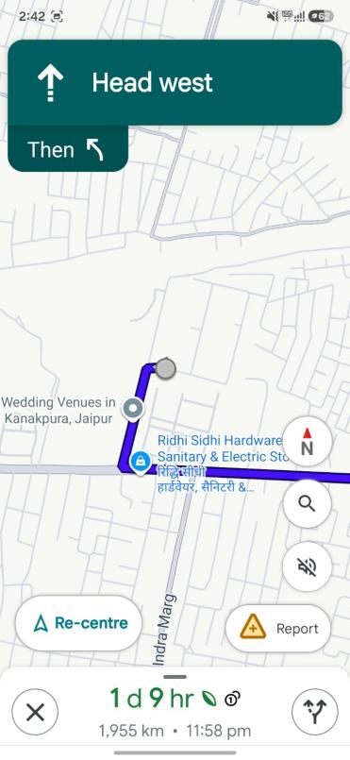

BUG_GMAP_005 — Deleted Search History Items Continue Appearing in Search Suggestions
Priority: Medium
Severity: Medium
Description: Even after deleting previously searched locations from search history, some deleted entries continue to appear in search suggestions after reopening the application.
Steps to Reproduce:
1. Open Google Maps.
2. Open search history.
3. Select the Clear History option.
4. Reopen the search bar.
Test Data:
• Search History: Existing search history cleared

Expected Result: Deleted search history items should be permanently removed and should not appear again in search suggestions.
Actual Result: Previously deleted search entries continued to appear in the search suggestion list.
Attachment:
