Hochschule Wismar University of Applied Sciences Technology, Business and Design
Fakultät für Ingenieurwissenschaften
Bereich Elektrotechnik und Informatik
Prof. Dr.-Ing. habil. Olaf Simanski , Niklas Huhs


Special Aspects of Automation
Image Recognition Coupling Matlab with Python
Anshaj Malhotra

Introduction
- Definition: Image recognition is a key technology in AI used in security, healthcare, and automation.
- Objective: This project integrates MATLAB and Python to build an image recognition system.
- Workflow:
  - Train a Convolutional Neural Network (CNN) in Python using TensorFlow/Keras.
  - Convert the trained model to ONNX (Open Neural Network Exchange) format.
  - Import the ONNX model into MATLAB for further analysis and simulation.

Theoretical Background
- Convolutional Neural Networks (CNNs)
  - Specialized deep learning models for image recognition.
  - Extract features through convolutional layers, pooling layers, and fully connected layers.
- CIFAR-10 Dataset
  - Benchmark dataset with 60,000 images across 10 categories.
  - Images classified as airplane, automobile, bird, cat, deer, dog, frog, horse, ship, truck.
- ONNX Format
  - Standard for cross-platform deep learning model exchange.
  - Enables seamless transition between Python and MATLAB.

Model Training in Python
- Implementation:
  - Built a CNN with three convolutional layers, batch normalization, dropout, and pooling layers.
  - Trained on CIFAR-10 dataset using TensorFlow/Keras.
- Key Hyperparameters:
  - Batch size: 64
  - Learning rate: 0.001
  - Epochs: 20
- Code Snippets

1. Load and preprocess the CIFAR-10 dataset
(x_train, y_train), (x_test, y_test) = cifar10.load_data()
x_train, x_test = x_train / 255.0, x_test / 255.0

2. CNN Model Training

model = Sequential([
Conv2D(32, (3,3), activation='relu', input_shape=(32,32,3)),
MaxPooling2D((2,2)),
Conv2D(64, (3,3), activation='relu'),
MaxPooling2D((2,2)),
Flatten(),
Dense(64, activation='relu'),
Dense(10, activation='softmax')
])

3.Compile the model
model.compile(
optimizer='adam',
loss='sparse_categorical_crossentropy',
metrics=['accuracy']
)

4. Add early stopping to prevent overfitting
early_stopping = EarlyStopping(
monitor='val_loss', patience=3, restore_best_weights=True
)

5. Train the model with augmented data
history = model.fit(
datagen.flow(x_train, y_train, batch_size=64),
epochs=20,
validation_data=(x_test, y_test),
callbacks=[early_stopping])

6. Save in HDF5 .h5 format
h5_file_path = 'cifar10_model.h5'
model.save(h5_file_path)
print(f"Model saved in .h5 format at: {h5_file_path}")

7. Conversion .h5 file to ONNX
import tf2onnx
model = tf.keras.models.load_model('cifar10_model.h5')
onnx_model, _ = tf2onnx.convert.from_keras(model)
with open("cifar10_model.onnx", "wb") as f:
f.write(onnx_model.SerializeToString())

8. Predict_ONNX

9.Displaying the results in Matlab

10. Snapshots from Code Run

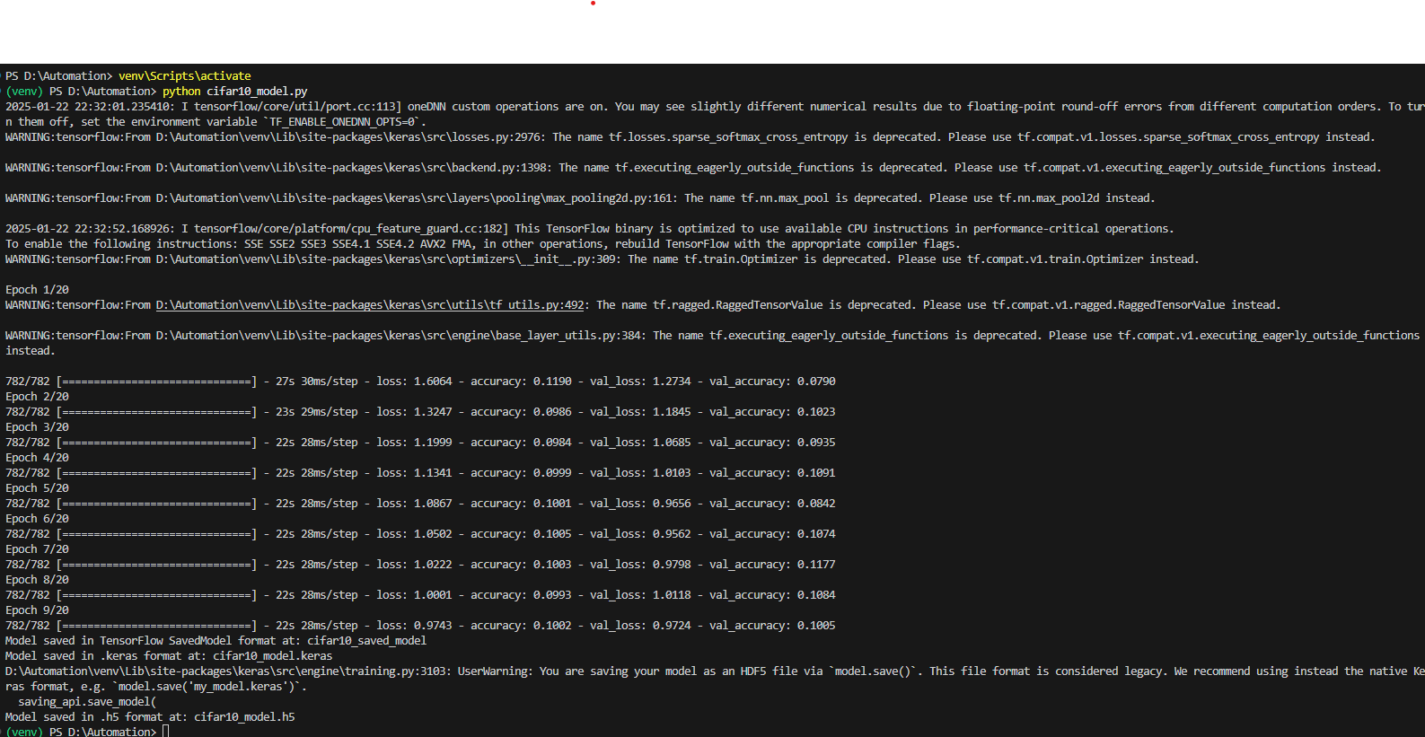
- Epochs Run

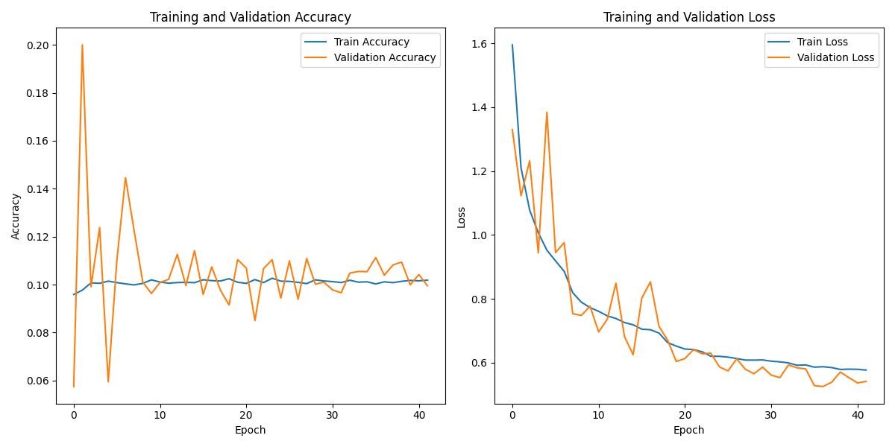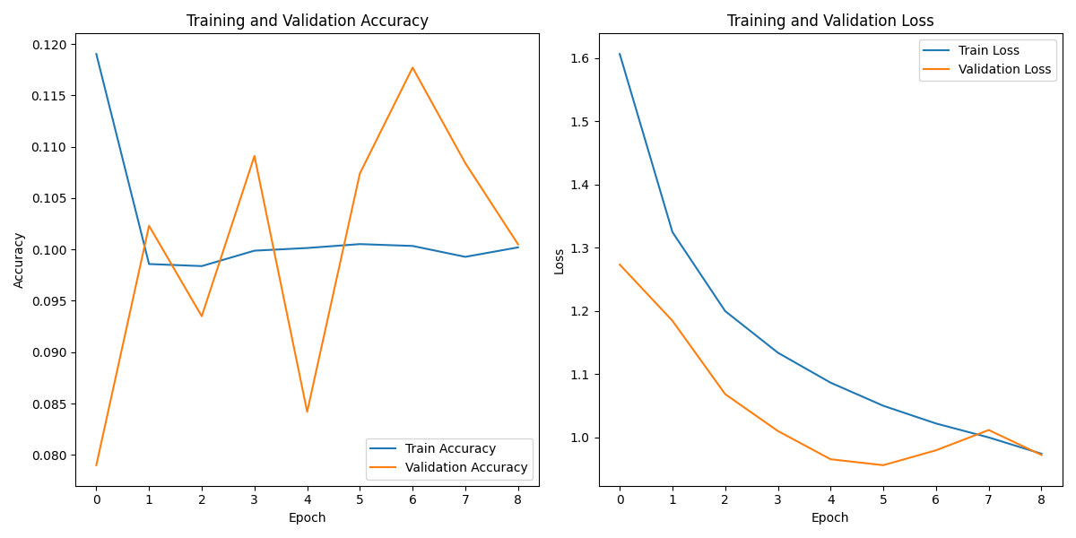
- Validation Plots in 40 epochs & 8 epochs

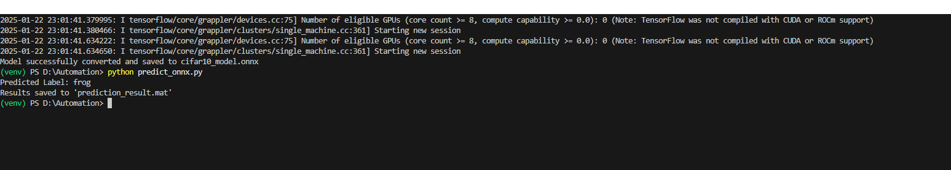
- Predicted Label
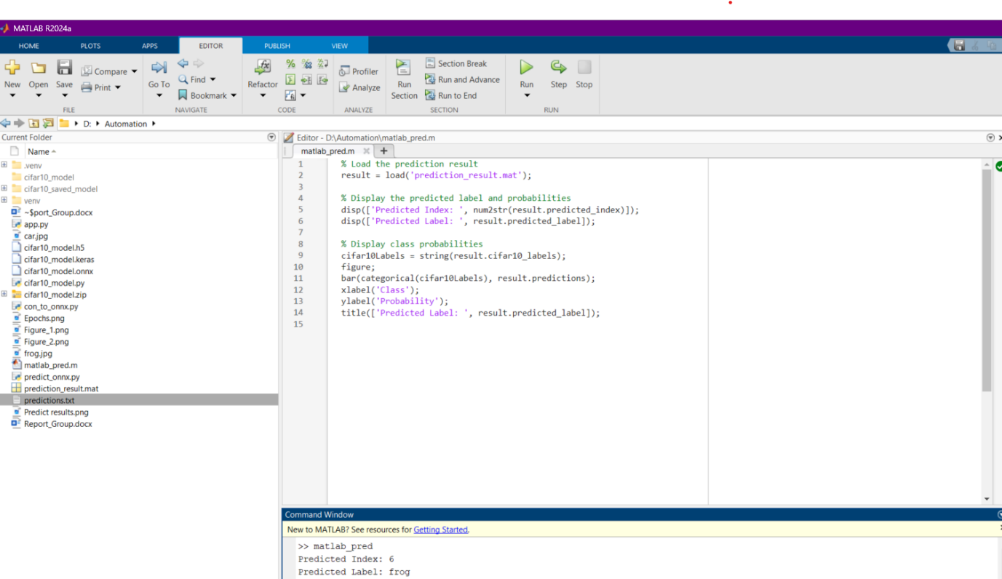
- Displaying of Results in Matlab

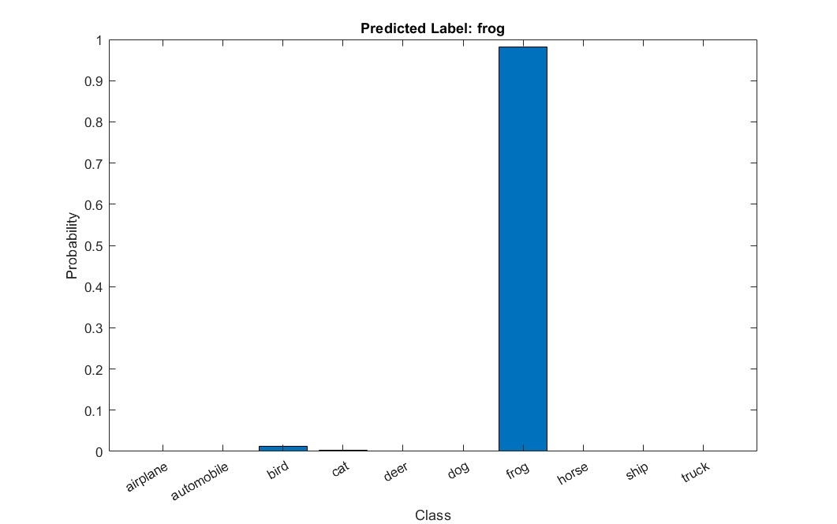
- Probability Plot

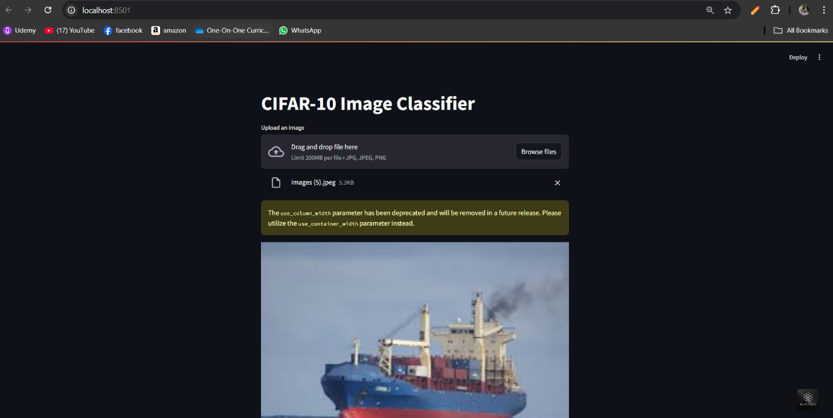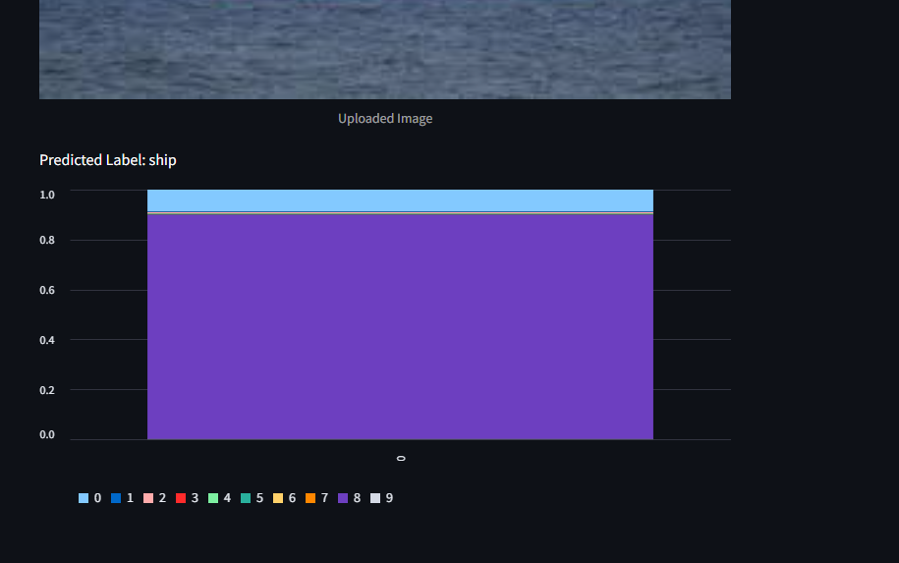

- Made a StreamLit App For validation of CNN model over a Web Application

