SOILSENSE

Website Design & Prototype
Documentation
Capstone Project
A visual walkthrough of the design approach, page structure,
interface decisions, and prototype-sharing limitation.

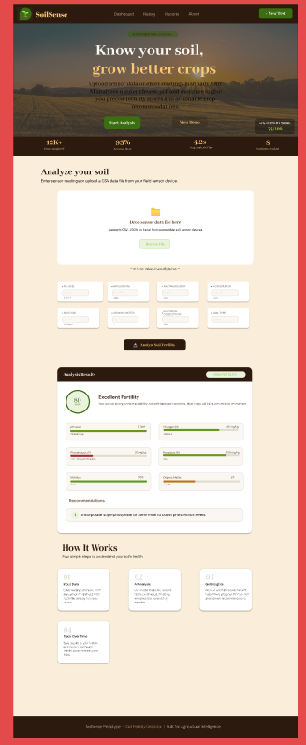
Figure 1. Full-page desktop prototype showing the complete SoilSense experience.

1. Project overview
SoilSense is a soil-fertility analysis website prototype designed to make soil assessment straightforward and understandable. The interface introduces the product, gives users a way to provide soil readings, and presents an easy-to-scan analysis summary with recommendations.
The design focuses on a clear path from entering soil data to understanding the result. It combines an agriculture-inspired visual identity with a structured dashboard-style layout.

2. Design goals
- Make the purpose immediately clear — The hero headline communicates the value proposition: understand soil condition and grow better crops.
- Support more than one input method — The analysis area presents a file-upload option as well as manual fields for users who want to enter readings themselves.
- Make results easy to interpret — The results panel uses a score, a fertility label, nutrient readings, visual progress bars, and a recommendation.
- Explain the workflow — A “How It Works” section breaks the experience into four steps so first-time users can understand the process.

3. Visual design and layout
I used a warm, earthy visual direction to connect the interface with agriculture and soil. The main page background is a light cream tone, while dark brown is used for the navigation, statistics strip, result header, and footer. Green is used for positive states and primary agriculture-related accents, with golden yellow/orange highlighting important words and details.
The page follows a single-column vertical structure: navigation, hero, key statistics, soil input, analysis results, explanatory steps, and footer. This keeps the main task prominent and allows the user to move down the page in a logical sequence.

4. Main sections and design decisions
- Navigation bar: A compact top bar contains the SoilSense identity and links such as Dashboard, History, Reports, and About. A “New Test” action is visually separated on the right.
- Hero section: A field photograph establishes the agricultural context. A dark overlay improves text contrast, while the headline, short description, and “Start Analysis” / “View Demo” actions introduce the experience.
- Statistics strip: Four summary metrics—tests completed, accuracy rate, average analysis time, and nutrients tracked—add context and make the product feel data-oriented.
- Soil input area: A large upload drop zone communicates that CSV, JSON, or Excel files can be supplied. Below it, manual-entry controls cover pH, nitrogen, phosphorus, potassium, moisture, organic matter, electrical conductivity, and soil type.
- Analysis results: A prominent result card displays an overall score and fertility category. Individual soil indicators use labels and horizontal bars to make values and relative levels easier to scan. A recommendation row translates the result into a suggested action.
- How It Works: Four small cards explain input data, AI analysis, getting insights, and tracking results over time. This gives users a simple overview without crowding the main input section.
- Footer: A dark footer closes the page and identifies the SoilSense prototype as a soil fertility detector for agricultural intelligence.

5. User journey represented in the prototype
- The user lands on the page and understands the purpose from the hero section.
- The user starts an analysis and either uploads a compatible sensor-data file or enters soil readings manually.
- The user selects the soil type and submits the readings for analysis.
- The results area presents a fertility score, nutrient and soil indicators, and a practical recommendation.
- The “How It Works” content explains the broader process and the idea of tracking soil health over time.

6. Figma design and prototype evidence
The website layout was assembled as a desktop frame in Figma. The workspace screenshot shows the selected frame and its dimensions (1440 × 3715), while the other screenshots show the page at full length and closer views of the main interface sections.
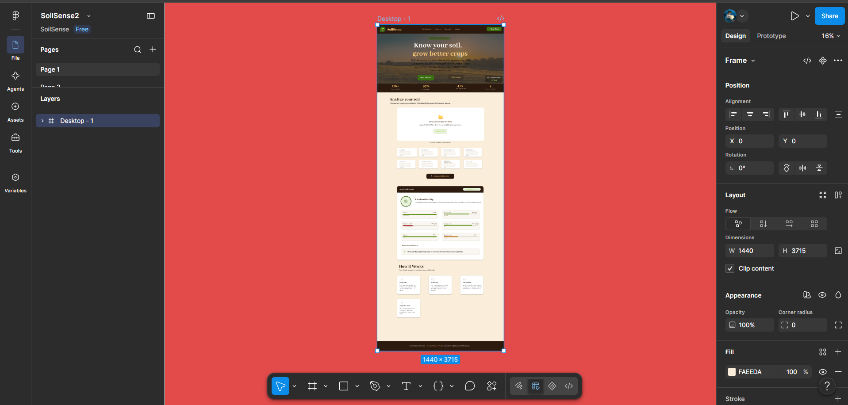
Figure 2. Figma workspace with the selected 1440 × 3715 desktop frame and its design settings.
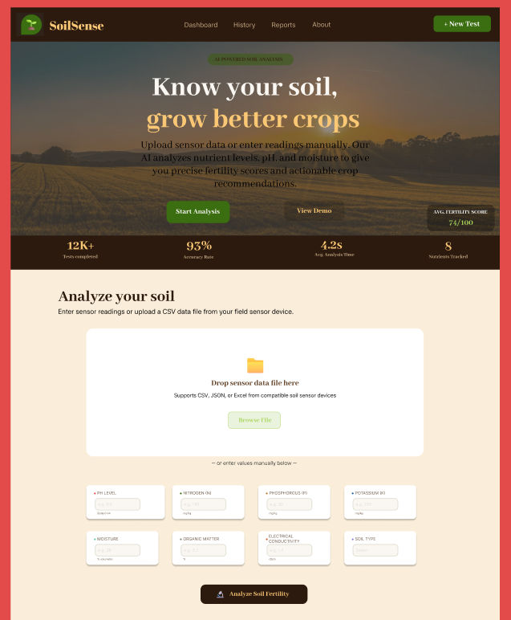
Figure 3. Hero section and soil-input interface, including the upload area and manual-entry fields.
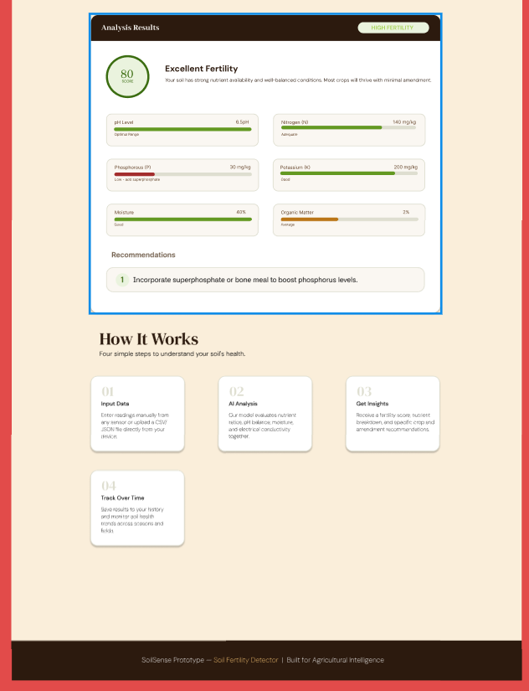
Figure 4. Detailed analysis-results panel and the “How It Works” section.

7. Figma sharing limitation
At the moment, I am unable to change the Figma file’s viewer access setting to “Anyone with the link”. Figma is prompting me to upgrade to a paid plan to enable that sharing option. Because of this plan restriction, I cannot currently provide an unrestricted public-view link.
For the capstone review, I am therefore including screenshots of the design in this document as visual evidence of the work. If access to the live Figma prototype is required, I can share it directly with specific email addresses if the available Figma permissions allow, or provide an exported PDF / image version of the design. The inability to enable “Anyone with the link” is a Figma plan limitation, not an omission of the design work.

8. Closing note
This prototype demonstrates the planned interface and user flow for SoilSense. It presents soil-data entry and fertility insights in a clean, agriculture-focused experience, with an emphasis on clarity, accessible information hierarchy, and actionable recommendations.
Note: This document describes the interface visible in the supplied Figma screenshots. It does not claim that every illustrated interaction or analysis function is fully implemented.

