PUBLISHING GUIDE (do not paste this page into Medium)
Title: Accuracy Was the Wrong Question: A Full CRISP-DM Walkthrough on Telco Churn
Subtitle: How following all six CRISP-DM phases, from business framing to drift monitoring, changed which model I deployed and why.
Tags (Medium allows 5): Data Science, Machine Learning, Crisp Dm, Churn Prediction, Python
Cover / featured image: CRISP-DM_Telco-Churn\figures\04_profit_curve.png (in Medium: ··· menu → Story settings → Change preview image)
How to publish
- Go to medium.com/new-story.
- Type the Title into the title line, press Enter, then type the Subtitle (Medium shows it as the subtitle).
- Copy the article (everything after this guide, starting from the paragraph below the subtitle) and paste it into Medium. Headings, bold, lists and links carry over.
- Tables: Medium has no tables. Screenshot each table in this Word file and insert it as an image, or rewrite it as a bullet list.
- Images: wherever you see a red [IMAGE n — upload …] line, delete that line in Medium, click the + button on the empty line → image icon → upload that file from your repo's figures folder. Paste the grey caption under the image.
- Replace every red [ADD LINK] with your YouTube link (or delete it if the video isn't up yet).
- Click Publish → add the 5 tags → Publish now. Copy the URL from the browser: that is your Medium link for the README.
Images in this article (in order)
1. CRISP-DM_Telco-Churn\figures\01_target_tenure_charges.png — Churn rate, tenure and monthly charges by churn status
2. CRISP-DM_Telco-Churn\figures\02_churn_rate_by_category.png — Churn rate by category (dashed line = overall churn rate)
3. CRISP-DM_Telco-Churn\figures\03_roc_pr_validation.png — ROC and precision–recall curves on the validation set: the three models are practically tied
4. CRISP-DM_Telco-Churn\figures\04_profit_curve.png — Expected net retention value vs decision threshold (validation set)
5. CRISP-DM_Telco-Churn\figures\05_confusion_matrix_test.png — Confusion matrix on the untouched test set at threshold 0.56
6. CRISP-DM_Telco-Churn\figures\06_gains_test.png — Cumulative gains: contacting the top 20% reaches about half of all churners
7. CRISP-DM_Telco-Churn\figures\07_permutation_importance.png — Permutation importance: contract type is the strongest churn driver

Accuracy Was the Wrong Question: A Full CRISP-DM Walkthrough on Telco Churn
How following all six CRISP-DM phases, from business framing to drift monitoring, changed which model I deployed and why.
Anshita Shah · MSSE, San José State University
📓 Colab notebook · 💻 GitHub · 🎥 Video walkthrough [ADD LINK]
Most churn tutorials go straight to the model: load the CSV, one-hot encode, fit XGBoost, report 80% accuracy. Then they stop.
CRISP-DM, the Cross-Industry Standard Process for Data Mining, is built to stop you doing that. It has six phases, and the modeling phase is only one of them. I ran one project through every phase and every generic task of the CRISP-DM 1.0 guide. The most important decisions turned out to happen before and after modeling.
The dataset is IBM's Telco Customer Churn (Kaggle): 7,043 customers, 21 attributes, and 26.5% of them churned.
[IMAGE 1 — upload: CRISP-DM_Telco-Churn\figures\01_target_tenure_charges.png]
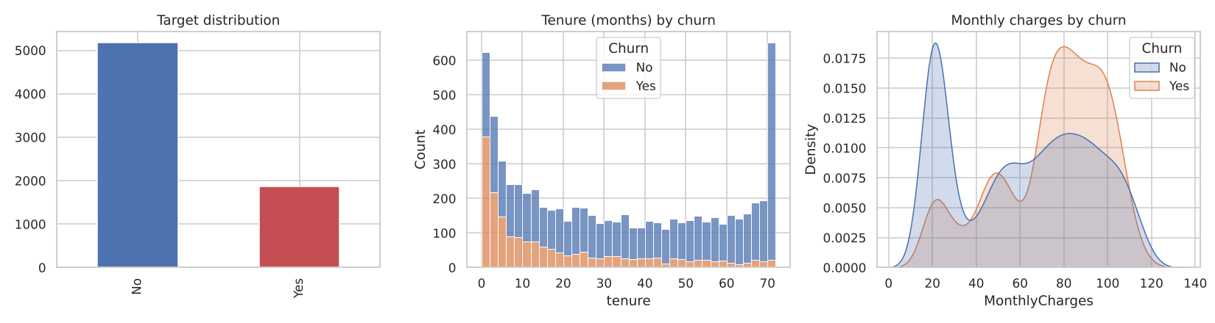
Churn rate, tenure and monthly charges by churn status
Phase 1: Business Understanding
"What does the business actually want to change?"
The retention team doesn't want "a churn model". It wants to spend a limited incentive budget on the customers it can save. That framing gave me three things a pure-ML approach skips.
1. A business success criterion. The targeting policy must earn more net value than both naive policies, "offer to everyone" and "offer to no one".
2. A cost model. These are my case-study assumptions, kept as editable parameters:
- Retention offer: $100 per customer
- Save rate: 35% of real churners who get the offer stay
- Value of a saved customer: 12 × monthly charges
3. Data-mining success criteria. Test ROC-AUC ≥ 0.80, recall on churners ≥ 0.70, and positive net value.
Why does this matter? With 26.5% churn, a model that says "nobody churns" is 73.5% accurate and completely useless. Accuracy was the wrong question from the start.
Phase 2: Data Understanding
CRISP-DM breaks this phase into four tasks: collect, describe, explore, verify quality.
[IMAGE 2 — upload: CRISP-DM_Telco-Churn\figures\02_churn_rate_by_category.png]
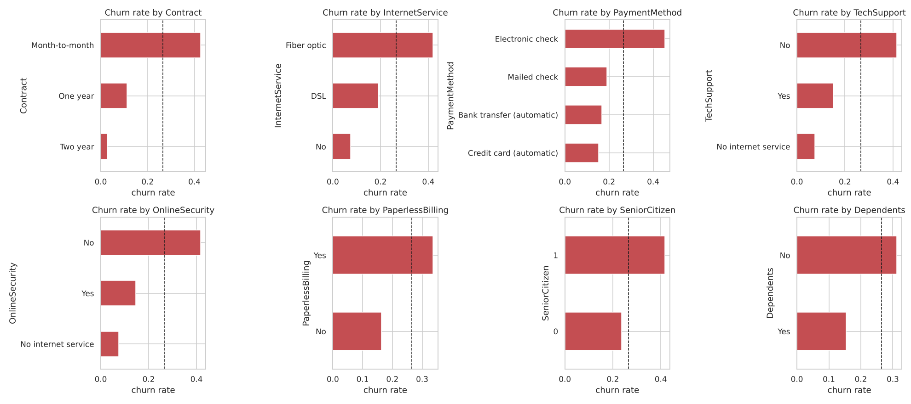
Churn rate by category (dashed line = overall churn rate)
What stood out:
- Contract type is the strongest signal. Its Cramér's V of 0.41 is the highest of any attribute. Month-to-month customers churn far more than customers on contracts.
- Churn piles up in the first months of tenure.
- gender (V = 0.008) and PhoneService (V = 0.011) carry essentially no signal.
The quality check found the most interesting detail. TotalCharges is stored as text, and 11 rows are blank. The obvious fix is mean imputation. But all 11 have tenure = 0: they are brand-new customers who haven't been billed yet. The value is structurally missing, so the right fill is 0, not the mean. You only catch this by asking why the data is missing.
Phase 3: Data Preparation
Five tasks: select, clean, construct, integrate, format.
- Select: I dropped customerID, gender (no signal, and a protected attribute) and PhoneService.
- Clean: filled TotalCharges blanks with 0, and collapsed "No internet service" into "No".
- Construct: six business-motivated features. These are the number of add-on services, average charge per month, recent price increase, tenure bucket, auto-pay flag and has-family flag.
- Format: a stratified 60/20/20 train/validation/test split. All scaling and encoding lives inside a scikit-learn Pipeline, so nothing leaks from validation or test into training.
Phase 4: Modeling
The test design is where many projects quietly cheat. I used three separate data roles:
Data | Used for
Train (5-fold CV) | comparing model families, tuning
Validation | choosing the champion and the decision threshold
Test | one final verdict, touched once

Cross-validated ROC-AUC:
Model | CV ROC-AUC
Majority baseline | 0.500
Logistic Regression | 0.851 ± 0.014
Random Forest | 0.847 ± 0.013
Gradient Boosting | 0.834 ± 0.013
Decision Tree | 0.822 ± 0.017

Logistic regression, random forest and gradient boosting all fall within about one standard deviation of each other. AUC cannot pick a winner here. So the business metric has to decide.
[IMAGE 3 — upload: CRISP-DM_Telco-Churn\figures\03_roc_pr_validation.png]
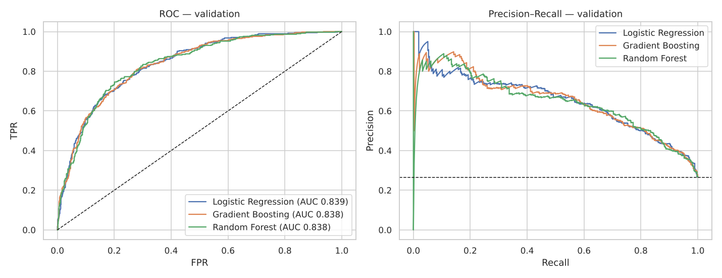
ROC and precision–recall curves on the validation set: the three models are practically tied
Phase 5: Evaluation
For each model I swept the decision threshold and computed the expected net retention value from Phase 1.
[IMAGE 4 — upload: CRISP-DM_Telco-Churn\figures\04_profit_curve.png]
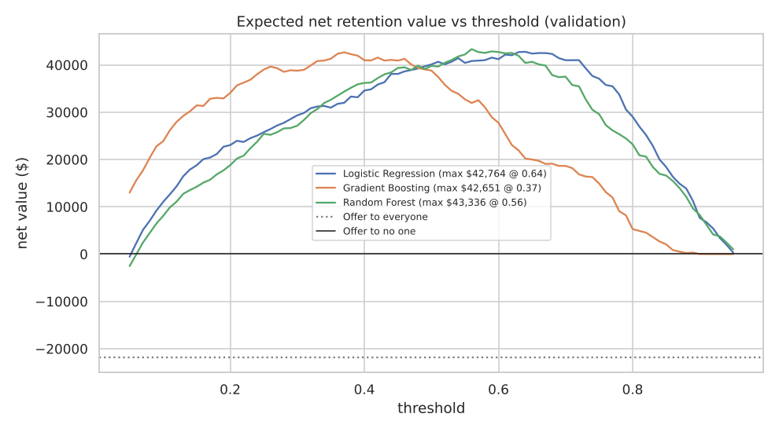
Expected net retention value vs decision threshold (validation set)
Look at the dotted line. Offering to everyone loses money. Every model, at a sensible threshold, earns about $40k+ on the 1,409-customer validation set. Random Forest peaked highest ($43.3k at threshold 0.56), even though logistic regression had the higher AUC. The margin is small, though. The curves are practically tied, and logistic regression would be a defensible choice if explainability mattered more.
I then refit the champion on train + validation and evaluated it on the untouched test set once:
Criterion | Target | Result
ROC-AUC | ≥ 0.80 | 0.847 ✅
Recall (churners) | ≥ 0.70 | 0.741 ✅
Net value vs. "offer to all" | > –$26.6k | +$37.5k ✅

[IMAGE 5 — upload: CRISP-DM_Telco-Churn\figures\05_confusion_matrix_test.png]
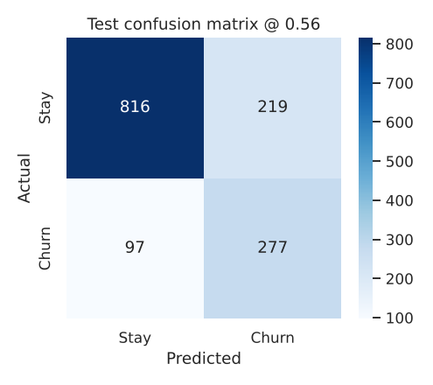
Confusion matrix on the untouched test set at threshold 0.56
Calling the riskiest 20% of customers reaches about 51% of all churners.
[IMAGE 6 — upload: CRISP-DM_Telco-Churn\figures\06_gains_test.png]
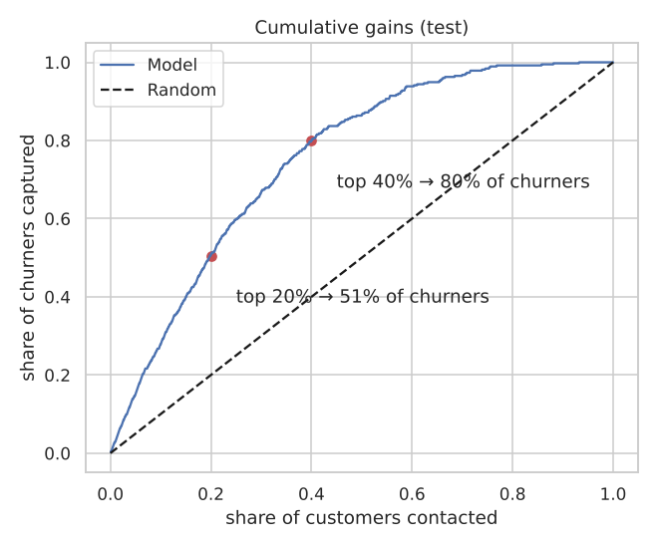
Cumulative gains: contacting the top 20% reaches about half of all churners
What drives churn? Permutation importance says contract type, then internet service type, then tenure. The retention team can act on all of these, for example with contract-upgrade offers for new fiber customers.
[IMAGE 7 — upload: CRISP-DM_Telco-Churn\figures\07_permutation_importance.png]
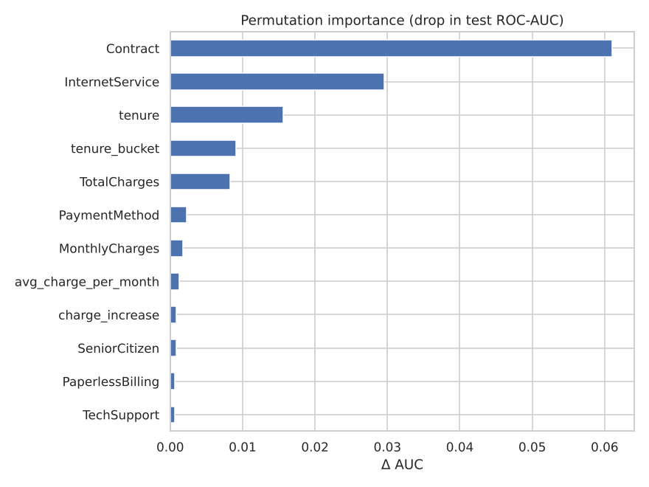
Permutation importance: contract type is the strongest churn driver
CRISP-DM also asks you to review the process. Two honest gaps remain. The data is a single snapshot, so there is no temporal validation. And I model who will churn, not who will respond to an offer (uplift). Both are listed as next steps.
Phase 6: Deployment
This is where most student projects end with joblib.dump(model). I treated deployment as four deliverables:
- One artifact (churn_model.joblib) bundling the preprocessing pipeline, the model, the business threshold and the feature list.
- Feature parity. The scoring-time feature code has an assert proving it reproduces the training features exactly.
- Two channels: a batch scorer (score_batch.py) that turns a CSV into a ranked call list, and a Streamlit app for the retention desk.
- Monitoring. A Population Stability Index (PSI) drift check. Train → test PSI is about 0.01, which is stable. A simulated 15% price increase pushes PSI on MonthlyCharges to 1.40, triggering a retrain alert.
Using an AI critic
The assignment asked me to have an LLM critique each phase while playing "a world-renowned CRISP-DM authority". It wasn't there to write the work. It challenged it, and it caught real problems. Scaling was being done before the split (leakage). The test set was being used to pick the threshold. And my first draft had no cost model at all. The full critique log is in the repo.
What I learned
The modeling phase was the easiest part. The decisions that changed the outcome were made in Business Understanding (the cost model), Data Understanding (why TotalCharges is missing) and Evaluation (choosing the champion on net value, not AUC). That is the point of CRISP-DM.
All code, figures, the deployed model, the Streamlit app and the critic logs are on GitHub.

