PUBLISHING GUIDE (do not paste this page into Medium)
Title: Accuracy Was the Wrong Question: A Full CRISP-DM Walkthrough on Telco Churn
Subtitle: How following all six CRISP-DM phases, from business framing to drift monitoring, changed which model I deployed and why.
Tags (Medium allows 5): Data Science, Machine Learning, Crisp Dm, Churn Prediction, Python
Cover / featured image: CRISP-DM_Telco-Churn\figures\04_profit_curve.png (in Medium: ··· menu → Story settings → Change preview image)
How to publish
- Go to medium.com/new-story.
- Type the Title into the title line, press Enter, then type the Subtitle (Medium shows it as the subtitle).
- Copy the article (everything after this guide, starting from the paragraph below the subtitle) and paste it into Medium. Headings, bold, lists and links carry over.
- Tables: Medium has no tables. Screenshot each table in this Word file and insert it as an image, or rewrite it as a bullet list.
- Images: wherever you see a red [IMAGE n — upload …] line, delete that line in Medium, click the + button on the empty line → image icon → upload that file from your repo's figures folder. Paste the grey caption under the image.
- Replace every red [ADD LINK] with your YouTube link (or delete it if the video isn't up yet).
- Click Publish → add the 5 tags → Publish now. Copy the URL from the browser: that is your Medium link for the README.
Images in this article (in order)
1. CRISP-DM_Telco-Churn\figures\01_target_tenure_charges.png — Churn rate, tenure and monthly charges by churn status
2. CRISP-DM_Telco-Churn\figures\02_churn_rate_by_category.png — Churn rate by category (dashed line = overall churn rate)
3. CRISP-DM_Telco-Churn\figures\03_roc_pr_validation.png — ROC and precision–recall curves on the validation set: the three models are practically tied
4. CRISP-DM_Telco-Churn\figures\04_profit_curve.png — Expected net retention value vs decision threshold (validation set)
5. CRISP-DM_Telco-Churn\figures\05_confusion_matrix_test.png — Confusion matrix on the untouched test set at threshold 0.56
6. CRISP-DM_Telco-Churn\figures\06_gains_test.png — Cumulative gains: contacting the top 20% reaches about half of all churners
7. CRISP-DM_Telco-Churn\figures\07_permutation_importance.png — Permutation importance: contract type is the strongest churn driver

Accuracy Was the Wrong Question: A Full CRISP-DM Walkthrough on Telco Churn
How following all six CRISP-DM phases, from business framing to drift monitoring, changed which model I deployed and why.
Anshita Shah · MSSE, San José State University
📓 Colab notebook · 💻 GitHub · 🎥 Video walkthrough [ADD LINK]
Most churn tutorials go straight to the model: load the CSV, one-hot encode, fit XGBoost, report 80% accuracy. Then they stop.
CRISP-DM, the Cross-Industry Standard Process for Data Mining, is built to stop you doing that. It has six phases, and the modeling phase is only one of them. I ran one project through every phase and every generic task of the CRISP-DM 1.0 guide. The most important decisions turned out to happen before and after modeling.
The dataset is IBM's Telco Customer Churn (Kaggle): 7,043 customers, 21 attributes, and 26.5% of them churned.
[IMAGE 1 — upload: CRISP-DM_Telco-Churn\figures\01_target_tenure_charges.png]
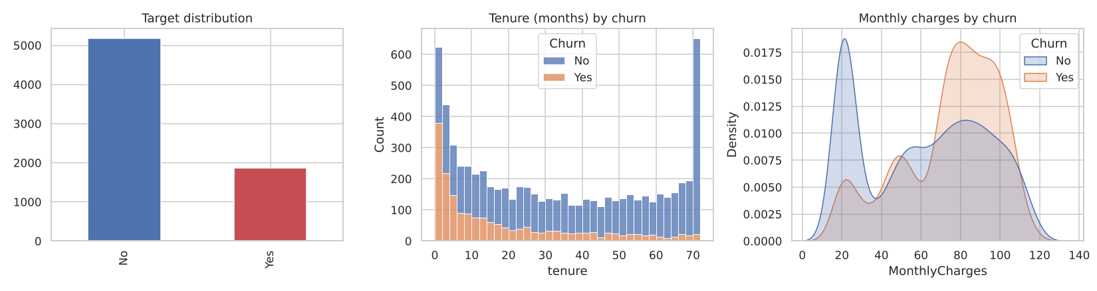
Churn rate, tenure and monthly charges by churn status
Phase 1: Business Understanding
"What does the business actually want to change?"
The retention team doesn't want "a churn model". It wants to spend a limited incentive budget on the customers it can save. That framing gave me three things a pure-ML approach skips.
1. A business success criterion. The targeting policy must earn more net value than both naive policies, "offer to everyone" and "offer to no one".
2. A cost model. These are my case-study assumptions, kept as editable parameters:
- Retention offer: $100 per customer
- Save rate: 35% of real churners who get the offer stay
- Value of a saved customer: 12 × monthly charges
3. Data-mining success criteria. Test ROC-AUC ≥ 0.80, recall on churners ≥ 0.70, and positive net value.
Why does this matter? With 26.5% churn, a model that says "nobody churns" is 73.5% accurate and completely useless. Accuracy was the wrong question from the start.
Phase 2: Data Understanding
CRISP-DM breaks this phase into four tasks: collect, describe, explore, verify quality.
[IMAGE 2 — upload: CRISP-DM_Telco-Churn\figures\02_churn_rate_by_category.png]
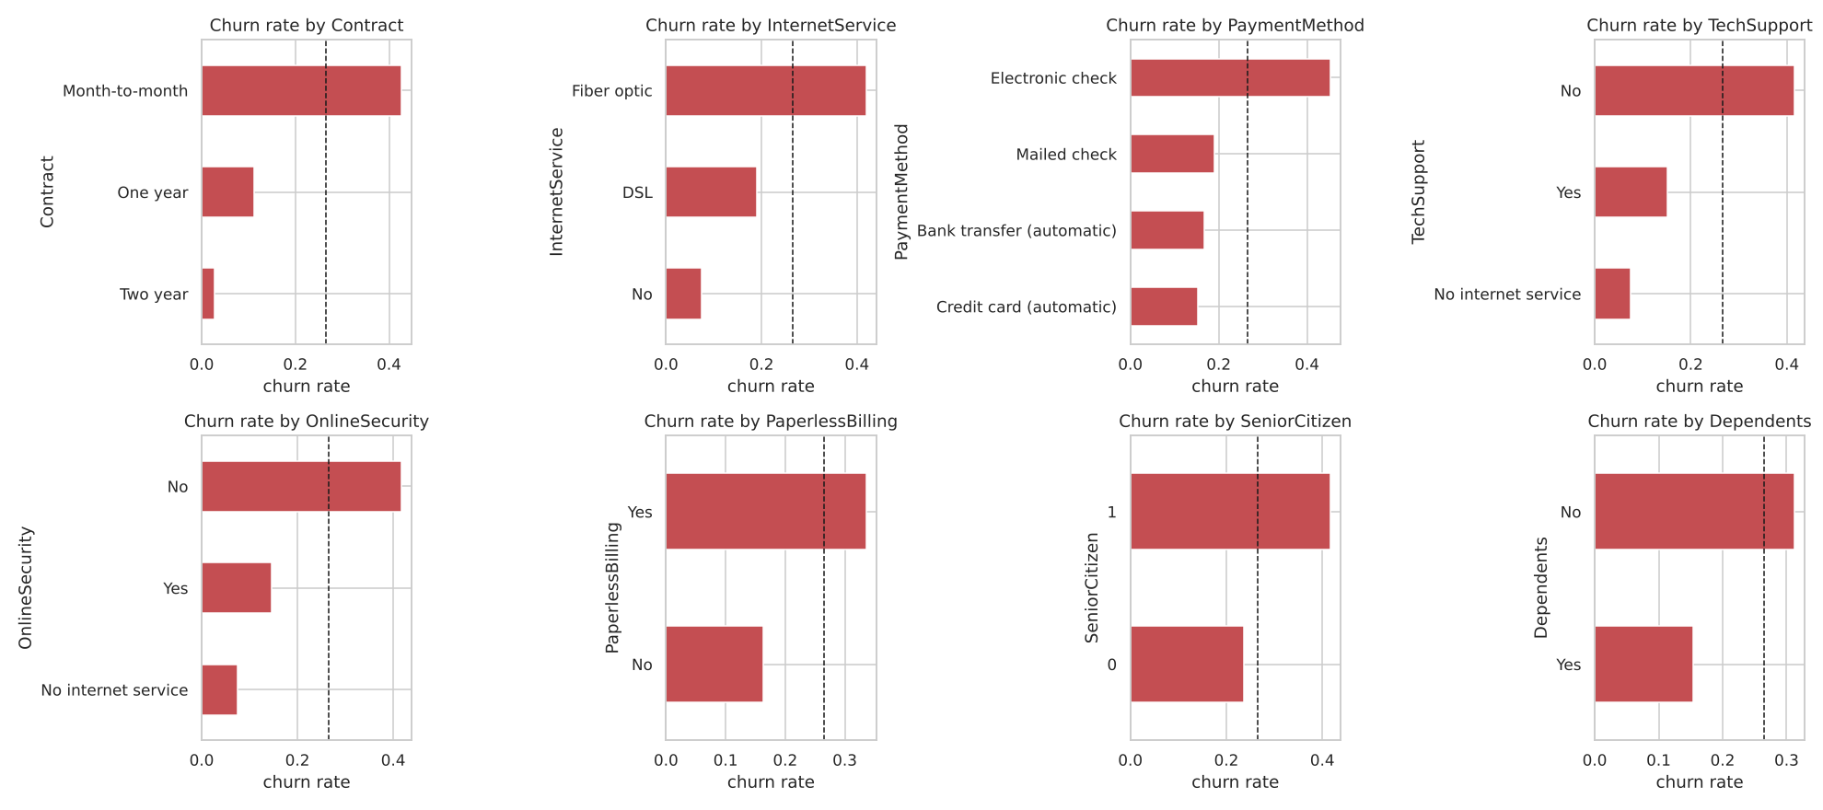
Churn rate by category (dashed line = overall churn rate)
What stood out:
- Contract type is the strongest signal. Its Cramér's V of 0.41 is the highest of any attribute. Month-to-month customers churn far more than customers on contracts.
- Churn piles up in the first months of tenure.
- gender (V = 0.008) and PhoneService (V = 0.011) carry essentially no signal.
The quality check found the most interesting detail. TotalCharges is stored as text, and 11 rows are blank. The obvious fix is mean imputation. But all 11 have tenure = 0: they are brand-new customers who haven't been billed yet. The value is structurally missing, so the right fill is 0, not the mean. You only catch this by asking why the data is missing.
Phase 3: Data Preparation
Five tasks: select, clean, construct, integrate, format.
- Select: I dropped customerID, gender (no signal, and a protected attribute) and PhoneService.
- Clean: filled TotalCharges blanks with 0, and collapsed "No internet service" into "No".
- Construct: six business-motivated features. These are the number of add-on services, average charge per month, recent price increase, tenure bucket, auto-pay flag and has-family flag.
- Format: a stratified 60/20/20 train/validation/test split. All scaling and encoding lives inside a scikit-learn Pipeline, so nothing leaks from validation or test into training.
Phase 4: Modeling
The test design is where many projects quietly cheat. I used three separate data roles:
Data | Used for
Train (5-fold CV) | comparing model families, tuning
Validation | choosing the champion and the decision threshold
Test | one final verdict, touched once

Cross-validated ROC-AUC:
Model | CV ROC-AUC
Majority baseline | 0.500
Logistic Regression | 0.851 ± 0.014
Random Forest | 0.847 ± 0.013
Gradient Boosting | 0.834 ± 0.013
Decision Tree | 0.822 ± 0.017

Logistic regression, random forest and gradient boosting all fall within about one standard deviation of each other. AUC cannot pick a winner here. So the business metric has to decide.
[IMAGE 3 — upload: CRISP-DM_Telco-Churn\figures\03_roc_pr_validation.png]
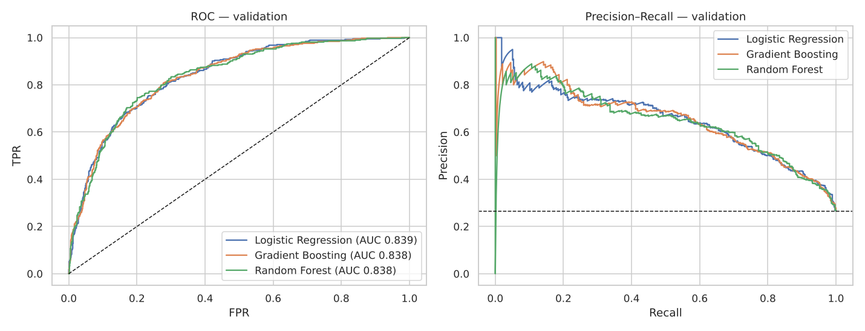
ROC and precision–recall curves on the validation set: the three models are practically tied
Phase 5: Evaluation
For each model I swept the decision threshold and computed the expected net retention value from Phase 1.
[IMAGE 4 — upload: CRISP-DM_Telco-Churn\figures\04_profit_curve.png]
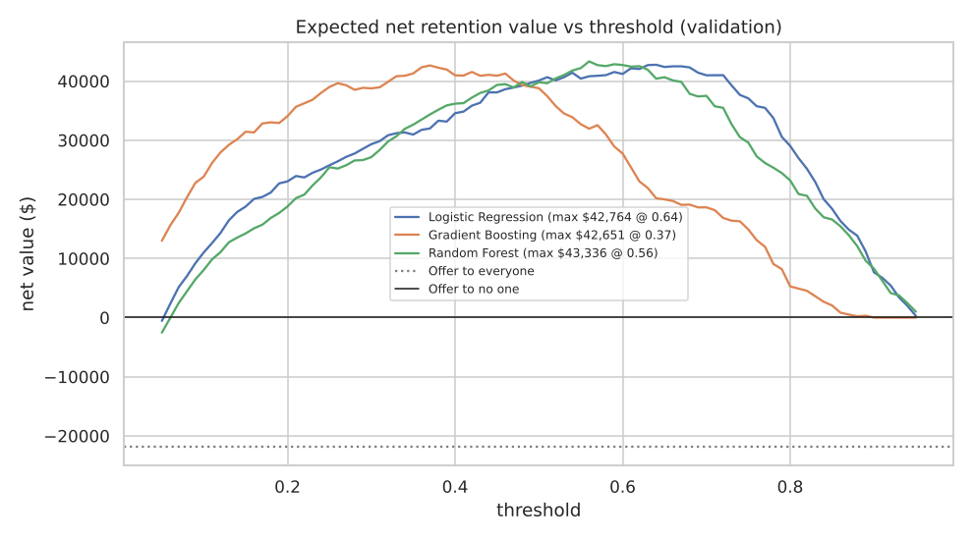
Expected net retention value vs decision threshold (validation set)
Look at the dotted line. Offering to everyone loses money. Every model, at a sensible threshold, earns about $40k+ on the 1,409-customer validation set. Random Forest peaked highest ($43.3k at threshold 0.56), even though logistic regression had the higher AUC. The margin is small, though. The curves are practically tied, and logistic regression would be a defensible choice if explainability mattered more.
I then refit the champion on train + validation and evaluated it on the untouched test set once:
Criterion | Target | Result
ROC-AUC | ≥ 0.80 | 0.847 ✅
Recall (churners) | ≥ 0.70 | 0.741 ✅
Net value vs. "offer to all" | > –$26.6k | +$37.5k ✅

[IMAGE 5 — upload: CRISP-DM_Telco-Churn\figures\05_confusion_matrix_test.png]
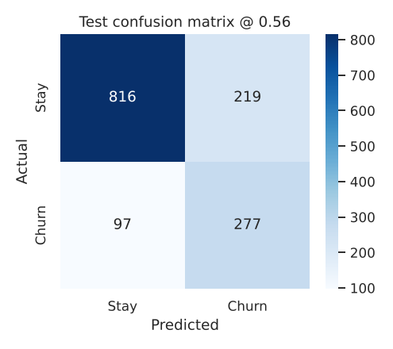
Confusion matrix on the untouched test set at threshold 0.56
Calling the riskiest 20% of customers reaches about 51% of all churners.
[IMAGE 6 — upload: CRISP-DM_Telco-Churn\figures\06_gains_test.png]
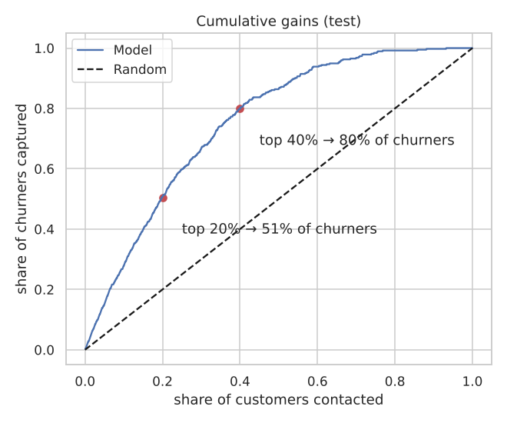
Cumulative gains: contacting the top 20% reaches about half of all churners
What drives churn? Permutation importance says contract type, then internet service type, then tenure. The retention team can act on all of these, for example with contract-upgrade offers for new fiber customers.
[IMAGE 7 — upload: CRISP-DM_Telco-Churn\figures\07_permutation_importance.png]
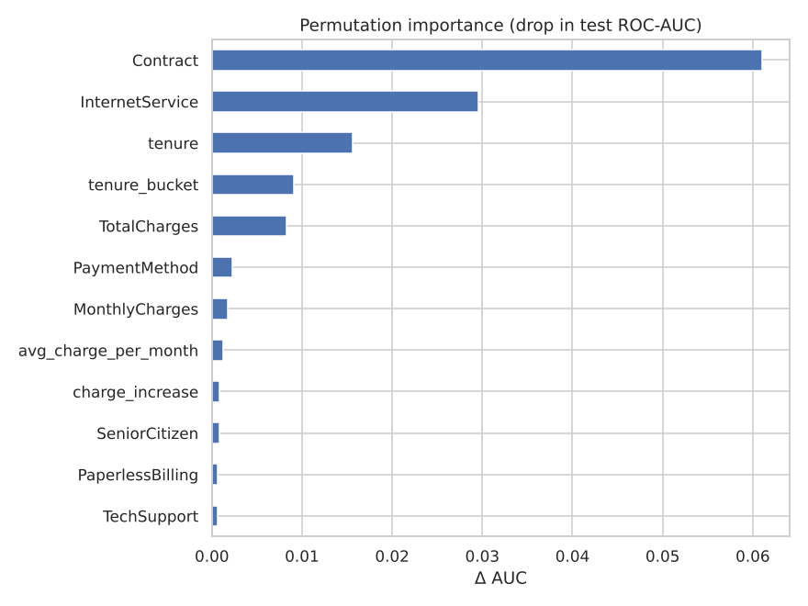
Permutation importance: contract type is the strongest churn driver
CRISP-DM also asks you to review the process. Two honest gaps remain. The data is a single snapshot, so there is no temporal validation. And I model who will churn, not who will respond to an offer (uplift). Both are listed as next steps.
Phase 6: Deployment
This is where most student projects end with joblib.dump(model). I treated deployment as four deliverables:
- One artifact (churn_model.joblib) bundling the preprocessing pipeline, the model, the business threshold and the feature list.
- Feature parity. The scoring-time feature code has an assert proving it reproduces the training features exactly.
- Two channels: a batch scorer (score_batch.py) that turns a CSV into a ranked call list, and a Streamlit app for the retention desk.
- Monitoring. A Population Stability Index (PSI) drift check. Train → test PSI is about 0.01, which is stable. A simulated 15% price increase pushes PSI on MonthlyCharges to 1.40, triggering a retrain alert.
Using an AI critic
The assignment asked me to have an LLM critique each phase while playing "a world-renowned CRISP-DM authority". It wasn't there to write the work. It challenged it, and it caught real problems. Scaling was being done before the split (leakage). The test set was being used to pick the threshold. And my first draft had no cost model at all. The full critique log is in the repo.
What I learned
The modeling phase was the easiest part. The decisions that changed the outcome were made in Business Understanding (the cost model), Data Understanding (why TotalCharges is missing) and Evaluation (choosing the champion on net value, not AUC). That is the point of CRISP-DM.
All code, figures, the deployed model, the Streamlit app and the critic logs are on GitHub.

PUBLISHING GUIDE (do not paste this page into Medium)
Title: SEMMA in Practice: When a Linear Regression Beat the Random Forest
Subtitle: Sample, Explore, Modify, Model, Assess. SAS's five-step data-mining method, applied to predicting medical insurance costs in Python (with a matching SAS program).
Tags (Medium allows 5): Data Science, Machine Learning, Sas, Regression, Data Mining
Cover / featured image: SEMMA_Insurance-Cost\figures\02_bivariate.png (in Medium: ··· menu → Story settings → Change preview image)
How to publish
- Go to medium.com/new-story.
- Type the Title into the title line, press Enter, then type the Subtitle (Medium shows it as the subtitle).
- Copy the article (everything after this guide, starting from the paragraph below the subtitle) and paste it into Medium. Headings, bold, lists and links carry over.
- Tables: Medium has no tables. Screenshot each table in this Word file and insert it as an image, or rewrite it as a bullet list.
- Images: wherever you see a red [IMAGE n — upload …] line, delete that line in Medium, click the + button on the empty line → image icon → upload that file from your repo's figures folder. Paste the grey caption under the image.
- Replace every red [ADD LINK] with your YouTube link (or delete it if the video isn't up yet).
- Click Publish → add the 5 tags → Publish now. Copy the URL from the browser: that is your Medium link for the README.
Images in this article (in order)
1. SEMMA_Insurance-Cost\figures\01_univariate.png — Univariate distributions on the training partition: charges are right-skewed, log(charges) is symmetric
2. SEMMA_Insurance-Cost\figures\02_bivariate.png — Charges by smoker, age and BMI: smokers jump in cost at BMI 30
3. SEMMA_Insurance-Cost\figures\04_model_comparison.png — Validation RMSE by model: the engineered linear regression wins
4. SEMMA_Insurance-Cost\figures\07_importance.png — Permutation importance of the champion: the smoker interaction features dominate
5. SEMMA_Insurance-Cost\figures\05_pred_vs_actual_test.png — Predicted vs actual charges and residuals on the test partition
6. SEMMA_Insurance-Cost\figures\06_decile_assessment.png — Mean predicted vs actual charges by predicted decile (test partition)

SEMMA in Practice: When a Linear Regression Beat the Random Forest
Sample, Explore, Modify, Model, Assess. SAS's five-step data-mining method, applied to predicting medical insurance costs in Python (with a matching SAS program).
Anshita Shah · MSSE, San José State University
📓 Colab notebook · 💻 GitHub · 🎥 Video walkthrough [ADD LINK]
SEMMA was created by SAS Institute to organise the work inside SAS Enterprise Miner. Compared with CRISP-DM it is deliberately narrow. It has no business-understanding phase and no deployment phase. It assumes the problem is already defined and covers the technical core, from data to an assessed model.
That narrowness turns out to be useful. It forces you to be rigorous about the parts most people rush: how you sample, and how you assess.
Problem: predict a person's annual medical insurance charges from age, sex, BMI, number of children, smoking status and region.
Data: Kaggle Medical Cost Personal Dataset, 1,338 policyholders.
I mapped every step to the SAS Enterprise Miner node it represents. A SAS program (semma_insurance.sas) in the repo reproduces the flow in SAS OnDemand for Academics.
S: Sample
SEMMA's first question is whether the data is representative, and how to partition it so the final assessment is honest.
Integrity first. There is one exact duplicate row. If it is left in, the same person could end up in both training and test data, which is a small but real leak. I removed it before partitioning.
Sampling decision. At 1,337 rows, down-sampling would only throw information away. So the real Sample decision here is the partition:
- 60% train / 20% validate / 20% test, in the style of the SAS Data Partition node
- stratified on smoker × charge quartile, because smokers (about 20%) drive the expensive tail
Proof of representativeness. I ran Kolmogorov–Smirnov and χ² tests comparing each partition to training. Every p-value is above 0.05, and the smoker share is 20.6% / 20.2% / 20.5% across the three partitions.
E: Explore (training data only)
[IMAGE 1 — upload: SEMMA_Insurance-Cost\figures\01_univariate.png]
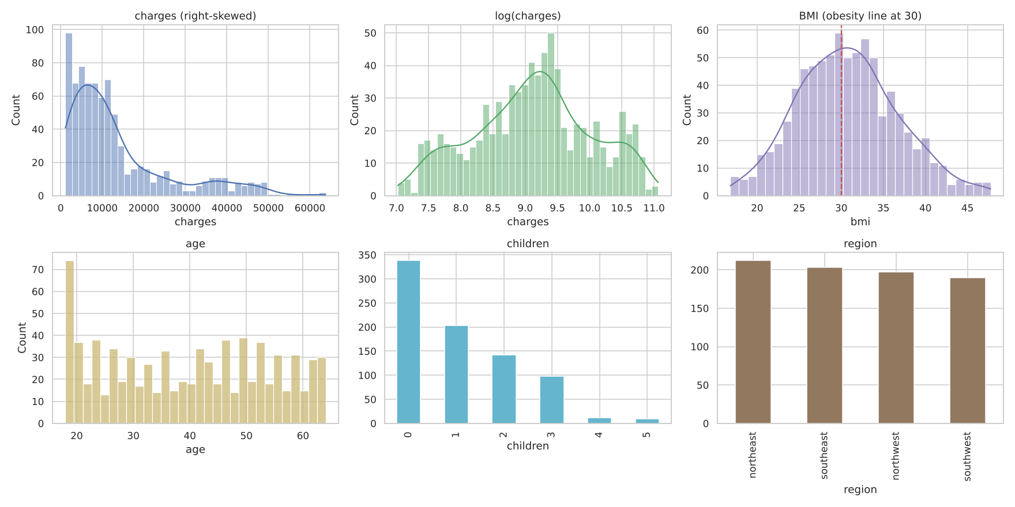
Univariate distributions on the training partition: charges are right-skewed, log(charges) is symmetric
[IMAGE 2 — upload: SEMMA_Insurance-Cost\figures\02_bivariate.png]
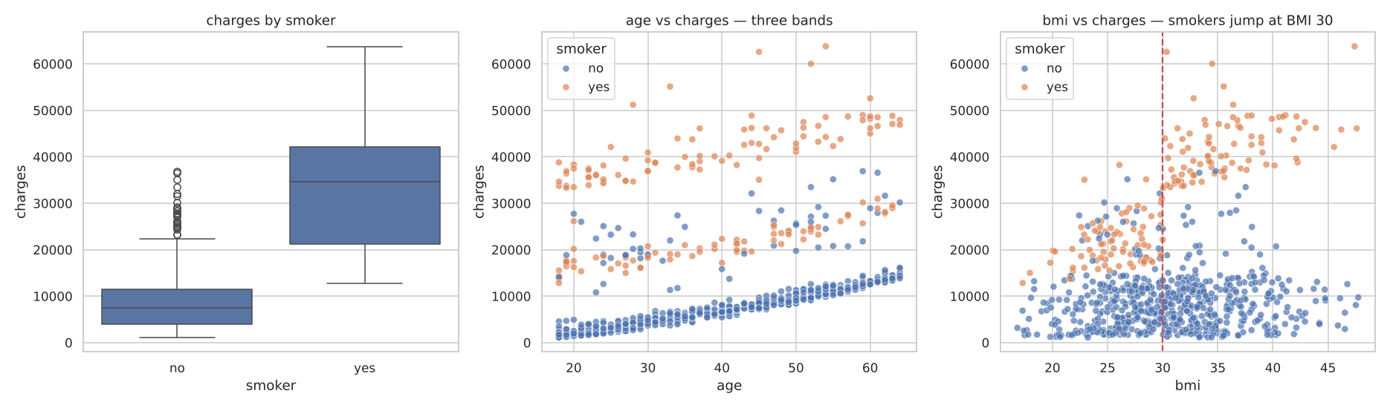
Charges by smoker, age and BMI: smokers jump in cost at BMI 30
Four findings shaped everything that followed:
- charges is right-skewed (skewness 1.54). Its log is nearly symmetric (–0.08).
- Smoking dominates, with Spearman ρ = 0.66 with charges.
- Age adds a near-linear effect, which shows up as three parallel bands.
- The key interaction. Smokers with BMI ≥ 30 average about $42,000, while smokers with BMI < 30 average about $21,700. For non-smokers, BMI barely matters ($8.3k vs $8.7k).
The "outliers" in charges are 97% smokers. They are real expensive cases, not errors, so I kept them.
M: Modify
Each transformation traces back to an Explore finding:
Variable | Rule | From finding
obese | BMI ≥ 30 | 4
smoker_obese | smoker × obese | 4
smoker_bmi | smoker × BMI | 4
age_sq | age² | 3
log target | log(charges) | 1, tested in Model

All encoding and scaling sit inside a pipeline fitted on training data only.
M: Model
I fit six candidates, mirroring the SAS modeling nodes:
- Regression on raw inputs (to measure the value of Modify)
- Regression with Modify features, on dollars
- Regression with Modify features, on log(charges)
- Decision tree, random forest and gradient boosting, each tuned with 5-fold CV
A: Assess
Results on the validation partition, as in the SAS Model Comparison node:
[IMAGE 3 — upload: SEMMA_Insurance-Cost\figures\04_model_comparison.png]
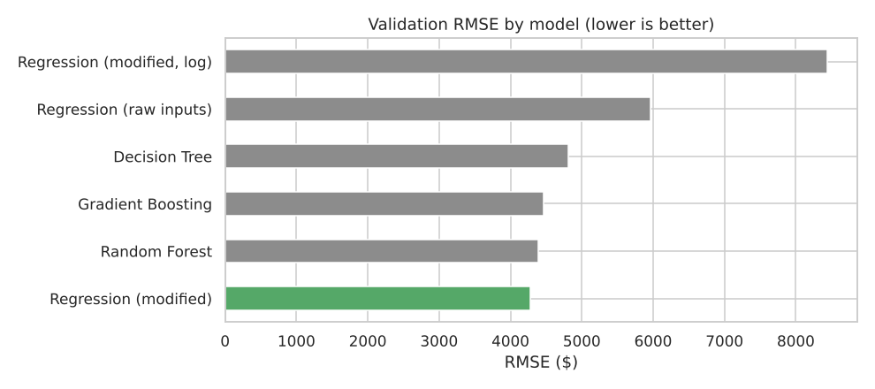
Validation RMSE by model: the engineered linear regression wins
Model | RMSE | MAE | R²
Regression (modified) | $4,279 | $2,349 | 0.860
Random Forest | $4,392 | $2,539 | 0.852
Gradient Boosting | $4,464 | $1,732 | 0.847
Decision Tree | $4,808 | $2,855 | 0.823
Regression (raw inputs) | $5,963 | $4,184 | 0.727
Regression (modified, log) | $8,442 | $4,667 | 0.453

Three lessons sit in this table.
1. Modify did most of the work. Adding three engineered interaction features moved linear regression from R² 0.73 to 0.86. That was enough to beat both ensembles on RMSE, and the model stays fully interpretable. Each coefficient is a dollar effect an underwriter can read.
[IMAGE 4 — upload: SEMMA_Insurance-Cost\figures\07_importance.png]
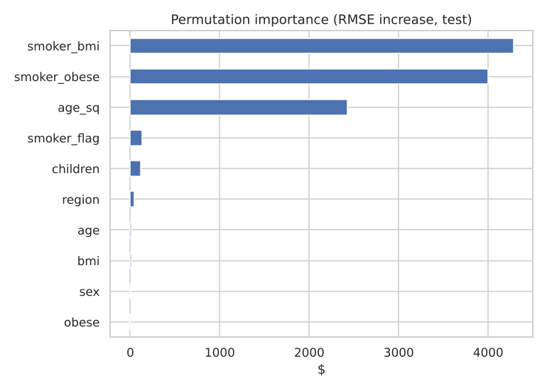
Permutation importance of the champion: the smoker interaction features dominate
2. Assess rejected a hypothesis that Explore suggested. The log target looked right because the distribution became symmetric. But it produced the worst model. The smoker effect behaves like a roughly fixed dollar surcharge, and a log-scale model distorts that. This is why SEMMA keeps Explore and Assess as separate steps: visual intuition has to be confirmed on held-out data.
3. Metrics disagree for a reason. Gradient boosting has the lowest MAE, so it is best on typical policies. But it makes bigger errors on the expensive tail, which RMSE penalises. For an insurer, mis-pricing the expensive tail is the costly mistake.
Champion on the untouched test set: RMSE $4,261, MAE $2,306, R² 0.875.
[IMAGE 5 — upload: SEMMA_Insurance-Cost\figures\05_pred_vs_actual_test.png]
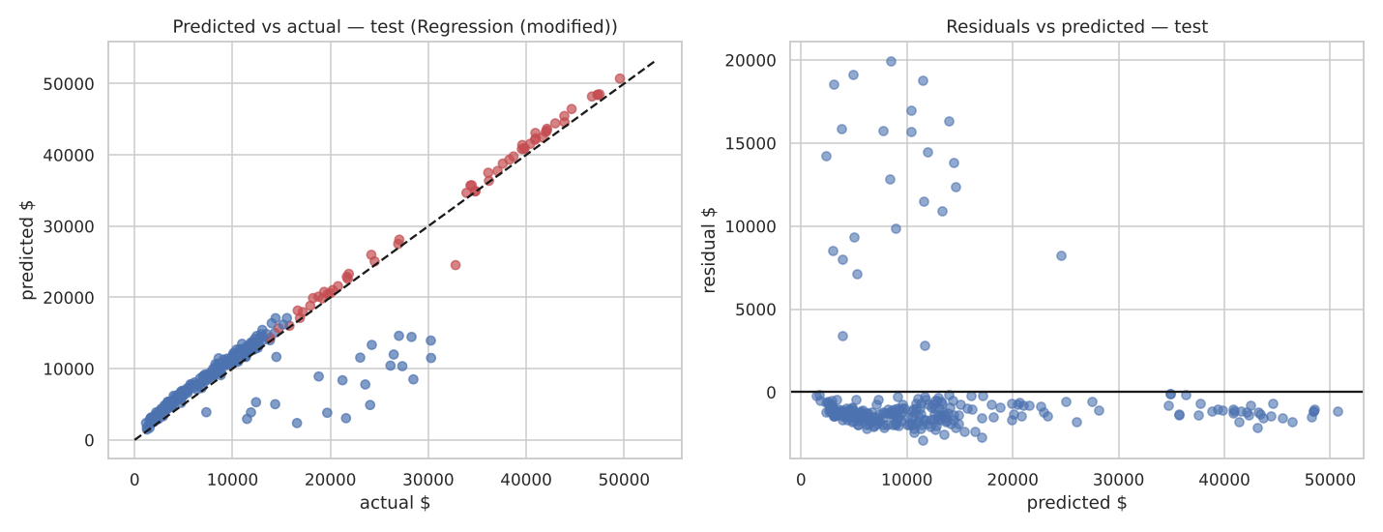
Predicted vs actual charges and residuals on the test partition
[IMAGE 6 — upload: SEMMA_Insurance-Cost\figures\06_decile_assessment.png]
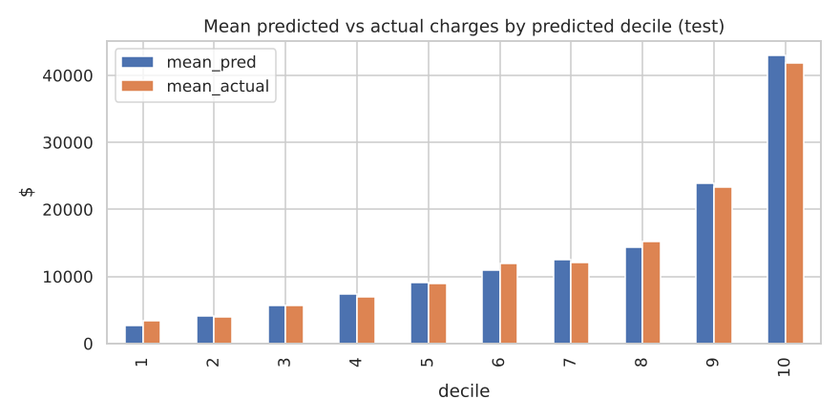
Mean predicted vs actual charges by predicted decile (test partition)
The decile chart confirms the model ranks risk correctly. Mean actual charges rise steadily across predicted deciles, and the top decile averages 3.1× the overall mean.
Example scores from the final model:
- 30-year-old non-smoker, BMI 24: $6,551
- the same person as a smoker: $19,449
- smoker with BMI 34: $39,533
Where SEMMA stops
SEMMA ends at Assess. The saved model and score function are the hand-off. Business framing and production monitoring are outside the method, which is exactly the gap CRISP-DM fills. A small Streamlit estimator in the repo demonstrates the hand-off.
The AI critic
Each step was critiqued by an LLM playing "the leading authority on SEMMA". Its most valuable challenge was "Explore suggested the log transform; where is the evidence it helps the model?" Testing that question changed the champion of the project. The full log is in the repo.

PUBLISHING GUIDE (do not paste this page into Medium)
Title: Beyond "People Buy Milk": Running the Full KDD Process on Grocery Baskets
Subtitle: Selection, preprocessing, transformation, data mining and interpretation: discovering validated shopping patterns from 9,835 real transactions.
Tags (Medium allows 5): Data Science, Data Mining, Association Rules, Market Basket Analysis, Python
Cover / featured image: KDD_Grocery-Basket\figures\05_lift_heatmap.png (in Medium: ··· menu → Story settings → Change preview image)
How to publish
- Go to medium.com/new-story.
- Type the Title into the title line, press Enter, then type the Subtitle (Medium shows it as the subtitle).
- Copy the article (everything after this guide, starting from the paragraph below the subtitle) and paste it into Medium. Headings, bold, lists and links carry over.
- Tables: Medium has no tables. Screenshot each table in this Word file and insert it as an image, or rewrite it as a bullet list.
- Images: wherever you see a red [IMAGE n — upload …] line, delete that line in Medium, click the + button on the empty line → image icon → upload that file from your repo's figures folder. Paste the grey caption under the image.
- Replace every red [ADD LINK] with your YouTube link (or delete it if the video isn't up yet).
- Click Publish → add the 5 tags → Publish now. Copy the URL from the browser: that is your Medium link for the README.
Images in this article (in order)
1. KDD_Grocery-Basket\figures\01_basket_size_item_support.png — Basket size distribution and the 25 most frequent items
2. KDD_Grocery-Basket\figures\02_runtime.png — Mining time vs minimum support for Apriori and FP-Growth
3. KDD_Grocery-Basket\figures\03_rules_scatter.png — Item-level rules: support vs confidence, coloured by lift
4. KDD_Grocery-Basket\figures\04_holdout_lift.png — Rule lift on discovery vs hold-out baskets: 97% of rules stay above 1
5. KDD_Grocery-Basket\figures\05_lift_heatmap.png — Pairwise lift among the 16 most frequent items (red = bought together more than chance)

Beyond "People Buy Milk": Running the Full KDD Process on Grocery Baskets
Selection, preprocessing, transformation, data mining and interpretation: discovering validated shopping patterns from 9,835 real transactions.
Anshita Shah · MSSE, San José State University
📓 Colab notebook · 💻 GitHub · 🎥 Video walkthrough [ADD LINK]
In 1996, Fayyad, Piatetsky-Shapiro and Smyth defined Knowledge Discovery in Databases (KDD) as the non-trivial process of finding patterns that are valid, novel, potentially useful and ultimately understandable. Their key point was that data mining is just one step in that process.
I took that definition literally. I applied it to market basket analysis, where it is easy to run Apriori and print a list of rules that nobody can trust or act on.
Data: the Groceries dataset (Hahsler et al.), one month of real point-of-sale data. It has 9,835 baskets and 169 product categories.
Step 0: Know the domain
Grocery staples dominate. Whole milk appears in about 25% of baskets. So the success criteria have to go beyond frequency. Each part of the definition got a measurable test:
KDD property | How I measured it
Valid | Fisher's exact test, Bonferroni-corrected, and lift > 1 on a hold-out set
Novel | consequent is not a mega-staple (whole milk, other vegetables)
Useful | maps to a merchandising action; recommender evaluated against a baseline
Understandable | short, human-readable rules

Step 1: Selection
Target data: every basket, with item presence recorded (quantities and prices aren't in the source).
Step 2: Preprocessing
[IMAGE 1 — upload: KDD_Grocery-Basket\figures\01_basket_size_item_support.png]
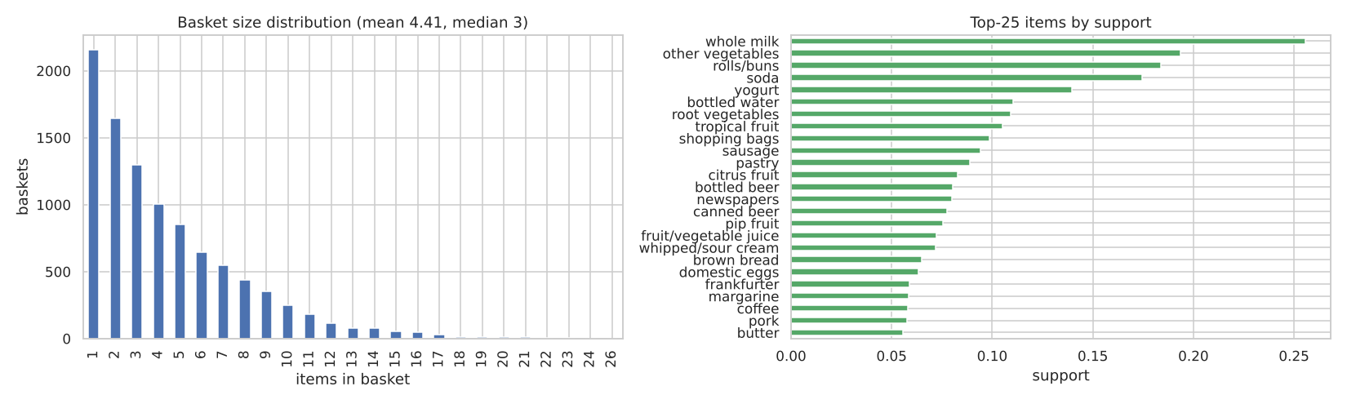
Basket size distribution and the 25 most frequent items
- Normalised item names and removed duplicates within baskets.
- Removed "shopping bags". It is in the top-10 items but it's a checkout artefact, not a product. Leaving it in would produce noise rules like {shopping bags} → {soda}. This is domain-knowledge cleaning, which an algorithm can't do for you. 48 baskets contained only bags and were dropped, leaving 9,787.
- Kept single-item baskets. They can't form rules, but dropping them would inflate every support value and bias lift.
Step 3: Transformation
This step is what separates KDD from "just preprocessing":
- Encoding baskets into a Boolean transaction matrix.
- Reduction: items below 0.5% support can't appear in any rule at my threshold. Removing them leaves 119 of 169 items.
- Concept hierarchy: mapping items to departments (dairy, produce, bakery and so on) creates a second, coarser view for multi-level mining.
- Hold-out split: 80% of baskets for discovery, 20% kept aside to validate the knowledge.
Step 4: Data mining
I ran both Apriori and FP-Growth at 1% minimum support. They produced the identical 322 frequent itemsets, which serves as a correctness check. At this data size their runtimes are similar (tens of milliseconds). FP-Growth's advantage shows up as support drops, as the runtime chart below shows.
[IMAGE 2 — upload: KDD_Grocery-Basket\figures\02_runtime.png]
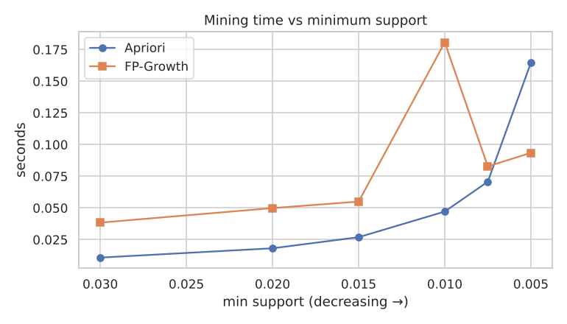
Mining time vs minimum support for Apriori and FP-Growth
This gave 592 rules with lift > 1 at the item level, plus 44 department-pair rules.
[IMAGE 3 — upload: KDD_Grocery-Basket\figures\03_rules_scatter.png]
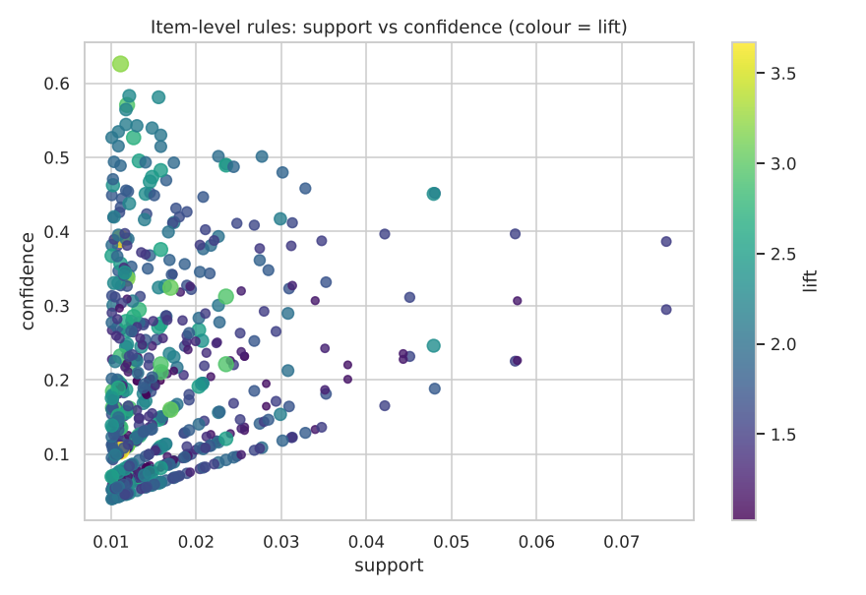
Item-level rules: support vs confidence, coloured by lift
Step 5: Interpretation and evaluation
This step turns patterns into knowledge. Most of the work is filtering.
Filter | Rules left
Mined (lift > 1) | 592
Significant (Fisher, Bonferroni α = 8.5×10⁻⁵) | 468
Non-redundant (simpler rule isn't equally good) | 466
Lift still > 1 on unseen hold-out baskets | 454 (97%)
Confidence ≥ 0.30 and lift ≥ 1.5 | 112
…with a non-staple consequent ("novel") | 18

[IMAGE 4 — upload: KDD_Grocery-Basket\figures\04_holdout_lift.png]
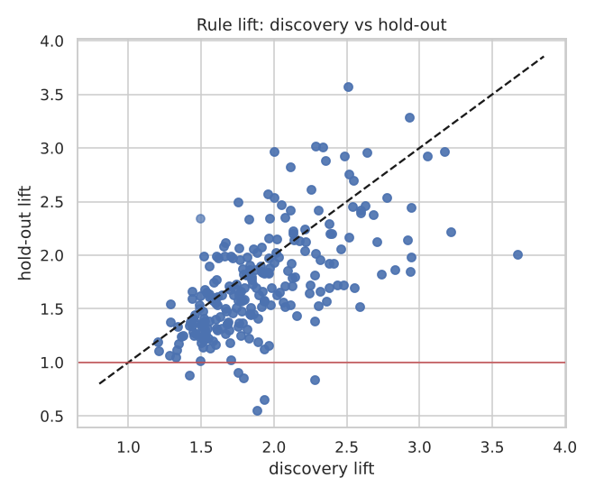
Rule lift on discovery vs hold-out baskets: 97% of rules stay above 1
Iteration. My first pass gave a wall of rules ending in whole milk. They were valid but obvious. Following KDD's iterative loop, I went back and tightened the evaluation criteria so the obvious rules were separated from the novel ones.
Some of the knowledge that survived every filter:
Rule | Lift | Hold-out lift
{beef} → {root vegetables} | 3.05 | 2.92
{other vegetables, tropical fruit} → {root vegetables} | 3.17 | 2.97
{tropical fruit, whole milk} → {yogurt} | 2.59 | 2.39
{curd} → {yogurt} | 2.25 | 2.62
{berries} → {yogurt} | 2.38 | 1.70

[IMAGE 5 — upload: KDD_Grocery-Basket\figures\05_lift_heatmap.png]
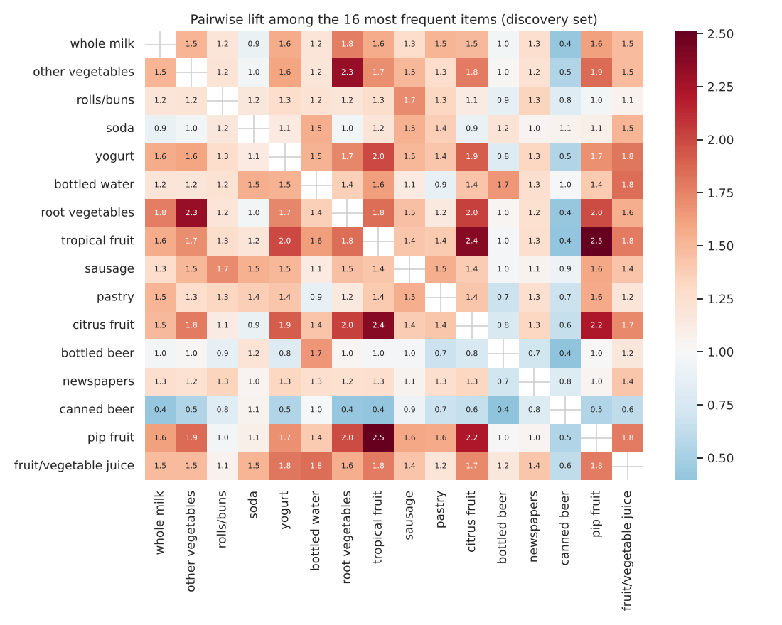
Pairwise lift among the 16 most frequent items (red = bought together more than chance)
Consolidated knowledge:
- "Cooking a meal" mission. Beef buyers are about 3× more likely than average to also buy root vegetables. That suggests recipe displays near the butcher counter.
- "Fresh & chilled" mission. Fruit, curd and cream buyers over-index on yogurt. Keep yogurt near fruit and run yogurt offers for fruit buyers.
- Department level. The highest-lift department pairs (pantry with household goods, pantry with meat & fish) point to cross-merchandising opportunities.
Is the knowledge useful? An honest test
I turned the rules into a "frequently bought together" recommender. To test it, I hid one item from each hold-out basket and checked whether it was recommended (hit-rate@5):
Recommender | Hit-rate@5
Rules only | 14.9%
Most-popular items | 27.2%
Hybrid (rules first, popularity fills the gaps) | 27.6%

The rules alone lose to simply recommending popular items. They are precise but sparse: for most baskets, only one or two rules fire. That is a genuine KDD evaluation result. The knowledge is most valuable for merchandising decisions and as a re-ranking layer on top of popularity, not as a stand-alone recommender. Reporting it this way is more honest, and more useful, than presenting the rules list on its own.
How KDD differs from CRISP-DM and SEMMA
- The goal is understandable knowledge, not a model with a business KPI, and there is no target variable.
- Transformation is a first-class step. The concept hierarchy produced knowledge at a level the raw data couldn't show.
- Interpretation/Evaluation asks four questions: valid, novel, useful, understandable. Answering them sent me back through the process.
The full notebook, critic logs (an LLM playing "the leading KDD authority"), rules.json and a Streamlit app are on GitHub.

