
INDIAN INSTITUTE OF INFORMATION TECHNOLOGY , LUCKNOW

REPORT ANALYSIS

NAME : Anshi Gupta
ROLL NO. : MSD23003
BRANCH : Msc. Data Science
SUBJECT : Data Mining

Credit Card Customer Segmentation Using K-Means Clustering

Introduction
Customer segmentation is a fundamental strategy in customer relationship management (CRM). This project uses K-Means clustering, an unsupervised machine learning algorithm, to segment customers based on their credit card usage patterns. These segments will help the bank better understand customer behaviour and tailor services accordingly.
To enhance accessibility and provide stakeholders with an interactive experience, we developed a Streamlit application that visualizes the customer segmentation and business scenarios derived from this analysis.

Problem Statement
Credit card companies need to understand their customer base better to provide personalized services, manage risks, and improve customer satisfaction. This project aims to segment credit card customers based on their behavioral and financial attributes using K-Means clustering. The segmentation enables targeted marketing strategies and better resource allocation.
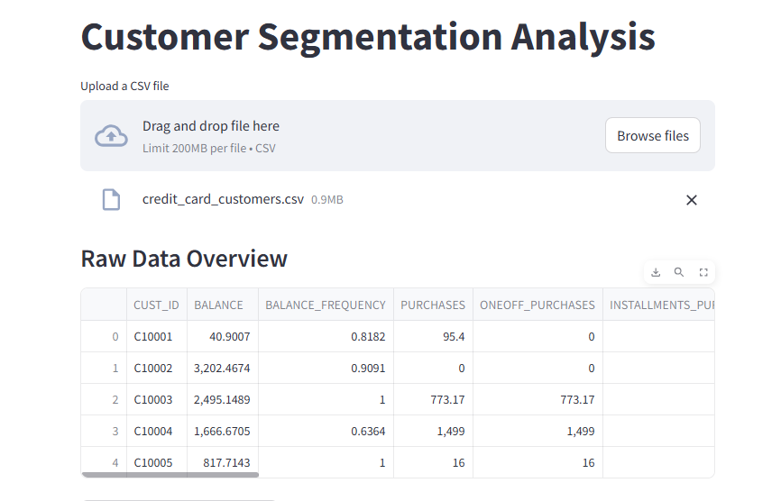

Objective
The primary goals of this project are:
- Segment credit card customers into distinct groups using machine learning.
- Identify actionable insights to improve customer retention and engagement.
- Provide a foundation for personalized services and targeted marketing strategies.

Data Overview
Dataset:
- The dataset used, credit_card_customers.csv, contains anonymized information about customer credit card usage.
- Key features include:
  - Demographic data (e.g., age, income).
  - Behavioural metrics (e.g., total spending, payment delays).
  - Financial statistics (e.g., balance, credit limit).

Workflow and Methodology
Step 1: Importing Libraries
The following Python libraries were used:
- Data Manipulation & Visualization: pandas, numpy, matplotlib, seaborn.
- Machine Learning Tools: scikit-learn for K-Means and preprocessing.
- Clustering Evaluation: yellowbrick for visualizations like the Elbow Method and Silhouette plots.
Step 2: Data Import and Inspection
The dataset was imported and analyzed for:
- Shape and Structure: Checked using .shape and .head() methods.
- Missing Values: Identified and handled to avoid skewed results.
Step 3: Exploratory Data Analysis (EDA)
- Statistical Summary: Summarized key statistics (mean, median, etc.) to understand data distribution.
- Feature Correlation: Correlation heatmap identified relationships between variables.
- Outlier Detection: Boxplots helped in identifying and handling extreme values.
Step 4: Data Preprocessing
To ensure effective clustering:
- Standardization: Features were scaled using StandardScaler to normalize the data.
- Feature Selection: Irrelevant columns were removed to focus on impactful variables like spending and payment behaviour.
Step 5: Applying K-Means Clustering
- Choosing the Optimal Number of Clusters:
  - The Elbow Method was used to analyze the variance explained by each cluster.
  - The "elbow point" indicated the ideal number of clusters.
- Clustering Process:
  - Applied K-Means with the optimal number of clusters.
  - Calculated cluster centroids to identify unique customer groups.
- Evaluation:
  - The Silhouette Score was used to assess cluster quality.
  - Visualizations (e.g., scatter plots) illustrated clear separations between clusters.
Step 6: Insights and Interpretation
The clusters revealed distinct patterns in customer behaviour:
- Cluster 1 (High Spenders):
  - Characteristics: High credit utilization, frequent transactions.
  - Recommendation: Offer premium services and exclusive benefits.
- Cluster 2 (Moderate Users):
  - Characteristics: Balanced usage and consistent payments.
  - Recommendation: Cross-sell related products, such as savings accounts.
- Cluster 3 (Dormant Users):
  - Characteristics: Low activity and low balances.
  - Recommendation: Re-engagement campaigns to increase activity.

Streamlit Application Development
- Objective: To make the analysis results and business scenarios interactive and accessible to stakeholders.
- Features:
  - Visualizations of customer clusters.
  - Business insights based on segmentation (e.g., recommendations for each cluster).
  - Interactive input options to explore scenarios (e.g., changing parameters to see how segmentation varies).
- How It Works:
  - The app uses the Streamlit framework to render insights dynamically.
  - The backend integrates pre-computed cluster results with visualizations powered by Matplotlib and Seaborn.
  - Link to the streamlit app :- https://creditcardcustomersegmentation-hphcsy7wpzscpys2hj4bo8.streamlit.app/

Results and Findings
Key Metrics:
- Optimal Clusters: Determined using the Elbow Method ( 3 clusters).
- Silhouette Score: A score of 0.25 indicated well-defined clusters .
Visualizations:
- Elbow Plot:
  - Showed a clear "elbow point" at the optimal number of clusters.
- Silhouette Plot:
  - Demonstrated the quality of clustering, with most samples assigned to distinct clusters.
- Scatter Plot:
  - Displayed clusters with identifiable patterns, aiding in interpretation.
The Streamlit application serves as an interface for stakeholders to explore cluster insights interactively. It visualizes clusters using scatter plots and silhouette analysis, and also provides tailored recommendations for each customer segment.

Challenges and Solutions
- Challenge: Missing values in key features.
  - Solution: Imputed missing values using mean/median imputation to retain dataset integrity.
- Challenge: Determining the optimal number of clusters.
  - Solution: Used the Elbow Method and Silhouette Score for validation.
- Challenge: Interpretability of clusters.
  - Solution: Analyzed centroids and used domain knowledge to label clusters meaningfully.

Conclusions
The K-Means clustering analysis successfully segmented credit card customers into distinct groups. These insights can assist businesses in devising personalized marketing strategies, identifying high-value customers, and optimizing credit risk management. Future work could explore additional features or apply alternative clustering methods to refine the segmentation.
The Streamlit app bridges the gap between technical analysis and business understanding by presenting interactive visualizations and insights. This ensures stakeholders can make informed decisions based on the clustering results.

Recommendations
- Focus marketing efforts on high spenders with tailored offers.
- Create educational campaigns for moderate users to increase service adoption.
- Design re-engagement strategies to activate dormant customers.

Thank You

