Table of Contents
Phase 3: Data Strategy & Dataset Creation 1
ADIP — AI-Powered Architecture Decision Intelligence Platform 1
1. Purpose of This Phase 1
2. The Final Target 1
3. Task Ownership 1
4. Data Source Inventory 1
5. How These Sources Fill the Schema 1
6. Data Folder Structure 1
7. Processing Principle: Don’t Combine Immediately 1
8. Final Dataset Design: Five Datasets, Not One 1
9. From Five Datasets to the ML Table 1
10. Quality, Versioning & Storage (Supporting Roles) 1
11. Next Steps (Phase 4 Preview) 1

Phase 3: Data Strategy & Dataset Creation

ADIP — AI-Powered Architecture Decision Intelligence Platform
Project Type: AI/ML + Full-Stack Systems Portfolio Project
Phase: 3 — Data Strategy & Dataset Creation
Primary Owner: Anshika (largest responsibility this phase)
Supporting: Ananya, Akriti, Shruti
Document Version: 1.1

1. Purpose of This Phase
Phase 1 fixed the system architecture; Phase 2 fixed the requirements (what the system accepts and produces). Phase 3 defines where the data comes from and how it becomes ML-ready — the data sources, collection strategy, folder structure, processing pipeline, and the final dataset schemas that the ML Prediction Engine (Phase 4 onward) will be trained on.
This is primarily Anshika’s responsibility, since ADIP’s core value proposition depends on a well-constructed, leakage-free, versioned dataset connecting architecture choices to measurable performance and cost outcomes.

2. The Final Target
The end-to-end research story Phase 3 is building toward:
PUBLIC DATA
│
├── Production traces
├── Benchmarks
├── Architecture datasets
├── Database workloads
└── Cloud pricing
│
▼
DATA NORMALIZATION
│
▼
ADIP CONTROLLED DATA
│
▼
FEATURE ENGINEERING
│
▼
ML DATASET
│
├── Latency
├── Throughput
├── CPU
├── Memory
├── Cost
└── Reliability
│
▼
ADIP ML MODELS
│
┌──────┼──────┐
▼ ▼ ▼
Predict What-if Recommend
│
▼
SHAP
│
▼
RAG + LLM
Public data (production traces, benchmarks, architecture datasets, database workloads, cloud pricing) is normalized and combined with ADIP’s own controlled experiments, then feature-engineered into the ML dataset that trains the Latency, Throughput, CPU, Memory, Cost, and Reliability models. Those models drive Prediction, What-if analysis, and Recommendation, with SHAP explaining predictions and RAG + LLM turning that evidence into natural-language answers — closing the loop back to the Intelligence Layer defined in Phase 1.

3. Task Ownership
Owner | Responsibility
Anshika | Data source research, data collection pipeline, dataset schema design
Ananya | Dataset quality checks, statistical validation, train/test methodology, data leakage checks, feature stability, dataset versioning
Akriti | PostgreSQL schema, data storage APIs, database integration
Shruti | Dataset storage infrastructure, S3/object storage (if required), secure data access

3.1 Anshika — Data Source Research
Investigate:
- TPC benchmarks
- YCSB
- TechEmpower
- Cloud pricing
- Controlled experiments
- Simulation data
- Research datasets
- Public benchmark reports

3.2 Anshika — Data Collection Pipeline
Raw Data
↓
Data Ingestion
↓
Data Cleaning
↓
Data Validation
↓
Feature Engineering
↓
Final Dataset

3.3 Anshika — Dataset Schema (Illustrative Field List)
architecture_pattern
database
cache
messaging
api_style
deployment
users
rps
concurrency
data_size
read_write_ratio
cpu
memory
latency
throughput
cost
reliability
scalability

4. Data Source Inventory

4.1 Core Sources (Retained)
# | Source | Role
1 | Zenodo Microservices Benchmark | Performance data
2 | Alibaba Microservices Trace | Production microservices behavior
3 | TechEmpower Framework Benchmarks | Web/application benchmarks
4 | Barista | Microservice performance
5 | Software-Architecture (Hugging Face) | Architecture knowledge / RAG
6 | Technical-Architectures-Large (Hugging Face) | Architecture / graph / LLM data
Source references: -
- Zenodo Microservices Benchmark — https://zenodo.org/records/6907619
- Alibaba Cluster Trace (Microservices v2021) —https://github.com/alibaba/clusterdata/tree/master/cluster-trace-microservices-v2021
- TechEmpower FrameworkBenchmarks — https://github.com/TechEmpower/FrameworkBenchmarks
- Barista Benchmarks — https://github.com/barista-benchmarks/barista
- Software-Architecture dataset — https://huggingface.co/datasets/ajibawa-2023/Software-Architecture
- Technical-Architectures-Large dataset — https://huggingface.co/datasets/ajibawa-2023/Technical-Architectures-Large

4.2 Additional Sources

# | Additional Source | Why It’s Needed | Priority
7 | YCSB | Database workload, read/write ratio, latency, throughput | High
8 | TPC Benchmarks | Standardized DB/transaction workloads and performance | Medium
9 | Cloud Pricing Data | Cost prediction | High
10 | Own Controlled Experiments | Connects architecture → workload → performance directly | Essential

4.3 Reference Application Sources (Architecture Specifications)
Alongside the benchmark and pricing sources, ADIP also draws on open reference microservice applications for realistic architecture topologies and dependency graphs:
Source | Role
DeathStarBench | Realistic microservice benchmark application suite (social network, hotel reservation, media service)
Train-Ticket | Large open-source microservices reference application (railway ticketing)
Online Boutique | Google’s open-source microservices demo e-commerce application
OpenTelemetry Demo | Reference distributed application instrumented for tracing/observability

5. How These Sources Fill the Schema
Not all sources contribute the same kind of information, and mixing them without distinction would blur the dataset’s quality guarantees. ADIP’s raw data falls into five distinct types, and keeping them separate is central to the research methodology.

Type A — Real Production Traces
- Alibaba Microservices Trace
Real-world operational behavior: actual production traffic, resource usage, and call graphs. Highest ecological validity, but uncontrolled (confounded by factors ADIP doesn’t model).

Type B — Controlled Benchmark Measurements
- Zenodo
- Barista
- TechEmpower
- YCSB
- TPC
Measurements from repeatable, controlled test setups. These directly supply performance fields (latency, throughput, cpu, memory) under known, varied conditions — the closest match to ADIP’s Performance dataset (Dataset D).

Type C — Architecture / Application Specifications
- Technical-Architectures-Large
- DeathStarBench
- Train-Ticket
- Online Boutique
- OpenTelemetry Demo
Concrete architecture topologies: service counts, dependency graphs, database/cache/messaging choices, deployment style. This is the primary source for Dataset B (Architecture) fields such as architecture_pattern, service_count, database, cache, messaging, deployment.

Type D — Knowledge / Text
- Software-Architecture
- Technical documentation
- Research papers
- Architecture decision records
- Cloud documentation
Unstructured knowledge used for the RAG + LLM layer (Phase 1, Section on RAG), not for training the numeric ML models directly. This is what grounds the LLM Advisor’s natural-language explanations.

Type E — ADIP-Generated Data
- ADIP Controlled Experiments
- ADIP Simulation Data
Data ADIP generates itself by running controlled experiments and simulations across architecture/workload combinations. This is the only source type that directly connects a specific architecture to a specific workload to a specific measured outcome under ADIP’s own controlled conditions — which is why it’s marked Essential priority in Section 4.2. It anchors and calibrates everything inferred from Types A–D.
Keeping these five types distinct (rather than merging them into one undifferentiated pool) keeps the research methodology auditable: every field in the unified dataset can be traced back to the type of evidence that produced it, and the quality/trust level of a given row is known rather than assumed.

6. Data Folder Structure
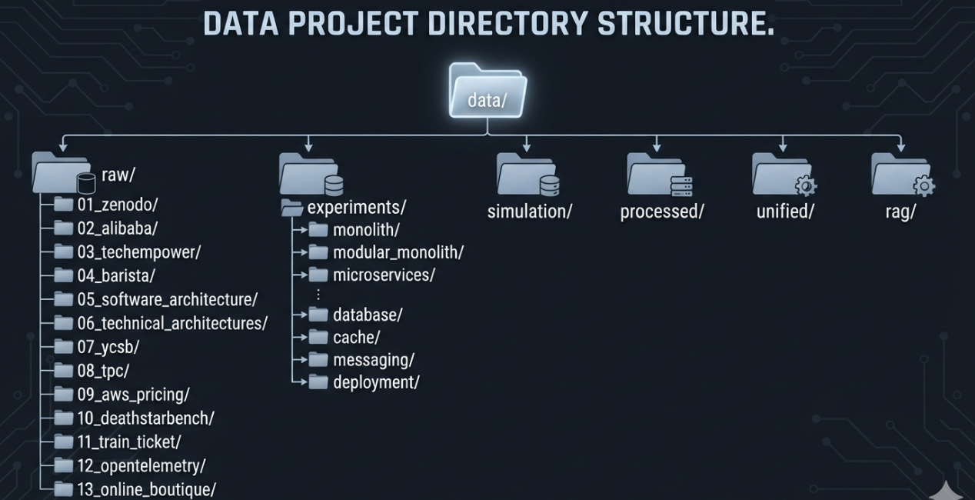
Notes on the structure: - raw/ holds every external source (Types A, B, C from Section 5) untouched, one subfolder per source, numbered for processing order. - experiments/ holds ADIP’s own controlled experiments (Type E), organized by the architectural dimension being varied — monolith/modular monolith/microservices, database, cache, messaging, deployment — so each experiment’s independent variable is obvious from its path. - simulation/ holds ADIP-generated simulation output (also Type E), kept separate from real controlled experiments so the two are never silently conflated. - processed/ holds standardized, per-source cleaned data (still traceable to its origin). - unified/ holds the final ML-ready joined datasets (Datasets A–E from Section 8). - rag/ holds the chunked/embedded knowledge base built from Type D sources, feeding pgvector for the RAG + LLM layer.

7. Processing Principle: Don’t Combine Immediately
This is extremely important. Raw data must remain untouched.
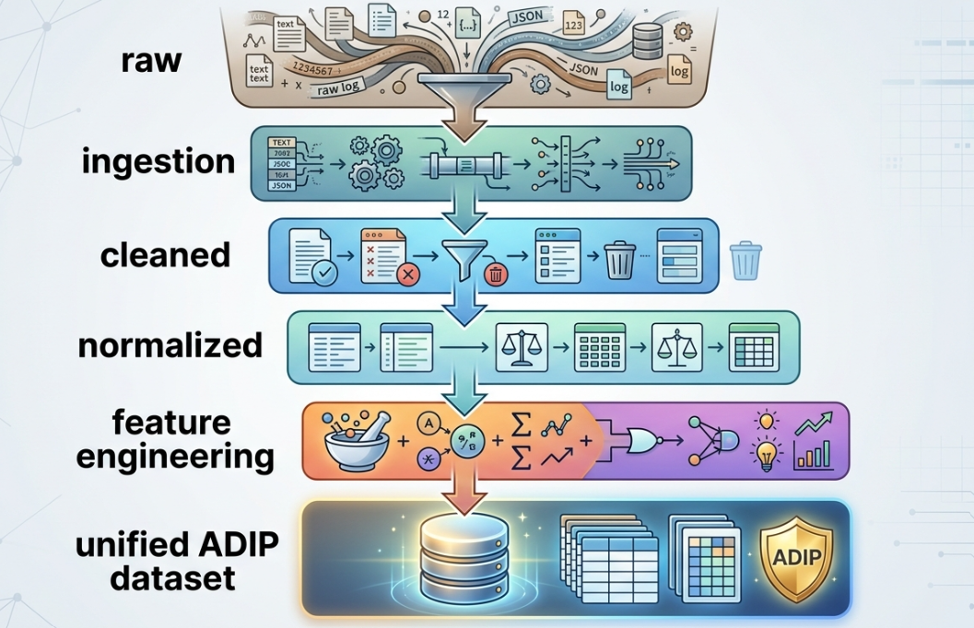
Sources stay separate at the raw layer:
raw/alibaba/
raw/barista/
raw/ycsb/
raw/zenodo/
The processed/ directory contains standardized versions of each source (consistent column names, units, and types — still per-source).
The unified/ directory contains the final ML-ready representation, built only after each source has been independently cleaned and validated. Keeping raw sources untouched and separated preserves traceability, allows re-processing without re-downloading, and makes it possible to isolate a data quality issue to a single source rather than the whole pipeline.

8. Final Dataset Design: Five Datasets, Not One
Instead of one enormous CSV, ADIP produces five linked datasets, each with a clear grain and purpose. This mirrors the Requirement / Architecture / Workload / Infrastructure separation already established in Phase 1 and Phase 2.

Dataset A — Requirements
- project_id
- domain
- users
- concurrency
- rps
- peak_rps
- data_size
- read_write_ratio
- latency_sla
- availability_sla
budget
- traffic_growth
team_size

Dataset B — Architecture
- architecture_id
- architecture_pattern
- architecture_style
- service_count
- database
- cache
- messaging
- api_style
- deployment
- cloud
- replica_count
- cpu_limit
- memory_limit
- node_count
- edge_count

Dataset C — Workload
- workload_id
- rps
- concurrency
- read_write_ratio
- data_size
- request_size
- workload_type
- traffic_pattern

Dataset D — Performance
- experiment_id
- architecture_id
- workload_id
- cpu memory
p50
p90
p95
p99
- throughput
- error_rate
- db_latency
- cache_hit_rate
- network_latency

Dataset E — Cost
- architecture_id
- cloud
- region
- instance_type
- instance_count
- storage
- network
- database_cost
- cache_cost
- compute_cost
- monthly_cost

9. From Five Datasets to the ML Table
The five datasets above are linked via architecture_id / workload_id and joined to produce the training tables used by the ML Prediction Engine:
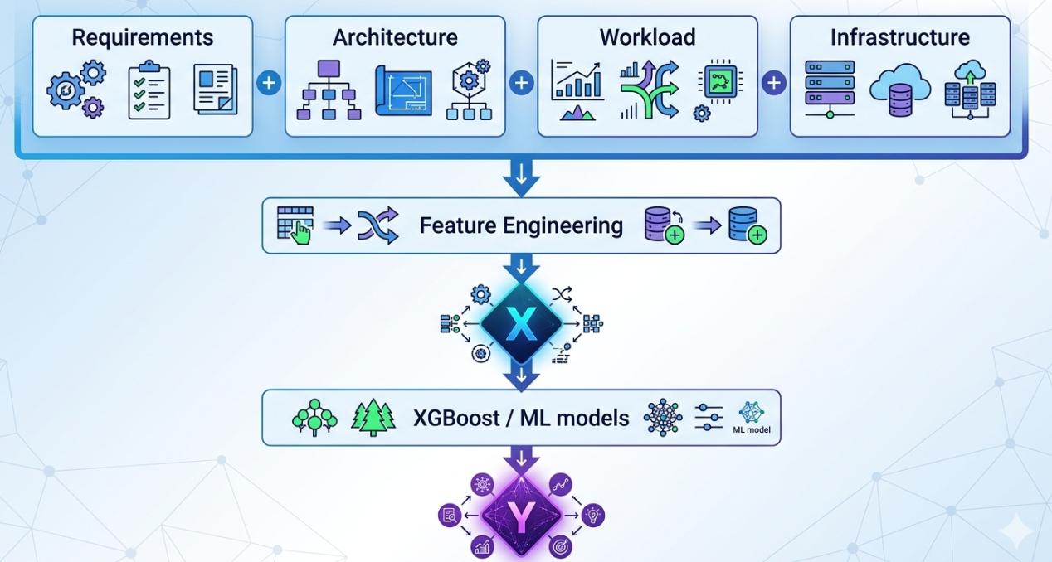

9.1 Latency Model
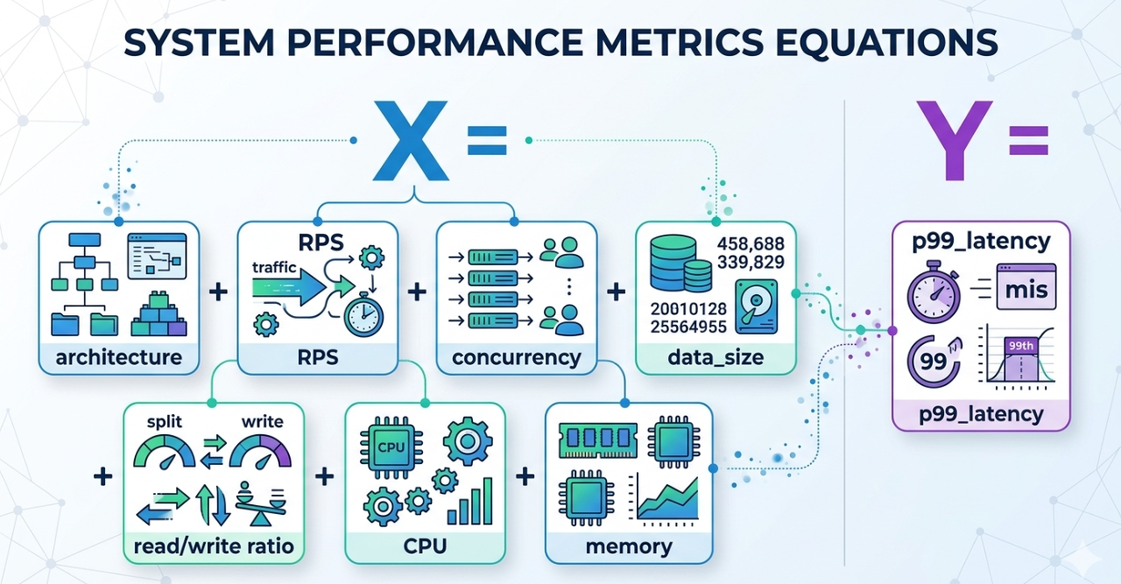

9.2 Throughput Model

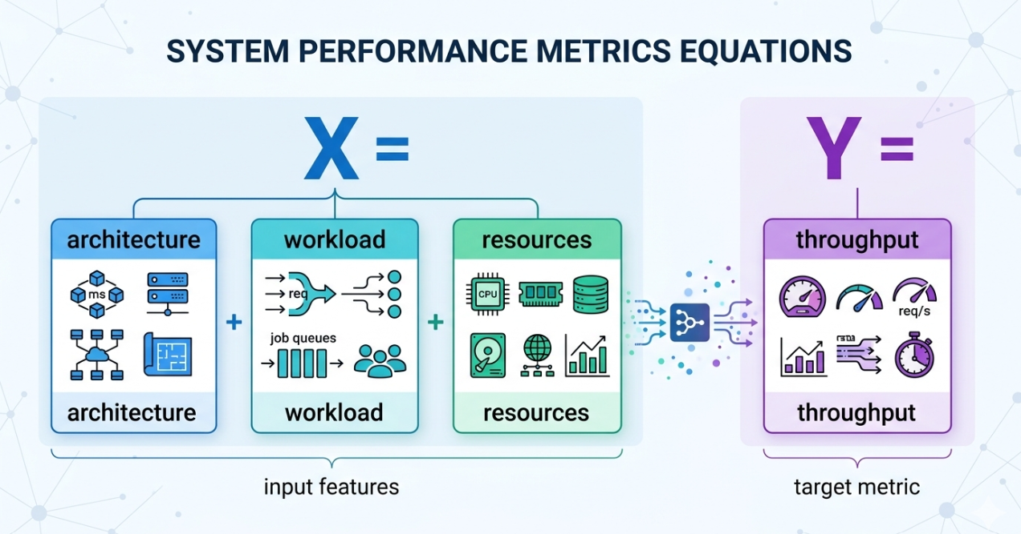

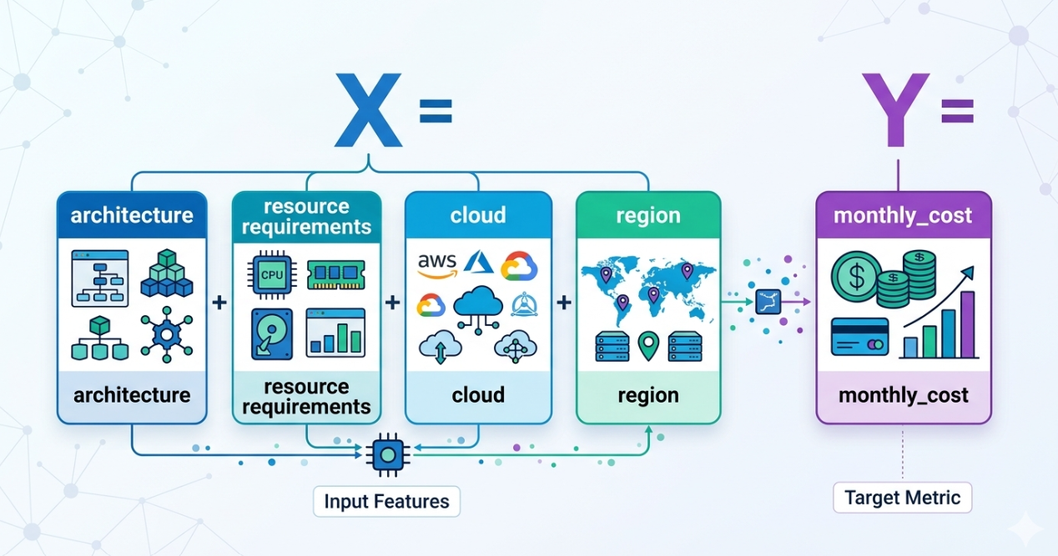
9.3 Cost Model

This structure lets Dataset D (Performance) and Dataset E (Cost) each drive their own target variable while sharing the same architecture_id/workload_id feature backbone from Datasets B and C — keeping the latency, throughput, and cost models consistent and comparable.

10. Quality, Versioning & Storage (Supporting Roles)
Area | Owner | Checks/Setup
Dataset quality checks | Ananya | Missing values, outliers, schema conformance per source
Statistical validation | Ananya | Distribution checks, correlation review, sanity bounds on latency/cost
Train/test methodology | Ananya | Split strategy (e.g., by architecture_id/time) to avoid overlap
Data leakage checks | Ananya | Confirm no target-derived fields leak into features (e.g., cost into latency features)
Feature stability | Ananya | Monitor feature distributions across dataset versions
Dataset versioning | Ananya | Version tags per unified dataset release, tracked alongside MLflow experiments
PostgreSQL schema | Akriti | Tables for Requirements, Architecture, Workload, Performance, Cost
Data storage APIs | Akriti | FastAPI endpoints/services for reading processed & unified data
Database integration | Akriti | Connecting unified datasets into the application data layer
Dataset storage infrastructure | Shruti | Directory/object layout for raw / experiments / simulation / processed / unified / rag
S3 / object storage | Shruti | If local storage is insufficient for raw benchmark data
Secure data access | Shruti | Access control for raw sources and generated datasets

11. Next Steps (Phase 4 Preview)
With the five-dataset structure, source typing, and processing pipeline defined, Phase 4 moves into Data Preparation & Feature Engineering:
- Implementing ingestion scripts per source (01_zenodo through 13_online_boutique)
- Standardizing units and schemas into processed/
- Populating experiments/ and simulation/ with ADIP’s own Type E data
- Joining Datasets A–E into the unified ML table(s) described in Section 9
- Engineering derived features (e.g., architecture complexity scores, workload intensity ratios)
- Establishing the initial train/validation/test split per Ananya’s methodology
- Loading unified datasets into PostgreSQL per Akriti’s schema
- Building the rag/ knowledge base (chunking + embedding Type D sources) for pgvector

