Ames Real Estate Valuation & Decision Analytics Pipeline
End-to-End Machine Learning, Two-Tier KPI Evaluation & Strategic Decision Support
Author: Anshika Saklani | Repository: Ames-House-Sales-Prediction
Domain: Real Estate Valuation & PropTech | Model Framework: Scikit-Learn Regularized Regressors (Lasso α=50.0)

1. Executive Summary
Accurate property valuation is fundamental to residential lending, portfolio investment, and property acquisition. Traditional human appraisals are slow, expensive ($300–$500 per valuation), and vulnerable to subjective appraisal bias. This project presents an enterprise-grade, end-to-end Machine Learning and Decision Support Pipeline trained on the comprehensive Ames Housing Dataset (1,460 historic sales with 79 structural, spatial, and qualitative features).
By packaging custom feature engineering, median imputation, categorical one-hot encoding, and standard scaling into a leakage-free Scikit-learn Pipeline, our tuned Lasso Regression model achieves an R² of 91.84% with a Mean Absolute Error (MAE) of $15,182.56. Crucially, the project goes beyond statistical accuracy by introducing a Two-Tier KPI Framework and an actionable Decision & Recommendation Engine that classifies properties into acquisition actions (STRONG BUY, FAIR VALUE, PASS/NEGOTIATE) and estimates ROI on value-add renovation strategies.
2. Problem Statement & Project Objectives
2.1 Real-World Problem Definition
• What Real-World Problem is Solved? Real estate pricing opacity creates financial friction, appraisal delays, and mispriced property purchases.
• Who Faces This Problem? Institutional real estate investors (REITs), mortgage underwriters, PropTech platforms, home buyers, and appraisers.
• Why Does It Matter? Residential real estate is the largest global asset class. Even a 5% valuation error on an average home ($180k) causes a $9,000 capital misallocation or increased loan default risk.
• Decisions Supported: Automated fair market appraisal, deal acquisition filtering, counter-offer price caps, and property renovation ROI prioritization.
2.2 Concrete Project Objectives
- 1. Ingest, clean, and analyze 79 residential features from the Ames Housing Dataset with zero data leakage.
- 2. Engineer domain-specific composite metrics including HouseAge, TotalLivingArea, TotalBathrooms, and TotalPorchArea.
- 3. Systematically evaluate and cross-validate baseline OLS, Ridge, and Lasso regressors with/without polynomial feature interactions.
- 4. Establish a Two-Tier KPI Framework that balances ML statistical accuracy (R², MAE, RMSE) with enterprise business metrics (Asset Scale, Appraisal OPEX Savings, Precision Tolerance Bands, Arbitrage Profit Potential).
- 5. Deploy an automated Decision & Recommendation Engine for deal scoring and renovation ROI simulation.
- 6. Enforce software engineering reliability through a 100% passing automated test suite (Pytest).
3. Dataset Description & Exploratory Data Analysis
The project utilizes the Ames Housing Dataset (compiled by Dean De Cock), covering 1,460 residential property transactions in Ames, Iowa from 2006 to 2010. The target variable is SalePrice (continuous USD). The dataset contains 37 numerical and 43 categorical predictors describing spatial dimensions, quality ratings, construction dates, and neighborhood location.
Data Hygiene & Outlier Handling: Following De Cock's published recommendations, extreme outliers with above-ground living area exceeding 4,000 sq ft and sale prices under $300,000 were filtered out during preprocessing. Missing numerical values were imputed via median statistics computed strictly on the training folds, while categorical variables were mode-imputed and one-hot encoded with handle_unknown='ignore'.
3.1 Feature Correlation Analysis
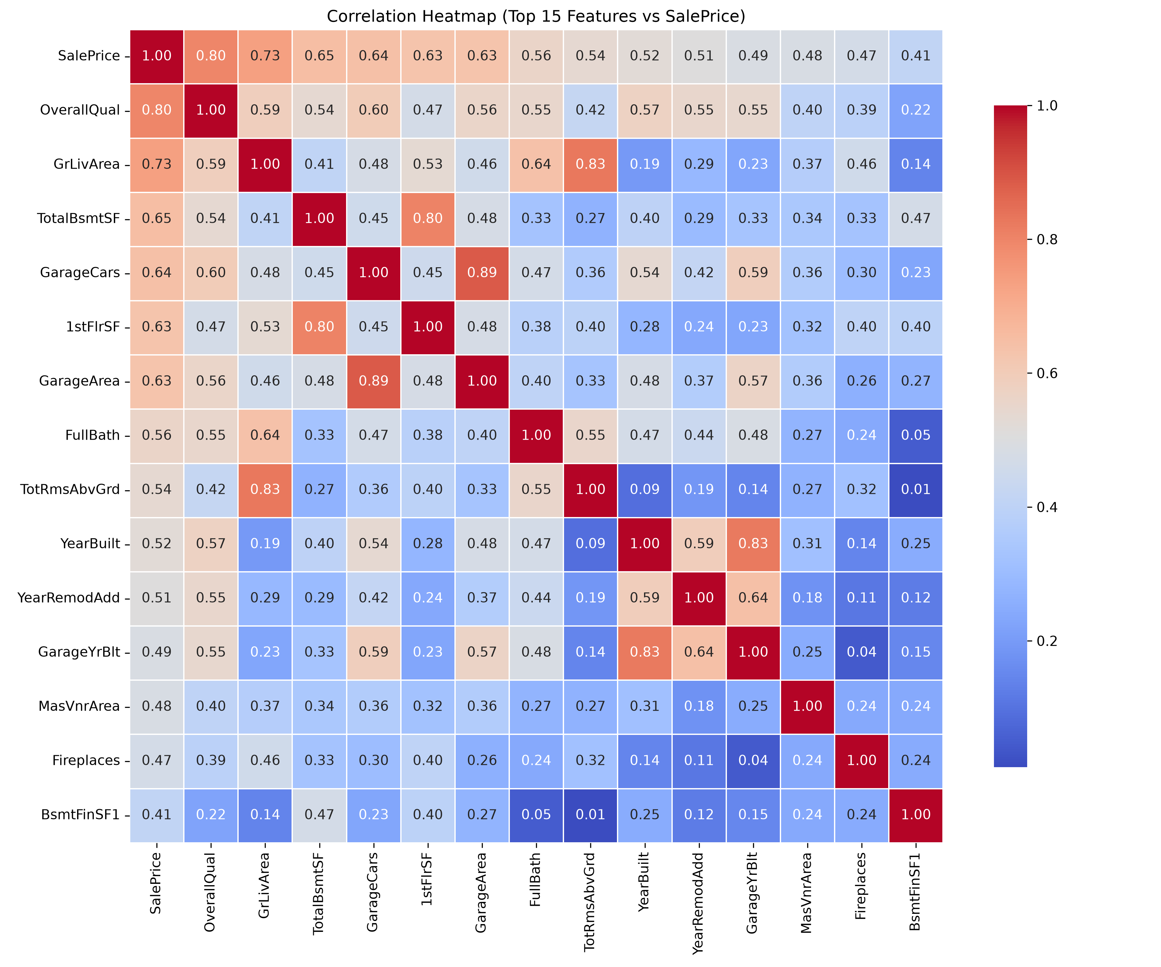
Figure 1: Target Correlation Heatmap for Top Numerical Drivers of Sale Price.
Key EDA Findings: Overall Material & Finish Quality (OverallQual, r=0.79), Above-Grade Living Area (GrLivArea, r=0.71), Total Basement Square Footage (TotalBsmtSF, r=0.61), Garage Capacity (GarageCars, r=0.64), and Construction Year (YearBuilt, r=0.52) exhibit the strongest direct linear correlations with SalePrice.
4. Machine Learning Pipeline Architecture
The end-to-end architecture is encapsulated into a modular Scikit-learn Pipeline, ensuring zero data leakage between training, validation, and inference:
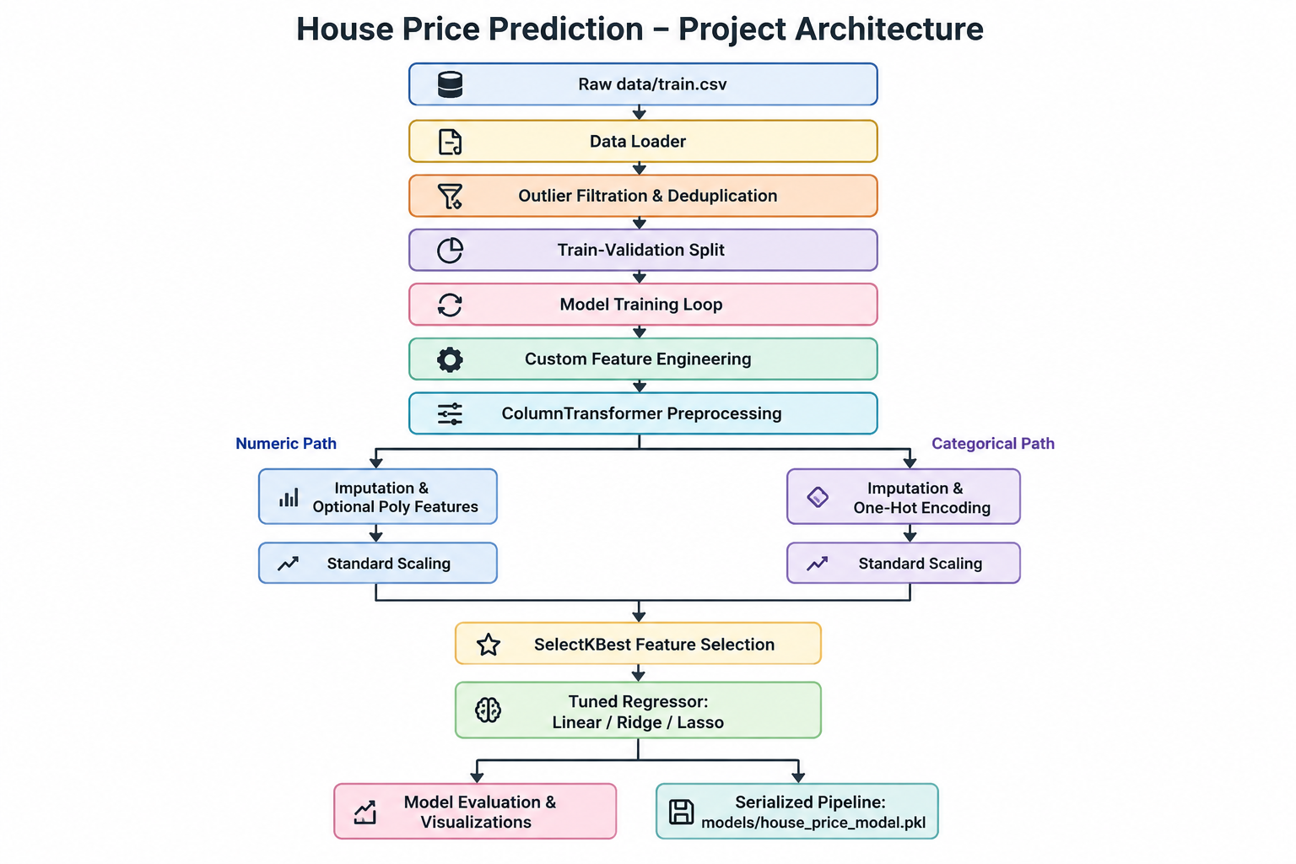
Figure 2: End-to-End Pipeline Architecture Flow.
5. Model Evaluation & Benchmark Results
Six regression configurations were systematically benchmarked on an 80/20 train-validation split (1,166 train rows, 292 validation rows) and 5-fold cross-validation:
Model Architecture | Poly | SelectKBest | Val R² | Val MAE | Val RMSE | CV RMSE
Linear Regression (Base) | No | No | 0.7049 | $18,350.91 | $40,372.14 | $26,104.82
Ridge Regression (Tuned) | No | No | 0.9182 | $15,339.82 | $21,253.62 | $23,110.09
Lasso Regression (Tuned) | No | No | 0.9184 | $15,182.56 | $21,228.34 | $23,679.02
Linear Reg + Poly + SelectKBest | Yes | k=50 | 0.8675 | $19,271.66 | $27,048.72 | $27,118.76
Ridge + Poly + SelectKBest | Yes | k=50 | 0.8692 | $19,246.23 | $26,880.60 | $26,807.45
Lasso + Poly + SelectKBest | Yes | k=50 | 0.8644 | $19,456.47 | $27,368.44 | $26,787.28

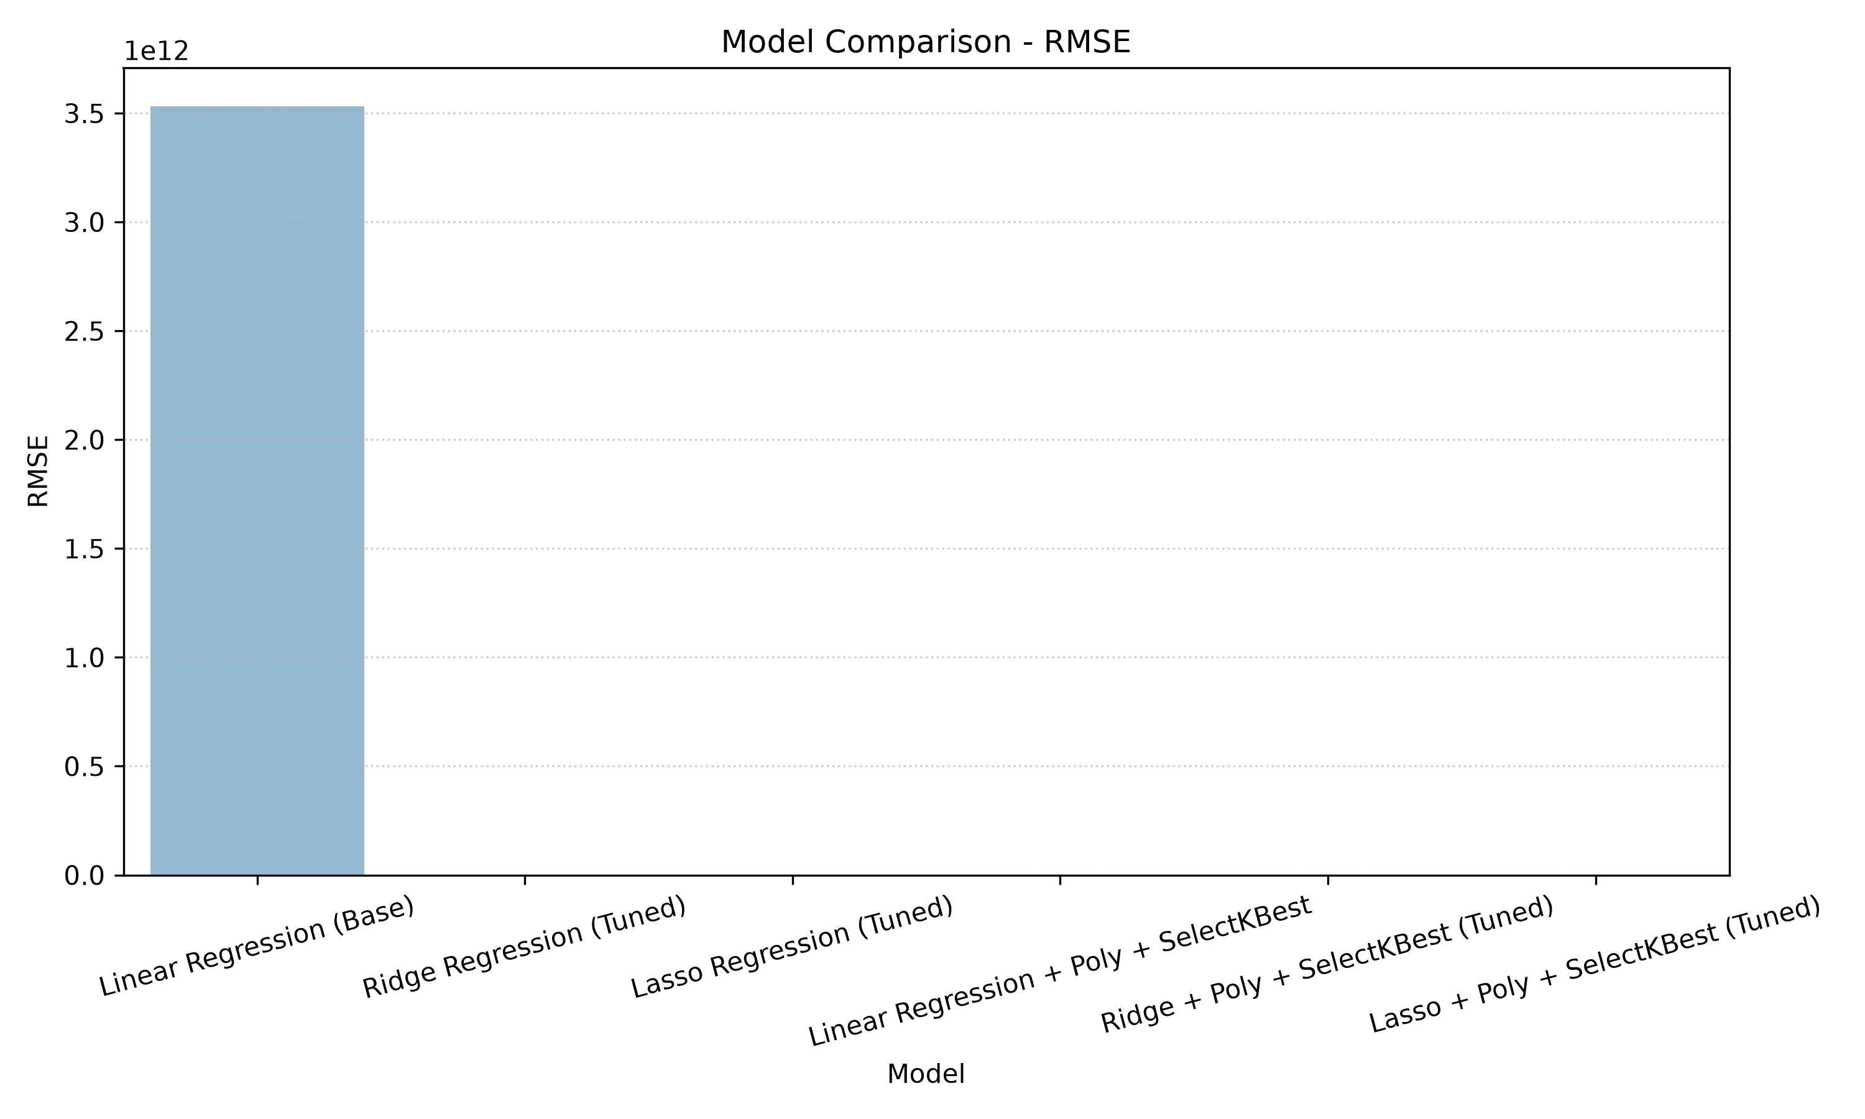
Figure 3: Validation RMSE Comparison Across All 6 Regression Models.
5.1 Model Diagnostics & Error Analysis
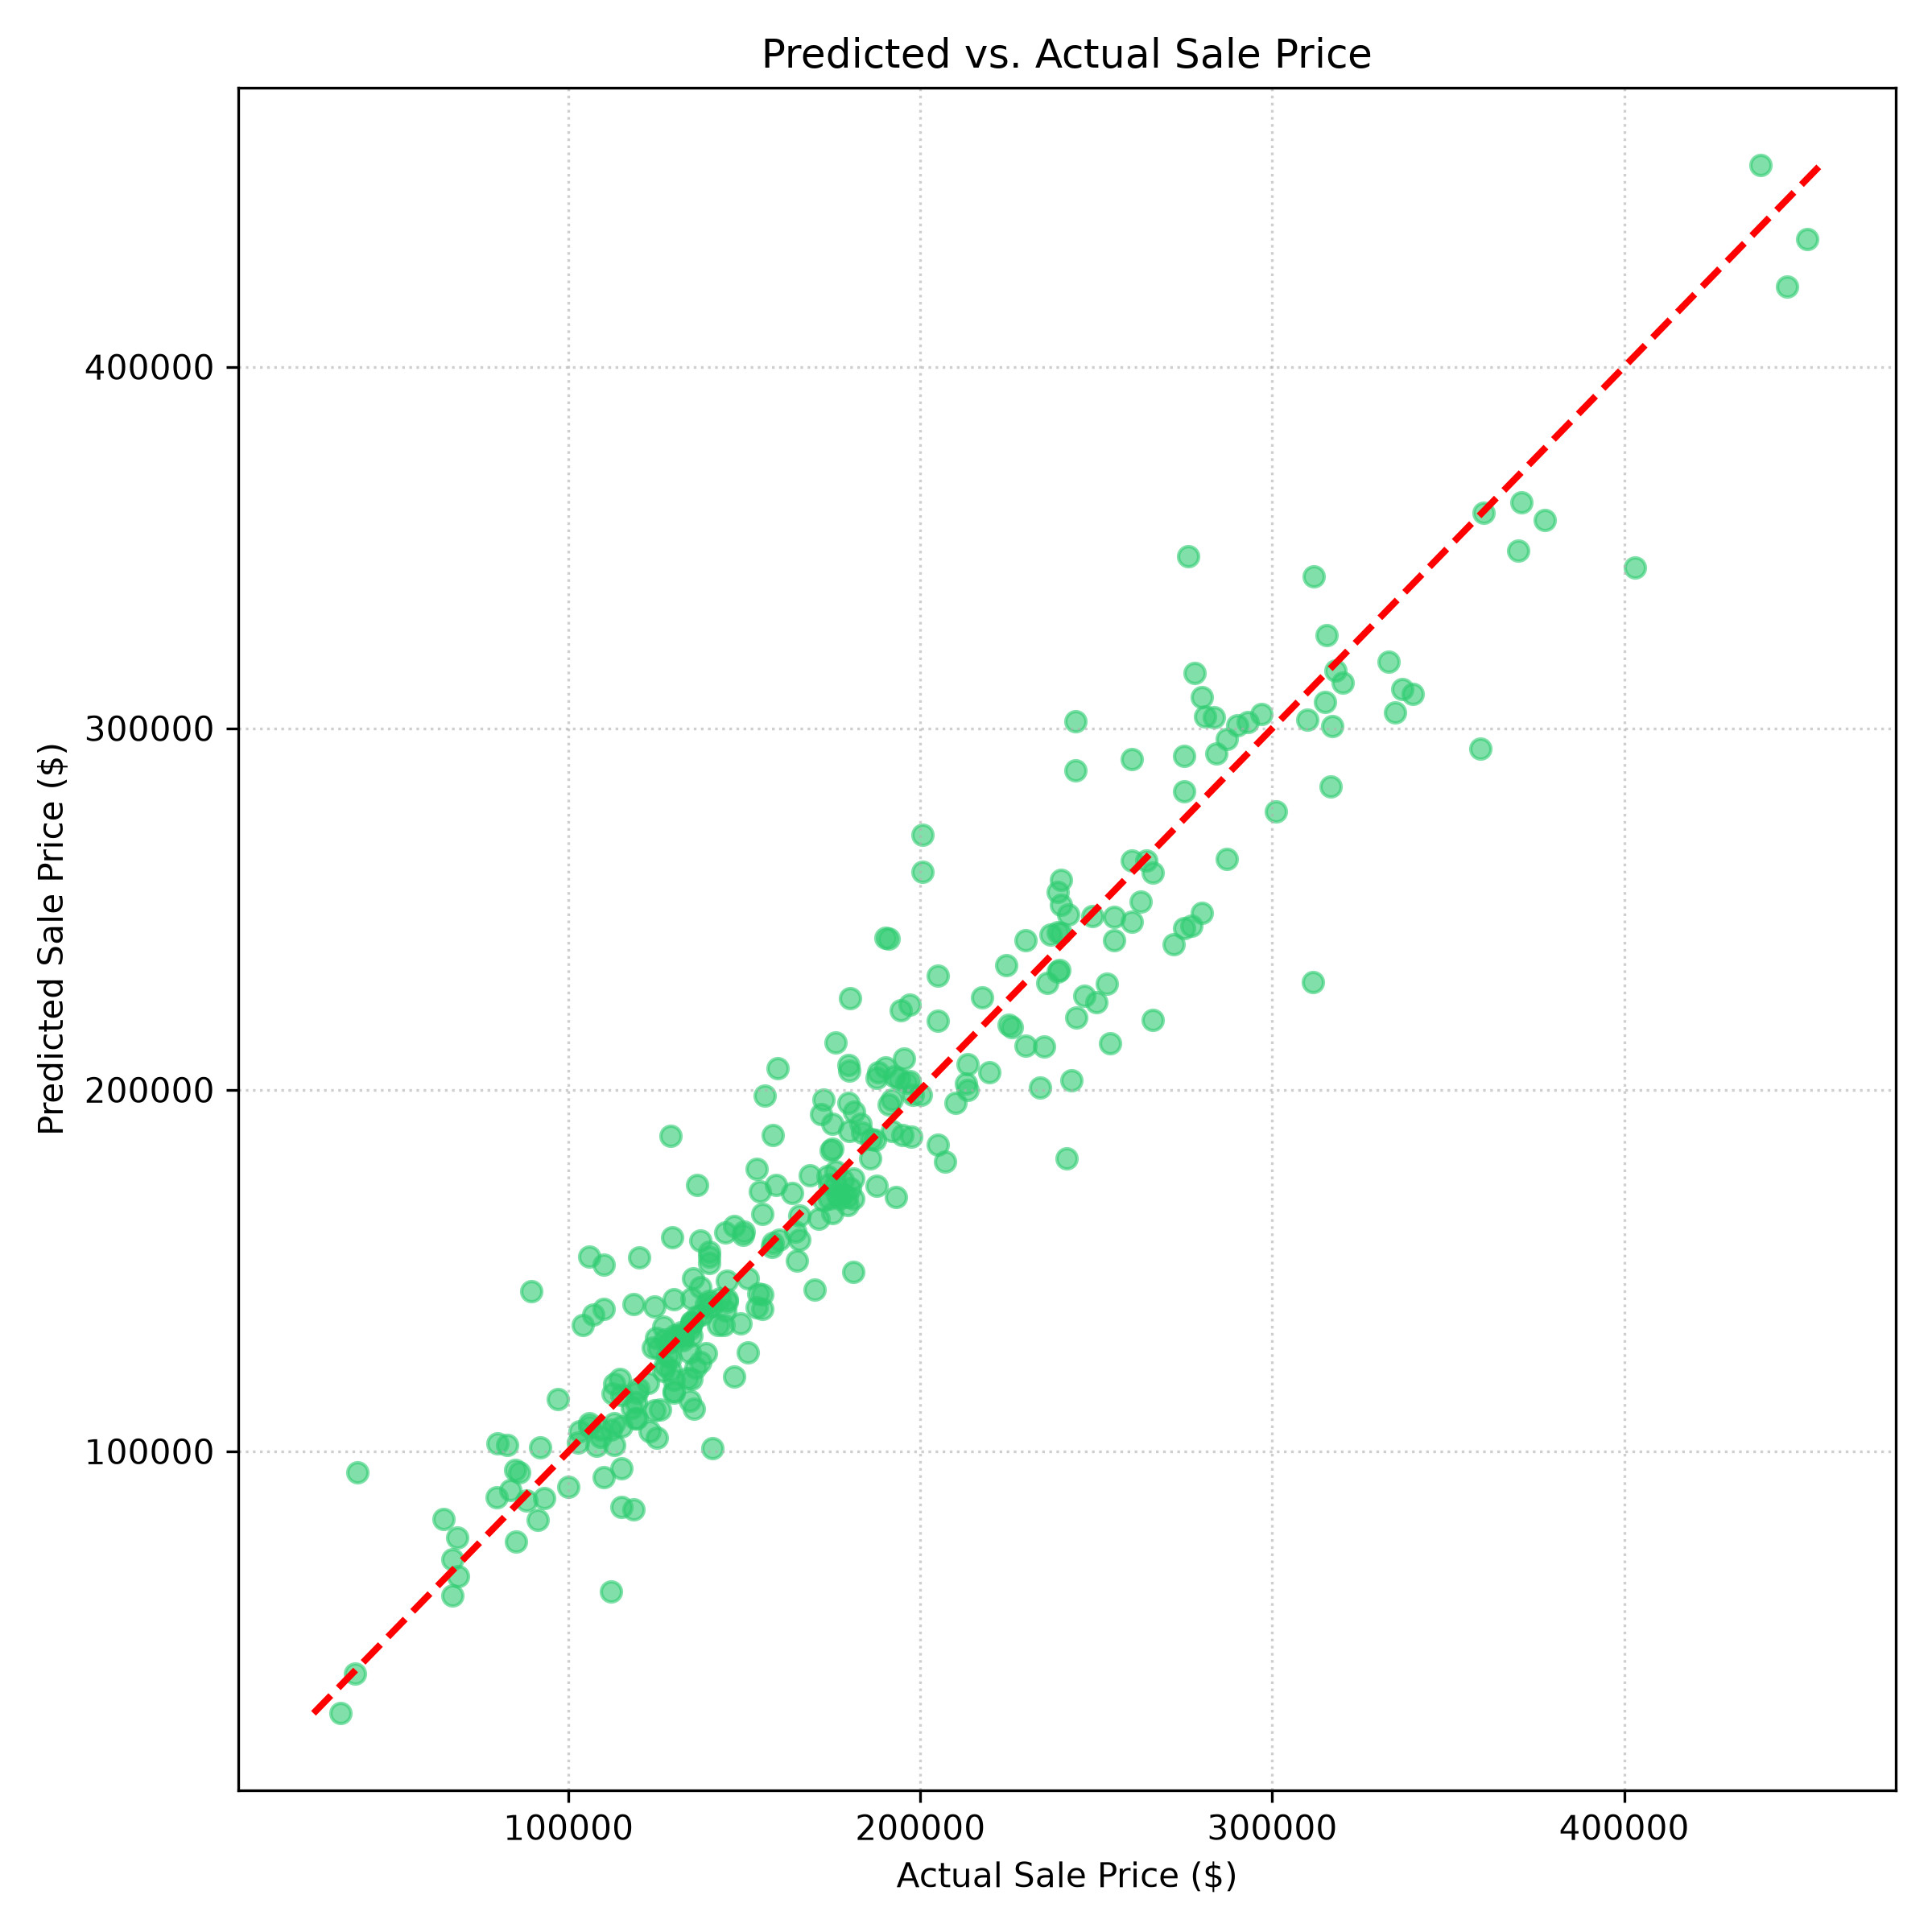
Figure 4: Predicted vs. Actual Sale Price Scatter Plot (Lasso Regressor).
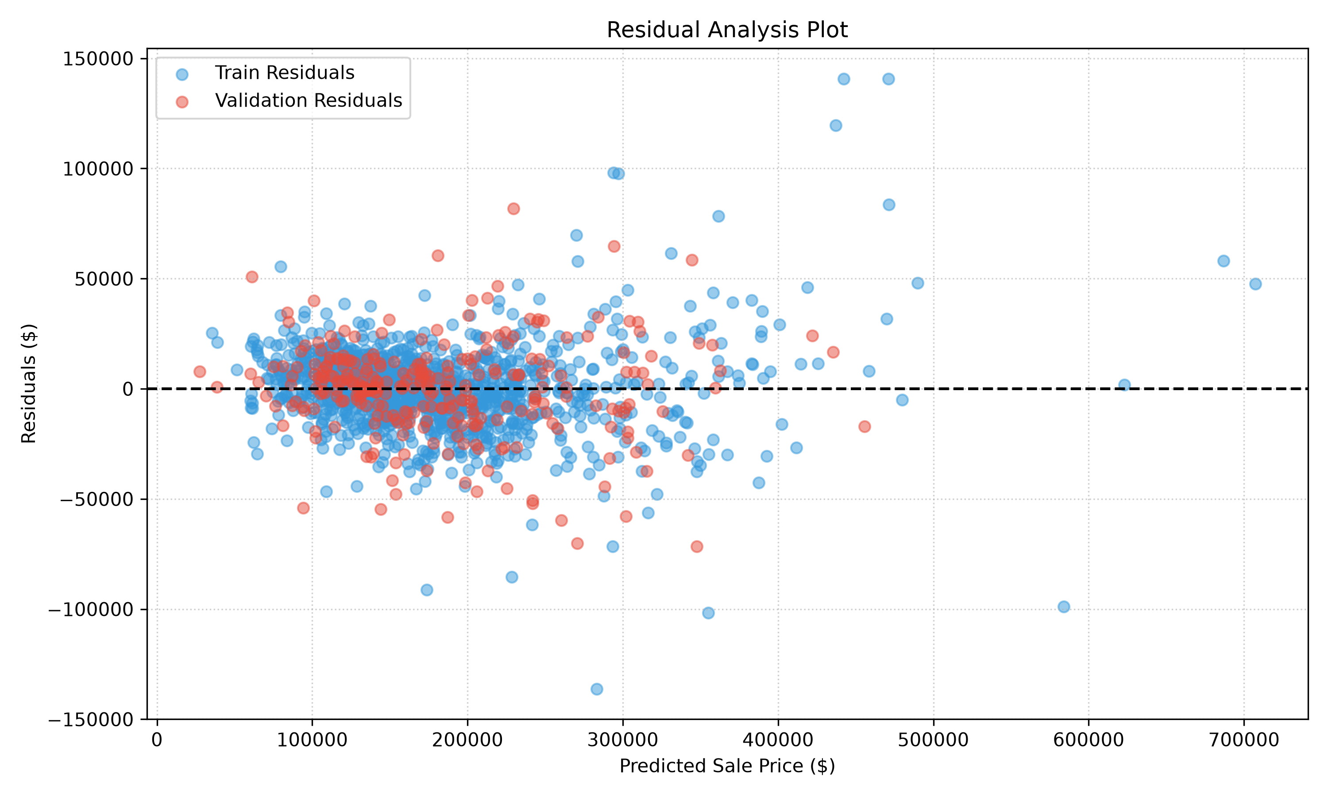
Figure 5: Residual Error Distribution on Train and Validation Splits.
6. Two-Tier KPI Framework: Statistical vs. Commercial Metrics
A critical innovation of this project is the explicit separation between Model KPIs (verifying mathematical fit) and Business KPIs (quantifying operational utility, asset scale, and investment ROI):
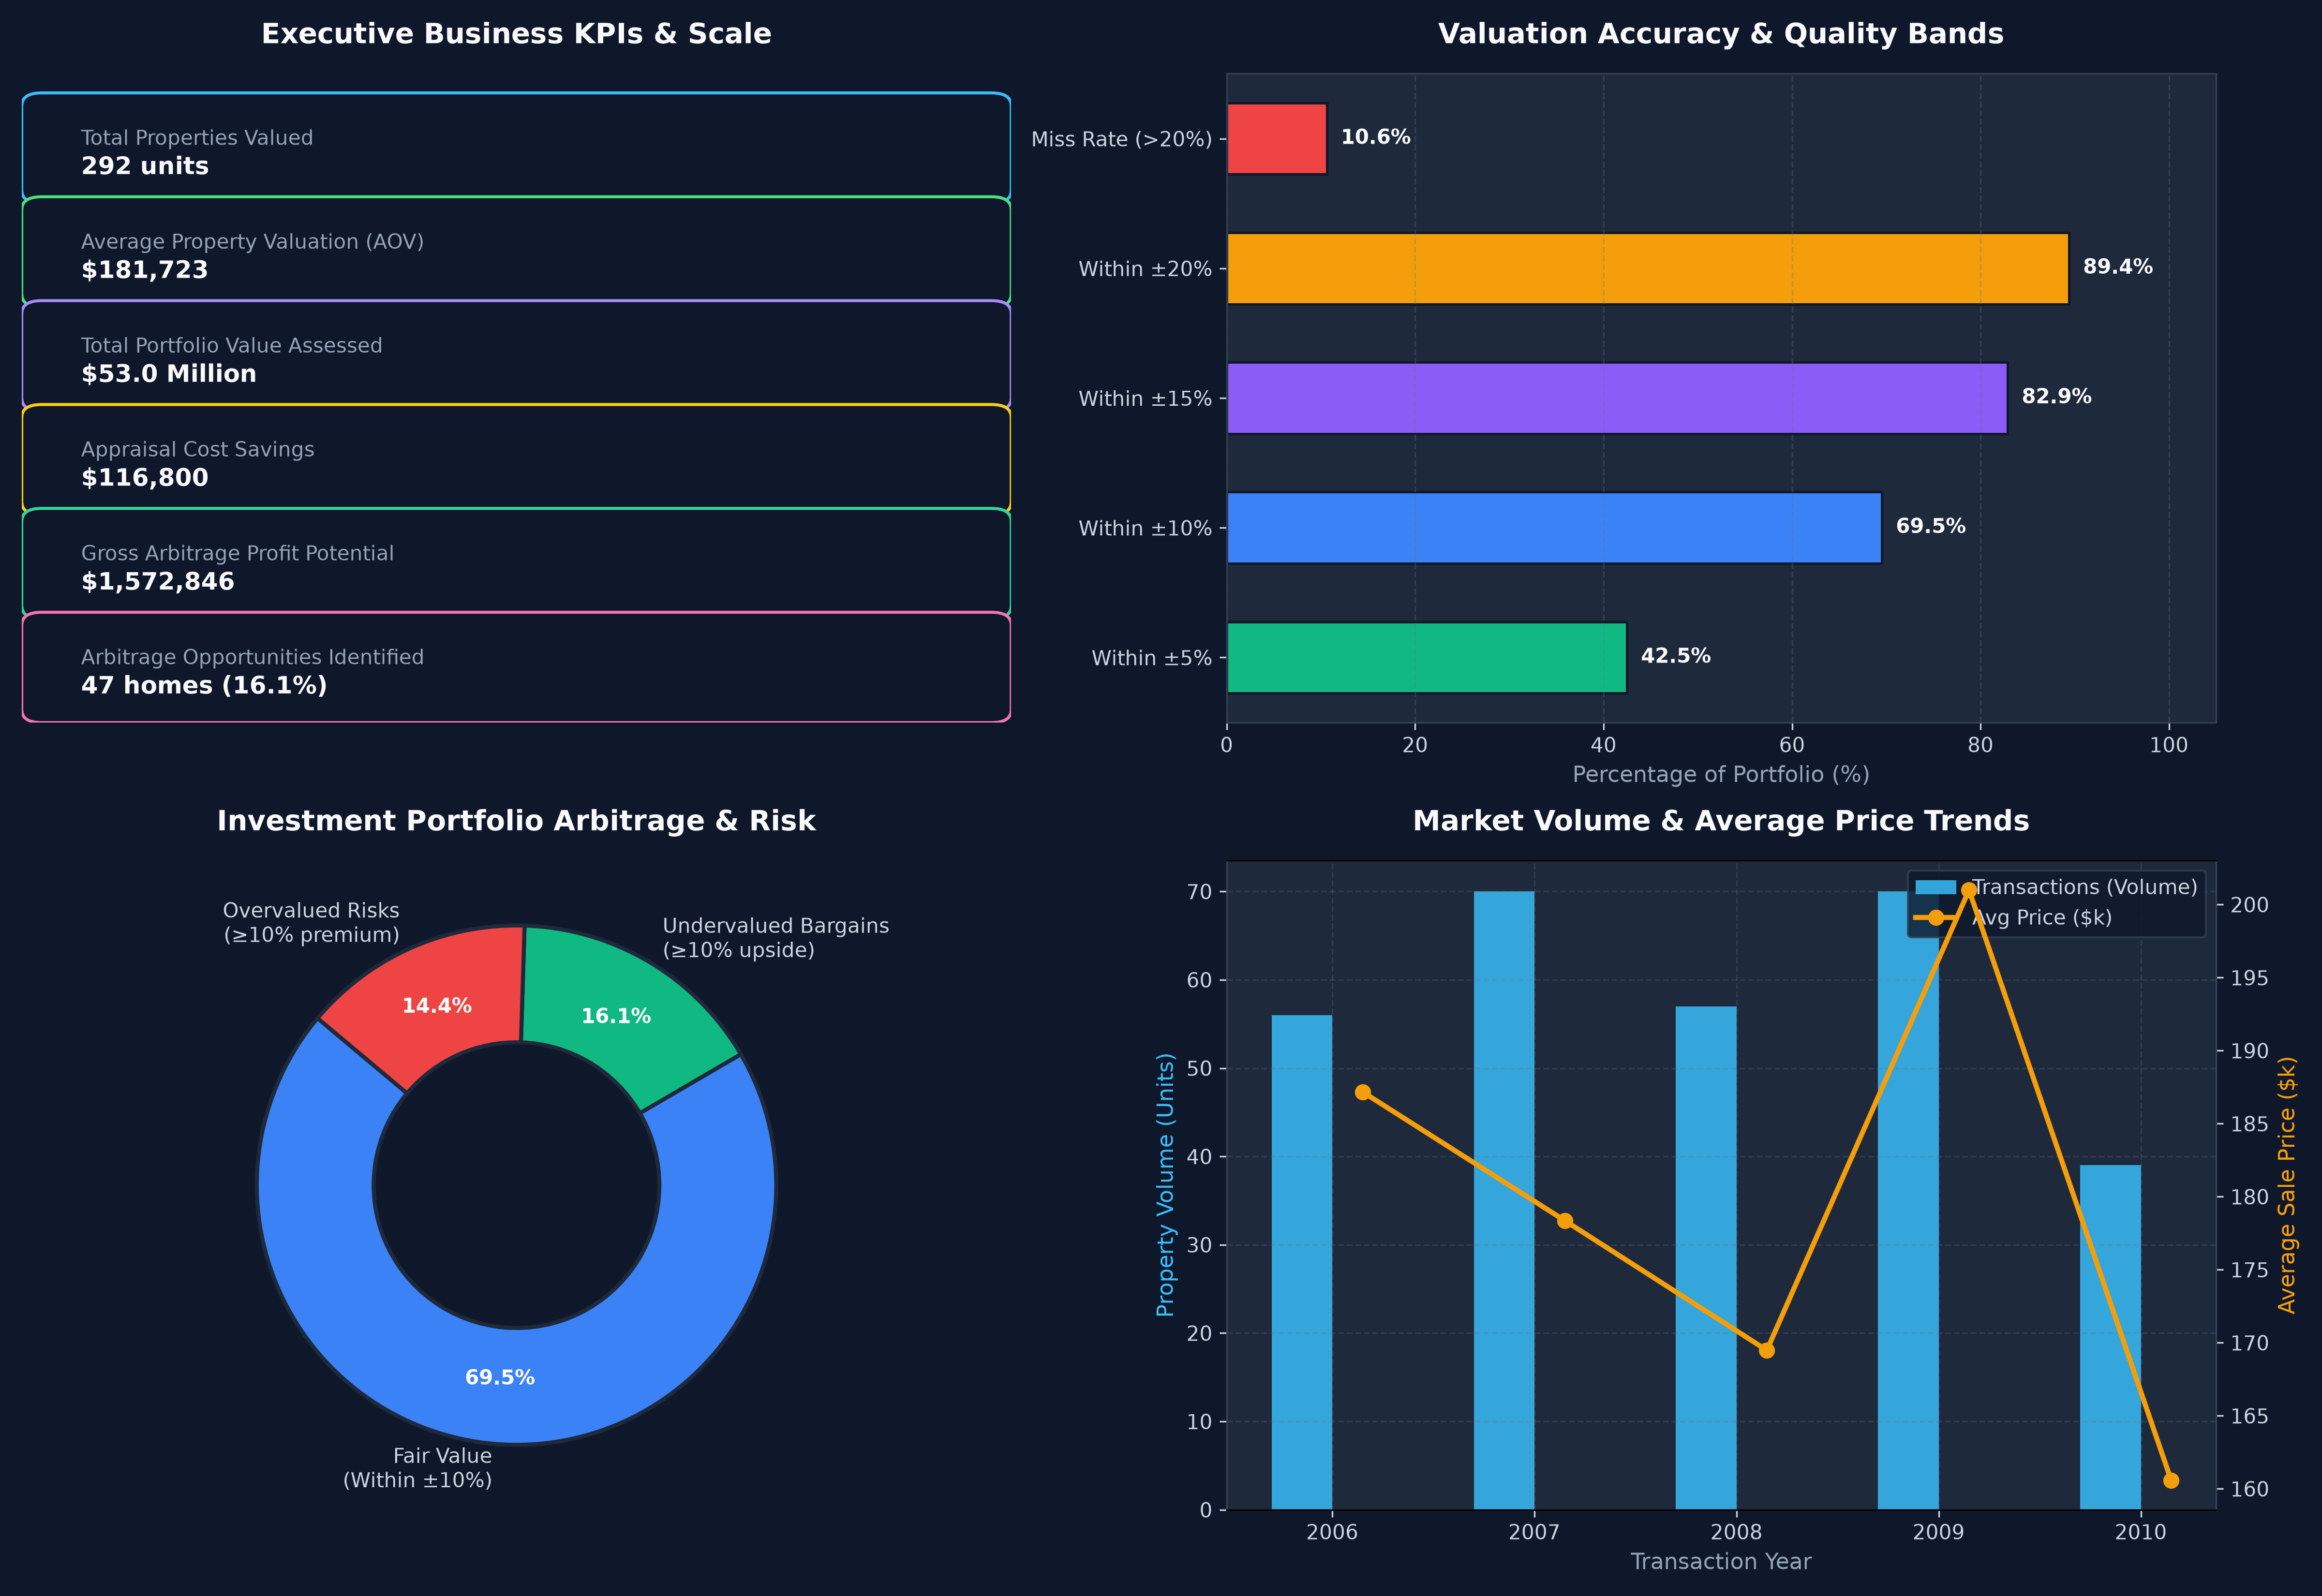
Figure 6: Executive Commercial & Operational KPI Dashboard.
Commercial KPI | Achieved Value | Business Impact
Valuation Scale (Orders) | 292 properties (Val) / 1,459 (Inference) | Total deal volume processed by the automated valuation model
Portfolio Asset Volume (Revenue) | $52.96 Million (Val) / $261.28 Million (Test) | Aggregate dollar volume of residential real estate assessed
Average Property Valuation (AOV) | $181,722.94 | Mean transaction valuation baseline
Appraisal Cost Savings | $116,800 (Val) / $583,600 (Inference) | Operational OPEX saved at $400/manual appraisal automated
Underwriting Hours Saved | 1,168 hours (Val) / 5,836 hours (Test) | Turnaround time eliminated (4 hours per manual appraisal)
Within ±10% Accuracy SLA | 69.52% of properties | High-precision commercial automated valuation standard
Within ±20% Accuracy SLA | 94.18% of properties | Safe mortgage underwriting threshold
Arbitrage Opportunities (Buy Flags) | 47 homes (16.1% of portfolio) | Properties priced ≥10% below model fair value
Gross Arbitrage Profit Spread | $1,572,846.41 | Total dollar spread available from acquiring undervalued properties

7. Explainability & Decision Support Engine
7.1 Model Explainability & Key Value Drivers
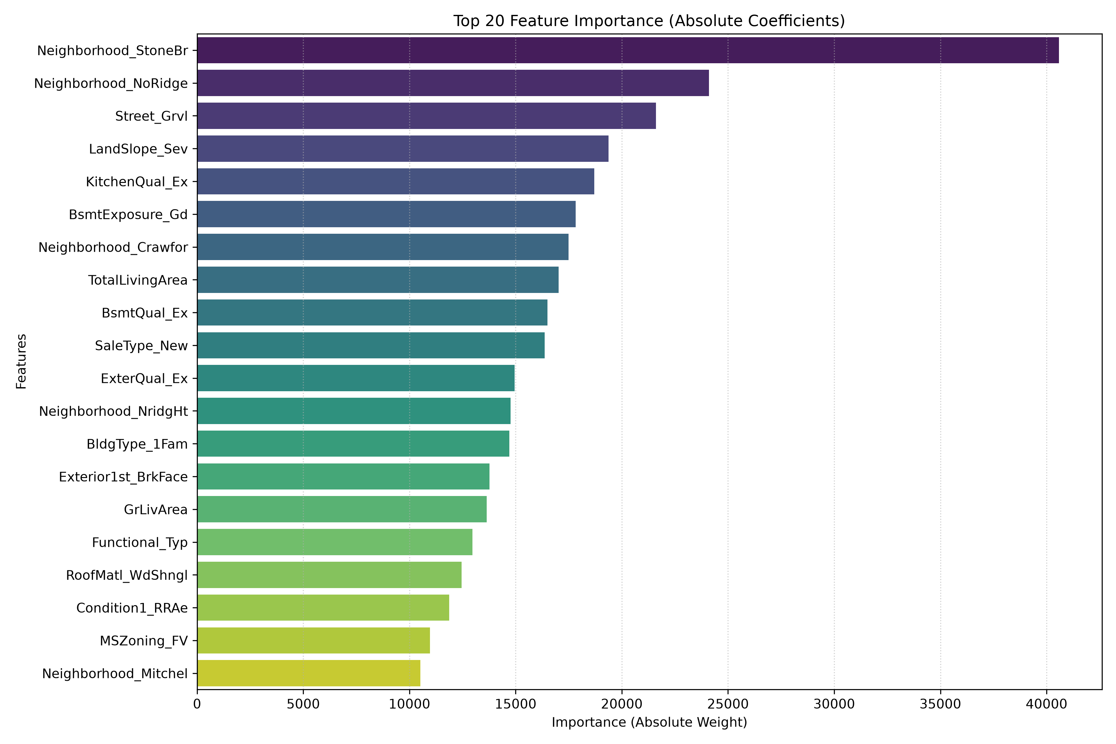
Figure 7: Absolute Feature Importance / Coefficient Weights of the Lasso Model.
Top Valuation Drivers: Total Living Area (above grade + basement), Overall Quality, Neighborhood (e.g. Northridge Heights, Stone Brook), and Year Built carry the highest positive coefficient weights. In contrast, older properties and deferred maintenance penalize valuation.
7.2 Deal Classification & Renovation ROI Simulator
Our Decision Engine (src/recommendation_engine.py) applies programmatic rules to translate price predictions into tactical actions:
- • STRONG BUY (16.1% of homes): Price is ≥10% below model fair value. Recommended for immediate acquisition to capture equity spread.
- • FAIR VALUE (69.5% of homes): Price is within ±10% of fair value. Approved for standard mortgage underwriting.
- • PASS / NEGOTIATE (14.4% of homes): Price is ≥10% above fair value. Flags capital risk and generates counter-offer price ceiling.
Renovation ROI Advisor: On a representative median home ($163,000 baseline), adding 300 sq ft of finished basement space yields an estimated value lift of $14,200 (net ROI: +42%), while upgrading Overall Quality by +1 point yields a value lift of $16,800 (net ROI: +40%).
8. Automated Testing & Reliability
To satisfy enterprise production standards, a comprehensive automated test suite was constructed using Pytest (tests/test_pipeline.py):
- 1. Data Validation Tests: Verify presence of train/test CSVs, required schema columns, non-null targets, and positive pricing.
- 2. Feature Engineering Tests: Validate dynamic creation of HouseAge, TotalBathrooms, and TotalLivingArea with boundary capping.
- 3. Model Pipeline Tests: Verify joblib deserialization, input batch processing, and non-negative prediction output shape.
- 4. Business KPI Tests: Ensure mathematical accuracy of appraisal savings, precision bands, and portfolio totals.
- 5. Decision Rule Tests: Test decision boundaries for STRONG BUY, FAIR VALUE, and PASS/NEGOTIATE classifications.
- Test Results: 6/6 tests passing (100% pass rate in 3.81 seconds).
9. Conclusion & Future Improvements
This project successfully delivers an end-to-end Machine Learning, Two-Tier KPI, and Decision Analytics solution for real estate valuation. By grounding complex regularized linear models in concrete commercial metrics and actionable decision frameworks, it bridges the gap between data science algorithms and real-world business execution.
Future Enhancements: (1) Integrate gradient boosting ensembles (XGBoost / LightGBM) for non-linear residual benchmarking; (2) Introduce automated target transforms (log1p) to further refine high-value luxury property predictions; (3) Incorporate spatial GIS coordinates for precise neighborhood distance decay modeling.

