
Subject : Database Management System
Course Code : ENCS254

Name : Anshika Kashyap
SEC: A
Roll No. : 2401010021
Program: B.TECH CSE (CORE)
Sem : 4th Sem
Faculty Name : Mrs. MANSI KAJAL

ONLINE LEARNING PLATFORM WITH ADAPTIVE LEARNING

DATABASE MANAGEMENT SYSTEM
CAPSTONE PROJECT

ABSTRACT:
This project presents the design and implementation of an advanced database system for an online learning platform that supports adaptive learning. The system stores student data, course content, modules, assessments, and detailed performance records including multiple attempts and topic-wise analysis. Based on student performance, it dynamically adjusts learning paths by recommending appropriate modules.
Unlike traditional systems, this platform incorporates progress tracking, attempt history, and topic performance analysis to generate personalized recommendations. The database ensures data integrity using constraints and relationships, while SQL queries are used to analyze performance and generate intelligent recommendations. This system enhances learning efficiency by providing customized and adaptive educational experiences.

INTRODUCTION:
Online learning platforms have become essential in modern education. However, most systems provide the same learning content to all students, ignoring individual capabilities and learning speed.
Adaptive learning solves this problem by personalizing the learning experience based on student performance and behavior. This project designs a relational database system that not only stores educational data but also tracks progress, multiple attempts, and topic-level performance.
The system dynamically adjusts learning paths using SQL queries and generates recommendations based on performance, making the learning process more efficient and intelligent.

OBJECTIVES:
- To design a relational database for an adaptive online learning system
- To store student, course, module, and assessment data
- To track student progress and multiple attempts efficiently
- To analyze topic-wise performance
- To implement adaptive learning logic
- To provide personalized learning recommendations
- To ensure data integrity using constraints and relationships

SYSTEM OVERVIEW:
The system works as follows:
- Students enroll in courses
- Each course contains multiple modules
- Students attempt assessments after modules
- Multiple attempts are recorded in the database
- Scores and progress are stored and analyzed
- Topic-wise performance is evaluated
- Based on performance, the system recommends the next module

ER- DIAGRAM:
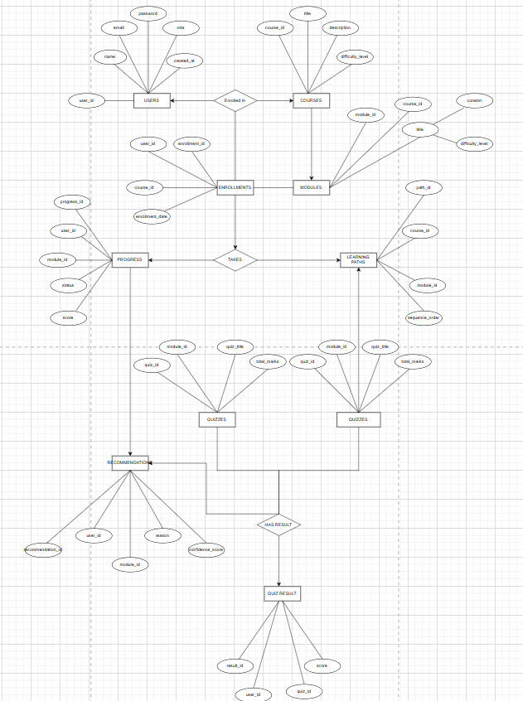
DATABASE DESIGN:

Student Table
· student_id (Primary Key)
· name
· email
· learning_style
· current_level
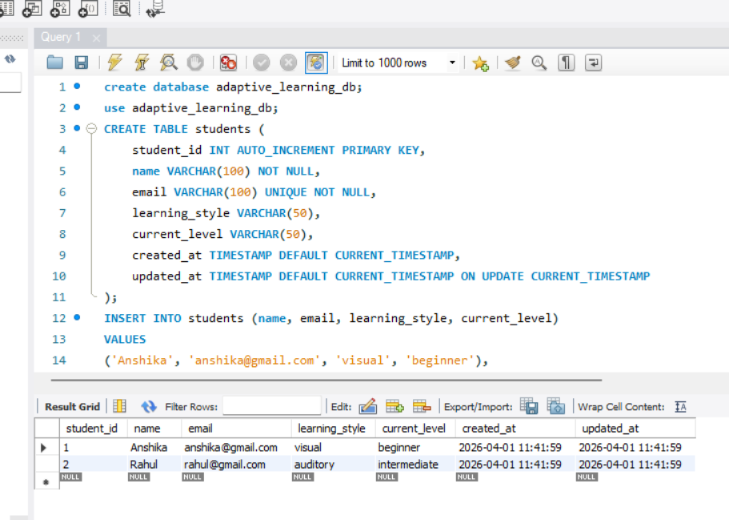

Course Table
· course_id (Primary Key)
· title
· description
· difficulty_level
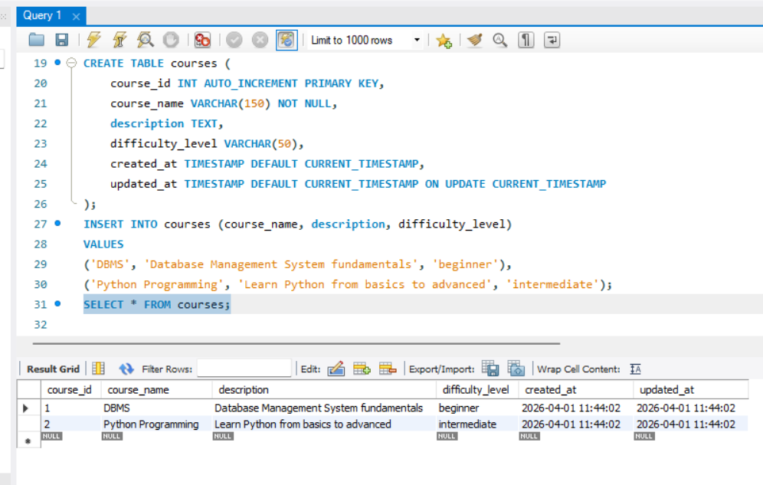

Module Table
· module_id (Primary Key)
· course_id (Foreign Key)
· title
· content
· difficulty_level
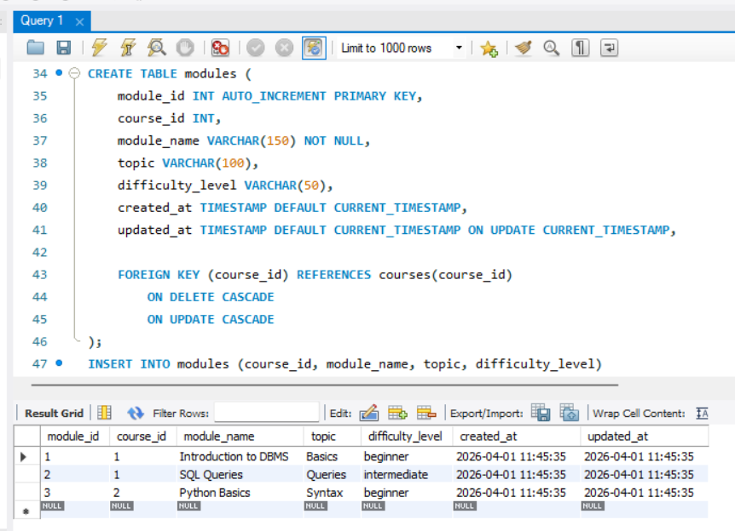

Assessment Table
· assessment_id (Primary Key)
· module_id (Foreign Key)
· total_marks
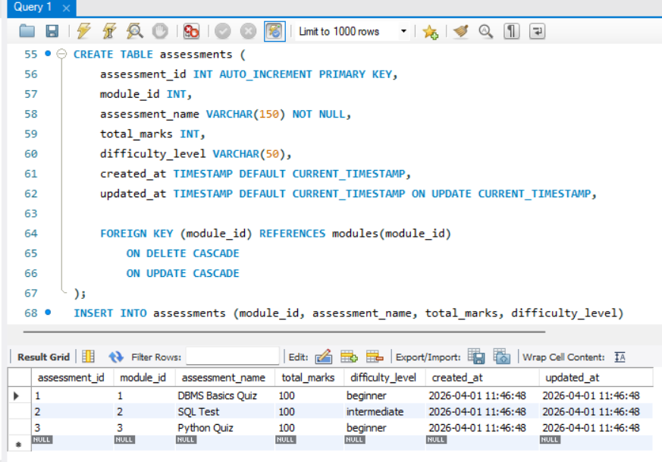

QUESTION

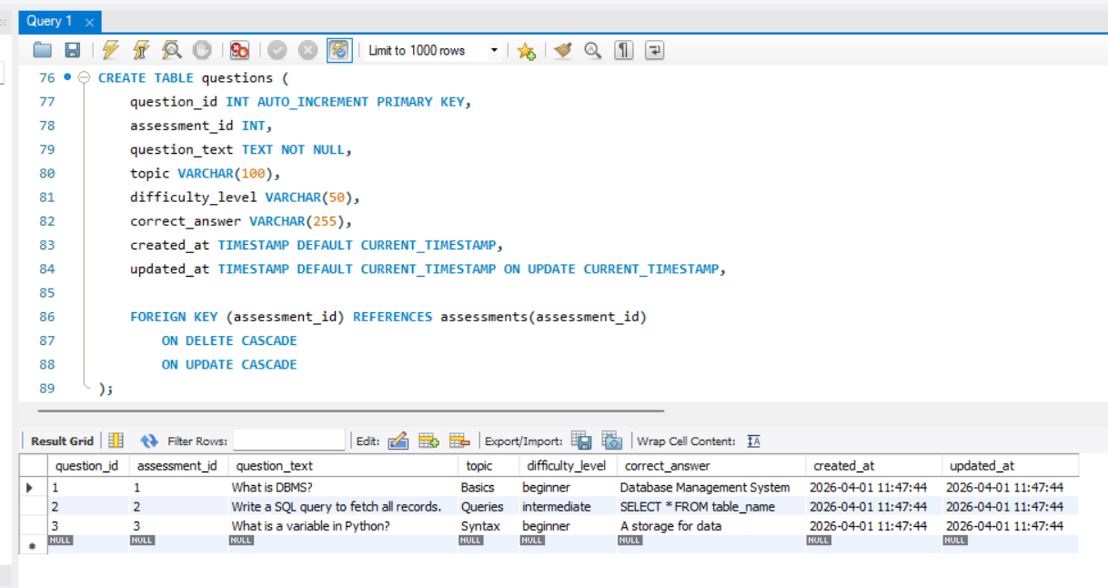

Progress Table
· progress_id (Primary Key)
· student_id (Foreign Key)
· module_id (Foreign Key)
· status
· score
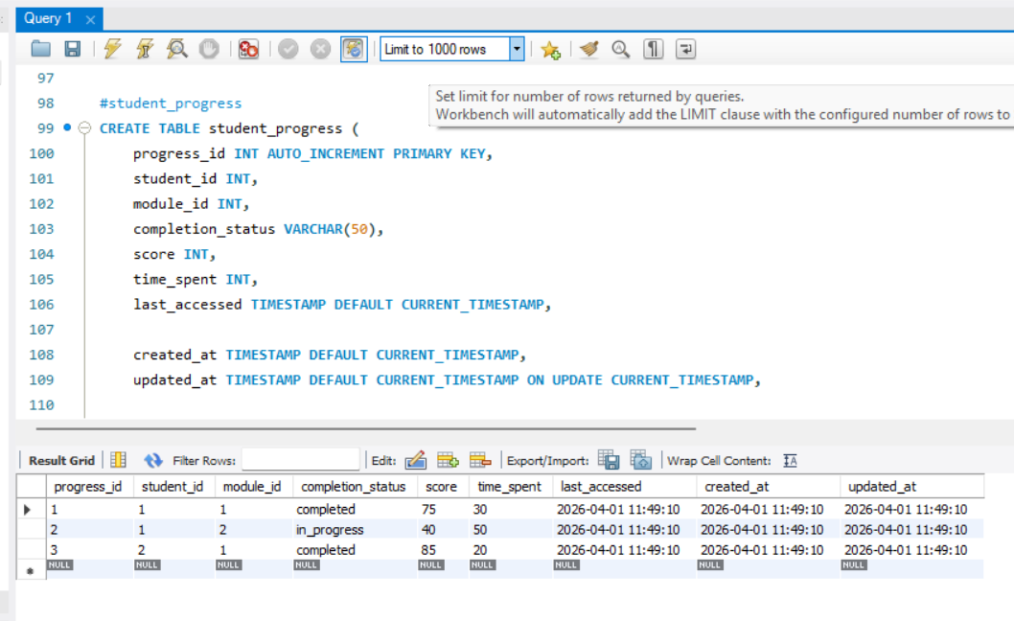

Attempt_History Table
· attempt_id (Primary Key)
· student_id (Foreign Key)
· assessment_id (Foreign Key)
· attempt_number
· score
· attempt_date
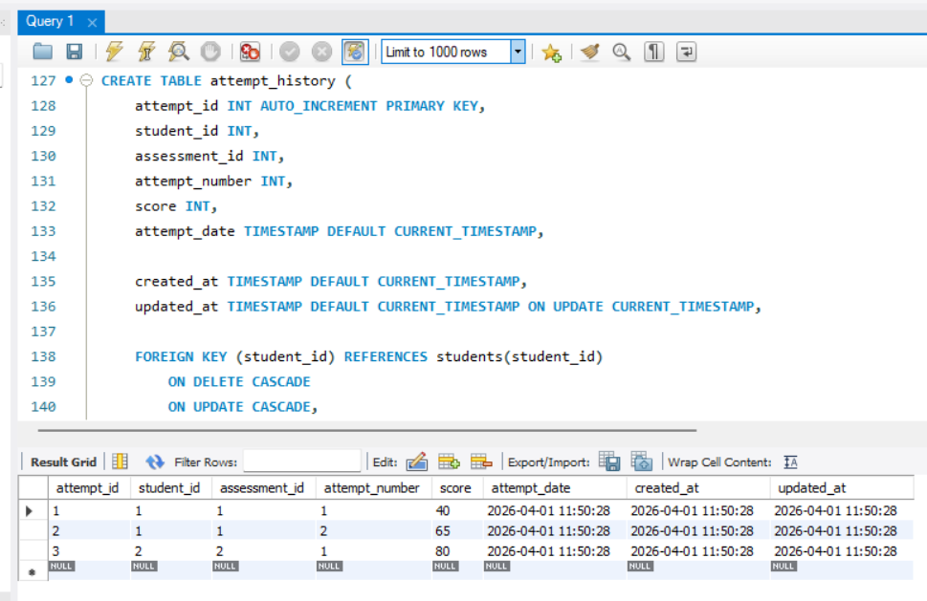

Topic_Performance Table
· performance_id (Primary Key)
· student_id (Foreign Key)
· topic
· avg_score
· mastery_level
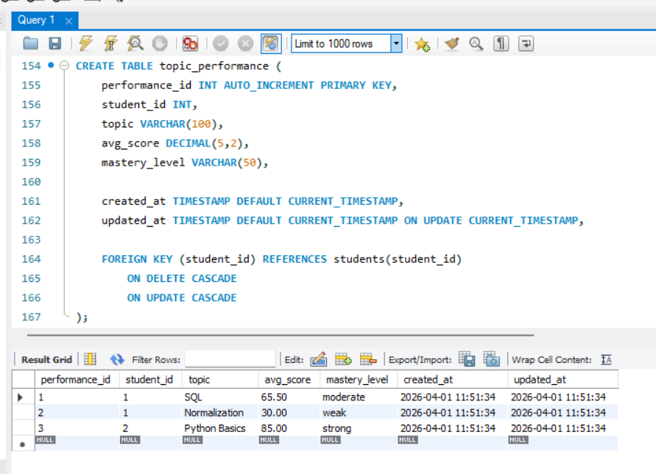

Learning_Path Table
· path_id (Primary Key)
· course_id (Foreign Key)
· module_id (Foreign Key)
· sequence_order
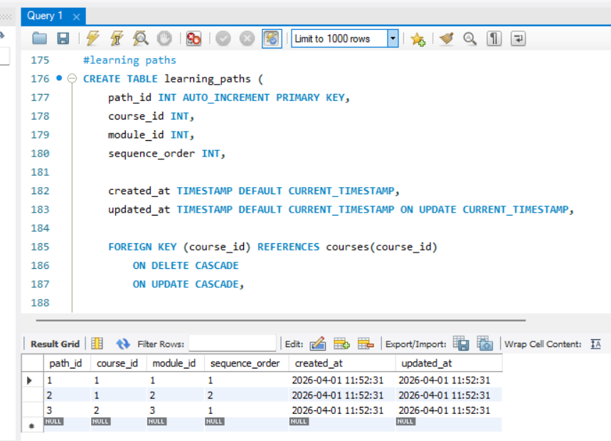

Recommendation Table
· recommendation_id (Primary Key)
· student_id (Foreign Key)
· module_id (Foreign Key)
· recommendation_reason
· confidence_score
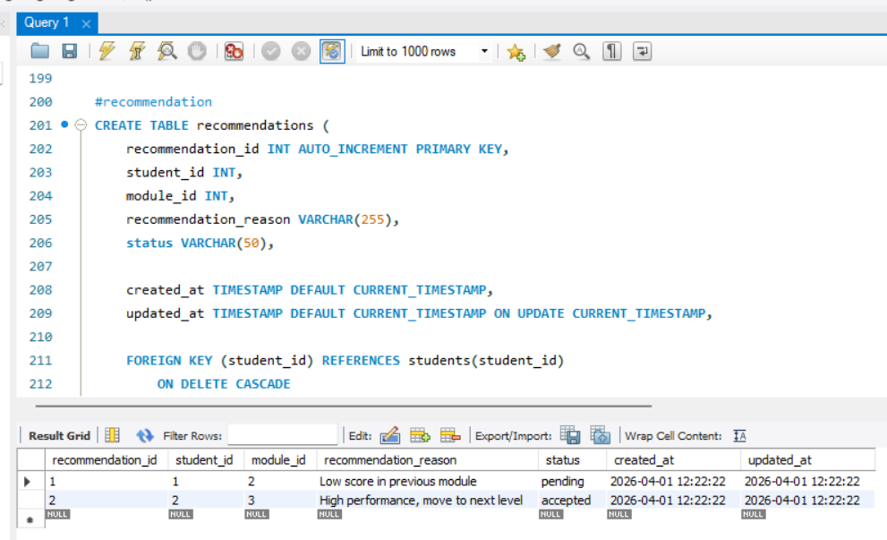

ENROLLMENTS

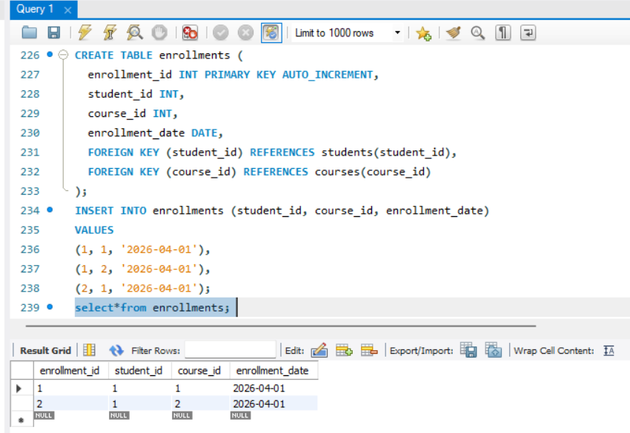
NORMALIZATION:
The database is normalized up to Third Normal Form (3NF):
· 1NF: All attributes are atomic
· 2NF: No partial dependency on primary key
· 3NF: No transitive dependency
This reduces redundancy and improves data integrity.

SQL IMPLEMENTATION:
Inserting values into student table.
Inserting values into module and course tables.
Inserting values into learning path table.
Recording attempts in attempt_history table.
Updating progress in progress table.
Storing topic performance data.
Generating recommendations in recommendation table.

QUERIES USED

Weak Students Detection
Identifies students scoring below 40.
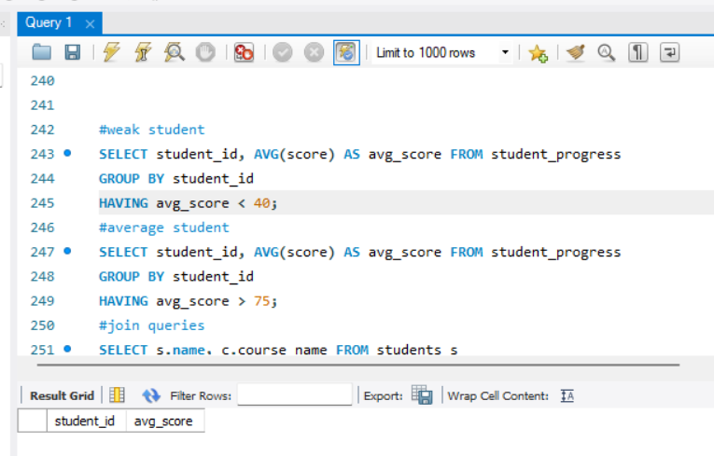

High Performers
Finds students with average score above 75.
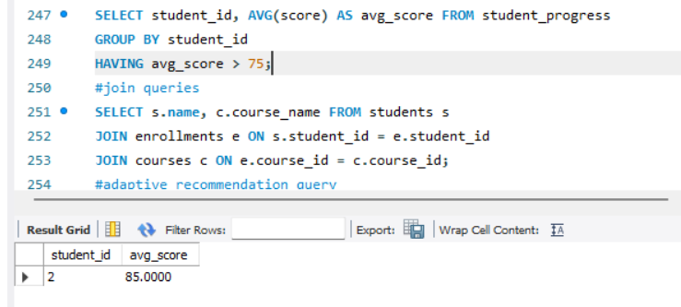

Join Quires
Tracks completed modules and performance.
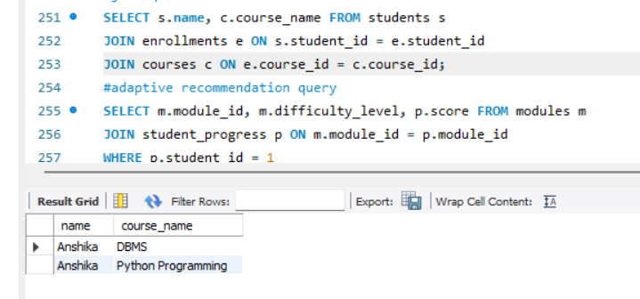

Adaptive Recommendation
Suggests modules based on score, difficulty level, and completion status.
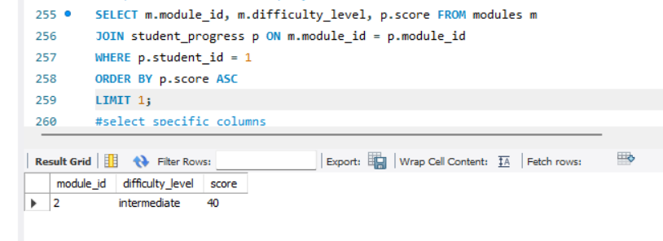

SPECIFIC COLUMS
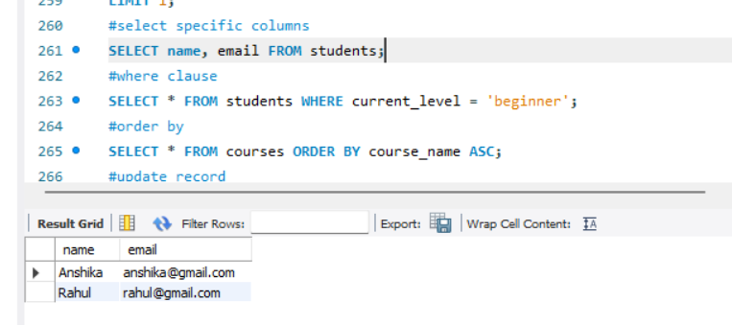
Clause
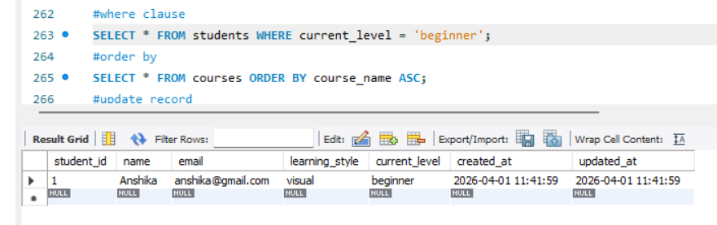
Order
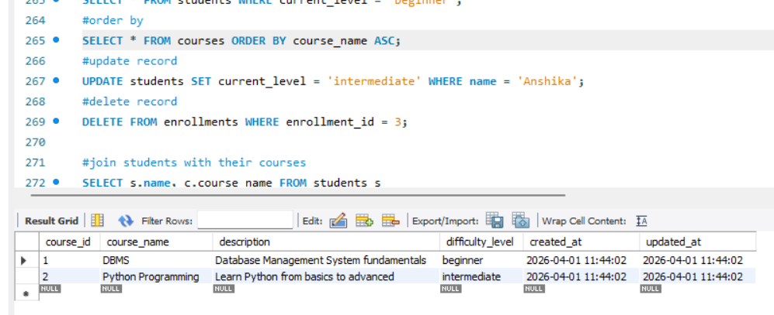
Join Student with their Courses
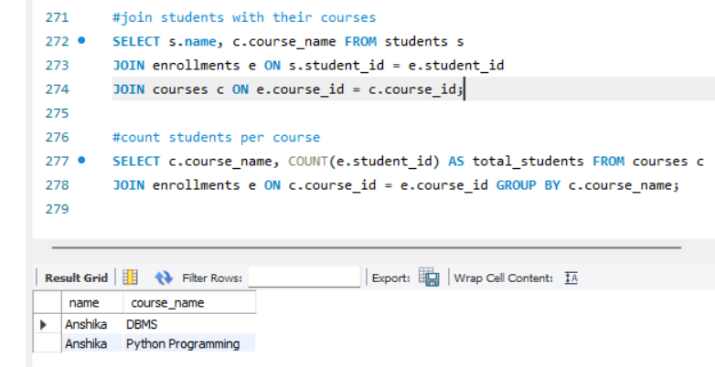

Count Students per course
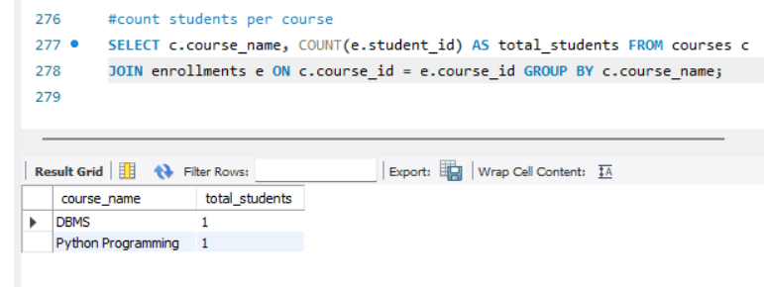
ADAPTIVE LEARNING LOGIC
The system adjusts learning paths based on performance:
· Score < 40 → Beginner modules
· Score 40–75 → Intermediate modules
· Score > 75 → Advanced modules
Additionally, the system considers:
· Multiple attempts
· Module difficulty
· Completion status
This ensures personalized and adaptive learning.

RESULTS AND ANALYSIS
The system successfully:
· Identifies weak students
· Tracks learning progress and multiple attempts
· Analyzes topic-wise performance
· Provides personalized recommendations
· Maintains data integrity using constraints

ADVANTAGES
· Personalized learning experience
· Advanced performance tracking
· Efficient data management
· Scalable system design
· Improved student performance

LIMITATIONS
· Depends on accurate assessment data
· Recommendation logic is rule-based
· No real-time updates

FUTURE SCOPE
· Integration with AI/ML models
· Real-time recommendation system
· Mobile application support
· Advanced analytics dashboard

CONCLUSION
This project demonstrates how a DBMS can be used to build an advanced adaptive learning system. By analyzing student performance, tracking multiple attempts, and dynamically adjusting learning paths, the system provides a personalized and efficient learning experience.
It serves as a strong foundation for future AI-powered educational systems.

