
Database Management Lab File
(ENCS205)
Bachelor of Technology in Computer Science and Engineering
Submitted by
ANSHIKA KASHYAP (2401010021)
B. Tech CSE (Core) – 4th Semester
Section: A
Submitted To: MS. Mansi Kajal
School of Engineering & Technology K. R. MANGALAM UNIVERSITY Sohna, Haryana 122103, India Jan-2026

EXPERIMENT-1
- Consider following databases and draw ER diagram and convert entities and relationships to relation table for a given scenario:

COMPANY DATABASE:

EMPLOYEE (SSN, Name, Address, Sex, Salary, SuperSSN, DNo)
DEPARTMENT (DNo, DName, MgrSSN, MgrStartDate)
DLOCATION (DNo,DLoc)
PROJECT (PNo, PName, PLocation, DNo)
WORKS_ON (SSN, PNo, Hours)

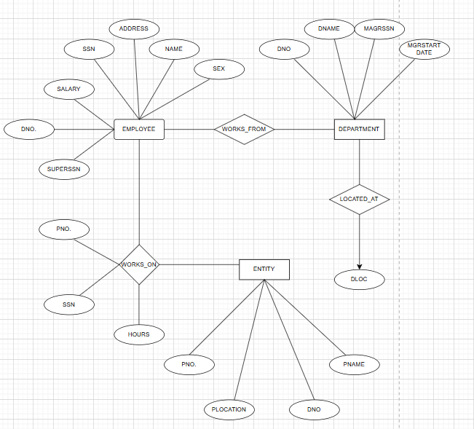

Explanation of ER Diagram – Company Database :

- This ER diagram represents a company database that stores information about employees, departments, locations, and projects and their interrelationship.

- The Employee entity stores details such as SSN, name, address, sex, salary, supervisor SSN, and department number. Each employee is associated with a department.

- This relationship is shown using WORKS_FOR. Many employees can work for one department, but each employee belong to only one department.

- The Department entity stores department information such as department number, department name, manager SSN, and manager start date. Departments can also be associated with one or more locations, represented by the LOCATED AT relationship between Department and DLocation.

- The Project entity stores information about projects such as project number, project name, project location, and department number. Each project is controlled by one department, and one department can control multiple projects.

- Employees work on multiple projects. This many-to-many relationship is represented by the WORKS_ON entity. The number of hours an employee works on a project is stored as an attribute of this relationship.

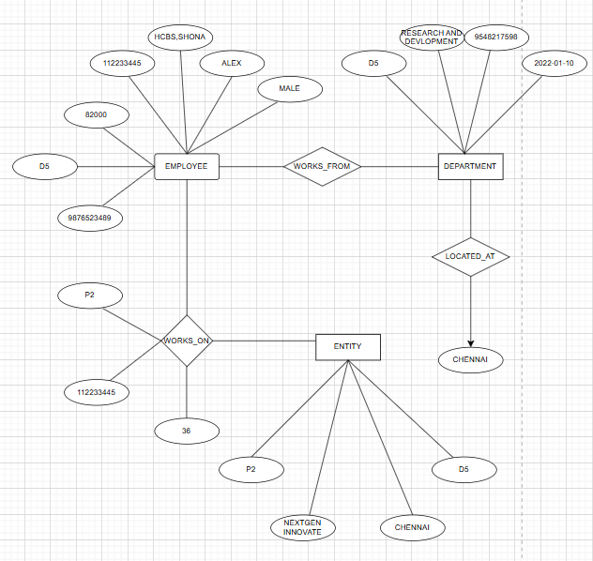

Company ER Diagram Explained Using Real Example :
- Imagine an employee named Alex with SSN 9876523489. He lives at HBSC, Sohna, earns a salary of 82,000, and is male. His supervisor’s SSN is 112233445. Alex belongs to the department with ID D5.

- Alex works for the Research and Development department (D5). Many employees can be part of this department, but each employee is linked to only one department.

- The Research and Development department has ID (D5), is managed by an employee with SSN 5648217598, and the manager started on 2022-01-10.

- The department controls a project called NewGen Innovate (P2), which is based in Chennai. Each project belongs to one department, but a department can manage multiple projects.

- Alex works on the NewGen Innovate project (P2). The relationship WORKS_ON shows that employees can work on multiple projects, and projects can have multiple employees.
In this case, Alex contributes 36 hours to the project. The attribute Hours in WORKS_ON captures this detail.

Conclusion :
The ER diagram clearly represents the structure of the college database system. It organizes student details, semester-section details, subject details, and internal assessment marks in a structured manner. The relationships ensure proper linkage between entities and help maintain data consistency.

EXPERIMENT-2
2. Consider following databases and draw ER diagram and convert entities and relationships to relation table for a given scenario:
COLLEGE DATABASE:
STUDENT (USN, SName, Address, Phone, Gender)
SEMSEC (SSID, Sem, Sec)
CLASS (USN, SSID)
SUBJECT (Subcode, Title, Sem, Credits)
IAMARKS (USN, Subcode, SSID, Test1, Test2, Test3, FinalIA)

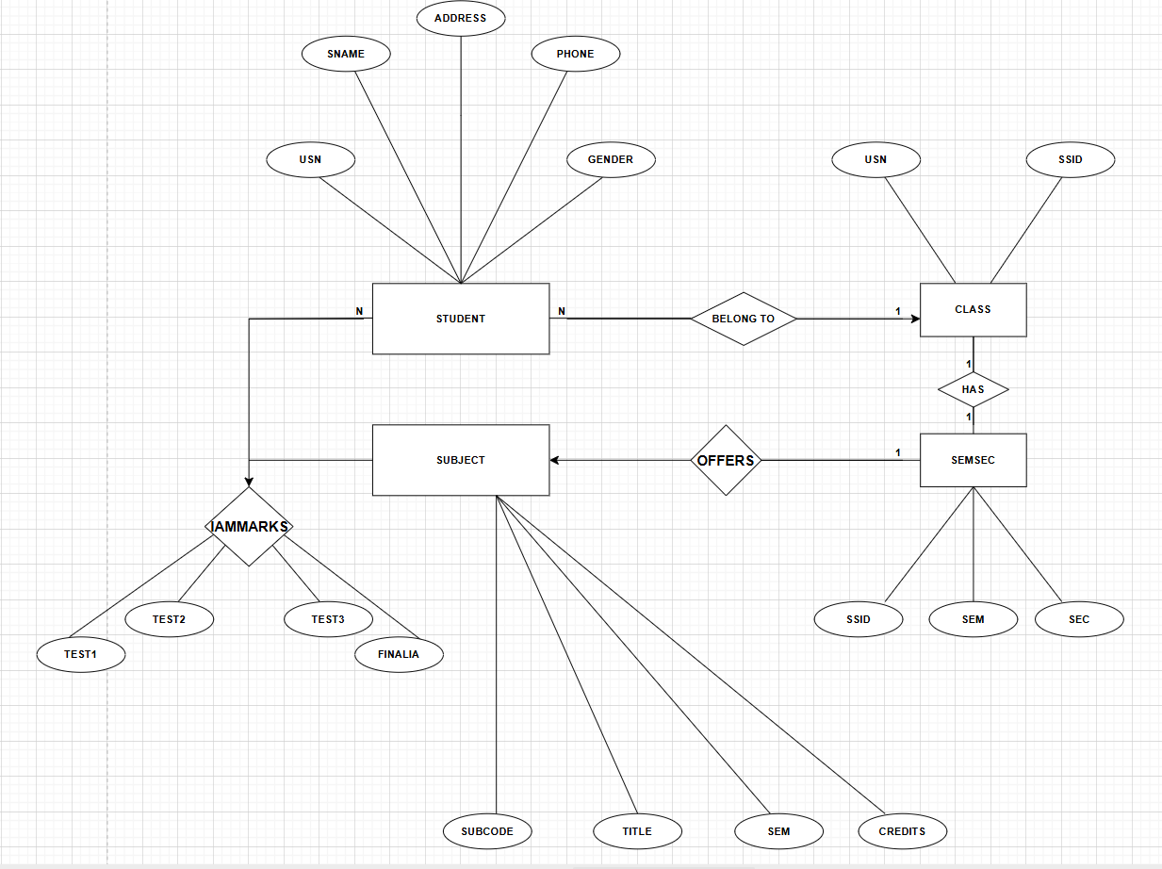

Explanation of ER Diagram – College Database :

- This ER diagram represents a college database that stores information about students, their classes, subjects, semesters, and internal assessment marks.

- In this diagram, the Student entity stores basic details of a student such as USN, name, address, phone number, and gender. Every student belongs to a particular class. This relationship is shown using the BELONGS TO relationship. Many students can belongs to the same class, but a student can belong to only one class.

- The Class entity represents a group of students. Each class is associated with exactly one semester and section, which is represented by the Sem Sec entity. The relationship between Class and Sem Sec is one-to-one, meaning each class has only one semester section and each semester-section belongs to one class.

- The Sem Sec entity stores information about the semester and section. The semester section offers multiple subjects. This is shown by the OFFERS relationship between Sem Sec and Subject. One Sem Sec can offer many subjects, but each subject is offered in one specific semester.

- The Subject Entity stores subject details such as subject code, title, semester, and credits. Students study multiple subjects, and each subject is studied by many students. This many-to-many relationship is represented using the IAMARKS relationship.

- The IAMARKS relationship stores the internal assessment marks of students for each subject. It includes Test1, Test2, Test3, and FinalIA. This relationship connects Student and Subject and stores marks for every student-subject combination.

Conclusion:
The ER diagram clearly represents the structure of the company database. It shows how employees are assigned to departments, how departments manage projects, and how employees work on multiple projects. The relationships ensure proper organization and efficient management of company data.
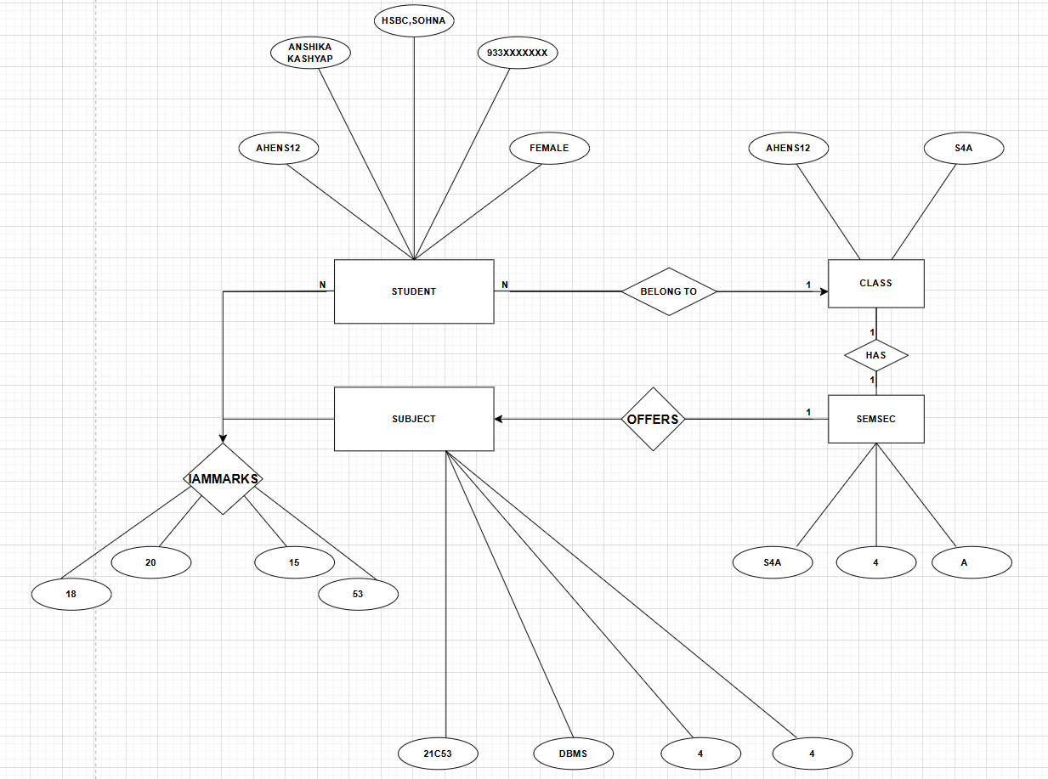

College ER Diagram Explained Using Real Example :

- Consider a student named Anshika Kashyap whose USN is AHENS12. She lives in HCBS , Sohna, her phone number is 9335XXXXX, and her gender is female.
- Anshika belongs to a Class identified by AIEN512 with section A. Many students can belong to one class, but each student is assigned to only one class. The class AIEN512 has section SAA. Each class is linked to a SEMSEC (Semester + Section).

- The class offers subjects such as DBMS and 21CS3. Each subject is tied to a semester-section (SEMSEC). For example, DBMS is offered in Semester 4, Section A.Subjects are linked to the semester-section they are taught in. This ensures that students in a particular class/semester get the correct subjects.

- Her internal assessment marks in DBMS are Test1 = 18, Test2 =20 , Test3 =15 , and FinalIA = 55. These marks are stored in the IAMARKS relationship, which connects Sneha to the DBMS subject.
EXPERIMENT-3
- Database Schema for a customer-sale scenario
- Customer(Cust id : integer, cust_name: string)
- Item(item_id: integer, item_name: string, price: integer)
- Sale(bill_no:integer,bill_data:date,cust_id: integer, item_id: integer, qty_sold: integer)
3.a) Create the tables with the appropriate integrity constraints.
CREATE TABLE Customer (
cust_id INT PRIMARY KEY,
cust_name VARCHAR(50) NOT NULL
) ENGINE=InnoDB;

CREATE TABLE Item (
item_id INT PRIMARY KEY,
item_name VARCHAR(50) NOT NULL,
price INT CHECK (price > 0)
) ENGINE=InnoDB;
SHOW TABLES;
DESCRIBE Customer;
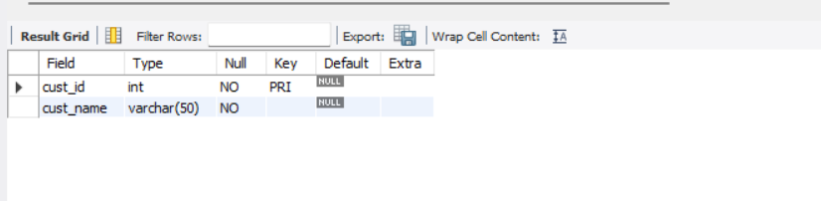

CREATE TABLE Sale (
bill_no INT PRIMARY KEY,
bill_date DATE NOT NULL,
cust_id INT,
item_id INT,
qty_sold INT CHECK (qty_sold > 0),
FOREIGN KEY (cust_id) REFERENCES Customer(cust_id),
FOREIGN KEY (item_id) REFERENCES Item(item_id)
) ENGINE=InnoDB;
SHOW TABLES;
DESCRIBE Item;

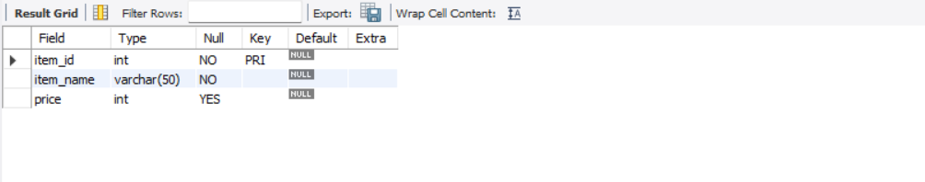

CREATE TABLE Sale (
bill_no INT PRIMARY KEY,
bill_date DATE NOT NULL,
cust_id INT,
item_id INT,
qty_sold INT CHECK (qty_sold > 0),
FOREIGN KEY (cust_id) REFERENCES Customer(cust_id),
FOREIGN KEY (item_id) REFERENCES Item(item_id)
) ENGINE=InnoDB;
SHOW TABLES;
DESCRIBE Sale;
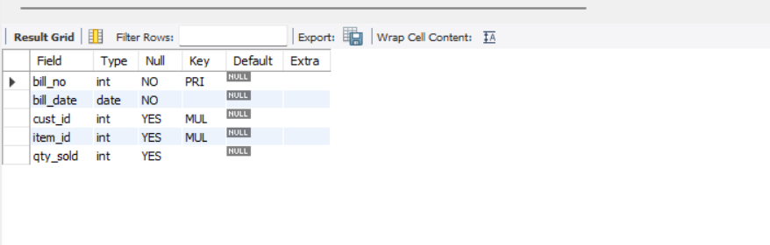

3.b) Insert around 10 records in each of the tables.
(CUSTOMER VALUES)
INSERT INTO Customer VALUES
(1,'ANSHIKA'),
(2,'PRIYA'),
(3,'SAKSHI'),
(4,'AAKRISHI'),
(5,'ANJALI'),
(6,'KARAN'),
(7,'MEERA'),
(8,'AMIT'),
(9,'RAHUL'),
(10,'ARJUN');
SELECT*FROM Customer;
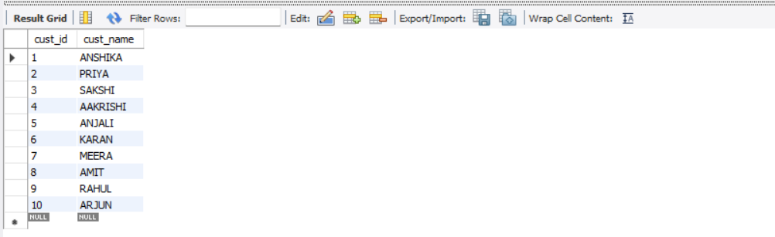

(ITEM VALUES)
INSERT INTO Item VALUES
(101,'LAPTOP',55000),
(102,'MOUSE',300),
(103,'KEYBOARD',800),
(104,'MONITOR',7000),
(105,'PHONE',25000),
(106,'PRINTER',4000),
(107,'CHARGER',500),
(108,'EARPHONES',12000),
(109,'TABLET',18000),
(110,'SMARTWATCH',6000);
SELECT*FROM Item;

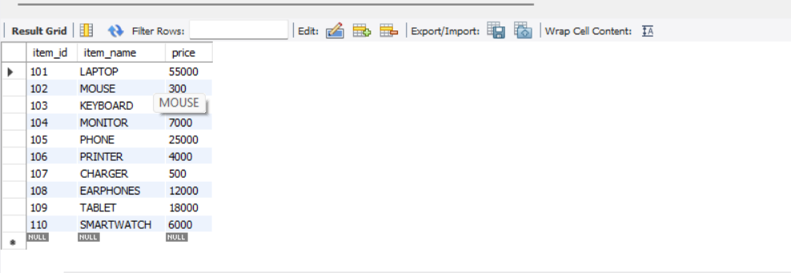

(SALE VALUES)
INSERT INTO Sale VALUES
(1001,CURRENT_DATE,1,101,1),
(1002,CURRENT_DATE,2,102,2),
(1003,CURRENT_DATE,3,105,1),
(1004,CURRENT_DATE,4,103,3),
(1005,CURRENT_DATE,5,108,1),
(1006,CURRENT_DATE,6,109,2),
(1007,CURRENT_DATE,7,104,1),
(1008,CURRENT_DATE,8,110,1),
(1009,CURRENT_DATE,9,106,2),
(1010,CURRENT_DATE,10,107,1);
SELECT*FROM Sale;
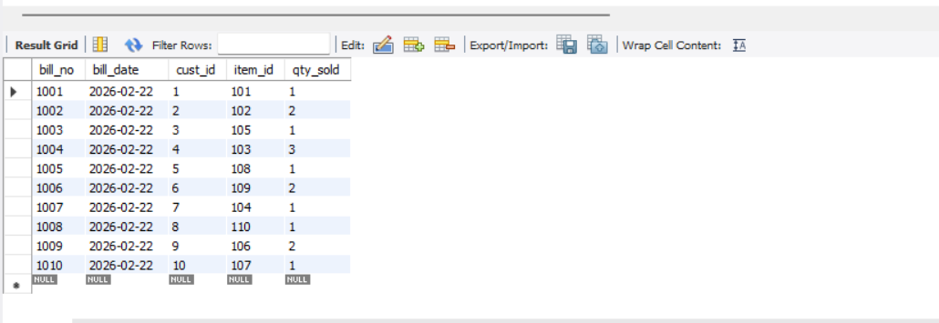

3.c)List all the bills for the current date with the customer names and item numbers.
SELECT s.bill_no, s.bill_date, c.cust_name, s.item_id
FROM Sale s
JOIN Customer c ON s.cust_id=c.cust_id
WHERE s.bill_date= CURRENT_DATE;

SCREENSHOT;

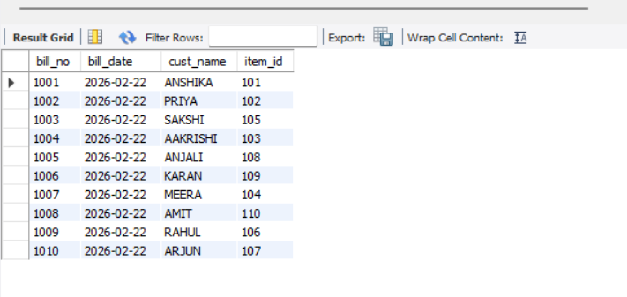

3.d) List the total Bill details with the quantity sold, price of the item and the final amount.
SELECT
s.bill_no,
s.bill_date,
c.cust_name,
SUM(s.qty_sold) AS total_qty,
SUM(s.qty_sold * i.price) AS final_amount
FROM Sale s
JOIN Customer c ON s.cust_id = c.cust_id
JOIN Item i ON s.item_id = i.item_id
GROUP BY s.bill_no, s.bill_date, c.cust_name;
SCREENSHOT;

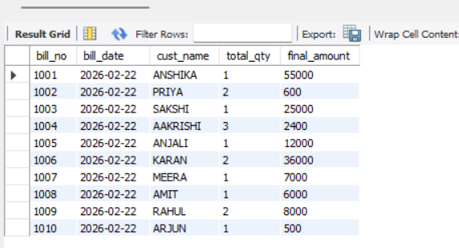

3.e) List the details of the customer who have bought a product which has a price>200.

SELECT DISTINCT
c.cust_id,
c.cust_name,
i.item_id,
i.item_name,
i.price
FROM Sale s
JOIN Customer c ON s.cust_id = c.cust_id
JOIN Item i ON s.item_id = i.item_id
WHERE i.price > 200;
SCREENSHOT;

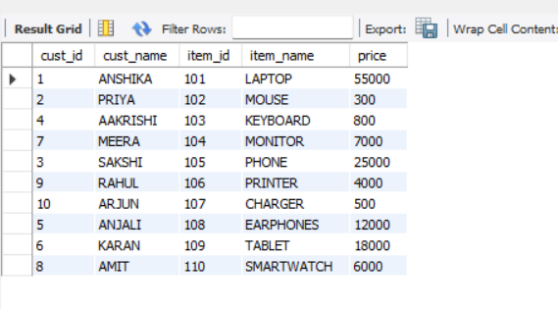

3.f)Give a count of how many products have been bought by each customer
SELECT
c.cust_id,
c.cust_name,
COUNT(s.item_id) AS products_bought
FROM Sale s
JOIN Customer c ON s.cust_id=c.cust_id
GROUP BY c.cust_id,c.cust_name;

SCREENSHOT;
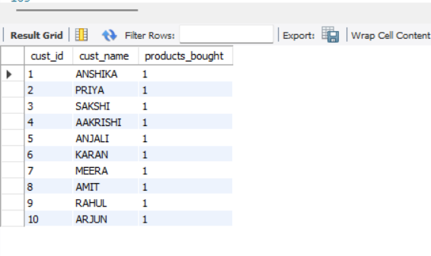

3.g) Give a list of products bought by a customer having cust_id as 5.
SELECT
c.cust_id,
c.cust_name,
i.item_id,
i.item_name,
i.price,
s.qty_sold
FROM Sale s
JOIN Customer c ON s.cust_id=c.cust_id
JOIN Item i ON s.item_id=i.item_id
WHERE s.cust_id=5;

SCREENSHOT;

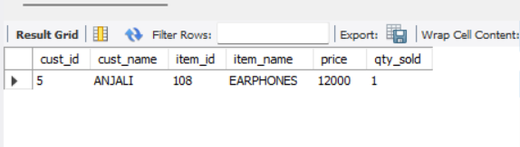

3.h) List the item details which are sold as of today.
SELECT DISTINCT
i.item_id,
i.item_name,
i.price
FROM Sale s
JOIN Item i ON s.item_id = i.item_id
WHERE s.bill_date = CURRENT_DATE;

SCREENSHOT;

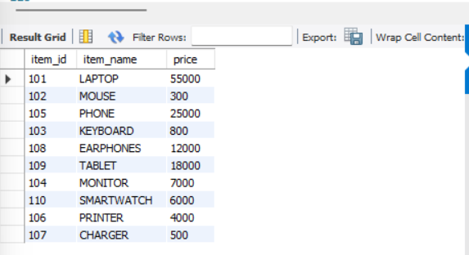

3.i) Create a view which lists out the bill_no, bill_date, cust_id, item_id, price, qty_sold,amount.
CREATE VIEW BillDetails AS
SELECT
s.bill_no,
s.bill_date,
s.cust_id,
s.item_id,
i.price,
s.qty_sold,
(s.qty_sold * i.price) AS amount
FROM Sale s
JOIN Item i ON s.item_id = i.item_id;
SELECT * FROM BillDetails;
SCREENSHOT;
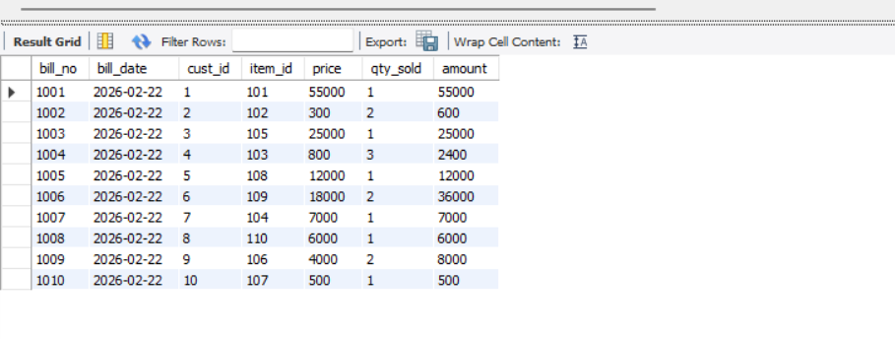

3.j) Create a view which lists the daily sales date wise for the last one week.
CREATE VIEW WeeklySales AS
SELECT
s.bill_date,
SUM(s.qty_sold * i.price) AS total_sales_amount,
SUM(s.qty_sold) AS total_quantity_sold
FROM Sale s
JOIN Item i ON s.item_id = i.item_id
WHERE s.bill_date >= (CURRENT_DATE - INTERVAL 7 DAY)
GROUP BY s.bill_date
ORDER BY s.bill_date;
SELECT * FROM WeeklySales;
SCREENSHOT;


EXPERIMENT-4

DDL Questions (Data Definition Language)
- Write SQL statements to create all the above relations with appropriate PRIMARY KEY and FOREIGN KEY constraints.
create database
create database dbms_anshika;
use dbms_anshika;
🔷 PART A – COLLEGE DATABASE
STUDENT TABLE:
create table student(
usn varchar(20) primary key,
Sname varchar(50),
adress varchar(100),
phone varchar(15),
gender char(1)
);
Explanation:
USN is defined as the Primary Key to uniquely identify each student.
SEMSEC Table
CREATE TABLE SEMSEC (
SSID VARCHAR(10) PRIMARY KEY,
Sem INT,
Sec CHAR(1)
);
Explanation:
SSID uniquely identifies each semester and section.
CLASS Table
CREATE TABLE CLASS (
USN VARCHAR(20),
SSID VARCHAR(10),
PRIMARY KEY (USN, SSID),
FOREIGN KEY (USN) REFERENCES STUDENT(USN),
FOREIGN KEY (SSID) REFERENCES SEMSEC(SSID)
);
Explanation:
- CLASS is an associative table.
- USN and SSID together form a composite Primary Key.
- Both are Foreign Keys referencing STUDENT and SEMSEC tables.

SUBJECT Table
CREATE TABLE SUBJECT (
Subcode VARCHAR(10) PRIMARY KEY,
Title VARCHAR(50),
Sem INT,
Credits INT
);
Explanation:
Subcode is the Primary Key.

IAMARKS Table
CREATE TABLE IAMARKS (
USN VARCHAR(20),
Subcode VARCHAR(10),
SSID VARCHAR(10),
Test1 INT,
Test2 INT,
Test3 INT,
FinalIA INT,
PRIMARY KEY (USN, Subcode, SSID),
FOREIGN KEY (USN) REFERENCES STUDENT(USN),
FOREIGN KEY (Subcode) REFERENCES SUBJECT(Subcode),
FOREIGN KEY (SSID) REFERENCES SEMSEC(SSID)
);
Explanation:
1. Composite Primary Key ensures unique student-subject-semester record.
2. Foreign Keys maintain referential integrity.

SCREENSHOTS:
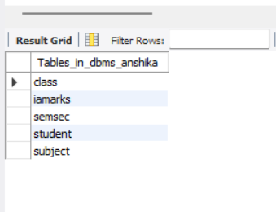

2.Add a new column Email to the STUDENT relation.

ALTER TABLE STUDENT
ADD Email VARCHAR(50);
DESC STUDENT;

SCREENSHOT;

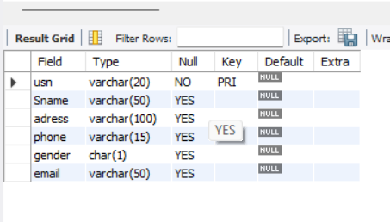

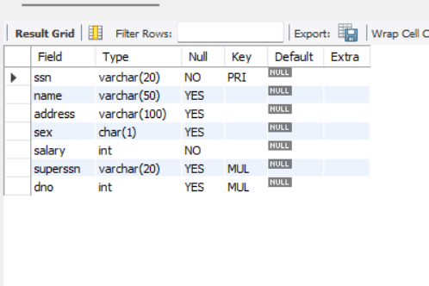

🔷 PART B – COMPANY DATABASE
USE DBMS_Anshika;

DEPARTMENT Table

CREATE TABLE DEPARTMENT (
Dno INT PRIMARY KEY,
Dname VARCHAR(50),
MgrSSN VARCHAR(20),
MgrStartDate DATE
);

EMPLOYEE Table

CREATE TABLE EMPLOYEE (
SSN VARCHAR(20) PRIMARY KEY,
Name VARCHAR(50),
Address VARCHAR(100),
Sex CHAR(1),
Salary INT,
SuperSSN VARCHAR(20),
Dno INT,
FOREIGN KEY (Dno) REFERENCES DEPARTMENT(Dno),
FOREIGN KEY (SuperSSN) REFERENCES EMPLOYEE(SSN)
);

Manager Foreign Key

ALTER TABLE DEPARTMENT
ADD FOREIGN KEY (MgrSSN) REFERENCES EMPLOYEE(SSN);

PROJECT Table

CREATE TABLE PROJECT (
PNo INT PRIMARY KEY,
PName VARCHAR(50),
PLocation VARCHAR(50),
DNo INT,
FOREIGN KEY (DNo) REFERENCES DEPARTMENT(Dno)
);

WORKS_ON Table

CREATE TABLE WORKS_ON (
SSN VARCHAR(20),
PNo INT,
Hours INT,
PRIMARY KEY (SSN, PNo),
FOREIGN KEY (SSN) REFERENCES EMPLOYEE(SSN),
FOREIGN KEY (PNo) REFERENCES PROJECT(PNo)
);

DLOCATION Table

CREATE TABLE DLOCATION (
Dno INT,
Dloc VARCHAR(50),
PRIMARY KEY (Dno, Dloc),
FOREIGN KEY (Dno) REFERENCES DEPARTMENT(Dno)
);

SHOW TABLES;

SCREENSHOTS:

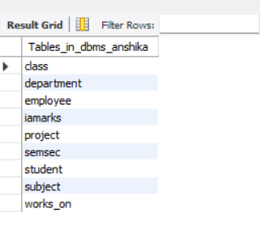



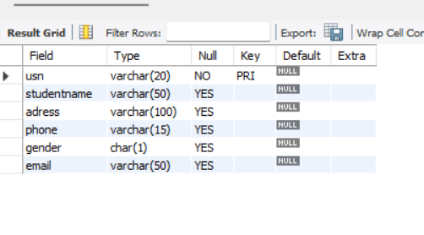
3.Apply NOT NULL constraints to Salary and Price attributes.

ALTER TABLE EMPLOYEE
MODIFY Salary INT NOT NULL;

SCREENSHOT;

ALTER TABLE ITEM
MODIFY Price INT NOT NULL;

SCREENSHOT;

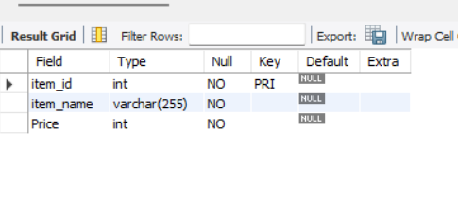

4.Rename attribute SName to StudentName in STUDENT relation.

ALTER TABLE STUDENT
RENAME COLUMN SName TO StudentName;

SCRRENSHOT;


5.Drop the DLOCATION relation.

DROP TABLE DLOCATION;

SCREENSHOT;

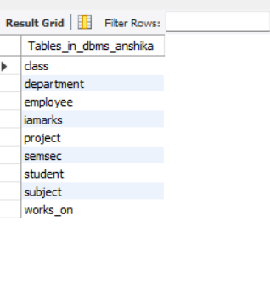

DML Questions (Data Manipulation Language):
- Insert at least 10 tuples into CUSTOMER, ITEM, and SALE relations.
CUSTOMER VALUE
INSERT INTO CUSTOMER VALUES
(1, 'Anaya'),
(2, 'Riya'),
(3, 'Karan'),
(4, 'Aman'),
(5, 'Neha'),
(6, 'Simran'),
(7, 'Arjun'),
(8, 'Priya'),
(9, 'Rahul'),
(10, 'Meera');
SELECT*FROM Customer;

SCREENSHOT:
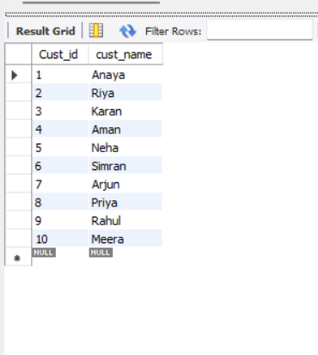

ITEM VALUES
INSERT INTO ITEM VALUES
(101, 'Laptop', 50000),
(102, 'Mouse', 500),
(103, 'Keyboard', 1200),
(104, 'Headphones', 2500),
(105, 'Charger', 800),
(106, 'Mobile', 20000),
(107, 'Tablet', 15000),
(108, 'Printer', 7000),
(109, 'Camera', 30000),
(110, 'USB Drive', 600);
SELECT*FROM ITEM;

SCREENSHOT:

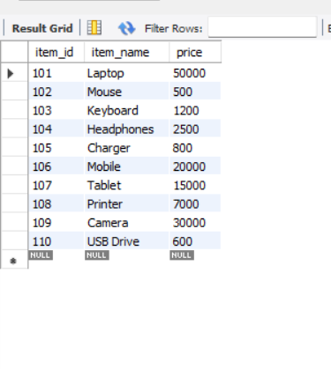

SALE VALUES

INSERT INTO SALE VALUES
(1001, CURDATE(), 1, 102, 2),
(1002, CURDATE(), 2, 103, 1),
(1003, CURDATE(), 3, 104, 1),
(1004, CURDATE(), 4, 105, 3),
(1005, CURDATE(), 5, 106, 1),
(1006, CURDATE(), 5, 102, 1),
(1007, CURDATE(), 6, 107, 1),
(1008, CURDATE(), 7, 108, 2),
(1009, CURDATE(), 8, 109, 1),
(1010, CURDATE(), 9, 110, 4);
SELECT* FROM SALE;

SCREENSHOT:

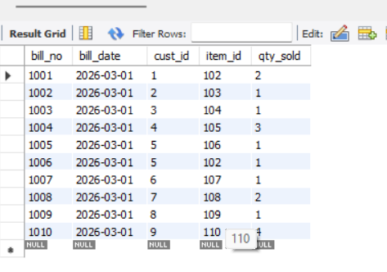

2.List all bills of the current date with customer names and item names.

SELECT s.bill_no, s.bill_date, c.cust_name, i.item_name
FROM SALE s
JOIN CUSTOMER c ON s.cust_id = c.cust_id
JOIN ITEM i ON s.item_id = i.item_id
WHERE s.bill_date = CURDATE();

SCREENSHOT:
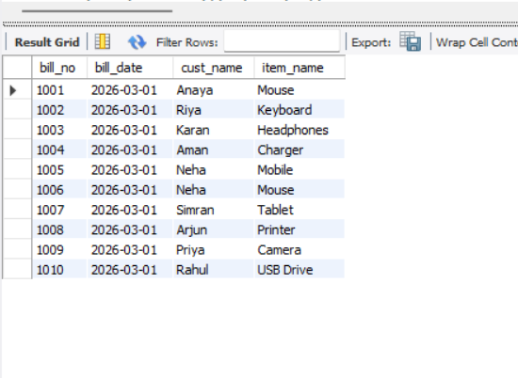
3.Display total bill amount using quantity and price.

SELECT s.bill_no, c.cust_name, i.item_name,
s.qty_sold, i.price,
(s.qty_sold * i.price) AS total_amount
FROM SALE s
JOIN CUSTOMER c ON s.cust_id = c.cust_id
JOIN ITEM i ON s.item_id = i.item_id;

SCREENSHOT: 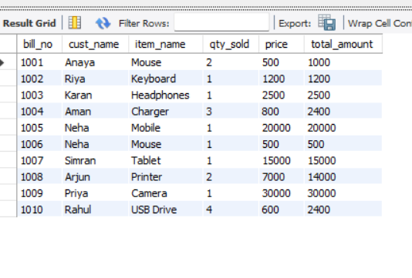

4. List customers who purchased products priced above 200.

SELECT DISTINCT c.cust_name
FROM SALE s
JOIN CUSTOMER c ON s.cust_id = c.cust_id
JOIN ITEM i ON s.item_id = i.item_id
WHERE i.price > 200;

SCREENSHOT:
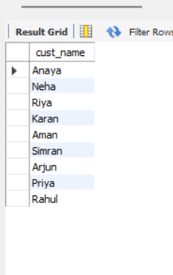
5. Count the number of products purchased by each customer.

SELECT c.cust_name, SUM(s.qty_sold) AS total_products
FROM SALE s
JOIN CUSTOMER c ON s.cust_id = c.cust_id
GROUP BY c.cust_name;

SCREENSHOT:

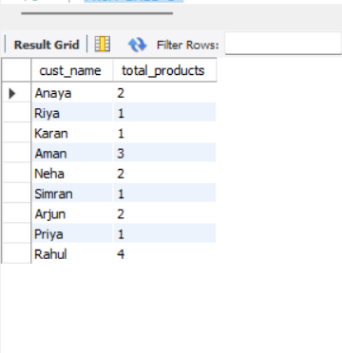
6. List products purchased by customer having Cust_id = 5.

SELECT i.item_name
FROM SALE s
JOIN ITEM i ON s.item_id = i.item_id
WHERE s.cust_id = 5;

SCREENSHOT:
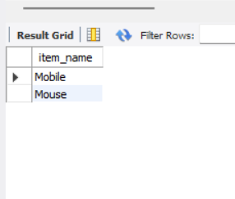

7.Create a VIEW showing bill_no, bill_date, cust_id, item_id, price, qty,sold, amount.

CREATE VIEW BILL_DETAILS AS
SELECT s.bill_no, s.bill_date, s.cust_id,
s.item_id, i.price,
s.qty_sold,
(s.qty_sold * i.price) AS amount
FROM SALE s
JOIN ITEM i ON s.item_id = i.item_id;
SELECT * FROM BILL_DETAILS;

SCREENSHOT:
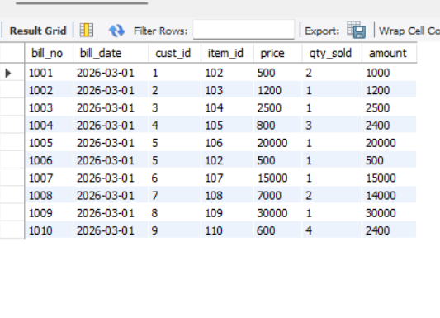

8.Create a VIEW showing daily sales date-wise for the last one week.

CREATE VIEW WEEKLY_SALES AS
SELECT bill_date, SUM(qty_sold * i.price) AS daily_total
FROM SALE s
JOIN ITEM i ON s.item_id = i.item_id
WHERE bill_date >= CURDATE() - INTERVAL 7 DAY
GROUP BY bill_date;
SELECT * FROM WEEKLY_SALES;

SCREENSHOT:
