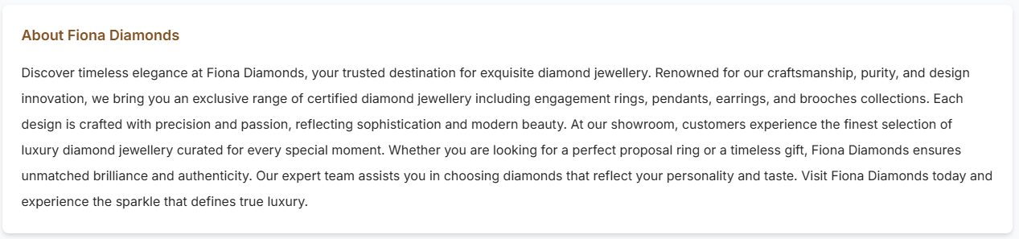
Fiona Diamonds Store Locator | Elegant Diamond Jewellery

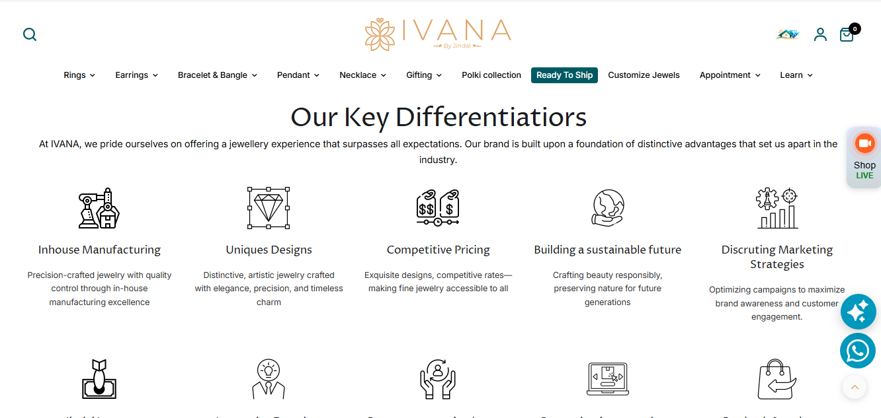
Franchise – Ivana Jewels

