Deepfake Video Detection Using Frame Analysis

1. Input Overview

In this project, the system takes a video file as input to check whether it is real or a deepfake. The video is provided by the user, and the program processes it automatically.

For example, a video like Deepfake.mp4 is used for testing.

2. Input Parameters

Some important parameters are used during processing:

Video Path – The location of the input video file

Frame Skipping – Instead of analyzing every frame, the system skips some frames (default is every 5th frame) to make processing faster

MSE Threshold (500) – Helps in measuring differences between frames

SSIM Threshold (0.85) – Helps in measuring similarity between frames

These values help the system decide whether the video is real or fake.

3. Frame Extraction

Before analysis, the video is divided into multiple frames.

The system reads the video using OpenCV

It extracts frames at regular intervals

These frames are stored temporarily for processing

This step is important because the model compares frames instead of analyzing the whole video at once.

4. Graph Input (How Data for Graphs is Created)

The graphs are not manually entered. Instead, they are automatically generated from the analysis:

The system compares consecutive frames

It calculates:

MSE (difference between frames)

SSIM (similarity between frames)

These values are stored in lists and later used to create graphs.

📤 Output Section (Results & Graphs)

1. Output Overview

After processing the video, the system provides the final result along with some useful metrics.

The output includes:

Whether the video is deepfake or real

Average MSE value

Average SSIM value

Confidence level

Graphs for visualization

2. Output Values

The system returns results in a structured format, which includes all important values needed for analysis.

3. Graphical Output

📊 MSE Graph

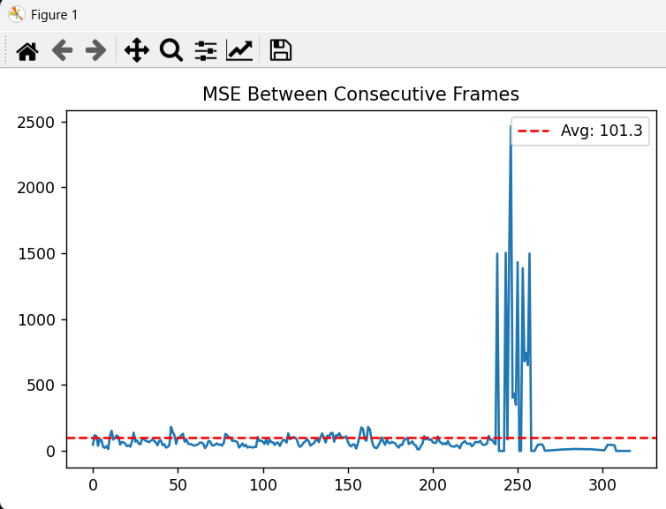

This graph shows how much difference exists between consecutive frames.

Lower values → frames are very similar

Higher values → frames are different

📊 SSIM Graph

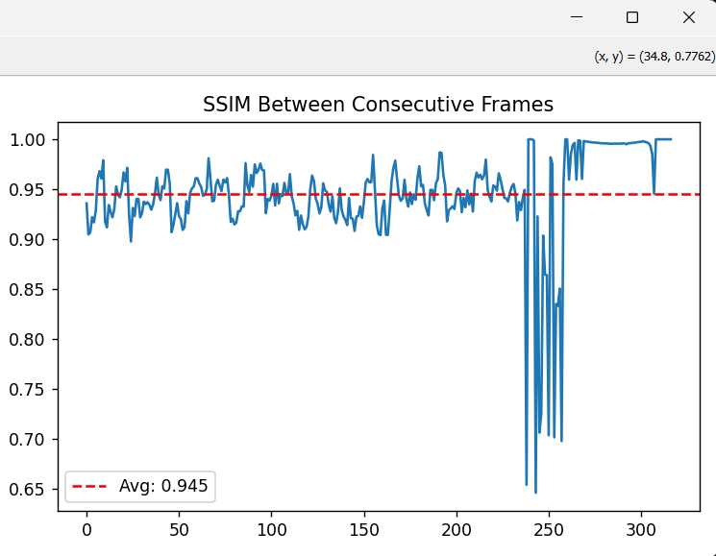

This graph shows how similar the frames are.

Higher values → frames are very similar

Lower values → frames are different

4. Final Decision

The system uses both MSE and SSIM values to make a decision:

If frames are too similar, it may indicate a deepfake

If frames show natural variation, the video is likely real

5. Output Example

A typical output may look like this:

Video is Deepfake / Real

Average MSE: 320.45

Average SSIM: 0.91

Confidence: 9%
