Title: Building a Retrieval-Augmented Generation (RAG) System for YouTube Content

1. Introduction
Retrieval-Augmented Generation (RAG) is an advanced natural language processing architecture that combines the strengths of information retrieval systems and generative models. Instead of relying solely on pre-trained knowledge, RAG systems dynamically retrieve relevant external content and use it to produce informed, context-aware responses.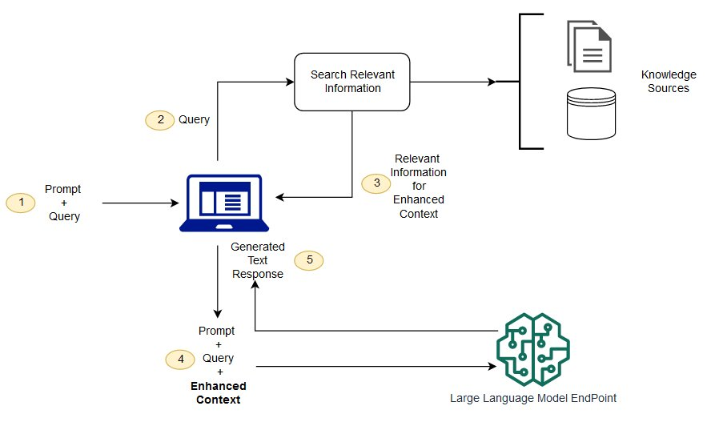
In a YouTube-based RAG system, this framework is adapted to interact with content from YouTube videos. The goal is to create an intelligent agent that can understand and respond to user queries using the knowledge extracted from video content. Applications range from educational bots and podcast summarizers to interactive video search assistants.

2. System Architecture Overview
A YouTube-based RAG system typically involves the following stages:
- Data Collection: Extract metadata, transcripts, and optionally audio from YouTube videos.
- Preprocessing: Clean and chunk the text data for embedding.
- Embedding and Storage: Convert text into embeddings using sentence-transformer models and store them in a vector database.
- Query Processing: Accept user queries, convert them into embeddings, and retrieve similar chunks from the database.
- Answer Generation: Use a large language model to generate responses based on the retrieved chunks.

3. Components and Tools
- YouTube Data Collection
  - API: YouTube Data API v3
  - Tools: yt-dlp, youtube-transcript-api, Whisper (for audio transcription)
- Text Processing
  - Chunking: Sentence-wise or token-wise splitting (e.g., 300 tokens with 50 overlap)
  - Libraries: NLTK, spaCy, LangChain
- Embeddings
  - Models: all-MiniLM-L6-v2, multi-qa-MiniLM, or OpenAI’s embedding models
  - Libraries: SentenceTransformers, OpenAI API
- Vector Database
  - Options: FAISS, Pinecone, Weaviate
- LLM for Generation
  - Models: OpenAI GPT-4, LLaMA 2, Cohere Command R
  - Frameworks: LangChain, LlamaIndex

4. Implementation Workflow
- Transcript Extraction
  - Use youtube-transcript-api or Whisper to extract transcripts.
- Chunking
  - Divide transcripts into overlapping chunks for meaningful context.
- Embedding
  - Convert chunks into vector embeddings.
- Storage in Vector DB
  - Store vectors with associated metadata (video title, URL, timestamps).
- Query Embedding and Retrieval
  - Convert user query into vector and retrieve top-K relevant chunks.
- Response Generation
  - Concatenate retrieved chunks and pass them to the LLM for final answer generation.

5. Use Case Examples
- Podcast Q&A: Ask detailed questions about a podcast episode.
- Educational Bots: Query lecture videos for specific concepts.
- Content Discovery: Search across multiple videos for specific discussions.
- Summarization: Generate summaries of entire playlists or channels.

6. Challenges and Limitations
- Inaccurate or missing transcripts
- Noisy audio affecting transcription quality
- Irrelevant retrieval results due to embedding limitations
- Latency and cost in querying large databases and LLMs

7. Future Scope
- Multimodal RAG: Incorporating audio and video features directly.
- Real-time RAG: Live transcription and querying of ongoing streams.
- User Feedback Loop: Improve retrieval and generation using user preferences.

8. Conclusion
YouTube-based RAG systems offer a powerful approach for transforming passive video content into interactive, intelligent dialogue systems. By leveraging transcript data, embedding models, vector databases, and LLMs, these systems can make vast video libraries searchable, conversational, and user-centric.

References
- YouTube Data API Documentation
- HuggingFace SentenceTransformers
- OpenAI and LangChain RAG Tutorials
- Pinecone and FAISS Documentation
- Research papers on RAG and multimodal retrieval

