DATA ANALYTICS INTERNSHIP PROJECT
Data Cleaning & Reporting Automation
Automating data preprocessing and reporting workflows with Python and Excel
Tools: Python (pandas, matplotlib, openpyxl) and Microsoft Excel
October 2026

1. Objective
The objective of this project is to automate the data cleaning and reporting workflow for a retail sales dataset. Raw business data is rarely analysis-ready: it contains gaps, duplicates and inconsistent entries. Cleaning it by hand is slow and error-prone, and the work has to be repeated every time new data arrives.
This project builds a single Python pipeline that cleans the raw data, documents every change, and regenerates an Excel report and a set of visual summaries with one command.

Requirements and how they were met
Requirement | Delivered
Use Python, Excel, or Power BI | Python for cleaning and charts; Excel for the automated report (Power BI-ready output)
Handle missing values | 554 missing cells across 9 columns resolved by inference, median imputation or labelling
Handle duplicates | 60 duplicate rows removed; order_id uniqueness validated
Handle inconsistent data | Text labels, dates and numeric formats standardised
Generate automated reports | Sales_Report.xlsx with 8 sheets, 122 live formulas and native charts
Generate visual summaries | 7 individual charts plus a one-page dashboard

2. Dataset
The dataset contains 1,560 retail orders placed during 2025, with 11 columns: order_id, order_date, customer_name, region, category, product, quantity, unit_price, discount_pct, payment_method and total_amount. The data was generated with a script (src/generate_data.py) that deliberately injects the quality problems analysts meet in practice, so each cleaning technique can be demonstrated and measured.

Data quality problems found
Problem type | Examples in the raw data
Missing values | Customer, region, payment, category, quantity, price, discount, total and date fields left blank
Duplicates | 60 exact duplicate order rows
Inconsistent text | Region written as north, NORTH, N., Nrth; category as Electroncs, Stationary, Clothing
Mixed formats | Dates in four formats (2025-03-14, 14/03/2025, Mar 14, 2025, 14-Mar-2025); prices stored as text such as $1,200.50
Invalid values | 14 negative quantities
Outliers | Quantities of 250, 500 and 999 against a normal range of 1 to 10

3. Methodology
The pipeline (src/pipeline.py) runs eight stages in a fixed order. Each action is written to an audit log together with the number of rows it affected.

Stage 1: Load and profile
The raw file is loaded and profiled to record the number of rows, missing cells and duplicate rows. This is the baseline for the before-and-after comparison.

Stage 2: Standardise text
Whitespace is trimmed and customer names converted to Title Case. Region, category and payment method are mapped to valid labels in three steps: exact match, a small alias table (for example cc to Credit Card), and fuzzy matching with Python's difflib to catch typos.

Stage 3: Fix data types
Dates are parsed from four text formats into one date type. Currency text is stripped of $ and comma characters and converted to numbers.

Stage 4: Remove duplicates
Exact duplicate rows are dropped, keeping the first occurrence, followed by a check for repeated order IDs. Twelve rows with no order date were removed because they cannot be placed in time.

Stage 5: Invalid values and outliers
Negative quantities are treated as sign-entry errors and converted to positive values. Extreme quantities are capped using the 3 x IQR rule, which here gives an upper limit of 13 units. A multiplier of 3 was chosen over the usual 1.5 so that legitimate large orders are not altered.

Stage 6: Impute missing values
- Category: inferred from the product name, because each product belongs to one category.
- Unit price and quantity: filled with the median of the same product, which is robust to outliers.
- Customer, region and payment method: labelled Unknown rather than guessed.
- Discount: assumed to be 0% (no discount).
- Total amount: recalculated for every row as quantity x unit price x (1 - discount).

Stage 7: Validate
Automated assertions confirm that no missing values remain, no duplicate rows or order IDs remain, all quantities and prices are positive, and every category and region is a valid label. The pipeline stops with an error if any check fails.

Stage 8: Report
The cleaned data is saved as CSV, the audit trail is saved as a log, the charts are drawn, and the Excel workbook is built.

4. Results
Metric | Before cleaning | After cleaning
Rows | 1,560 | 1,488
Missing cells | 554 | 0
Duplicate rows | 60 | 0

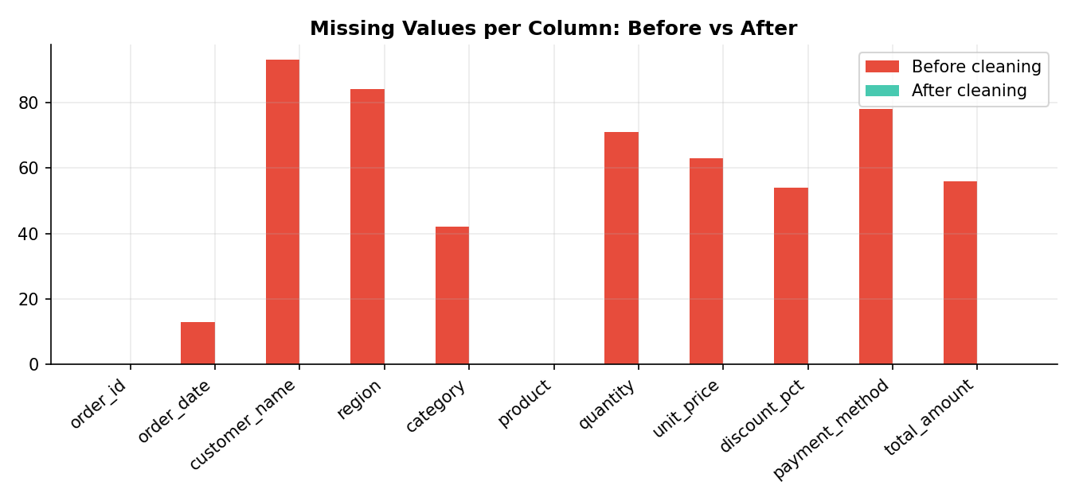
Figure 1: Missing values per column before and after cleaning

Cleaning log summary
Stage | Issue found | Action | Rows
Standardise text | Customer names: mixed case and spaces | Trim + Title Case | 188
Standardise text | Region labels inconsistent | Mapped to standard labels | 276
Standardise text | Category labels inconsistent | Mapped to standard labels | 270
Standardise text | Payment labels inconsistent | Mapped to standard labels | 149
Fix types | Dates in 4 text formats | Parsed to one format | 1,157
Fix types | Prices stored as text | Converted to numbers | 121
Fix types | Totals stored as text | Converted to numbers | 100
Duplicates | Exact duplicate rows | Dropped | 60
Duplicates | Missing order date | Rows removed | 12
Invalid values | Negative quantity | Absolute value | 14
Outliers | Quantity above 13 | Capped at 13 | 9
Missing values | Category | Inferred from product | 39
Missing values | Customer name | Labelled Unknown | 90
Missing values | Region | Labelled Unknown | 80
Missing values | Payment method | Labelled Unknown | 74
Missing values | Unit price | Product median | 60
Missing values | Quantity | Product median | 69
Missing values | Discount | Assumed 0% | 49
Missing values | Total amount | Recalculated | 54
Missing values | Stored total inconsistent after fixes | Recalculated | 94

5. Automated Excel Report
The workbook Sales_Report.xlsx is regenerated on every run. All summary figures are live Excel formulas (SUMIFS, COUNTIF, INDEX/MATCH) that point to the cleaned data sheet, so the report stays correct if the data is edited.
Sheet | Content
Summary | Key performance indicators and a data cleaning snapshot
By Region / By Category | Orders, units, revenue, share of revenue and average order value, each with a chart
Monthly Trend | Revenue and orders by month with month-over-month growth and a line chart
Top Products | Product ranking by revenue with a bar chart
Data Quality | Before and after comparison, including missing values per column
Cleaning Log | Audit trail of every transformation
Clean Data | The cleaned dataset with filters and frozen header row

6. Visual Summaries
The charts below are produced automatically by the pipeline with matplotlib.
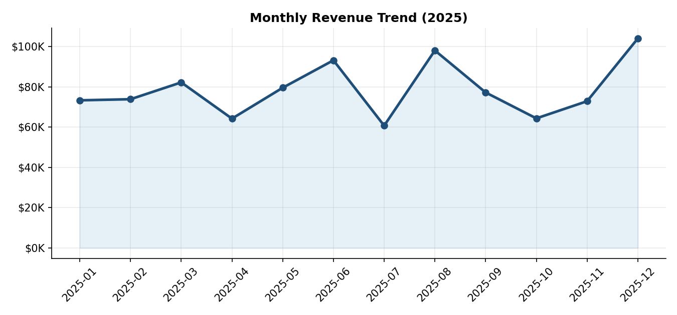
Figure 2: Monthly revenue trend, 2025
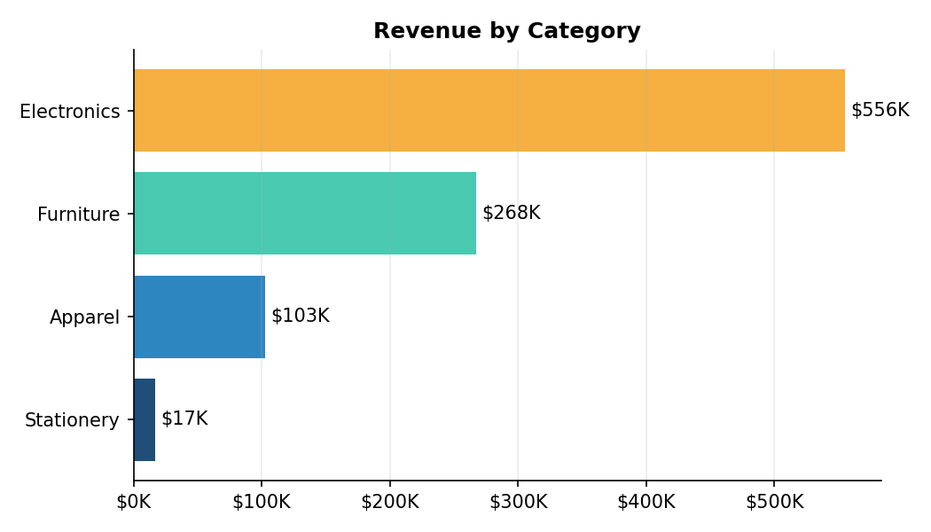
Figure 3: Revenue by category
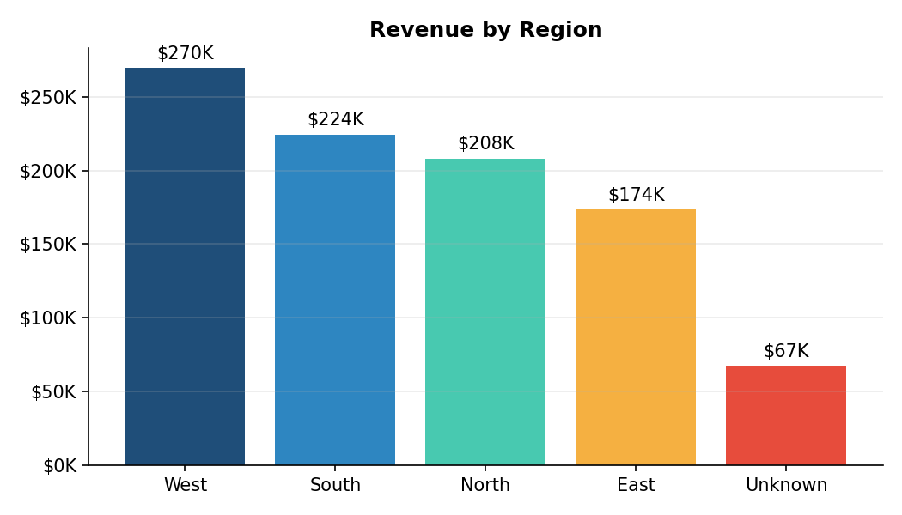
Figure 4: Revenue by region
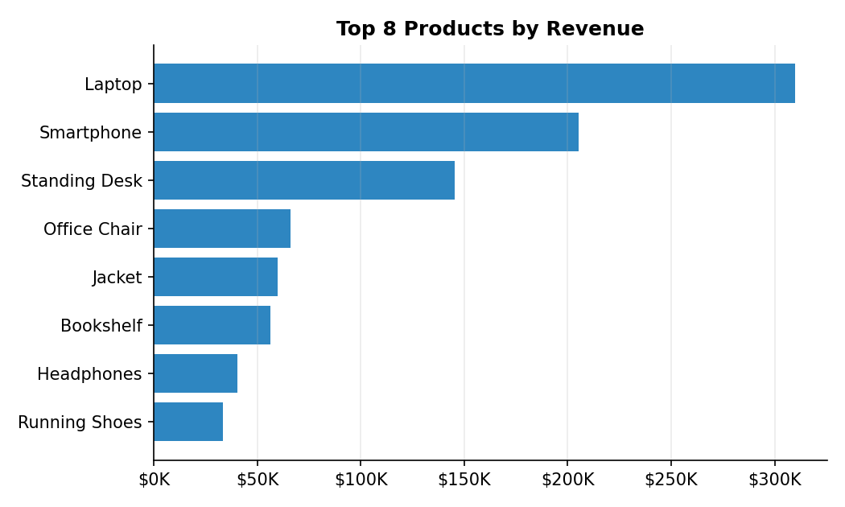
Figure 5: Top 8 products by revenue
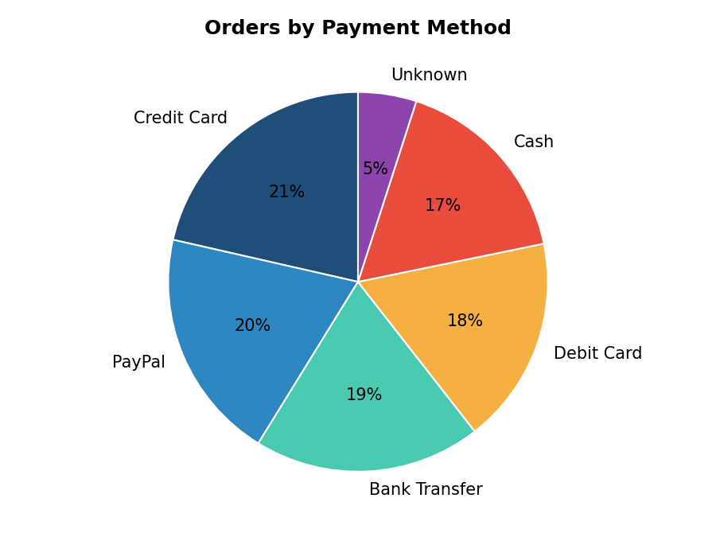
Figure 6: Orders by payment method
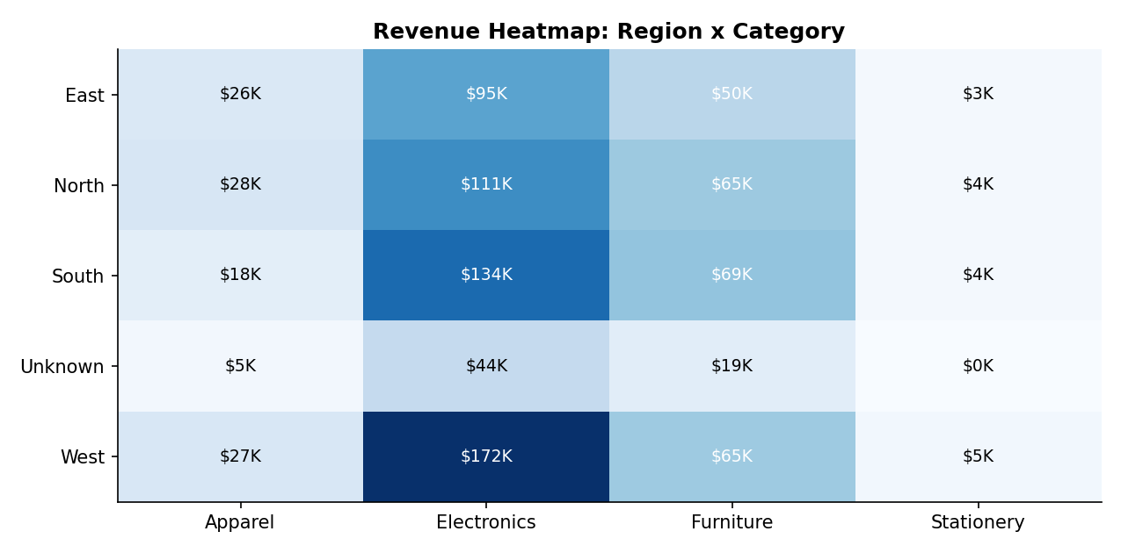
Figure 7: Revenue heatmap by region and category

7. Key Insights
- Overall performance. Total revenue is about $943,000 from 1,488 orders, an average order value of about $634.
- Product mix. Electronics generates roughly 59% of revenue. Laptops and smartphones are the two best-selling products by revenue.
- Regions. West is the strongest region, with about 28.6% of revenue.
- Seasonality. December is the best month. July shows a clear dip compared with June and August.
- Data gaps. About $67,000 (7.2%) of revenue has no recorded region. Capturing region at order entry would make regional analysis more reliable.

8. Automation
The whole workflow runs with one command: python src/pipeline.py. It accepts any CSV with the same columns through the --input option. It can be scheduled so reports refresh without manual effort:
- Windows: Task Scheduler running python src\pipeline.py.
- Linux and macOS: a cron entry such as 0 8 * * 1 cd /path/to/project && python src/pipeline.py.
The Clean Data sheet of the workbook can also be loaded directly into Power BI (Get Data, then Excel) to build interactive dashboards on the same cleaned data.

Manual versus automated workflow
Aspect | Manual cleaning | This pipeline
Time per run | Hours | A few seconds
Repeatability | Depends on the person | Identical every run
Audit trail | Usually none | Every change logged with row counts
Error checking | Visual inspection | Automated validation checks
Reporting | Rebuilt by hand | Regenerated automatically

9. Assumptions and Limitations
- Median imputation keeps totals realistic but gives estimates, not the true original values.
- Negative quantities were treated as typing errors. In a live business they could be product returns and should then be flagged separately.
- Missing customer, region and payment values are labelled Unknown rather than guessed.
- The dataset is synthetic, so the business insights illustrate the reporting method rather than a real company.

10. Conclusion and Learning Outcomes
The project turned a dataset with 554 missing cells, 60 duplicates and many inconsistent entries into a validated, analysis-ready dataset, and automated every step from cleaning through to the final report. Because the process is scripted, logged and validated, it can be reused for any new data with the same structure.
Key learning outcomes:
- Profiling data to find quality problems before changing anything.
- Choosing a suitable treatment for each problem: removal, correction, imputation or labelling.
- Documenting every transformation so results are traceable and defensible.
- Automating a repeatable workflow with Python and producing reports in Excel.
- Communicating findings with clear charts and summary tables.

