DATA COMPUTING AND COMPUTER NETWORKS
LABORATORY MANUAL
B.TECH
(2st YEAR – 4nd SEMESTER)
Academic Year ->2025-2026



DEPARTMENT OF COMPUTER SCIENCE AND ENGINEERING
INDIRA GANDHI DELHI TECHNICAL UNIVERSITY FOR WOMEN

SUBMITTED TO: SUBMITTED BY:
Mr.Vijay Kumar Yadav Anshika Sharma
ENROLLMENT NUMBER:
025010102024
BATCH: B.Tech CSE-1 (A1)
INDEX

Serial Number | Name of The  Experiment | Date | Signature
1. | To implement Parity Check technique for error detection in data communication using even parity.
2. | To implement the Checksum method for error detection in data transmission.
3. | To implement CRC for error detection using polynomial division.
4. | To implement Hamming Code for single-bit error detection and correction.
5. | To implement Stop-and-Wait ARQ protocol for reliable data transmission.
6. | To implement the Go-Back-N ARQ protocol using sliding window mechanism for reliable data transmission.
7. | To implement the Selective Repeat ARQ protocol to retransmit only lost or corrupted frames.
8. | To implement Stop-and-Wait protocol for reliable data transmission over the noiseless channel.

EXPERIMENT 1: Parity Check(Even Parity)

- Aim:
To implement Parity Check technique for error detection in data communication using even parity.
- Code Snippet:
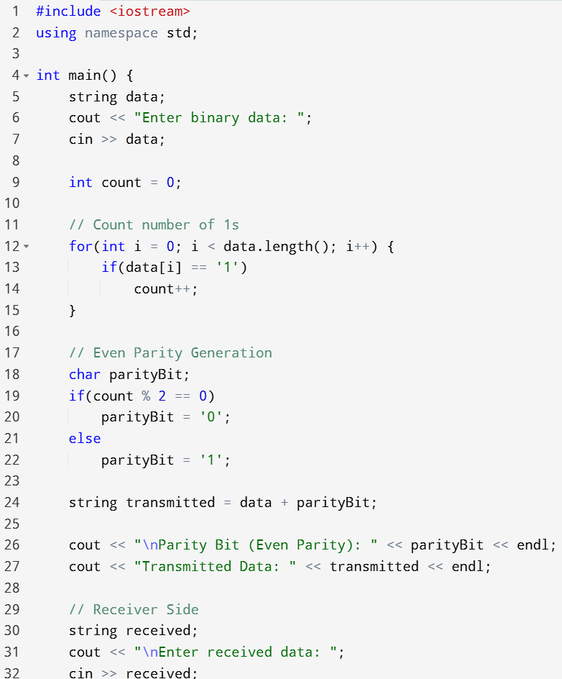

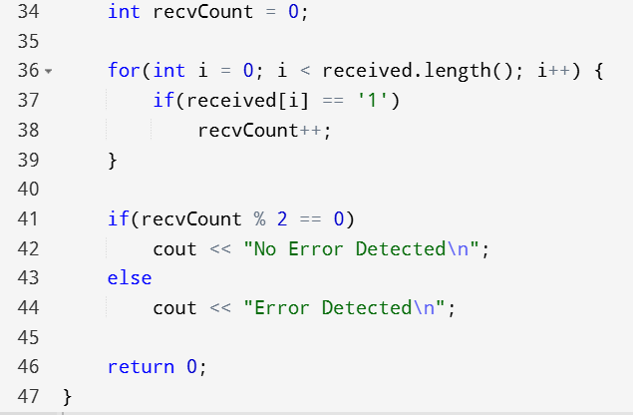

- Sample Output:
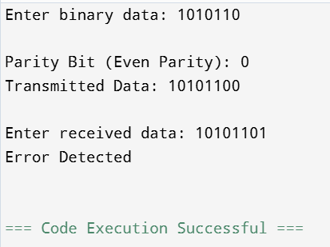

- Conclusion:
Parity Check is a simple error detection technique where a parity bit is added to make the total number of 1s either even or odd. It can detect single-bit errors but cannot detect multiple errors reliably.

EXPERIMENT 2: Checksum Technique

- Aim:
To implement the Checksum method for error detection in data transmission.

- Code Snippet:

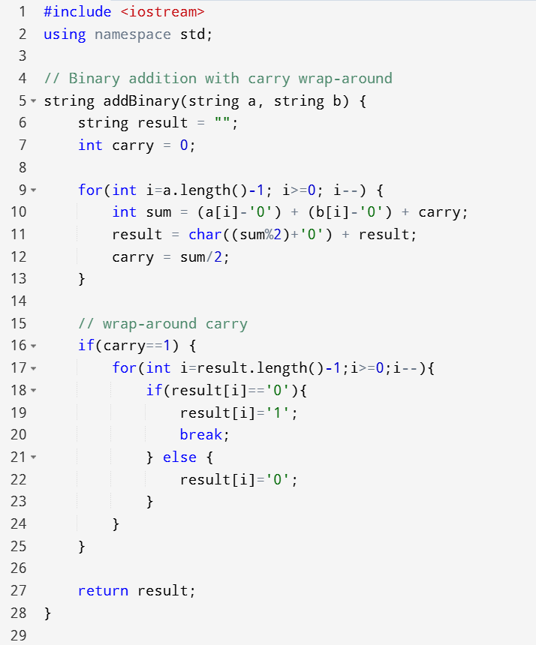
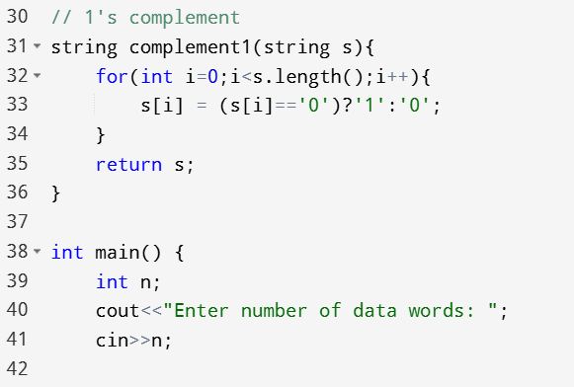
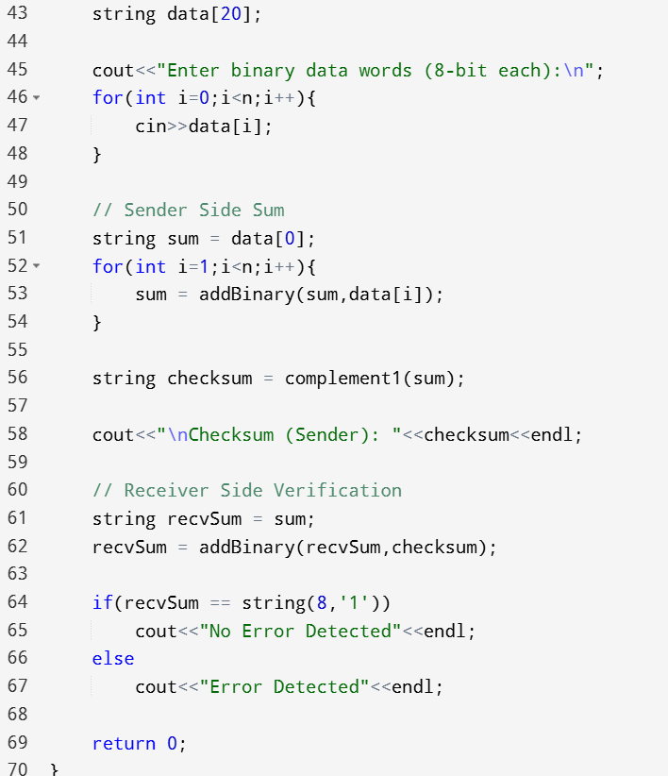
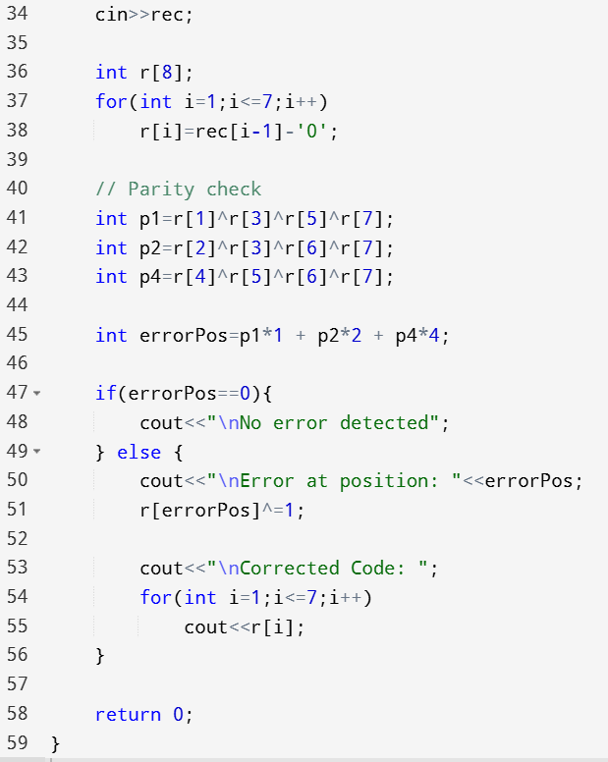

- Sample Output:
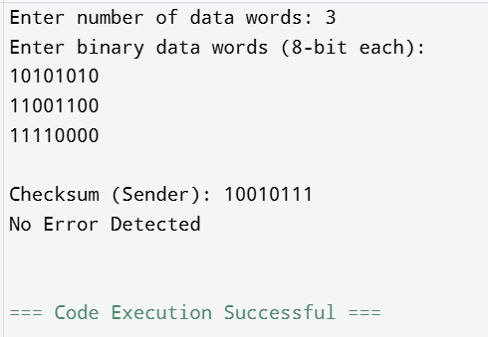
- Conclusion:
Checksum helps detect errors by sending the complement of sum. If total sum at receiver is all 1s, data is correct.
Experiment 3: CRC (Cyclic Redundancy Check)

- Aim:
To implement CRC for error detection using polynomial division.

- Code Snippet:

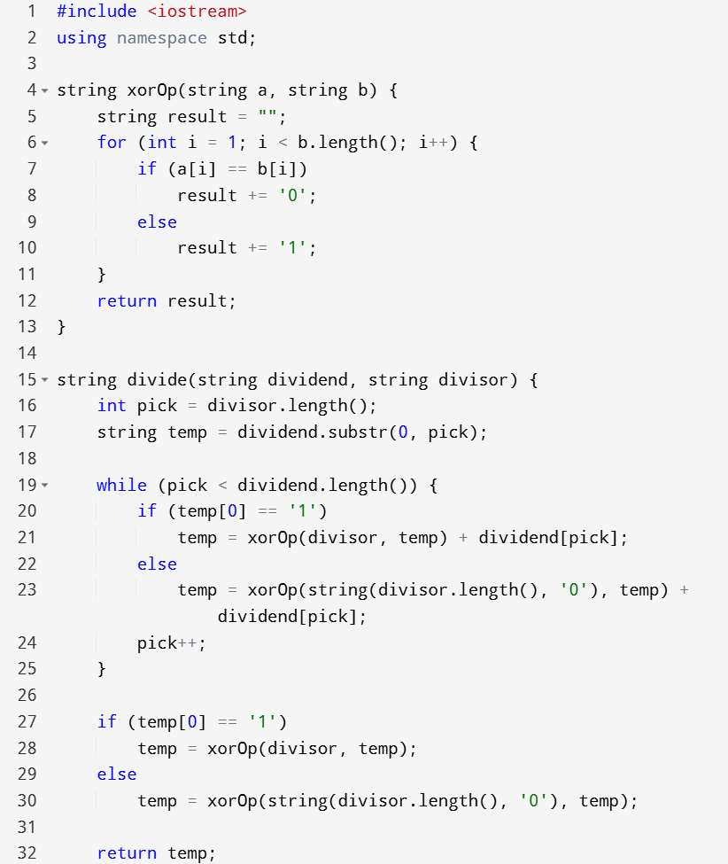

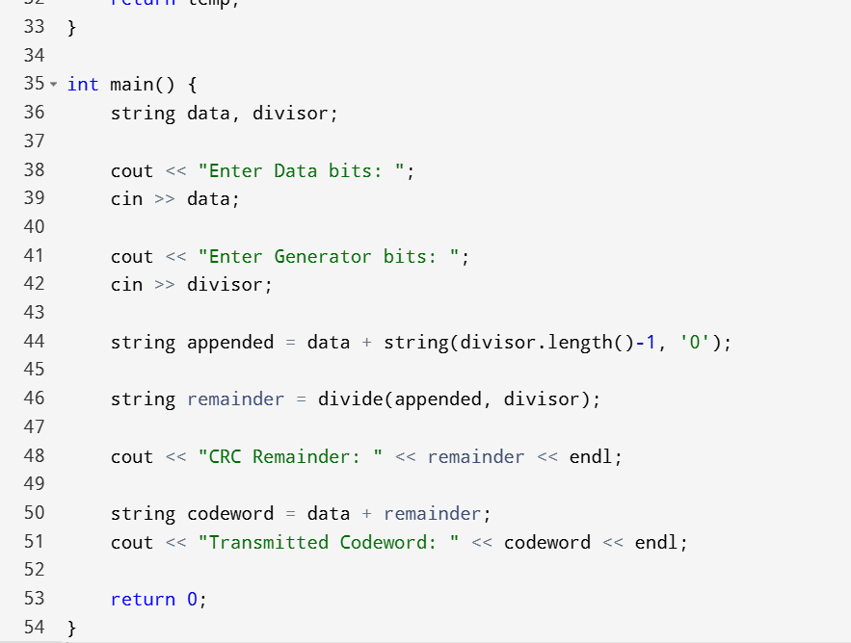

- Sample Output:

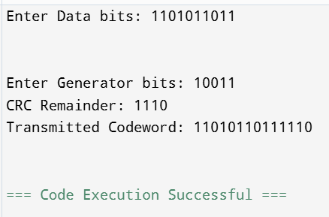

- Conclusion:
CRC detects burst errors effectively using polynomial division and is more reliable than checksum.

Experiment 4: Hamming Code

- Aim:
To implement Hamming Code for single-bit error detection and correction.

- Code Snippet:

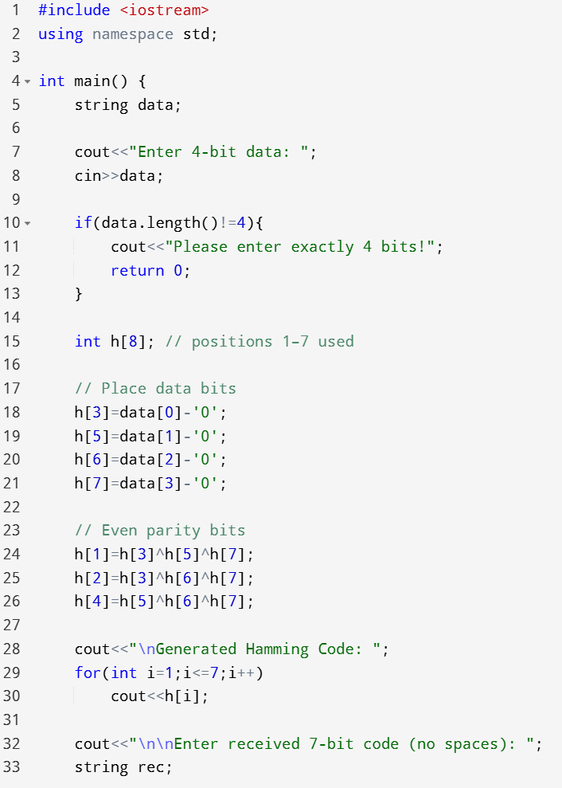

- Sample Output:
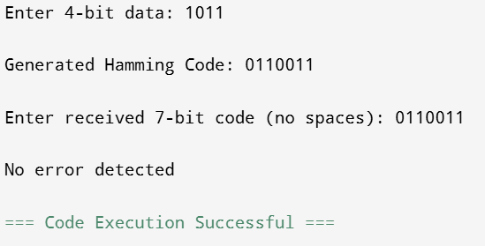
- Conclusion:
Hamming Code can both detect and correct single-bit errors, making it highly useful in reliable communication systems.

EXPERIMENT 5: Stop and Wait Protocol

- Aim:
To implement Stop-and-Wait ARQ protocol for reliable data transmission.

- Code Snippet:

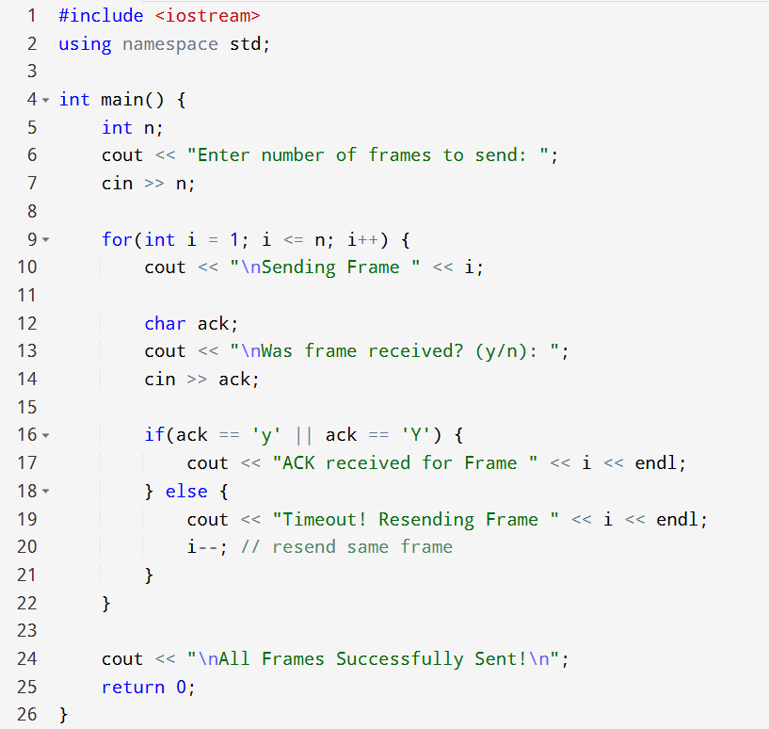

- Sample Output:
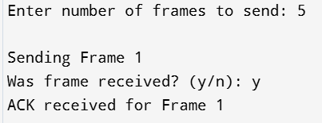

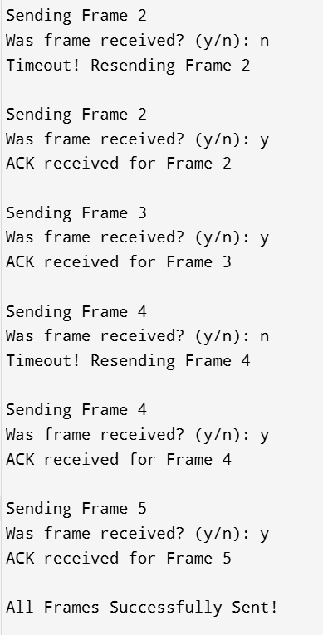

- Conclusion:
Stop-and-Wait ARQ ensures reliable communication by sending one frame at a time and waiting for acknowledgment before sending the next frame. If acknowledgment is not received, the frame is retransmitted.

EXPERIMENT 6: Go-Back-N ARQ

- Aim:
To implement the Go-Back-N ARQ protocol using sliding window mechanism for reliable data transmission.

- Code Snippet:
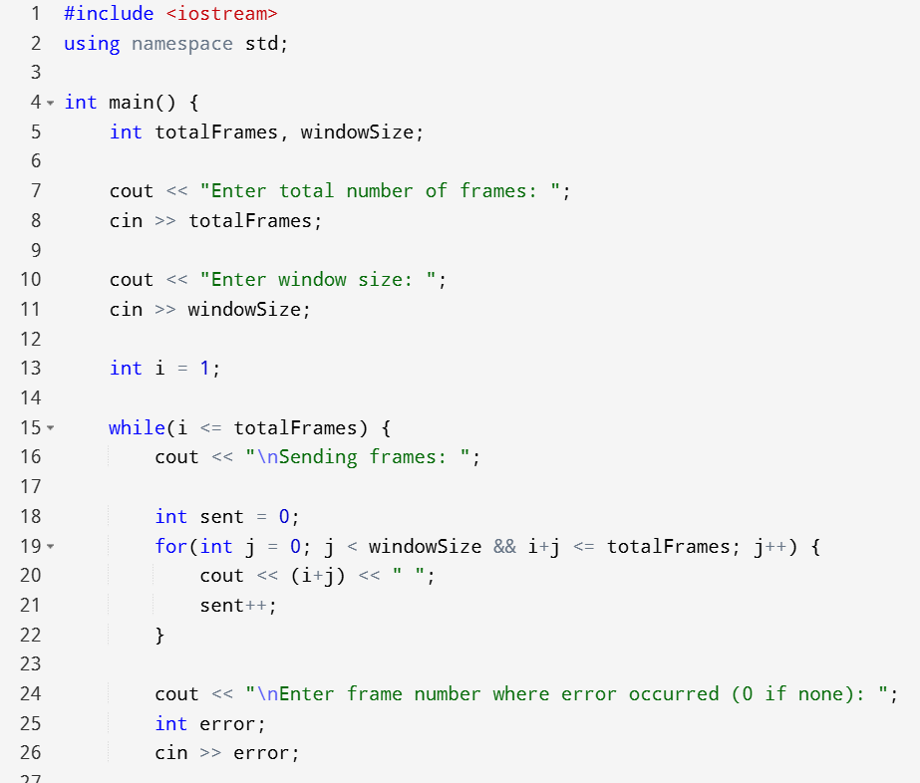
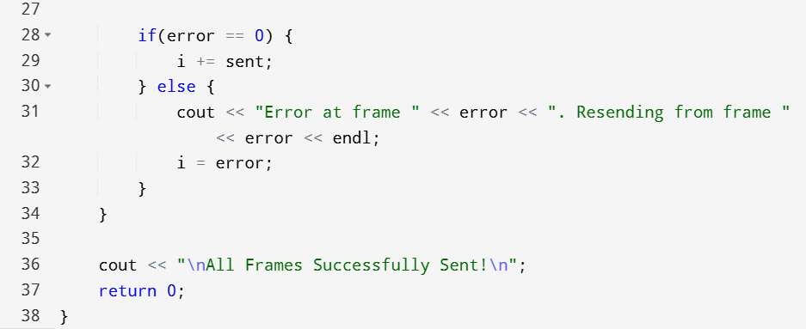
- Sample Output:

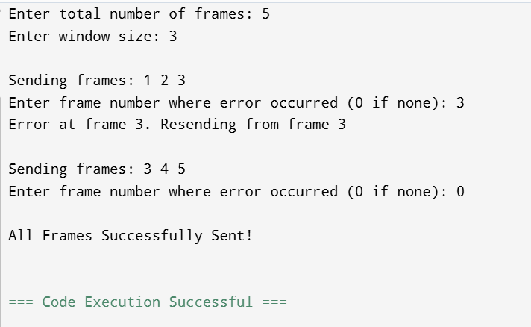

- Conclusion:
Go-Back-N ARQ improves efficiency by allowing multiple frames to be sent before receiving acknowledgment. If an error occurs, the sender retransmits from the erroneous frame onward.

EXPERIMENT 7: Selective Repeat ARQ

- Aim:
To implement the Selective Repeat ARQ protocol to retransmit only lost or corrupted frames.

- Code Snippet:
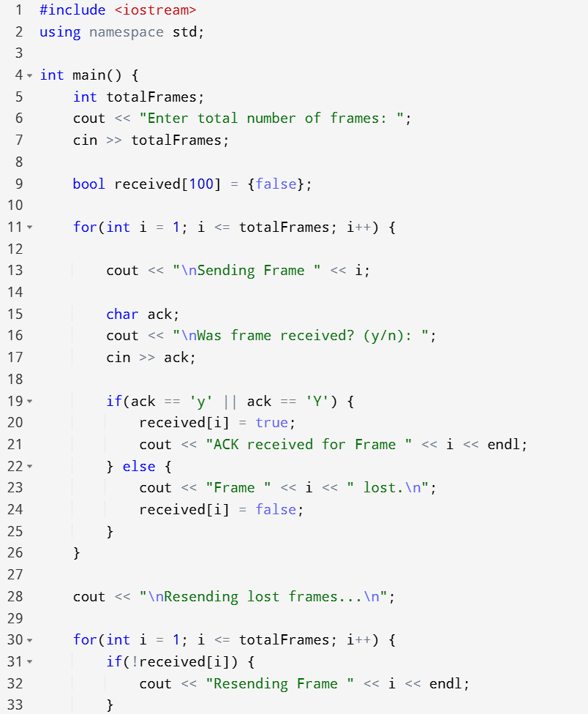
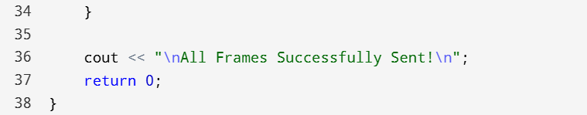

- Sample Output:

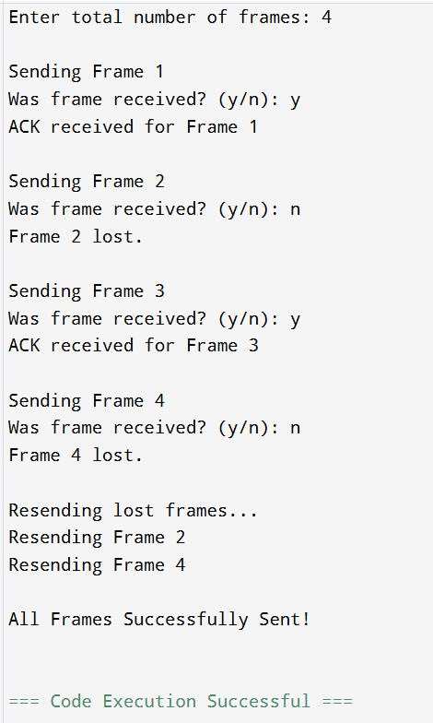

- Conclusion:
Go-Back-N ARQ improves efficiency by allowing multiple frames to be sent before receiving acknowledgment. If an error occurs, the sender retransmits from the erroneous frame onward.

EXPERIMENT 8: Stop-and-Wait Protocol (Noiseless Channel)

- Aim:
To implement Stop-and-Wait protocol for a noiseless channel where frames are transmitted successfully without errors.

- Code Snippet:

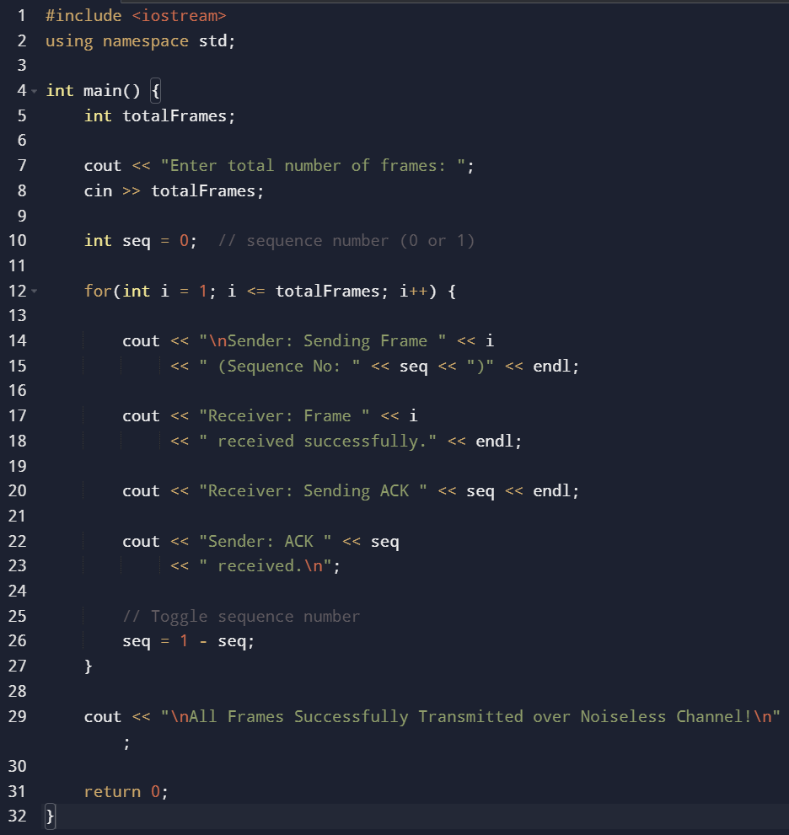

- Sample Output:
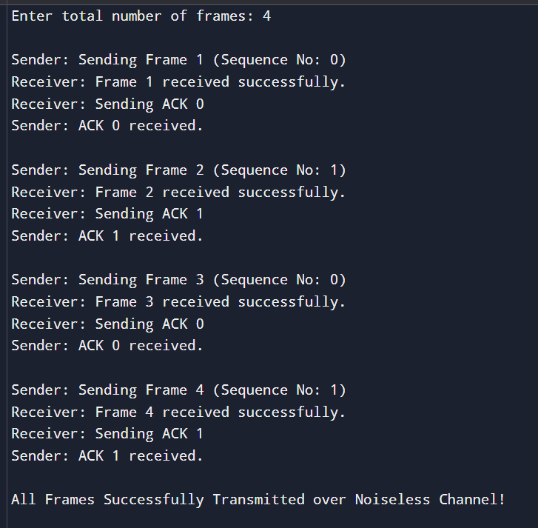

- Conclusion:
In a noiseless channel, Stop-and-Wait protocol ensures reliable communication by sending one frame at a time and waiting for acknowledgment. Since the channel is error-free, no retransmissions are required, making the process simple but less efficient compared to sliding window protocols.

EXPERIMENT 9: IP Address Classes
• Aim:
To study different classes of IP addresses (Class A, B, C, D, E) and understand their characteristics and usage.

• Code Snippet (C++):
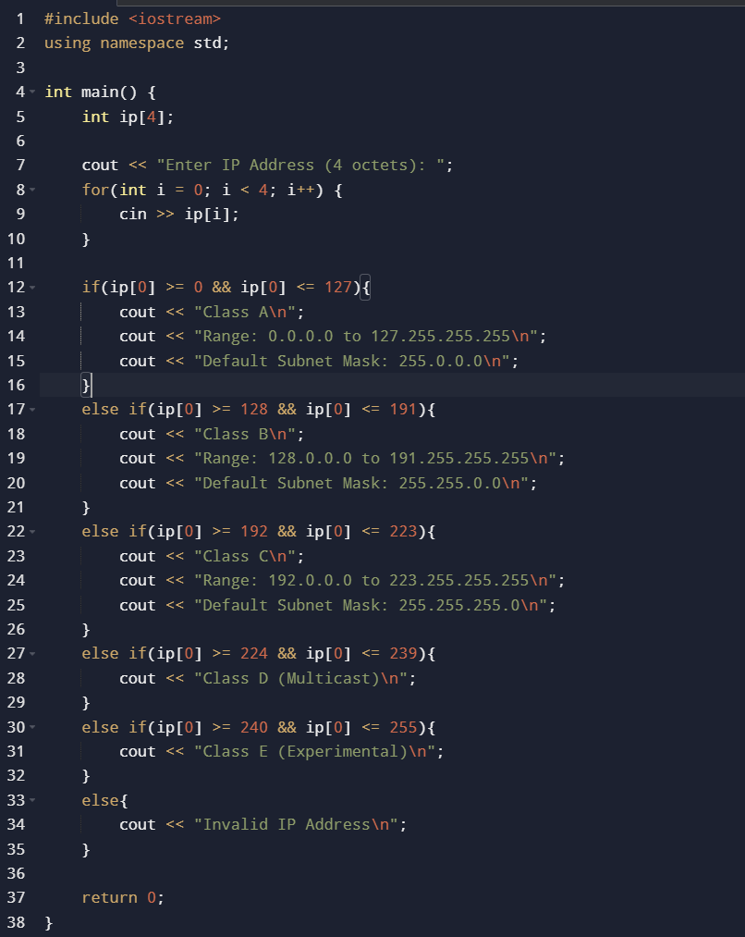

• Sample Output:
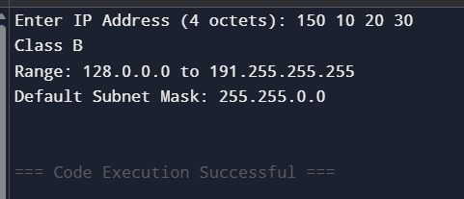
• Result:
The program successfully identifies the class of a given IP address and displays its range and default subnet mask, helping in understanding IP address classification and network design.

EXPERIMENT 10: Subnetting

• Aim:
To divide a large network into smaller subnetworks using subnet masks for efficient IP address utilization.
• Code Snippet (C++):
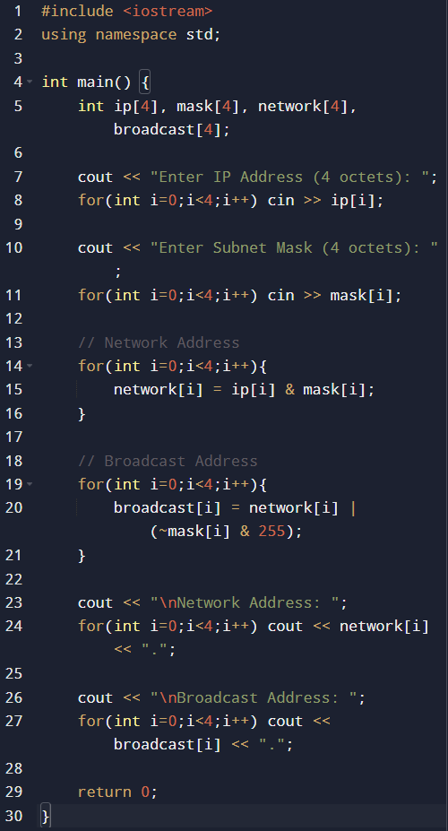
• Sample Output:
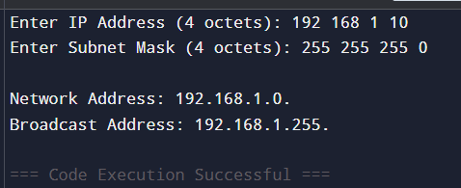

• Result:
Subnetting successfully divides a network into smaller subnets, allowing efficient utilization of IP addresses and improved network management.

EXPERIMENT 11: Class Identification with Subnet Mask

• Aim:
To identify the class of a given IP address and determine its default subnet mask.

• Code Snippet (C++):

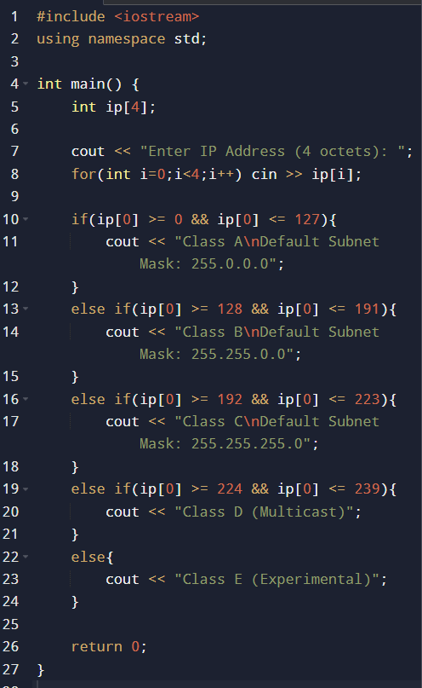

• Sample Output:

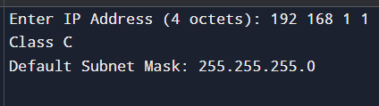

• Result:
The program correctly identifies the class of an IP address and provides the corresponding default subnet mask, helping in network classification and configuration.

EXPERIMENT 12: Subnetting & Supernetting

- Aim :
To perform subnetting and supernetting to efficiently manage and allocate IP addresses..
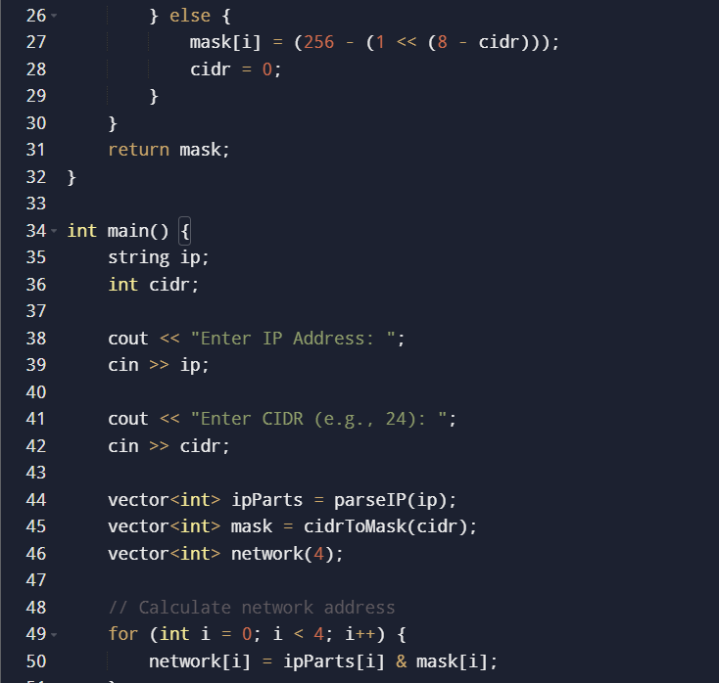
- Code Snippet:
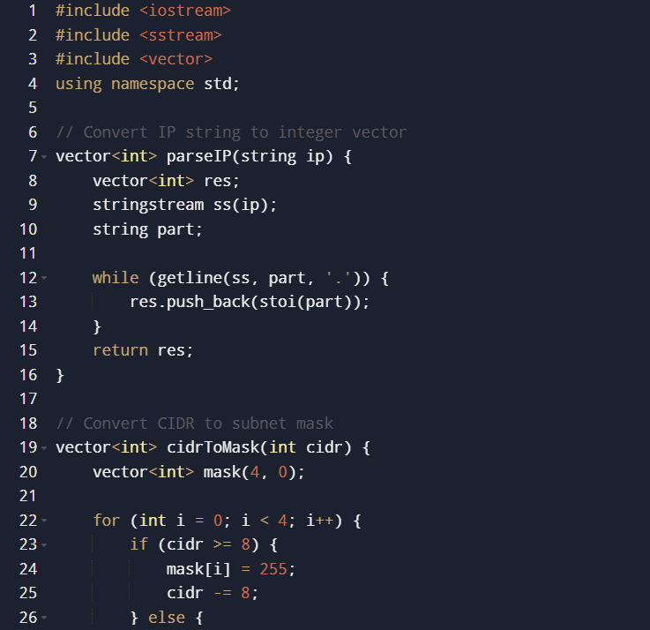

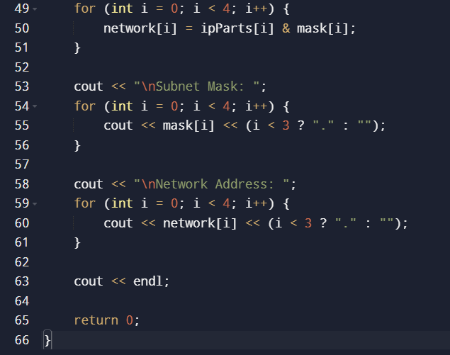

- Sample Output :
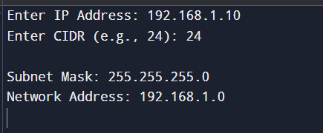

- Conclusion :
Subnetting and supernetting are fundamental techniques used to optimize the allocation and management of IP addresses in a network. Through subnetting, a large network is divided into smaller sub-networks by applying a subnet mask, which helps in improving network performance, security, and efficient utilization of address space. The implemented program demonstrates how an IP address can be combined with a CIDR value to compute the subnet mask and determine the network address using bitwise operations.

