OPERATING SYSTEMS LAB
(BIT 204)
LABORATORY MANUAL
B.TECH
(2st YEAR – 4nd SEMESTER)
Academic Year ->2025-2026



DEPARTMENT OF COMPUTER SCIENCE AND ENGINEERING
INDIRA GANDHI DELHI TECHNICAL UNIVERSITY FOR WOMEN

SUBMITTED TO: SUBMITTED BY:
Ms. Jagriti Singh ANSHIKA SHARMA
ENROLLMENT NUMBER:
025010102024
BATCH: B.Tech CSE-1 (A1)
INDEX

SERIAL NO. |  | NAME OF  EXPERIMENT |  | DATE | REMARKS
1. |  | Execute various LINUX commands:  - i) clear, cal, who, date, pwd  - ii) cd, mkdir, rmdir, wc, cat |  | 20-01-2026
2. |  | Execute various LINUX commands:  - i) ps, alias, ls, grep  - ii) cmp, comm, diff  - iii) chmod, chown, chgrp |  | 27-01-2026
3. |  | To write shell script to find average of three numbers. |  | 03-02-2026
4. |  | Write a program in C to implement First Come First Serve (FCFS) algorithm |  | 10-02-2026
5. |  | Write a program in C to implement Shortest Job First (SJF) algorithm |  | 17-02-2026
6. |  | Write a program in C to implement Shortest Run Time Next (SRTN) algorithm |  | 24-02-2026
7. |  | Write a program in C to implement Priority based Preemption algorithm |  | 03-03-2026
8. |  | Write a program in C to implement Priority based Non-Preemption algorithm |  | 09-03-2026
9. |  | Write a program in C to implement Round Robin algorithm |  | 10-03-2026
10. |  | Write a program in C to implement Banker’s algorithm |  | 10-03-2026
11. |  | Write a program in C to implement Optimal Page Replacement algorithm |  | 17-03-2026
12. |  | Write a program in C to implement FIFO Page Replacement algorithm |  | 17-03-2026
13. | Write a program in C to implement LRU Page Replacement algorithm |  | 24-03-2026
14. | Write a program in C to implement SCAN Disk Scheduling algorithm |  | 26-03-2026
15. | Write a program in C to implement Shortest Seek Time First (SSTF) Disk Scheduling algorithm |  | 07-04-2026
16. | Write a program in C to implement C-SCAN Disk Scheduling algorithm |  | 07-04-2026
EXPERIMENT 1:
Basic Linux Commands

- Aim :
To study, understand, and execute fundamental Linux commands used for system interaction, directory handling, and file management.

- Theory :
Linux is a command-line driven operating system where users interact with the system using commands executed in a terminal. These commands allow users to:
- Navigate directories
- Manage files and folders
- View system information
- Perform basic operations efficiently
Each command has a specific syntax and purpose. Understanding these commands is essential before moving to advanced topics like shell scripting and process management.

- Hardware Requirements:
- A computer system (PC/Laptop)
- Minimum 4GB RAM recommended

- Software Requirements:
- Linux OS (Ubuntu/Fedora) OR
- Windows with Git Bash / WSL installed

- Commands Used with Explanation

Command | Description
clear | Clears the terminal screen
cal | Displays calendar
who | Shows logged-in users
date | Displays system date and time
pwd | Prints working directory
cd | Changes directory
mkdir | Creates a directory
rmdir | Removes directory
cat | Displays file content
wc | Counts lines, words, characters

- Execution :

Terminal 1: System Information Commands
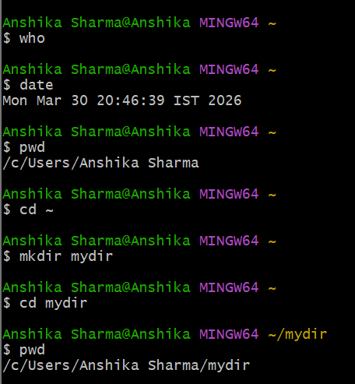

Terminal 2: Directory Creation & Navigation
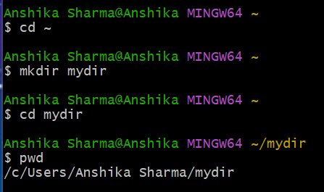

Terminal 3: File Handling Commands
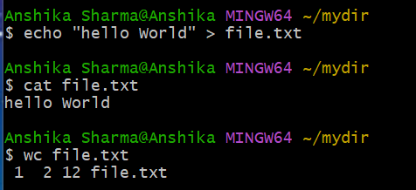

Terminal 4: Directory Removal
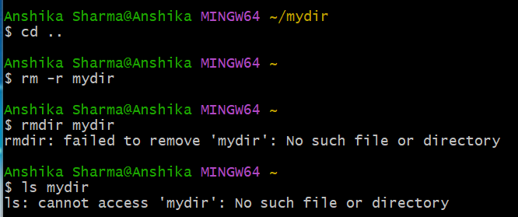

- Conclusion:
This experiment helps in building a strong foundation in Linux command-line usage. These commands are essential for system administration and further experiments.

EXPERIMENT 2:
Advanced Linux Commands

- Aim:
To learn and execute advanced Linux commands related to file comparison, permissions, and process handling.

- Theory:
Advanced Linux commands allow users to:
- Compare files
- Manage permissions
- Monitor system processes
These commands are crucial for developers and system administrators.

- Commands Used:

Command | Description
ls -l | Detailed list of files
ps | Displays running processes
alias | Creates shortcut commands
cmp | Compares two files byte-by-byte
diff | Shows line-by-line difference
chmod | Changes file permissions
chown | Changes file owner
chgrp | Changes group

- Execution :

Terminal 1: Listing & Process Management

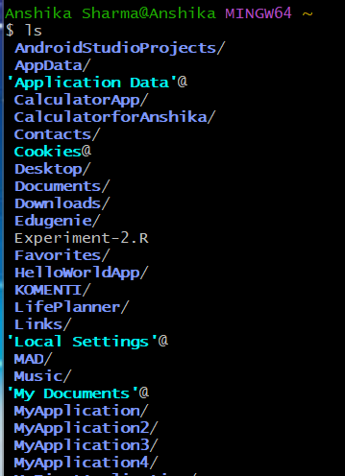
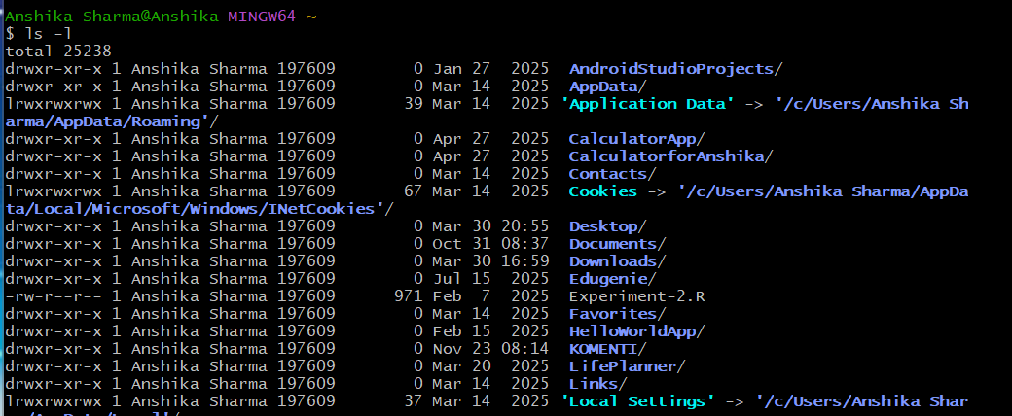
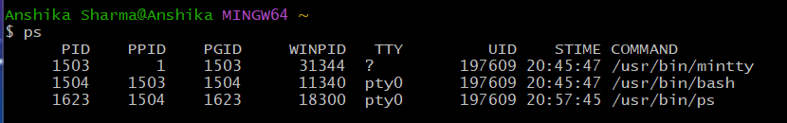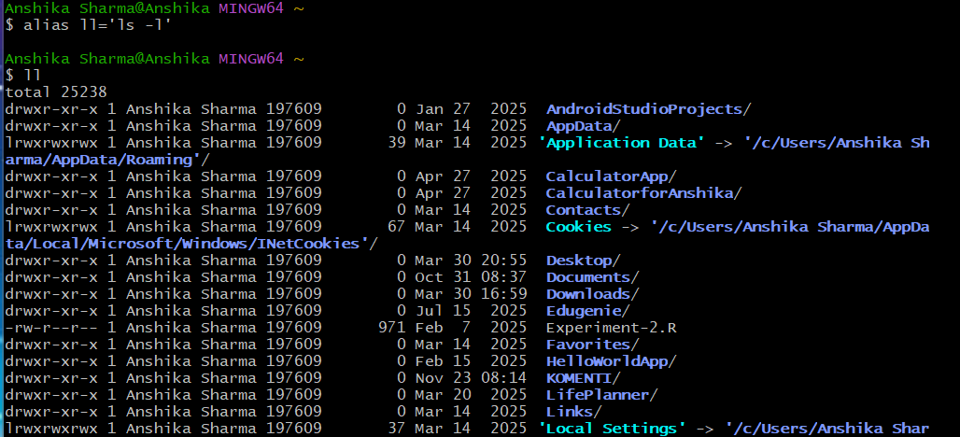

Terminal 2: File Comparison

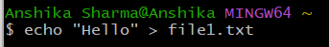
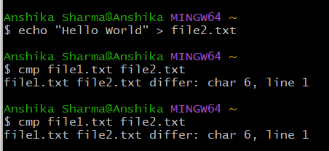

Terminal 3: Permissions Handling

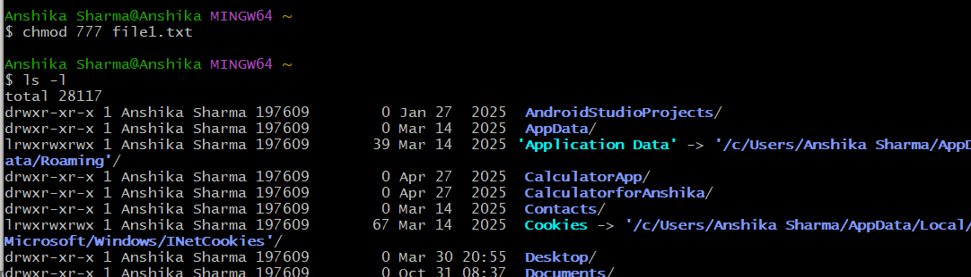

- Conclusion:
Advanced commands provide deeper system-level control.

EXPERIMENT 3:
Shell Scripting

- Aim:
To develop a shell script for calculating the average of three numbers.

- Theory:
Shell scripting is used to automate repetitive tasks using bash programming.

- Commands :

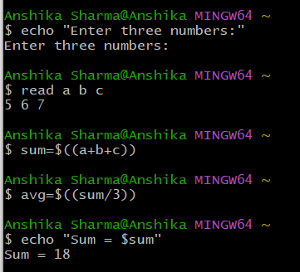

- Sample Input
5 6 7
- Expected Output
Sum = 18
Average = 6

- Conclusion:
Shell scripting automates calculations and reduces manual effort.

EXPERIMENT 4:
FCFS Scheduling

- Aim:
To implement FCFS scheduling and understand basic Git commands.

- Theory:
FCFS executes processes in the order they arrive. It is simple but inefficient for long jobs.

- Program:

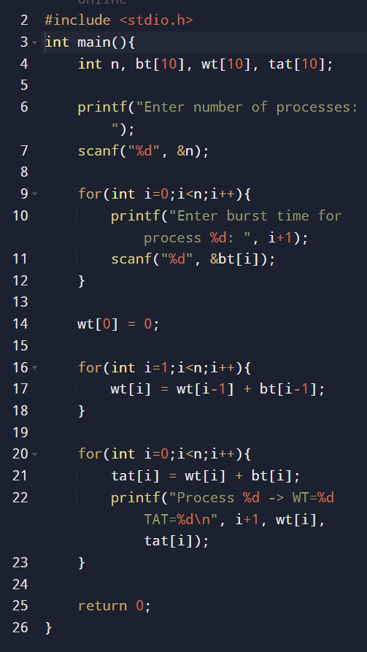

- Output:

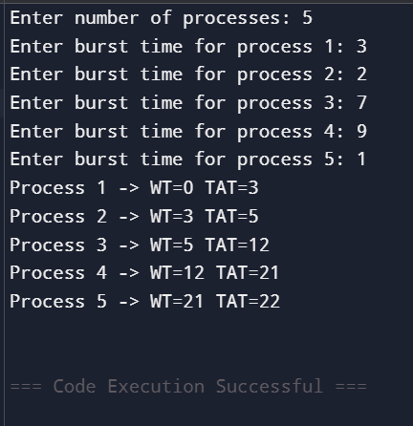

- Conclusion:
FCFS scheduling demonstrates process execution order, and Git Bash helps in version control.
EXPERIMENT 5:
SJF Scheduling

- Aim:
To implement Shortest Job First (SJF) scheduling algorithm.

- Theory:
SJF selects the process with the smallest burst time. It minimizes average waiting time but may cause starvation.

- Program:

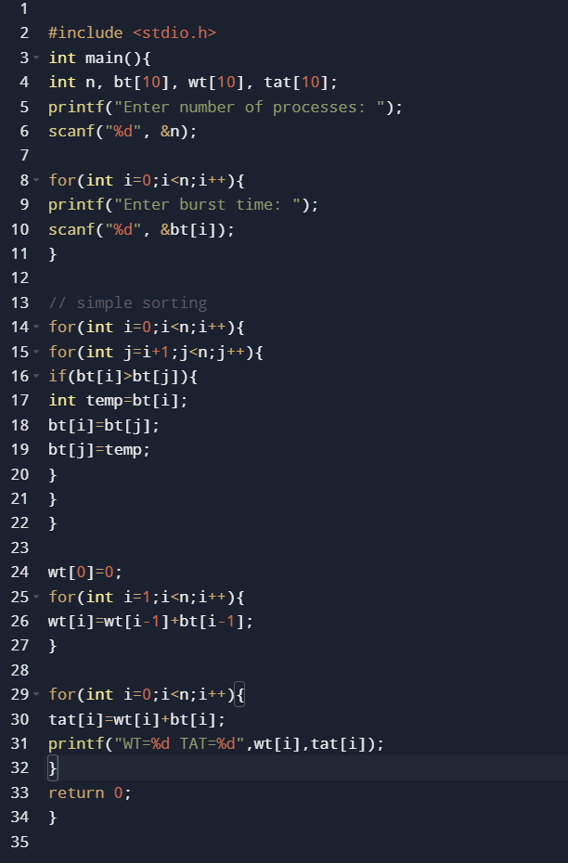

- Output:

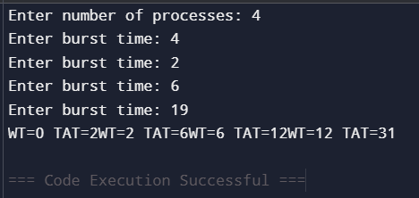

- Conclusion:
SJF reduces waiting time but is not suitable for long processes.

EXPERIMENT 6:
Shortest Run Time Next

- Aim:
To implement Shortest Remaining Time Next (SRTN) scheduling algorithm.

- Theory:
SRTN is the preemptive version of SJF. At every unit of time, the process with the smallest remaining burst time is selected. If a new process arrives with a shorter burst time than the current one, the CPU switches to it.

- Program :

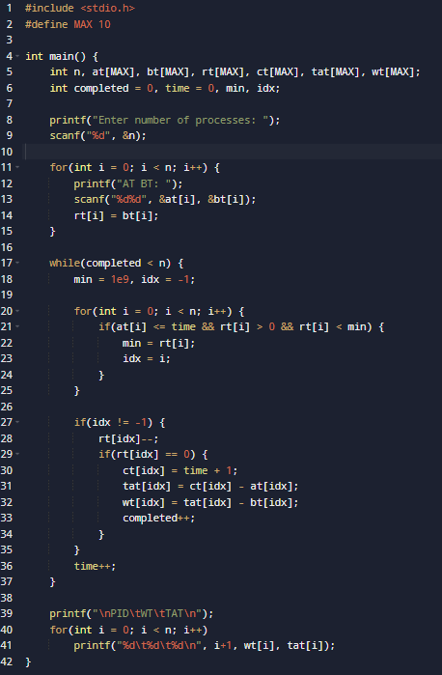

- Output:

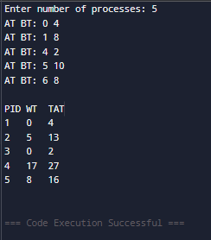

- Conclusion:
SRTN minimizes average waiting time but increases context switching and may cause starvation of longer processes.

EXPERIMENT 7:
Preemptive Priority Scheduling

- Aim:
To implement Priority Scheduling with preemption.

- Theory:
In preemptive priority scheduling, the CPU is allocated to the process with the highest priority (lowest number). If a new process arrives with higher priority, it preempts the current one.

- Program :

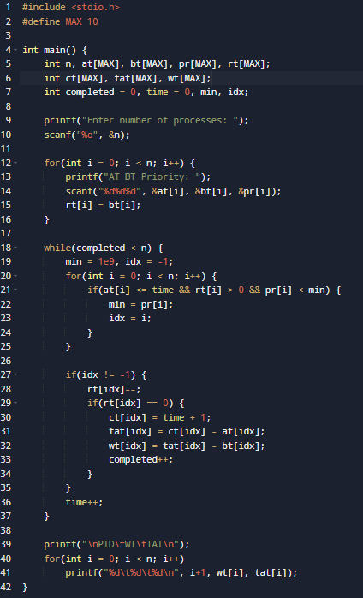

- Output:

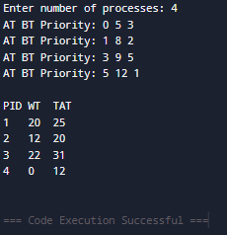

- Conclusion:
Preemptive priority improves response for high-priority tasks but may starve low-priority ones.

EXPERIMENT 8:
Non-Preemptive Priority Scheduling

- Aim:
To implement non-preemptive priority scheduling.

- Theory:
CPU is assigned to the highest priority process, and it runs till completion with no interruption.

- Program :

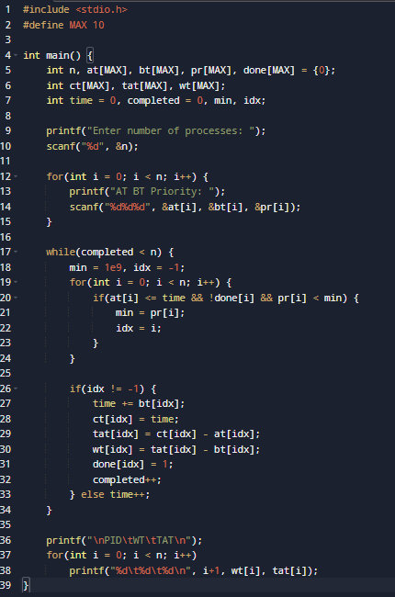

- Output:

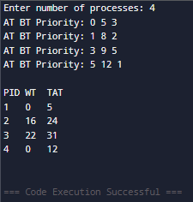

- Conclusion:
This algorithm is simple but can cause long waiting times for low-priority processes.

EXPERIMENT 9:
Round Robin Scheduling

- Aim:
To implement Round Robin scheduling.

- Theory:
Each process gets a fixed time slice called quantum, ensuring fairness.

- Program :

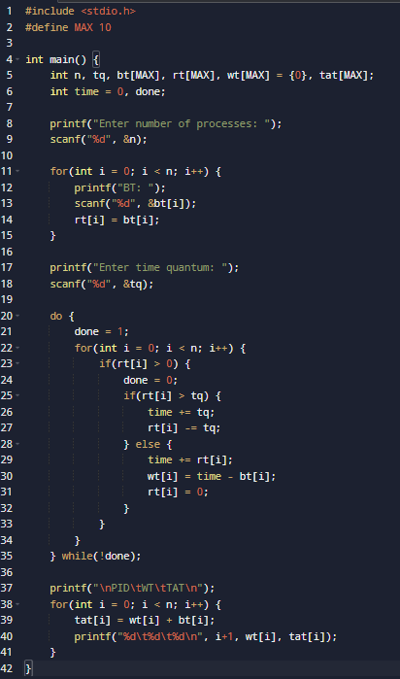

- Output:

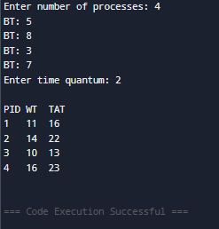

- Conclusion:
Fair scheduling but high context switching overhead.

EXPERIMENT 10:
Banker’s Algorithm

- Aim:
To implement Banker’s algorithm for deadlock avoidance.

- Theory:
Ensures system stays in a safe state by checking resource allocation.

- Program :

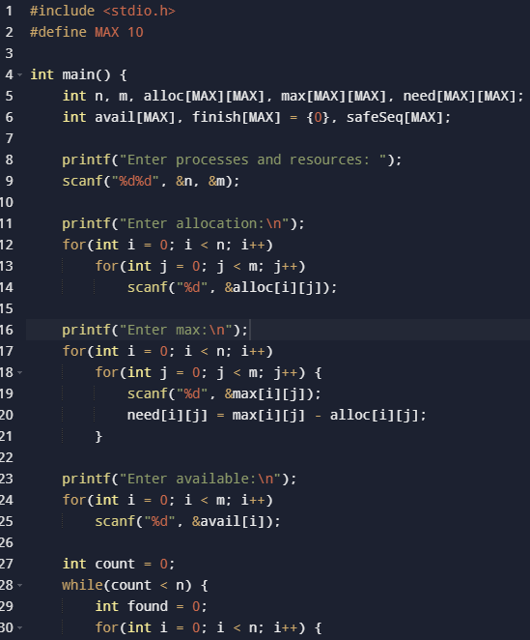

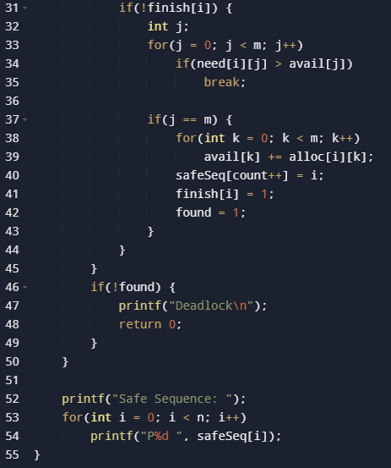

- Output:

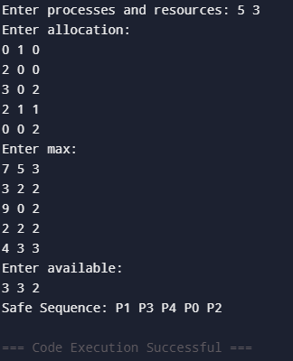

- Conclusion:
Prevents deadlock but requires prior knowledge of maximum resources.
EXPERIMENT 11:
Optimal Page Replacement

- Aim:
To implement Optimal Page Replacement algorithm.

- Theory:
Replaces the page that will not be used for the longest time in future.

- Program :

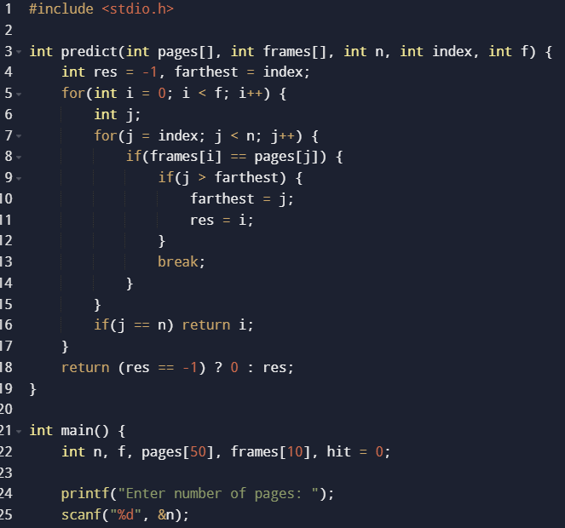
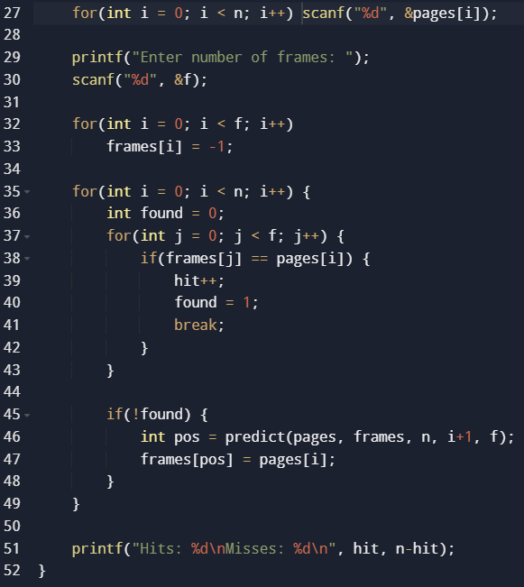

- Output:

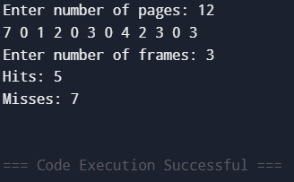

- Conclusion:
Gives minimum page faults but not practical due to future knowledge requirement.

EXPERIMENT 12:
FIFO Page Replacement

- Aim :
To implement FIFO (First In First Out) Page Replacement Algorithm in C.

- Code :
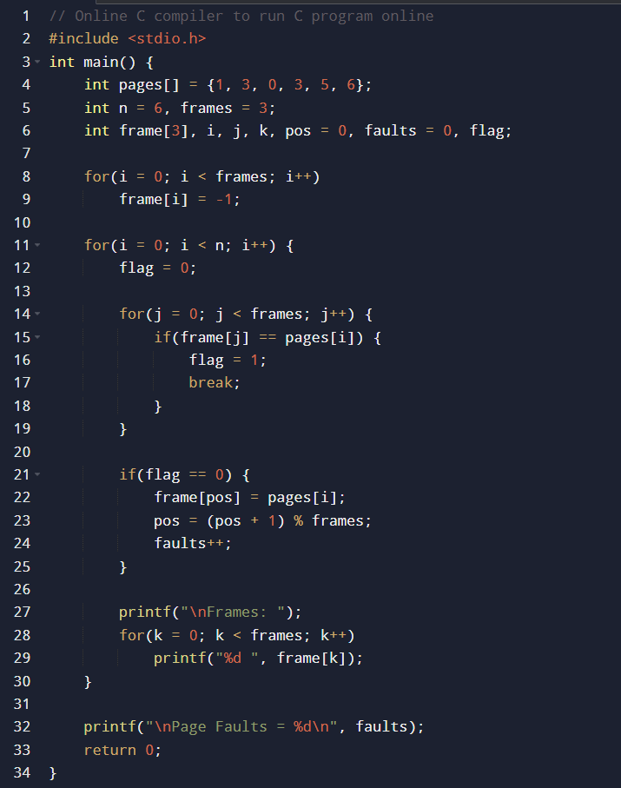
- Output :
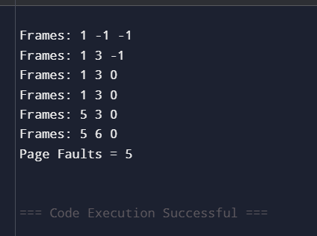

- Conclusion
FIFO replaces the oldest page first but may lead to more faults (Belady’s anomaly).

EXPERIMENT 13:
LRU Page Replacement

- Aim :
To implement LRU (Least Recently Used) Page Replacement.

- Code :

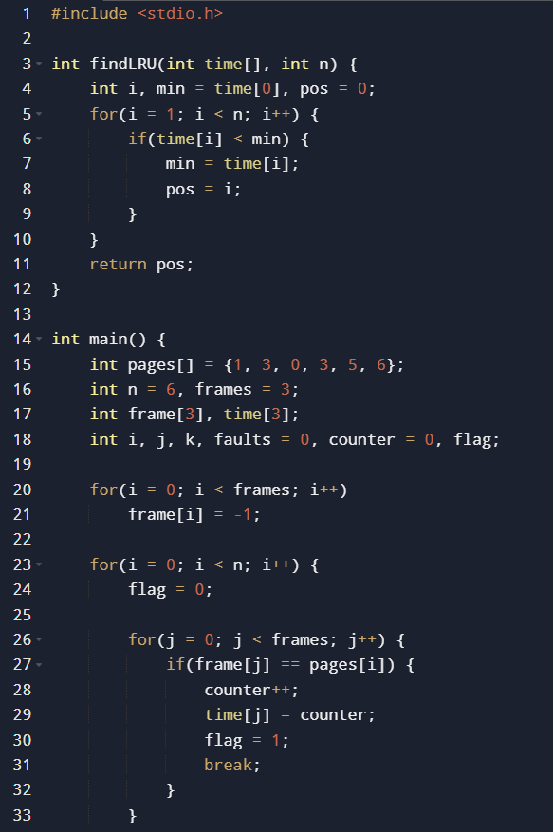
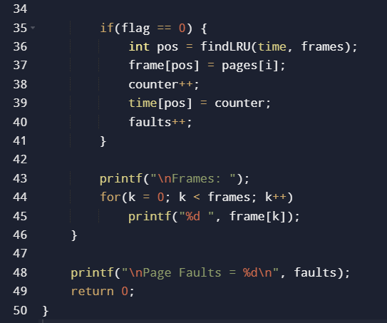

- Output :

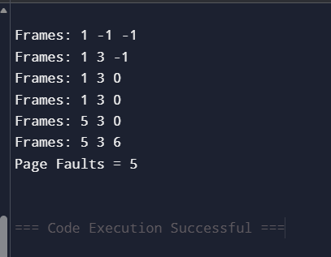

- Conclusion :
LRU gives better performance than FIFO by replacing least recently used pages.

EXPERIMENT 14:
SCAN Disk Scheduling

- Aim :
To implement SCAN (Elevator Algorithm) and find the shortest seek time in order to implement all the processes in the queue.

- Code :

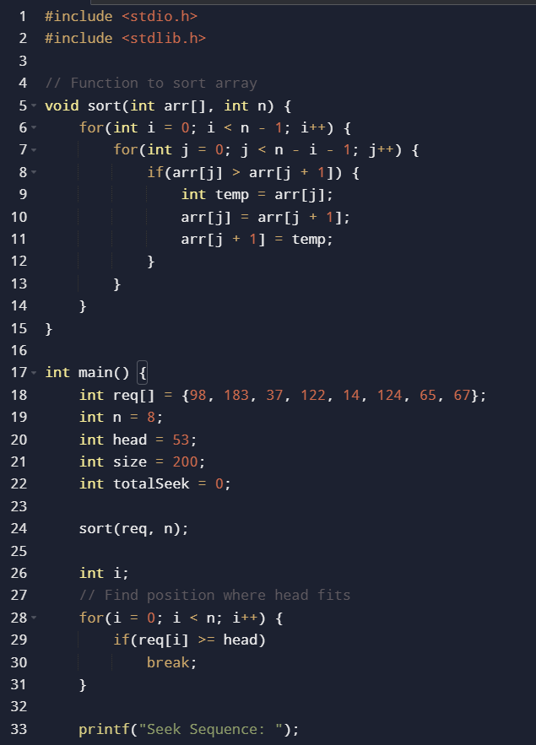

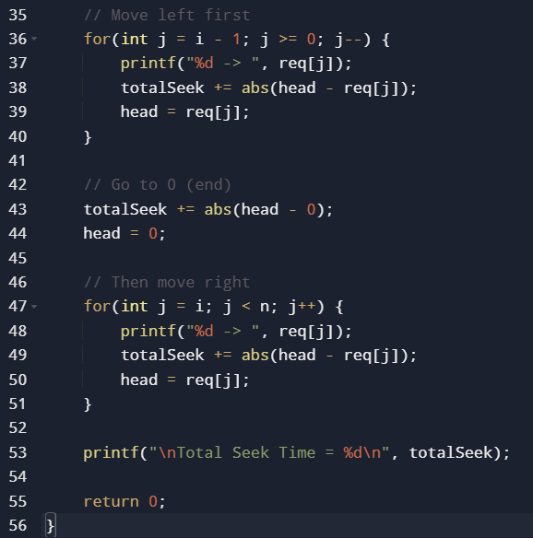

- Output :

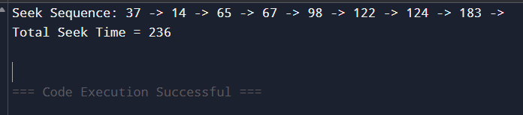

- Conclusion :
SCAN reduces starvation by servicing requests in one direction like an elevator.

EXPERIMENT 15:
SSTF Disk Scheduling

- Aim :
To implement Shortest Seek Time First (SSTF).

- Code :

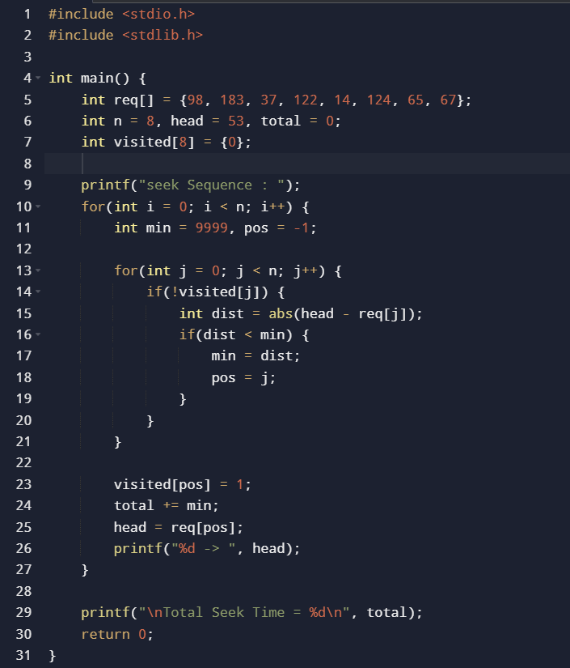

- Output :

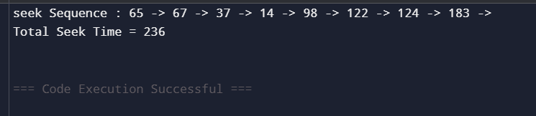

- Conclusion :
SSTF minimizes seek time but may cause starvation.

EXPERIMENT 16:
C-SCAN Disk Scheduling

- Aim :
To implement C-SCAN Disk Scheduling.

- Code :

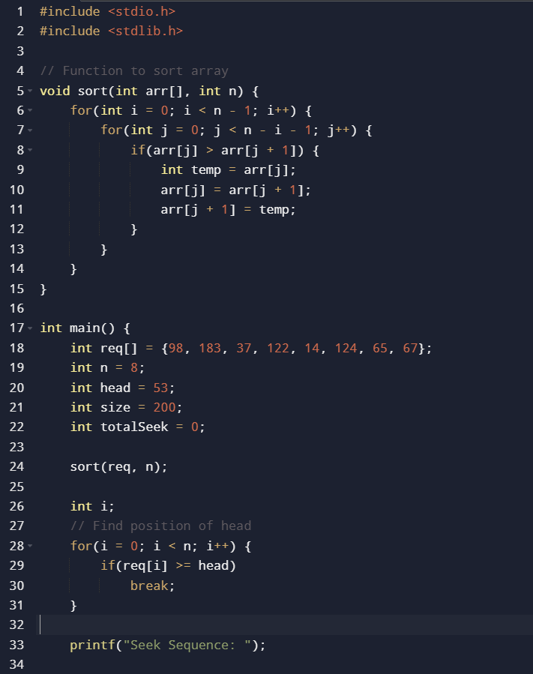

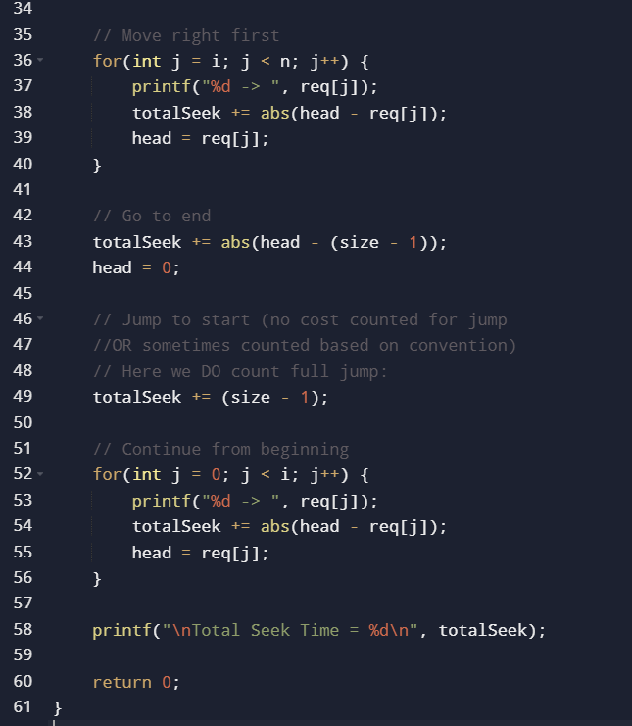

- Output :

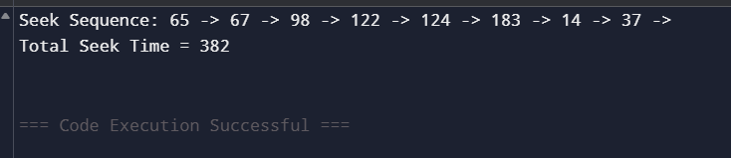

- Conclusion :
C-SCAN provides uniform wait time by servicing in one direction only.

