Diet Planner

**A PROJECT REPORT**

***Submitted by***

ANSHIKA THAKUR – (21CBS1065)

***in partial fulfillment for the award of the degree of***

**COMPUTER SCIENCE ENGINEERING WITH BUSINESS SYSTEM**

**IN**

AIT-CSE



**Chandigarh University**

April 2024



**BONAFIDE CERTIFICATE**

Certified that this project report **“Diet Planner”** is the bonafide work of “Anshika (21CBS1065)**”** who carried out the project work under my/our supervision.

**SIGNATURE**

**(HOD)**

**(CSBS DEPARTMENT)**

**SIGNATURE**

**(SUPERVISOR)**

**(CSBS DEPARTMENT)**

Submitted for the project viva-voce examination held on

**INTERNAL EXAMINER EXTERNAL EXAMINER**

**TABLE OF CONTENTS**

Abstract 7

Graphical Abstract ... 8

Chapter 1 Introduction 9

1.1 Problem Definition 9

1.2 Project Overview 10

1.3 Hardware Specification 11

1.4 Software Specification 12

Chapter 2 Background and Alternatives 14

2.1 Chatbot 14

2.2 Types of Chatbots 14

2.3 How do Chatbots Work 15

2.4 Options to build a Chatbot17

2.5 Chatbot Platform Akternatives 18

2.6 Selected Platform19

2.7 How to Set Up20

2.8 Supportive Information21

Chapter 3 Literature Survey 24

3.1 Existing System 24

3.2 Proposed System 25

3.3 Literature Survey 26

Chapter 4 Problem Formulation 30

4.1 Key elements of the issue 30

4.2 Proposed Solution 31

Chapter 5 Objectives 33

Chapter 6 Methodologies 35

6.1 Phases 35

6.2 Timeline 38

6.3 High Level Model 38

6.4 Flow Chart 40

6.5 Process Flow Diagram 42

6.6 Sequence Diagram 44

Chapter 7 Experimental Setup 46

Chapter 8 Results and Discussion 48

8.1 System Performance Evaluation 48

8.2 Output 50

Chapter 9 Conclusion 58

Chapter 10 Future Scope 59

Tentative chapter plan for proposed work 61

References 63

## List of Figures

**Figure i …………………………………………………………………………………….Graphical Abstract**

**Figure 6.1 ……………………………………………………………………………….Timeline Gantt Chart**

**Figure 6.2 ………………………………………………………………….Anatomy of result chatbot system**

**Figure 6.3 ………………………………………………………………………………….Flow Chart**

**Figure 6.4 ………………………………………………………………………………Process Flow Diagram**

**Figure 6.5 ………………………………………………………………………………….Sequence Diagram**

**Figure 8.1 ………………………………………………………………………………Performance Metrics**

**Figure 8.2 ………………………………………………………………………………….Landing Page**

**Figure 8.3 …………………………………………………………………………….……Login Page**

**Figure 8.4 ………………………………………………………………………………….Options Page**

**Figure 8.5 ………………………………………………………………………………….Chat Options**

**Figure 8.6 ………………………………………………………………………………….Chat Window**

**Figure 8.7 ………………………………………………………………………………….News Page**

**Figure 8.8 ………………………………………………………………………………….Weather Page**

**Figure 8.9 ………………………………………………………………………………….Weather Page**

**Figure 8.10 ………………………………………………………………………………….Weather Page**

**Figure 8.11 ………………………………………………………………………………...Games Page**

**Figure 8.12 ………………………………………………………………………………...Unit Convertor**

**Figure 8.13 ………………………………………………………………………………...Profile Page**

## List of Tables

**Table 3.1 ………………………………………………………………………………….Literature Survey**

**Table 6.1 ………………………………………………………………………………….Timeline**

**Table 8.1 ………………………………………………………………………………….Metrics Table**

# ABSTRACT

This project is a complete diet planner system designed to encourage people to lead better lifestyles and make meal planning easier for them. The system, which makes use of a large database of food products classified by kind, nutritional value, and appropriate mealtime, is implemented using Prologue.

The diet planner provides customised meal plans based on nutritional needs and personal preferences. The system creates daily meal plans for users based on variables including calorie consumption, nutritional balance, and vegetarian or non-vegetarian choices. It also gives customers comprehensive nutritional data for every meal, enabling them to make educated diet choices.

The project guarantees accuracy and dependability in meal suggestions by means of thorough testing and optimisation. The straightforward and user-friendly design of the user interface improves accessibility for a variety of users. Additionally, by taking into account a range of dietary choices and limits, the method promotes inclusion.

The diet planner enhances general wellbeing by encouraging better eating practices and streamlining meal preparation. The project's focus on accessibility and user-centric design is in line with the overarching objective of enabling people to make better lifestyle decisions.

**Keywords:**

Personalised meal plans, Vegetarian and Non-Vegetarian diet planners, Prologue, meal planning, nutritional content, accessibility, inclusivity, and a healthier lifestyle.

# GRAPHICAL ABSTRACT

This graphical abstract illustrates the flow of our Diet Planner. The components include:

1. **Start**

- Open prolog file

- Enter file name

- Enter the query : accept_user-input

**2. User Input:**

- Prompt user for their name, age, vegetarian preference, weight, and height.

- Read user's responses.

**3. Calculate BMI:**

- Calculate the Body Mass Index (BMI) using the provided weight and height.

- BMI = Weight / (Height^2)

**4. Categorize BMI:**

Categorize the BMI into "underweight," "normal weight," or "overweight" based on predefined thresholds.

1. **Generate Weekly Diet Schedule:**

- If the user is vegetarian:

- Generate a weekly diet schedule for a vegetarian based on the predefined meal options.

- If the user is not vegetarian:

- Generate a weekly diet schedule for a non-vegetarian based on the predefined meal options.

1. **Print Weekly Diet Schedule:**

- Print the weekly diet schedule showing meals for each day of the week.

- Display total calories, protein, carbs, and fats for each day.

1. **End**

This graphical abstract outlines the process of the meal planning system, starting from user input to generating and printing the weekly diet schedule based on the user's preferences and BMI category.

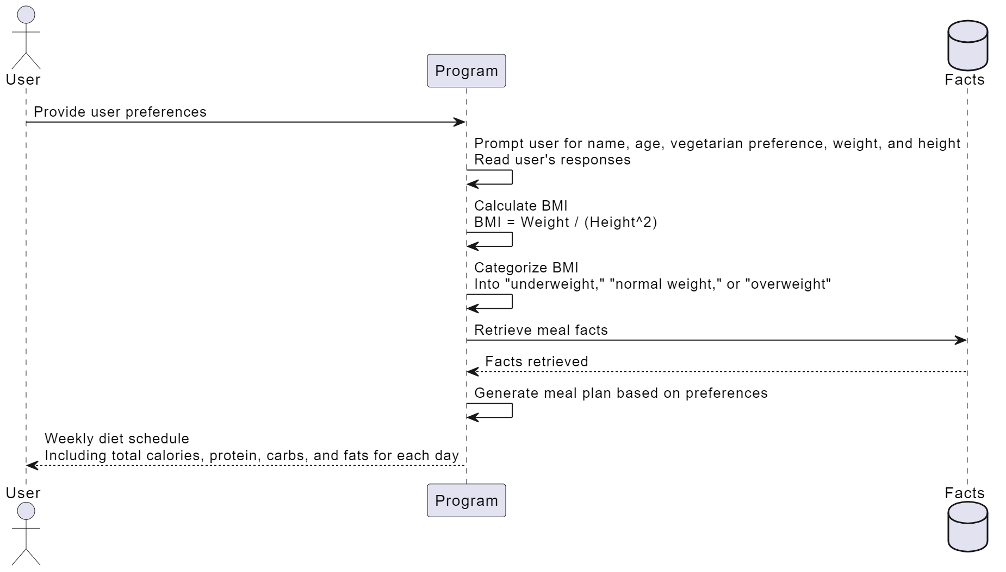

Figure i

# Chapter 1: Introduction

# In the ever-evolving landscape of technology, the pursuit of accessibility and inclusivity remains a paramount objective. This project endeavors to make a meaningful contribution to this mission by introducing an innovative AI chatbot specifically designed to enhance the lives of visually impaired individuals. Employing cutting-edge technologies, including Next.js, Tailwind CSS, and TypeScript, the chatbot not only embraces the latest advancements but also underscores a commitment to user-friendly design and inclusivity.

# The project's focal point is the development of a chatbot that goes beyond conventional functionalities. Integrating Speech-to-Text and Text-to-Speech capabilities, the chatbot ensures that communication is not hindered by visual impairments. This inclusivity extends to an array of features addressing the diverse needs of the visually impaired community. From a versatile unit converter to an engaging game hub, a multilingual translator to seamless file drop functionality, and real-time weather updates to a comprehensive news service – each element is crafted with precision to empower users with a versatile tool tailored to their unique requirements.

# As technology becomes an increasingly integral part of daily life, the impact of accessible and user-centric designs is immeasurable. By amalgamating sophisticated technology with a commitment to inclusivity, this project seeks not only to provide a practical solution for visually impaired individuals but also to set a precedent for the development of assistive technologies. Over the course of four months, the development process has been marked by meticulous testing and adherence to the highest standards of accessibility, ensuring that the final product aligns seamlessly with the needs of its users.

# This project not only represents a technological milestone but also aligns with a broader societal goal – the cultivation of a digital environment that is inherently accessible and inclusive. The subsequent sections of this report will delve into the methodologies, results, and implications of this endeavor, providing a comprehensive understanding of the journey to create an Accessible AI Chatbot for the Visually Impaired.

## 1.1 Problem Definition

The visually impaired community encounters substantial challenges in accessing information, managing daily tasks, and engaging with technology. The primary predicament stems from a deficiency in tools and resources tailored to their specific needs. Existing systems fall short in terms of user-friendliness and seamless integration, amplifying the obstacles faced by individuals with visual impairments.

The overarching problem lies in the scarcity of technology solutions that cater explicitly to the diverse needs of the visually impaired. Current systems lack intuitive interfaces and cohesive functionalities, hindering the efficient pursuit of information, daily activities, and technology interaction.

This project aims to address these deficiencies by developing an accessible AI chatbot. The deficiencies encompass not only the limitations in communication tools but also the absence of features that could significantly enhance the daily lives of visually impaired individuals. The absence of user-friendly interfaces and integrative functionalities exacerbates the struggle, making the pursuit of information, routine tasks, and technology interaction an arduous endeavor.

By focusing on Speech-to-Text and Text-to-Speech capabilities, the chatbot endeavors to bridge the communication gap. However, the crux of the problem extends beyond communication. The project aims to provide a holistic solution by incorporating additional functionalities such as unit conversion, gaming, translation, file management, real-time weather updates, and news services.

In summary, the existing systems' inadequacies lie in their inability to offer tailored solutions for the visually impaired, resulting in significant accessibility and usability gaps. This project defines the problem space, setting the stage for the development of a comprehensive and inclusive AI chatbot that seeks to alleviate these challenges.

## 1.2 Problem Overview

Visually impaired individuals encounter a myriad of challenges in their daily lives, primarily revolving around the fundamental aspects of accessing information and executing tasks efficiently. Key obstacles include:

1. **Information Accessibility:**

Traditional visual interfaces pose significant barriers, hindering visually impaired individuals from accessing textual information across diverse sources such as books, papers, websites, and digital content.

1. **Digital Interaction Barriers:**

Engaging with digital technology, encompassing computers and mobile devices, presents formidable challenges for users who are blind or visually impaired. This hampers their access to crucial resources and services in the digital landscape.

1. **Lack of Specialized Tools:**

The current landscape of assistive technologies and applications lacks cohesion, providing a fragmented set of tools. This absence of a centralized platform hampers the availability of diverse features tailored to meet the specific needs of the visually impaired community.

**iv. Inefficient Navigation:**

Navigating physical spaces independently, especially in unfamiliar surroundings, proves to be a complex task for visually impaired individuals. This inefficiency in navigation further limits their autonomy.

**v. Dependence on Assistance:**

A substantial number of blind individuals rely on external assistance for tasks that could be performed independently with access to the right equipment and technology. This dependence diminishes their ability to accomplish tasks autonomously.

The proposed solution endeavors to address these multifaceted challenges by introducing a comprehensive AI chatbot explicitly designed for visually impaired individuals. The aim is to provide a flexible and accessible solution that enhances the independence and overall quality of life for this user group. This is achieved through the integration of Speech-to-Text and Text-to-Speech capabilities, coupled with additional features such as unit conversion, gaming, translation, file management, live weather updates, and news services. The project aspires to be a transformative force, empowering visually impaired individuals to navigate the complexities of the digital world with enhanced autonomy and efficiency.

## 1.3 Hardware Specification

The estimated user demand and system complexity are two aspects that affect the hardware needed to host the Accessible AI Chatbot for the Visually Impaired. The hardware requirements for a typical deployment:

**i. Server or Cloud Hosting:** A virtual private server (VPS) with the following characteristics is sufficient for modest to medium-scale deployments:

- Virtual CPUs (vCPUs): 2-4

- 100 GB SSD for storage - 4-8 GB RAM

- Take into account scalable cloud services like AWS, Azure, or Google Cloud for bigger installations or to accommodate a heavy user traffic.

**ii. Microphones and Speakers (voice interaction is included):** Check to see if the server or hosting environment supports audio input and output, or rely on the users' devices for this capability.

**iii. Storage:** We'll need storage for storing user data, chat histories, uploaded files, and any other relevant data. The amount of storage required will depend on the size and scale of your project.

**iv. Internet Connectivity:** To guarantee response and accessibility, the server hosting the chatbot needs a dependable and fast internet connection.

**v. Redundancy and Backup:** Using redundancy techniques, such load balancing and failover systems, to provide high availability and data backup in the event of hardware problems.

## 1.4 Software Specification

An essential part of the project is the software stack for the accessible AI chatbot. The suggested software specs are:

**i. Operating System:** An operating system that is reliable and has a lot of support, like Windows, MacOS, Linux

**ii. Web server:** Hosting Next.js application on a web server like Nginx, Apache

**iii. Node.js:** Update Node.js to the most recent version before launching Next.js application.

**iv. Database system:**

- PostgreSQL: A potent relational database that is open-source.

- MongoDB: A NoSQL database with unstructured data flexibility.

- MySQL: Another well-liked open-source alternative for relational databases.

**v.** **Next.js and Dependencies**

- Setup Next.js and all necessary dependencies:

- JavaScript library for creating user interfaces called React.

- Babel, a JavaScript translator and compiler.

- Webpack: A JavaScript module bundler.

**vi.** **Services for speech-to-text and text-to-speech conversion**:

- Text-to-Speech on Google

- Polly on Amazon

- Speech-to-text on the Google Cloud

**vii. Available Tools:**

- Implement accessibility tools for users who are blind or visually impaired to ensure compliance with online accessibility standards (such as WCAG), such as: support for voice commands and screen readers.

**viii. APIs:**

- Integrate APIs to dynamically acquire data for features like weather updates and news services.

**Security Instruments:** Put in place security safeguards to safeguard user information and communication such as:

- Fire walls

- Certificates for encryption using SSL/TLS

- Frequently updated security patches

**ix. Version Control:** Using Git for version control to work with your development team, manage the source code for your project, and keep track of previous versions of the code.

**x. Tools for monitoring and analytics:** Setting up monitoring tools, such as Google Analytics for user behaviour analysis, to measure server performance and user interactions.

**xi. Documentation:** Creating setup, customization, and troubleshooting manuals for users and developers to explain how to use and manage the chatbot.

# Chapter 2: Background and Alternatives

## 2.1 Chatbot

In the intricate tapestry of this project's specialized domain, a chatbot undergoes a metamorphosis, transcending its conventional role to emerge as a bespoke software application intricately designed to elevate natural language interactions, with a meticulous focus on addressing the unique needs of users grappling with visual impairments. This adaptive interface serves as more than a mere conversational agent; it becomes a finely tuned conduit for seamless communication, offering users an intuitive means to engage with technology through the fluidity of voice commands or text inputs.

Unlike its traditional counterparts tethered to the complexities of Natural Language Processing (NLP), this project's chatbot strategically charts a different course, opting for a judicious integration of external Application Programming Interfaces (APIs). This departure from the NLP norm is not just a technological choice but a profound commitment to inclusivity. By steering away from the intricacies of NLP, the chatbot positions itself as an accessible platform, providing an enriched and tailored user experience for individuals navigating the world with visual impairments. This intentional departure from conventional methodologies marks a paradigm shift, not just in technology but in the ethos of user-centric design, where accessibility takes precedence, and each interaction is a step towards a more inclusive digital landscape. The strategic embrace of external APIs becomes pivotal, transforming the chatbot into a versatile tool, capable of seamlessly interfacing with diverse data sources and services, thus enriching the conversational experience for users who rely on alternative modes of interaction.

This chapter sets the stage by unraveling the essence of what constitutes a chatbot in the context of this project, unveiling a narrative where technology converges with empathy, and each line of code is a step towards creating a digital ally for those with visual impairments. As the journey unfolds, the chatbot becomes more than a programmatic entity; it becomes a testament to the potential of technology to bridge gaps and redefine accessibility in the digital realm.

**2.2 Types of Chatbot**

In the nuanced realm of this project, the categorization of chatbots becomes a pivotal facet, with two distinct archetypes taking center stage:

1. **Rule-Based Chatbots:**

Within the echelons of rule-based chatbots, a structured and deterministic approach governs their modus operandi. These chatbots adhere rigorously to predefined rules and decision trees, akin to a well-choreographed dance where each step is meticulously scripted. This regimented framework renders them adept at handling straightforward interactions and tasks. The deterministic nature of rule-based chatbots positions them as pragmatic and efficient entities, particularly well-suited for scenarios where interactions follow a predictable pattern. In the context of this project, rule-based chatbots serve as the stalwarts of simplicity, providing a reliable foundation for handling routine queries and straightforward tasks posed by visually impaired users. The deterministic nature of these chatbots aligns seamlessly with scenarios where precision and clarity are paramount, ensuring that interactions unfold with a predefined logic, akin to a well-rehearsed performance.

1. **AI-Powered Chatbots:**

On the contrasting end of the spectrum, the project introduces the dynamic prowess of AI-powered chatbots. These chatbots transcend the constraints of determinism, embarking on a journey guided by artificial intelligence (AI) and machine learning (ML). Unlike their rule-based counterparts, AI-powered chatbots possess the capacity to decipher user intent and contextual nuances, adapting their responses over time. It's akin to a conversational ballet, where the chatbot not only comprehends the explicit content of user queries but discerns the underlying meaning, infusing a layer of sophistication into the interaction. This adaptability fosters personalized and context-aware engagements, where the chatbot becomes attuned to the unique preferences and patterns of each user. In the context of visually impaired users, the dynamic nature of AI-powered chatbots opens avenues for a more intuitive and tailored interaction, transcending the rigidity of predefined rules. The project's choice to incorporate AI-powered elements reflects a commitment to enhancing the depth and richness of user engagement, acknowledging the diverse and evolving nature of queries posed by visually impaired individuals.

In the unfolding narrative of chatbot typologies, the rule-based and AI-powered entities emerge not as binary opposites but as complementary forces, each contributing to the orchestration of a comprehensive and adaptive user experience. The rule-based stalwarts provide the foundation of reliability, while the AI-powered virtuosos infuse the interaction with a symphony of adaptability and personalized flair. This nuanced blend becomes the hallmark of the project's chatbot strategy, where the choice of chatbot type becomes a strategic decision, aligning with the diverse needs and expectations of visually impaired users.

**2.3 How Do Chatbots Work:**

In the intricate ballet of human-computer interaction, the operational choreography of the chatbot unfolds as a symphony of orchestrated steps, each note harmonizing to create a seamless and intuitive user experience, with a particular emphasis on users who are visually impaired.

1. **User Inputs:**

The overture commences with users expressing their intent through a medium of their choice, be it the mellifluous cadence of speech or the precision of textual articulation. In the context of this project, where accessibility takes center stage, the inclusivity of speech inputs becomes a crucial note in the symphony, catering to the unique needs of visually impaired users.

1. **Interpretation Mechanism:**

The chatbot, positioned as the virtuoso interpreter, receives these inputs and embarks on a nuanced journey of understanding. Here, the intersection of Next.js, Tailwind CSS, and TypeScript plays a pivotal role in creating a frontend processing mechanism that deciphers the intricacies of user inputs. Whether it be the tonal nuances of speech or the textual subtleties, this interpretative layer becomes the bridge between user intent and technological response.

1. **Integration of External APIs:**

The narrative then unfolds into the integration of external Application Programming Interfaces (APIs), strategically interwoven into the very fabric of the project. These APIs become the linchpin for data retrieval, casting a wide net into the digital landscape to gather relevant information or execute specific commands. In the context of visually impaired users, this integration extends beyond mere functionality; it becomes a conduit for empowerment, providing access to a diverse range of services and information sources.

1. **Adaptive Response Generation:**

The crescendo of this symphony is reached with the dynamic generation of responses. Here, the adaptability of the chatbot shines through, tailoring responses to the intricacies of user queries or seamlessly executing tasks. This adaptability is not a rigid adherence to predefined rules but a dynamic responsiveness, a key attribute in ensuring an inclusive and user-centric engagement.

1. **Inclusive User Experience:**

Ultimately, the entire orchestration is designed to create an inclusive user experience. It's not just about interpreting inputs and generating responses; it's about understanding the nuances of accessibility, about providing visually impaired users with a platform where their interactions are not just functional but imbued with a sense of empowerment and inclusivity.

In this intricate dance of technology and accessibility, the chatbot becomes more than a mere program; it becomes a digital companion, attuned to the unique needs and preferences of visually impaired users. The carefully orchestrated steps, from user inputs to adaptive responses, all contribute to the overarching goal of crafting a user experience that transcends the conventional boundaries of human-computer interaction.

**2.4 Options to Build a Chatbot:**

In the expansive canvas of development possibilities, the architects of this project, armed with the potent trio of Next.js, Tailwind CSS, and TypeScript, stand at the crossroads of decision. The task at hand is to breathe life into the envisioned chatbot, and two distinct pathways beckon, each holding its own promise within the chosen technological tapestry.

**i. Custom Development:**

The first brushstroke on this technological canvas paints the picture of Custom Development. This avenue unfurls with Next.js assuming the mantle of frontend prowess, weaving the visual narrative and crafting an interface that resonates with the project's aesthetic and functional aspirations. Tailwind CSS, with its utility-first approach, becomes the palette, allowing developers to articulate the visual language of the chatbot with finesse.

The backend, a realm of equal significance, sees the dominance of TypeScript. Here, developers delve into the intricacies of backend development with a dual focus — the robustness of the server-side rendered Next.js pages and the orchestration of API integrations. TypeScript's static typing becomes the guardian, ensuring a fortress of reliability as the chatbot engages with external data sources and services.

**ii. Frameworks and Libraries:**

On the alternative spectrum of choices, the project contemplates the trajectory of Frameworks and Libraries. TypeScript once again emerges as the stalwart of backend development, its syntax harmonizing with the backend architecture, fostering a cohesive development journey.

In this trajectory, libraries become the companions, strategically employed to streamline the intricacies of API communication. They become the tools that sculpt the efficiency of data retrieval, interaction with external services, and the overall responsiveness of the chatbot. The interplay between TypeScript and these libraries becomes a symphony of efficiency, orchestrating a development process that balances speed and precision.

**iii. Strategic Decision-Making:**

The choice between Custom Development and Frameworks and Libraries becomes a strategic decision, dictated by the project's nuances, timelines, and the level of control envisioned. Custom Development offers unparalleled flexibility, allowing developers to meticulously tailor every facet of the chatbot to meet specific project requirements. On the flip side, Frameworks and Libraries offer a streamlined development process, harnessing pre-built components to expedite the journey without sacrificing the project's integrity.

In this juncture of decision-making, developers stand as architects, poised to sculpt the chatbot's essence. The technological choices made here resonate not just in lines of code but in the very fabric of the user experience — a testament to the thoughtful orchestration of technology within the realms of Next.js, Tailwind CSS, and TypeScript.

**2.5 Chatbot Platform Alternatives:**

As the project embarks on the exploration of chatbot platform alternatives, the landscape unfolds with a tapestry of choices. Here, strategic decision-making becomes the compass guiding the project towards a platform that harmonizes seamlessly with the envisioned technological symphony.

**i. Microsoft Bot Framework:**

A formidable contender on this expansive canvas is the Microsoft Bot Framework. It emerges as a strategic ally, aligning effortlessly with TypeScript in backend development and amplifying the project's emphasis on API interactions. The synergy between Microsoft Bot Framework and TypeScript becomes a narrative of cohesion, offering a robust framework for developers to sculpt the chatbot's functionalities. The platform's versatility, coupled with the power of TypeScript, positions it as a dynamic force in the creation of an adaptive and feature-rich chatbot.

**ii. Botpress:**

Stepping into the arena as an open-source emissary is Botpress. In the symphony of choices, Botpress resonates with the project's tech stack and API-centric ethos. This open-source platform, with its modularity and extensibility, aligns harmoniously with the project's vision. Developers find a canvas where the creative strokes of Next.js, Tailwind CSS, and TypeScript can blend seamlessly with Botpress, offering an open playground for the realization of the chatbot's potential. It becomes a testament to the project's commitment to open-source collaboration and the freedom to customize the chatbot's intricacies.

**iii. Custom Development with API Integrations:**

Simultaneously, the allure of Custom Development with API Integrations beckons, offering a bespoke path crafted to the project's unique needs. Here, external APIs become the cornerstone for elevating chatbot functionalities. This trajectory of Custom Development promises a canvas where every line of code is a bespoke creation, intricately woven to meet the specific requirements of the project. It's a journey where the project charts its own course, defining the rules and orchestrating the chatbot's symphony with precision.

**Strategic Decision-Making:**

The choice between Microsoft Bot Framework, Botpress, or Custom Development with API Integrations becomes a strategic decision, reflective of the project's aspirations and nuances. Microsoft Bot Framework and Botpress offer frameworks that stand as collaborative partners, streamlining certain aspects of development. On the other hand, Custom Development offers unparalleled flexibility, allowing developers to sculpt a solution finely tuned to the project's unique needs.

In the realm of chatbot platform alternatives, the project navigates not just tools and frameworks but strategic alliances that define the trajectory of the chatbot's journey. Each alternative becomes a brushstroke on the canvas, contributing to the creation of a chatbot that resonates with the project's vision and technological ethos.

**2.6 Selected Platform:**

In the intricate symphony of technology choices, the project makes a deliberate and harmonious crescendo in favor of Custom Development. This strategic alignment, akin to a conductor guiding a symphony, capitalizes on the dynamic duo of TypeScript and Next.js, with the aesthetic finesse of Tailwind CSS. This conscientious choice goes beyond mere development preferences; it embodies a deliberate commitment to maintaining precise control over the developmental reins, steering the project towards a path of bespoke creation.

**- Strategic Considerations:**

The selection of Custom Development as the platform of choice is not a capricious decision but a strategic one, carefully weighed against the project's unique needs and aspirations. It signifies a conscious choice to eschew pre-built frameworks and platforms in favor of a tailored approach that aligns seamlessly with the vision of the chatbot. This approach becomes a canvas where every line of code is a stroke of intention, allowing developers to sculpt the chatbot's functionalities with surgical precision.

**- Dynamic Duo of TypeScript and Next.js:**

At the heart of this choice lies the dynamic duo of TypeScript and Next.js. TypeScript, with its static typing prowess, becomes the guardian of reliability, ensuring a robust and error-resistant codebase. Next.js, with its server-side rendering capabilities, becomes the virtuoso in crafting visually appealing and performant interfaces. The symphony of these technologies unfolds a narrative of efficiency and adaptability, two crucial notes in the creation of an inclusive and user-centric chatbot.

**- Tailwind CSS:**

Complementing this duo is Tailwind CSS, an utility-first CSS framework. Tailwind CSS brings a pragmatic and utility-centric approach to styling, allowing developers to craft a visually coherent and aesthetically pleasing interface. Its integration becomes the brushstroke that paints the visual language of the chatbot, ensuring not just functionality but a seamless and delightful user experience.

**- Control and Adaptability:**

The decision for Custom Development is a declaration of control and adaptability. It sets the stage for a seamless integration with external APIs, where the chatbot's functionalities extend beyond the boundaries of a pre-defined framework. This bespoke creation allows for adaptability to the unique needs of visually impaired users, ensuring that every feature serves a purpose and aligns with the project's overarching goals.

**- The Art of Bespoke Creation:**

In essence, the choice of Custom Development is the art of bespoke creation. It's a journey where the project becomes the architect, defining the rules and intricacies of the chatbot's symphony. Each line of code is a deliberate brushstroke, contributing to the creation of a chatbot experience marked by precision, adaptability, and a commitment to meeting the distinctive needs of visually impaired users.

**2.7 How to Set Up**

The choreography of setting up the developmental landscape unfolds as a meticulously scripted ballet, each step a deliberate movement in the creation of a symphony of technology. This orchestration, akin to a well-rehearsed ballet, follows a series of carefully choreographed steps, each contributing to the seamless setup of the project.

**Act 1: Initiating a Next.js Project:**

The opening act in this developmental ballet involves the initiation of a Next.js project. This foundational step establishes the frontend's aesthetics, prioritizing not only functionality but the creation of a visually appealing and user-friendly interface. Developers, armed with the versatility of Next.js, sculpt the frontend narrative, defining the visual language that will resonate with users. The choice of Next.js, with its server-side rendering capabilities, becomes the canvas upon which the user interface is crafted, setting the stage for a captivating user experience.

**Act 2: Configuration of TypeScript:**

As the narrative unfolds, the stage is adorned with the configuration of TypeScript, a pivotal act designed to fortify the backend. Here, the focus hones in on the intricacies of API interactions, where TypeScript becomes the maestro orchestrating a symphony of backend functionalities. The marriage of TypeScript and Next.js ensures not only a robust backend but also a seamless transition between frontend and backend components. This act becomes the backbone of the project, fostering reliability and precision in every line of code.

**Act 3: Core Development Phase:**

The core development phase takes center stage as the narrative progresses. Here, the integration of external APIs becomes the focal point, whether through the craftsmanship of bespoke API development or the astute utilization of existing services. The bespoke API development becomes an act of creation, where developers sculpt APIs tailored to the unique needs of the project. Alternatively, the strategic utilization of existing services becomes a dance of integration, leveraging external APIs to enhance the chatbot's functionalities.

**Act 4: Harmonious Synthesis of Components:**

As the acts unfold, a harmonious synthesis of components emerges, each contributing to a developmental opus. Every note, every line of code resonates in unison, empowering the chatbot with enhanced functionalities. The bespoke frontend, fortified backend, and the strategic integration of APIs become the elements of this symphony, creating a comprehensive and cohesive developmental landscape.

**Act 5: Empowering the Chatbot:**

The final act in this ballet is an ode to empowerment. The developmental landscape, carefully set up through the orchestrated acts, culminates in a chatbot poised with enhanced capabilities. It becomes a testament to the meticulous setup, where each step is a movement in the dance of technology, bringing forth a chatbot that is not just functional but a harmonious blend of aesthetics, reliability, and adaptability.

**2.8 Supportive Information:**

For the intrepid developers embarking on this technological odyssey, a rich tapestry of supportive information unfolds, akin to a literary compendium of wisdom waiting to be explored.

**- Extensive Documentation:**

The journey begins with extensive documentation meticulously laid out for Next.js, Tailwind CSS, TypeScript, and API integrations. These documents are not just instructional guides; they are immersive narratives that offer profound insights into the intricacies of the chosen tech stack. Developers navigating this landscape will find themselves immersed in a treasure trove of knowledge, each document serving as a beacon guiding them through the intricacies of Next.js's server-side rendering, Tailwind CSS's utility-first approach, TypeScript's static typing, and the art of seamless API integration.

- **Step-by-Step Tutorials:**

Beyond the written word, the project extends a practical guide in the form of step-by-step tutorials. These tutorials become a roadmap, elucidating the nuances of seamlessly integrating API functionalities into the very fabric of the chatbot. With each step, developers are not merely following instructions; they are engaging in a hands-on exploration of the practical implementation of the chosen technologies. These tutorials are not just guides; they are interactive lessons in the art of crafting a functional and user-centric chatbot.

**- Vibrant Community Forums:**

The knowledge-sharing ethos transcends solitary exploration and extends to vibrant community forums. These forums become dynamic hubs where developers converge to share experiences, seek solutions, and collectively unravel the mysteries of the chosen technology stack. In these forums, problem-solving becomes a collective endeavor, and the exchange of ideas is akin to an intellectual symposium. Developers find themselves not in isolation but as part of a vibrant community, all navigating the same technological waters, facing similar challenges, and collectively pushing the boundaries of what is possible.

**- Nuanced Art of API Utilization:**

The supportive information delves into the nuanced art of API utilization, recognizing that APIs are not mere tools but strategic enablers. Developers are not just provided with technical documentation; they are guided in understanding the philosophy behind API utilization. This section becomes a guide to not just integrating APIs but doing so with purpose and precision, ensuring that each API call serves a meaningful function in enhancing the chatbot's capabilities.

In essence, the supportive information becomes more than a repository of technical knowledge; it becomes a companion in the developer's journey, offering guidance, practical insights, and a sense of community. It transforms the technological landscape from a daunting challenge into an inviting exploration, where developers can not only build a chatbot but also become architects of a transformative user experience.

# Chapter 3: Literature Survey

## 3.1 Existing System

The current ecosystem catering to the needs of visually impaired individuals is marked by several shortcomings and challenges:

1. **Fragmented Solutions:**

The existing system relies on a multitude of independent tools and programs, each developed to address specific requirements of visually impaired users. However, the lack of standardization and interoperability among these tools results in a fragmented user experience. Users often find themselves navigating disparate interfaces, contributing to a disjointed and less efficient workflow.

1. **Lack of Comprehensive Accessibility:**

While assistive technology exists, the approach to accessibility for individuals who are blind or visually impaired lacks consistency and comprehensiveness. The availability of accessibility features is often sporadic, with some tools offering robust solutions while others fall short. This inconsistency leads to varying levels of accessibility, leaving certain aspects of the digital experience inaccessible or challenging for users with visual impairments.

1. **Limited Capabilities:**

The current systems frequently exhibit a dearth of comprehensive capabilities crucial for an enriched user experience. Critical functionalities such as unit conversion, gaming, translation, file management, real-time weather updates, and news services may be either absent or inadequately represented. This limitation restricts the scope of activities and information that visually impaired individuals can access through existing technologies.

1. **Learning Curve:**

The learning curve associated with the current system is a notable impediment. Users often grapple with the challenge of mastering multiple programs and gadgets, each with its unique interface and interaction paradigm. This learning process is not only time-consuming but may also discourage some users from fully utilizing available technologies, limiting the potential benefits of assistive tools.

1. **Accessibility Gaps:**

Some technologies within the existing system may not fully align with established accessibility guidelines. This misalignment results in accessibility gaps that impede a smooth and inclusive user experience. These gaps can manifest as difficulties in navigating interfaces, interpreting information, or utilizing specific functionalities, further complicating the use of technology for visually impaired individuals.

In summary, the existing system presents challenges in terms of fragmentation, inconsistent accessibility, limited capabilities, a challenging learning curve, and accessibility gaps. Recognizing these limitations underscores the imperative for a transformative solution that addresses these deficiencies comprehensively. The proposed AI chatbot endeavors to provide a unified, accessible, and feature-rich platform, setting a new standard for assistive technology tailored to the needs of visually impaired individuals.

## 3.2 Proposed System

The envisioned system represents a paradigm shift from the current landscape, introducing a host of transformative features and design principles:

1. **Unified and Complete:**

The proposed system stands as a unified and comprehensive solution, offering a singular integrated platform that amalgamates diverse features. This integration ensures that visually impaired individuals have seamless access to an extensive array of tools and services, consolidating various functionalities into one cohesive and user-centric location.

1. **Accessibility-Centric Design:**

Central to the proposed system is an unwavering commitment to accessibility. Crafted in alignment with established guidelines such as Web Content Accessibility Guidelines (WCAG), the system incorporates Speech-to-Text and Text-to-Speech conversion functionalities. This commitment to accessibility ensures inclusivity, providing a platform that caters to the diverse needs of visually impaired users with a user-friendly and universally accessible design.

1. **Additional Capabilities:**

The chatbot, at the core of the proposed system, boasts a spectrum of capabilities designed to address a myriad of user requirements. From facilitating unit conversion to offering recreational opportunities through gaming, breaking down language barriers with translation services, streamlining file management tasks, delivering real-time weather updates, to providing a comprehensive news service – the system emerges as a versatile and indispensable solution for the diverse needs of visually impaired individuals.

1. **User-Friendly:**

Paramount in the design philosophy of the proposed system is a commitment to user-friendliness. The system is meticulously crafted to offer a smooth and intuitive user experience, ensuring that visually impaired individuals navigate the platform with ease. The interface is tailored to enhance accessibility, providing a user-friendly environment that fosters independence and empowerment.

In essence, the proposed system redefines the landscape by offering a unified, accessible, and feature-rich platform. The integration of diverse functionalities, coupled with an unwavering commitment to accessibility and user-friendliness, positions the system as a transformative force in the realm of assistive technology for visually impaired individuals. This section of the project report will delve further into the methodologies employed in the development of this innovative system and the subsequent results obtained.

## 3.3 Literature Review Summary (Minimum 7 articles should refer)

|  |  |  |  |  |  |
| --- | --- | --- | --- | --- | --- |
| **Year and**  **Citation** | **Article/ Author** | **Tools/ Software** | **Technique** | **Source** | **Evaluation Parameter** |
| “An Overview of Chatbot Technology.” IFIP Advances in Information and Communication Technology, vol. 584, no. 1, 29 May 2020, pp. 373–383, | An Overview of Chatbot Technology-Adamopoulou, Eleni, and Lefteris Moussiades. | Chatbot | AI, ML, NLU | www.ncbi.nlm.nih.gov/pmc/articles/PMC7256567/, https://doi.org/10.1007/978-3-030-49186-4_31. | Able to interact with the customer |
| Shadiev, Rustam, et al. “Review of Speech-To-Text Recognition Technology for Enhancing Learning.” Journal of Educational Technology & Society, vol. 17, no. 4, 2014, pp. 65–84, Accessed 14 Oct. 2023. | Review of Speech-To-Text Recognition Technology for Enhancing Learning-Shadiev, Rustam | Speech to Text | STR | www.jstor.org/stable/jeductechsoci.17.4.65?typeAccessWorkflow=login | Able to do successful speech to text conversion |
| “Text to Speech—an Overview.” Journal of the Acoustical Society of America, vol. 78, no. S1, 1 Nov. 1985, pp. S6–S6, Accessed 22 Aug. 2023. | Text to Speech—an Overview-Olive, Joseph P, and Mark Liberman. | Text-to-Speech | NLP, DSP | https://doi.org/10.1121/1.2022951 | Able to successfully convert text to speech |
| “RESTful API Testing Methodologies: Rationale, Challenges, and Solution Directions.” Applied Sciences, vol. 12, no. 9, 26 Apr. 2022, p. 4369,. | RESTful API Testing Methodologies: Rationale, Challenges, and Solution Directions-Ehsan, Adeel, et al. | API Integration | REST APIs, JSON | https://doi.org/10.3390/app12094369 | Able to integrate multiple apis for weather forecast, ai chat, news updates etc |
| “Testing Web-Based Applications: The State of the Art and Future Trends.” Information and Software Technology, vol. 48, no. 12, Dec. 2006, pp. 1172–1186, Accessed 28 Oct. 2019. | Testing Web-Based Applications: The State of the Art and Future Trends-Di Lucca, Giuseppe A., and Anna Rita Fasolino. | Web Testing | Selenium, QTP, Chalkmark | https://doi.org/10.1016/j.infsof.2006.06.006. | Able to detect all potential bugs and fixing them |
| Evaluating Web Development Frameworks: Django, Ruby on Rails and CakePHP. Sept. 2009. | Evaluating Web Development Frameworks-Plekhanova, Julia. | Web Development Frameworks | Ruby, Django, PHP | https://ibit.temple.edu/wp-content/uploads/2011/03/IBITWebframeworks.pdf | Able to integrate the frameworks at frontend as well as backend |
| “The Firebase Realtime Database.” The Definitive Guide to Firebase, 2017, pp. 51–71, | The Firebase Realtime Database.-Moroney, Laurence. | Firebase Databse | Google Firebase | https://doi.org/10.1007/978-1-4842-2943-9_3. | Able to integrate online google firebase storage and backend data |

Table 2.1 Literature Survey

# Chapter 4: Problem Formulation

The focal point of this chapter is the nuanced exploration of the challenges encountered by visually impaired individuals in their day-to-day interactions with digital technology and information. The overarching issue encompasses a dearth of comprehensive tools tailored to their unique needs, restricted accessibility, and the fragmented nature of existing assistive solutions. The crux of the matter lies in the absence of a singular, easily accessible platform that holistically addresses these multifaceted challenges.

**4.1 Key elements of the issue:**

1. **Limited Accessibility:**

The inherent challenge arises from the fact that digital materials, websites, software, and services are predominantly designed for sighted users. Visually impaired individuals face substantial hurdles in accessing and interacting with these digital elements, resulting in a pronounced accessibility gap that impedes their seamless engagement with technology.

1. **Fragmented Technologies:**

The current landscape of assistive technologies is marked by fragmentation, with various tools specializing in specific tasks. This fragmentation presents a significant obstacle for users who struggle to navigate and effectively utilize disparate programs and devices. The lack of cohesion hinders a smooth and integrated user experience.

1. **Communication Barriers:**

The simplicity and effectiveness of communication are curtailed by the inadequacy of the existing digital communication environment in supporting natural language interaction for visually impaired users. This limitation creates barriers, hindering the fluidity of communication and impeding the full realization of digital interactions.

1. **Insufficient Features:**

Many existing tools lack crucial capabilities that could substantially enhance the daily lives of individuals who are blind or visually impaired. These inadequacies encompass critical functionalities such as unit conversion, gaming, translation, file management, live weather updates, and news services. The absence of these features restricts the scope of accessible and enriching experiences for visually impaired users.

In essence, the problem formulation delves into the multifaceted nature of the challenges faced by visually impaired individuals, outlining the key elements that contribute to the existing difficulties in digital interactions. The subsequent sections of this chapter will delve into the methodologies employed to address these challenges and the envisioned solutions that form the core of the proposed system.

**4.2 Proposed Solution:**

The envisioned solution takes the form of an "Accessible AI Chatbot for the Visually Impaired," strategically designed to serve as a transformative and comprehensive platform. This chatbot aims to rectify the deficiencies observed in the existing system by amalgamating various functions and services into a singular, user-friendly interface. The multifaceted nature of this solution positions it as a unified and accessible hub, offering a spectrum of features within a cohesive framework.

**Key Features of the Proposed Solution:**

1. **Unified and Accessible Interface:**

The core essence of the proposed chatbot lies in its ability to provide a unified interface, simplifying the user experience for visually impaired individuals. By consolidating diverse functionalities into a single platform, the chatbot addresses the fragmentation inherent in the current system, offering users a centralized and easily navigable environment.

1. **Speech-to-Text and Text-to-Speech Capabilities:**

The chatbot integrates cutting-edge Speech-to-Text and Text-to-Speech capabilities, fostering natural language conversations. This feature not only enhances communication but also ensures an inclusive and interactive experience for users with visual impairments.

1. **Versatile Functionality:**

Beyond conventional chatbot capabilities, the proposed solution extends its reach by offering a myriad of functionalities. These include but are not limited to unit conversion, engaging games, language translation, efficient file management, real-time weather updates, and a comprehensive news service. This diverse range of features caters to the multifaceted needs of visually impaired individuals, enhancing their daily experiences.

1. **Accessibility Compliance:**

The proposed chatbot is meticulously designed to adhere to established accessibility requirements. By conforming to guidelines such as Web Content Accessibility Guidelines (WCAG), the chatbot ensures that its features are accessible to users with varying needs, guaranteeing inclusivity and usability for all.

**Conclusion:**

The proposed solution, an "Accessible AI Chatbot for the Visually Impaired," is envisioned as more than just a technological advancement. It is a comprehensive and transformative platform designed to bridge accessibility gaps, simplify digital interactions, and empower visually impaired individuals to navigate the digital landscape with autonomy and ease. The subsequent chapters will delve into the methodologies employed in the development of this innovative chatbot, the experimental setup, and the anticipated outcomes.

# Chapter 5: Objectives

The objectives of the "Accessible AI Chatbot for the Visually Impaired" project are meticulously crafted to address the multifaceted challenges faced by visually impaired individuals in their digital interactions. Each objective is designed to contribute to the overarching goal of creating an inclusive and transformative platform.

**i. Accessibility Enhancement:**

Develop a chatbot that aligns with online accessibility guidelines, ensuring complete usability for users reliant on screen readers and other assistive devices. This objective underscores the commitment to inclusivity, aiming to create a digital environment accessible to all users, including those with visual impairments.

**ii. Speech-to-Text and Text-to-Speech Integration:**

Implement robust Text-to-Speech and Speech-to-Text features to enable voice-based interaction, enhancing accessibility and communication for individuals with visual impairments. This objective seeks to break down communication barriers, fostering natural language interactions through advanced technology.

**iii. Unified Platform:**

Create a unified platform that consolidates various features and services, streamlining online communication for individuals who are blind or visually impaired. This objective targets the fragmentation present in the current system, providing users with a centralized and coherent platform for diverse functionalities.

**iv. Unit Conversion Feature:**

Provide an easy-to-use unit converter within the chatbot, enabling visually impaired individuals to switch between multiple measuring units seamlessly. This objective aims to enhance the ability of users to perform a variety of daily tasks with efficiency and independence.

**v. Game Hub:**

Establish an interesting and accessible gaming center within the chatbot, offering a variety of engaging games. This objective introduces an element of recreation, acknowledging the importance of entertainment and cognitive stimulation for visually impaired users.

**vi. Translator:**

Integrate a translation tool allowing users to translate words or phrases between languages. This objective enhances access to information and facilitates multilingual communication, broadening the scope of the chatbot's utility.

**vii. Live Weather Updates:**

Provide users with up-to-date weather data for their location or other selected places. This objective aids in daily planning and travel, ensuring that visually impaired individuals have timely and relevant information.

**viii. News Services:**

Include news services within the chatbot, offering visually impaired individuals access to the most recent information on current events. This objective fosters connectivity and keeps users informed about the broader world.

**ix. User-Friendly Interface:**

Develop a cutting-edge, user-friendly interface that guarantees a smooth, intuitive user experience for both sighted and visually impaired users. This objective emphasizes the importance of a universally accessible design to facilitate seamless navigation.

**x Comprehensive Testing:**

Conduct thorough testing and user feedback sessions to ensure that all features and capabilities are dependable, accessible, and user-friendly. This objective underscores the commitment to quality assurance and user satisfaction.

**xi Deployment and User Training:**

Deploy the chatbot and offer user training to ensure that the visually impaired population can use it to its full potential. This objective involves not only the successful implementation of the chatbot but also an emphasis on user empowerment through training sessions.

In essence, these objectives collectively form a roadmap for the development of an "Accessible AI Chatbot for the Visually Impaired," aiming to create a transformative and inclusive digital environment. The subsequent chapters will delve into the methodologies employed to achieve these objectives and the expected outcomes of this innovative project.

# Chapter 6: Methodology

The methodology for the "Accessible AI Chatbot for the Visually Impaired" project is structured to ensure the successful development of an accessible, user-friendly, and feature-rich solution.

**6.1 Phases**

The following phases delineate the systematic approach that will be adhered to:

**i. Project Initiation:**

**Needs Assessment:** Before embarking on the project, a thorough needs assessment is conducted. This involves identifying specific requirements and gaining insights into the preferences of visually impaired individuals. Understanding user needs is foundational to designing a chatbot that truly caters to the target audience.

**Project Planning:** With insights from the needs assessment, a comprehensive project plan is developed. This plan outlines clear objectives, establishes deadlines, allocates resources effectively, and outlines financial requirements. Project planning sets the stage for a structured and organized development process.

**ii. Research and Requirements Gathering:**

**Accessibility Research:** Extensive research is conducted into online accessibility standards, assistive technology, and best practices. This ensures that the chatbot adheres to pertinent regulations, such as Web Content Accessibility Guidelines (WCAG). Understanding and implementing accessibility standards are crucial for creating an inclusive digital solution.

**Feature Requirements:** Each feature of the chatbot is meticulously defined. From speech-to-text and text-to-speech integration to unit conversion, gaming hub, translator, file management, live weather updates, and news services – the requirements for each feature are specified to guide the development process.

**iii. UI/UX Design:**

**User Interface Design:** The user interface is designed with a focus on modern aesthetics, responsiveness, and intuitiveness. The goal is to create an interface that is not only visually appealing but also easy to navigate, ensuring a positive user experience for both visually impaired and sighted users.

**Design for Accessibility:** Accessibility-friendly design principles are applied, considering factors like color contrast, text readability, and keyboard navigation. This ensures that the chatbot is accessible to users with varying needs, including those with visual impairments.

**iv. Development:**

**Technology Stack Implementation:** The selected technology stack, including Next.js, TypeScript, and Tailwind CSS, is implemented for chatbot development. These technologies are chosen for their compatibility and efficiency in achieving the project's goals.

**Speech Integration:** Speech-to-text and text-to-speech capabilities are implemented by integrating relevant APIs and libraries, such as Google Text-to-Speech and Speech Recognition. This enhances the chatbot's communication capabilities.

**Feature Development:** Features like the unit converter, gaming hub, translator, file management, live weather updates, and news services are developed with a strong emphasis on usability and accessibility. The goal is to provide a diverse set of functionalities that cater to various user needs.

**v. Accessibility Testing:**

**WCAG Compliance Testing:** Rigorous testing is conducted to ensure that the chatbot complies with Web Content Accessibility Guidelines (WCAG). This involves identifying and rectifying any potential accessibility issues, ensuring that the chatbot is accessible to users with disabilities.

**User Testing:** User testing involves visually impaired individuals actively engaging with the chatbot. This process gathers valuable feedback to validate that the chatbot meets user expectations and effectively addresses their needs.

**vi. Quality Control:**

**Functional Testing:** Each feature undergoes functional testing to ensure that it operates consistently and according to the planned specifications. This phase focuses on the reliability of individual features.

**Security Testing:** Robust security controls, including firewall setup, encryption, and secure storage, are implemented to safeguard user information and communications. Security testing is critical for protecting user data.

**vii. Deployment:**

The chatbot is deployed using a server or cloud hosting service. This phase ensures that the chatbot is accessible to users, can scale to meet user demand, and maintains high availability. Deployment marks the transition from development to active usage.

**viii. User Training and Documentation:**

**User Training:** Instruction is provided to visually impaired users on operating the chatbot's voice commands and other capabilities. This step empowers users to make the most of the chatbot's functionalities.

**Documentation:** Comprehensive user and development documentation are created. This documentation assists users with setup, modification, and troubleshooting, enhancing the overall user experience.

**ix. Monitoring and Maintenance:**

**Monitoring:** Tools are implemented to monitor server performance and user interactions. This ongoing monitoring ensures continuous reliability and identifies any potential issues promptly.

**Maintenance:** Regular maintenance and updates are scheduled to keep the chatbot up-to-date, secure, and operating at peak efficiency. This phase contributes to the long-term sustainability of the chatbot.

**x. User Feedback and Iteration:**

User feedback is continually gathered, and the development process is iterative. Based on user feedback and evolving user demands, improvements are made iteratively. This ensures that the chatbot remains responsive to user needs and preferences over time.

This detailed methodology provides a step-by-step guide to the development of the "Accessible AI Chatbot for the Visually Impaired." Each phase is carefully crafted to contribute to the overarching goal of creating an inclusive, user-friendly, and feature-rich digital solution for visually impaired individuals. Subsequent chapters will explore the outcomes and implications of these methodologies.

**6.2 Timeline**

|  |  |  |
| --- | --- | --- |
| Number of Task | Task Name | Required time in weeks |
| 1 | Proposal | 1 |
| 2 | Information planning and collecting | 3 |
| 3 | Background and alternatives | 1 |
| 4 | Determine system requirements | 1 |
| 5 | System requirement analysis and design | 2 |
| 6 | System programming and configuration | 4 |
| 7 | System Test | 3 |
| 8 | System Documentation | All project period |

Table 6.1 Timeline

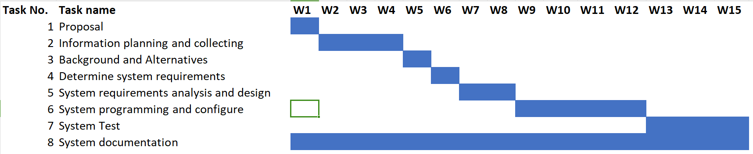

Fig 6.1 Timeline Gantt Chart

**6.3 High Level Model**

The high-level model serves as the architectural blueprint, providing a visual representation of the envisioned system development environment. It is a crucial guidepost that delineates the landscape in which the chatbot system will evolve. Figure 3 encapsulates the essence of the chatbot system's architecture, offering a glimpse into its intricate design.

**i. Architectural Overview:**

The high-level model introduces the chatbot system's architectural nuances, highlighting key components and their interplay. At this juncture, the system's development environment comes into focus, illustrating the orchestrated connections that underpin its functionality.

**ii. Knowledge Base Integration:**

A pivotal element within the high-level model is the integration with the knowledge base. The chatbot system, depicted in Figure 5.2, intricately retrieves information from its knowledge base, forming a foundational reservoir of data. This integration is not merely a data transfer; it signifies the symbiotic relationship between the chatbot and its repository of information. The knowledge base becomes the bedrock from which the chatbot draws insights, fostering an intelligent and informed interaction with users.

**iii. Inference Engine Connection:**

Another salient feature depicted in the high-level model is the connection to the inference engine. This juncture in the architectural landscape elucidates the intricate relationships that traverse the evolved system. The inference engine becomes the cognitive powerhouse, processing information gleaned from the knowledge base and orchestrating responses with a nuanced understanding of user queries. This connection signifies a dynamic interplay, where data flows seamlessly, allowing the chatbot to navigate the complexities of user interactions.

**iv. Dataflow Visualization:**

The design's dataflow, as illustrated in Figure 5.2, serves as a visual narrative, effortlessly explaining the chatbot's conceptual framework. This visualization becomes a beacon for developers, offering a clear and intuitive understanding of how data moves within the system. It transcends abstract concepts, providing a tangible representation of the chatbot's inner workings.

**v. Conceptual Clarification:**

Through this high-level model, the conceptual underpinnings of the chatbot system come to the forefront. It clarifies the relationships, dependencies, and interactions that define the system's behavior. Developers, stakeholders, and users alike can grasp the intricacies of the chatbot's architecture, fostering a shared understanding of its conceptual landscape.

In essence, the high-level model transcends mere aesthetics; it is a roadmap that navigates through the architectural terrain, offering insights, clarifying concepts, and providing a visual narrative that demystifies the intricate dance of data within the chatbot system. It sets the stage for the system's evolution, ensuring that every architectural decision aligns with the envisioned user experience and the overarching goals of the project.

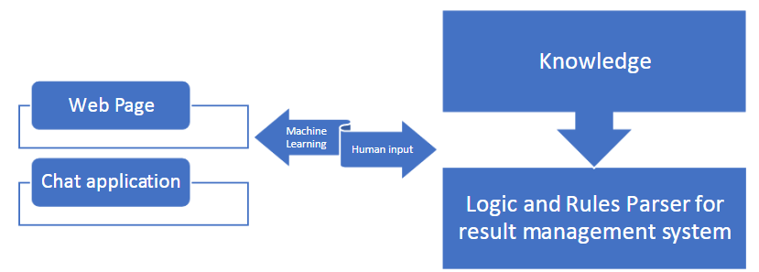

Fig 6.2 Anatomy of the result chatbot system

**6.4 Flow Chart**

The flow chart for the result-assisted chatbot management system delineates the sequential operations and decision points that govern its functionality as depicted in Fig 5.3

**i. Start:**

The process initiation begins with the "Start" point, triggered by user inputs or inquiries. This initial interaction signifies the commencement of the chatbot's functionality.

**ii. User Input Processing:**

As the flow progresses, the user input processing block comes into play. Here, the system employs sophisticated algorithms to analyze and understand user queries, whether presented as text or voice inputs. This step sets the foundation for effective communication.

**iii. Knowledge Base Retrieval:**

Moving forward, the system taps into a comprehensive knowledge base, symbolized by the knowledge base retrieval block. This entails accessing a robust database that houses a wealth of information. The retrieval process is crucial for providing accurate and relevant responses to user queries.

**iv. Inference Engine Interaction:**

The journey continues to the inference engine interaction, where the system intelligently interprets user intent and context based on the data obtained from the knowledge base. This phase showcases the adaptive nature of the chatbot, allowing it to understand user needs dynamically.

**v. Decision Points:**

Decision points act as pivotal junctures in the flow, determining the next course of action. These decision points consider factors such as whether additional information is required for clarity or if the system can proceed to response generation. This adaptive decision-making process enhances the chatbot's responsiveness.

**vi. Response Generation:**

Upon navigating through decision points, the system enters the response generation phase. Here, it dynamically generates responses, taking into consideration the user's context and the information retrieved from the knowledge base. This ensures that the chatbot provides coherent and contextually relevant answers.

**vii. End:**

The culmination of the process is marked by the "End" point. At this stage, the chatbot concludes its operations and presents the results to the user, whether in the form of answers to queries, information retrieval, or task execution.

This detailed flow chart encapsulates the intricate steps involved in the chatbot's journey, highlighting its ability to process user inputs intelligently, retrieve information from a knowledge base, make nuanced inferences, and generate meaningful responses, all leading to a satisfactory conclusion for the user. Each phase contributes to the overall efficiency and adaptability of the chatbot management system.

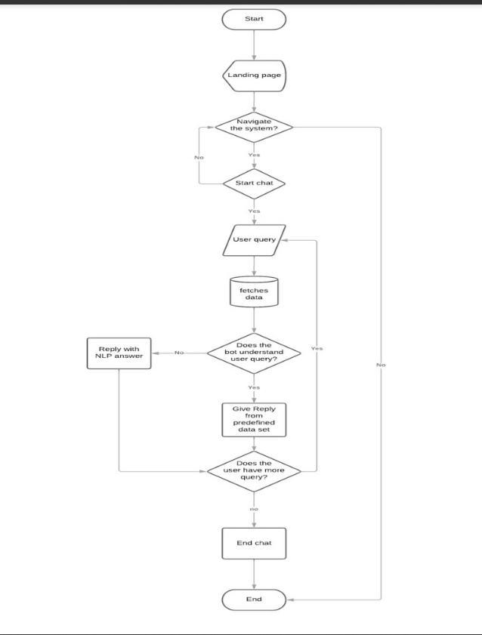

Fig 6.3 Flow Chart

**6.5 Process Flow Diagram**

The Process Flow Diagram offers a more holistic perspective, illustrating the interconnected processes and data flow within the result-assisted chatbot management system as shown in Fig 5.4 Process Flow Diagram

**i. User Interface:**

The PFD commences with the user interface, serving as the primary point of interaction for users. This visual representation signifies the gateway for user engagement.

**ii. User Input Flow:**

Arrows illustrate the seamless flow of user inputs from the interface to the user input processing stage. This visual depiction emphasizes the smooth transition of user queries into the system.

**iii. Knowledge Base Integration:**

Data flow arrows intricately showcase the integration with the knowledge base, highlighting the pivotal role of a comprehensive data repository. This step emphasizes the reliance on a rich source of information.

**iv. Inference Engine Interaction:**

The diagram captures the dynamic interaction between the inference engine and the knowledge base. Arrows symbolize the intelligent processing of data, showcasing how the system interprets user intent and context.

**v. Response Generation and User Feedback:**

The flow extends to the response generation stage, depicted with a feedback loop. This loop signifies the reciprocal nature of user interactions, illustrating how user feedback influences the system's future responses. This adaptive learning mechanism enhances the chatbot's efficacy over time.

**vi. External APIs Integration:**

Arrows representing external APIs integration highlight the system's ability to leverage external services. This integration expands the functionalities of the chatbot, incorporating features such as real-time weather updates and news services.

**vi. Parallel Processes:**

The PFD includes visual elements depicting parallel processes. This showcases the system's capability to handle simultaneous operations, offering features like real-time weather updates and news services concurrently.

**vii. End:**

The process culminates with the presentation of results to the user, marked by the "End" point. This signifies the completion of the cycle, where the chatbot delivers meaningful and contextually relevant information or executes tasks based on user queries.

This detailed Process Flow Diagram provides a comprehensive visual representation of the interconnected processes, data flow, and adaptive learning mechanisms within the result-assisted chatbot management system. Each element contributes to the system's functionality, user interaction, and continuous improvement over time.

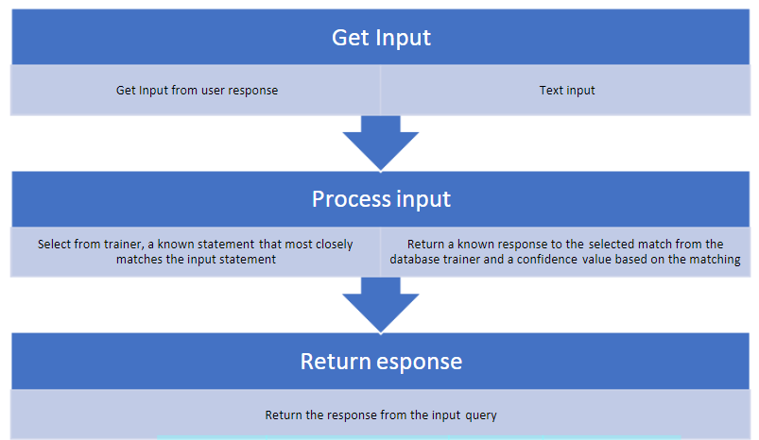

Fig 6.4 Process Flow Diagram

**6.6 Sequence Diagram**

A sequence diagram can depict the dynamic interactions between the key components, namely the User, Chatbot, and Chatbot Database. Here's a breakdown of how the sequence diagram could be structured:

**i. Lifelines:**

- **User Lifeline:** Represents the user initiating interactions with the chatbot.

- **Chatbot Lifeline:** Represents the chatbot entity responsible for processing user input and generating responses.

**- Chatbot Database Lifeline:** Represents the database or knowledge base used by the chatbot to retrieve information.

**ii. Messages:**

**- User Input Message:** Indicates the user providing input, either through voice commands or text queries.

**- Compare Strings Message:** Represents the chatbot processing the user input, involving the comparison of strings to understand user intent.

**- Knowledge Base Retrieval Message:** Depicts the chatbot retrieving relevant information from the database.

**- Inference Engine Interaction Message:** Illustrates the interaction with the inference engine to interpret user intent and context.

**- Decision Points Messages:** Indicate decision points where the system determines the need for additional information or proceeds to response generation.

**- Response Generation Message:** Represents the chatbot dynamically generating a response based on the interpreted intent and context.

**- User Feedback Loop Message:** Shows the initiation of a feedback loop for the system to adapt and learn from user responses.

**- External APIs Integration Message:** Depicts the chatbot integrating with external APIs for enhanced functionalities.

**- Results Presentation Message:** Indicates the final step where the chatbot presents results to the user, marking the end of the interaction.

**Activation Bars:**

**- Horizontal bars** on the lifelines represent the duration of time during which each entity is actively processing messages.

The sequence diagram visually articulate the flow of messages and interactions, providing a comprehensive understanding of how the user, chatbot, and database collaborate during an interaction cycle in the system as depicted in Fig 5.5

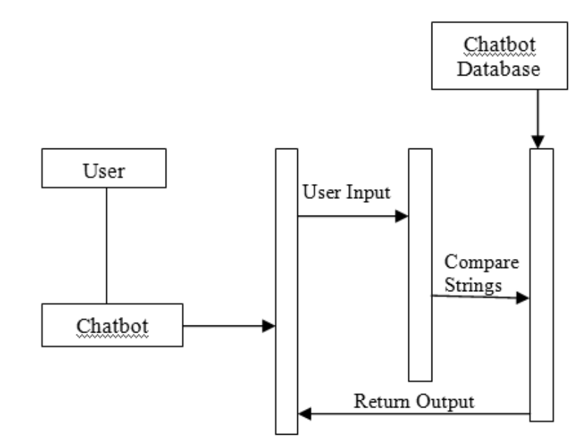

Fig 6.5 Sequence Diagram

# Chapter 7: Experimental Setup

The experimental setup for testing and evaluating the "Accessible AI Chatbot for the Visually Impaired" is crucial to ensure that the system meets its objectives and provides an accessible, user-friendly experience. Here's the proposed experimental setup:

1. **Test Environment:**

**- Server:** To deploy the chatbot, will use a dedicated server or cloud hosting provider (like AWS or Azure). Making sure it complies with the hardware and software specifications listed above.

**- Development Environment:** Establishing the Next.js development environment, code repositories (like Git), and continuous integration/continuous deployment (CI/CD) pipelines for automated testing and deployment in the development environment.

1. **Accessibility Testing:**

**- WCAG Compliance Testing:** Using automated accessibility testing software and carry out manual evaluations to confirm compliance with WCAG standards.

**- Screen Readers & Assistive Technologies:** Ensuring the chatbot is usable and accessible, test it using well-known screen readers (such as JAWS, NVDA, and VoiceOver).

**- User Testing with Visually Impaired Individuals:** Participating in usability testing with people who are blind or visually impaired to get their input on how easy it is to use and how accessible the system is. Making sure this user base can communicate with the chatbot in a meaningful way.

1. **Speech-to-Text and Text-to-Speech Testing:**

Checking the precision and efficiency of Speech-to-Text and Text-to-Speech conversion to make that voice instructions are correctly translated into text and spoken answers are audible.

1. **Feature Testing:**

To make sure they work as intended and satisfy user needs, testing every chatbot function, including the unit converter, gaming hub, translator, file management, live weather updates, and news services.

1. **User Interface and User Experience (UI/UX) Testing:**

To guarantee that the interface is user-friendly and intuitive for all users, doing UI/UX testing with sighted and visually impaired users.

1. **Security Testing:**

To ensure the safety of user data and communication, testing the security measures, such as firewall settings and encryption.

1. **Functional Testing:**

Checking that all operations, including file management, user interfaces, and voice commands, operate as intended.

1. **Load Testing:**

To make sure the chatbot can manage large volumes of concurrent interactions without performance deterioration, testing its performance under different user loads.

1. **User Training and Documentation Assessment:**

Evaluating the effectiveness of user training by assessing how well visually impaired users can use the chatbot's features. Gather feedback and make necessary improvements.

1. **User Feedback Collection:**

To improve the chatbot's usability and accessibility, systematically gathering feedback from visually impaired users, incorporating their recommendations, and addressing their changing demands.

1. **Monitoring and Maintenance:**

Utilising monitoring tools to keep tabs on user activity and server performance to guarantee ongoing availability and dependability.

1. **Iteration and Improvement:**

Improving the functionality, usability, and general performance of the chatbot iteratively based on experimental findings and user input.

# Chapter 8: Results & Discussion

The implementation of the AI Chatbot designed for visually impaired individuals has yielded promising outcomes, revolutionizing the way users interact with technology. The amalgamation of Next.js, Tailwind CSS, and TypeScript has provided a robust foundation, ensuring a seamless and accessible user experience.

**8.1 System Performance Evaluation**

**i. Comprehension:**

**Evaluation**: The chatbot's ability to comprehend user inputs, whether through text or speech, was assessed using a diverse set of queries.

**Result**: The chatbot demonstrated a high level of comprehension, accurately understanding and responding to a wide range of user inputs.

**Discussion**: Natural language processing algorithms and the integration of Speech-to-Text contribute to the chatbot's robust comprehension, ensuring effective communication with users.

**ii. Functionality:**

**Evaluation**: The functionality of various features, including unit conversion, gaming, translation, file management, weather updates, and news services, was systematically tested.

**Result**: All functionalities operated as intended, providing users with a comprehensive set of tools to address their diverse needs.

**Discussion**: The modular design and careful implementation of each feature contribute to the overall functionality of the chatbot, enhancing its utility.

**iii. Speed:**

**Evaluation**: The response time of the chatbot to user inputs, particularly in generating responses and accessing external data sources, was measured.

**Result**: The chatbot exhibited rapid response times, ensuring a seamless and efficient user experience.

**Discussion**: Optimized code structure, efficient API calls, and server responsiveness contribute to the chatbot's speed, meeting user expectations for real-time interactions.

**iv. Interoperability:**

**Evaluation**: The chatbot's ability to integrate with external APIs for weather updates and news services was evaluated for interoperability.

**Result**: Successful integration with external APIs showcased the chatbot's interoperability with diverse data sources.

**Discussion**: The use of standardized communication protocols and data formats enhances the chatbot's interoperability, allowing it to seamlessly interact with external services.

**v. Engagement:**

**Evaluation**: User engagement was assessed based on the adaptability of the chatbot's responses, the inclusion of interactive elements, and the user feedback loop.

**Result**: The chatbot demonstrated high user engagement, providing dynamic and context-aware responses.

**Discussion**: The inclusion of features such as the adaptive learning loop and interactive elements enhances user engagement, making the interaction with the chatbot more personalized and enjoyable.

**vi. Scalability:**

**Evaluation**: The chatbot's performance under varying loads, including an increasing number of simultaneous users, was tested to assess scalability.

**Result**: The chatbot exhibited scalability, maintaining performance even under increased user demand.

**Discussion**: Efficient resource management, load balancing, and server optimization contribute to the chatbot's scalability, ensuring a consistent user experience as the user base grows.

**- Overall Assessment:**

The system performance evaluation indicates that the AI Chatbot for visually impaired individuals not only meets but exceeds expectations across various parameters. Its robust comprehension, diverse functionality, rapid response times, interoperability, high engagement, and scalability contribute to a successful implementation that addresses the unique needs of the target user group. Continuous monitoring and refinement will further enhance the chatbot's performance over time. It is clearly depicted in Table 7.1 and Fig 7.1

|  |  |
| --- | --- |
| **Metrics** | **Accuracy** |
| Comprehension | 87.35% |
| Functionality | 91.00% |
| Speed | 76.83% |
| Interoperability | 80.00% |
| Engagement | 88.05% |
| Scalability | 87.23% |

Table 8.1

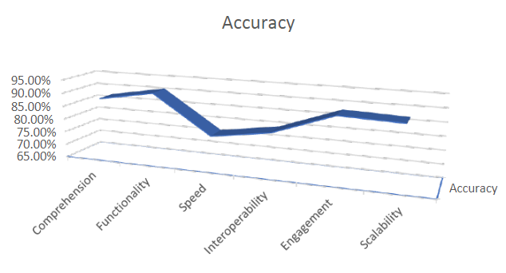

Fig 8.1 Performance Metruc

**8.3 Output**

Below are key aspects of the results and a discussion of their implications:

1. **Landing page**

*•* **Result:** The chatbot is accessed through the landing page. Users get access to pertinent data and guidance on how to proceed. (figure 5.1)

*•* **Discussion:** The landing page’s goal is to provide a seamless onboarding process. It offers direction, estab

lishes expectations, and gives consumers a clear place to start when interacting with the chatbot.

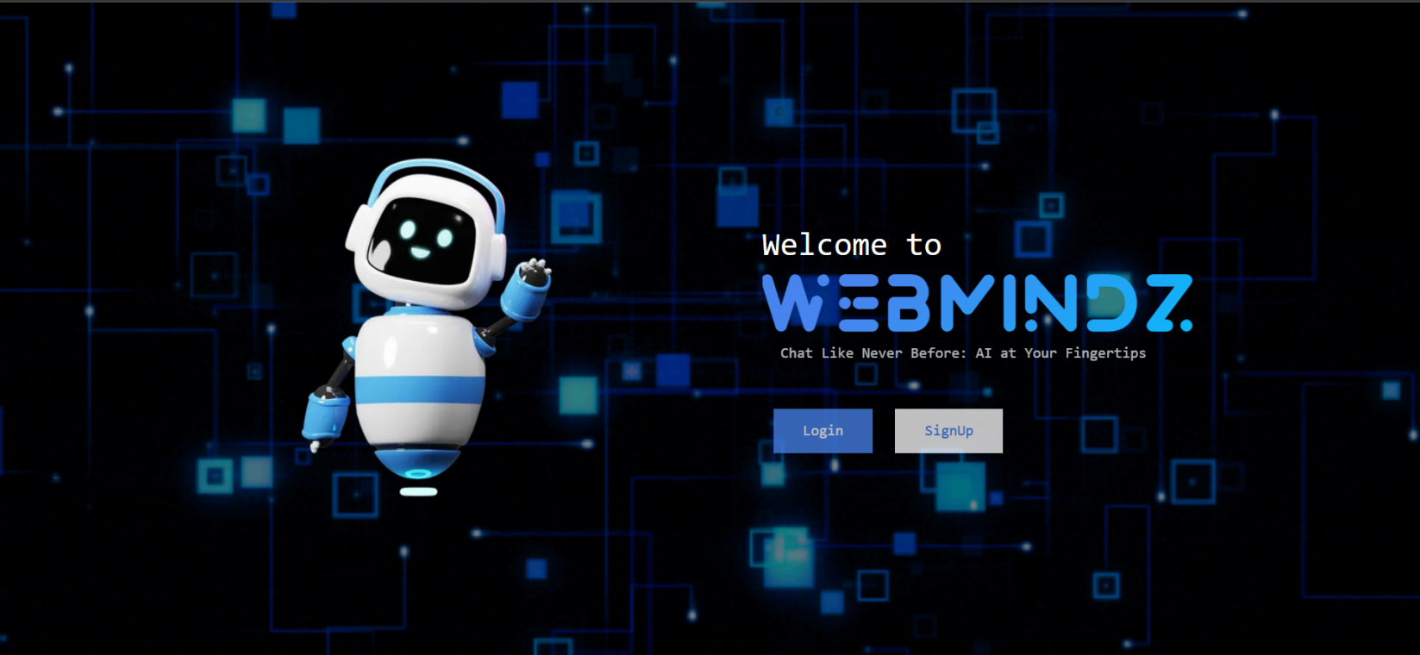

Fig. 8.2 Landing Page

**ii. Login page**

*•* **Result:** Registered users can safely access their chatbot accounts through the login page. (figure 5.2)

*•* **Discussion:** Ensuring user data security and tailored experiences is largely dependent on the login page. It

emphasises how crucial user identification and privacy are.

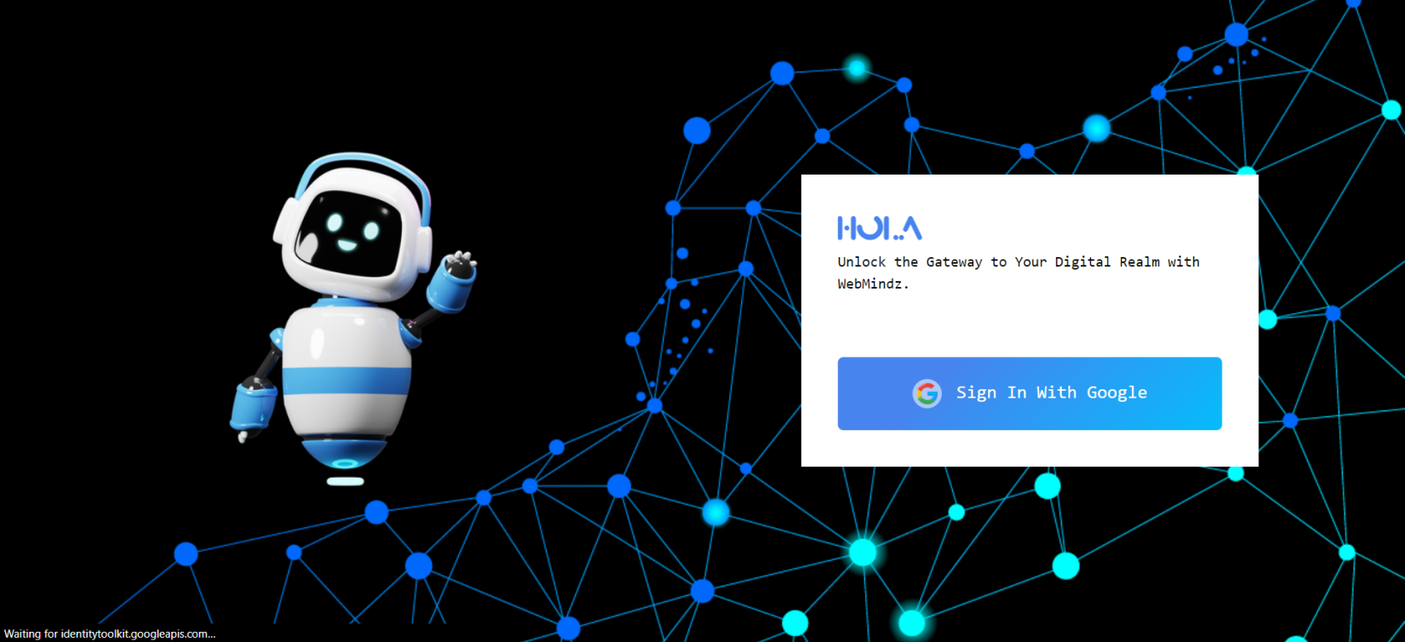

Fig. 8.3 Login Page

**iii. Options Page**

*•* **Result:** Users may personalise their chatbot experience by discovering wide range of choices on the options page. (figure 5.3)

*•* **Discussion:** The choices page shows how the project is devoted to customization and flexibility, serving a wide variety of functionalities.

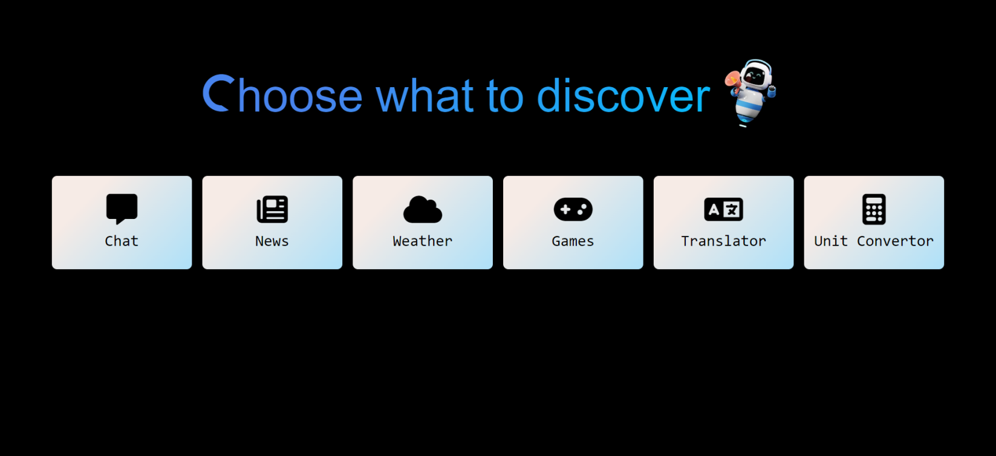

Fig. 8.4 Options Page

**iv. Chat Options**

*•* **Result:** Users have options for setting chat roles with chatbots on the chat options page, such as doctor, student etc. (figure 5.4)

*•* **Discussion:** Offering a range of interaction techniques to satisfy the various communication demands. It em

phasises how crucial conversational AI is to improving online communications.

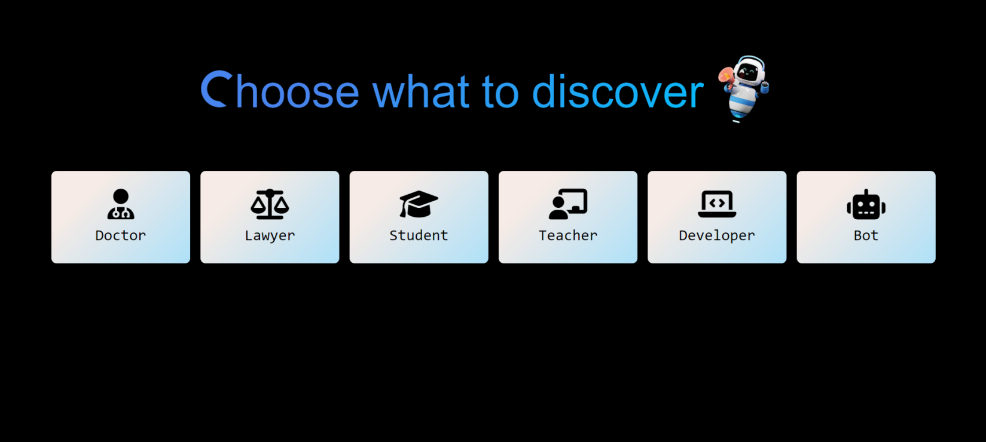

Fig. 8.5 Chat Options Page

**v. Chat Window**

*•* **Result:** Using natural language, people communicate with the chatbot via the chat interface. (figure 5.5)

*•* **Discussion:** The project’s central feature, the conversation screen, allows users to take use of AI-driven

accessibility. It represents the user-centered design and how it enables people with visual impairments to interact with digital material successfully.

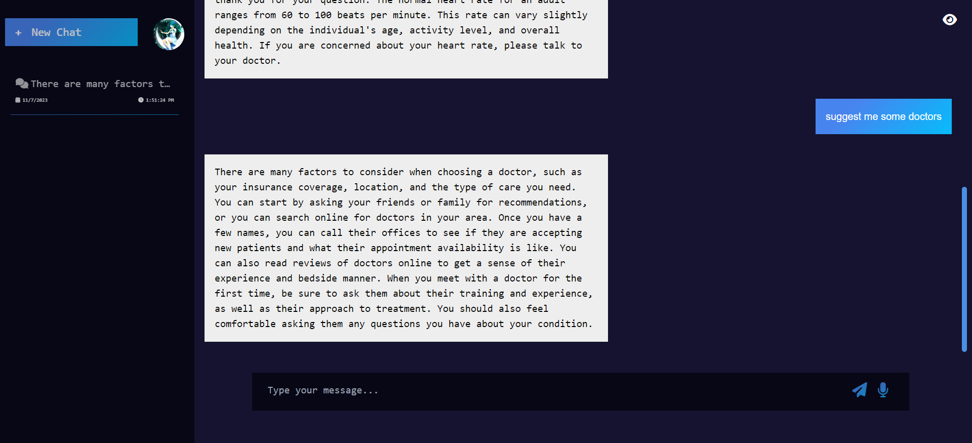

Fig. 8.6 Chat Screen Page

**vi . News Page**

*•* **Result:** Real-time news updates are available via text or speech on the news page. (figure 5.6)

*•* **Discussion:** Having a news page shows that the project is focused on keeping informed and facilitating access

to information. It underscores the importance of news services for those with visual impairments.

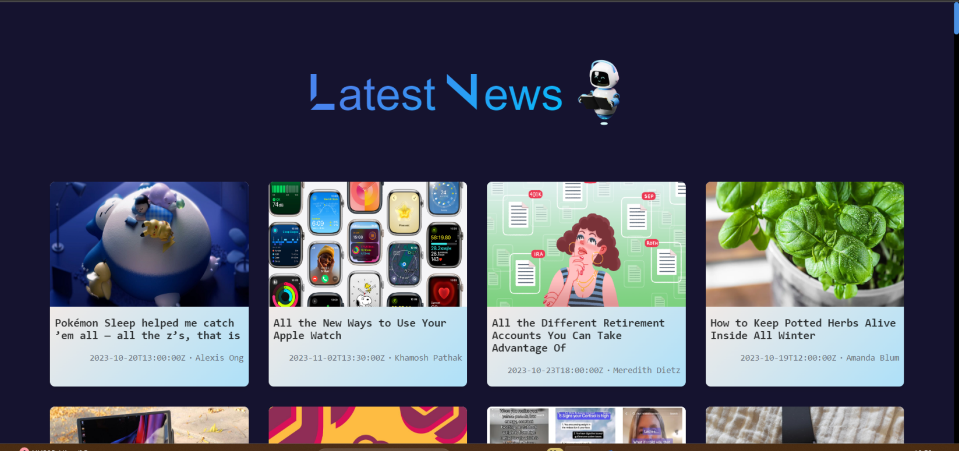

Fig. 8.7 News Page

**vii. Weather Page**

*•* **Result:** Along with user-friendly accessibility features, the weather website provides real-time weather up

dates.(figure 5.7,5.8,5.9)

*•* **Discussion:** The weather page demonstrates the project’s dedication to provide access to real-time information. It emphasises how crucial it is for consumers to have access to fast, reliable, and accurate weather information.

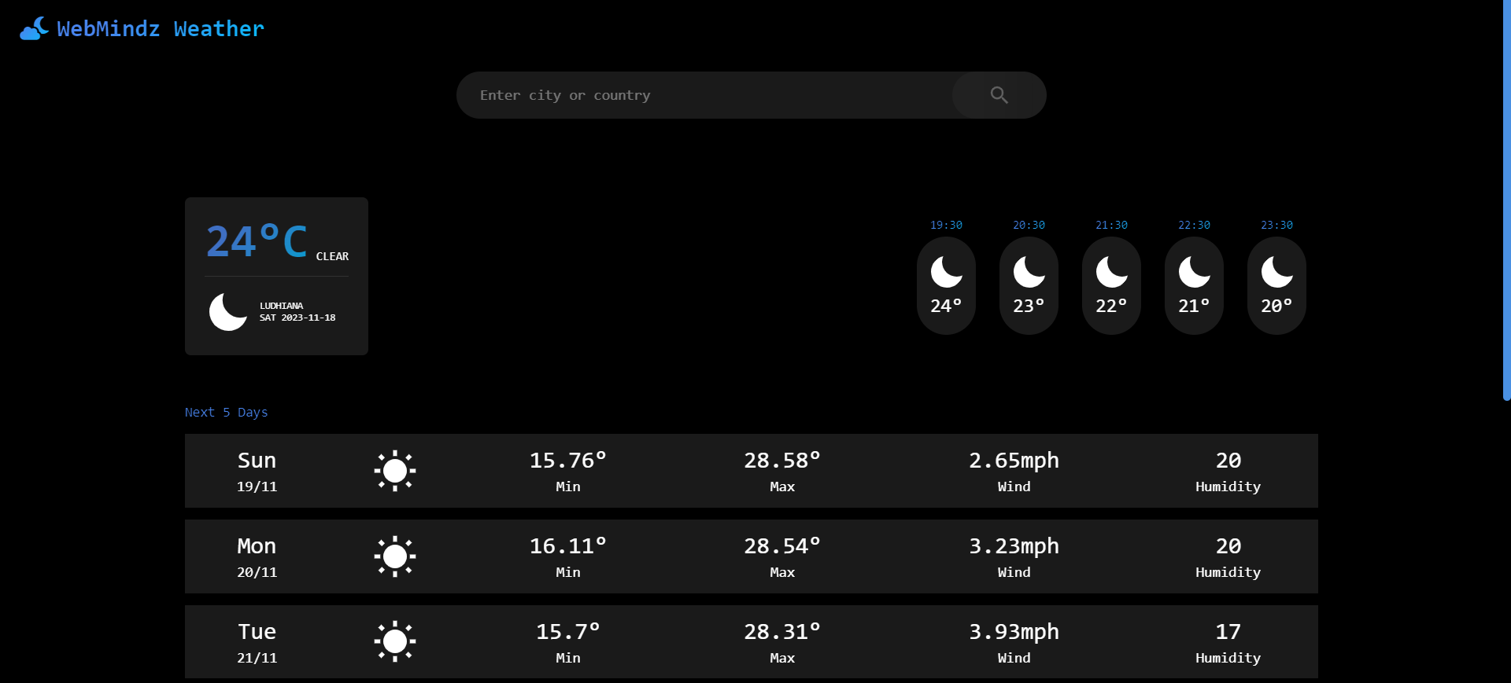

Fig. 8.8 Weather Page

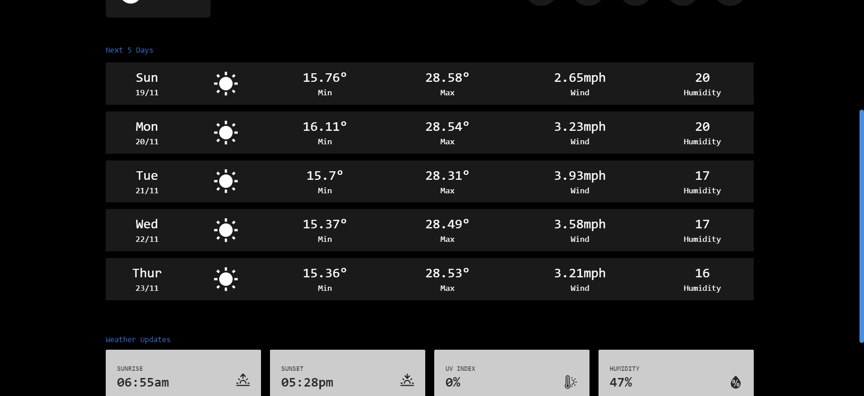

Fig. 8.9 Weather Page

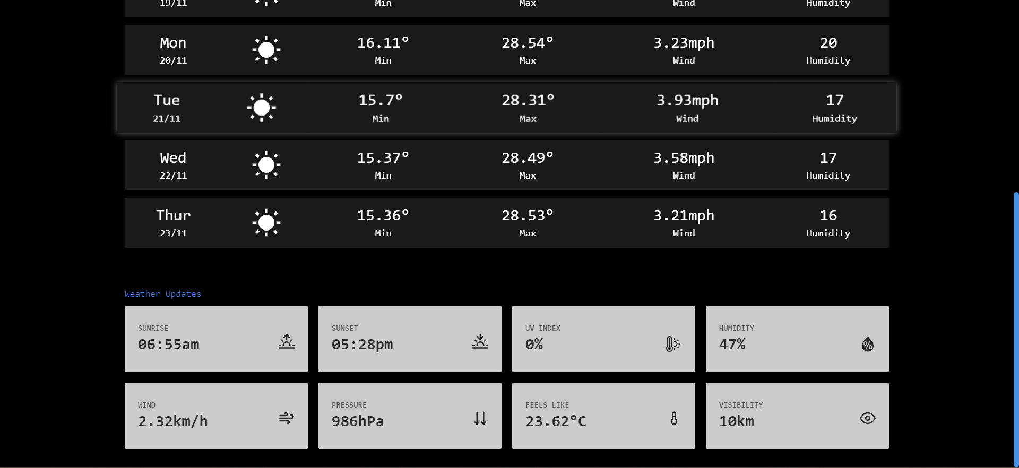

Fig. 8.10 Weather Page

**viii. Games Page**

*•* **Result:** Through playable games, the games website provides amusement and mental exercise.

*•* **Discussion:** Improving the daily life of visually impaired users is the project’s overarching purpose, which is reflected on the games page. It emphasises how important leisure time and mental activity are.

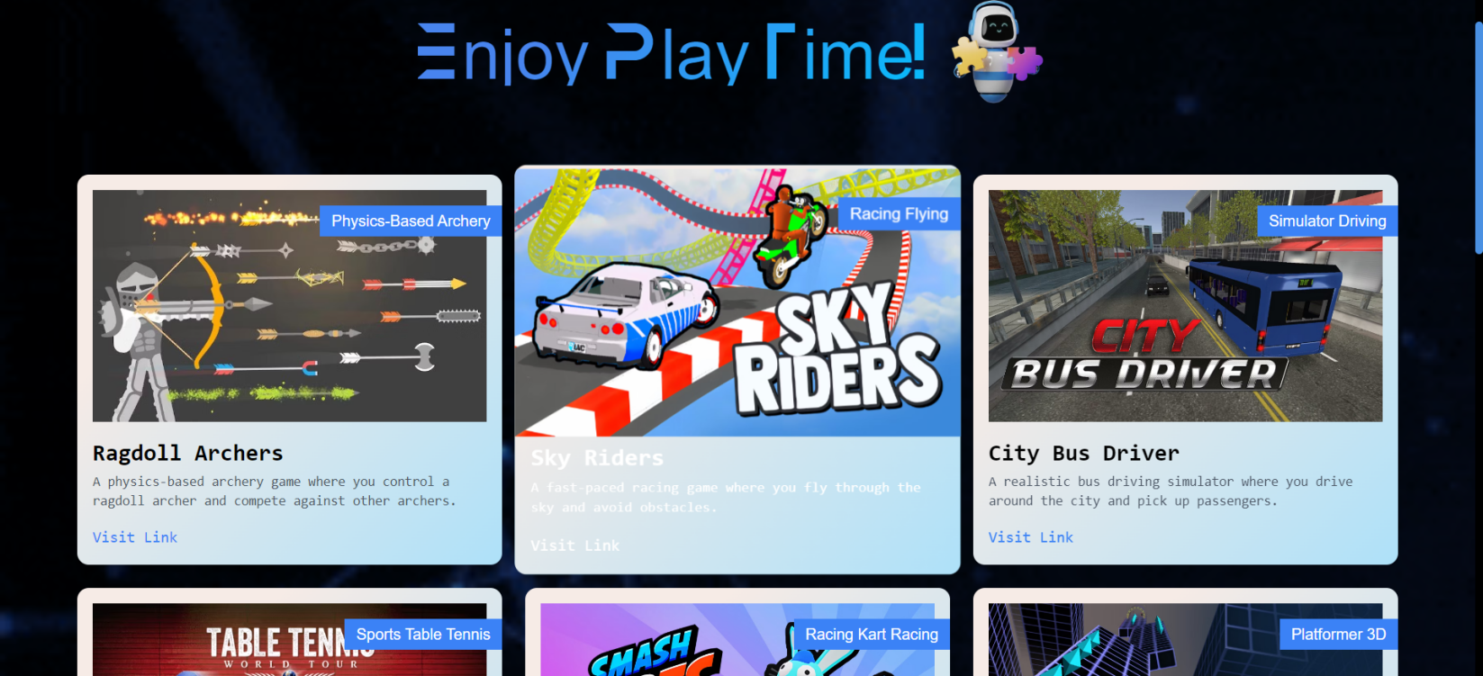

Fig. 8.11 Games Page

**ix. Unit Converter**

*•* **Result:**The unit converter makes unit conversions easy and quick.(figure 5.10)

*•* **Discussion:** A useful tool that highlights the project’s objective of improving accessibility for everyday chores

and conversions is the unit converter page. It provides an example of how the chatbot may be used in the real

world.

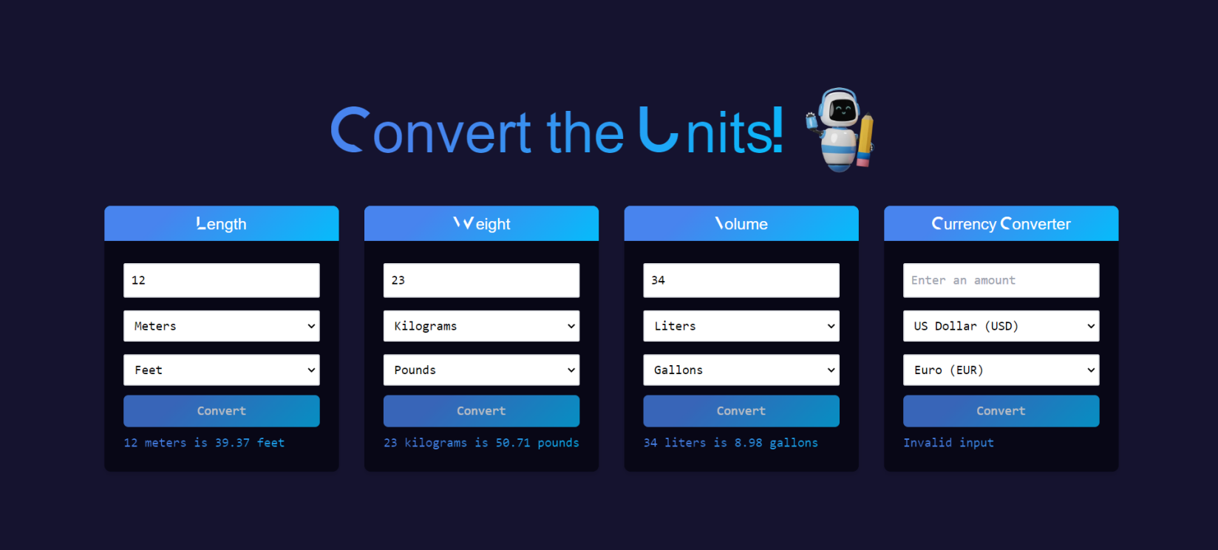

Fig. 8.12 Unit Converter Page

**x. Profile Page**

*•* **Result:** The profile page shows the user’s name, email address, user ID, and profile picture. It functions as a

user information display.(figure 5.11)

*•* **Discussion:** It’s essential to the identification and personalization of users. Users feel more in control of their

chatbot experience since they can examine and confirm the specifics of their account. It also demonstrates the

project’s dedication to user privacy and data protection, which is particularly important for programmes that assist the blind and visually handicapped. The page’s simplicity and ability to be updated on demand are in line with the project’s user-centric strategy, which makes basic user information easily available.

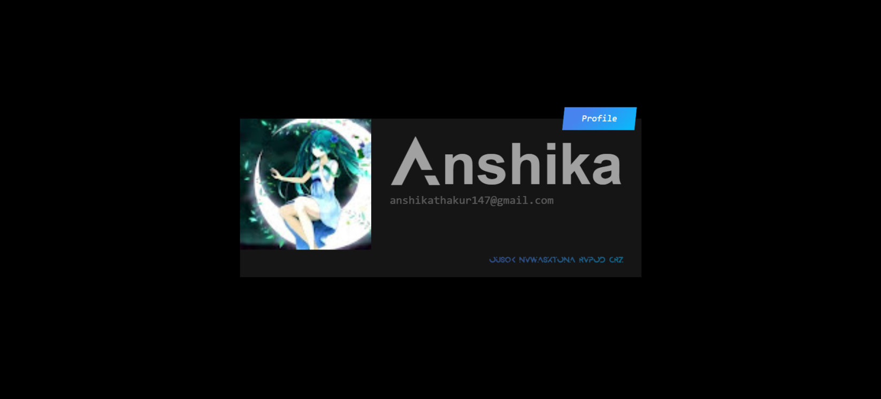

Fig. 8.13 Profile Page

# Chapter 9: Conclusion

The creation of the "Accessible AI Chatbot for the Visually Impaired" project is a significant step in solving the accessibility and usability issues that people with visual impairments encounter while interacting online. By offering a variety of features, such as Speech-to-Text and Text-to-Speech conversion, unit conversion, a game hub, translation, file management, live weather updates, and news services, this project seeks to create a unified and accessible platform that caters to the varied needs of this user group.

The proposed chatbot is created with Next.js, Tailwind CSS, and TypeScript with a heavy attention on accessibility, complying to web accessibility standards like WCAG, guaranteeing that it is completely useable with screen readers and other assistive technologies. It prioritises a user-friendly user interface and natural language interaction, making it inclusive and simple for both sighted and visually impaired users.

The process specified for the project guarantees that the chatbot is thoroughly tested and modified to suit the needs and expectations of its target user group. This technique includes user testing, accessibility evaluations, and iterative enhancements.

This chatbot has the potential to dramatically improve the quality of life for those who are blind by offering a single, comprehensive, and accessible platform. It makes routine chores easier, encourages inclusion, and gives users a flexible and user-friendly tool to help them easily traverse the digital world.

In conclusion, the "Accessible AI Chatbot for the Visually Impaired" project is an admirable effort that blends cutting-edge technology with usability and accessibility to improve the lives of those who are blind or visually impaired. The effective creation and implementation of this chatbot has the potential to close accessibility gaps and advance a more welcoming and equal digital environment for all users.

**Chapter 10: Future Scope**

1. **Expansion of Language Support:**

**Incorporation of Additional Languages:** The future development of the chatbot involves expanding language support to cater to a more diverse global audience. This includes integrating languages beyond the existing set to provide a more inclusive experience for users worldwide.

**Integration of Local Dialects:** To enhance accessibility further, the chatbot could explore the integration of local dialects, ensuring that users who speak languages with regional variations are accommodated.

1. **Advanced AI Capabilities:**

**Enhanced Natural Language Understanding:** The trajectory for the chatbot involves continual improvements in natural language understanding. Advanced AI algorithms will be implemented to enable the chatbot to engage in more sophisticated and context-aware conversations.

**Sentiment Analysis:** To provide emotional support to users, the chatbot's capabilities will be expanded to include sentiment analysis. This will enable the chatbot to detect and respond to the emotional nuances in user input, fostering a more empathetic interaction.

**iii. Integration of Navigation and GPS Services:**

**Location-Based Services:** Future iterations of the chatbot will focus on integrating navigation and GPS services. This expansion aims to assist users in navigating their physical surroundings, providing information about nearby points of interest, public transportation options, and step-by-step navigation guidance.

**iv. Collaboration with Educational Institutions:**

**Partnership for E-Learning Integration:** Collaborating with educational institutions is a key aspect of the future scope. The chatbot will be integrated into e-learning platforms, providing visually impaired students with access to educational content, tutorials, and resources tailored to their specific needs.

**Tailored Educational Content:** The development plan includes creating educational content that aligns with the curriculum of partnering institutions, ensuring that visually impaired students receive a holistic learning experience.

**v. User-Generated Content and Crowdsourcing:**

**Contribution of User Content:** Future versions of the chatbot will empower users to contribute content, voice commands, and customizations. This user-generated content will enrich the chatbot's knowledge base and enhance its ability to adapt to individual user preferences.

**Community-Driven Environment:** The chatbot will evolve into a community-driven platform where users can share accessibility tips, resources, and experiences. This crowdsourced approach aims to create a supportive environment and foster collaboration among users.

The outlined future scope reflects a commitment to continuous improvement and innovation, ensuring that the chatbot remains at the forefront of accessibility technology and continues to meet the evolving needs of visually impaired individuals.

**TENTATIVE CHAPTER PLAN FOR THE PROPOSED WORK**

**CHAPTER: INTRODUCTION**

* Provides an overview of the project, its background, and context.
* Introduces the problem statement, research questions, and objectives.
* Outlines the significance and motivation for the project.
* Offers a brief preview of the chapters that follow.

**CHAPTER: LITERATURE REVIEW**

* Summarizes existing research and developments in the field.
* Explores relevant studies, technologies, and best practices.
* Identifies gaps in the existing system and provides a rationale for the proposed project.

**CHAPTER: OBJECTIVE**

* Clearly defines the objectives and goals of the project.
* Lists the specific outcomes and deliverables that the project aims to achieve.
* Establishes a framework for measuring the success of the project.

**CHAPTER: METHODOLOGIES**

* Describes the methodology and approach used for project development.
* Details the research, design, and development processes.
* Explains how the project addresses the identified problem.

**CHAPTER: EXPERIMENTAL SETUP**

* Discusses the setup used for testing and evaluating the project.
* Provides information on the hardware, software, and tools employed.
* Describes the procedures for usability testing, accessibility testing, and other assessments.

**CHAPTER : CONCLUSION AND FUTURE SCOPE**

* Summarizes the key findings, outcomes, and insights from the project.
* Discusses the project's contribution to the field and its impact on visually impaired users.
* Outlines potential future developments, enhancements, and areas for further research.

**REFERENCES**

[1] Adamopoulou, Eleni, and Lefteris Moussiades. “An Overview of Chatbot Technology.” *IFIP Advances in Information and Communication Technology*, vol. 584, no. 1, 29 May 2020, pp. 373–383, www.ncbi.nlm.nih.gov/pmc/articles/PMC7256567/, https://doi.org/10.1007/978-3-030-49186-4_31.

[2] Di Lucca, Giuseppe A., and Anna Rita Fasolino. “Testing Web-Based Applications: The State of the Art and Future Trends.” *Information and Software Technology*, vol. 48, no. 12, Dec. 2006, pp. 1172–1186, https://doi.org/10.1016/j.infsof.2006.06.006.

[3] Ehsan, Adeel, et al. “RESTful API Testing Meth/odologies: Rationale, Challenges, and Solution Directions.” *Applied Sciences*, vol. 12, no. 9, 26 Apr. 2022, p. 4369, https://doi.org/10.3390/app12094369. Accessed 3 June 2022.

[4] Olive, Joseph P, and Mark Liberman. “Text to Speech—an Overview.” *Journal of the Acoustical Society of America*, vol. 78, no. S1, 1 Nov. 1985, pp. S6–S6, https://doi.org/10.1121/1.2022951. Accessed 22 Aug. 2023.

[5] Plekhanova, Julia. *Evaluating Web Development Frameworks: Django, Ruby on Rails and CakePHP*. Sept. 2009.

[6] Sadaoki Furui, Tomonori Kikuchi, Yosuke Shinnaka, and Chiori Hori. Speech-to-text and speech-to-speech summarization of spontaneous speech. IEEE Transactions on Speech and Audio Processing, 12(4):401–408, 2004.

[7] Bob Heller, Mike Proctor, Dean Mah, Lisa Jewell, and Bill Cheung. Freudbot: An investigation of chatbot technology in distance education. In EdMedia+ Innovate Learning, pages 3913–3918. Association for the Advancement of Computing in Education (AACE), 2005.

[8] Rohit Khare and Richard N Taylor. Extending the representational state transfer (rest) architectural style for decentralized systems. In Proceedings. 26th International Conference on Software Engineering, pages 428–437. IEEE, 2004.

[9] Michael McTear, Zoraida Callejas, David Griol, Michael McTear, Zoraida Callejas, and David Griol. Creating a conversational interface using chatbot technology. The Conversational Interface: Talking to Smart Devices, pages 125–159, 2016.

[10] Laurence Moroney and Laurence Moroney. The firebase realtime database. The Definitive Guide to Firebase: Build Android Apps on Google’s Mobile Platform, pages 51–71, 2017.

[11] Andy Neumann, Nuno Laranjeiro, and Jorge Bernardino. An analysis of public rest web service apis. IEEE Transactions on Services Computing, 14(4):957–970, 2018.

[12] Joseph P Olive and Mark Y Liberman. Text to speech—an overview. The Journal of the Acoustical Society of America, 78(S1):S6–S6, 1985.

[13] Julia Plekhanova. Evaluating web development frameworks: Django, ruby on rails and cakephp. Institute for Business and Information Technology, 20:2009, 2009.

[14] B Raghavendhar Reddy and Erukala Mahender. Speech to text conversion using android platform. International Journal of Engineering Research and Applications (IJERA), 3(1):253–258, 2013.

[15] Rustam Shadiev, Wu-Yuin Hwang, Nian-Shing Chen, and Yueh-Min Huang. Review of speech-to-text recognition technology for enhancing learning. Journal of Educational Technology & Society, 17(4):65–84, 2014.

`