Full Stack Engineering

Project Report
Semester-V (Batch-2023)

Appointment Booking System


Supervised By: Submitted By:
Rahul Sir
Anshika Asija 2310990288
Anshul Kumar 2310990289
Anubhav Garg 2310990290
Suhani Goyal 2310991059

Department of Computer Science and Engineering
Chitkara University Institute of Engineering & Technology,
Chitkara University, Punjab

ABSTRACT

The Company Appointment System is a web-based platform designed to streamline communication, project management, and appointment scheduling within an organization. The system operates under a super-admin (owner) who creates and manages projects, adds staff, and registers clients. Once registered, staff members and clients receive login credentials via email, enabling them to access the system securely.

The admin panel provides functionalities for adding new staff, clients, and projects, ensuring centralized control over company operations. Clients can book appointments with staff or the owner, making the scheduling process efficient and transparent. Additionally, clients can raise questions or queries related to projects directly through the system. These queries can be addressed by either the staff or the owner, promoting effective collaboration and timely resolution.

To further enhance usability, the system integrates automated email notifications, role-based access control, and real-time interaction features. This ensures that clients remain updated on their appointments, staff can manage schedules effectively, and the owner can oversee all project activities with ease. By bringing project management, communication, and appointment booking under a single interface, the Company Appointment System provides a reliable and professional solution for modern organizations.

The system also focuses on improving customer experience by providing clients with an easy-to-use portal where they can book meetings, monitor project updates, and communicate with company representatives without delays. From the company’s perspective, it reduces manual administrative tasks, eliminates scheduling conflicts, and ensures a structured flow of information between the owner, staff, and clients. This makes the system not only a tool for appointment booking but also a platform for strengthening client relationships and increasing organizational productivity.

Table of Content

- Abstract/Keywords

- Introduction to the project

  - Background

  - Problem Statement

- Problem Definition and Requirements

  - Methods

  - Programming/Working Environment

  - Requirements to run the application

- Proposed Design / Methodology

- Results

2. Introduction

In today’s fast-paced business environment, effective communication and efficient appointment management play a critical role in the smooth functioning of any organization. Companies often face challenges in managing multiple projects, coordinating between staff and clients, and ensuring timely meetings. Traditional manual methods, such as phone calls, emails, or spreadsheets, are prone to errors, scheduling conflicts, and delays in response. To overcome these limitations, there is a growing need for a centralized digital solution that can automate these tasks while maintaining professionalism and transparency.

The Company Appointment System has been developed to address these challenges by providing a unified platform where company owners, staff, and clients can collaborate seamlessly. At the core of the system is the super-admin (owner), who is responsible for creating new projects, adding staff, and registering clients. Once registered, both staff and clients receive login credentials through automated emails, enabling them to securely access the system. This ensures a smooth onboarding process and eliminates the hassle of manual account creation.

The system offers a role-based access structure where each user has specific permissions. The owner maintains complete control over the system, staff members can manage tasks and interact with clients, while clients are empowered to book appointments, raise queries, and track their interactions with the company. This structured flow improves accountability, ensures data security, and simplifies communication across all levels.

Another important feature of the system is the appointment booking module, which allows clients to schedule meetings with staff or the owner without conflicts. The system automatically notifies users via email, ensuring that both parties are aware of their commitments. In addition, clients can raise questions related to ongoing projects directly within the system, which can be answered by either staff or the owner. This feature not only saves time but also enhances client satisfaction by ensuring timely responses and transparent communication.

By integrating project management, appointment scheduling, and client communication into a single web-based application, the Company Appointment System significantly improves organizational efficiency. It reduces administrative overhead, minimizes the risk of missed meetings, and provides a professional platform for managing client relationships. Ultimately, this system supports companies in maintaining structured workflows, strengthening trust with clients, and achieving higher levels of productivity in their operations.

2.1 Background and Significance

The rapid advancement of technology has transformed the way organizations interact with clients and manage internal operations. In earlier times, companies relied heavily on manual systems for handling appointments, project coordination, and client communication. These methods often involved maintaining registers, making phone calls, or exchanging long email chains to confirm meetings and share updates. While these approaches worked on a small scale, they became inefficient and prone to errors as businesses expanded and the number of clients and staff increased. The lack of centralized systems often led to missed appointments, poor communication, and customer dissatisfaction.

With the rise of web-based applications, organizations began shifting toward digital platforms that could integrate multiple functionalities such as scheduling, project tracking, and client interaction. Appointment management systems in particular gained popularity in sectors like healthcare, education, consultancy, and corporate services, where time management and customer relations are critical. These systems not only saved time but also created a structured environment where tasks were more transparent and easy to monitor. However, most existing solutions focused on either appointment booking or customer communication separately, leaving a gap for a comprehensive system that combines both while also supporting project-level management.

The Company Appointment System was conceptualized to fill this gap. Unlike traditional appointment booking software, this system goes a step further by integrating project creation, staff and client onboarding, role-based access, email notifications, and a query management module into one cohesive platform. The super-admin (owner) has the authority to initiate projects and manage both staff and clients, while administrators and staff handle day-to-day tasks. Clients, on the other hand, can directly book appointments, raise questions, and interact with the company without delays.

Objectives

The main objective of the Company Appointment System is to provide a centralized, web-based platform that improves the way companies manage projects, appointments, and communication with clients. The system is designed to eliminate the limitations of traditional manual methods by automating the process of project creation, staff and client onboarding, appointment scheduling, and query handling. One of the primary objectives is to allow the super-admin (owner) to create and manage projects while adding staff and clients under each project. This ensures that every project has a structured flow of activities and responsibilities. Another objective is to implement role-based access control so that every user—whether owner, staff, or client—has secure login credentials and specific permissions according to their role, thereby maintaining data security and accountability. A key goal of the system is to make appointment booking simple and transparent for clients, reducing scheduling conflicts through automated notifications and confirmations. Along with scheduling, the system also aims to strengthen client communication by providing a query management module, where clients can raise questions that can be answered by staff or the owner. Automated email notifications are another important objective, as they keep users updated about account details, meetings, and project updates in real time, minimizing the risk of miscommunication. Additionally, the system is designed to improve organizational efficiency by reducing manual administrative work, saving time, and ensuring smooth coordination between all stakeholders. Finally, the system aims to be user-friendly and scalable, ensuring that it is easy to use for all types of users while also being capable of adapting to future company growth. Overall, the objective of the Company Appointment System is not only to provide a tool for booking appointments but also to create a comprehensive solution that supports project management, enhances client relationships, and improves productivity within modern organizations.

Features and Functionality

The Company Appointment System has been designed with a rich set of features and functionalities to make business operations more structured, efficient, and user-friendly. It not only supports appointment booking but also integrates project management, communication, and client interaction into one unified platform. By offering role-based access, automated processes, and real-time notifications, the system ensures that both the company and its clients can collaborate effectively without the delays and confusion common in traditional methods. The major features and functionalities of the system are highlighted below:

Role-Based User Access: Separate modules for the super-admin (owner), staff, and clients with defined permissions to maintain security and accountability.

Project Management: The owner can create new projects, add staff and clients, and assign them roles within specific projects for better organization.

Staff and Client Onboarding: Automated email notifications with login credentials are sent when new users are added, ensuring a smooth and professional onboarding process.

Appointment Scheduling: Clients can book appointments with staff or the owner seamlessly, with the system automatically checking availability to prevent conflicts.

Query and Communication Module: Clients can raise project-related questions directly through the platform, and both staff and the owner can respond, enabling transparent communication.

Automated Email Notifications: Instant updates for account creation, appointment confirmations, cancellations, and project activities keep all stakeholders informed in real-time.

User-Friendly Dashboard: Simple and intuitive interfaces for different roles ensure ease of use, even for non-technical users.

Scalability and Reliability: Designed to handle organizational growth by supporting additional projects, staff, and clients while ensuring secure data handling.

In summary, the system combines simplicity and efficiency by integrating project management, scheduling, and communication into a single platform. Its features not only save time and resources but also enhance client satisfaction, making it a reliable and scalable solution for modern organizations.
Technology Stack

The development of the Company Appointment System requires a robust and scalable technology stack to ensure security, reliability, and smooth performance. Since the system involves role-based access, appointment scheduling, email notifications, and real-time communication between users, it makes use of a combination of front-end, back-end, database, and supporting technologies. The chosen stack is designed to provide an intuitive user interface, strong server-side processing, efficient data storage, and secure user authentication.

1. Front-End (User Interface Layer)

The front-end is responsible for providing a smooth and user-friendly experience to staff, clients, and the owner. It focuses on dashboards, appointment booking forms, project views, and query modules.

HTML5, CSS3, JavaScript – For structuring, designing, and adding interactivity to web pages.

Bootstrap / Tailwind CSS – For responsive design and consistent styling across devices.

React.js (or Angular/Vue.js, depending on choice) – For building dynamic, interactive, and component-based user interfaces.

2. Back-End (Server-Side Layer)

The back-end handles business logic, database interactions, and secure user authentication. It ensures smooth communication between the user interface and the database.

Node.js with Express.js – For building a fast, scalable, and event-driven server.

RESTful APIs – For communication between the front-end and back-end.

Authentication & Authorization – Implemented using JWT (JSON Web Tokens) or OAuth for secure login.

3. Database (Data Storage Layer)

The database stores all the critical information, including staff records, client details, projects, appointments, and queries.

MySQL / PostgreSQL – For relational data storage and structured queries.

MongoDB (optional alternative) – For flexible, document-based storage if scalability is a higher priority.

4. Email and Notification Services

Automated notifications are crucial for account creation, appointment confirmations, and updates.

NodeMailer / SMTP – For sending automated emails.

Firebase Cloud Messaging (optional) – For push notifications.

5. Hosting and Deployment

To ensure accessibility and reliability, the system can be deployed on secure cloud platforms.

AWS / Microsoft Azure / Google Cloud – For hosting the application and database.

Docker – For containerization and easier deployment.

Nginx / Apache – For web server management.

6. Additional Tools and Technologies

Git & GitHub/GitLab – For version control and collaborative development.

Postman – For testing APIs.

Visual Studio Code – As the primary IDE for development.

2.2 Problem Statement
In modern organizations, managing internal communication, project tracking, and client interactions often involves using multiple disconnected tools, leading to inefficiencies, miscommunication, scheduling conflicts, and delays in resolving client queries. There is a lack of a unified platform that seamlessly integrates appointment scheduling, project management, and real-time communication among the owner, staff, and clients.
To address these challenges, there is a pressing need for a centralized, web-based appointment and project management system that allows:
- The owner (super-admin) to manage staff, clients, and projects from a single dashboard.
- Staff members to track appointments and respond to client queries efficiently.
- Clients to book appointments, raise project-related queries, and track updates with ease and transparency.
This solution must also ensure secure role-based access, automated email notifications, and a user-friendly interface that enhances collaboration, eliminates administrative overhead, and improves overall productivity and customer satisfaction.

3. Problem Definition and Requirements

In many organizations, managing client interactions, appointments, and project coordination is often cumbersome and time-consuming. Traditional methods such as phone calls, emails, spreadsheets, or manual registers are inefficient and prone to errors, often resulting in scheduling conflicts, missed appointments, delayed responses, and poor client satisfaction. Without a centralized system, tracking project-related queries, assigning tasks to staff, and monitoring project progress becomes extremely difficult for owners and administrators. The absence of a unified platform also creates communication gaps between clients, staff, and management, requiring clients to follow up multiple times for updates while staff and owners struggle to respond promptly due to scattered information. Manual onboarding of clients and staff, coupled with a lack of automated notifications, further reduces operational efficiency. To address these challenges, the Company Appointment System provides a centralized, web-based platform that integrates project management, appointment scheduling, staff and client management, and query handling. The system enables the super-admin (owner) to create and manage projects, assign staff and clients, and oversee all operations while sending automated email notifications for account creation, appointment confirmations, cancellations, and project updates. Clients can book appointments seamlessly, raise project-related questions, and receive timely responses from staff or the owner. Role-based access ensures that users can only access features relevant to their responsibilities, maintaining data security and accountability. The system is designed to be user-friendly, scalable, secure, reliable, and performant, ensuring smooth workflows, real-time communication, and improved client satisfaction. By combining these functional and non-functional requirements into a single platform, the Company Appointment System provides an efficient and professional solution for modern organizations.

3.1 Methods

The development of the Company Appointment System follows a structured methodology to ensure efficiency, scalability, and usability. The system is developed using a combination of Agile and Incremental approaches, allowing continuous improvements and feedback integration during the development process. The first step involves requirement gathering and analysis, where the needs of the company, staff, and clients are identified. Functional requirements, such as appointment booking, project management, query handling, and user management, are defined alongside non-functional requirements like security, scalability, performance, and usability. Once the requirements are finalized, the system design phase begins, including database modeling, designing user interfaces, creating wireframes, and defining role-based access structures.

For the implementation phase, the project uses a web-based architecture where the front-end is developed using HTML5, CSS3, JavaScript, and a front-end framework like React.js for dynamic interaction. The back-end is implemented using Node.js with Express.js, providing robust server-side processing and RESTful API communication with the front-end. A relational database such as MySQL or PostgreSQL stores all project, user, appointment, and query data securely. Email services are integrated using NodeMailer for sending automated credentials, notifications, and updates to users.

The testing phase involves unit testing of individual modules, integration testing for combined modules, and system testing to ensure that all functionalities work correctly. User acceptance testing (UAT) is conducted to verify the system meets client and staff expectations. Additionally, security testing is performed to protect sensitive data and ensure secure login and role-based access.

Finally, the deployment phase involves hosting the system on a cloud platform such as AWS, Azure, or Google Cloud, with proper configuration for scalability, reliability, and backup. Continuous monitoring and maintenance are planned to handle system updates, bug fixes, and performance enhancements. This structured methodological approach ensures that the Company Appointment System is efficient, reliable, and user-friendly, providing a seamless experience for the owner, staff, and clients while automating and streamlining company operations.

3.2 Programming / Working Environment

The Company Appointment System is developed in a modern web-based programming and working environment that ensures scalability, performance, and ease of maintenance. The system uses a full-stack JavaScript environment, with Node.js and Express.js on the server-side to handle business logic, APIs, and secure data processing, while the front-end is built using HTML5, CSS3, JavaScript, and React.js for dynamic and interactive user interfaces. For styling and responsive design, frameworks like Bootstrap or Tailwind CSS are utilized, ensuring the platform works seamlessly across various devices and screen sizes.

The database environment is designed using MySQL or PostgreSQL, providing a robust relational structure to manage information such as staff and client records, projects, appointments, and queries efficiently. Database queries and transactions are optimized to handle multiple concurrent users without performance issues. For sending automated emails and notifications, NodeMailer integrated with SMTP servers is used, ensuring clients and staff receive timely information about appointments, project updates, and login credentials.

The development environment includes Visual Studio Code (VS Code) as the primary IDE, along with Git for version control and GitHub/GitLab for collaborative code management. APIs are tested using Postman, and the application is deployed on cloud platforms like AWS, Azure, or Google Cloud, ensuring reliability, accessibility, and scalability. The system also uses Nginx or Apache as a web server to manage client requests and ensure smooth communication between the front-end and back-end.

The working environment is designed to support role-based access, where super-admins, staff, and clients can securely log in and perform actions according to their permissions. The platform is optimized for performance, security, and usability, with automated email notifications, real-time updates, and intuitive dashboards to enhance user experience. Overall, this programming and working environment ensures that the Company Appointment System is efficient, scalable, secure, and easy to maintain, meeting the needs of modern organizations and their clients.

3.3 Requirements to Run the Application

The Company Appointment System requires a combination of hardware, software, and network resources to function efficiently and provide a seamless experience to all users. The system is designed to be web-based, so it can be accessed from any device with a compatible browser and internet connection. Additionally, server-side and client-side environments must meet specific software requirements to ensure proper execution of the application. Proper installation of the database, back-end, and front-end frameworks is essential for the smooth functioning of all features, including appointment scheduling, project management, and query handling. The following are the detailed requirements:

Hardware Requirements

A computer or server with at least 4 GB RAM and dual-core processor (8 GB recommended for optimal performance).

Minimum 500 MB of free disk space for application files and database storage.

Internet connectivity for accessing the web application and sending automated email notifications.

Software Requirements

Operating System: Windows 10 or above, Linux (Ubuntu 18.04+), or macOS.

Web Browser: Google Chrome, Mozilla Firefox, Microsoft Edge, or Safari (latest versions recommended).

Server Environment: Node.js (v14 or higher) with Express.js framework.

Database: MySQL or PostgreSQL installed and configured.

Email Service: SMTP server configured for sending automated notifications (NodeMailer recommended).

Development / Working Tools

IDE / Code Editor: Visual Studio Code or any preferred code editor.

Version Control: Git installed for tracking changes and collaborative development.

API Testing: Postman for testing back-end APIs.

Hosting / Deployment: Cloud platform such as AWS, Azure, or Google Cloud.

Additional Requirements

Proper firewall and security configurations to protect sensitive client and project data.

Internet access to fetch updates, integrate APIs, and enable real-time notifications.

Optional: Docker for containerized deployment to ensure consistency across environments.

By meeting these hardware, software, and network requirements, the Company Appointment System can operate efficiently, securely, and reliably, providing a smooth experience for super-admins, staff, and clients alike.

4. Proposed Design / Methodology

The proposed design and methodology of the Company Appointment System is aimed at providing a comprehensive, secure, and user-friendly platform for managing projects, appointments, staff, and client communications in an organization. The design focuses on creating a centralized system that integrates all critical operations under a single web-based application. By doing so, it reduces manual effort, eliminates scheduling conflicts, and ensures smooth collaboration between the super-admin (owner), staff, and clients. The system follows a modular, role-based, and scalable architecture to accommodate future expansions and enhancements.

The methodology starts with requirement analysis, where the needs of the organization, staff, and clients are carefully gathered and analyzed. This step ensures that all essential functionalities, such as appointment scheduling, project creation, query handling, email notifications, and user management, are included. Both functional requirements (what the system must do) and non-functional requirements (security, performance, usability, and scalability) are defined at this stage. Once the requirements are finalized, the system design phase begins, focusing on the division of tasks into modular components, database modeling, workflow planning, and interface design. The design ensures separation of the front-end, back-end, and database layers to simplify development, testing, and future maintenance.

The key features of the proposed design are as follows:

Modular Architecture: Each core functionality, including user management, project management, appointment scheduling, and query handling, is developed as a separate module. This modularity allows easier debugging, testing, and addition of future features without affecting other modules.

Role-Based Access Control: The system differentiates between super-admin, staff, and client roles. Super-admins have complete control over project creation and user management, staff members can manage appointments and respond to queries, and clients can book meetings, raise questions, and view project updates. This ensures data security and accountability.

Centralized Database Design: A relational database (MySQL/PostgreSQL) stores all records, including user details, project information, appointments, and queries. The database structure ensures efficient retrieval, updates, and management of data while maintaining integrity and consistency.

Interactive Front-End Interface: The front-end is designed using HTML5, CSS3, JavaScript, and React.js to provide an intuitive, responsive, and user-friendly interface. Dashboards for different roles display relevant information clearly, enabling users to perform tasks efficiently.

Robust Back-End Processing: Node.js with Express.js handles server-side processing, business logic, and API communication between the front-end and the database. This ensures fast, reliable, and scalable operations, even with multiple concurrent users.

Automated Email and Notification Module: Integration of NodeMailer and SMTP servers allows automatic sending of account credentials, appointment confirmations, reminders, cancellations, and project updates, keeping all users informed in real-time.

Scalability and Reliability: The system is designed to accommodate increasing numbers of staff, clients, and projects without performance degradation. Its architecture ensures high availability, smooth workflows, and consistent reliability.

Security and Data Protection: Secure login, password encryption, and role-based access prevent unauthorized access. Sensitive information is stored and transmitted securely, ensuring privacy and compliance with data protection standards.

Testing and Validation: The methodology includes unit testing for individual modules, integration testing for combined functionalities, system testing for end-to-end verification, and user acceptance testing (UAT) to ensure the system meets organizational requirements.

The workflow of the proposed system begins with the super-admin creating a project and adding staff and clients to it. Staff and clients receive their credentials via email and log into the system. Clients can then book appointments, which are checked for availability to prevent conflicts. They can also raise queries regarding specific projects, which are addressed by staff or the owner. Notifications and reminders are sent automatically to ensure everyone stays informed. The database tracks all interactions, appointments, and queries, allowing the owner to monitor project progress and staff performance effectively.

Furthermore, the proposed design emphasizes future enhancement possibilities, such as integrating mobile applications for on-the-go access, adding analytics dashboards for performance tracking, and enabling real-time chat between clients and staff. This ensures that the system remains adaptable and scalable, meeting the growing needs of organizations over time.

Overall, this methodology and design approach ensures that the Company Appointment System is efficient, secure, and user-friendly, streamlining appointment management, project tracking, and client communication. By combining modularity, role-based access, centralized database management, automated notifications, and interactive interfaces, the system provides a comprehensive solution for modern organizations seeking to improve operational efficiency and client satisfaction.

5. Results

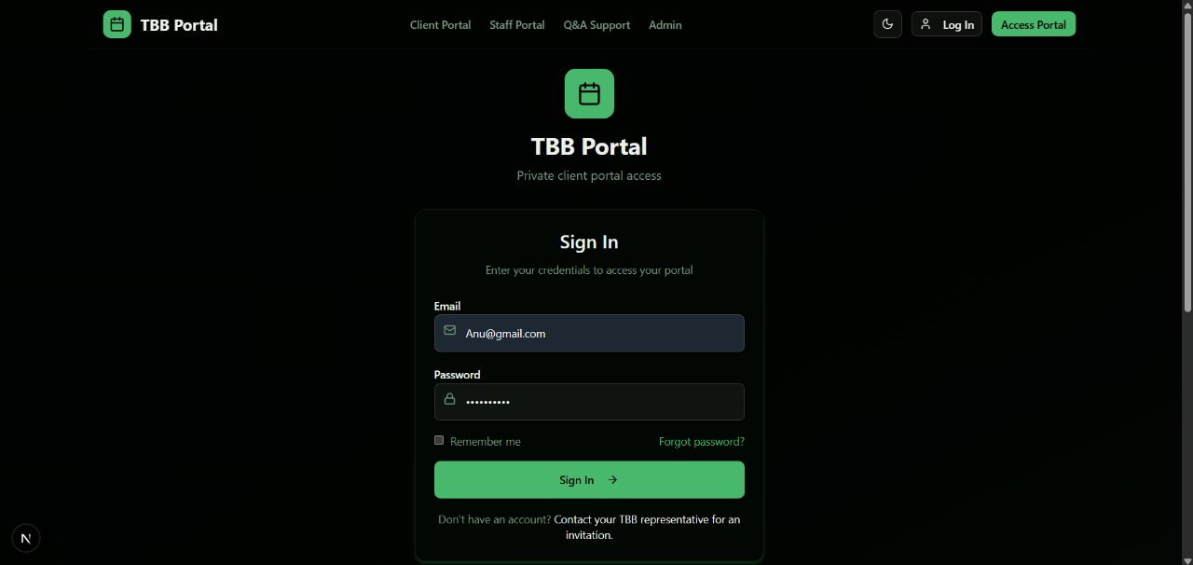
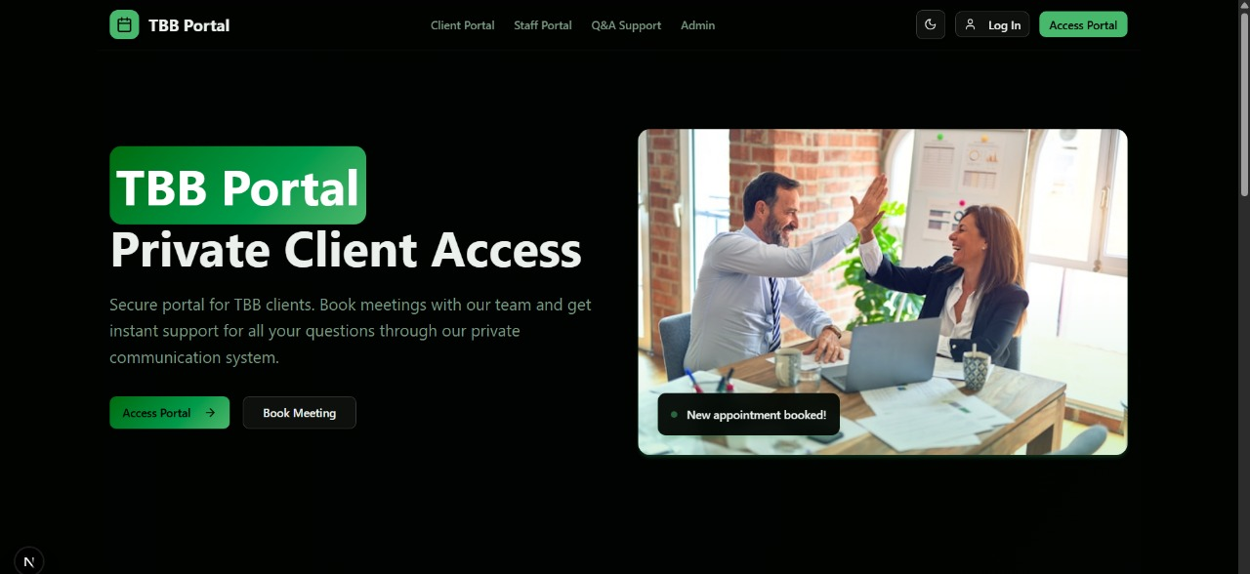

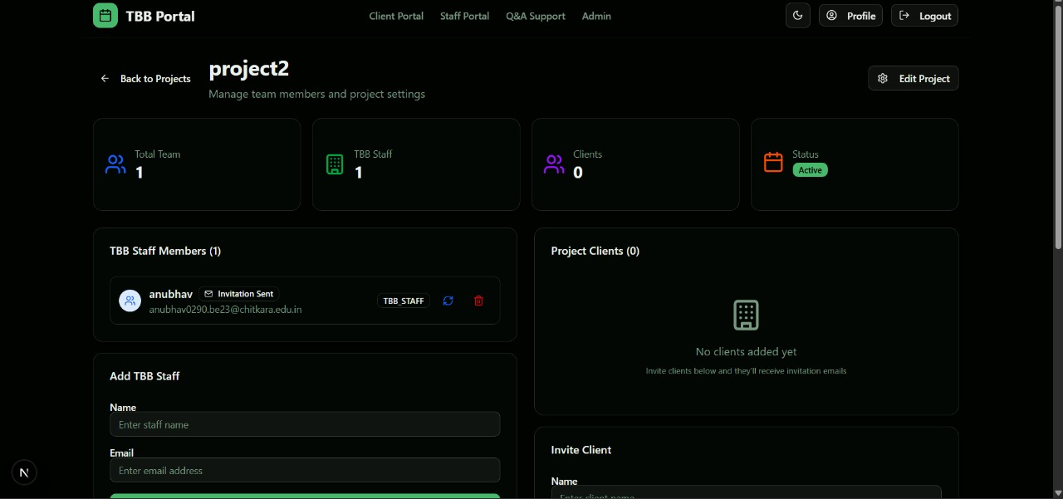

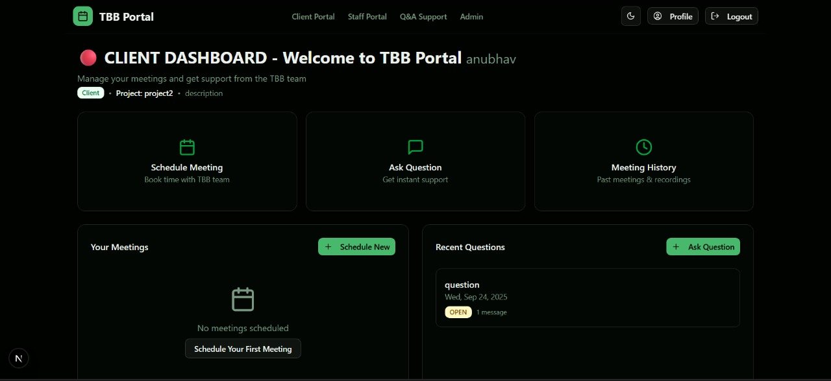

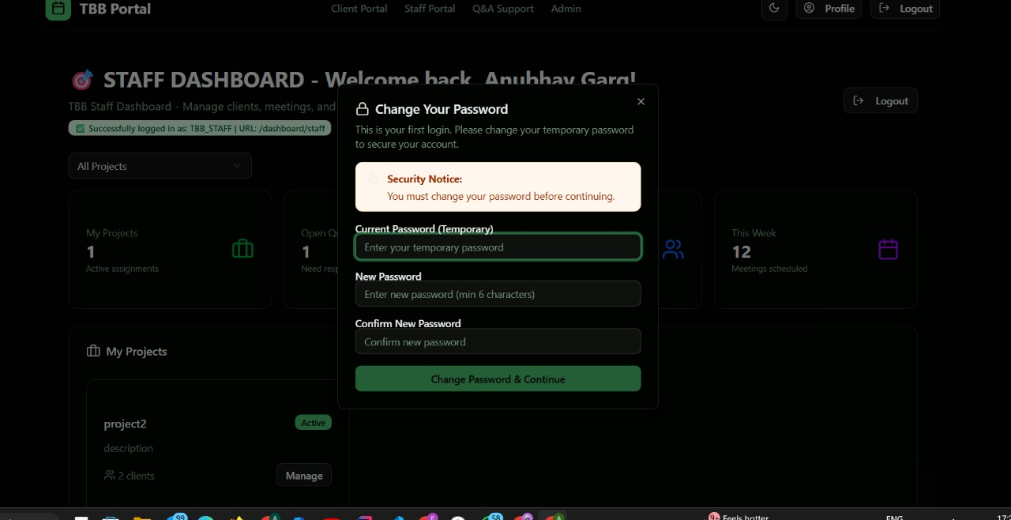
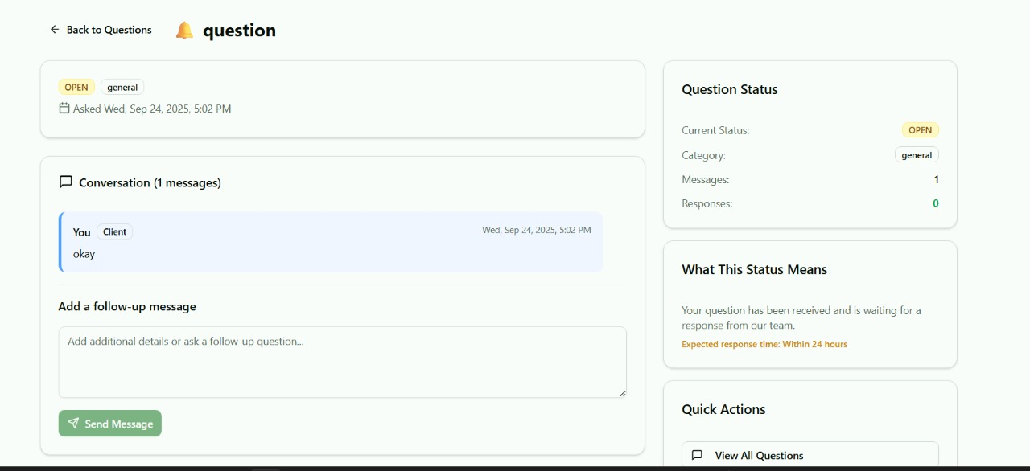

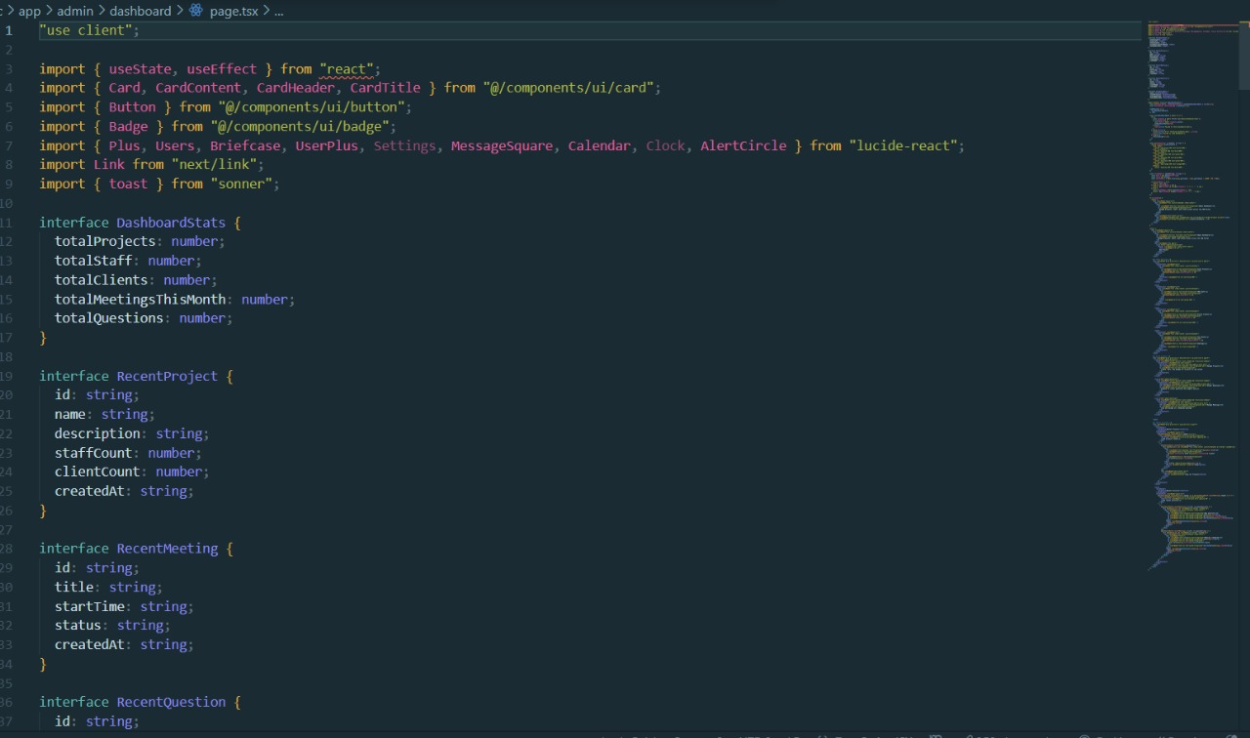

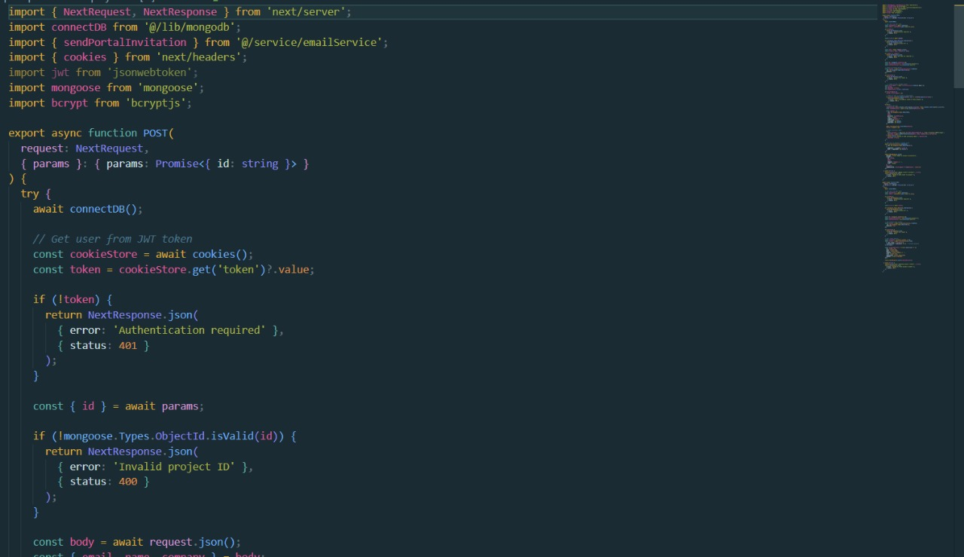

References:

Official Documentation: Documentation for libraries, frameworks, and tools used in the project, as well as APIs or services integrated.
Tutorials and Guides: Online tutorials, guides, blog posts, and educational videos that provided assistance or insights during development.
Code Repositories: GitHub repositories or other code repositories where code snippets, examples, or inspiration were found.

Forums and Communities: Online forums, such as Stack Overflow or Reddit, and developer communities where questions were asked, advice was sought, or discussions were participated in.

Personal Communication: Mentors, peers who provided guidance, feedback, or support during development.

