# Sales Representative Management System

The Sales Representative Management System is designed as a **scalable, maintainable full-stack web application** to manage sales representatives across multiple platforms efficiently. It follows a **layered architecture** ensuring separation of concerns, maintainability, and security.

**Tech Stack:**

* **Backend:** .NET 8 Web API
* **Database & ORM:** SQL Server + Entity Framework Core (Code-First Approach)
* **Frontend:** Angular (Version 19)

## **Architectural Layers**

The application follows a three-tier architecture, separating concerns into distinct layers:

| **Layer** | **Description** |
| --- | --- |
| **Presentation Layer (Angular)** | Provides an intuitive and dynamic UI using Angular's component-based architecture. |
| **Business Logic Layer (Controller, Services in .NET)** | Handles core logic, validation, and interaction with the database through services and repository. |
| **Data Access Layer (Entity Framework Core)** | Manages database interaction through repository patterns and data models. |

## **Design Choices & Reasoning**

**.NET 8 for Backend**

* High performance and efficiency with minimal API support.
* Strong type safety and robust exception handling.
* Seamless integration with SQL Server and Entity Framework Core.
* Global Exception Handler

**Entity Framework Core - Code-First Approach**

* Provides flexibility in defining models without needing database-first schema definitions.
* Supports migrations, enabling incremental changes to the database.
* Improves maintainability by using Models and Repository Patterns.

**Angular 19 for Frontend**

* Component-based architecture for modularity.
* Bootstrap CSS framework for responsiveness.

**Repository Pattern –**

Implemented to ensure a clear separation between the **business logic layer** and the **data access layer**, promoting modularity, maintainability, and scalability.

**Authentication with JWT-**

* Ensures secure token-based authentication for API access.
* Allows easy integration with role-based authorization mechanisms.

**Security Features in Sales Representative Management System-**

To ensure data protection and system integrity, the Sales Representative Management System incorporates various security measures.

**1. Authentication & Authorization**

* **JWT-Based Authentication:** Uses JSON Web Tokens (JWT) for secure login and session management.
* **Role-Based Access Control (RBAC):** Ensures users can only access authorized features based on their assigned role (Admin, Manager, Sales Rep).

**2. Secure API Communication**

* **HTTPS Enforcement:** All API interactions occur over **SSL/TLS** to protect sensitive data.
* **CORS Configuration:** Allows only requests from the Angular UI to prevent unauthorized cross-origin access.

**3. Data Protection & Encryption**

* **Password Hashing**

**4. Secure Database Practices**

* **Parameterized Queries:** Prevents SQL Injection attacks.
* **Access Controls:** Limits database privileges to necessary roles to prevent unauthorized modifications.

**5. API Security Measures**

* **Rate Limiting & Throttling:** Prevents API abuse by restricting excessive requests from a single source.
* **Logging & Monitoring:** Used serilog and ILogger to Implements centralized logging for tracking suspicious activities.

**6. Input Validation**

* **Input Validation & Sanitization**

**7. Exception Handling**

Refer the below screenshot of Sales Representative Listing Page-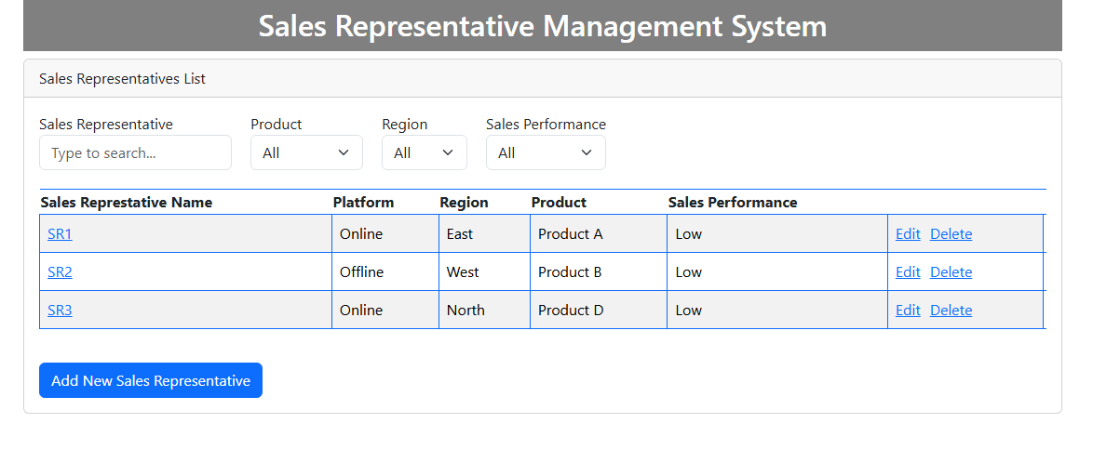

**Functionality Implemented -**

**Add –** Enables users to input and save details for new sales representatives.

**Delete –** Provides the option to remove sales representative records from the system.

**Edit –** Allows users to update or modify existing sales representative information.

**Search –** Facilitates quick lookup of sales representatives by name.

**Filters –** Allows users to refine data based on product, region, and sales performance criteria.