

**MINOR PROJECT - I**

Project Synopsis

## Topic: Video Script Summarizer

**Submitted to:**

Dr. Archana Purwar

Dr. Prakash Kumar

**Submitted by:**

Shivi Singh - 22103243

Anshika Agarwal – 22103245

Suyash Saraswat – 22103261

**Abstract:** The Machine Learning-Based Video-to-Text Summarizer is an innovative solution designed to streamline the process of extracting key information from video content. Using advanced machine learning algorithms, this tool automatically transcribes the audio from a video into text and subsequently condenses that text into a concise summary. It is particularly beneficial for users who need to quickly grasp the main points of lengthy video content without having to watch the entire video.

This project enhances both accessibility and efficiency in various contexts, including education, media, corporate training, and content review. For instance, educators and students can quickly access critical information from lecture videos, while media professionals can analyze long-form content more efficiently. Additionally, businesses can use the tool to summarize meetings, presentations, or training videos, enabling employees to access important details in less time.

By converting video audio into a brief, digestible text format, this tool significantly reduces the time required to gather information, providing users with a faster, more convenient way to consume content. It addresses the growing demand for time-efficient solutions in today’s fast-paced digital environment.

**Objective:** To develop a machine learning-based application that converts video audio to text and generates a meaningful summary, thereby facilitating efficient information extraction and improving user productivity.

**Scope:**

* Automate transcription and summarization of video content.
* Provide concise and relevant summaries for quick information access.
* Support various video types and content domains.

**Technology Stack:**

* **Frontend:** HTML, CSS, JavaScript
* **Backend:** Python(Flask Framework)
* **Machine Learning Libraries:** TensorFlow, PyTorch, Hugging Face Transformers
* **Speech-to-Text API:** Google Cloud Speech-to-Text or AssemblyAI
* **Text Summarization:** Pre-trained NLP models (e.g., BERT, GPT)
* **Database:** MySQL
* **Deployment:** GitHub Pages (Frontend)

**Functionalities:**

1. **Video Input:**
   * Upload videos via file upload or URL input.
2. **Audio Extraction:**
   * Extract audio from the video for further processing.
3. **Speech-to-Text Conversion:**
   * Use machine learning models to transcribe audio into text.
4. **Text Summarization:**
   * Apply NLP techniques to summarize the transcribed text.
5. **Summary Display:**
   * Present the summarized text in a user-friendly interface.
6. **Download Option:**
   * Allow users to download the summarized text for offline access.
7. **Mobile Responsiveness:**
   * Ensure the application is accessible and functional on both desktop and mobile devices.

**Flow chart**

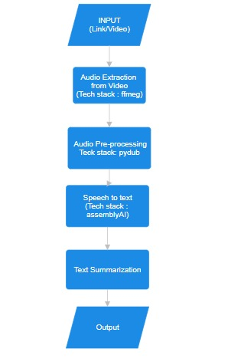

**Modules:**

1. **Input Module:** Handles video uploads and URL input.
2. **Audio Processing Module:** Extracts and processes audio from video files.
3. **Speech-to-Text Module:** Converts audio to text using machine learning models.
4. **Summarization Module:** Generates summaries from the transcribed text using advanced NLP techniques.
5. **Output Module:** Displays the summary and provides download options.
6. **Database Module:** Stores summaries for future reference.

**Future Enhancements:**

* Enhancing the model’s capability to handle multiple language.
* Incorporating real-time summarization for live video streams.
* Adding sentiment analysis to provide additional context to summaries.

**Conclusion:** The Machine Learning-Based Video-to-Text Summarizer will streamline the process of extracting and summarizing information from videos, offering users a more efficient way to access key content. By employing state-of-the-art machine learning techniques, this tool aims to improve the accessibility and usability of video media.