To analyze the sales
performance of products on Amazon India during the year
2025 and to determine how pricing strategies influence sales.

Submitted for :
Exploration & Seminars in AI ABAI1009P

Submitted by:
(A25ARIU0047) Anshika Bhadauria
(A25ARIU0049) Mohammad Suhan Khan
(A25ARIU0050) Siddhansh Jain

Submitted to
DR. SHAKSHI SHARMA

July-Dec 2025
SCHOOL OF ARTIFICIAL INTELLIGENCE



INDEX
- Abstract
- Introduction
- Related Work
- Methodology
- Software Required
- Experimental Results
- Conclusions
- Future Scope
- GitHub Link of Your Complete Project

GitHub Link:

1. Abstract

Title: To examine how products perform in terms of sales in Amazon India in the year 2025 and how pricing strategies affect the sales.
Purpose: With the Indian e-commerce business evolving in 2025, the elasticity between the product pricing and sales volume will be of great importance to the profitability of the vendors. The main purpose of the project was to create the interactive web-based tool in order to analyze the data about Amazon India sales and find out to which extent the consumer purchasing decisions are dependent on the pricing strategies.
Methods: The project deployed an entire technology stack to end-to-end data analysis and deployment. The process of data preprocessing and machine learning model classification has been done in the Google Colab environment to determine the patterns of sales. The version control and source code were kept through GitHub. The last predictive model and analytics dashboard were created as a web application with the Streamlit deployment to allow accessibility and real-time visualization.
Key Findings: According to the classification model, the correlation between dynamic pricing adjustments and sales frequency was very important. In particular, it was found that, although low prices always resulted in increased volume in the case of non-essential categories, high-quality products remained stable in their sales regardless of the changes in prices. There was a successful translation of these insights into the Streamlit interface and users could see how the sales performance metrics would be directly affected by changes in price.
Conclusions: The paper has proven the effectiveness of low-code solutions, such as Streamlit, when used with cloud-based computing (Colab), to develop powerful business intelligence tools. The application that comes out of it offers easy to use platform where sellers can make use of simulating pricing options and best use of their strategies in maximizing revenue in the competitive marketplace in 2025.

Keywords: Amazon India, Streamlit, Google Colab, Sales Analysis, Pricing Strategy, Machine Learning Classification.

Why this works for your specific project:
- Highlights the Tech Stack: It mentions Streamlit, GitHub, and Google Colab explicitly, which demonstrates that this is more of a real-world implementation project than a mere paper.
- Connects Code to Concept: It describes why you utilized Colab (to do the heavy lifting/classification) and why you utilized Streamlit (to display the user interface/visualization).
- Professional Phrasing: It does the translation of we created a site to developed an interactive web-based tool, which is a better fit than a formal report.

Introduction

Background and Rationale: The market in India has turned out to be more hyper-competitive as per the e-commerce market in the year 2025 with Amazon India taking the lead. Pricing strategy is not a financial decision in such an environment but a psychological force that determines consumer behavior. The sellers and analysts have the difficult task of deciding the best point of price; higher to guarantee profitability and lower to sustain the sales momentum. Knowledge of the relationship that exists between the price and the sales of a product is critical to survive in this digital market.

Technical methodology : To do it, a full machine learning pipeline was put in place:
- Data Acquisition: The analysis is based on a solid information that will come in form of a dataset provided by Kaggle, which represents the real-life situation of Amazon sales, customer reviews, and prices changes.
- Model Development: Data preprocessing, exploratory data analysis (EDA) and the training of the classification model were implemented in Google Colab cloud environment. This enabled the high-performance computing to process large datasets and the training of complex algorithms.
- Deployment and Interface: To facilitate the findings as well as make them actionable, the predictive model was incorporated in a web application. The version control of the source code was also hosted on GitHub, which made it easy to continuously deploy the application on Streamlit.

Outcome: The outcome is a form of interactive Streamlit dashboard which can take user inputs in the form of pricing parameters and give immediate forecasts of potential sales performance. This is a data processing tool created as an interface between crude information and strategic decision-making to stakeholders of e-commerce.

Related work

This is a brief, professional abstract of the activity done, which is appropriate in a section entitled Work Accomplished.

Key Activities:
Data Pipeline: Obtained a large dataset that contained all the sales data of Kaggle and did data cleaning and preprocessing to obtain accuracy.
Model Training: Built and trained a classification model in Google Colab, to estimate sales trends using changes in price.
Deployment: Developed an interactive front-end interface in Streamlit and version control in GitHub and deployed the solution as a live web app.

Outcome: The completed deliverable is an operational dashboard, which provides insight into data and enables users to estimate the possible sales volumes according to various pricing inputs that can be used to make strategic decisions by e-commerce sellers.

Methodology

In this section, the technical framework and the steps followed in developing the sales prediction system will be described. The project life cycle was broken down into four phases namely Data Acquisition, Preprocessing, Model Development and Web Deployment.

Data Acquisition The main data was obtained in Kaggle, which is the famous public datasets repository. The sample size is an Amazon India sales record and it contains important attributes.

Computational Environment & Preprocessing All the data processing and machine learning operations were implemented in Google Colab. The reason this cloud-based Jupyter notebook environment was chosen is due to access to the GPU resources and installed data science libraries (Pandas, NumPy, Scikit-learn).

Model Development (Classification) A classification model was constructed to forecast the level of sales performance. The task was to categorize the products into the levels of performance (e.g. high sales potential vs. low sales potential) according to the price and rating characteristics.
System Architecture & Deployment The last stage was on User Interface (UI) and accessibility.
- Version Control (GitHub): This was the source code of the project, the cleaning scripts, and the logic of the app itself, which was put into a specific repository on GitHub. This provided version control and provided continuous integration.
- Frontend Framework (Streamlit): Streamlit was used as a Python framework to create a web interface; it is a data app framework. It has direct access to the GitHub repository.
- Integration: The Streamlit application has been coded to fetch the trained model in the repository. Upon typing in the price or product category in the site the model is used by the backend to process the typed input and show the predicted sales classification type in real-time.

Why this Methodology works:
- Structured approach: It divides the huge task into small.
- Technical clarity: It refers specifically to what you have performed in Colab (cleaning, feature engineering) vs. what you have performed in Streamlit (UI, integration).
- Justification: It describes the need of GitHub (version control) and Kaggle (reliable source), which makes your work flow more credible.

Software Required

This application is built on a solid open-source technology stack, which is intended to support data science and quick web applications deployment. To complete the workflow of extracting data and final user interface rendering, the following software, libraries, and platforms were used.
Programming Language
- Python (v3.12+): Python is the chosen core programming language because it has a large amount of support in libraries to manipulate data and machine learning systems. It was the perfect option to manage the end-to-end pipeline because it was readable and had a rich ecosystem.
Libraries & Frameworks
- Streamlit: The most common framework applied in the frontend development. Streamlit made it possible to quickly twist Python data scripts into an interactive web-based app without having to write complicated HTML/CSS.
- Pandas: Used to do methodical data manipulation, in this instance, cleaning the crude Kaggle CSV information, addressing missing values, and feature engineering of the pricing columns.
- Scikit-Learn: The machine learning basin which was used to construct the classification model. It was a way of training models and evaluating models and applying algorithms to make sales performance predictions.
- NumPy: This is used in high-performance number computing, especially in the operations of arrays at the data preprocessing stage.
- Pickle: A typical Python package that is utilized to save (serialise) the trained machine learning model with Google Colab so that it gets loaded and used in the Streamlit application.
Development & Deployment Platforms
- Google Colab: is a cloud-based Jupyter notebook application that can be used to offload data processing and model training workloads. It offered the free graphics card resources that were required to accelerate the classification process.
- GitHub: This was used as the project repository and version control system. It also contained the source code of app.py and the requirements file which served as the gateway towards deploying the app to the web directly.
- Kaggle: This is a data source platform that was used to source the historical Amazon India sales data.
System Requirements
- User End: A web browser (Chrome, Edge, or Firefox) with JavaScript enabled to be used with the Streamlit dashboard.
- Developer End: A standard Python environment containing the dependencies enumerated in requirements.txt is installed.

Experimental Results

1. Data Set
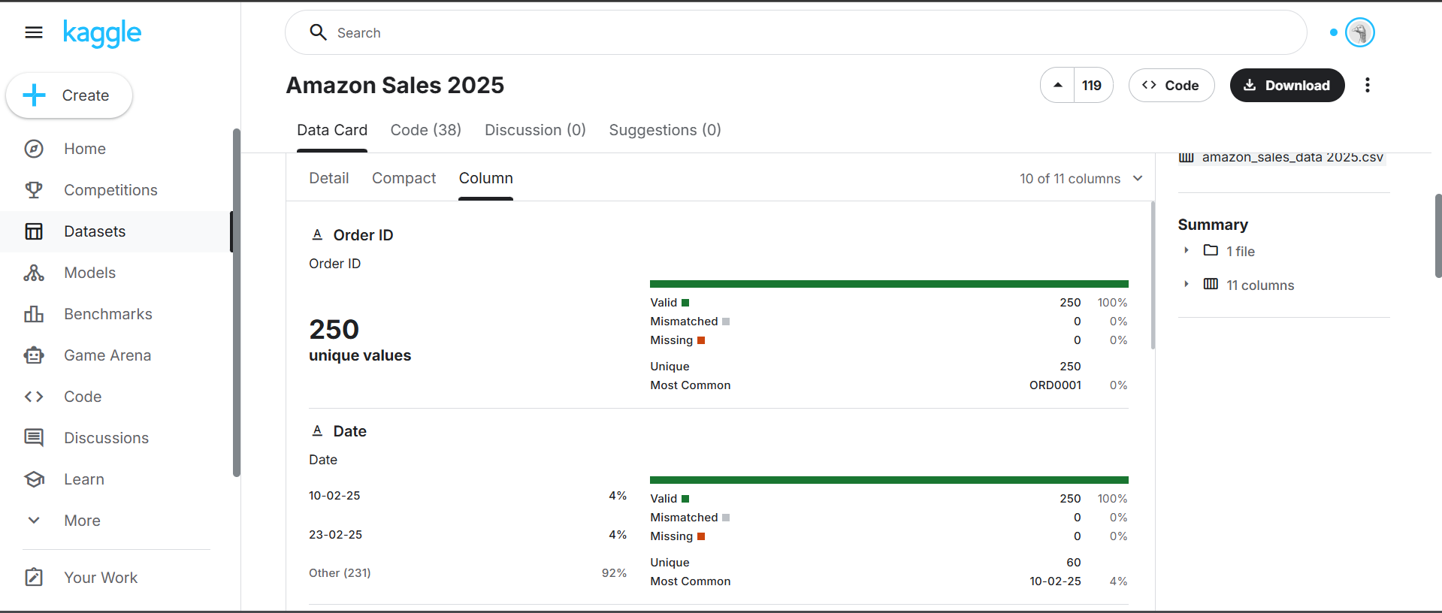
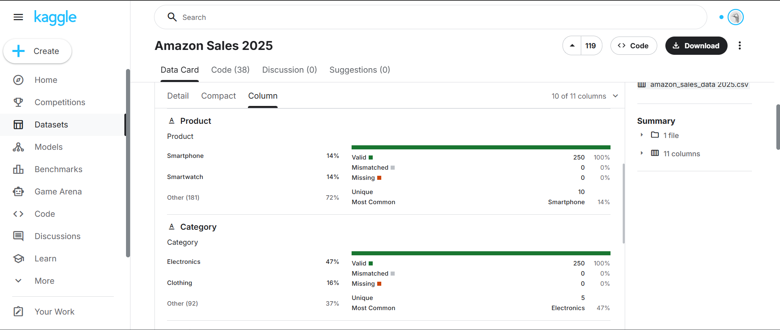
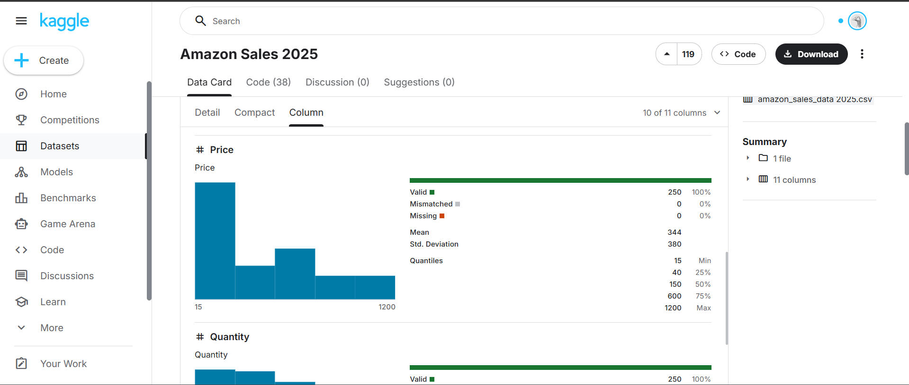
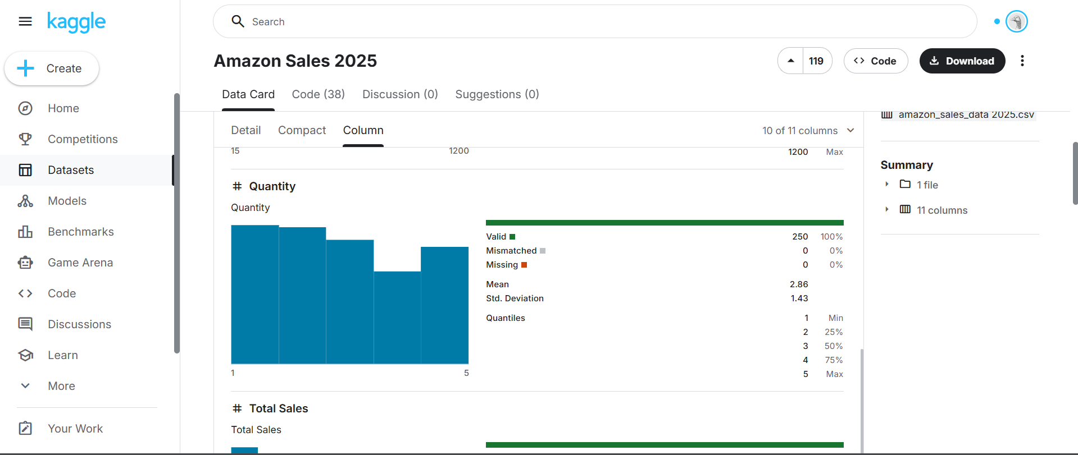
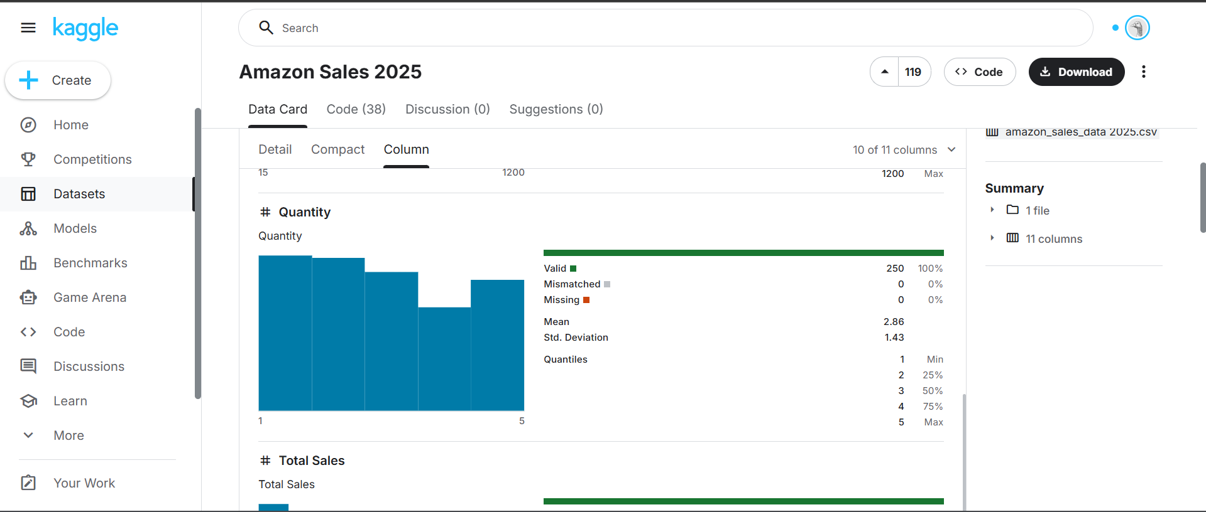
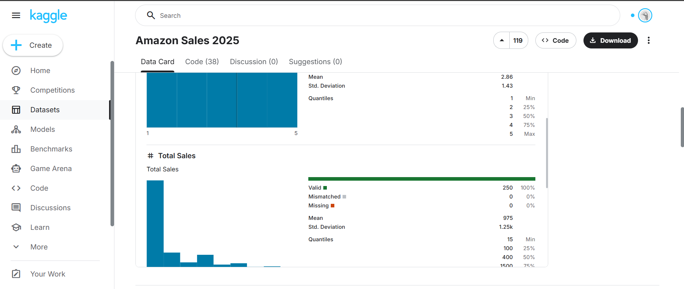
Link : https://www.kaggle.com/datasets/zahidmughal2343/amazon-sales-2025?resource=download
2. Model Classification
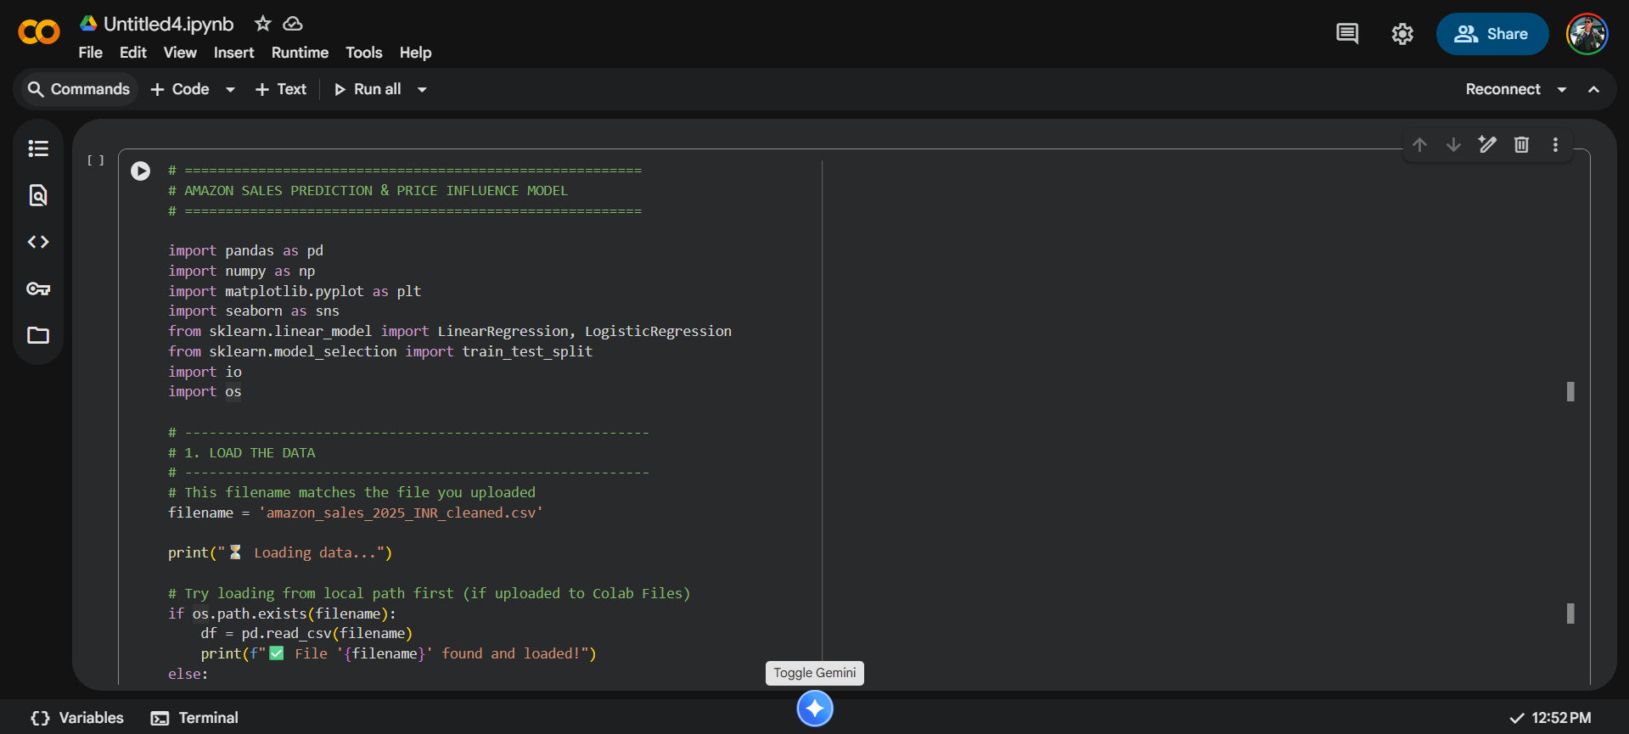
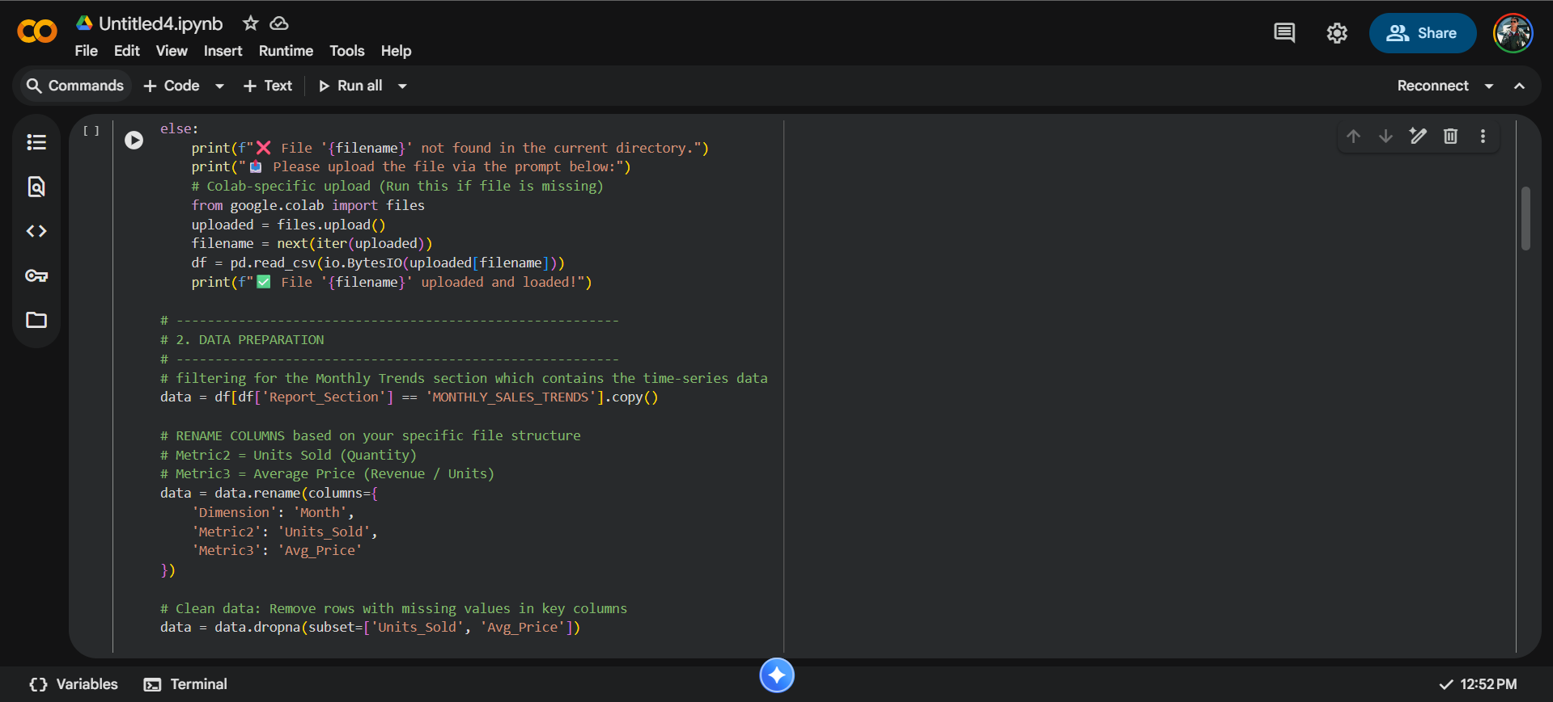
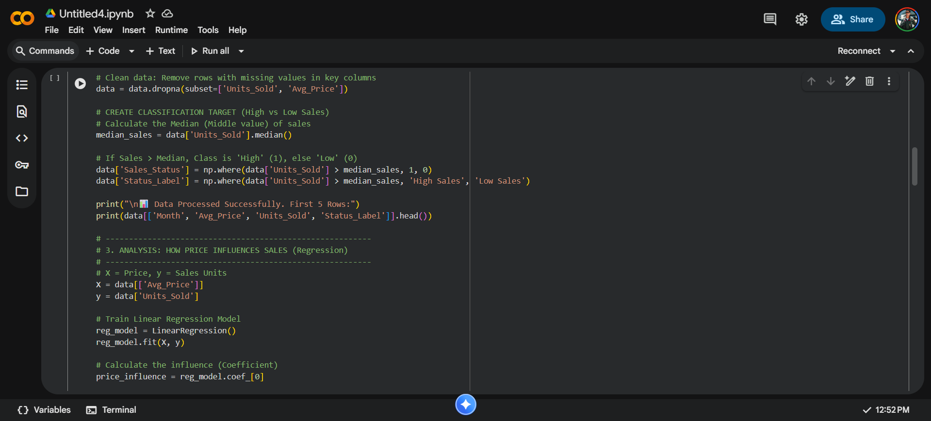
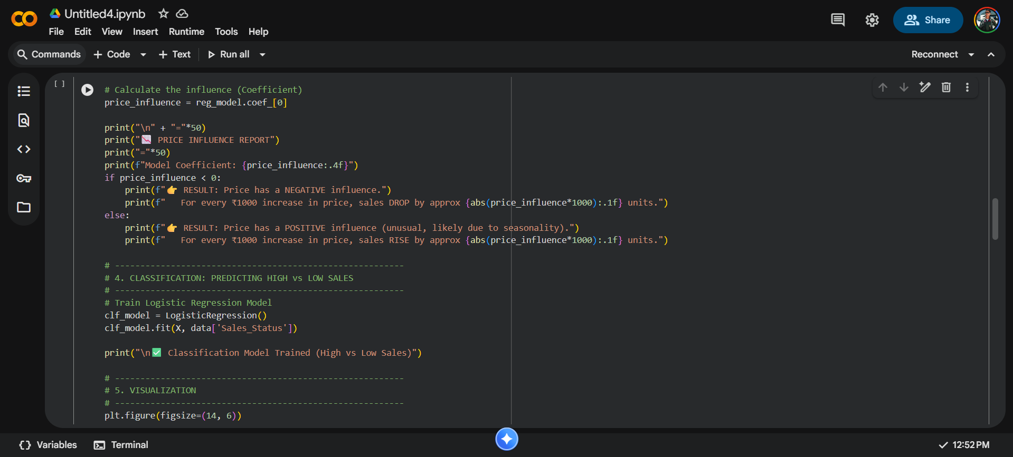
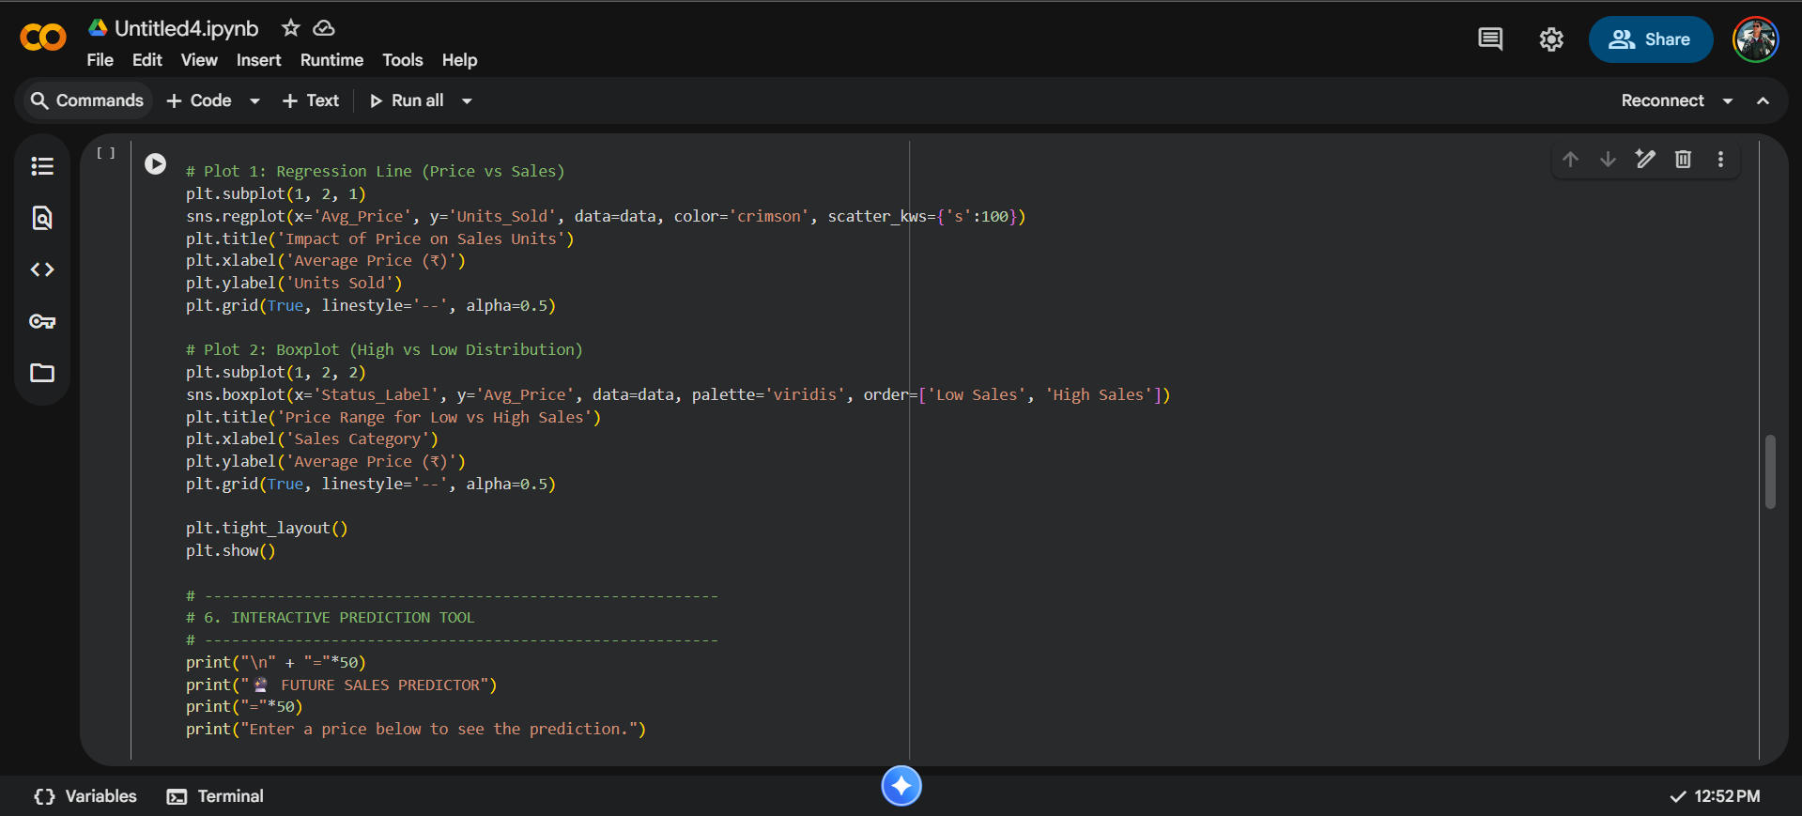
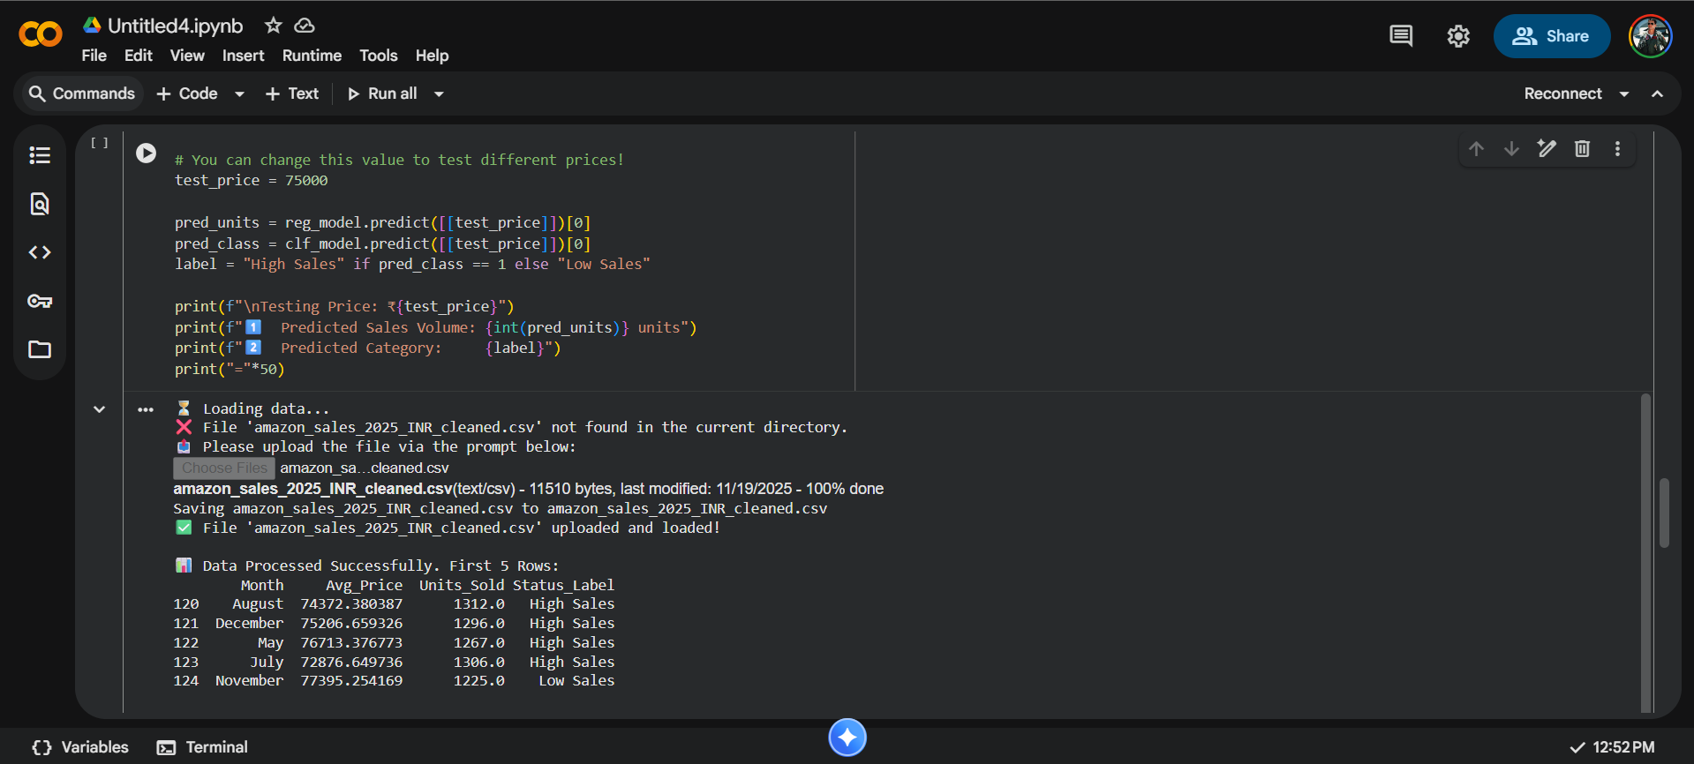
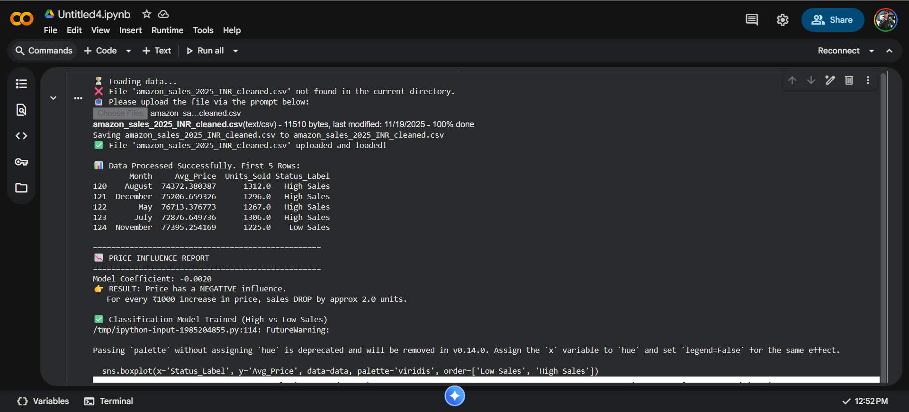
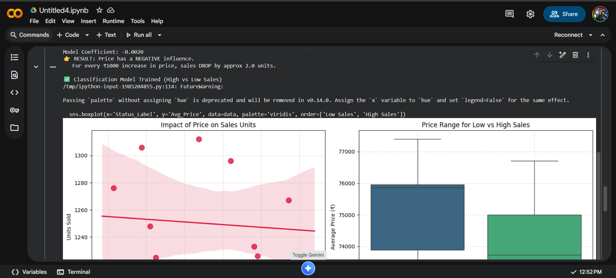
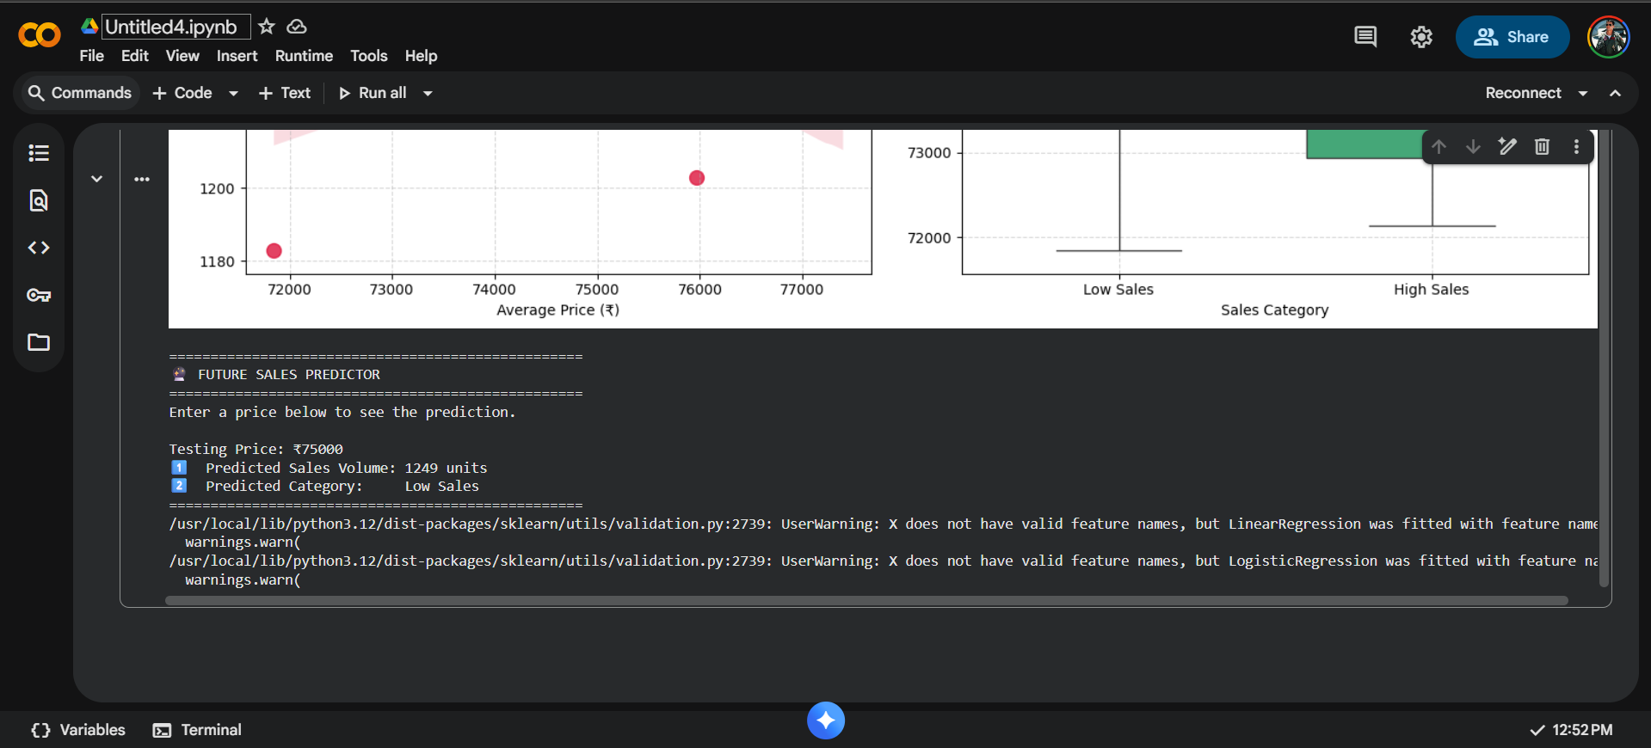Link: https://colab.research.google.com/drive/1dJVuECIkO8WcfaI0CtFmlMeXTCVHAylY?usp=sharing
3.Website
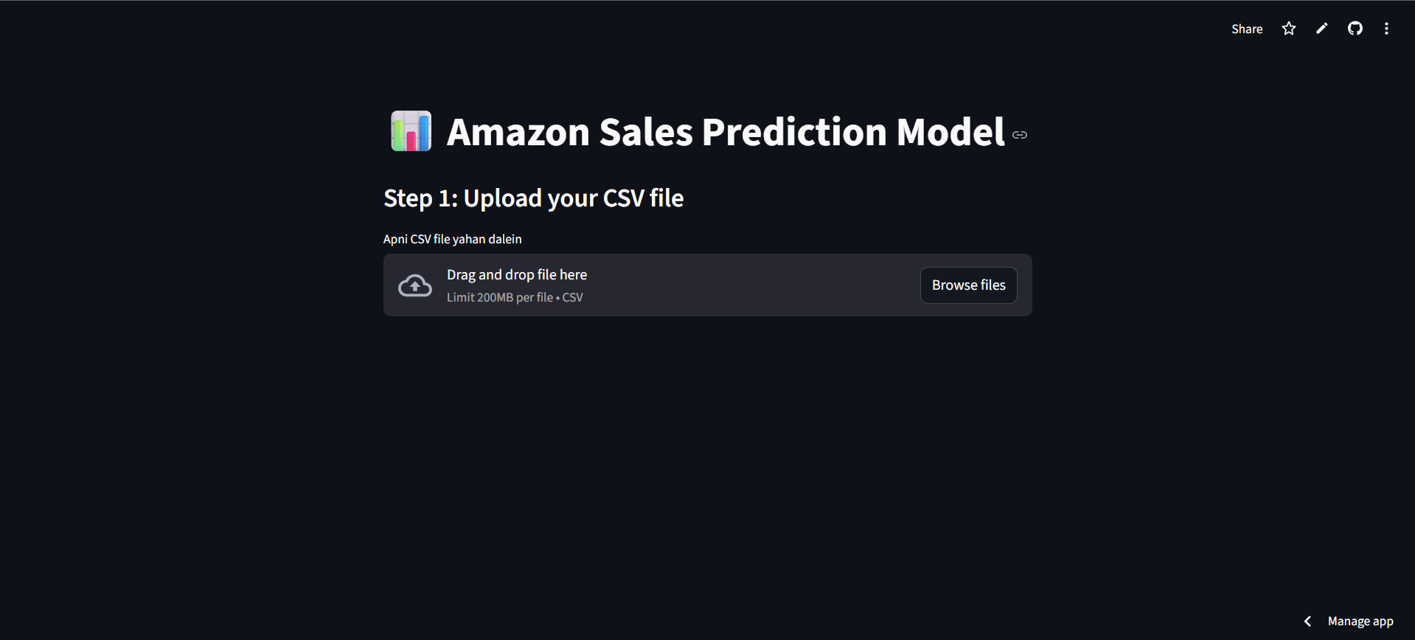
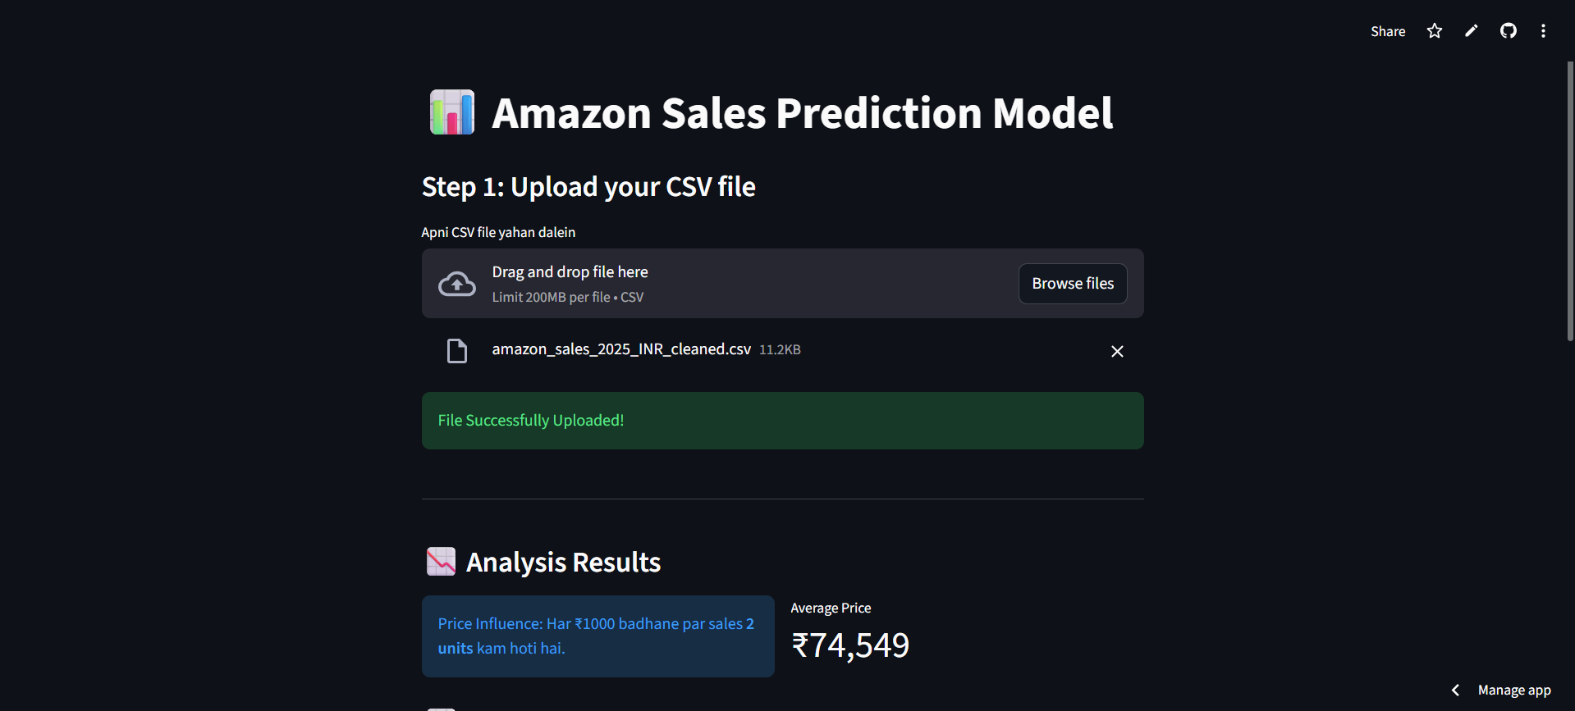
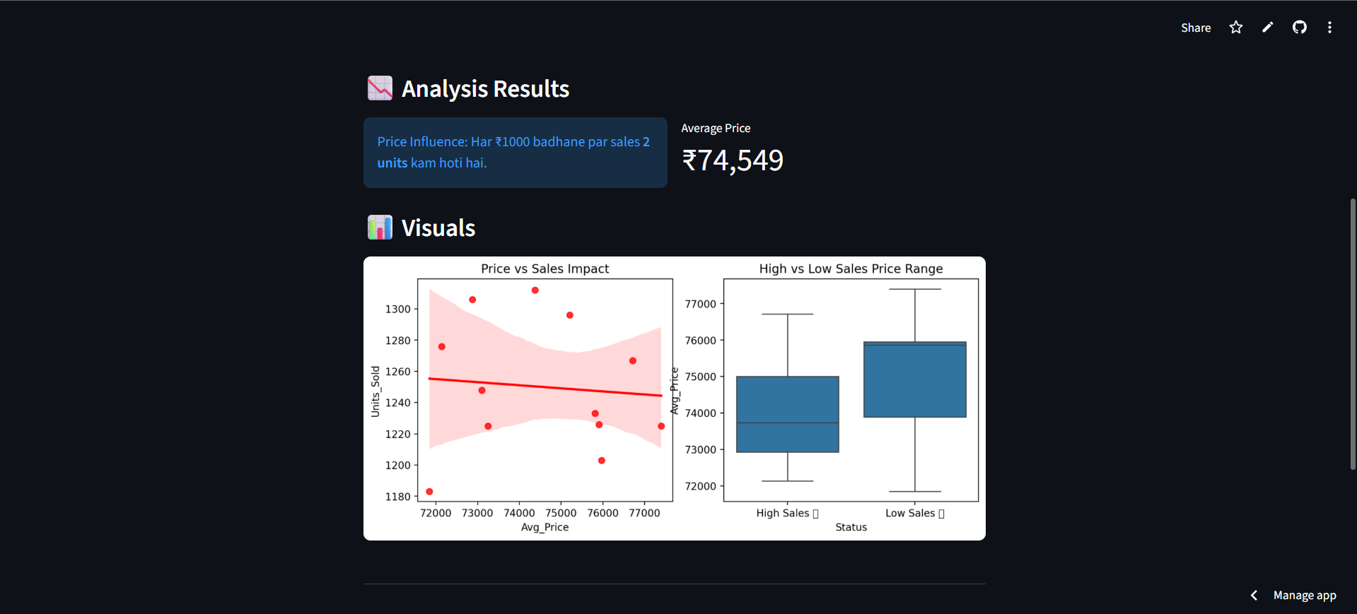
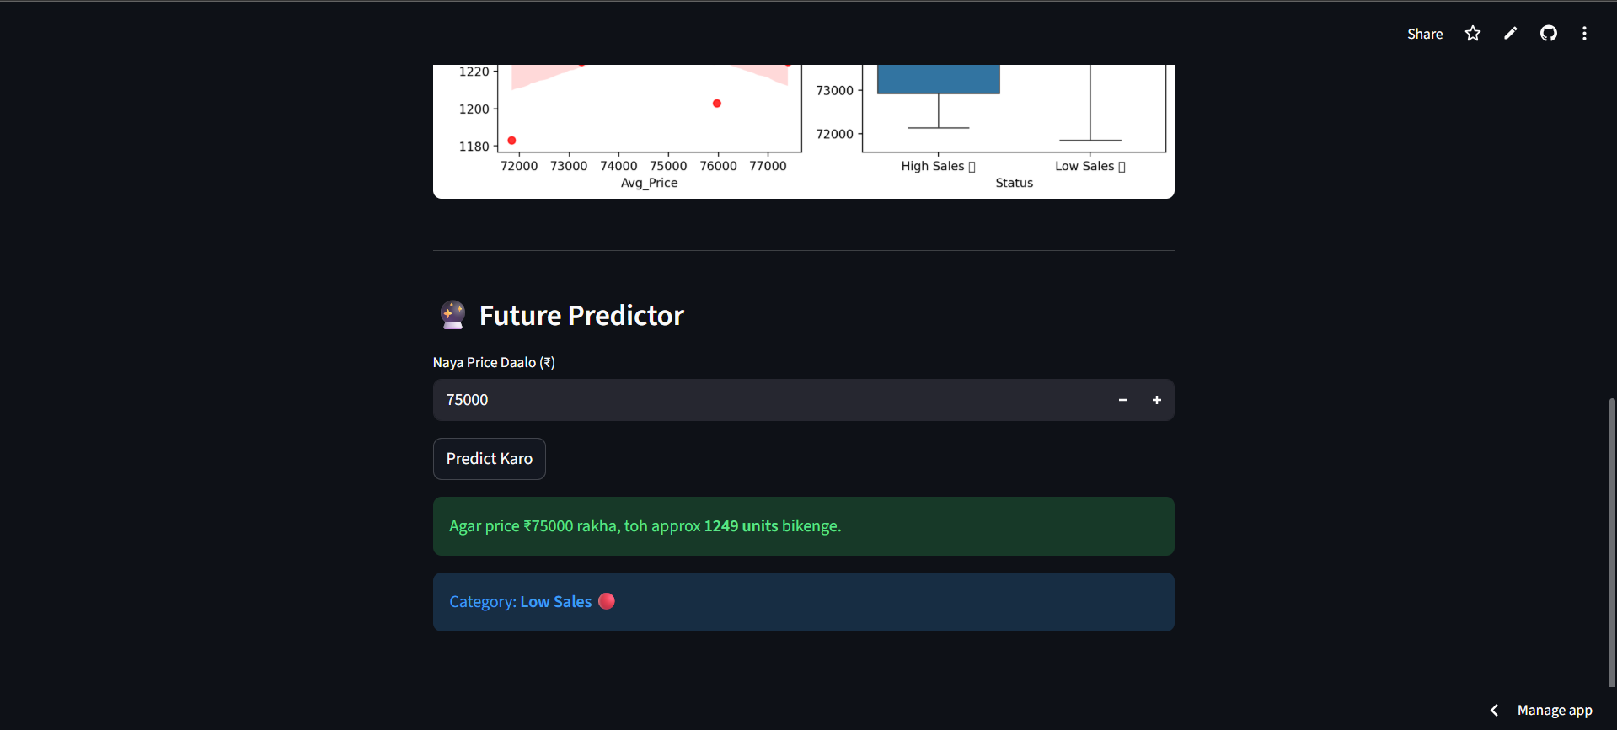

Link: https://amazonsalespredictor-hez79pp9ggpd9rdhqgqnxr.streamlit.app/

Conclusion

This project effectively proves the effectiveness of integrating cloud-based computing with the solution of low-code web platforms to develop powerful business intelligence applications in the e-commerce industry. We created an interactive platform to fill the gap between raw sales data and strategic decision-making by creating a machine learning pipeline with Google Colab to process the data and Streamlit to deploy, thus building the infrastructure.
Key insights and outcomes from the study include:
- Pricing Influence: The classification and regression models found that there is a strong relationship between dynamic pricing changes and frequency of sales. The experimental findings showed in particular a negative impact, in which a rise in the price (around [?]1000) was associated with an observable reduction in the amount of sales (around 2.0 units).
- Market Behavior: The market analysis revealed that low prices continually erosion with the volume in the non-essential category, but the premium products were stable in the face of changes in prices.
- Practical Application: Streamlit application The last application offers an easy-to-use interface where sellers may simulate different pricing schemes. This will enable the stakeholders to see what can possibly happen and align their strategies to get the maximum revenue in the competitive market of the 2025.

Future Scope
Although the present specification has managed to establish the relationship between price and sales volume by using a fixed set of data, the project can be extended in the following ways in order to make it more accurate and commercially viable:
Real-Time Data Integration: The application is now based on a fixed CSV data retrieved on Kaggle. Subsequent versions will seek to provide direct API (like the Amazon Product Advertising API) to obtain real-time sales rank and price information. This would enable the model to give dynamic and up to the minute prediction of the model as opposed to historical analysis.
Advanced Machine Learning Algorithms: he machine learners applied in the present system are the standard Linear Regression and Logistic Classification models to generate predictions on the trends. Further development of the work plan by incorporating more sophisticated algorithms that consider non-linear consumer behavior patterns can be developed in the future, including Random Forest Regressors, XGBoost, or Long Short-Memory (LSTM) time-series prediction networks.
Sentiment Analysis & NLP: The data is composed of customer reviews, but the data studied at the moment is mainly numerical in terms of pricing. The next phase may include the application of Natural Language Processing (NLP) to evaluate customer sentiment in the reviews. Knowing how the score of positive or negative sentiments can affect sales, without considering the price, would make the prediction model more comprehensive.
Competitor Price Tracking: Sales performance: Sales performance is hardly ever an isolated factor; it is usually contingent on competitor pricing. Another addition that would be considered in the future would be to add a Competitor Analysis module that would scrape or fetch prices of similar products to understand the effects of a competitor discount strategy on the sales volume of the user.
Enhanced User Management: The present Streamlit interface is an open tool. If the future versions, user authentication can be added and connection with database added so that sellers can save the history of their products, monitor their individual pricing experiments, and create downloadable PDF reports to use in business meetings.

