Course- BTech | Type- Core
Course Code- CSET101 | Course Name- Computational Thinking and Programming
Year- 2023 | Semester- odd
Date- | Batch- ALL

Tutorial Assignment: 8 Solutions

Q1.Write a python program to find out all permutation of given string. Take input without any space.

from itertools import permutations
def allPermutations(str):
# Get all permutations of string 'ABC'
permList = permutations(str)
# print all permutations
for perm in list(permList):
#print(permList)
print (''.join(perm))
# Driver program
if __name__ == "__main__":
str = 'ABC'
allPermutations(str)

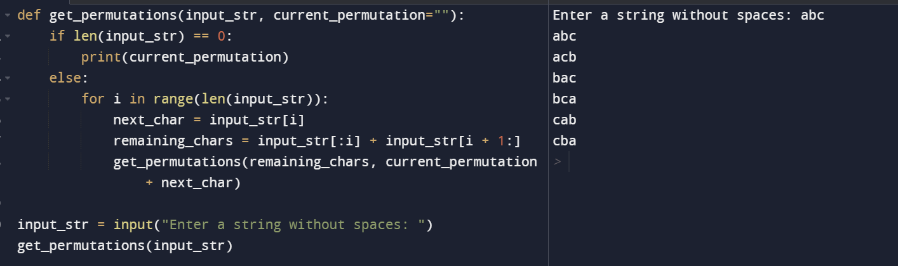

Q2.What is the output of given code-

def fun(**kwargs):
for key, value in kwargs.items():
print("%s == %s" % (key, value))
fun(a='bennett', b='university', c='greater noida')

output
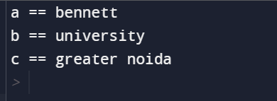

Q3.

def myAtoi(string):
res = 0
# Iterate through all characters of
# input string and update result
for i in range(len(string)):
res = res * 10 + (ord(string[i]) - ord('0'))
return res
string = "89789"
print(type(string))
print(string)
new_no = myAtoi(string)
print(type(new_no))
print(new_no)

Q4. What will be the output of the following code.
string1 = "python"
list_string = ["computer", "python", "prog"]

print(list_string [1] == string1)
print(list_string [1] is string1)

Output-

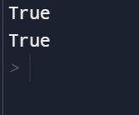

Q5. Predict the output of the following code:

string1 = "welcome tothe thetothe World of the Python the"
substring1 = "the"
print(string1.count(substring1, 15))

Output- 3

Q6. Predict the output of the following code:

string1 = 'Python'
print (string1[:2] + ' Programming')

Output- Py Programming

Q7. What will be the output of the following code?

string1 = 'Python'
string2 = 'Prog'
string3 = 2 * (string1 + string2)
print(string3)
if "onPr" in string3:
print("Python is cool")
else:
print("Python is tough")

Output-

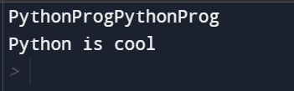

Q8. Find out the error in the following code

def display(*param):
for i in param:
print(i)

display(name="Aarav", age="15")

Output-
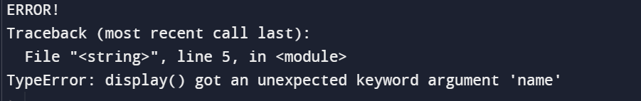

There should be double asterisk sign in the formal parameter

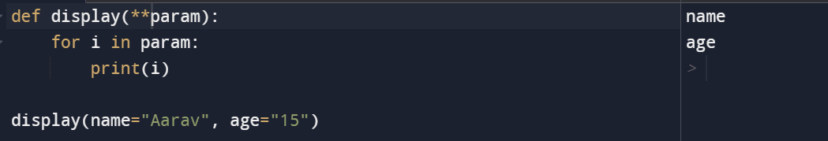

Q9. Find out the error in the following code:

def fn(x):
temp=100
return x + temp

fn(500)
print(temp)

Output-



temp is a local variable defined inside the function, so it is not accessible outside the function. To access it outside the function temp should be declared as global variable.
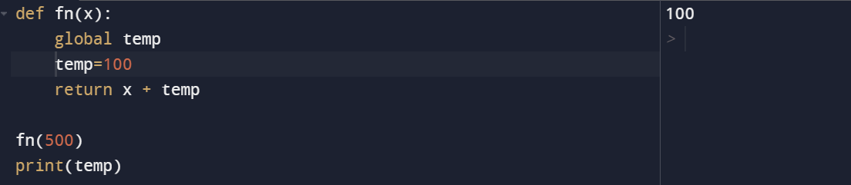

Q10. What will be the output of the following code?
output

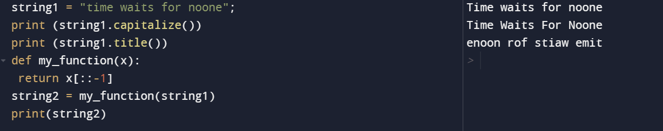

Q11. What will be the output of the following code? If there is any error, identify it.

string1="Bennett"
print(string1)
string2=ord(string1)
print(string2)

Output-
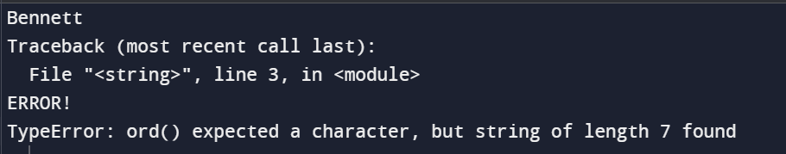

ord() function can take only a character as an input but here in the code string has been passed.

Q12. What will be the output of the following code?

def fn(name = "Dravid"):
print("My favourite cricketer is " + name)
fn("Sachin")
fn()
fn("Sehwag")

Output-
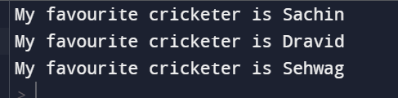

Q13. Predict the output of the following code.

def my_function(list1):
for i in list1:
print(i)
colors = [("red", '1'),("green", '2'),("orange",'3')]
my_function(colors)

Output-
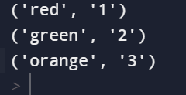

Q14. Predict the output of the following code:

string1 = 'pyython'
print(string1[::-1][::-5])
print(string1[::5])
print(string1[0] + string1[-1])
print(string1[::-1][-1] + string1[len(string1)-1])
print(string1[::-5])

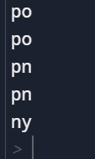

Q15. Predict the outcome of the following:

(A)
name = 'Nina'
pi = 3.14
food = 'pie'
message = (
f"Hello, my name is {name}. "
f"I can calculate pi to two places: {pi:4.3}. "
f"But I would rather be eating {food}.")
output
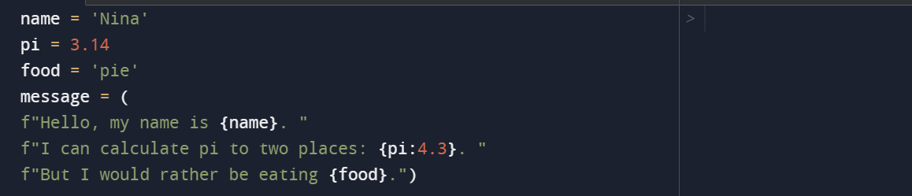

B)

Q16. Predict the outcome of the following:

def vowel(text):
vowels = "aeiuoAEIOU"
print(len([letter for letter in text if letter in vowels]))
print([letter for letter in text if letter in vowels])
vowel('Welcome India')

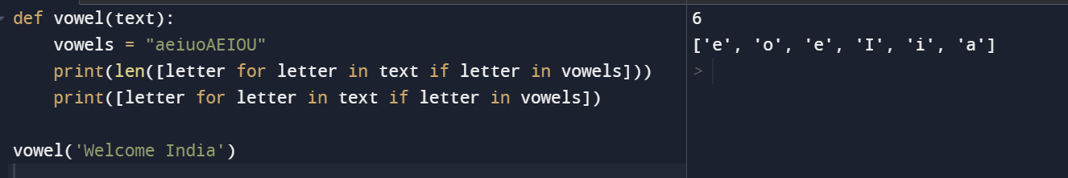

Q17. Predict the outcome of following:

n = 10
row = "*"
while n > 0:
print(" " * n + row)
row += "**"
n -= 1

*
***
*****
*******
*********
***********
*************

