**Contents**

1. Cover Page
2. List of Figures
3. Introduction
4. BackGround
5. Objectives
6. What are we Building ?
7. System Design
8. Implementation
9. Requirement Analysis
10. Scope and Applicability
11. Refrences

**Introduction**

A virtual assistant, also called an AI assistant or digital assistant, is an application program that understands natural language voice commands and completes tasks for the user.

We all know what is Virtual Assistant. If you don’t, don’t worry, open your mobile and say “Ok Google” or “Hey Siri”. Well, Google Assistant, Siri, Alexa all these are example of Virtual Assistant.

In today’s era almost all tasks are digitalized. We have Smartphone in hands and it is nothing less than having world at your finger tips. These days we aren’t even using fingers. We just speak of the task and it is done. There exist systems where we can say Text Dad, “I’ll be late today.” And the text/mail is sent. That is the task of a Virtual Assistant. It also supports specialized task such as booking a flight, or finding cheapest book online from various e-commerce sites and then providing an interface to book an order are helping automate search, discovery and online order operations.

**Background**

There already exist a number of desktop virtual assistants. A few examples of current virtual assistants available in market are:-

**SIRI from Apple:**

SIRI is personal assistant software that interfaces with the user thru voice interface, recognizes commands and acts on them. It learns to adapt to user’s speech and thus improves voice recognition over time. It also tries to converse with the user when it does not identify the user request. It integrates with calendar, contacts and music library applications on the device and also integrates with GPS and camera on the device. It uses location, temporal, social and task based contexts, to personalize the agent behavior specifically to the user at a given point of time.

**ReQall:**

ReQall is personal assistant software that runs on smartphones running Apple iOS or Google Android operating system. It helps user to recall notes as well as tasks within a location and time context. It records user inputs and converts them into commands, and monitors current stack of user tasks to proactively suggest actions while considering any changes in the environment. It also presents information based on the context of the user, as well as filter information to the user based on its learned understanding of the priority of that information.

**Alexa from Amazon:**

Alexa can also control several smart devices using itself as a home automation system. Users are able to extend the Alexa capabilities by installing "skills" (additional functionality developed by third-party vendors, in other settings more commonly called apps) such as weather programs and audio features.

**Objectives**

The main of an intelligent virtual assistant is to answer questions that users may have. This may be done in a business environment, for example, on the business website, with a chat interface. On the mobile platform, the intelligent virtual assistant is available as a call-button operated service where a voice asks the user “What can I do for you?” and then responds to verbal input.

One of the main advantages of voice searches is their rapidity. In fact, voice is reputed to be four times faster than a written search: whereas we can write about 40 words per minute, we are capable of speaking around 150 during the same period of time15. In this respect, the ability of personal assistants to accurately recognize spoken words is a prerequisite for them to be adopted by consumers.

There is an increased overall awareness and a higher level of comfort demonstrated specifically by millennial consumers. In this ever-evolving digital world where speed, efficiency, and convenience are constantly being optimized, it’s clear that we are moving towards less screen interaction.

**What are we building?**

**Our virtual assistant will able to do the followings things-**

Weather forecasting, Update you with Covid-19 Cases, Stock Prices, Launch Virtual Mouse (as a thread via.,subprocess), Launch Windows Applications, Open Websites, send an e-mail, authorize you by face detection,play music tells you about almost everything you ask through searching wikipedia, tells you about date and time, greetings, news, etc.

*You can interact with your laptop’s microphone/console. The response generated by the assistant will display on the console or as a speech via the speaker.*

**Table of Figures**

1. **mic_input()**
2. **text2speech()**
3. **shutdown()**
4. **website_opener()**
5. **send_mail()**
6. **tell_me_date()**
7. **tell_me_time()**
8. **launch_any_app()**
9. **weather()**
10. **news()**
11. **tell_me()**
12. **play_music()**
13. **virtual_mouse()**
14. **wish_me()**
15. **And yet to be added more…**

**System Design**

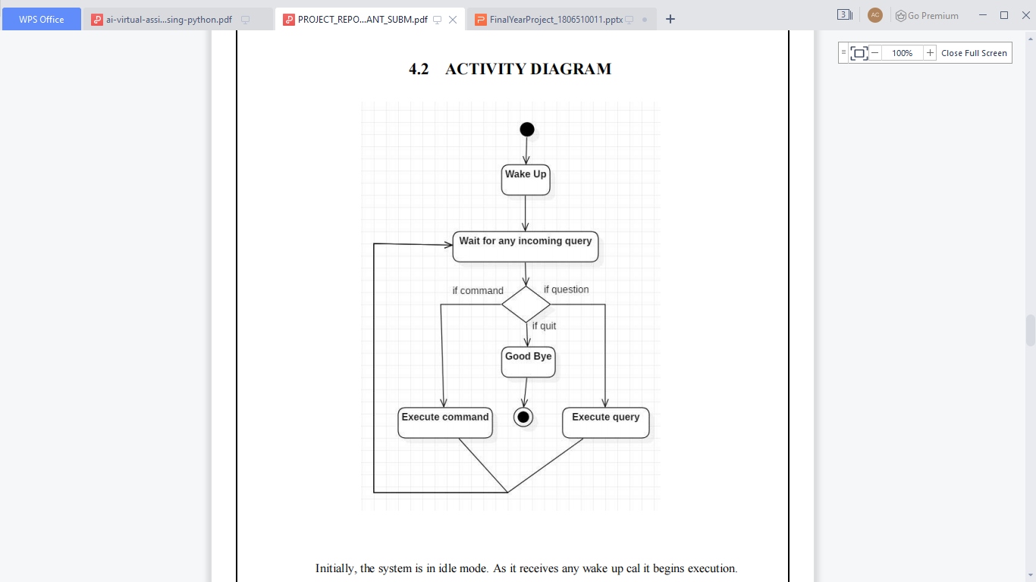

**Application Diagram**

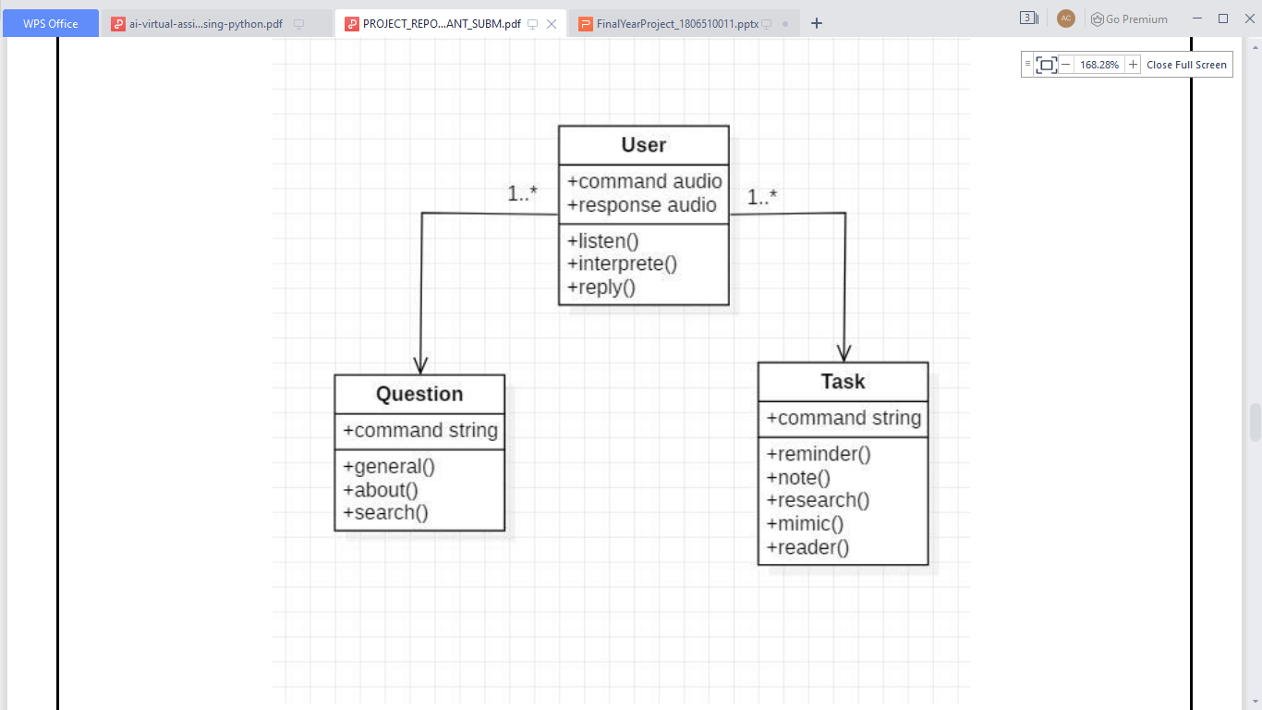

**Class Diagram**

**Use Case Diagram**

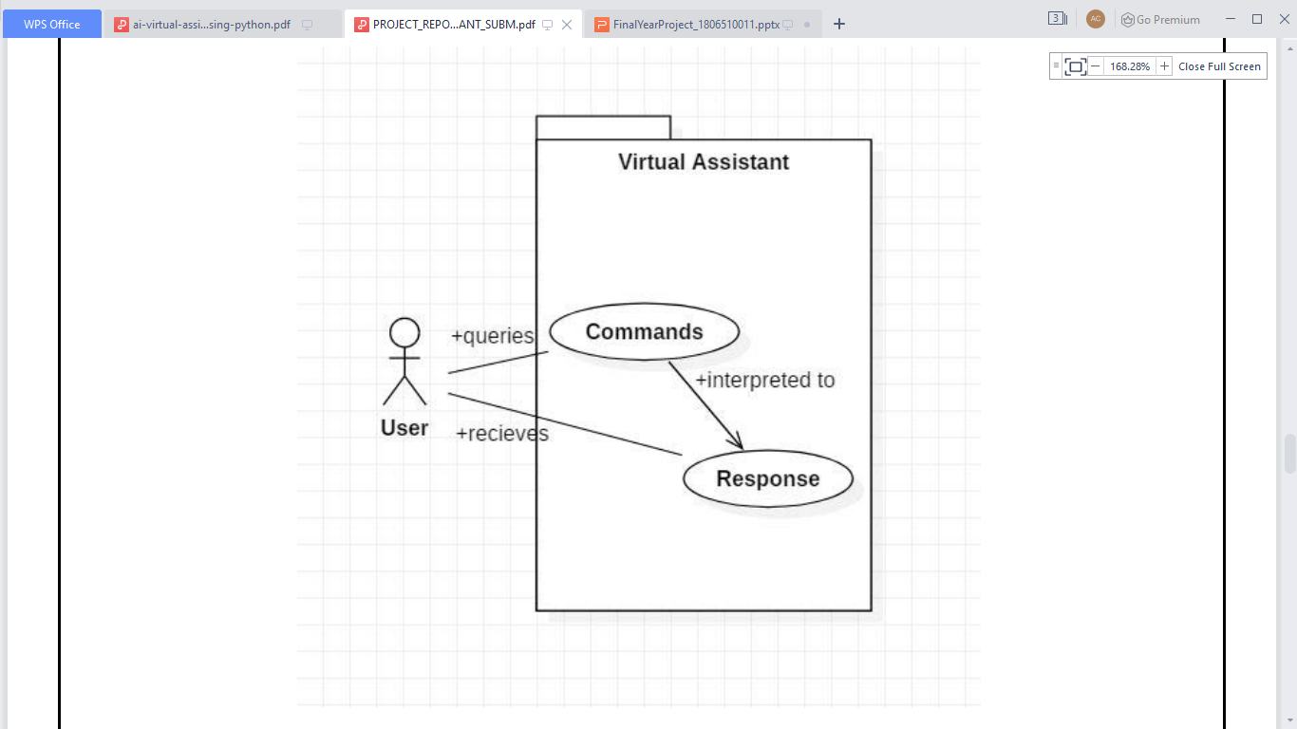

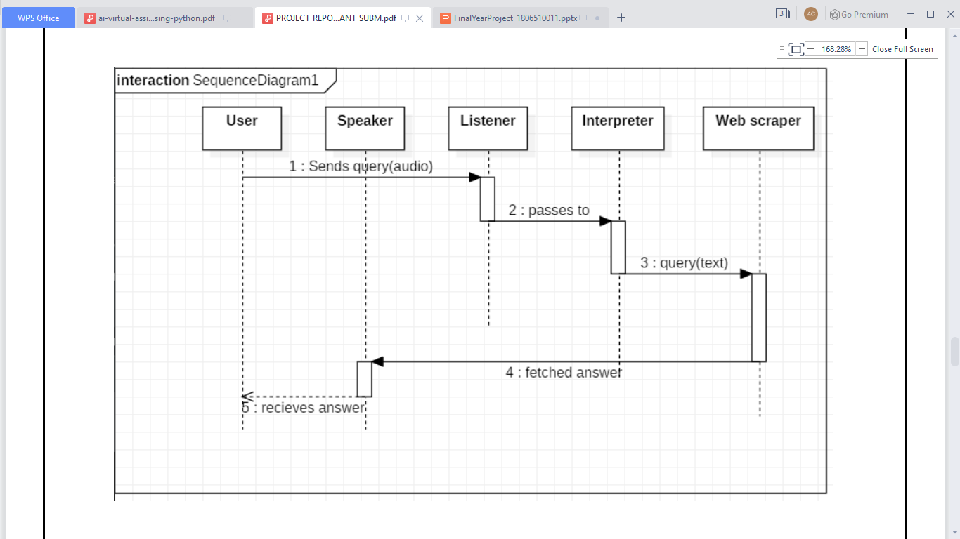

**Sequence Diagram**

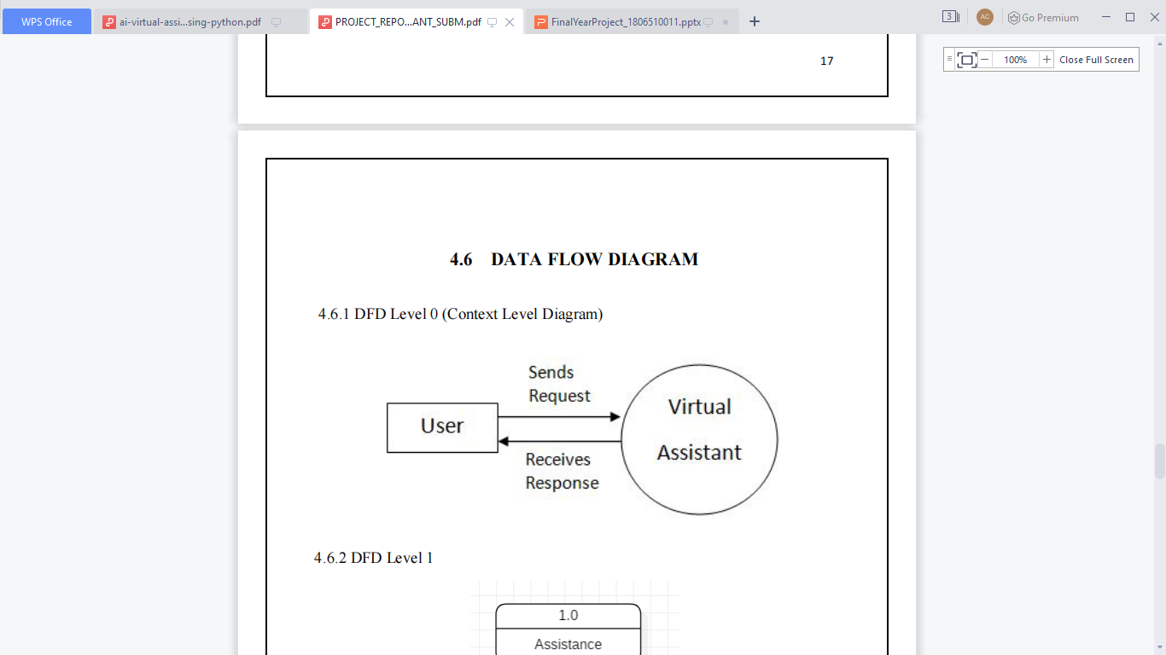

**Data Flow Diagram**

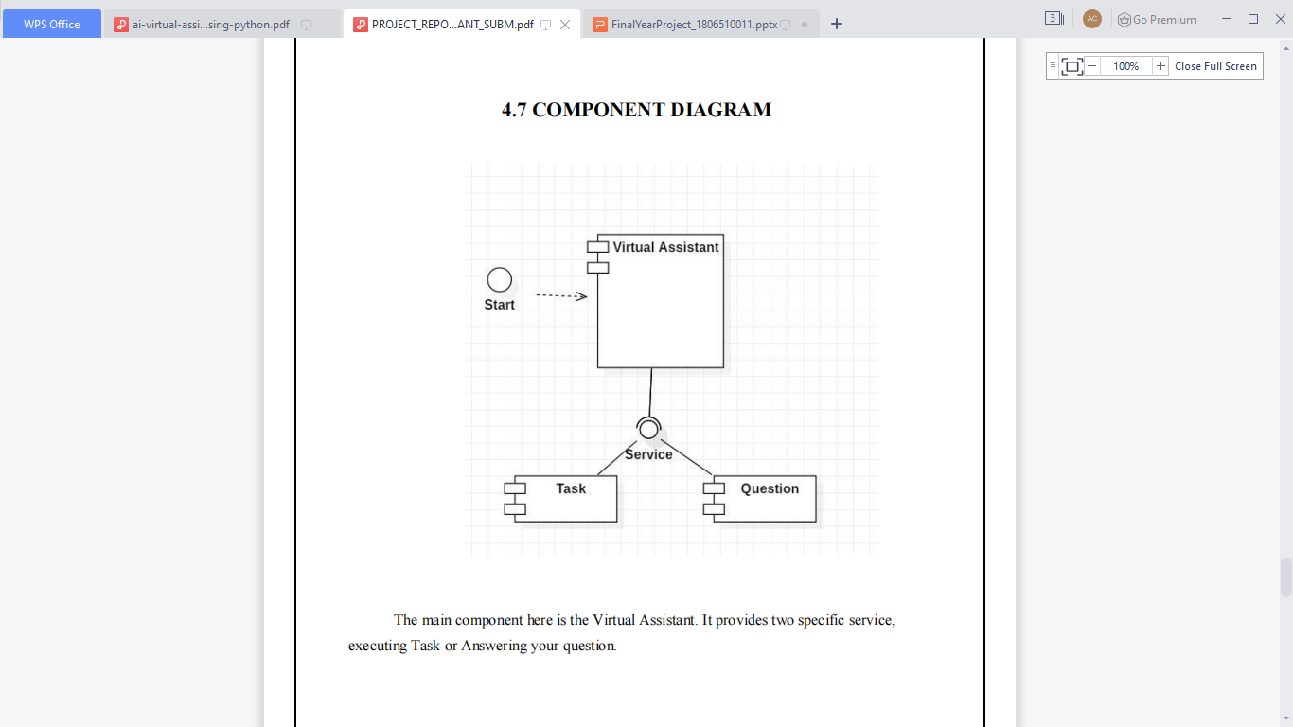 **Componenent Diagram**

**Component Diagram**

**Implementation**

**Code Demo**:-

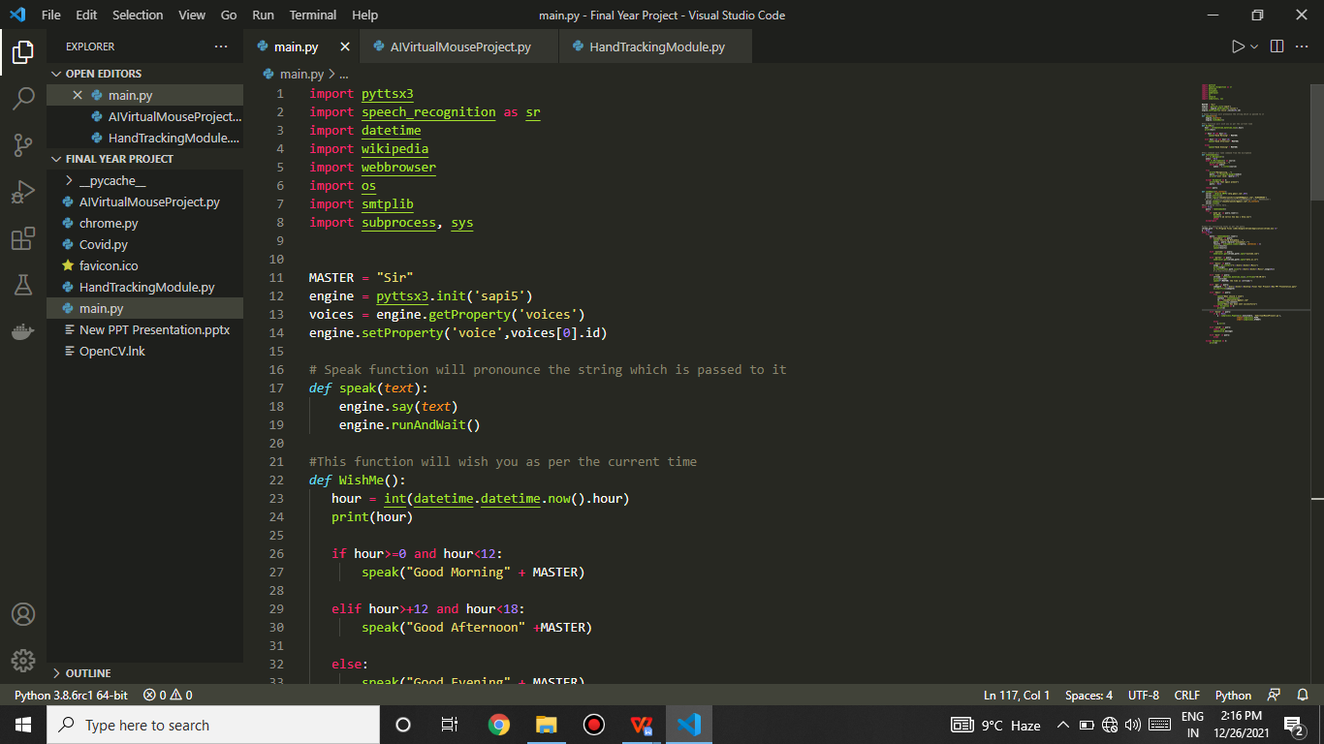

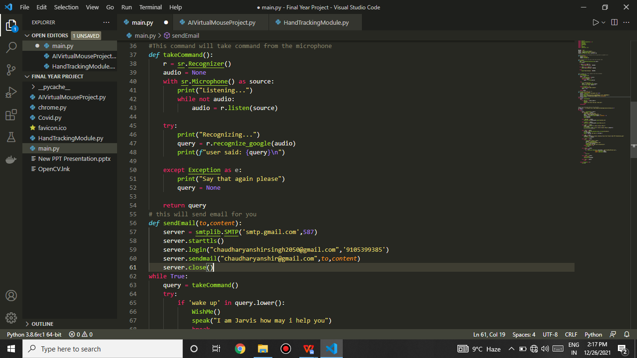

**Requirement analysis**

**Hardware Requirements:**

* Intel i3 or AMD r3 processor (i5 or r5 recommended)
* Compatible microphone/speakers for efficient I/O.
* 4 G.B. Ram or above .

**Software Requirements:**

* Windows 7 or above
* Python (Version - 3.6 or >3.6)
* An IDE , (Visual Studio Code recommended)

**Non-Functional Requirements:**

* Operation - To Leverage the functionalities.
* Revision - To change the system or data that drives the system.
* Transition - To manage the unkeep of the system.

**Scope**

Voice assistants will continue to offer more individualized experiences as they get better at differentiating between voices. However, it’s not just developers that need to address the complexity of developing for voice as brands also need to understand the capabilities of each device and integration and if it makes sense for their specific brand. They will also need to focus on maintaining a user experience that is consistent within the coming years as complexity becomes more of a concern. This is because the visual interface with voice assistants is missing. Users simply cannot see or touch a voice interface.

**Applicability**

The mass adoption of artificial intelligence in users’ everyday lives is also fueling the shift towards voice. The number of IoT devices such as smart thermostats and speakers are giving voice assistants more utility in a connected user’s life. Smart speakers are the number one way we are seeing voice being used. Many industry experts even predict that nearly every application will integrate voice technology in some way in the next 5 years.

The use of virtual assistants can also enhance the system of IoT (Internet of Things). Twenty years from now, Microsoft and its competitors will be offering personal digital assistants that will offer the services of a full-time employee usually reserved for the rich and famous.

**Refrences**

* Official Docs:-

1. Python
2. Open-CV
3. Media Pipe
4. Speech_Recognition
5. O.S., numpy, etc.

* GitHub
* StackOverflow
* Google, Y.Tube