PROJECT REPORT

Employee Salary Management

#### GROUP 17

* Anshit Srivastava IIT2022085
* Shubham Dahiya IIT2022086
* Harshini Bhukya IIT2022084
* Hrithik Roshan IIT2022082
* Samar Borkar IIT2022083



# Introduction

The Employee Salary Management System project is designed to automate the process of managing employee salaries and related tasks for an organization. The system is designed to handle various tasks such as adding employee information, calculating salaries, and generating payroll reports. The system uses a database to store all employee information, including their personal details, job title, salary information, and tax details

# REQUIREMENT SPECIFICATION

**Web Server**: APACHE

* Apache is chosen as the web server due to its flexibility, power, and widespread support. It serves as the bridge between the backend PHP scripts and the client’s web browser, managing HTTP requests and responses.

**Frontend:** HTML, CSS, Javascript

* The front end will provide an intuitive user interface for both administrators and users. Users can log in, submit complaints, and view the status of their previous complaints. Administrators can view all complaints, assign personnel, and manage user and personnel data.

**Backend:** PHP

* The back end will handle business logic, database operations, user session management, and integration of front end with the database. It ensures secure login, data processing, and provides APIs for the front end.
* The backend of the help desk system is developed using PHP, a popular server-side scripting language. PHP handles all the logic of the application, including user authentication, data processing, and interaction with the MySQL database.
* It processes the requests sent from the client side, interacts with the database for data retrieval or storage, and sends the response back to the web browser.

**Database server:** MySQL

* MySQL is used as the relational database management system. It is robust, reliable, and ideal for handling high-volume data transactions typical in a help desk scenario.

**Web Browser: Google Chrome or a**ny Compatible Browser

* The frontend is optimized for all modern web browsers, including Google Chrome, Mozilla Firefox, Safari, and Microsoft Edge, ensuring wide accessibility and consistent user experience across different platforms.

**Operating System:** Windows or any equivalent OS

* The system is designed to be operating system agnostic, functioning seamlessly on Windows, macOS, Linux, or any other system capable of supporting a web browser and an internet connection.

## Functional Components:

**Employee Information Management:**

This component stores and manages employee details like personal information, job title, salary, and tax details in a secure database, accessible to authorized personnel.

**Payroll Calculation:**

Automates salary calculation based on job title and hours worked, while managing deductions such as taxes and benefits, ensuring accurate and timely payroll processing.

**Pay-slip Generation:**

Generates electronic and printed pay-slips for employees, incorporating calculated salary and deductions, enhancing transparency and communication.

**Reports Generation**:

Empowers users to generate various payroll reports, including summaries, tax, and deduction reports, and allows customization to meet specific organizational needs.

**Integration with Other Systems:**

Facilitates seamless data exchange with accounting, HR, and attendance systems, ensuring coherence and efficiency across organizational processes.

**User Roles and Permissions:**

Assigns distinct access levels to users, safeguarding sensitive data and ensuring compliance with security protocols and regulatory requirements.

# ER Diagram

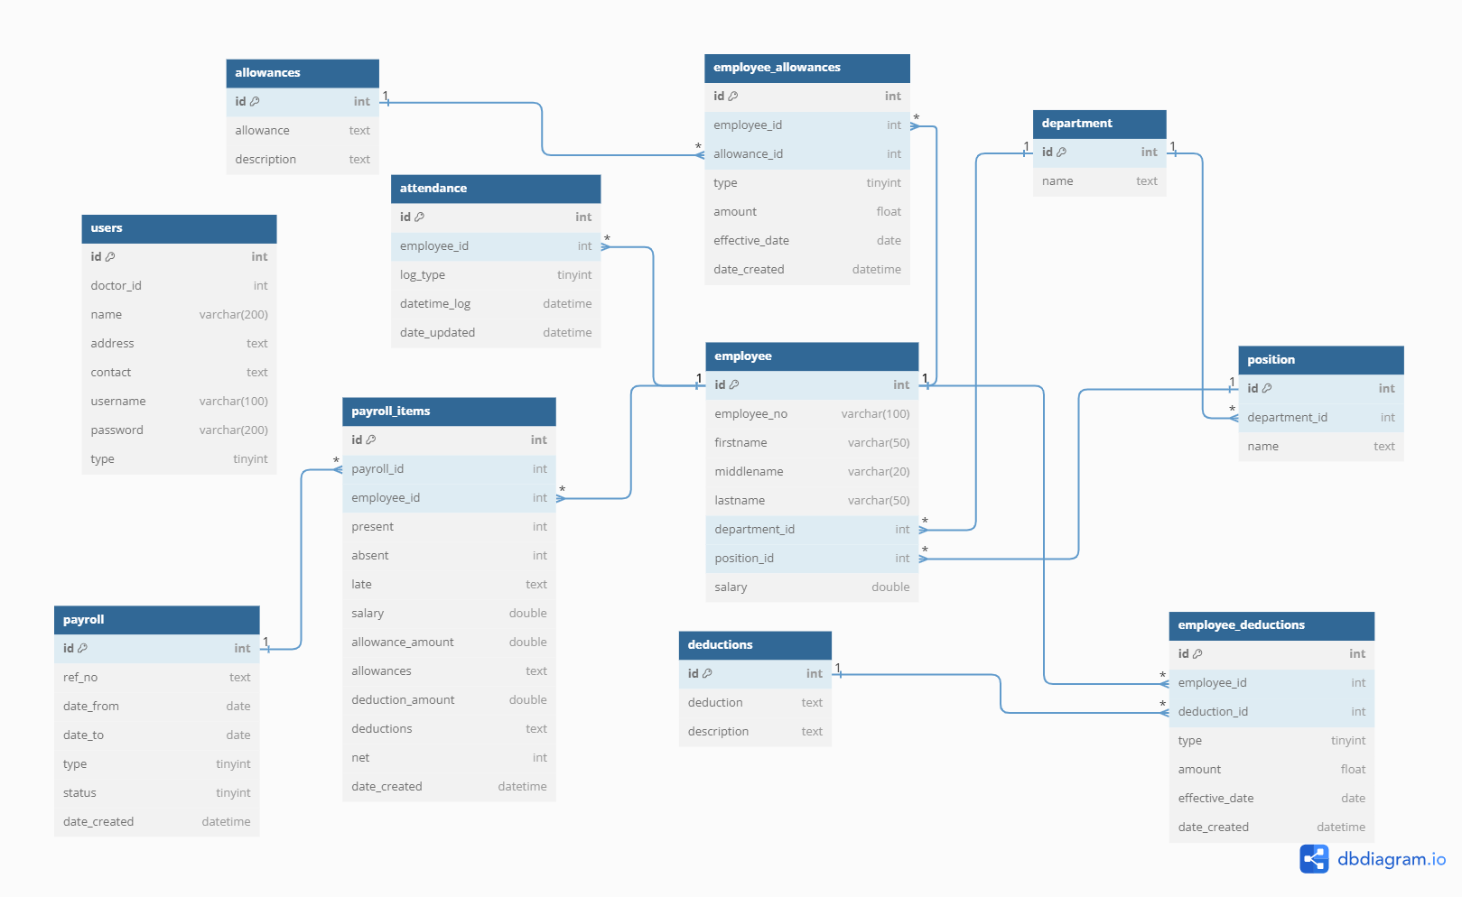

Different Relations Used

The **Employee Payroll Management System Database** consists of 11 tables. It has the **Department**, **Position**, **Allowances**, **Deductions**, **Allowances**, **Attendance**, **Employee**, **Employee Allowances**, **Employee Deductions**, **Payroll**, **Payroll Items/Payslip**, and **Users** Tables.

The **Department Table** stores all the list of departments in the company. This table is connected to both the **Position** and **Employee** tables. The data stored in this table helps to identify the certain departments of the employees.

Department Table

The Position Table stores all the Employees' Positions in the company. Each of the positions is connected to the department which means the position is only available for a certain **Department**

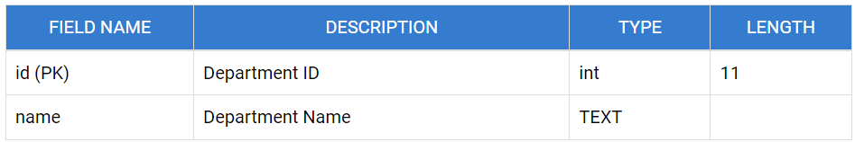

### Position Table

### 

### Allowances Table

### The Allowances Table stores all the allowances available for the company's employees.

### 

Deductions Table

The **Deductions Table** stores all the allowances available for the company's employees.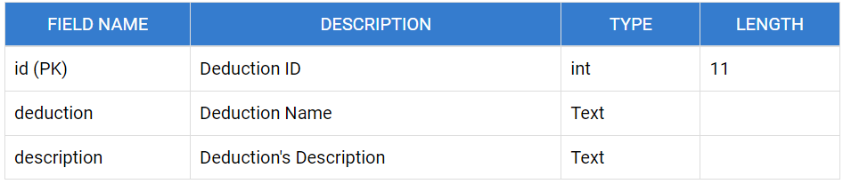

### Employee Table

The **Employee Table** stores the list of the employees of the company. This contains fields about the basic personal information and employee's details to the company.

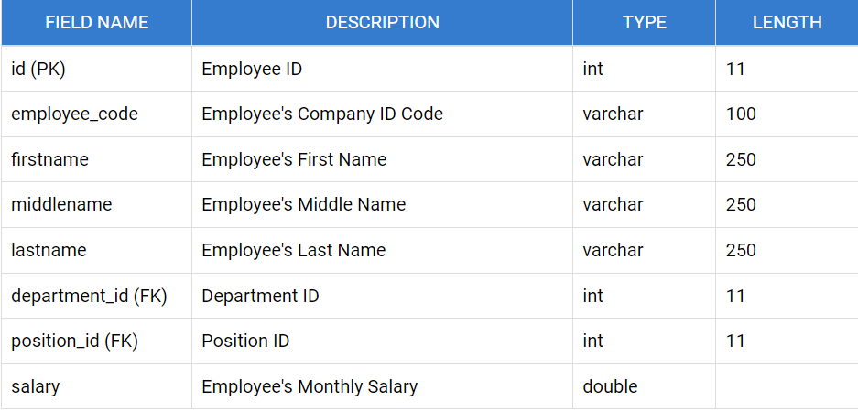

### Employee Allowances Table

### The Employee Allowances Table store the list of allowances of each employee. Employees' Allowances might be different to others and others might not have. This table contains a field that helps the system to identify when (Monthly, Semi-Monthly) the system will add the other earnings of the employee.

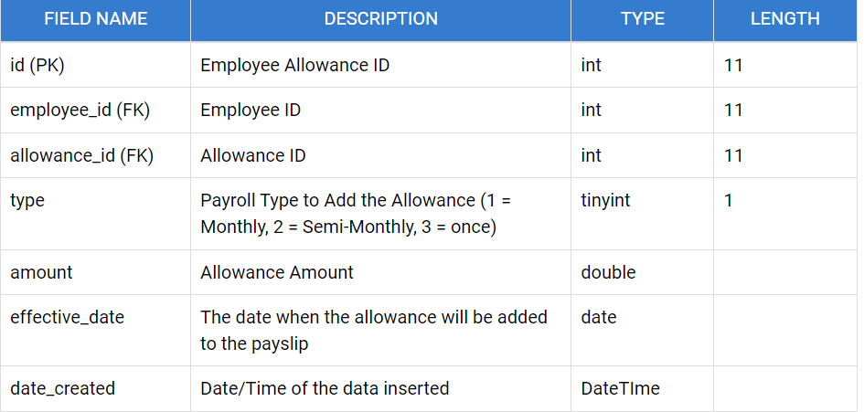

### Employee Deductions Table

The **Employee Deductions Table** store the list of deductions of each employee. Like the Allowance Table, Employees Deduction might be different from others and others might not have. This table contains a field that helps the system to identify if when (Monthly, Semi-Monthly, or once) the system will deduct the amount to the certain employee.

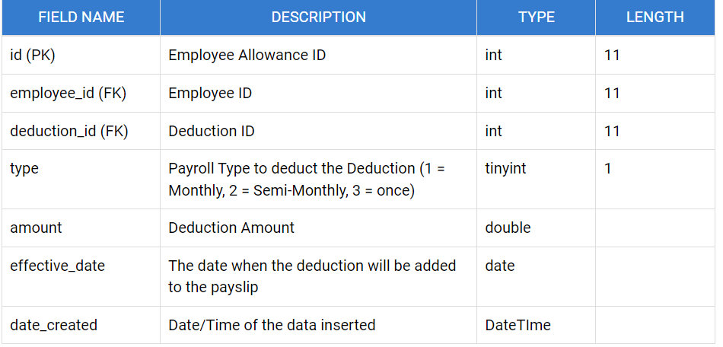

### Attendance Table

The **Attendance Table** stores all the attendances of the employees. Each employee will have 4 data per day in this table. This data could be the employees for Time-in, Lunch-out, After Lunch-in, and Time-out. This also contains a Date Time log that will be used in calculating the rendered working hours of the employees each working day.

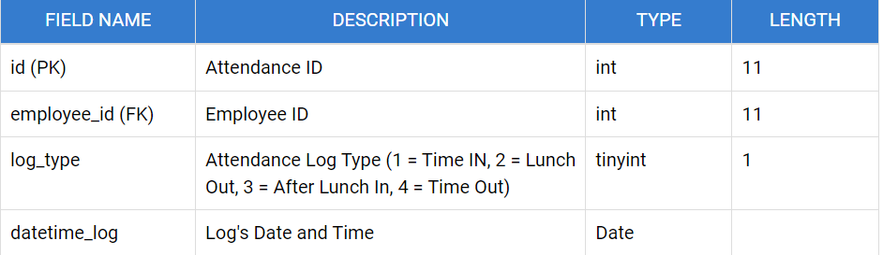

### Payroll Table

### The Payroll Table stores the payroll cut-offs of the company. The system relies on this table on how to compute the employees' payslips. The system will also fetch the employees' attendances between the cut-off's date range.

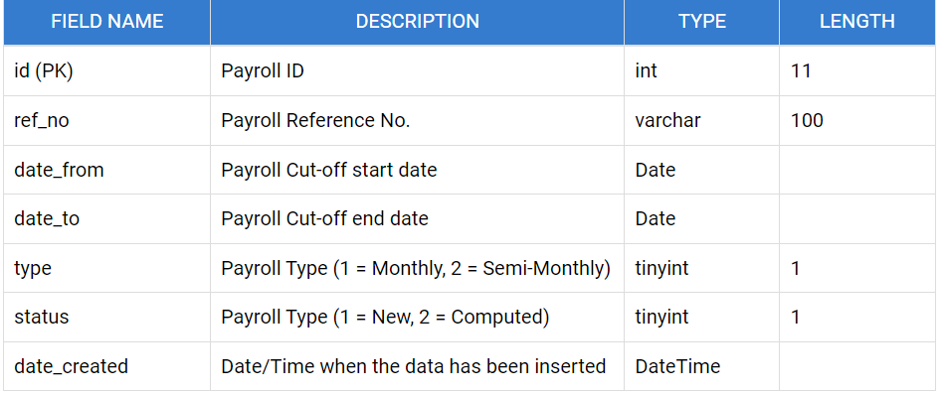

### Payslip Table

### The Payroll Item/Payslip Table stores the payslip details of each employee for a certain payroll. This table contains the number of presents, absences, late of the employee. The Allowances and Deductions JSON Data of employees is also stored in this table.

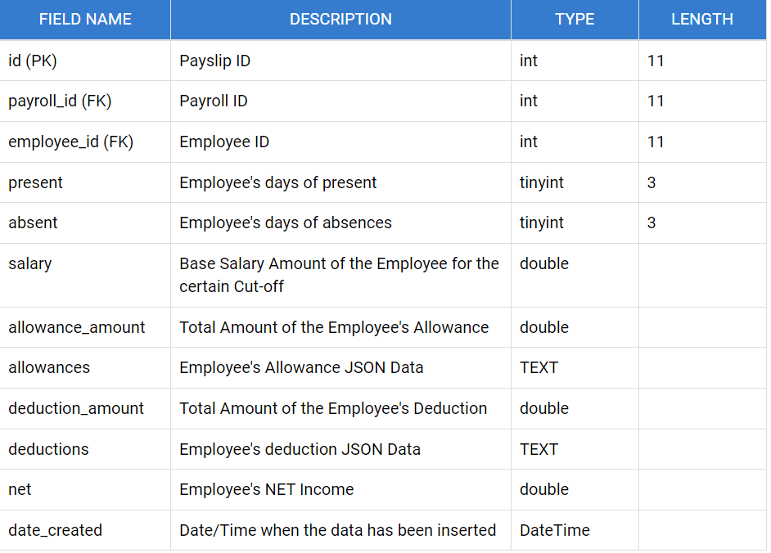

### Users Table

### Lastly, the Users Table. This table doesn't have any relation with the other tables above. This table only stores the system users' credentials.

