**RESUME**

**ABOUT:**

Name: Anshita Tayal

Email-id : [anshitatayal722@gmail.com](mailto:anshitatayal722@gmail.com)

**PROFILE SUMMARY:**

I am a motivated engineering student looking for an internship opportunity to apply my knowledge . I have background in andoird app development and a passion for solving problems and coming up with innovative solutions.

**EDUCATION:**

**B.Tech – 3rd year (2023)**

Sushant University, Gurgaon (Haryana)

**12th (2021)**

School Name - Sarti Devi Raja Ram Public School, Shamli (Up)

Board – Central Board Of Secondary Education

Academic Marks – 81.8%

**10th (2019)**

School Name - Sarti Devi Raja Ram Public School, Shamli (Up)

Board – Central Board Of Secondary Education

Academic Marks – 70%

**SKILLS:**

Basics Of Java, HTML, CSS, Android app development, Java Script

**CERTIFICATES:**

1. **INTRODUCTION TO JAVA**

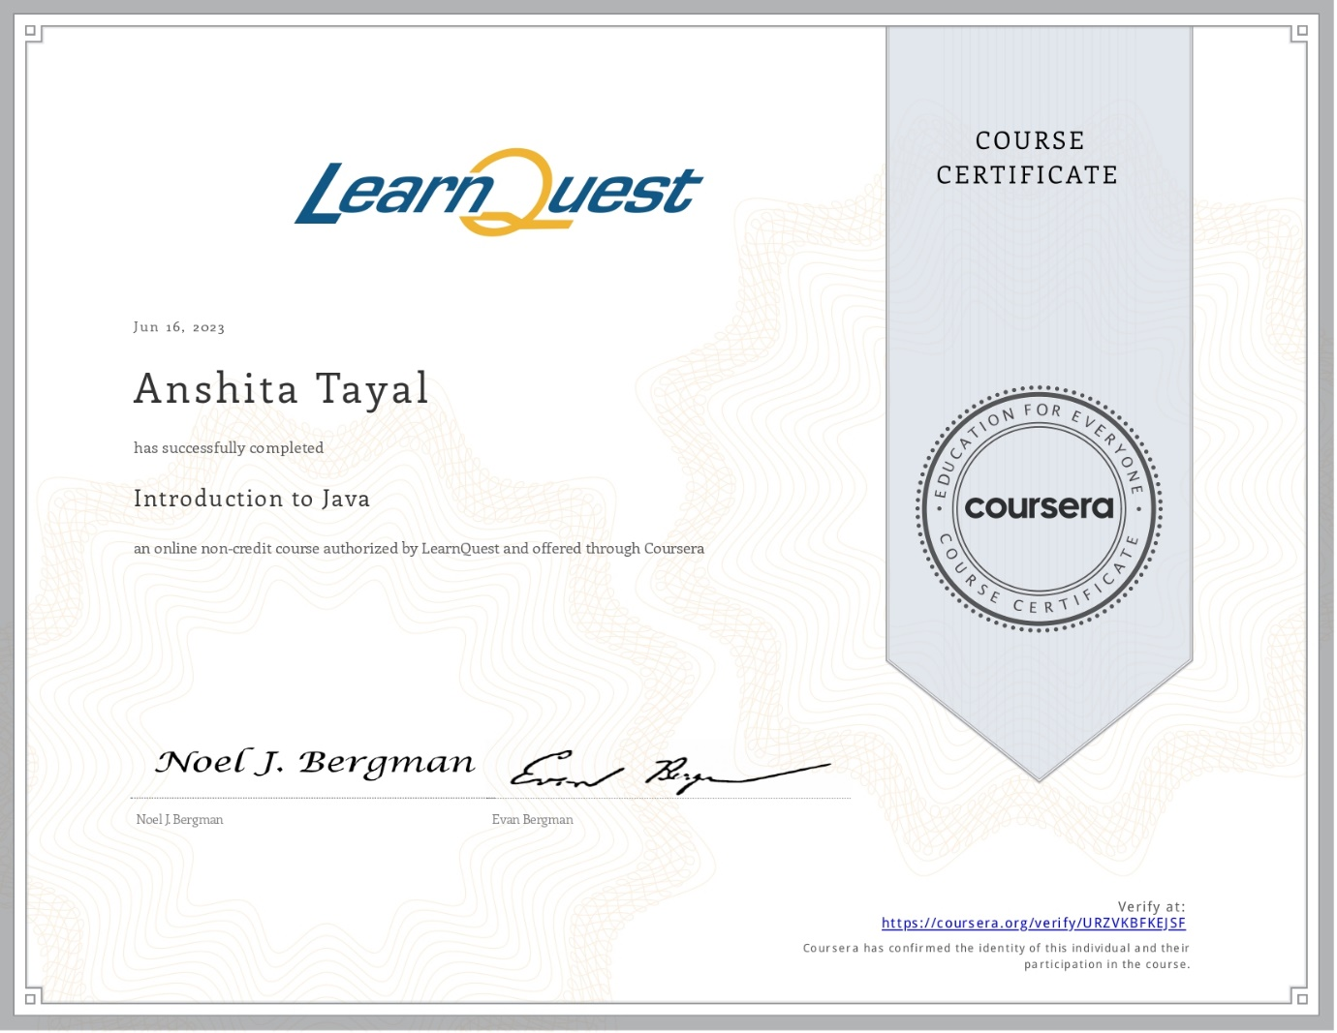

1. **TCS ION CAREER EDGE**

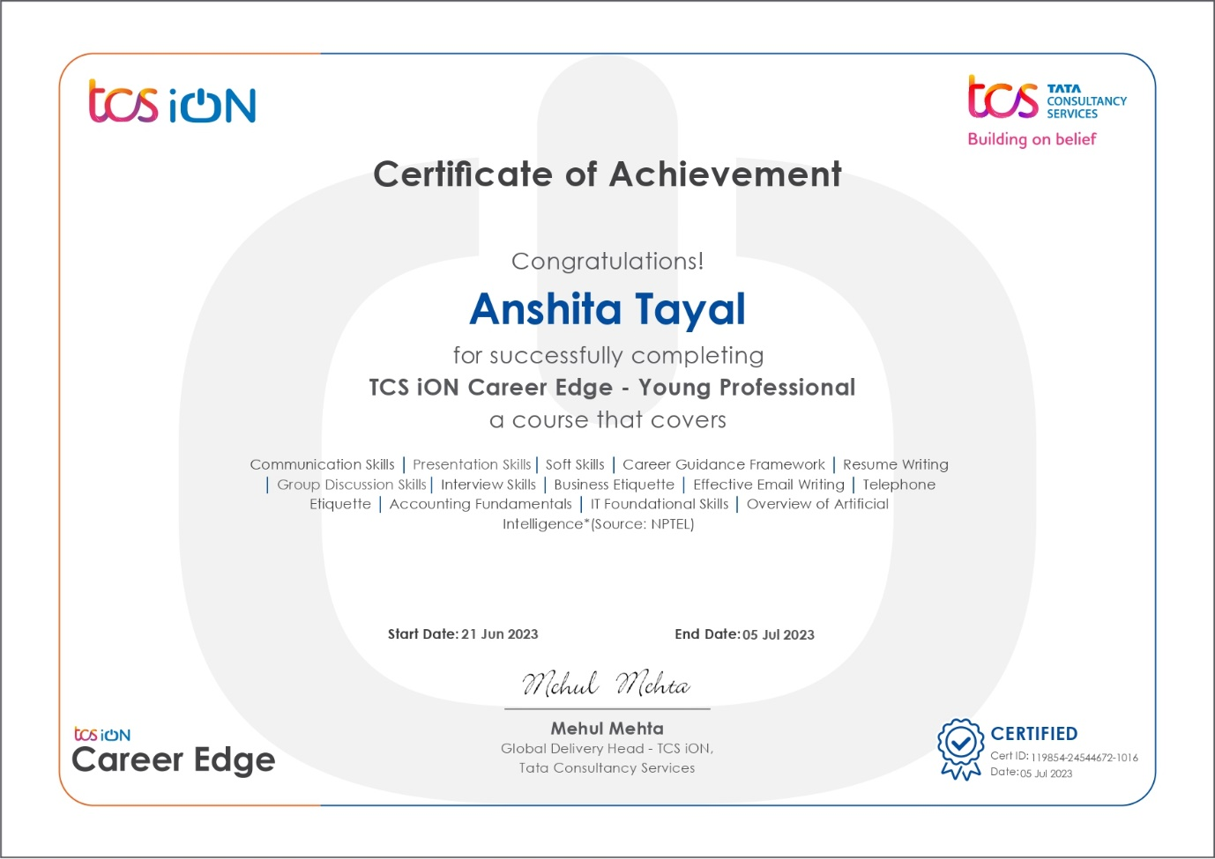

1. **ESG Virtual Experience Program**

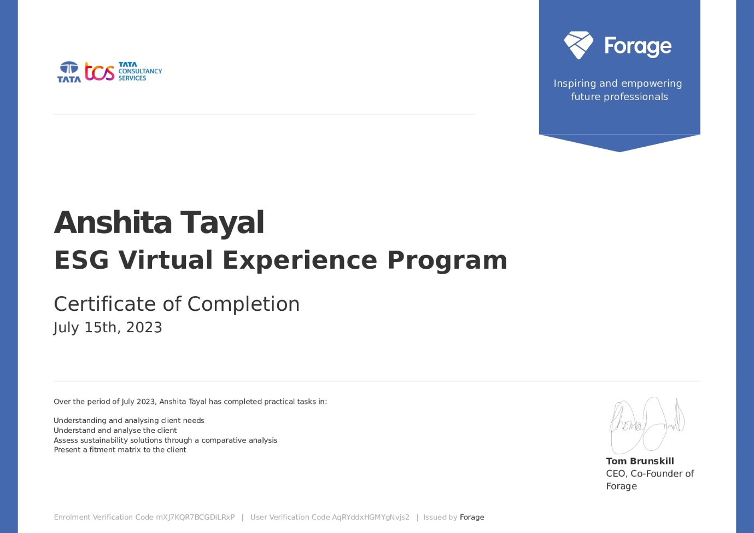

1. Android Mobile Apps Training

