
PROJECT REPORT
ON
“WebSoul Engineers Website using HTML, CSS and JavaScript”
Submitted By:
Ansh Kamboj,
UID- 26MCA20194
Submitted To:
Ms. Shruti
October 2026

University Institute of Computing
Chandigarh University,
Mohali, Punjab
ACKNOWLEDGEMENT
I deem it a pleasure to acknowledge my sense of gratitude to my project guide Miss Shruti under whom I have carried out the project work.
Her incisive and objective guidance and timely advice encouraged me with a constant flow of energy to continue the work.
I wish to reciprocate in full measure the kindness shown by the Head of the Department, University Institute of Computing, whose valuable suggestions inspired me in successfully completing the project work.
I shall remain grateful to the Additional Director, University Institute of Computing, for providing a strong academic atmosphere by enforcing strict discipline to do the project work with utmost concentration and dedication.
Finally, I must say that no height is ever achieved without some sacrifices made at some end and it is here where I owe my special debt to my parents and my friends for showing their generous love and care throughout the entire period.
Date: 31.10.2026
Place: Chandigarh University, Mohali, Punjab
Ansh Kamboj, UID- 26MCA20194
ABSTRACT
Every business needs a website that shows clearly what it does, and a company that builds websites needs one that proves it. This project, "WebSoul Engineers Website using HTML, CSS and JavaScript," presents the design and implementation of the company website of WebSoul Engineers, a start-up that builds websites and web applications for clients. The site presents the front-end and back-end services of the company, its working process, typical project sizes and tools, and a contact form, all on one responsive page.
The page is written with HTML, CSS and JavaScript and delivered as a single file of about 27 KB, with no framework or script library. Its layout follows one idea, a waterline: front-end services sit above the line on a light background and back-end services below it on a dark background. All colours are stored as named design tokens with light and dark values, three typefaces cover headings, text and technical labels, and CSS Grid and Flexbox let the layout adapt from a 360-pixel phone to a wide desktop.
The contact section asks five short questions, checks the required fields and builds a project brief that the visitor can copy and send to the company. Because the site has no server, the form does not send data; no cookies are set and nothing is stored. The page follows accessibility basics, including strong contrast, visible keyboard focus, labelled form fields and support for reduced motion.
The website was tested in Chromium with the Playwright tool. The tests confirmed that the page does not scroll sideways at widths from 360 to 1920 pixels, that navigation, the form, the copy button and both colour themes work as designed, and that all measured text colours have a contrast ratio above 6:1. The project shows that a clear, accessible and attractive business website can be built with plain web technologies, and it can later be connected to a back-end service that receives the project briefs directly.
TABLE OF CONTENTS
Introduction 1
Objective 1
Background 1
Scope of the Project 2
System Requirements 2
Hardware Requirements 2
Software Requirements 2
System Analysis 2
Limitations of the Existing System 2
Proposed System 3
Functional Modules 3
Design Rules 3
Website Design 4
Content Structure 4
Design Tokens 5
Typography 5
Layout Breakpoints 5
System Design and Page Flow 6
Architecture 6
Flow of the Contact Brief Form 6
Responsiveness, Theme and Accessibility 7
Implementation 7
Step 1: Page Skeleton and Design Tokens 7
Step 2: Theme Support 7
Step 3: Responsive Layout 8
Step 4: Services Markup 8
Step 5: Contact Form Script 9
Step 6: Automated Browser Tests 10
Testing and Results 10
Test Cases 10
Sample Output 11
Advantages and Limitations 13
Advantages 13
Limitations 14
Future Scope 14
Conclusion 14
References 14

Introduction
A website is usually the first place a customer looks before trusting a business. A clear, fast and good-looking site tells visitors what a company does, how it works and how to reach it. For a company that sells web development, the website has one more job: it is also the best sample of the work the company can do. A web development services website is therefore built around one central idea: the page itself must show the quality that the company promises.
This project presents the design and implementation of the company website of WebSoul Engineers, a start-up that builds websites and web applications for clients. The company offers two kinds of services. Front-end services cover everything a visitor sees and uses in the browser, such as layouts, pages and forms. Back-end services cover the server, database and application programming interfaces (APIs) that sit behind the screen and make the site do real work, such as login, orders and payments.
The website is written with HTML, CSS and JavaScript and is delivered as a single responsive page. It introduces the company, lists the front-end and back-end services, explains the working process, shows three typical project sizes, names the tools used, and ends with a contact form that turns a visitor's answers into a ready-to-send project brief. The page adapts to phones, tablets and desktops and follows the light or dark setting of the visitor's device.

Objective
The main objective of this project is to design and build a professional, responsive and accessible website for the start-up WebSoul Engineers. The specific objectives are:
- To design a single-page website that presents the company, its services and its working method clearly.
- To describe front-end and back-end services separately so that a client can decide what to ask for.
- To build a consistent visual identity from a small set of design tokens for colour and type.
- To support light and dark display modes without writing the styles twice.
- To provide a contact form that turns the visitor's answers into a project brief that can be copied and sent.
- To follow accessibility basics: readable contrast, visible keyboard focus, labelled form fields and reduced-motion support.
- To test the website in a real browser at phone, tablet and desktop widths and record the results.

Background
Early business websites were hand-written static pages that looked different on every screen. Later, template builders and content management systems made it easy to publish a site quickly, but many of the resulting sites look alike and are difficult to customise. Modern CSS has changed what is possible without extra software. Custom properties (variables), CSS Grid, Flexbox and media queries such as prefers-color-scheme allow one page to rearrange itself for any screen and to follow the visitor's light or dark preference.
In this project the website is treated as one unit of delivery. The structure (HTML), the presentation (CSS) and the behaviour (JavaScript) are kept together in a single file of about 27 KB. No framework or script library is used. The file can be placed on any static web host, opened directly from a folder for testing, and edited with an ordinary code editor.

Scope of the Project
The project covers the public marketing website of WebSoul Engineers. It is a front-end only deliverable: it runs entirely in the visitor's browser. User accounts, a database, payment processing, a blog and a content management system are outside the scope of this report. The back-end services described on the page are what the company offers to its clients; the website itself does not need them. The contact form has been written so that a server endpoint can be attached to it in future.

System Requirements
The following hardware and software environment is needed to create, test and view the WebSoul Engineers website.

Hardware Requirements
- Processor: Intel Core i3 or AMD equivalent (64-bit) or higher.
- RAM: Minimum 4 GB (8 GB recommended for running the browser test tools).
- Hard Disk Space: At least 5 GB of free space for the project, browsers and test tools.
- Display: 1366 x 768 resolution or higher; a phone or tablet is useful for manual checks.

Software Requirements
Table 1: Software used in the project
Component | Specification
Markup | HTML5 with semantic elements (header, nav, main, section, footer)
Styling | CSS3: custom properties, Grid, Flexbox, media queries
Scripting | JavaScript (plain, no libraries)
Typefaces | Bricolage Grotesque, Public Sans and JetBrains Mono from Google Fonts
Code Editor | Any text editor, for example Visual Studio Code
Test Browser | Chromium, driven by Playwright (Node.js)
Report Figures | Python with Matplotlib
Hosting | Any static web host that serves HTTPS
Documentation | Microsoft Word
Note: the copy button of the contact form uses the Clipboard API (navigator.clipboard.writeText), which works only on pages served over HTTPS or from localhost. In other cases the page selects the text so that the visitor can copy it by hand.

System Analysis

Limitations of the Existing System
- Many small businesses and start-ups have no website at all, so potential clients cannot check them online.
- Template-based builders produce pages that look alike and make custom features such as login, orders and payments hard to add.
- Service lists are often vague, for example "web solutions", and do not say what is delivered or how long it takes.
- Pages that are designed for large screens first need zooming or sideways scrolling on phones.
- A contact page that shows only an e-mail address does not tell the visitor what information to send, which leads to long question-and-answer exchanges before a quote.

Proposed System
The proposed system is a single responsive page that keeps all content, style and behaviour in one file. The page is divided at an imaginary "waterline". Front-end services sit above the line on a light background, because they are the part the visitor sees. Back-end services sit below the line on a dark background, because they are the part that works out of sight. The same idea is repeated in the hero illustration, which shows a web page above a sample request log, and in the tools section, which groups technologies above and below the line.
After the services, the page explains a five-step working process, three typical project sizes with timelines, and the tools in use. The contact section asks five short questions and builds a project brief that the visitor can copy and send. Colours, fonts and spacing come from a small set of named design tokens, so the whole look can be changed from one place.

Functional Modules
Table 2: Modules of the website
Module | Description
Header and Navigation | Sticky bar with the logo, section links and a "Start a project" button. On narrow screens the section links are hidden and the button remains.
Hero | Headline, short description, two call-to-action buttons and an illustration of a web page above a sample request log.
Services | Two bands, front-end (light) and back-end (dark), each with four service items and the technologies used.
Process | Five steps in order: brief, design, build, launch and support.
Project Sizes | Three cards: launch page, business website and web application, with typical timelines.
Tools | Sixteen technology chips grouped above and below the line.
Contact Brief Form | Collects name, business, need, timeline and description, checks the required fields and builds a brief that can be copied.
Theme Support | Switches between light and dark colours according to the visitor's device setting.
Footer | Copyright line and a short description of the services.

Design Rules
- Every colour must come from a named design token; no component may hard-code a colour.
- Text must keep a contrast ratio above 4.5:1 against its background in both themes.
- The page must not scroll sideways at any width from 360 pixels upwards.
- Only three typefaces are used: one for headings, one for body text and one monospaced face for labels and code.
- Every link, button and form field must show a visible outline when reached by keyboard.
- Animation must stop when the visitor asks the device for reduced motion.
- No external script or library is loaded; the only external resource is the font stylesheet.
- Placeholder text such as "lorem ipsum" is not used.

Website Design
The design of the website has three parts: the structure of the content, the design tokens that control colour and type, and the layout rules that make the page adapt to the screen. Figure 1 shows the order of the sections from top to bottom and the position of the waterline.
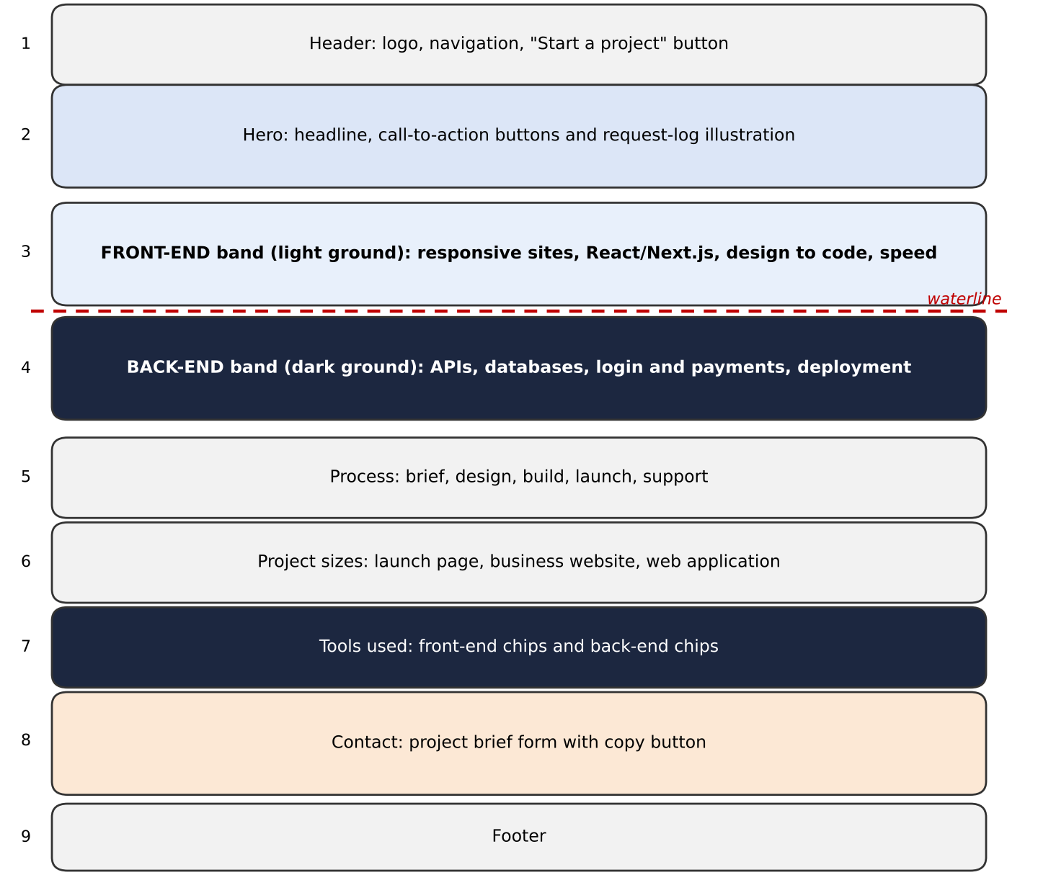
Fig. 1: Page structure of the WebSoul Engineers website

Content Structure
Each section has a purpose and, where the visitor may want to jump to it, an anchor name that the navigation links use. Table 3 lists the sections.
Table 3: Sections of the page
Section | Anchor | Purpose
Header | #top | Brand, navigation and the main call to action.
Hero | - | Say in one headline what the company does and offer two actions.
Services | #services | Describe front-end and back-end services in two bands, four items each.
Process | #process | Show the five steps of a project from brief to support.
Project Sizes | - | Give typical timelines for a launch page, a business website and a web application.
Tools | #stack | Name the technologies used above and below the line.
Contact | #contact | Collect the information needed for a first estimate.
Footer | - | Copyright and a one-line description.

Design Tokens
All colours are defined once as CSS custom properties on the root element and are used everywhere through var(--name). The dark theme redefines the same names with new values, so no component needs a second set of rules. Table 4 lists the main tokens.
Table 4: Colour tokens in the light and dark themes
Token | Light | Dark | Use
--paper | #EEF2F6 | #0F1626 | Page background
--paper-2 | #E1E8F0 | #162038 | Background of the process section
--surface | #FFFFFF | #18233D | Cards, form and illustration
--ink | #0E1726 | #E8EDF5 | Main text
--ink-soft | #46546A | #9DABC0 | Secondary text
--line | #C6D1DE | #28344E | Borders and dividers
--signal | #2747F5 | #8397FF | Accent: buttons, labels, focus outline
--deep | #0B1220 | #070B14 | Back-end band, tools section, request log
--ok | #2FBF8A | #2FBF8A | Success green in the request log

Typography
Typography sets the personality of the page. A characterful display face is used only for headings, a calm text face carries the running text, and a monospaced face marks technical labels, so that the page itself feels like a developer's work. Each face has a fallback stack, so the page stays readable if the fonts cannot be loaded.
Table 5: Typefaces
Role | Typeface | Used for | Fallback
Display | Bricolage Grotesque (500, 700, 800) | Headings and brand name | Segoe UI, system-ui, sans-serif
Body | Public Sans (400, 500, 600) | Running text, buttons, form | system-ui, Segoe UI, sans-serif
Utility | JetBrains Mono (400, 500) | Labels, tags, request log, code | ui-monospace, Menlo, Consolas

Layout Breakpoints
The layout uses CSS Grid with flexible tracks and wraps or stacks its columns when the screen becomes narrow. Headline sizes use the CSS clamp() function, so they grow smoothly between a minimum and a maximum. A side gutter of at least 16 pixels is kept at every width. Table 6 lists the points at which the layout changes.
Table 6: Layout changes at narrow widths
Width up to | Change
920 px | Hero, service bands and contact section change from two columns to one column.
720 px | Section links in the header are hidden; the "Start a project" button stays.
640 px | Service items stack in one column and the band padding is reduced.
520 px | Pairs of form fields stack and the form padding is reduced.

System Design and Page Flow

Architecture
The website has no server-side code. The web host sends one file to the visitor's browser, and the browser also fetches the typefaces from Google Fonts. After that, everything happens inside the browser: the stylesheet lays out the page and applies the theme, and a short script handles the contact form. Figure 2 shows the parts and how they connect.
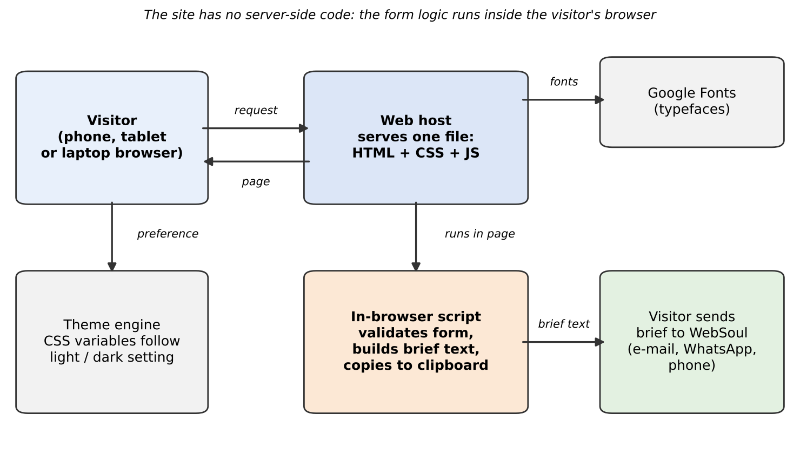
Fig. 2: Architecture of the WebSoul Engineers website
Because there is no back end, the site is quick to load and cheap to host, and no visitor data leaves the page. The same architecture also explains the main limitation: the contact form cannot send a message by itself.

Flow of the Contact Brief Form
The contact form does not send data anywhere. It helps the visitor write a complete project brief and then copy it. Table 7 describes the steps.
Table 7: Steps of the contact brief form
Step | Action
1 | The visitor enters name, business or project, need, timeline and a description of what the site should do.
2 | On "Build my brief" the submit event is intercepted with preventDefault(), so the page does not reload.
3 | The script checks that name, business and description are not empty.
4 | If a required field is empty, a message is shown, the cursor moves to the first empty field and the copy button stays hidden.
5 | Otherwise the brief text is assembled from the five answers and shown in a dark text box.
6 | The visitor presses "Copy brief"; the script calls navigator.clipboard.writeText inside the click handler.
7 | If the browser refuses to copy, the text is selected and the visitor is asked to press Ctrl+C.
8 | The visitor sends the brief to WebSoul Engineers by e-mail, WhatsApp or phone.

Responsiveness, Theme and Accessibility
The following design decisions are applied throughout the page.
- Responsive layout: flexible grid tracks, wrapping rows and clamp() font sizes let the same markup serve phones and desktops. Side gutters respect the safe area of phones.
- Theme: tokens are defined on the root element; the dark values are applied through prefers-color-scheme: dark and through a data-theme attribute, so an explicit choice overrides the device setting.
- Accessibility: meaningful landmarks, a label for every form control, a status area that announces copy results, and a 3-pixel outline on focused elements.
- Motion: the only animation is the blinking cursor in the request log. It is switched off, together with smooth scrolling, when the visitor prefers reduced motion.
- Privacy: the page sets no cookies, stores nothing in the browser and sends nothing to a server.

Implementation
The website was built in six steps. The listings below are taken from the actual source file of the project; long lines have been wrapped for printing.

Step 1: Page Skeleton and Design Tokens
The page begins with its title and a style block. The first rule defines the design tokens for the light theme and the three font roles. Every later rule reads its colours from these names.
Listing 1: Design tokens
:root {
--paper: #EEF2F6;
--paper-2: #E1E8F0;
--surface: #FFFFFF;
--ink: #0E1726;
--ink-soft: #46546A;
--line: #C6D1DE;
--signal: #2747F5;
--signal-ink: #FFFFFF;
--deep: #0B1220;
--deep-2: #141E34;
--deep-fg: #E6ECF5;
--deep-soft: #98A6BD;
--deep-line: #27344F;
--ok: #2FBF8A;
--font-display: "Bricolage Grotesque", "Segoe UI", system-ui, sans-serif;
--font-body: "Public Sans", system-ui, -apple-system, "Segoe UI", sans-serif;
--font-mono: "JetBrains Mono", ui-monospace, "SFMono-Regular", Menlo, Consolas, monospace;
}

Step 2: Theme Support
The dark theme redefines only the token values. It is applied in two places: through the device setting and through an explicit data-theme="dark" attribute. The body rule always sets a background from a token.
Listing 2: Dark theme and body rule
@media (prefers-color-scheme: dark) {
:root:not([data-theme="light"]) {
--paper: #0F1626; --paper-2: #162038; --surface: #18233D; --ink: #E8EDF5; --ink-soft:
#9DABC0;
--line: #28344E; --signal: #8397FF; --signal-ink: #0B1220;
--deep: #070B14; --deep-2: #0E1628; --deep-line: #1F2B44;
color-scheme: dark;
}
}
:root[data-theme="dark"] {
--paper: #0F1626; --paper-2: #162038; --surface: #18233D; --ink: #E8EDF5; --ink-soft: #9DABC0;
--line: #28344E; --signal: #8397FF; --signal-ink: #0B1220;
--deep: #070B14; --deep-2: #0E1628; --deep-line: #1F2B44;
color-scheme: dark;
}

Step 3: Responsive Layout
The .wrap container centres the content and keeps a side gutter of at least 16 pixels. The hero is a two-column grid that becomes one column at 920 pixels. Grid columns use minmax(0, 1fr) so that long words cannot push the page wider than the screen.
Listing 3: Container, hero grid and breakpoints
.wrap {
width: 100%; max-width: 1200px; margin: 0 auto;
padding-left: max(16px, env(safe-area-inset-left, 0px));
padding-right: max(16px, env(safe-area-inset-right, 0px));
}
.hero .wrap { display: grid; grid-template-columns: minmax(0, 1.05fr) minmax(0, 1fr); gap: 56px;
align-items: center; }
@media (max-width: 920px) { .hero .wrap { grid-template-columns: minmax(0, 1fr); gap: 40px; } }
.band .wrap { display: grid; grid-template-columns: minmax(0, 0.8fr) minmax(0, 1.6fr); gap:
56px; }
.items { display: grid; grid-template-columns: repeat(2, minmax(0, 1fr)); gap: 0 40px; }
.item { padding-block: 24px 28px; border-top: 1.5px solid var(--ink); min-width: 0; }

Step 4: Services Markup
The services are plain HTML. Each band is a div inside a section, and each service is an item with a title, a description and a line of technology tags. Only the first item is printed here; the other seven follow the same pattern.
Listing 4: Front-end band of the services section
<section id="services" aria-label="Services">
<div class="band light">
<div class="wrap">
<div>
<p class="eyebrow">Above the line</p>
<h2>Front-end</h2>
<p class="intro">Everything a visitor sees and touches, built to load fast and work on
any screen.</p>
</div>
<div class="items">
<div class="item">
<h3>Responsive business websites</h3>
<p>Pages that read well on a 360px phone and a 27-inch monitor, with clear calls to
action and search-friendly markup.</p>
<p class="tags">HTML · CSS · JavaScript</p>
</div>
...
</div>
</div>
</div>
</section>

Step 5: Contact Form Script
The script reads the contact details from a small object, checks the form on submit, builds the brief and handles the copy button. Text is written with textContent, so nothing typed by a visitor is ever interpreted as HTML.
Listing 5: Contact form script
var form = document.getElementById("brief");
var result = document.getElementById("result");
var out = document.getElementById("out");
var status = document.getElementById("status");

function val(id) { return document.getElementById(id).value.trim(); }

form.addEventListener("submit", function (e) {
e.preventDefault();
var missing = ["f-name", "f-biz", "f-msg"].filter(function (id) { return !val(id); });
if (missing.length) {
document.getElementById(missing[0]).focus();
status.textContent = "";
result.hidden = false;
out.textContent = "Please fill in your name, your business or project, and what the site
should do.";
document.getElementById("copy").hidden = true;
return;
}
document.getElementById("copy").hidden = false;
out.textContent =
"Project brief for WebSoul Engineers\n" +
"-----------------------------------\n" +
"Name: " + val("f-name") + "\n" +
"Business: " + val("f-biz") + "\n" +
"Need: " + val("f-type") + "\n" +
"Timeline: " + val("f-when") + "\n\n" +
"What it should do:\n" + val("f-msg");
result.hidden = false;
status.textContent = "";
});

document.getElementById("copy").addEventListener("click", function () {
var text = out.textContent;
function fallback() {
var r = document.createRange();
r.selectNodeContents(out);
var s = window.getSelection();
s.removeAllRanges(); s.addRange(r);
status.textContent = "Press Ctrl+C (or Cmd+C) to copy the selected text.";
}
try {
navigator.clipboard.writeText(text).then(function () {
status.textContent = "Copied. Now send it to us.";
}, fallback);
} catch (err) { fallback(); }
});

Step 6: Automated Browser Tests
The page was tested with Playwright, which drives a real Chromium browser. The excerpt below (formatted for printing) checks that the page does not scroll sideways at five widths and exercises the form with empty and valid input and the copy button. The results are given in the next chapter.
Listing 6: Excerpt of the test script
// Test 2: no sideways scroll at five widths
R.overflow = {};
for (const w of [360, 400, 768, 1280, 1920]) {
await p.setViewportSize({ width: w, height: 900 });
await p.waitForTimeout(150);
R.overflow[w] = await p.evaluate(() => [
document.documentElement.scrollWidth, window.innerWidth]);
}
// Test 4: empty form
await p.click('#brief button[type=submit]');
R.emptyForm = await p.evaluate(() => ({
msg: document.getElementById('out').textContent,
focus: document.activeElement.id,
copyHidden: document.getElementById('copy').hidden }));
// Test 5: valid form
await p.fill('#f-name', 'Aman Verma');
await p.fill('#f-biz', 'Verma Traders');
await p.selectOption('#f-type', 'Online store');
await p.selectOption('#f-when', 'Within 1 month');
await p.fill('#f-msg', 'Customers should see products, place orders and pay online.');
await p.click('#brief button[type=submit]');
// Test 6: copy button
await p.click('#copy');
R.copy = await p.evaluate(() => document.getElementById('status').textContent);

Testing and Results
The website was tested with the script described in Step 6. The test copy of the page was opened from a local file inside the standard HTML document wrapper that a web host adds (document type, character set and viewport tag). The test environment cannot reach Google Fonts, so the screenshots in this chapter use the fallback typefaces; the typefaces on the live page will differ slightly in shape but not in layout. Only Chromium was used.

Test Cases
Table 8: Test cases and actual results
No. | Test | Input / condition | Actual result
1 | Page loads | Open at 1280 x 800 | Title is "WebSoul Engineers"; the four anchors (services, process, stack, contact) exist; no script errors. The only failed request was Google Fonts, which the test environment cannot reach.
2 | No sideways scroll | Widths 360, 400, 768, 1280 and 1920 | Page width equals window width at all five widths.
3 | Navigation links | Click Services, Process, Stack, Contact | Each section scrolls to 72 to 99 px from the top, just below the sticky header, and the address hash is updated.
4 | Empty form | Press "Build my brief" with empty fields | Message asks for name, business and description; focus moves to the name field; copy button stays hidden.
5 | Valid form | Aman Verma, Verma Traders, Online store, Within 1 month, short description | Brief with all five values is shown; copy button appears.
6 | Copy brief | Click "Copy brief" with clipboard permission | Status reads "Copied. Now send it to us."; clipboard text starts with "Project brief for WebSoul Engineers".
7 | Phone layout | 390 x 844 touch device | No sideways scroll; section links hidden; "Start a project" button still visible.
8 | Dark theme | Device set to dark | Background rgb(15, 22, 38); text rgb(232, 237, 245).
9 | Explicit light theme | data-theme="light" on a dark device | Background returns to rgb(238, 242, 246).
10 | Contrast | Computed colours in both themes | All measured text pairs are above 6:1 (see Table 9).
11 | Keyboard focus | Press Tab three times | Focus moves to the logo, Services and Process links; each shows a solid 3 px outline in the accent colour.
12 | Reduced motion | Device set to reduce motion | Cursor animation name is "none"; it is "blink" otherwise.

The text-to-background contrast ratios calculated from the computed colours are given in Table 9. WCAG 2.1 level AA requires at least 4.5:1 for normal text.
Table 9: Measured contrast ratios
Text and background | Light theme | Dark theme
Main text on page background | 15.97 : 1 | 15.36 : 1
Secondary text on page background | 6.82 : 1 | 7.76 : 1
Button label on accent colour | 6.35 : 1 | 6.99 : 1
Main text on the dark back-end band | 15.76 : 1 | not measured
Secondary text on the dark back-end band | 7.60 : 1 | not measured

Sample Output
The summary printed by the test script is shown below. The page contains 8 service items, 5 process steps, 3 project sizes and 16 tool chips.
Output 1: Result of the test script
Title : WebSoul Engineers
Sections found : services, process, stack, contact
Overflow check : 360=360 400=400 768=768 1280=1280 1920=1920
Nav click (top) : services 72, process 72, stack 74, contact 99
Empty form : focus -> f-name, copy button hidden
Valid form : brief built, copy button visible
Copy status : Copied. Now send it to us.
Dark background : rgb(15, 22, 38)
Forced light : rgb(238, 242, 246)
Reduced motion : animation-name = none (normal: blink)
Mobile 390 wide : section links hidden, no overflow

The brief produced by test case 5 is shown in Output 2. It is exactly the text that a visitor would copy and send.
Output 2: Project brief built by the form
Project brief for WebSoul Engineers
-----------------------------------
Name: Aman Verma
Business: Verma Traders
Need: Online store
Timeline: Within 1 month

What it should do:
Customers should see products, place orders and pay online.

Figures 3, 4 and 5 show the page on a desktop in the light theme, on a desktop in the dark theme and on a phone.
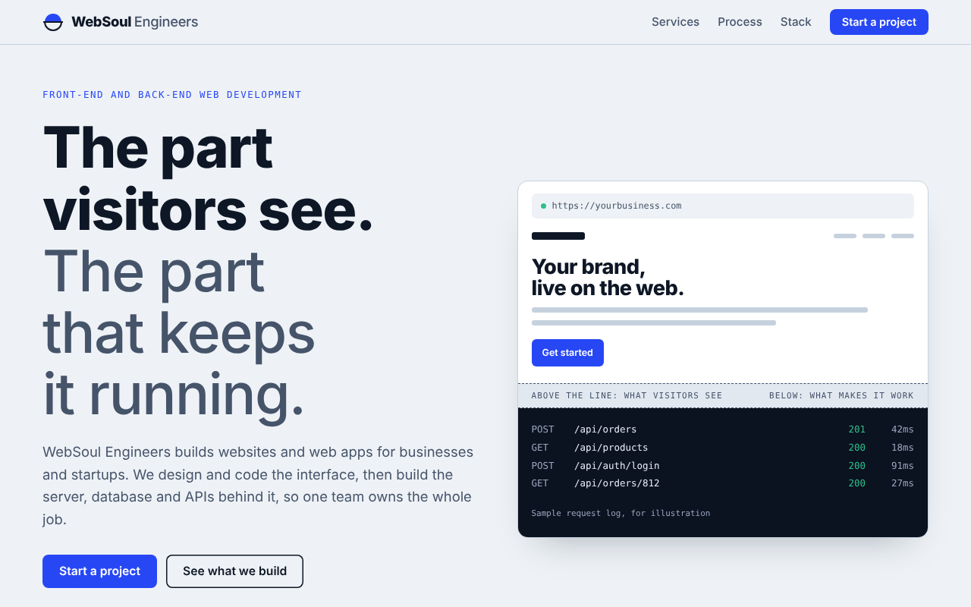
Fig. 3: Top of the page on a desktop, light theme
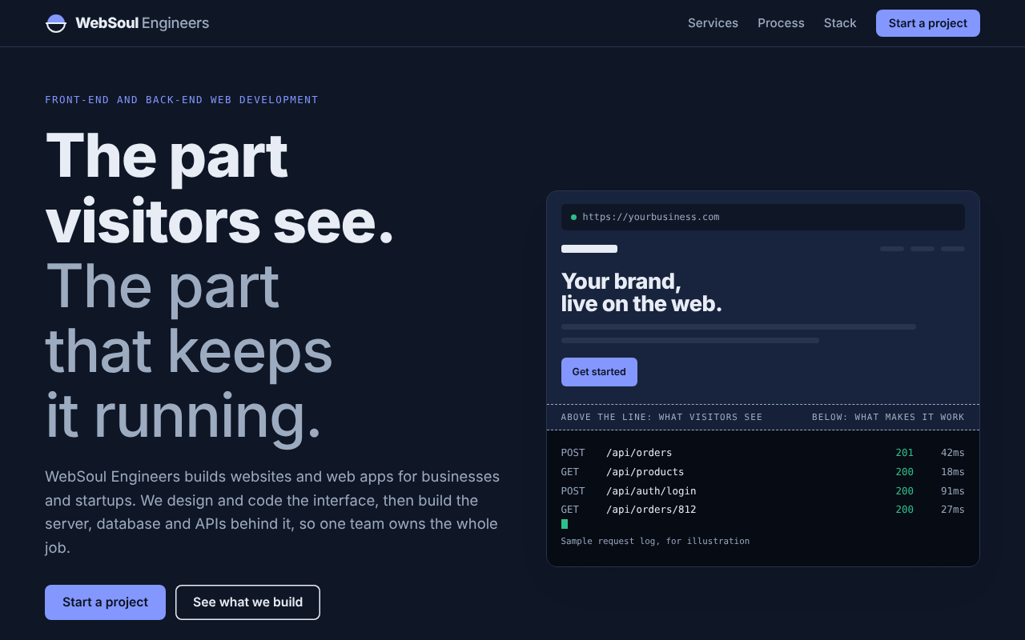
Fig. 4: Top of the page on a desktop, dark theme
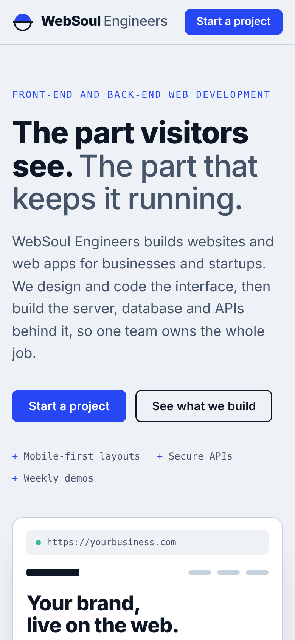
Fig. 5: Top of the page on a 390-pixel wide phone

Advantages and Limitations

Advantages
- The whole site is one self-contained file of about 27 KB, which is easy to host, copy and update.
- No framework or script library has to be maintained; the only outside resource is the font stylesheet.
- The page works from 360-pixel phones to wide desktops without sideways scrolling.
- Light and dark themes come from one set of tokens, so a colour change is made in one place.
- Services are split into front-end and back-end, so a client can see quickly what applies to them.
- The contact form helps visitors give the information needed for a first estimate.
- Accessibility basics are in place: strong contrast, visible focus, labelled fields and reduced-motion support.

Limitations
- The contact form cannot send a message by itself; the visitor has to copy the brief and send it.
- The company e-mail, phone and WhatsApp details have not been added yet and must be entered in the script.
- There are no portfolio items, client testimonials or prices yet, because the company is just starting.
- A single page can target fewer search keywords than a site with many pages.
- The typefaces depend on Google Fonts; if they cannot load, fallback fonts change the look slightly.
- Automated tests were run only in Chromium; other browsers still need manual checks.
- The timelines shown for project sizes are typical values and not promises.

Future Scope
The website is a base that can grow with the company. The following improvements are planned or possible:
- A back-end endpoint, for example Node.js with Express, that receives the brief, stores it in a database such as PostgreSQL and sends a confirmation e-mail.
- A portfolio section with case studies as soon as the first client projects are complete, followed by client testimonials.
- Separate pages for each service and a blog, to help the site appear in search results.
- A client portal where customers can follow the progress of their project and approve designs.
- Privacy-friendly analytics to learn which sections visitors read and where they leave.
- Automated deployment from a code repository and regular performance and accessibility audits.
- Manual and automated tests in more browsers, and a version of the site in Hindi.

Conclusion
This project designed and built the company website of WebSoul Engineers, a start-up offering front-end and back-end web development. The result is a responsive single page that explains the services, the working process, the project sizes and the tools, and that helps a visitor prepare a project brief. The page is built only from HTML, CSS and JavaScript, keeps its colours and fonts in a small set of tokens, and follows the light or dark setting of the visitor's device.
Tests in a real browser confirmed that the page does not scroll sideways from 360 to 1920 pixels, that the navigation, form, copy button and both themes behave as designed, and that all measured text colours are well above the contrast level recommended by WCAG 2.1. The main gap is that the contact form cannot yet send messages. Adding a small back-end service is the natural next step, and it would also let the company show its own back-end skills on its own website.

References
- MDN Web Docs. CSS Grid Layout, Flexbox, CSS Custom Properties and the prefers-color-scheme media feature. Mozilla. https://developer.mozilla.org
- MDN Web Docs. Clipboard API. Mozilla. https://developer.mozilla.org/en-US/docs/Web/API/Clipboard_API
- World Wide Web Consortium (W3C). Web Content Accessibility Guidelines (WCAG) 2.1. https://www.w3.org/TR/WCAG21/
- web.dev. Learn Responsive Design. Google. https://web.dev/learn/design
- Google Fonts. Bricolage Grotesque, Public Sans and JetBrains Mono. https://fonts.google.com
- Playwright. Documentation for browser automation and testing. Microsoft. https://playwright.dev
- Matplotlib. Documentation. https://matplotlib.org

