PROJECT REPORT

ON
“Trading Calculator using Python (Tkinter)”

Submitted By:
Ansh Kamboj,
UID- 26MCA20194

Submitted To:

Mr. Randeep
October 2026

University Institute of Computing
Chandigarh University,
Mohali, Punjab

ACKNOWLEDGEMENT
I deem it a pleasure to acknowledge my sense of gratitude to my project guide Miss Shruti under whom I have carried out the project work.
Her incisive and objective guidance and timely advice encouraged me with a constant flow of energy to continue the work.
I wish to reciprocate in full measure the kindness shown by the Head of the Department, University Institute of Computing, whose valuable suggestions inspired me in successfully completing the project work.
I shall remain grateful to the Additional Director, University Institute of Computing, for providing a strong academic atmosphere by enforcing strict discipline to do the project work with utmost concentration and dedication.
Finally, I must say that no height is ever achieved without some sacrifices made at some end and it is here where I owe my special debt to my parents and my friends for showing their generous love and care throughout the entire period.

Date: 30.10.2026
Place: Chandigarh University, Mohali, Punjab

Ansh Kamboj, UID- 26MCA20194

ABSTRACT
Traders depend on a handful of calculations before and after every trade, yet these are often done by hand or with scattered online tools, which invites costly mistakes. This project, “Trading Calculator using Python (Tkinter),” presents the design and implementation of a stand-alone desktop application that brings four of the most common risk-management calculators into one window: position size, profit and loss, risk/reward and margin and leverage.
The system is written in Python 3 using only its standard library. The calculation logic is placed in the module calculations.py as four independent functions, namely position_size, profit_loss, risk_reward and margin_leverage, each of which validates its inputs, raises a ValueError for impossible values and returns a dictionary of labelled results. The graphical interface in main.py is built with Tkinter and ttk. A single reusable class, CalculatorTab, creates every tab from a list of field descriptions, reads and converts the entries, calls the calculation function and displays the formatted answer.
Fixed-fractional position sizing, gross and net profit with trading fees for both long and short trades, the risk/reward ratio with its break-even win rate, and the margin and approximate liquidation price of a leveraged position are all implemented. Wrong input such as text, empty fields, zero or negative prices, or an entry price equal to the stop loss is rejected with a clear message box instead of a crash or a misleading result.
The project uses important Python concepts including functions with default arguments, dictionaries, classes and inheritance, callbacks, exception handling, f-string formatting and the Tkinter widget set. Six automated unit tests written with the unittest module verify the formulas and the error handling, and all of them pass. The separation of logic from interface makes the program easy to test and extend, and the same functions can later be connected to a web page, a trade journal or live market data.

TABLE OF CONTENTS

Introduction 1
Objective 1
Background 1
Scope of the Project 2
System Requirements 3
Hardware Requirements 3
Software Requirements 3
System Analysis 4
Limitations of the Existing System 4
Proposed System 4
Functional Modules 4
Validation Rules 4
Program Design 5
Formulas Used 5
Function Specifications 6
System Design and Program Flow 7
Architecture 7
Flow of a Calculation 7
Input Validation and Error Handling 8
Implementation 9
Step 1: Creating the Calculation Module 9
Step 2: Creating the Input Form and Helper Function 10
Step 3: Building the Main Window 11
Step 4: Writing the Unit Tests 12
Step 5: Running the Application 13
Testing and Results 14
Test Cases 14
Sample Output 14
Advantages and Limitations 16
Advantages 16
Limitations 16
Future Scope 17
Conclusion 18
References 19

Introduction
Risk management is the part of trading that decides whether an account survives a bad week. Before every trade a trader has to answer a few simple but important questions: how many units can I buy without risking more than a fixed part of my capital, how much will I really earn or lose after fees, is the reward worth the risk, and how much margin will the position block? Answering these questions by hand with a pocket calculator is slow, and a single slip in a decimal place can turn a planned 1 percent risk into a 10 percent loss.
This project implements a desktop application named Trading Calculator using Python and its standard graphical toolkit Tkinter. The application groups four everyday calculators in one window: Position Size, Profit / Loss, Risk / Reward and Margin & Leverage. The user types the values in labelled boxes, presses the Calculate button and immediately receives a neatly aligned result table. Wrong or missing values are rejected with a clear message instead of a wrong answer.
The program is divided into two files. The file calculations.py contains the mathematics as ordinary Python functions that know nothing about the screen, and the file main.py contains the Tkinter interface that collects the inputs and shows the results. A third file, test_calculations.py, checks every function automatically with the unittest module. This separation keeps the code easy to read, easy to test and easy to extend.

Objective
The main objective of this project is to build a simple, reliable and easy-to-use desktop tool that performs the common pre-trade and post-trade calculations of a trader. The specific objectives are:
- To calculate the correct position size from the account balance, the percentage of capital risked, the entry price and the stop-loss price.
- To calculate gross profit or loss, trading fees, net profit or loss and return on position for both Buy (long) and Sell (short) trades.
- To calculate the risk/reward ratio of a trade and the break-even win rate that this ratio requires.
- To calculate the margin required for a leveraged position and an approximate liquidation price.
- To validate every input and report errors through message boxes instead of crashing or giving misleading output.
- To separate the calculation logic from the user interface and to verify the logic with automated unit tests.

Background
Traders in the stock, forex, commodity and crypto markets commonly follow a rule such as “never risk more than 1 or 2 percent of the account on a single trade”. To follow this rule the trader first decides where the stop loss will be placed and only then works backwards to find how many units can be bought. This technique is called fixed-fractional position sizing. Two other ideas are equally important: the risk/reward ratio, which compares the possible gain with the possible loss, and leverage, which allows a position larger than the capital to be opened by blocking only a fraction of its value as margin.
Python is a good language for such a tool because its syntax is short and readable, floating-point arithmetic is built in and its standard library already includes Tkinter for graphical windows and unittest for testing. No third-party package has to be installed, so the application runs on any computer that has Python.

Scope of the Project
The project covers a stand-alone desktop calculator for one trade at a time. It does not connect to a broker, does not download live prices and does not store trade history. All the values are entered by the user and all the results are computed locally. The functions in calculations.py have no dependency on Tkinter, so they can be reused in a web application, a command-line tool or a trading journal in future.

System Requirements
The following hardware and software environment is required to run the Trading Calculator.

Hardware Requirements
- Processor: Intel Core i3 or AMD equivalent (32-bit or 64-bit) or higher.
- RAM: Minimum 2 GB (4 GB recommended).
- Hard Disk Space: Less than 500 MB of free space for Python, the editor and the project files.
- Display: 1366 x 768 resolution or higher (the window has a fixed size and cannot be resized).

Software Requirements
Table 1: Software used in the project
Component | Specification
Language | Python 3.8 or later
GUI Toolkit | Tkinter with the themed widgets of tkinter.ttk (part of the Python standard library)
Testing Framework | unittest (part of the Python standard library)
Editor / IDE | Visual Studio Code, IDLE or PyCharm
Operating System | Windows 10 / 11 (64-bit); also runs on Linux and macOS
External Packages | None required
Documentation | Microsoft Word, draw.io / Python (matplotlib) for diagrams

Note: the interface requests the Segoe UI and Consolas fonts, which are installed by default on Windows. On other systems Tkinter automatically substitutes a similar font.

System Analysis

Limitations of the Existing System
- Manual calculation with a pocket calculator is slow and a small slip in a decimal place can change the risk of a trade completely.
- Spreadsheets need formulas to be written and protected, and they accept any value, including zero or negative prices, without a warning.
- Many online calculators contain advertisements, need an internet connection, cover only one calculation and often ignore trading fees.

Proposed System
The proposed system is a single offline desktop window with one tab for each calculator. Every tab is created from the same reusable class, CalculatorTab, which receives the list of input fields, the calculation function and a title. When the user presses Calculate, the tab converts the typed text into numbers, calls the function from calculations.py and prints the returned dictionary as aligned lines in a read-only result box. A ValueError from the function is shown in an error dialog.

Functional Modules
Table 2: Modules of the system
Module | Description
Position Size | Finds how many units to trade so that a stop-loss hit loses only the chosen percentage of the balance; optionally reports the potential reward and risk/reward ratio.
Profit / Loss | Calculates gross profit or loss, total fees, net profit or loss and the return on position for a Buy or Sell trade.
Risk / Reward | Calculates risk per unit, reward per unit, the risk/reward ratio and the break-even win rate.
Margin & Leverage | Calculates the margin needed for a position and an approximate liquidation price.
Input and Result Handling | The CalculatorTab class reads and converts the entries, handles optional fields and shows the result; fmt() formats the numbers.
Testing | Six unittest test cases verify the formulas and the rejection of invalid data.

Validation Rules
- Position Size: balance, risk percentage, entry price and stop-loss price must be positive, and the entry price must differ from the stop-loss price.
- Profit / Loss: entry price, exit price and quantity must be positive and the fee percentage must not be negative.
- Risk / Reward: entry, stop-loss and target prices must be positive and the entry price must differ from the stop-loss price.
- Margin & Leverage: position value must be positive and leverage must be at least 1.
- Every number field must hold a valid number; only the optional fields may be left empty.

Program Design
The program follows a two-layer design. The presentation layer (main.py) is responsible only for windows, buttons and text boxes, and the logic layer (calculations.py) is responsible only for numbers. Each calculator is a Python function that receives plain numbers and returns an ordered dictionary whose keys are the labels shown to the user. Because the labels are part of the dictionary, the interface needs no special code for each calculator. Figure 1 shows the structure of the project.
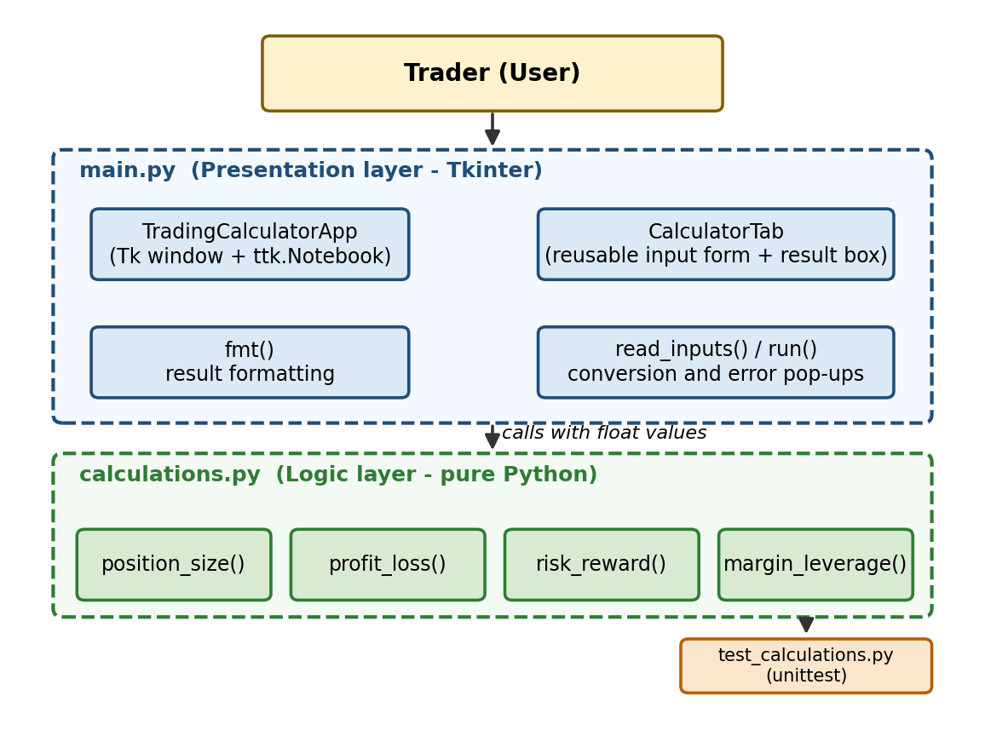
Figure 1: Structure of the Trading Calculator project

Formulas Used
Table 3 lists every formula that is implemented in calculations.py. The symbol | | means the absolute value, so the result is the same whether the stop loss lies above or below the entry price.
Table 3: Formulas implemented in calculations.py
Quantity | Formula
Risk amount | Balance x Risk % / 100
Risk per unit | |Entry - Stop loss|
Position size (units) | Risk amount / Risk per unit
Position value | Position size x Entry
Potential reward | |Target - Entry| x Position size
Gross P/L | (Exit - Entry) x Quantity x d, where d = +1 for Buy and -1 for Sell
Total fees | (Entry + Exit) x Quantity x Fee % / 100
Net P/L | Gross P/L - Total fees
Return on position (%) | Net P/L / (Entry x Quantity) x 100
Risk/Reward ratio | |Target - Entry| / |Entry - Stop loss|
Break-even win rate (%) | 100 / (1 + Risk/Reward ratio)
Margin required | Position value / Leverage
Approx. liquidation price | Buy: Entry x (1 - 1/Leverage); Sell: Entry x (1 + 1/Leverage)

Function Specifications
Tables 4 to 7 describe the parameters and the return values of the four functions of calculations.py.
Table 4: position_size(balance, risk_pct, entry, stop_loss, target=None)
Parameter | Type | Description / Return value
balance | float | Account balance; must be positive.
risk_pct | float | Percentage of the balance to risk on the trade; must be positive.
entry | float | Planned entry price; must be positive.
stop_loss | float | Stop-loss price; must be positive and different from entry.
target | float / None | Optional target price; if given, the reward and the ratio are added.
Returns | dict | Risk amount, Risk per unit, Position size (units), Position value and, with a target, Potential reward and Risk/Reward ratio.

Table 5: profit_loss(entry, exit_price, quantity, side="Buy", fee_pct=0.0)
Parameter | Type | Description / Return value
entry | float | Price at which the position was opened; must be positive.
exit_price | float | Price at which the position was closed; must be positive.
quantity | float | Number of units traded; must be positive.
side | str | "Buy" for a long trade, anything else for a short trade.
fee_pct | float | Fee in percent charged on each side of the trade; must not be negative.
Returns | dict | Gross P/L, Total fees, Net P/L, Return on position (%) and Position value.

Table 6: risk_reward(entry, stop_loss, target)
Parameter | Type | Description / Return value
entry | float | Entry price; must be positive.
stop_loss | float | Stop-loss price; must be positive and different from entry.
target | float | Target price; must be positive.
Returns | dict | Risk per unit, Reward per unit, Risk/Reward ratio and Break-even win rate (%).

Table 7: margin_leverage(position_value, leverage, entry=None, side="Buy")
Parameter | Type | Description / Return value
position_value | float | Total value of the position; must be positive.
leverage | float | Leverage multiple; must be at least 1.
entry | float / None | Optional entry price; if given, the liquidation price is added.
side | str | "Buy" or any other value (short).
Returns | dict | Margin required and, with an entry price, Approx. liquidation price.

System Design and Program Flow

Architecture
When main.py is started, the class TradingCalculatorApp, which inherits from tk.Tk, creates the main window, applies the “clam” theme if it is available and adds a ttk.Notebook. Four objects of the class CalculatorTab are added to the notebook, one for each calculator. A tab is described entirely by a list of tuples of the form (label, key, kind, default). The kind is “number” for a required number, “optional” for a number that may be left empty and “side” for the Buy / Sell drop-down list. The key is the name of the parameter of the calculation function, so the dictionary of inputs can be passed to the function directly with the operator.

Flow of a Calculation
The flow of every calculation is the same, whichever tab is used. The method run() reads the inputs, calls the calculation function and formats the returned dictionary. If a value is not a number or breaks a validation rule, a ValueError is raised, run() catches it and the message is shown with messagebox.showerror(). Otherwise each result is formatted by fmt() and written into the result box. The flow is shown in Figure 2.
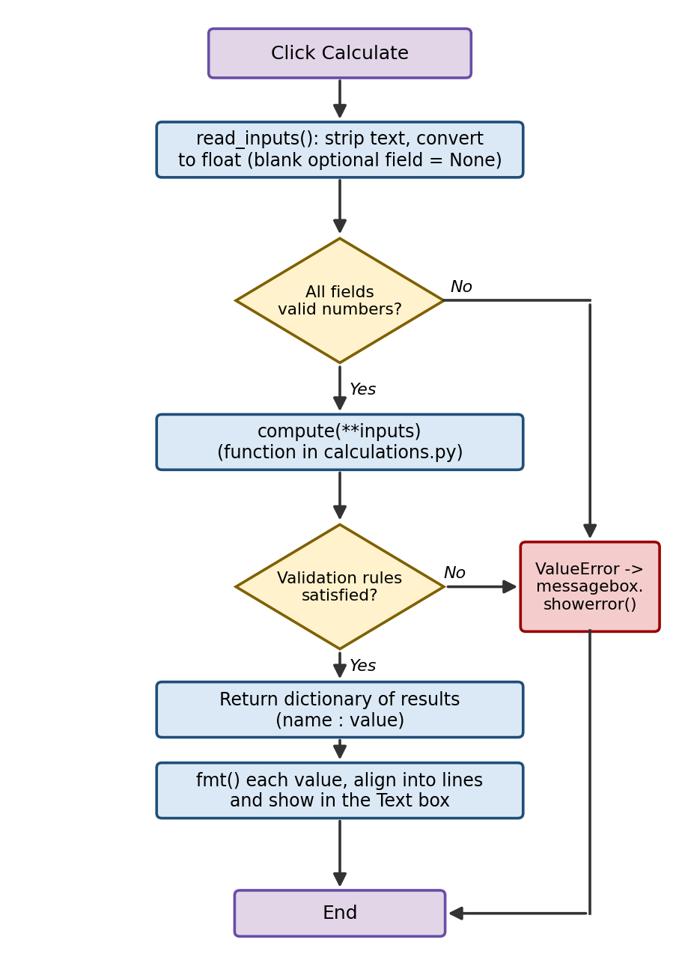
Figure 2: Flowchart of the Calculate button

Input Validation and Error Handling
Table 8: How wrong input is handled
Layer | Situation | Behaviour
read_inputs() | A required field is empty or contains text such as abc | Raises ValueError: ‘<text>’ is not a valid number.
read_inputs() | An optional field is left empty | The value None is passed, so the optional part is skipped.
calculations.py | A price, quantity or balance is zero or negative | Raises ValueError with a message naming the fields that must be positive.
calculations.py | Entry price equals stop-loss price | Raises ValueError, which also prevents division by zero.
calculations.py | Fee is negative or leverage is below 1 | Raises ValueError with an explanatory message.
run() | Any ValueError is raised | Shown in an “Invalid input” dialog; the old result is not changed.

Division by zero: the risk per unit is the denominator of the position-size and risk/reward formulas. Because the functions test for an entry price equal to the stop-loss price before dividing, a ZeroDivisionError can never reach the user.

Implementation
The implementation is divided into five steps: writing the calculation module, writing the input form and the helper function, building the main window, writing the unit tests and finally running the program. The code was written for Python 3 and uses only the standard library. The Python features used in the project are summarised in Table 9.
Table 9: Python concepts used
Concept | Where it is used
Functions with default arguments | position_size(..., target=None), profit_loss(..., side="Buy", fee_pct=0.0)
Dictionaries | Every calculation returns a dictionary of label-value pairs
Exception handling | raise ValueError in calculations.py; try / except ValueError in read_inputs() and run()
Classes and inheritance | CalculatorTab(ttk.Frame) and TradingCalculatorApp(tk.Tk)
Functions as arguments | The calculation function is passed to CalculatorTab and stored as self.compute
Keyword-argument unpacking | self.compute(self.read_inputs())
String formatting | f-strings with width specifiers: f"{name:<26}{fmt(val):>12}"
Tkinter widgets | Notebook, Frame, Label, Entry, Combobox, Button, Text and messagebox
Unit testing | unittest.TestCase with assertAlmostEqual and assertRaises

Step 1: Creating the Calculation Module
The file calculations.py holds the four calculation functions. Each function first validates its arguments and raises a ValueError with a meaningful message if they are not acceptable, and then performs the arithmetic and returns a dictionary. The module imports nothing and has no knowledge of Tkinter.
Listing 1: calculations.py
def position_size(balance, risk_pct, entry, stop_loss, target=None):

if balance <= 0 or risk_pct <= 0 or entry <= 0 or stop_loss <= 0:
raise ValueError("Balance, risk %, entry and stop loss must be positive.")
per_unit_risk = abs(entry - stop_loss)
if per_unit_risk == 0:
raise ValueError("Entry and stop loss cannot be the same price.")

risk_amount = balance * risk_pct / 100
quantity = risk_amount / per_unit_risk
result = {
"Risk amount": risk_amount,
"Risk per unit": per_unit_risk,
"Position size (units)": quantity,
"Position value": quantity * entry,
}
if target:
reward = abs(target - entry) * quantity
result["Potential reward"] = reward
result["Risk/Reward ratio"] = reward / risk_amount
return result

def profit_loss(entry, exit_price, quantity, side="Buy", fee_pct=0.0):

if entry <= 0 or exit_price <= 0 or quantity <= 0:
raise ValueError("Entry, exit and quantity must be positive.")
if fee_pct < 0:
raise ValueError("Fee cannot be negative.")

direction = 1 if side == "Buy" else -1
gross = (exit_price - entry) * quantity * direction
fees = (entry + exit_price) * quantity * fee_pct / 100
net = gross - fees
invested = entry * quantity
return {
"Gross P/L": gross,
"Total fees": fees,
"Net P/L": net,
"Return on position (%)": net / invested * 100,
"Position value": invested,
}

def risk_reward(entry, stop_loss, target):

if entry <= 0 or stop_loss <= 0 or target <= 0:
raise ValueError("Entry, stop loss and target must be positive.")
risk = abs(entry - stop_loss)
reward = abs(target - entry)
if risk == 0:
raise ValueError("Entry and stop loss cannot be the same price.")
ratio = reward / risk
return {
"Risk per unit": risk,
"Reward per unit": reward,
"Risk/Reward ratio": ratio,
"Break-even win rate (%)": 100 / (1 + ratio),
}

def margin_leverage(position_value, leverage, entry=None, side="Buy"):

if position_value <= 0 or leverage < 1:
raise ValueError("Position value must be positive and leverage at least 1.")
result = {"Margin required": position_value / leverage}
if entry:
move = 1 / leverage
liq = entry * (1 - move) if side == "Buy" else entry * (1 + move)
result["Approx. liquidation price"] = liq
return result

Step 2: Creating the Input Form and Helper Function
The first part of main.py contains the helper function fmt() and the class CalculatorTab. The function fmt() shows floats with thousand separators; numbers below 1000 keep up to four decimals with trailing zeros removed and numbers from 1000 upwards are shown with two decimals. The constructor of CalculatorTab builds one label and one entry box (or drop-down list) for every field description, the Calculate and Clear buttons and the read-only result box. The methods read_inputs(), run(), show() and clear() implement the behaviour described in the previous chapter.
Listing 2: Helper function and CalculatorTab class (main.py, part 1)
import tkinter as tk
from tkinter import ttk, messagebox

import calculations as calc

def fmt(value):

if isinstance(value, float):
return f"{value:,.4f}".rstrip("0").rstrip(".") if abs(value) < 1000 else f"{value:,.2f}"
return str(value)

class CalculatorTab(ttk.Frame):

def __init__(self, parent, fields, compute, title):
super().__init__(parent, padding=15)
self.compute = compute
self.vars = {}

ttk.Label(self, text=title, font=("Segoe UI", 13, "bold")).grid(
row=0, column=0, columnspan=2, sticky="w", pady=(0, 10)
)

row = 1
for label, key, kind, default in fields:
ttk.Label(self, text=label).grid(row=row, column=0, sticky="w", pady=4)
var = tk.StringVar(value=default)
if kind == "side":
widget = ttk.Combobox(self, textvariable=var, values=["Buy", "Sell"],
state="readonly", width=18)
else:
widget = ttk.Entry(self, textvariable=var, width=20)
widget.grid(row=row, column=1, sticky="e", pady=4, padx=(15, 0))
self.vars[key] = (var, kind)
row += 1

btns = ttk.Frame(self)
btns.grid(row=row, column=0, columnspan=2, pady=12, sticky="ew")
ttk.Button(btns, text="Calculate", command=self.run).pack(side="left", expand=True, fill="x")
ttk.Button(btns, text="Clear", command=self.clear).pack(side="left", expand=True, fill="x", padx=(8, 0))

self.result = tk.Text(self, height=9, width=38, state="disabled",
font=("Consolas", 10), relief="solid", borderwidth=1)
self.result.grid(row=row + 1, column=0, columnspan=2, sticky="nsew")
self.columnconfigure(1, weight=1)

def read_inputs(self):
values = {}
for key, (var, kind) in self.vars.items():
text = var.get().strip()
if kind == "side":
values[key] = text
elif kind == "optional" and text == "":
values[key] = None
else:
try:
values[key] = float(text)
except ValueError:
raise ValueError(f"'{text}' is not a valid number.")
return values

def run(self):
try:
output = self.compute(**self.read_inputs())
except ValueError as err:
messagebox.showerror("Invalid input", str(err))
return
lines = [f"{name:<26}{fmt(val):>12}" for name, val in output.items()]
self.show("\n".join(lines))

def show(self, text):
self.result.config(state="normal")
self.result.delete("1.0", "end")
self.result.insert("1.0", text)
self.result.config(state="disabled")

def clear(self):
for var, kind in self.vars.values():
if kind != "side":
var.set("")
self.show("")

Step 3: Building the Main Window
The class TradingCalculatorApp creates the window, fixes its size and adds the four tabs. The default values of the fields (for example 10000 for the balance and 1 percent for the risk) save typing for the most common case. The last two lines start the Tkinter event loop when the file is run directly.
Listing 3: Main window (main.py, part 2)
class TradingCalculatorApp(tk.Tk):
def __init__(self):
super().__init__()
self.title("Trading Calculator")
self.resizable(False, False)

style = ttk.Style(self)
if "clam" in style.theme_names():
style.theme_use("clam")

notebook = ttk.Notebook(self, padding=5)
notebook.pack(fill="both", expand=True)

notebook.add(CalculatorTab(
notebook,
[("Account balance", "balance", "number", "10000"),
("Risk per trade (%)", "risk_pct", "number", "1"),
("Entry price", "entry", "number", ""),
("Stop loss price", "stop_loss", "number", ""),
("Target price (optional)", "target", "optional", "")],
calc.position_size, "Position Size"), text="Position Size")

notebook.add(CalculatorTab(
notebook,
[("Side", "side", "side", "Buy"),
("Entry price", "entry", "number", ""),
("Exit price", "exit_price", "number", ""),
("Quantity", "quantity", "number", ""),
("Fee per side (%)", "fee_pct", "number", "0")],
calc.profit_loss, "Profit / Loss"), text="Profit / Loss")

notebook.add(CalculatorTab(
notebook,
[("Entry price", "entry", "number", ""),
("Stop loss price", "stop_loss", "number", ""),
("Target price", "target", "number", "")],
calc.risk_reward, "Risk / Reward"), text="Risk / Reward")

notebook.add(CalculatorTab(
notebook,
[("Side", "side", "side", "Buy"),
("Position value", "position_value", "number", ""),
("Leverage (x)", "leverage", "number", "10"),
("Entry price (optional)", "entry", "optional", "")],
calc.margin_leverage, "Margin & Leverage"), text="Margin")

if __name__ == "__main__":
TradingCalculatorApp().mainloop()

Step 4: Writing the Unit Tests
The file test_calculations.py contains six test cases. Floating-point results are compared with assertAlmostEqual because binary floating-point numbers cannot always represent decimal values exactly, and invalid data is checked with assertRaises.
Listing 4: test_calculations.py
import unittest
import calculations as calc

class TestCalculations(unittest.TestCase):
def test_position_size(self):
r = calc.position_size(10000, 1, 100, 95, target=110)
self.assertAlmostEqual(r["Risk amount"], 100)
self.assertAlmostEqual(r["Position size (units)"], 20)
self.assertAlmostEqual(r["Risk/Reward ratio"], 2)

def test_profit_loss_buy_and_sell(self):
self.assertAlmostEqual(calc.profit_loss(100, 110, 10, "Buy")["Net P/L"], 100)
self.assertAlmostEqual(calc.profit_loss(100, 90, 10, "Sell")["Net P/L"], 100)

def test_profit_loss_fees(self):
r = calc.profit_loss(100, 110, 10, "Buy", fee_pct=0.1)
self.assertAlmostEqual(r["Total fees"], 2.1)
self.assertAlmostEqual(r["Net P/L"], 97.9)

def test_risk_reward(self):
r = calc.risk_reward(100, 95, 115)
self.assertAlmostEqual(r["Risk/Reward ratio"], 3)
self.assertAlmostEqual(r["Break-even win rate (%)"], 25)

def test_margin_leverage(self):
r = calc.margin_leverage(10000, 10, entry=100, side="Buy")
self.assertAlmostEqual(r["Margin required"], 1000)
self.assertAlmostEqual(r["Approx. liquidation price"], 90)

def test_bad_input(self):
with self.assertRaises(ValueError):
calc.position_size(10000, 1, 100, 100)
with self.assertRaises(ValueError):
calc.margin_leverage(1000, 0.5)

if __name__ == "__main__":
unittest.main()

Step 5: Running the Application
Both programs are started from a terminal opened in the project folder. The first command opens the Trading Calculator window and the second command runs the unit tests with a line of output for every test.
Listing 5: Commands to run the project
python main.py
python -m unittest -v test_calculations

Testing and Results
The project was tested at two levels. The formulas were verified with automatic unit tests, and invalid inputs were checked to confirm that every wrong request is rejected with a clear message. All sample values below were also checked by hand against the formulas of Table 3.

Test Cases
Table 10: Unit test cases
Test method | Input | Expected result | Status
test_position_size | balance 10000, risk 1 %, entry 100, stop 95, target 110 | Risk amount 100, size 20 units, R/R 2 | Pass
test_profit_loss_buy_and_sell | Buy 100 to 110 and Sell 100 to 90, 10 units | Net P/L 100 in both cases | Pass
test_profit_loss_fees | Buy 100 to 110, 10 units, fee 0.1 % | Fees 2.1, Net P/L 97.9 | Pass
test_risk_reward | entry 100, stop 95, target 115 | Ratio 3, break-even win rate 25 % | Pass
test_margin_leverage | value 10000, leverage 10, entry 100, Buy | Margin 1000, liquidation 90 | Pass
test_bad_input | entry = stop loss; leverage 0.5 | ValueError in both cases | Pass

Table 11: Invalid-input test cases
Tab | Invalid input | Message shown
Any tab | Required field left empty | ‘’ is not a valid number.
Any tab | Text such as abc in a number field | ‘abc’ is not a valid number.
Position Size | Balance -500 | Balance, risk %, entry and stop loss must be positive.
Position Size | Entry 100 and stop loss 100 | Entry and stop loss cannot be the same price.
Risk / Reward | Entry 100 and stop loss 100 | Entry and stop loss cannot be the same price.
Profit / Loss | Fee per side -0.1 | Fee cannot be negative.
Margin | Leverage 0.5 | Position value must be positive and leverage at least 1.

Sample Output
Output 1 shows the result of running the unit tests. All six tests pass.
Output 1: Result of the unit tests
test_bad_input (test_calculations.TestCalculations.test_bad_input) ... ok
test_margin_leverage (test_calculations.TestCalculations.test_margin_leverage) ... ok
test_position_size (test_calculations.TestCalculations.test_position_size) ... ok
test_profit_loss_buy_and_sell (test_calculations.TestCalculations.test_profit_loss_buy_and_sell) ... ok
test_profit_loss_fees (test_calculations.TestCalculations.test_profit_loss_fees) ... ok
test_risk_reward (test_calculations.TestCalculations.test_risk_reward) ... ok

----------------------------------------------------------------------
Ran 6 tests in 0.000s

OK

Outputs 2 to 5 show the text that appears in the result box of each tab. For the Position Size tab the inputs are an account balance of 10000, a risk of 1 percent, an entry price of 100, a stop loss of 95 and a target of 110. The risk amount is 10000 x 1 / 100 = 100, the risk per unit is 5, so 100 / 5 = 20 units can be bought; the position value is 20 x 100 = 2000 and the reward is 10 x 20 = 200, giving a ratio of 2.
Output 2: Position Size tab
Risk amount 100
Risk per unit 5
Position size (units) 20
Position value 2,000.00
Potential reward 200
Risk/Reward ratio 2

For the Profit / Loss tab the inputs are a Buy trade with entry 100, exit 110, quantity 10 and a fee of 0.1 percent per side. The gross profit is 10 x 10 = 100, the fees are (100 + 110) x 10 x 0.1 / 100 = 2.1 and the net profit is 97.9, which is 9.79 percent of the invested 1000.
Output 3: Profit / Loss tab
Gross P/L 100
Total fees 2.1
Net P/L 97.9
Return on position (%) 9.79
Position value 1,000.00

For the Risk / Reward tab the inputs are entry 100, stop loss 95 and target 115. The risk is 5, the reward is 15 and the ratio is 3, so the trade is profitable in the long run if more than 100 / (1 + 3) = 25 percent of such trades win.
Output 4: Risk / Reward tab
Risk per unit 5
Reward per unit 15
Risk/Reward ratio 3
Break-even win rate (%) 25

For the Margin tab the inputs are a Buy position of 10000 with 10x leverage and an entry price of 100. The margin is 10000 / 10 = 1000 and the approximate liquidation price is 100 x (1 - 1/10) = 90.
Output 5: Margin tab
Margin required 1,000.00
Approx. liquidation price 90

Table 12: Additional sample calculations
Tab | Inputs | Key results
Position Size | Balance 25000, risk 2 %, entry 1850.5, stop 1832, target 1905 | Risk 500; size 27.027 units; value 50,013.51; R/R 2.9459
Profit / Loss | Sell, entry 2500, exit 2450, quantity 4, fee 0.05 % | Gross 200; fees 9.9; net 190.1; return 1.901 %
Risk / Reward | Entry 1850.5, stop 1832, target 1905 | Ratio 2.9459; break-even win rate 25.3425 %
Margin | Sell, position value 50000, leverage 5x, entry 2000 | Margin 10,000.00; liquidation 2,400.00

Advantages and Limitations

Advantages
- Four commonly used trading calculations are available in one offline window with no installation of extra packages.
- The mathematics is separated from the interface, so it can be tested and reused independently.
- One reusable class creates all the tabs, so a new calculator needs only a function and a list of fields.
- Invalid or missing input is reported with a clear message instead of a crash or a wrong result.
- Both Buy and Sell trades are supported, and trading fees are included in the profit and loss.
- Automatic unit tests give confidence that future changes do not break the formulas.

Limitations
- The application performs calculations only; it does not connect to a broker, fetch prices or save trade history.
- The position-size and risk/reward functions use absolute differences, so they do not check that the stop loss and target lie on the correct side of the entry price for the chosen direction.
- The liquidation price is only approximate because it ignores maintenance margin, funding rates and fees.
- The Clear button empties every entry, including the fields that had default values (such as fee and leverage), which must then be typed again.
- The window has a fixed size, a single currency-less number format and no support for different languages.
- The Tkinter interface itself is not covered by automated tests; only the calculation module is.

Future Scope
- Add a trade journal that stores every calculation in a CSV file or an SQLite database and shows statistics such as win rate and average R multiple.
- Fetch live prices from a broker or exchange API so that the entry price can be filled automatically.
- Add validation that the stop loss and target are on the correct side of the entry price for a Buy or a Sell trade.
- Add more calculators such as pip value, average entry price for scaled positions, compounding growth and drawdown recovery.
- Use maintenance-margin and fee data of real exchanges to give a more accurate liquidation price.
- Add a dark theme, a resizable window, currency symbols and the option to export results as PDF or Excel.
- Package the program as a Windows executable with PyInstaller so that it can be shared without installing Python.

Conclusion
The project “Trading Calculator using Python (Tkinter)” shows how a small but useful desktop application can be built with only the Python standard library. The four calculators for position size, profit and loss, risk/reward and margin turn the most common risk-management formulas into a single, easy-to-use window. Strong validation protects the user from invalid prices and impossible values, and the clear messages explain what has to be corrected.
The design principle of separating the calculation logic in calculations.py from the interface in main.py made the program simple to test and simple to extend: the six unit tests verify the formulas without opening a window, and a new calculator can be added with one function and one list of fields. Through this project the author gained practical experience in Python programming, GUI development with Tkinter, exception handling, unit testing and the basic ideas of position sizing and leverage. The application can be extended into a complete trading assistant by adding live data, a trade journal and more calculators.

References
- Python Software Foundation. tkinter — Python interface to Tcl/Tk. Python 3 Documentation. Available at https://docs.python.org/3/library/tkinter.html
- Python Software Foundation. unittest — Unit testing framework. Python 3 Documentation. Available at https://docs.python.org/3/library/unittest.html
- Python Software Foundation. The Python Tutorial. Available at https://docs.python.org/3/tutorial/
- Grayson, J. E. Python and Tkinter Programming. Manning Publications.
- Lutz, M. Learning Python. O’Reilly Media.
- Tharp, V. K. Trade Your Way to Financial Freedom. McGraw-Hill Education.

