**COFFEE SALES REPORT ANALYSIS**

**☕ Coffee Shop Sales – Power BI Dashboard**

This project analyzes **coffee shop sales data** using **SQL for data transformation** and **Power BI for visualization**. It highlights sales performance, customer demand trends, and key growth metrics across different dimensions such as Date & Time, Store locations, and Product categories, Day & Hours and Trend Over the Period.

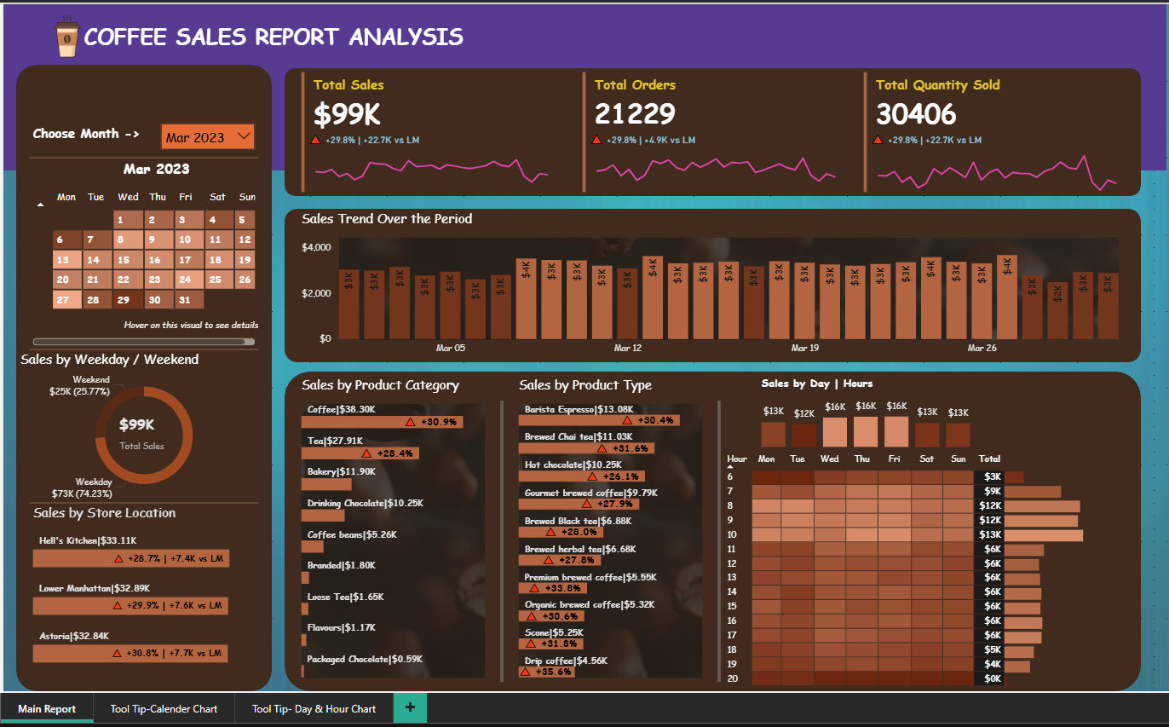

**🔑 Key Insights & Metrics**

* **Total Sales, Orders & Quantity** – Overall revenue, number of transactions, and items sold for the selected month (e.g., May).
* **Month-over-Month Growth (MoM)** – Calculated KPIs showing percentage change in sales, orders, and quantity compared to the previous month.
* **Daily Trends** – Breakdown of sales per day with comparison against average daily sales to highlight **above vs below average days**.
* **Sales by Time** – Analysis of sales by **hour of day** and **day of week (Mon–Sun)** to identify peak sales periods.
* **Weekday vs Weekend Performance** – Distinguishes sales behavior between weekdays and weekends.
* **Store & Product Analysis**
  + Sales by **store location** to compare branch performance.
  + Sales by **product category** (e.g., coffee, tea, bakery).
  + **Top 10 best-selling products**.
* **Calendar-based KPIs** – Ability to track daily sales, orders, and quantity for any given date.

**⚙️ Data Preparation (SQL)**

* Converted transaction date & time columns into proper **DATE** and **TIME** formats.
* Cleaned column names (e.g., fixed transaction_id).
* Created **aggregated queries** for sales, orders, and quantity at **daily, monthly, and hourly levels**.
* Used **window functions (LAG)** to calculate MoM difference and growth %.

**📊 Dashboard Features**

* Interactive visuals to track **Total Sales, Orders, Quantity KPIs**.
* Trend charts for **daily sales vs average sales**.
* Comparison of **weekday vs weekend sales performance**.
* Drilldowns by **location, product category, and product type**.
* Hourly sales distribution for operational insights.
* Applied **hover** for the better and quick visualization of **Total Sales**

👉 This dashboard enables the coffee shop management to:

* Monitor business performance at a glance.
* Identify peak business hours and high-performing products.
* Compare month-over-month growth to track business health.
* Make data-driven decisions for **inventory, staffing, and promotions**.