1. Find local IP address:

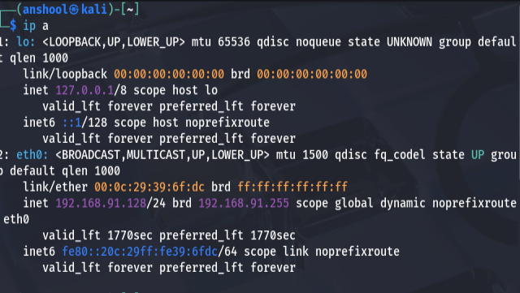

1. Find the all open ports:

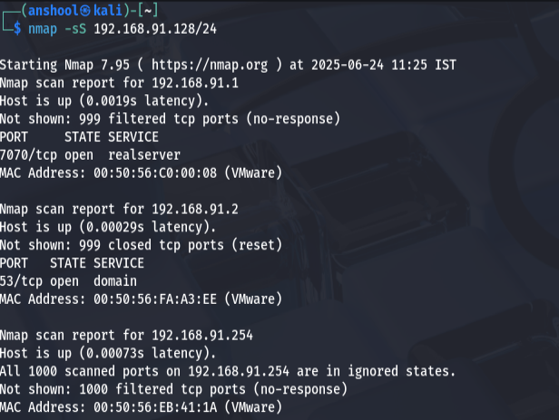

1. Using wireshark capture packets

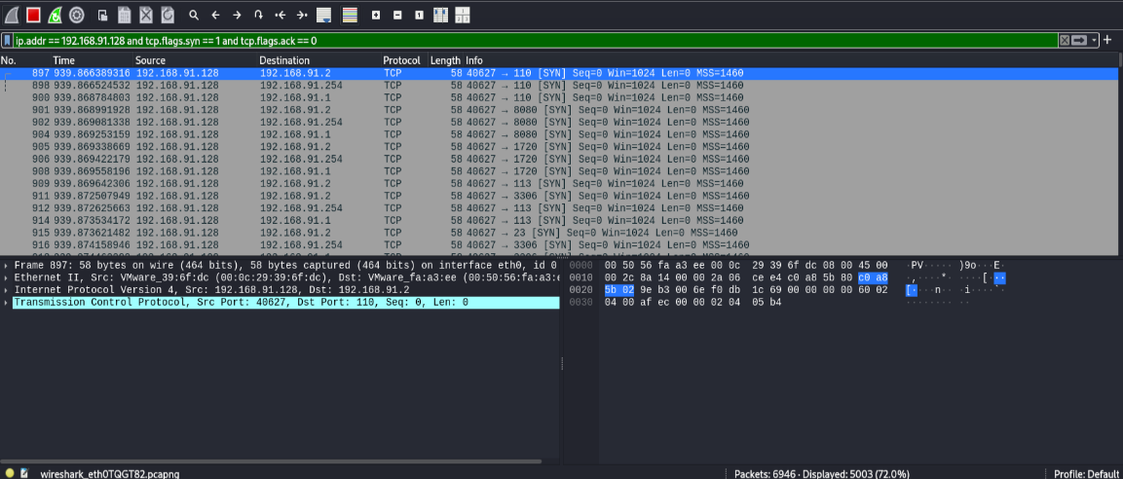

1. Research on the open ports.

* **Port 53 (TCP/UDP) – DNS (Domain Name System)**
* **Purpose**: Resolves domain names (like google.com) to IP addresses.
* **Common Use**:
  + Used by DNS servers like BIND, dnsmasq, Unbound.
* **Risks**:
  + If open to the internet, **can be exploited for DNS amplification attacks** (DDoS).
  + Misconfigured DNS may allow zone transfers (AXFR) exposing internal records.
* **Port 7070 (TCP) – Custom / Proxy / Streaming**
* **Purpose**: Not officially reserved, but commonly used for:
  + **RealNetworks RealServer** (streaming media)
  + **Proxy servers**, like **Sock proxy**, or internal admin tools
* **Risks**:
  + May expose **unauthenticated internal tools**, **custom web services**, or **poorly secured admin panels**.
  + **Attackers scan this port** often for misconfigured services.