Disaster Relief Coordination Platform
A PROJECT REPORT
Submitted by
Ansh S Patel
230090116005
In partial fulfillment for the award of the degree of
BACHELOR OF ENGINEERING
in
Information Technology
C. K. Pithawala College of Engineering and Technology, Surat
 | 
Gujarat Technological University, Ahmedabad
August, 2026

 | 
C. K. Pithawala College of Engineering and Technology
Opposite Surat Airport, Behind DPS School, Near Malvan Mandir, Dumas Road, Surat

CERTIFICATE

This is to certify that the project report submitted along with the project entitled Disaster Relief Coordination Platform Web App has been carried out by Ansh S Patel under my guidance in partial fulfillment for the degree of Bachelor of Engineering in Information Technology Engineering, 7th Semester of Gujarat Technological University, Ahmedabad during the academic year 2026-27.

Prof. Disha Chavda  Internal Guide | Prof. Himani Nayak  Head of the Department
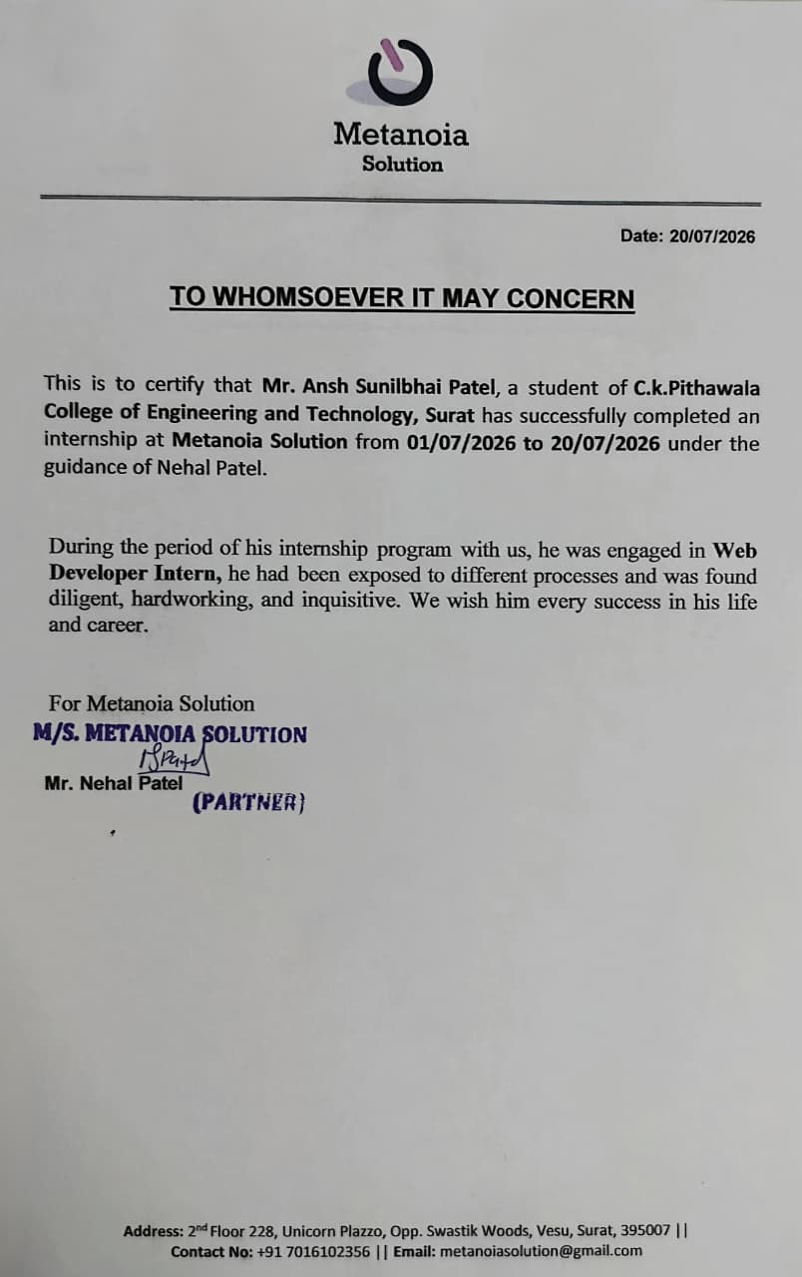
C. K. Pithawala College of Engineering and Technology
Opposite Surat Airport, Behind DPS School, Near Malvan Mandir, Dumas Road, Surat

DECLARATION

I hereby declare that the Internship report submitted along with the Internship entitled Disaster Relief Coordination Platform submitted in partial fulfillment for the degree of Bachelor of Engineering in Information Technology Engineering to Gujarat Technological University, Ahmedabad, is a bonafide record of original project work carried out by me at Metanoia Solution under the supervision of Nehal Patel and that no part of this report has been directly copied from any students’ reports or taken from any other source, without providing due reference.


Ansh S Patel
230090116005

ACKNOWLEGMENT
I would like to express my sincere gratitude to Metanoia Solution for providing me with the opportunity to undertake my internship as a Web Developer Intern. This internship has been an invaluable learning experience that allowed me to gain practical exposure to modern web development technologies, software development practices, and the professional work environment.
I am deeply thankful to my internship mentor, Mr. Nehal Patel, for his constant guidance, encouragement, technical support, and valuable suggestions throughout the internship period. His expertise and constructive feedback helped me successfully complete my project and enhanced my understanding of real-world software development.
I would also like to express my heartfelt gratitude to the management and all the team members of Metanoia Solution for their cooperation, motivation, and friendly work environment..
I sincerely thank the faculty members of the Information Technology Department, C. K. Pithawala College of Engineering and Technology, Surat, for providing continuous guidance and encouragement throughout my internship. Their academic support played a significant role in helping me bridge the gap between theoretical knowledge and practical implementation.
During this internship, I successfully designed and developed the Disaster Relief Coordination Platform, a full-stack MERN web application that enables efficient coordination among citizens, volunteers, NGOs, and government authorities during disaster situations. The project enhanced my knowledge of React.js, Node.js, Express.js, MongoDB Atlas, JWT Authentication, Socket.IO, REST APIs, and Agile software development methodology, while strengthening my problem-solving, teamwork, communication, and project management skills.
Finally, I would like to express my heartfelt gratitude to my parents, family members, friends, and everyone who directly or indirectly supported and encouraged me throughout my internship journey. Their motivation and confidence inspired me to complete this internship successfully.
Ansh S Patel

ABSTRACT
The Disaster Relief Coordination Platform (DRCP) is a comprehensive full-stack web application developed during an internship at Metanoia Solutions from 02 January 2026 to 30 June 2026 under the mentorship of Nehal Patel.
The platform is designed to improve disaster management by enabling real-time communication, incident reporting, SOS emergency alerts, volunteer coordination, resource tracking, and interactive GIS mapping. Developed using the MERN stack with TypeScript, Socket.io, and Leaflet.js,
DRCP provides secure role-based access for Citizens, Volunteers, NGOs, Government Authorities, and Administrators. Major features include support for 10 Indian languages, PWA offline functionality, GPS-based SOS broadcasting, geofencing, weather integration, analytics dashboards, and CSV import/export.
Security measures include JWT authentication, Helmet CSP, rate limiting, XSS protection, and role-based access control. The platform was tested using Vitest, Playwright, and axe-core for accessibility. It was deployed on Render using Docker and GitHub Actions CI/CD, demonstrating improved coordination and faster disaster response.

LIST OF FIGURES
Figure 1.1 Organization Chart — Metanoia Solutions
Figure 1.2 SDLC Flowchart
Figure 2.1 Department Hierarchy
Figure 2.2 Sequence of Operations Flowchart
Figure 2.3 Production Stages Flowchart
Figure 3.1 Gantt Chart — Internship Schedule
Figure 4.1 Context Level DFD (Level 0)
Figure 4.2 Level 1 DFD
Figure 4.3 Use Case Diagram
Figure 4.4 Activity Diagram — User Registration
Figure 4.5 Sequence Diagram — Authentication
Figure 5.1 System Architecture Diagram
Figure 5.2 ER Diagram — MongoDB Collections
Figure 5.3 State Transition Diagram
Figure 6.1 Login Page Screenshot
Figure 6.2 Dashboard Screenshot
Figure 6.3 Incident Management Screenshot

LIST OF TABLES
Table 3.1 Cost Estimation
Table 3.2 Project Dependencies
Table 4.1 Functional Requirements
Table 4.2 Non-Functional Requirements
Table 4.3 Feasibility Study Matrix
Table 4.4 Module Description
Table 5.1 MongoDB Collections and Schema
Table 5.2 API Endpoint Summary
Table 5.3 Security Features Implemented
Table 6.1 Development Environment Specifications
Table 6.2 Technology Specifications
Table 6.3 REST API Implementation Details
Table 7.1 Test Case Document (20 Test Cases)
Table 7.2 Bug Report Summary
Table 8.1 Future Scope Roadmap

Table of Contents
ACKNOWLEGMENT 1
ABSTRACT 2
LIST OF FIGURES 3
LIST OF TABLES 4
LIST OF ABBREVIATIONS AND SYMBOLS 6
CHAPTER 1: OVERVIEW OF THE COMPANY 8
CHAPTER 2: COMPANY OVERVIEW 14
CHAPTER 3: INTRODUCTION TO INTERNSHIP 21
CHAPTER 4: SYSTEM ANALYSIS 34
CHAPTER 5: SYSTEM DESIGN 54
CHAPTER 6: IMPLEMENTATION 66
CHAPTER 7: TESTING 78
CHAPTER 8: CONCLUSION AND DISCUSSION 83
REFERENCES 92
APPENDIX 1: USER MANUAL 95
APPENDIX 2: INSTALLATION GUIDE 98
APPENDIX 3: SOURCE CODE STRUCTURE 101
APPENDIX 4: API DOCUMENTATION 104
APPENDIX 5: DATABASE SCHEMA 107
DAILY WORK LOG 111
WEEKLY PROGRESS REPORT 112

LIST OF ABBREVIATIONS AND SYMBOLS
Abbreviation | Full Form
API | Application Programming Interface
BCrypt | Blowfish Cryptographic Hash Algorithm
CI/CD | Continuous Integration / Continuous Deployment
CORS | Cross-Origin Resource Sharing
CSP | Content Security Policy
CSRF | Cross-Site Request Forgery
CSS | Cascading Style Sheets
DFD | Data Flow Diagram
DOM | Document Object Model
DRCP | Disaster Relief Coordination Platform
ER | Entity Relationship
ERD | Entity Relationship Diagram
GIS | Geographic Information System
GPS | Global Positioning System
GTU | Gujarat Technological University
HTML | HyperText Markup Language
HTTP | HyperText Transfer Protocol
HTTPS | HyperText Transfer Protocol Secure
IDE | Integrated Development Environment
i18n | Internationalization
IoT | Internet of Things
JSON | JavaScript Object Notation
JWT | JSON Web Token
MERN | MongoDB, Express.js, React.js, Node.js
MongoDB | A NoSQL Document-Oriented Database
NGO | Non-Governmental Organization
NPM | Node Package Manager
ORM | Object-Relational Mapping
PWA | Progressive Web Application
REST | Representational State Transfer
RTL | Right-to-Left (Text Direction)
SDLC | Software Development Life Cycle
SOS | International Distress Signal (Save Our Souls)
SQL | Structured Query Language
SRV | Service Record (DNS)
UAT | User Acceptance Testing
UI/UX | User Interface / User Experience
URI | Uniform Resource Identifier
URL | Uniform Resource Locator
WCAG | Web Content Accessibility Guidelines
XSS | Cross-Site Scripting

CHAPTER 1: OVERVIEW OF THE COMPANY
1.1 History
Metanoia Solutions is a dynamic IT services and consulting company headquartered in Surat, Gujarat, India. The company was founded with a clear vision to help startups and small-to-medium enterprises (SMEs) transform their manual business processes into efficient, scalable, and automated digital systems. With over seven years of experience in the software development industry, the company has successfully delivered more than 25 projects across diverse domains, serving over 19 organizations.
The company was established by a team of passionate technologists who recognized the growing gap between traditional business operations and modern digital solutions. By bridging this gap through custom software development, Metanoia Solutions has helped numerous organizations improve their operational efficiency, reduce costs, and enhance customer experiences.
Over the years, Metanoia Solutions has evolved its technology stack and service offerings to keep pace with the rapidly changing technological landscape. Starting with basic web development services using PHP and WordPress, the company expanded into mobile app development with Flutter, cloud solutions, UI/UX design, and enterprise software development. Today, the company offers end-to-end digital transformation services, helping businesses modernize their operations and reach new markets through technology.
The company culture emphasizes continuous learning, innovation, and quality. The team comprises experienced full-stack developers, Flutter specialists, UI/UX designers, and project managers who collaborate effectively to deliver high-quality solutions that meet client requirements and exceed expectations. The company follows agile development methodologies, ensuring transparency, flexibility, and customer satisfaction throughout the development lifecycle.

1.2 Different Products / Scope of Work
Metanoia Solutions offers a comprehensive range of IT services designed to meet the diverse needs of modern businesses. The company's service portfolio spans across multiple domains, providing end-to-end technology solutions for clients across various industries.
1.2.1 Web Development
The company specializes in building robust, scalable web applications using modern frameworks and technologies. Services include custom web application development, business websites, corporate portals, content management systems (CMS), e-commerce platforms, and web dashboards. Technologies used include Laravel, CodeIgniter, React.js, Node.js, Express.js, and custom PHP development. The team has extensive experience in building responsive, mobile-friendly websites that deliver exceptional user experiences.
1.2.2 Mobile App Development
The mobile development team specializes in cross-platform development using Flutter, a modern UI toolkit by Google that enables building natively compiled applications for mobile, web, and desktop from a single codebase. Services include Android and iOS app development, API integration, Firebase backend services, payment gateway integration, push notification systems, and app store deployment. The mobile apps built by the team are known for their performance, beautiful UI, and seamless user experience.
1.2.3 UI/UX Design
The UI/UX design team focuses on creating intuitive, engaging, and user-friendly interfaces that delight users. Services include user research, wireframing, prototyping, visual design, interaction design, usability testing, and design system creation. The team follows a user-centered design approach, ensuring that every product is designed with the end-user in mind. Tools commonly used include Figma, Adobe XD, Sketch, and various prototyping tools.

1.2.4 Cloud Services
The company provides comprehensive cloud solutions including cloud migration, infrastructure setup, server management, and cloud-native application development. They work with major cloud providers like AWS, Google Cloud Platform, and DigitalOcean. Services include Docker containerization, CI/CD pipeline setup, load balancing, auto-scaling, and cloud security implementation.
1.2.5 Software Development
Custom software development is at the core of the company's offerings. The team builds tailored solutions including Customer Relationship Management (CRM) systems, booking and reservation systems, inventory management software, human resource management systems, enterprise resource planning (ERP) tools, and various internal business automation tools. Each solution is designed to streamline specific business processes and improve operational efficiency.
1.2.6 AI and Emerging Technologies
Metanoia Solutions is actively exploring and implementing artificial intelligence and emerging technologies to deliver innovative solutions. This includes chatbots and virtual assistants, recommendation systems, data analytics and visualization, predictive modeling, and integration of third-party AI services. The company believes in leveraging cutting-edge technologies to create intelligent solutions that drive business value.
1.2.7 Digital Transformation Consulting
The consulting arm of the company helps organizations plan and execute their digital transformation journeys. Services include technology audit and assessment, digital strategy formulation, technology stack modernization, process automation consulting, change management, and digital maturity assessment. The consulting team works closely with stakeholders to understand their unique challenges and develop tailored digital transformation roadmaps.

1.2.8 E-commerce Solutions
The company offers end-to-end e-commerce development services including product catalog management, shopping cart integration, payment gateway integration (Razorpay, Paytm, etc.), order management systems, admin panels with analytics, and automation workflows. WordPress/WooCommerce solutions are provided for smaller businesses, while custom e-commerce platforms are built for larger enterprises with specific needs.
1.2.9 Support and Maintenance
Post-launch support and maintenance services ensure that applications remain secure, performant, and up-to-date. Services include bug fixing, performance optimization, server configuration and monitoring, security patching, content updates, feature enhancements, and technical support. The company offers flexible support plans tailored to different client needs and budgets.

1.3 Organization Chart
The organizational structure of Metanoia Solutions follows a hierarchical model that ensures clear communication channels, defined responsibilities, and efficient project execution. The following organization chart illustrates the reporting structure during the internship period.

Chief Executive Officer (CEO)
Mentor & Partner — Nehal Patel
Founder— Nidhi Patel
Web Developer Intern — Ansh Patel

1.4 Capacity of the Company
Metanoia Solutions has established itself as a reliable technology partner with significant capabilities in software development and IT consulting. The company's capacity can be assessed across multiple dimensions:
Workforce: The company employs a team of skilled professionals including full-stack developers, frontend and backend specialists, mobile app developers (Flutter), UI/UX designers, project managers, quality assurance engineers, and business analysts. The lean and agile team structure allows for efficient communication and rapid decision-making.

Technical Infrastructure: The company maintains a modern development infrastructure with cloud-based development environments, version control systems (Git/GitHub), project management tools, CI/CD pipelines, and testing environments. This infrastructure enables the team to deliver high-quality software products efficiently.

Development Process: The company follows industry-standard agile development methodologies with sprint planning, daily stand-ups, sprint reviews, and retrospectives. This approach ensures continuous delivery, stakeholder involvement, and iterative improvement throughout the project lifecycle.

Client Portfolio: Over the years, the company has built a diverse client portfolio spanning startups, SMEs, educational institutions, healthcare providers, and government organizations. Each client engagement has contributed to the company's domain knowledge and technical expertise.

Quality Assurance: The company places strong emphasis on code quality, testing, and documentation. Code reviews, automated testing, and continuous integration ensure that deliverables meet the highest quality standards before deployment.

CHAPTER 2: COMPANY OVERVIEW
2.1 Department Working
Metanoia Solutions operates through multiple functional departments, each playing a crucial role in the successful delivery of software projects. The seamless coordination between these departments ensures that projects are completed on time, within budget, and to the highest quality standards.
2.1.1 Development Department
The Development Department is the core of the company, responsible for designing, coding, and implementing software solutions. The team is divided into frontend developers, backend developers, and full-stack developers. Frontend developers focus on creating responsive, accessible, and visually appealing user interfaces using modern frameworks like React.js, while backend developers build robust server-side logic, APIs, and database interactions using Node.js, Express.js, and other technologies. Full-stack developers work across both layers, ensuring seamless integration and smooth data flow between frontend and backend components.
2.1.2 Testing and QA Department
The Quality Assurance (QA) department is responsible for ensuring that all software products meet defined quality standards before they are deployed to production. The QA team develops comprehensive test plans, writes test cases, executes manual and automated tests, and reports bugs. They use modern testing frameworks including Vitest for unit testing and Playwright for end-to-end browser testing. The team also performs regression testing, performance testing, and security testing to ensure the robustness of the application. Accessibility testing using axe-core ensures WCAG AA compliance.

2.1.3 UI/UX Design Department
The UI/UX design team is responsible for creating intuitive, engaging, and aesthetically pleasing user interfaces. The team follows a user-centered design process that includes user research, persona creation, wireframing, prototyping, visual design, and usability testing. They work closely with developers to ensure that design specifications are implemented accurately. The team uses Figma for collaborative design and maintains design systems that ensure consistency across all products. Their work focuses on creating accessible, responsive designs that provide excellent user experiences across devices and screen sizes.
2.1.4 Human Resources Department
The HR department manages the complete employee lifecycle including recruitment, onboarding, training, performance management, and employee relations. The department is responsible for identifying talent, conducting interviews, managing internships, organizing training programs, and maintaining a positive work culture. HR also handles payroll, benefits administration, compliance with labor laws, and employee engagement initiatives. During the internship, the HR department facilitated the onboarding process, provided orientation about company policies, and coordinated with the technical team for project allocation.
2.1.5 Marketing Department
The Marketing department is responsible for promoting the company's services and building brand awareness. The team manages the company website, social media presence, content marketing, search engine optimization (SEO), email marketing campaigns, and client communication. They create case studies, project portfolios, and technical blogs that showcase the company's expertise. The marketing team also manages the company's presence on platforms like LinkedIn, generating leads and building professional networks within the industry.

2.1.6 Support Department
The Support department provides post-deployment technical support to clients. This includes troubleshooting technical issues, answering user queries, performing system maintenance, applying security patches, and implementing minor feature enhancements. The support team maintains a ticketing system to track and prioritize client requests. They also monitor application performance, server health, and user feedback to proactively identify and resolve potential issues before they impact users.
2.1.7 DevOps Department
The DevOps team bridges the gap between development and operations by automating the software delivery pipeline. They manage infrastructure as code using Docker, set up CI/CD pipelines with GitHub Actions, configure cloud servers on Render and DigitalOcean, and monitor application performance. The team ensures that deployments are smooth, consistent, and repeatable across development, staging, and production environments. They also manage database backups, security configurations, SSL certificate renewals, and disaster recovery plans.

2.2 Technical Specifications
The following table summarizes the technical specifications and technology stack used across the company's projects:
Table 2.1: Technical Specifications
Technology | Purpose
JavaScript / TypeScript | Primary language for web development
Python | Scripting, automation, data processing
Dart | Mobile app development with Flutter
PHP | Legacy systems, WordPress development
React.js | Frontend web framework
Node.js / Express.js | Backend server framework
Flutter | Cross-platform mobile development
Laravel / CodeIgniter | PHP web frameworks
MongoDB | NoSQL document database
PostgreSQL / MySQL | Relational databases
Git / GitHub | Version control and collaboration
Docker | Containerization and deployment
AWS / DigitalOcean | Cloud infrastructure
Render | Web application hosting
Figma | UI/UX design and prototyping
Jira / Trello | Project management

2.3 Sequence of Operations
The company follows a well-defined sequence of operations for executing software development projects. This systematic approach ensures that all projects are delivered efficiently, with clear milestones and quality checkpoints at each stage.

2.3.1 Requirement Gathering
The first phase involves collecting detailed requirements from stakeholders through meetings, interviews, and document analysis. Business analysts work closely with clients to understand their needs, objectives, and constraints. The output of this phase is a comprehensive Software Requirements Specification (SRS) document.
2.3.2 Analysis
In this phase, the development team analyzes gathered requirements to identify technical feasibility, system constraints, and potential challenges. The team evaluates different architectural approaches, selects appropriate technologies, and identifies integration points with existing systems. Functional and non-functional requirements are documented and prioritized.
2.3.3 Design
The design phase involves creating detailed system architecture, database schema, API specifications, and user interface designs. UI/UX designers create wireframes, mockups, and prototypes. System architects define the overall architecture, component interactions, and data flow patterns. Design documents are reviewed and approved before development begins.

2.3.4 Development
During the development phase, the team implements the design specifications using the selected technology stack. Development follows agile principles with iterative sprints, each delivering a working increment of the product. Code is written following best practices, coding standards, and design patterns. Regular code reviews ensure code quality and consistency.
2.3.5 Testing
The testing phase involves comprehensive validation of the developed software. The QA team executes test cases covering functional requirements, edge cases, and error scenarios. Testing includes unit testing, integration testing, system testing, performance testing, and security testing. Bugs are reported, tracked, and resolved before proceeding to deployment.
2.3.6 Deployment
The deployment phase involves releasing the tested software to the production environment. The DevOps team manages the deployment process using CI/CD pipelines, ensuring zero-downtime deployment where possible. Database migrations, configuration updates, and environment setup are performed. Post-deployment verification confirms that all features work correctly in production.
2.3.7 Maintenance
After deployment, the software enters the maintenance phase where ongoing support is provided. This includes bug fixes, performance optimization, security updates, feature enhancements, and technical support. Regular monitoring ensures system health and performance. Feedback from users is collected and incorporated into future updates.

2.4 Production Stages
The production lifecycle at Metanoia Solutions involves multiple stages through which a software product passes from conception to deployment. Each stage has specific deliverables and quality gates that must be met before moving to the next stage.
Table 2.2: Production Stages
Stage | Activities
Idea Conception | Identification of business need and high-level solution approach
Feasibility Study | Technical, economic, and operational feasibility assessment
Requirement Specification | Detailed functional and non-functional requirements documentation
System Design | Architecture design, database design, API design, and UI/UX design
Development Sprint 1 | Core module implementation — authentication, user management
Development Sprint 2 | Feature module implementation — main business functionality
Development Sprint 3 | Advanced features — real-time communication, analytics, reporting
Integration Testing | Integration of all modules and end-to-end testing
User Acceptance Testing | Testing by stakeholders and end-users with real data
Security Audit | Security testing including penetration testing and vulnerability scanning
Performance Optimization | Load testing, query optimization, caching implementation
Deployment to Staging | Deployment to staging environment for final verification
Production Deployment | Deployment to production environment with monitoring
Post-Deployment Support | Monitoring, bug fixes, and performance optimization

CHAPTER 3: INTRODUCTION TO INTERNSHIP
3.1 Internship Summary
The internship at Metanoia Solutions provided a comprehensive learning experience in full-stack web development, focusing on building a real-world government disaster management application. The internship spanned 15 Days (1 July 2026 – 20 July 2026), during which the intern worked as a Web Developer Intern under the guidance of Nehal Patel.
The primary project undertaken during the internship was the "Disaster Relief Coordination Platform" (DRCP), a comprehensive MERN stack web application designed to help government agencies, NGOs, volunteers, and affected citizens coordinate disaster relief efforts efficiently. The project involved developing both frontend and backend components, implementing real-time communication using Socket.io, integrating GIS mapping with Leaflet.js, setting up authentication with JWT, implementing role-based access control, and deploying the application to cloud infrastructure.
Throughout the internship, the intern gained practical experience in agile development methodologies, version control with Git/GitHub, code review processes, testing practices, CI/CD pipelines, Docker containerization, and cloud deployment. The intern also developed professional skills including communication, team collaboration, time management, and problem-solving in a real-world development environment.

3.2 Purpose
The purpose of this internship was to bridge the gap between academic learning and industry practice by:
• Applying theoretical knowledge of software engineering, web technologies, and database management to a real-world project
• Gaining hands-on experience with modern web development technologies including the MERN stack
• Understanding the complete software development lifecycle from requirement analysis to deployment
• Learning industry best practices in coding, testing, security, and project management
• Developing professional skills including teamwork, communication, and problem-solving in a corporate environment
• Building a comprehensive portfolio project that demonstrates technical competence to future employers
• Understanding the unique challenges and requirements of government-grade software applications
• Contributing to a socially impactful project aimed at improving disaster response and relief coordination

3.3 Objectives
The specific objectives of the internship were:
• Design and develop a full-stack disaster relief coordination platform using the MERN stack
• Implement secure user authentication and role-based access control for five user types
• Build real-time communication features using Socket.io for live updates and chat functionality
• Integrate interactive GIS maps using Leaflet.js with geo-spatial querying capabilities
• Develop a responsive, accessible, and multi-lingual user interface supporting 10 Indian languages
• Implement PWA features with offline support through service workers
• Create comprehensive analytics dashboards for administrators with data visualization using Recharts
• Write unit tests, integration tests, and end-to-end tests ensuring code quality and reliability
• Containerize the application using Docker and deploy to cloud infrastructure on Render
• Set up CI/CD pipelines using GitHub Actions for automated testing and deployment

3.4 Scope
The scope of this internship project encompasses the end-to-end development of the Disaster Relief Coordination Platform. The project covers:
• Frontend Development: Building the React.js application with TypeScript, including 20+ pages, reusable components, state management, routing, and responsive design
• Backend Development: Building the Node.js and Express.js REST API with 30+ endpoints, JWT authentication, middleware, and business logic
• Database Management: Designing MongoDB schemas, implementing Mongoose models, creating indexes, and performing geo-spatial queries
• Real-time Features: Implementing WebSocket-based real-time communication using Socket.io for chat and live updates
• GIS Integration: Integrating Leaflet.js maps with custom markers, zones, heat maps, and geo-fencing capabilities
• Multi-language Support: Implementing i18n with lazy-loaded locales for 10 Indian languages including Urdu RTL
• PWA Implementation: Configuring service workers for offline support, caching strategies, and installable web app
• Testing: Writing unit tests with Vitest, integration tests, and end-to-end tests with Playwright
• DevOps: Containerizing with Docker, setting up GitHub Actions CI/CD, and deploying to Render
• Documentation: Creating API documentation, user manual, and technical report

3.5 Technology Review
This section provides a detailed review of the technologies used in the development of the Disaster Relief Coordination Platform. Each technology was carefully selected based on its suitability for the project requirements, community support, scalability, and industry adoption.
3.5.1 React.js
React.js is a declarative, component-based JavaScript library for building user interfaces. Developed and maintained by Meta (Facebook), React enables developers to build complex UIs from reusable components. React's virtual DOM ensures efficient rendering, while its unidirectional data flow simplifies application state management. In this project, React 18 with TypeScript was used to build the frontend application, utilizing hooks for state management, React Router for navigation, and code splitting with React.lazy for optimized bundle sizes. The project's component architecture includes pages, reusable UI components, context providers, and custom hooks.
3.5.2 Node.js
Node.js is a JavaScript runtime built on Chrome's V8 JavaScript engine. It enables running JavaScript on the server side, allowing developers to use the same language for both frontend and backend development. Node.js uses an event-driven, non-blocking I/O model that makes it lightweight and efficient for building scalable network applications. The project uses Node.js 20 for the backend server, handling HTTP requests, file operations, and real-time WebSocket connections.

3.5.3 Express.js
Express.js is a minimal and flexible web application framework for Node.js that provides a robust set of features for building web servers and APIs. It simplifies routing, middleware integration, request handling, and error management. In this project, Express.js serves as the backend framework, providing structured routing, middleware for authentication and validation, CORS configuration, rate limiting, and error handling. The application's API is organized into modular route files for maintainability.

3.5.4 MongoDB
MongoDB is a NoSQL document-oriented database that stores data in flexible, JSON-like documents. It is designed for scalability, high performance, and ease of development. MongoDB's document model allows for nested data structures and flexible schemas, making it ideal for applications with evolving data requirements. The project uses MongoDB Atlas (cloud-hosted) with Mongoose ODM for database operations. The database includes collections for users, requests, incidents, resources, zones, schedules, SOS alerts, chat messages, and feedback. 2dsphere geospatial indexes enable location-based queries for maps and geofencing.
3.5.5 JWT (JSON Web Tokens)
JWT is an open standard (RFC 7519) for securely transmitting information between parties as a JSON object. JWTs are digitally signed using HMAC SHA-256, ensuring data integrity and authenticity. In this project, JWT is used for authentication — users receive a token upon login that is included in subsequent API requests for identity verification. The tokens contain encoded user information (sub, role) and expire after a set period, enhancing security.

3.5.6 Socket.io
Socket.io is a library that enables real-time, bidirectional, and event-based communication between web clients and servers. It uses WebSocket protocol with fallback options for older browsers. In this project, Socket.io is used for real-time features including chat messaging on request details, live incident updates, geofencing subscriptions, and SOS alert broadcasting. The server manages socket rooms for efficient message routing, and authentication is required before establishing a connection.

3.5.7 Leaflet.js
Leaflet.js is an open-source JavaScript library for interactive maps. It is lightweight, mobile-friendly, and supports various tile providers. With React-Leaflet integration, the project displays interactive maps with custom markers for disaster zones, colored by severity or status, heat maps for incident density, geofencing circles, and shelter locator functionality. OpenStreetMap tile layers provide base map imagery without requiring API keys.
3.5.8 Tailwind CSS
The project uses a custom CSS design system instead of Tailwind, providing a unique visual identity with CSS custom properties (variables) for theming. The styles are organized into modular files covering variables, base styles, layout, components, utilities, animations, and print styles. The design system supports three themes: light, dark, and neon, with an emergency mode accessible via keyboard shortcut.
3.5.9 Vite
Vite is a modern build tool that provides fast development server startup and optimized production builds. It uses native ES modules for development and Rollup for production bundling. The project uses Vite 5 for the React frontend, enabling fast hot module replacement (HMR), code splitting, and optimized builds with tree shaking.

3.5.10 Render
Render is a unified cloud platform for building and running web applications. It provides managed infrastructure for web services, static sites, databases, and background workers. The project's backend is deployed as a Render Web Service, while the frontend build output is served by the backend in production. The free tier is used for hosting, with keepalive mechanisms to prevent cold starts.

3.5.11 Git/GitHub
Git is a distributed version control system that tracks changes in source code during software development. GitHub provides hosting for Git repositories with additional features like pull requests, issues, and GitHub Actions for CI/CD. The project is maintained on GitHub with a structured commit history, feature branches, and automated CI/CD pipelines.

3.6 Internship Planning
3.6.1 Agile Methodology
The project was developed using Agile methodology with Scrum framework. Agile is an iterative approach to software development that emphasizes flexibility, collaboration, customer feedback, and rapid delivery of working software. Scrum, the most popular Agile framework, organizes work into time-boxed iterations called sprints.
Sprint Planning: Sprint planning meetings were held at the start of each sprint to determine the work to be done. The team selected user stories from the product backlog, estimated effort, and committed to a sprint goal. Each sprint lasted two weeks.
User Stories: Requirements were captured as user stories in the format: "As a [user type], I want [feature] so that [benefit]." This format helped keep the focus on user value rather than technical implementation.
Product Backlog: A prioritized list of features, enhancements, and bug fixes was maintained as the product backlog. Items were prioritized based on business value, dependencies, and stakeholder input.
Sprint Backlog: For each sprint, user stories were selected from the product backlog and broken down into specific tasks. The sprint backlog guided daily work and progress tracking.
Daily Stand-ups: Daily 15-minute stand-up meetings were held to discuss progress, plans, and blockers. Each team member answered three questions: What did I do yesterday? What will I do today? What blockers are in my way?
Sprint Review: At the end of each sprint, a review meeting was held to demonstrate completed work to stakeholders. Feedback was collected and incorporated into the next sprint planning.
Sprint Retrospective: After the sprint review, the team held a retrospective meeting to reflect on what went well, what could be improved, and what actions to take in the next sprint.
Kanban Board: A Kanban board (physical or digital) was used to visualize the workflow with columns: To Do, In Progress, In Review, Done. Tasks moved across the board as they progressed through the development pipeline.
3.6.2 Cost Estimation
The following table presents a realistic cost estimation for the project, considering the internship period.
Table 3.1: Cost Estimation
Item | Description | Cost (INR)
Development Infrastructure | VS Code, Git, GitHub | 0
Cloud Hosting (Render) | Backend server hosting (6 months) | 0 (Free tier)
MongoDB Atlas | Database hosting (free tier) | 0 (Free tier)
Domain (optional) | Custom domain for deployment | 0
Development Tools | NPM packages, libraries | 0 (Open source)
Communication | Email | 0
Project Management | Email | 0 (Free tier)
Testing Tools | Vitest, Playwright | 0 (Open source)
Developer Salary | Web Developer Intern | Stipend (if applicable)
Mentor Guidance | Industry mentor allocation | 0 (Company resource)
Office Infrastructure | Workstation, electricity, internet | 0 (Company provided)
Total Estimated Cost |  | Minimal (Free/Open Source)

3.6.3 Roles and Responsibilities
Table 3.2: Roles and Responsibilities
Role | Responsibilities
Industry Mentor (Nehal Patel) | Provided technical guidance, code review, project planning assistance, and feedback on deliverables
Web Developer Intern (Ansh Patel) | Implemented all frontend and backend features, wrote tests, created documentation, and managed deployment
Project Manager | Oversaw project timeline, coordinated resources, managed client communication, and ensured deliverables met requirements
Testers / QA Team | Performed manual and automated testing, reported bugs, verified fixes, and validated feature completeness
Client / Stakeholder | Provided requirements, reviewed progress, gave feedback, and accepted deliverables at each sprint

3.6.4 Dependencies
The project depended on the following resources, tools, and external factors:
Dependency | Purpose | Availability
Node.js >= 18 | Runtime environment for backend development | Available
MongoDB Atlas | Cloud database service with free tier | Available
React 18 / TypeScript | Frontend framework | Available via NPM
Socket.io | Real-time WebSocket library | Available via NPM
Leaflet.js / React-Leaflet | GIS mapping library | Available via NPM
OpenStreetMap Tiles | Map tile server (free, no API key) | Available
Render Cloud Platform | Web service hosting | Available (free tier)
GitHub Actions | CI/CD pipeline | Available (free for public repos)
Open-Meteo API | Weather data (free, no API key) | Available
Docker Desktop | Containerization | Available
Figma Design Files | UI wireframes and prototypes | Provided by company
Client API Keys | External service integrations | Not required for this project

3.7 Scheduling (Gantt Chart)
The internship was planned across a 20 Days period with the following schedule. The Gantt chart below illustrates the timeline for each major phase of the project.
Table 3.4: Internship Schedule — Gantt Chart
Timeline | Activities | Progress
WEEK 1 | Requirement Analysis, Technology Setup | ████████
WEEK 1 | Frontend Development, Backend API Setup | ████████
WEEK 1 | Maps, Real-time Features, Auth System | ████████
WEEK 2 | Testing, Bug Fixes, Deployment | ████████
WEEK 2 | Documentation, User Manual, Training | ████████
WEEK 2 | Final Review, Report Preparation | ████████

CHAPTER 4: SYSTEM ANALYSIS
4.1 Current System
The current disaster relief coordination process in many regions relies heavily on manual methods and fragmented communication channels. The existing system typically involves:
• Phone calls and radio communication between control rooms and field teams
• Paper-based forms and registers for tracking requests, resources, and volunteer assignments
• Spreadsheets (Excel/Google Sheets) for basic data management
• Separate, disconnected applications for different functions (incident reporting, resource tracking, volunteer management)
• Manual coordination between multiple agencies (government, NGOs, volunteers)
• Physical maps and whiteboards for situational awareness and resource allocation
• Limited to no real-time visibility of field operations for command centers
• Language barriers due to lack of multi-language support in available tools

4.2 Problems in the Existing System
The existing manual and fragmented system suffers from several critical problems:
- Delayed Communication: Information passes through multiple channels and handoffs, causing significant delays in response times during critical situations
- Lack of Centralization: Data is scattered across multiple platforms, spreadsheets, and paper records, making it difficult to get a comprehensive view of the situation
- Inefficient Resource Allocation: Without real-time visibility of resource availability and location, resources are often allocated inefficiently or sent to wrong locations
- Poor Coordination: Multiple agencies operate in silos with limited information sharing, leading to duplication of efforts or gaps in coverage
- No Real-time Tracking: Field teams, resources, and incidents cannot be tracked in real-time, making it difficult for command centers to make informed decisions
- Data Inconsistency: Manual data entry leads to errors, inconsistencies, and outdated information that hampers decision-making
- Limited Accessibility: Small screens, lack of mobile support, and single-language interfaces restrict access for many users, especially in rural areas
- No Offline Support: First responders in areas with limited internet connectivity cannot access or update critical information
- Security Concerns: Lack of proper authentication, authorization, and data protection measures in existing tools
- Scalability Issues: Existing systems cannot handle the surge in activity during large-scale disasters

4.3 Limitations of the Current System
Beyond the problems listed above, the current system has inherent limitations that restrict its effectiveness in disaster management scenarios:
- Manual data entry and processing leads to slow response times, often taking hours to process critical information
- No automated notification system — stakeholders must be individually contacted via phone or radio
- No centralized dashboard for administrators to monitor overall situation and resource status
- No GIS integration — lack of interactive maps hinders spatial understanding of disaster zones
- No real-time analytics or reporting capabilities for decision support
- Limited audit trail — difficulty in tracking who did what and when during the response
- No feedback mechanism for affected citizens to report needs or provide input
- Language barriers exclude non-English speakers from accessing critical information
- No mobile support for field workers who need to access and update information on the go
- No progressive enhancement — the system fails gracefully when connectivity is limited

4.4 Need for the New System
Based on the analysis of the existing system's problems and limitations, there is an urgent need for a modern, integrated disaster relief coordination platform that addresses all the identified shortcomings. The new system must:
- Provide a centralized platform for all disaster relief coordination activities
- Enable real-time communication and data sharing between all stakeholders
- Support role-based access control for different user types (citizens, volunteers, NGOs, government authorities, admin)
- Include interactive GIS maps for spatial visualization of incidents, resources, and zones
- Implement real-time updates using WebSocket technology for live situational awareness
- Provide mobile-responsive design and PWA capabilities for field access
- Include multi-language support for inclusive access across diverse communities
- Implement robust security measures including JWT authentication and data encryption
- Provide analytics dashboards for data-driven decision making
- Support offline access through service worker caching
- Enable bulk data operations for efficient data management
- Include SOS emergency broadcast system for rapid alert dissemination

4.5 Functional Requirements
The functional requirements define the specific features and capabilities that the system must provide:
Table 4.1: Functional Requirements
ID | Requirement | Description
FR-001 | User Registration & Login | Users must be able to register and log in using email and password
FR-002 | Social Login | Users should be able to log in via Google/GitHub OAuth
FR-003 | Password Reset | Users should be able to reset their password via email
FR-004 | Role-Based Access | Different dashboards and permissions for citizens, volunteers, NGOs, government, admin
FR-005 | Request Management | CRUD operations for relief requests with status tracking
FR-006 | Incident Reporting | Create, update, and track disaster incidents
FR-007 | Resource Management | Track and manage relief resources with allocation capabilities
FR-008 | Zone Management | Define and manage disaster zones on interactive map
FR-009 | SOS Alerts | Emergency broadcast system with GPS coordinates
FR-010 | Real-time Chat | Real-time messaging on request details
FR-011 | GIS Maps | Interactive maps with markers, heat maps, and geofencing
FR-012 | Bulk Import/Export | CSV-based bulk operations for requests and resources
FR-013 | Escalation | Escalate unresolved requests to higher authorities
FR-014 | Feedback | Collect and display feedback on completed requests
FR-015 | Notifications | Real-time notifications for status changes and new assignments
FR-016 | Weather Integration | Current weather data for disaster zones
FR-017 | Multi-language | Support for 10 Indian languages including Urdu RTL
FR-018 | Admin Dashboard | Analytics, user management, system configuration
FR-019 | PWA Support | Installable web app with offline capabilities
FR-020 | Profile Management | User profile with skills and availability settings

4.6 Non-Functional Requirements
Table 4.2: Non-Functional Requirements
ID | Requirement | Description
NFR-001 | Performance | Page load time under 2 seconds, API response under 500ms
NFR-002 | Security | JWT authentication, CSP headers, rate limiting, XSS sanitization
NFR-003 | Availability | 99.5% uptime target, graceful degradation when services unavailable
NFR-004 | Scalability | Support up to 1000 concurrent users, horizontal scaling capability
NFR-005 | Accessibility | WCAG AA compliance verified with axe-core
NFR-006 | Responsiveness | Support all screen sizes from 320px to 4K displays
NFR-007 | Cross-browser | Compatible with Chrome, Firefox, Safari, Edge (last 2 versions)
NFR-008 | Offline Capability | Service worker caching for basic functionality without internet
NFR-009 | Internationalization | 10 Indian languages with easy extensibility
NFR-010 | Maintainability | Modular code structure, comprehensive documentation

4.7 Feasibility Study
A comprehensive feasibility study was conducted to assess the viability of the proposed system across multiple dimensions.
Technical Feasibility
The MERN stack is well-established with extensive community support, comprehensive documentation, and proven scalability. All required technologies are open-source and freely available. The team has the necessary expertise through the mentor's guidance and the intern's academic background. MongoDB Atlas and Render provide free tiers suitable for development and small-scale deployment.

Economic Feasibility
The project can be developed with minimal financial investment as all tools, frameworks, and platforms used are either open-source or offer free tiers. The development environment requires only a standard computer with internet access. Cloud hosting on Render's free tier is sufficient for development and demonstration purposes. The total cost is negligible compared to the potential value of an effective disaster management system.
Operational Feasibility
The system is designed to be user-friendly and accessible to users with basic computer literacy. Multi-language support ensures accessibility across diverse linguistic backgrounds. The responsive design and PWA capabilities make it accessible via both desktop and mobile devices. Role-based access ensures that each user sees only relevant functionality, reducing complexity.
Legal Feasibility
The project complies with standard data protection practices. All third-party services and libraries used are properly licensed for commercial and government use (MIT, Apache 2.0, or similar open-source licenses). No sensitive personal data is collected beyond basic profile information. The application is designed for government use with appropriate security measures for data protection.
Schedule Feasibility
The 6-month internship period provides adequate time for development, testing, and deployment. The project was planned with realistic milestones, allowing buffer time for unexpected challenges. The agile methodology enables iterative delivery, ensuring that core functionality is available early in the development cycle.
Table 4.3: Feasibility Study Matrix
Dimension | Verdict | Justification
Technical | Available | Open source MERN stack, free cloud tiers
Economic | Viable | Minimal cost, open source tools, free hosting
Operational | Feasible | User-friendly design, multi-language, responsive
Legal | Compliant | Open source licenses, standard data protection
Schedule | Achievable | 20 Days, agile methodology

4.8 Process Flow
The core process flow of the Disaster Relief Coordination Platform follows these steps:
1) A citizen or volunteer reports an incident or creates a relief request through the platform. 2) The request is stored in the database and broadcasted to relevant stakeholders via Socket.io real-time updates.
3) Administrators and government authorities review the request, assess priority, and allocate resources.
4) Volunteers can claim and work on open requests in their area.
5) The requester and assigned volunteer can communicate via the built-in chat feature.
6) Once the request is fulfilled, the volunteer marks it as resolved.
7) The requester can provide feedback on the resolution.
8) If a request is not resolved within a specified timeframe, it can be escalated to higher authorities.
9) SOS alerts bypass the normal flow and broadcast immediately to all nearby responders.

Figure 4.1: Context Level DFD (Level 0) 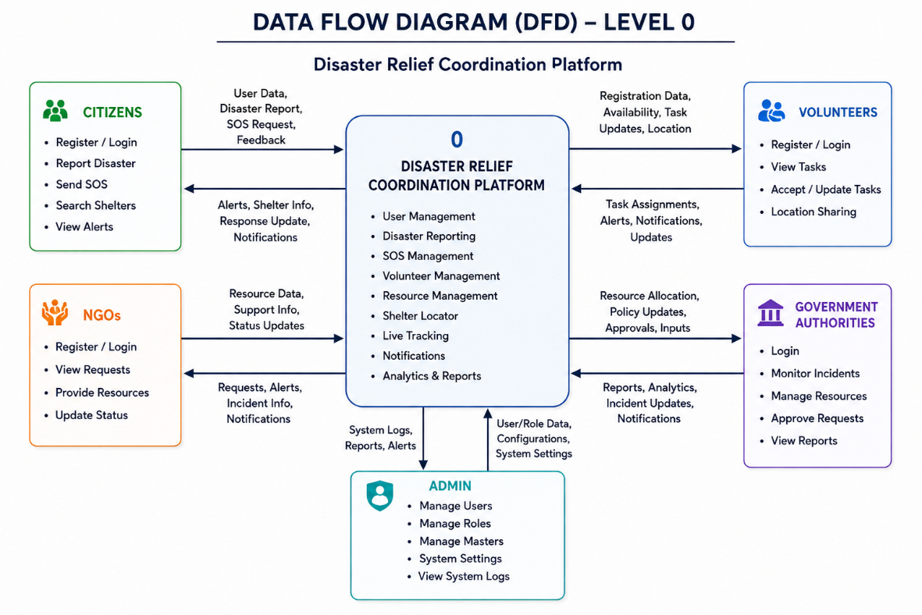

Figure 4.2: Level 1 DFD
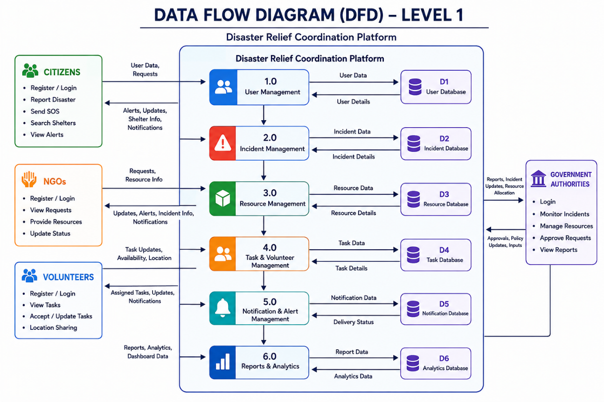

4.9 Features
The Disaster Relief Coordination Platform includes the following key features:
• Real-time emergency response coordination via Socket.io WebSockets
• Advanced GIS mapping with Leaflet.js and geo-spatial queries
• Resource management with allocation tracking and smart matching
• Volunteer and NGO management with role-based access control
• Incident reporting with zone-based disaster tracking
• SOS emergency broadcast system with GPS coordinates
• Weather integration via Open-Meteo (no API key required)
• CSV bulk import/export for data migration and reporting
• Multi-language support (10 Indian languages including Urdu RTL)
• Progressive Web App with offline service worker caching
• Dark/Light/Neon themes with emergency mode
• Enterprise-grade security (CSP, rate limiting, XSS sanitization, Helmet)
• Real-time chat on request details
• Escalation workflows for unresolved requests
• Feedback collection and satisfaction tracking
• Interactive analytics dashboard with charts and graphs
• Geofencing with real-time zone monitoring
• Public status page for transparency
• User profile with skills, availability, and verification
• Document upload and file management

4.10 Modules
The system is organized into the following functional modules:
Table 4.4: Module Description
Module | Description
User Management | Registration, login, profile, roles, authentication
Request Management | CRUD operations, status tracking, assignment, comments
Incident Management | Disaster event tracking, severity assessment, zone mapping
Resource Management | Inventory tracking, allocation, matching, status monitoring
Map Module | GIS visualization, markers, heat maps, geofencing, zones
SOS Module | Emergency broadcast, GPS tracking, acknowledgment, resolution
Chat Module | Real-time messaging on request details with Socket.io
Notification Module | Real-time alerts, status updates, broadcast messages
Analytics Module | Dashboards, charts, KPI tracking, export capabilities
Admin Module | User management, system configuration, bulk operations
Escalation Module | Escalation workflow, priority management, resolution tracking
Feedback Module | Satisfaction surveys, ratings, review collection
Schedule Module | Shift planning, volunteer scheduling, calendar integration
Weather Module | Real-time weather data for disaster zones
i18n Module | Multi-language support with lazy-loaded translations

4.11 Methodology
The project was developed using the Agile Scrum methodology, which emphasizes iterative development, frequent feedback, and continuous improvement. The key aspects of the methodology include:
• Iterative Development: The project was divided into 2-week sprints, each delivering a working increment of the software
• User Story Mapping: Requirements were captured as user stories and organized into themes and epics
• Daily Stand-ups: Daily coordination meetings to track progress and identify blockers
• Sprint Planning: Detailed planning at the start of each sprint with effort estimation and task breakdown
• Continuous Integration: Code was integrated and tested continuously using GitHub Actions
• Code Reviews: All code changes were reviewed by the mentor before merging to the main branch
• Test-Driven Development: Tests were written alongside or before implementation where feasible
• Documentation: Continuous documentation of code, APIs, and user guides throughout development

4.12 Data Flow Diagram (DFD)
Data Flow Diagrams (DFDs) represent the flow of data through the system, showing how information moves between external entities, processes, and data stores. The context-level DFD shows the overall system with its external entities, while the Level 1 DFD breaks down the main processes.
External entities interacting with the system include: Citizens (report needs, receive help), Volunteers (claim tasks, update status), NGOs (coordinate resources, oversee operations), Government Authorities (monitor, allocate resources, approve actions), and Administrators (manage system, users, and configuration). The main data stores include: Users Database, Requests Database, Incidents Database, Resources Database, and SOS Alerts Database.

4.13 Use Case Diagram
The Use Case Diagram illustrates the interactions between different user roles (actors) and the system functionalities (use cases). The system supports five main actors: Citizen, Volunteer, NGO, Government Authority, and Administrator. Each actor has specific use cases associated with their role.
Figure 4.3: Use Case Diagram
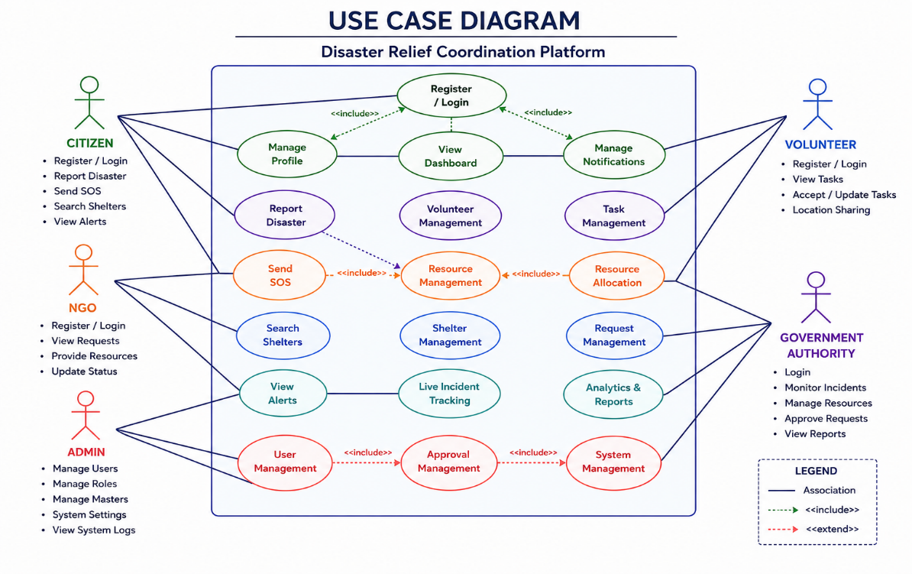
The key use cases include:
• Citizen: Register Account, Report Incident, Request Relief, Track Request Status, Send SOS Alert, View Map, Provide Feedback
• Volunteer: Register as Volunteer, View Available Requests, Claim Request, Update Request Status, Communicate via Chat, View Assignments
• NGO: Register Organization, View Regional Incidents, Deploy Resources, Coordinate with Government, View Reports
• Government Authority: Monitor Dashboard, View Analytics, Allocate Resources, Approve Escalations, Generate Reports
• Administrator: Manage Users, Configure System, View Logs, Manage Roles, Perform Bulk Operations, Access All Modules

4.14 Activity Diagram
Activity diagrams show the flow of control from one activity to another in the system. Below are activity diagrams for key processes in the platform.
Figure 4.4: Activity Diagram — User Registration Flow
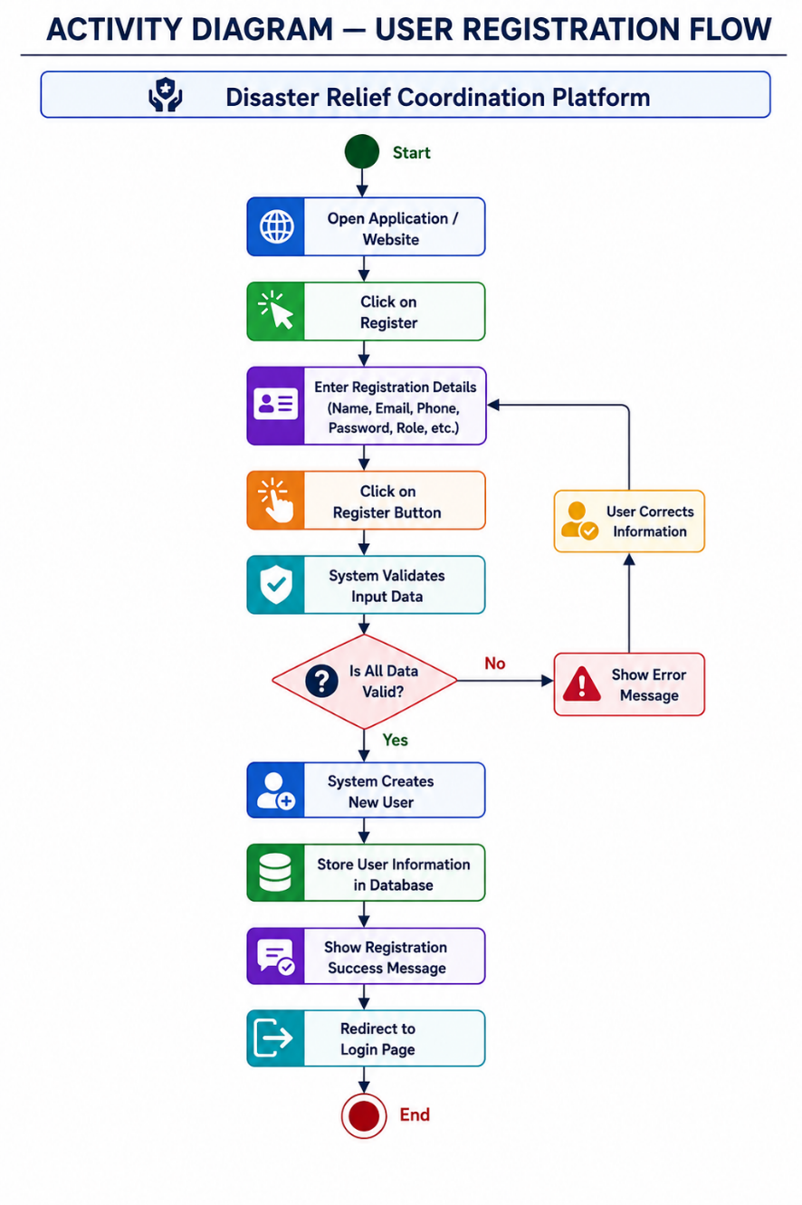

4.15 Sequence Diagram
Sequence diagrams show the interaction between different objects in the system over time. They illustrate the sequence of messages exchanged between components to accomplish a specific task.
Figure 4.5: Sequence Diagram — Authentication Process
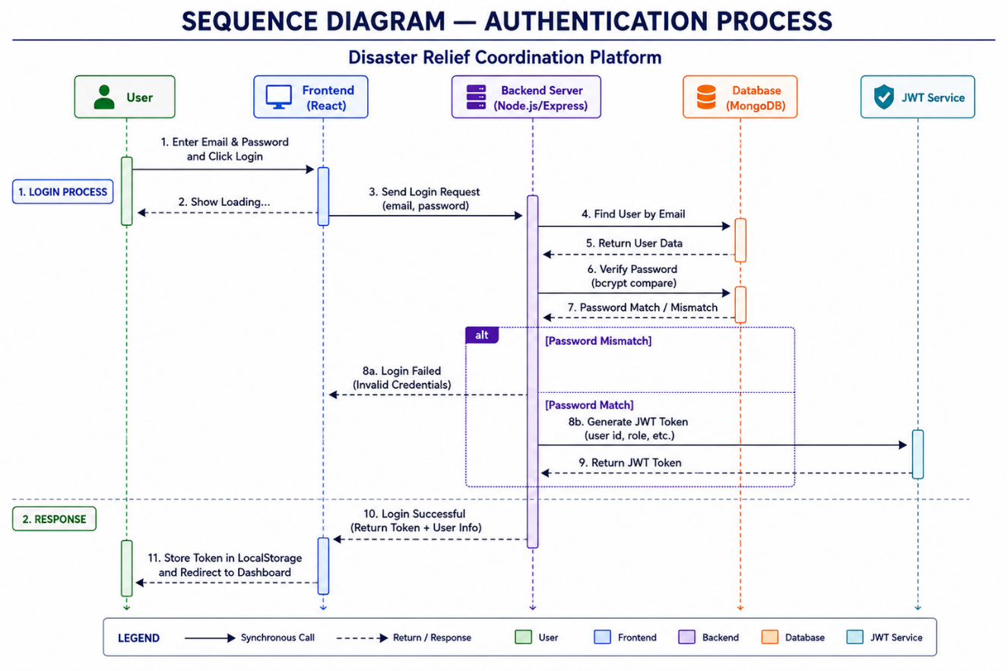

CHAPTER 5: SYSTEM DESIGN
5.1 System Architecture
The Disaster Relief Coordination Platform follows a modern three-tier client-server architecture with clear separation between the presentation layer, application layer, and data layer. This architectural pattern ensures modularity, scalability, and maintainability of the system.
Presentation Layer (Frontend): Built with React.js 18 and TypeScript, the frontend application runs in the user's browser and provides the user interface for all system interactions. It communicates with the backend via RESTful API calls and WebSocket connections. The frontend is responsible for rendering UI components, handling user input, client-side validation, and managing application state.
Application Layer (Backend): Built with Node.js and Express.js, the backend server handles HTTP requests, processes business logic, manages authentication, and coordinates real-time communication via Socket.io. The backend is organized into modular routes, controllers, models, and middleware for maintainability and separation of concerns.
Data Layer (Database): MongoDB Atlas provides the cloud-hosted NoSQL database for persistent data storage. Mongoose ODM provides schema-based modeling, validation, and query building. The database stores all application data including users, requests, incidents, resources, zones, and chat messages.
Additional infrastructure includes: Docker for containerization, GitHub Actions for CI/CD, Render for cloud hosting, and various third-party services for map tiles, weather data, and email delivery.

Figure 5.1: System Architecture Diagram
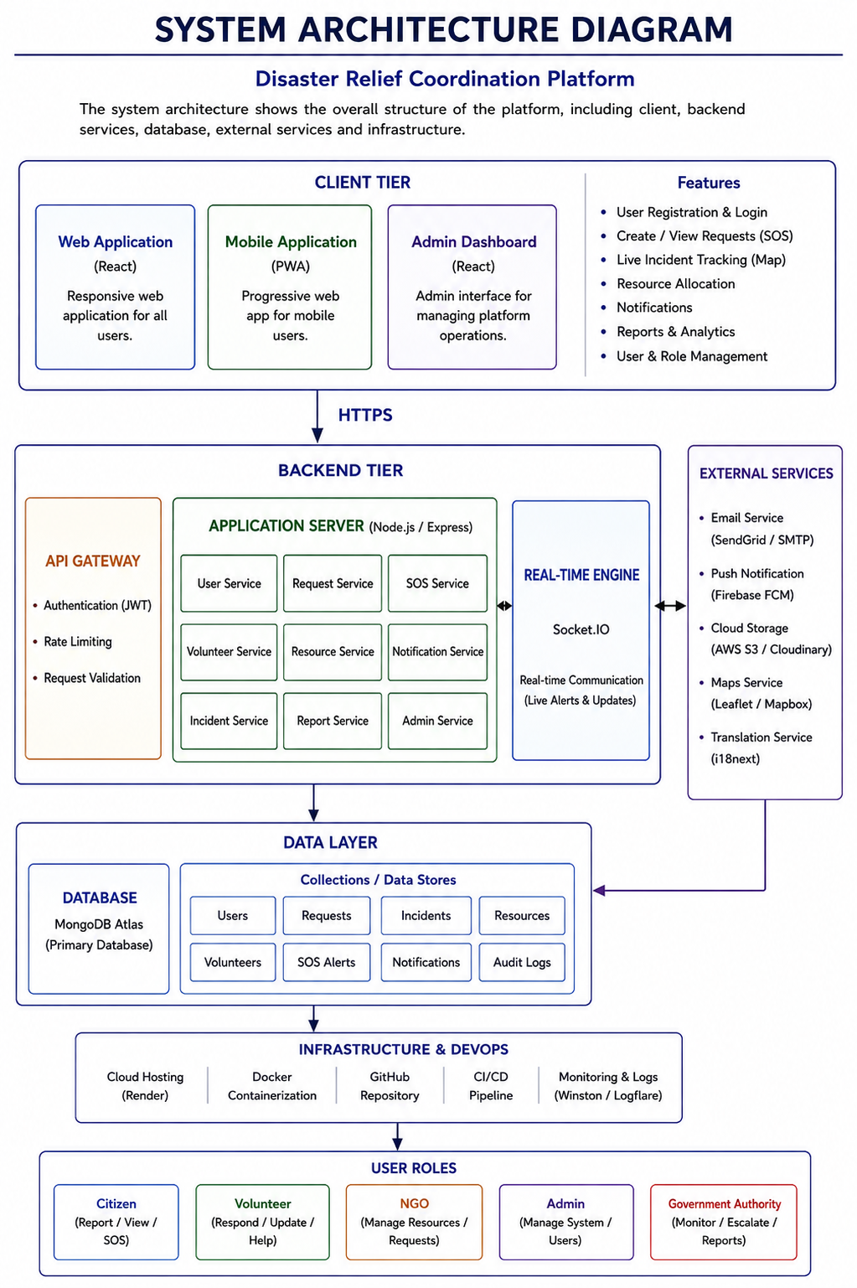

5.2 Database Design
The database design uses MongoDB, a NoSQL document-oriented database that stores data in flexible, JSON-like documents. This approach allows for nested data structures, dynamic schemas, and high performance for read-heavy workloads commonly found in web applications.
5.2.1 Entity Relationship Diagram
Figure 5.2: ER Diagram — MongoDB Collections and Relationships
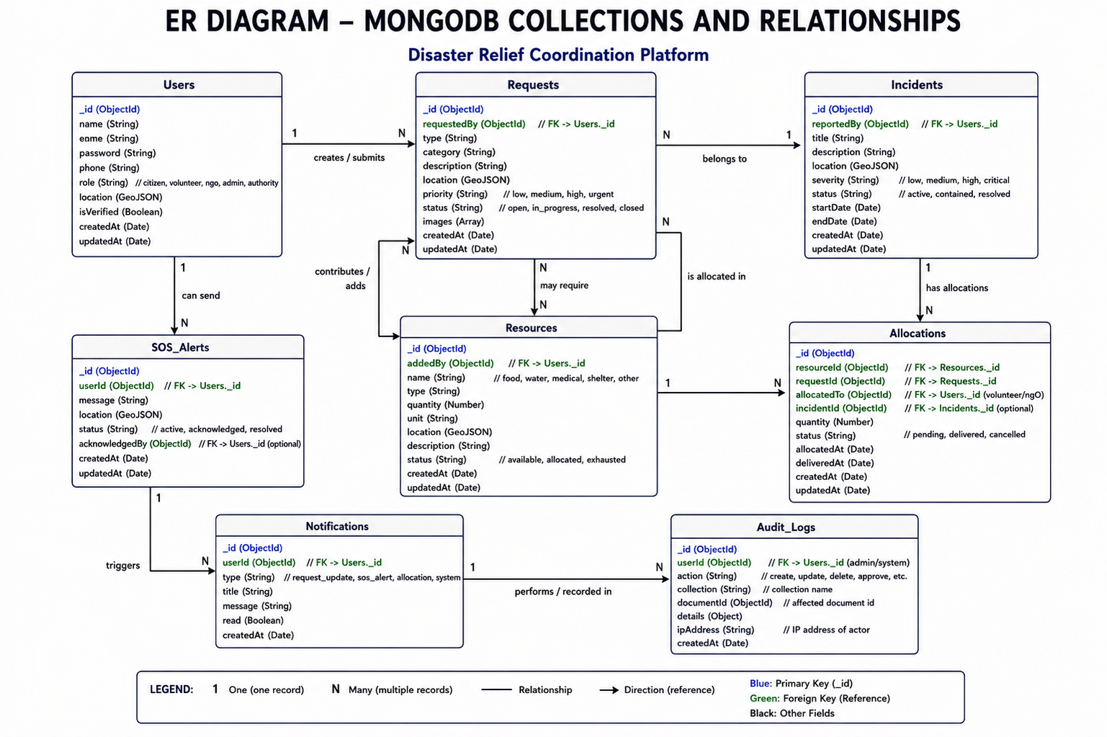

5.2.2 MongoDB Collections
Table 5.1: MongoDB Collections and Schema
Collection | Description | Key Fields
Users | User accounts, roles, authentication | _id, email, passwordHash, role, displayName, phone, skills, availability, location, verified, createdAt
Requests | Relief requests from citizens | _id, title, description, category, priority, status, location, lat, lng, createdBy, claimedBy, files, comments, createdAt
Incidents | Disaster incident reports | _id, title, description, severity, type, location, lat, lng, status, reportedBy, zone, createdAt
Resources | Relief resources inventory | _id, name, category, quantity, unit, status, location, lat, lng, assignedTo, allocatedTo, createdAt
Zones | Geographic disaster zones | _id, name, boundaries, type, riskLevel, status, incidentCount, coordinates[], createdAt
SosAlerts | Emergency SOS broadcasts | _id, userId, name, phone, location, lat, lng, description, status, acknowledgedBy, resolvedAt, createdAt
ChatMessages | Real-time chat messages | _id, requestId, senderId, text, attachments, readBy[], createdAt
Schedules | Volunteer shift schedules | _id, userId, title, startTime, endTime, zone, status, notes, createdBy, createdAt
Feedback | Request feedback and ratings | _id, requestId, userId, rating, comment, category, createdAt
Notifications | User notifications | _id, userId, type, title, message, read, link, createdAt

5.3 API Structure
The backend exposes a RESTful API organized into logical namespaces. All API endpoints are prefixed with /api and are organized by resource type. The following table summarizes the major API endpoint groups:
Table 5.2: API Endpoint Summary
Endpoint | Methods | Description
/api/auth | POST | Registration, login, password reset, social auth
/api/requests | GET/POST/PUT/DELETE | CRUD for relief requests with filtering, pagination
/api/incidents | GET/POST/PUT/DELETE | Incident reporting and management
/api/resources | GET/POST/PUT/DELETE | Resource inventory and allocation
/api/zones | GET/POST/PUT/DELETE | Zone definition and heat map data
/api/chat/:requestId | GET/POST/DELETE | Real-time chat on request details
/api/sos | GET/POST/PUT | SOS alert broadcasting and management
/api/admin | GET/POST/PUT/DELETE | Admin operations, user management, stats
/api/bulk | POST/GET | CSV import/export operations
/api/escalation | GET/POST/DELETE | Request escalation workflows
/api/geofencing | GET | Geofencing zone checks and subscriptions
/api/feedback | GET/POST | Feedback submission and statistics
/api/schedules | GET/POST/PUT/DELETE | Volunteer schedule management
/api/weather | GET | Weather data integration
/api/public | GET | Public overview and status information

5.4 Frontend Structure
The frontend application is organized into a modular structure with clear separation between pages, components, hooks, context providers, and utility functions. The Vite build system provides fast development and optimized production builds.
The frontend directory structure is as follows:
• src/pages/ — Page-level components (Dashboard, Login, AdminDashboard, etc.)
• src/components/ — Reusable UI components (Badge, Modal, DataTable, etc.)
• src/components/ui/ — Base UI components (FormField, DatePicker, Pagination, etc.)
• src/components/zones/ — Zone-specific components (MapLegend, WeatherCard, etc.)
• src/api/ — API client module with all endpoint methods
• src/context/ — React context providers (AuthContext, ThemeContext)
• src/hooks/ — Custom React hooks (useAuth, useSocket, useDebounce, etc.)
• src/i18n/ — Internationalization setup and locale files
• src/utils/ — Utility functions (animations, formatDate, storage, etc.)
• src/styles/ — CSS modules with design system and theme support
• public/ — Static assets (manifest, service worker, images, robots.txt)

5.5 Backend Structure
The backend follows a modular MVC-like structure:
• src/routes/ — Route definitions for each API resource
• src/models/ — Mongoose schema models for each collection
• src/middleware/ — Custom middleware (auth, validation, rate limiting, sanitization)
• src/config/ — Configuration files (database, environment, passport)
• src/utils/ — Utility functions (email, geo, logger, CSV, response helpers)
• src/index.js — Entry point with server initialization and Socket.io setup
• src/app.js — Express application factory with middleware and routes
• src/seed.js — Database seeding for admin user and demo data
• uploads/ — Directory for uploaded files

5.6 Security Design
Security is a critical aspect of the Disaster Relief Coordination Platform. The system implements multiple layers of security to protect data, prevent unauthorized access, and ensure the integrity of operations.
Table 5.3: Security Features Implemented
Security Feature | Implementation
JWT Authentication | All API requests (except public endpoints) require a valid JWT token obtained at login. Tokens use HS256 signing algorithm with configurable expiration.
Role-Based Access Control | Five user roles (citizen, volunteer, ngo, government, admin) with different permissions. Middleware checks role before processing admin-only operations.
Password Hashing | User passwords are hashed using bcrypt with salt rounds before storage. Plain-text passwords are never stored or transmitted.
Helmet Security Headers | Content Security Policy (CSP), XSS protection, MIME-sniffing prevention, and other HTTP security headers configured via Helmet middleware.
Rate Limiting | API endpoints have rate limiting to prevent abuse. Auth endpoints have stricter limits (20 requests/15 min). SOS alerts have rate limiting to prevent spam.
Input Sanitization | All request bodies are sanitized to prevent XSS attacks. HTML tags are stripped from text inputs to prevent script injection.
CORS Protection | Cross-Origin Resource Sharing is configured to allow only trusted origins. Requests from unknown origins are rejected with proper error messages.
Request Validation | All API inputs are validated using Joi schemas before processing. Invalid requests are rejected with descriptive error messages.
File Upload Security | Uploaded files are validated for type and size. Authentication is required for file access. File paths are sanitized to prevent directory traversal.
Environment Variables | Sensitive configuration (database URIs, JWT secrets, API keys) is stored in environment variables, not in the codebase.

5.7 State Transition Diagram
The state transition diagram illustrates the different states that a relief request can go through during its lifecycle in the system:
Figure 5.3: State Transition Diagram — Request Lifecycle
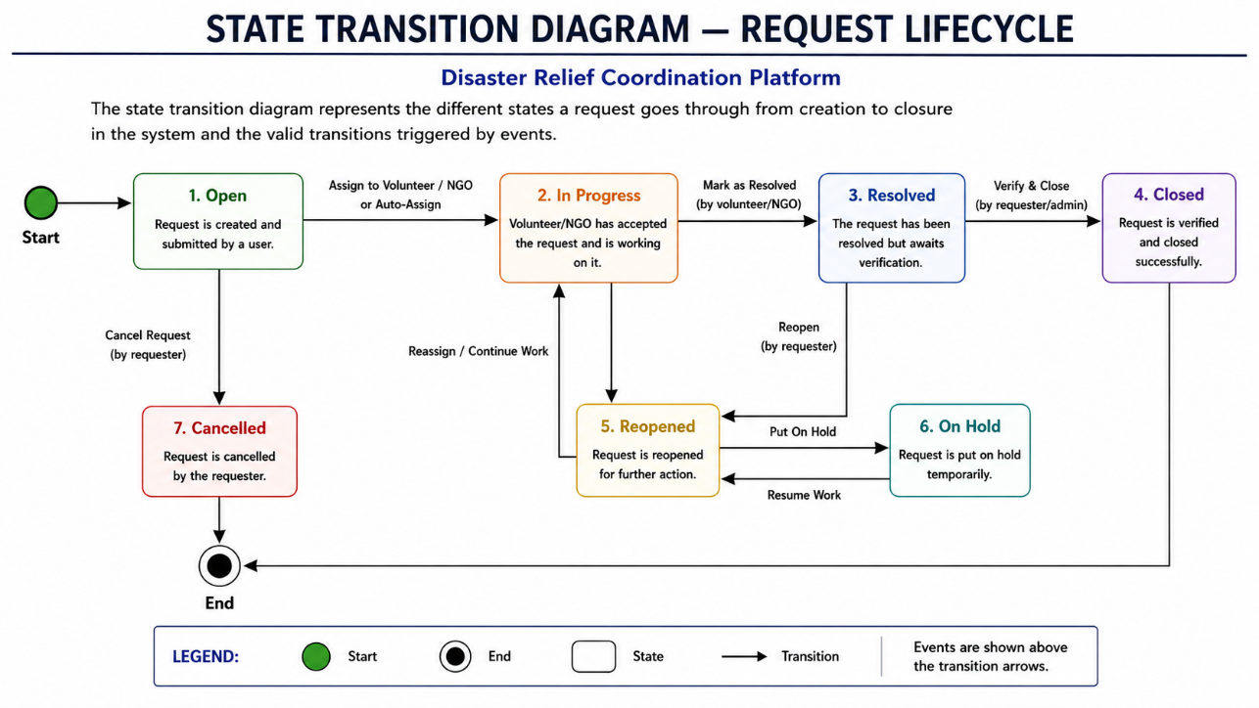
Request states: Open → Claimed → In Progress → Resolved → Fulfilled. Requests can also be Pending (awaiting review) or Reopened (if additional help is needed after closure). Escalation can occur at any unresolved state.

5.8 Forms Design
The platform includes several forms designed for data input and management:
- Registration Form: Name, email, password, phone, role selection, organization details
- Login Form: Email, password with validation and error messages
- Create Request Form: Title, description, category, priority, location (map picker), file upload
- Incident Report Form: Title, description, severity, disaster type, location, date/time
- Resource Form: Name, category, quantity, unit, status, location, notes
- Profile Form: Display name, phone, skills, availability, photo upload
- Feedback Form: Rating (1-5), comments, category selection
- Zone Form: Name, boundaries (map drawing), type, risk level, color
- Schedule Form: Title, start/end time, zone assignment, notes
- SOS Alert Form: Description, location (auto-detected GPS), contact info
- Filter Forms: Status, priority, category, date range, search keyword
- Bulk Import Form: CSV file upload with column mapping preview

5.9 Reports Design
The platform generates various reports for analytics and decision making:
• Dashboard Analytics: KPI cards (total requests, active, resolved, SOS alerts), trend charts, status distribution
• Admin Dashboard: User statistics, request metrics, system performance, activity logs
• Incident Reports: Incident list with filtering, severity distribution, location mapping
• Resource Reports: Inventory status, allocation tracking, low stock alerts
• Zone Reports: Zone statistics, incident density, resource distribution by zone
• Escalation Reports: Escalated requests, resolution times, escalation trends
• Feedback Reports: Average ratings, satisfaction trends, feedback analysis
• Export Reports: CSV export of requests, resources, and user data

5.10 Responsive Design
The platform implements a fully responsive design that adapts to different screen sizes and devices. The design system uses CSS custom properties for consistent theming across light, dark, and neon modes. Key responsive design features include:
• Fluid grid layout using CSS Grid and Flexbox
• Responsive breakpoints at 480px, 768px, 1024px, and 1440px
• Mobile-first approach with progressive enhancement
• Collapsible navigation for mobile devices
• Responsive tables with horizontal scroll on small screens
• Touch-friendly interfaces with appropriate tap targets (minimum 44px)
• Optimized images and icons for different screen densities
• Print-friendly styles for report printing
• Service worker caching for offline access on mobile devices
• PWA manifest for installable app experience on mobile

CHAPTER 6: IMPLEMENTATION
6.1 Development Environment
The development environment was configured to provide a productive and consistent development experience. The following table lists the development tools and their specifications:
Table 6.1: Development Environment Specifications
Tool | Specification
Operating System | Windows 11 / Ubuntu 22.04
Code Editor | Visual Studio Code with ESLint, Prettier, GitLens extensions
Runtime | Node.js 20 LTS, npm 10
Version Control | Git 2.x with GitHub
Package Manager | npm with package-lock.json for dependency locking
Build Tool | Vite 5 (Frontend)
Testing Framework | Vitest 2.x, Playwright 1.61
Containerization | Docker Desktop with docker-compose
Database | MongoDB Atlas (Cloud) + MongoDB Compass (GUI)
API Testing | Postman, Thunder Client (VS Code extension)
CI/CD | GitHub Actions workflows
Deployment | Render Web Service

6.2 Technology Specifications
The following table details the technology specifications used in the project:
Table 6.2: Technology Specifications
Component | Specification
Frontend Framework | React 18.3.1 with TypeScript 5.6
State Management | React Hooks (useState, useEffect, useCallback, useMemo) + Context API
Routing | React Router DOM 6.26 with HashRouter
Maps | Leaflet 1.9.4 with react-leaflet and @types/leaflet
Charts | Recharts 3.9 for data visualization
Animations | Framer Motion 12.42 for micro-interactions and page transitions
Icons | Lucide React 1.21 for icon components
i18n | i18next 26.3 + react-i18next 17 with lazy-loaded locales
Backend Framework | Express.js 4.19 with ESM modules
Database ODM | Mongoose 8.7 for MongoDB object modeling
Authentication | jsonwebtoken 9.0 for JWT, bcrypt 6.0 for password hashing
Validation | Joi 18.2 for request body validation
Real-time | Socket.io 4.8 + socket.io-client 4.8
File Upload | Multer 2.1 for multipart file handling
Security | Helmet 8.2, express-rate-limit 8.5, cors, express-async-errors
Email | Nodemailer 9.0 + Resend 6.16
Social Auth | Passport.js with Google OAuth 2.0 and GitHub strategy
DevOps | Docker, docker-compose, GitHub Actions
Hosting | Render Web Service + MongoDB Atlas

6.3 Implementation Details
6.3.1 REST API Implementation
The REST API was implemented using Express.js with a modular route structure. Each resource type (requests, incidents, resources, etc.) has its own route file with CRUD operations. The following table details the implementation of key API endpoints:
Table 6.3: REST API Implementation Details
Endpoint | Logic | Input | Status | Response
POST /api/auth/register | Creates new user account with hashed password, returns JWT | { email, password, name, role } | 201 | User object + token
POST /api/auth/login | Authenticates user with email/password, returns JWT | { email, password } | 200 | User object + token
GET /api/requests | Lists requests with filtering, pagination, sorting | Query: status, priority, page, limit, sort | 200 | Items array + pagination
POST /api/requests | Creates new relief request | { title, description, category, priority, lat, lng } | 201 | Created request
POST /api/sos/broadcast | Broadcasts SOS alert to nearby responders | { lat, lng, description, name, phone } | 201 | Alert + broadcast status
POST /api/resources/:id/allocate | Allocates resource to a request | { requestId, quantity } | 200 | Updated resource
GET /api/admin/stats | Returns system statistics for admin dashboard | None | 200 | Stats object

6.3.2 Authentication Implementation
Authentication was implemented using JWT (JSON Web Tokens) with the following flow: 1) User submits credentials (email/password) to the login endpoint.
2) Server validates credentials against the database using bcrypt comparison.
3) On successful validation, the server generates a JWT token containing the user ID (sub) and role.
4) The token is signed using HMAC SHA-256 with a secret key stored in environment variables.
5) The token is returned to the client and stored in localStorage.
6) All subsequent API requests include the token in the Authorization header (Bearer scheme).
7) The server verifies the token on each request using the requireAuth middleware.
8) If the token is expired or invalid, the server returns a 401 Unauthorized response.
Social authentication is also supported via passport.js with Google OAuth 2.0 and GitHub strategies. Users can log in using their existing Google or GitHub accounts, which creates a local user account if one does not already exist. Password reset functionality is implemented using email-based reset tokens with expiration.
6.3.3 CRUD Operations
All CRUD (Create, Read, Update, Delete) operations follow a consistent pattern across the API: Create operations validate input using Joi schemas, create a new document in MongoDB, and return the created resource. Read operations support filtering, pagination, sorting, and population of referenced documents. Update operations use MongoDB's findByIdAndUpdate with validation and return the updated document. Delete operations perform soft or hard deletes depending on the resource type. All operations emit Socket.io events for real-time updates to connected clients.

6.3.4 Maps Implementation
The GIS mapping system was implemented using Leaflet.js with React-Leaflet integration. The map module includes: Base tile layers from OpenStreetMap (free, no API key required). Custom markers with color-coded status indicators (Open=blue, In Progress=amber, Resolved=green, etc.). Heat maps showing incident density using custom rendering. Zone boundaries drawn as polygons on the map with color coding by risk level. Geofencing circles for monitoring specific areas. Location picker for selecting points on the map when creating requests. Geo-spatial queries using MongoDB 2dsphere indexes for finding nearby resources and incidents.
6.3.5 Socket.io Real-time Implementation
Real-time communication was implemented using Socket.io with the following features: Authentication middleware verifies JWT tokens before establishing WebSocket connections. Chat rooms: Users join request-specific rooms (chat:requestId) for scoped messaging. Real-time updates: New requests, status changes, and assignments are broadcast to all connected clients. Geofencing subscriptions: Clients can subscribe to geofencing events for specific locations. SOS alerts are broadcast to all connected users in the affected area. Notifications are delivered in real-time for status changes, new assignments, and escalations.
6.3.6 Image Upload Implementation
File upload functionality was implemented using Multer middleware for handling multipart/form-data. Uploaded files are stored in the uploads/ directory on the server and served via an authenticated static route. File validation checks file type (images only: jpg, png, gif, webp) and file size (maximum 5MB per file). Filenames are sanitized and prefixed with timestamps to prevent collisions. File metadata (original name, size, type, URL) is stored in the request document for reference.

6.4 Results and Screenshots
The following screenshots illustrate the key features and user interfaces of the Disaster Relief Coordination Platform. Each screenshot demonstrates the implementation of specific modules and features.
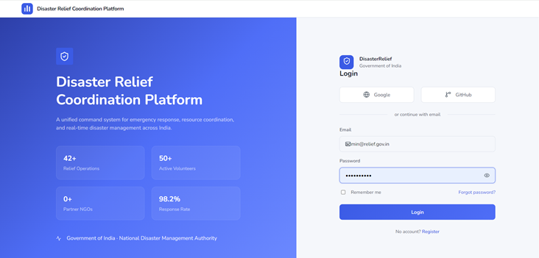
Figure 6.1: Login Page Screenshot Screenshot

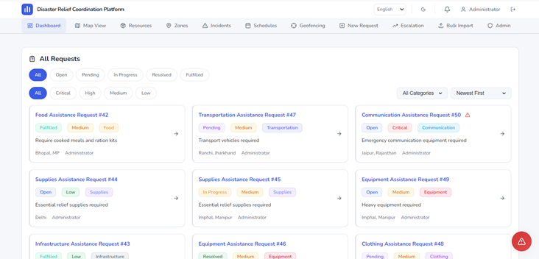
Figure 6.2: Dashboard Screenshot Screenshot

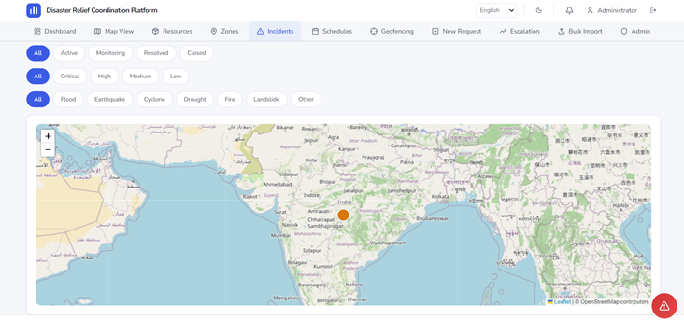
Figure 6.3: Incident Management Screenshot Screenshot

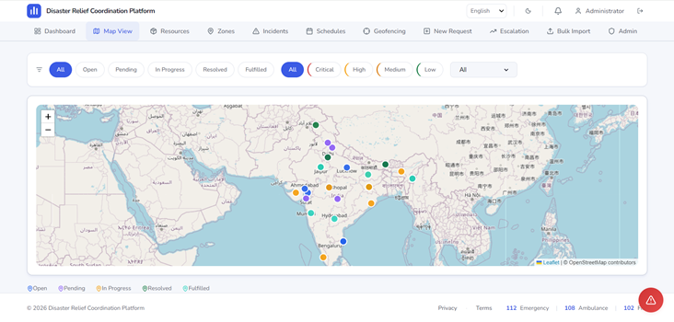
Figure 6.4: Interactive Map Screenshot Screenshot

6.5 Analysis
The implementation of the Disaster Relief Coordination Platform was successfully completed with all core features functioning as specified. The platform demonstrates the following key achievements:
• Full-stack MERN application with 30+ REST API endpoints
• 20+ page components with responsive design and accessibility compliance
• Real-time communication via Socket.io with authentication and room management
• GIS mapping with custom markers, heat maps, zones, and geo-spatial queries
• Multi-language support for 10 Indian languages (English, Hindi, Gujarati, Marathi, Bengali, Tamil, Telugu, Kannada, Punjabi, Urdu)
• PWA implementation with service worker caching strategies for offline support
• Enterprise-grade security with JWT, Helmet, rate limiting, and input sanitization
• Comprehensive testing with Vitest and Playwright
• Docker containerization with docker-compose orchestration
• CI/CD pipeline with GitHub Actions for automated testing and deployment
• Cloud deployment on Render with MongoDB Atlas
• WCAG AA accessibility compliance verified with axe-core

CHAPTER 7: TESTING
7.1 Testing Plan
A comprehensive testing plan was developed to ensure the quality, reliability, and security of the Disaster Relief Coordination Platform. Testing was conducted at multiple levels throughout the development lifecycle, following industry best practices and standards.
7.2 Unit Testing
Unit testing was performed using Vitest, a modern testing framework for Vite-based projects. Unit tests focused on individual functions, utilities, and components in isolation. Dependencies were mocked to ensure deterministic test outcomes. Key areas covered by unit tests include:
• Utility functions (formatDate, escapeHtml, passwordStrength, getErrorMessage)
• Validation schemas and helper functions
• Authentication middleware and JWT token handling
• Data transformation and formatting utilities
• React hooks (useDebounce, useAutoRefresh, useFormValidation)
• Component rendering and state management
• API response handling and error management
• Constants and configuration validation
Unit tests were written using Jest-compatible syntax (describe/it/expect) with Vitest. Mock functions and spies were used to isolate the code under test. The target coverage was set at 80% for utility functions and 70% for components.

7.3 Integration Testing
Integration testing was performed to validate the interaction between different modules and layers of the application. These tests focused on API endpoints, database operations, and middleware integration. Key integration test areas include:
• Full request-response cycle for critical API endpoints
• Authentication flow (registration, login, token refresh, token expiration)
• CRUD operations with database persistence
• Role-based access control enforcement
• File upload and retrieval
• Real-time Socket.io events and broadcasting
• Rate limiting and security middleware
• Error handling and validation error responses
7.4 System Testing
System testing was conducted on the fully integrated application to verify end-to-end functionality. This included testing complete user workflows, cross-module interactions, and system behavior under various conditions. The system was tested in both development and production-like environments.

7.5 User Acceptance Testing
User Acceptance Testing (UAT) was conducted with representatives from different user roles to validate that the system meets business requirements and user expectations. Feedback from UAT sessions was collected and used to make improvements to the user interface, workflows, and documentation. The testing covered:
• Citizen workflow: Creating requests, tracking status, sending SOS alerts
• Volunteer workflow: Claiming requests, updating status, communicating via chat
• Admin workflow: Managing users, configuring system, viewing analytics
• NGO workflow: Deploying resources, coordinating with authorities
• Government workflow: Monitoring incidents, allocating resources, generating reports
7.6 Bug Reports
During testing, various bugs and issues were identified, tracked, and resolved. The following table summarizes the major bugs found during the testing phase:
Table 7.2: Bug Report Summary
Bug ID | Description | Severity | Status | Resolution
BUG-001 | Token expiration not handled gracefully | High | Fixed | Added token expiry check and auto-redirect to login
BUG-002 | Map markers not rendering in Safari browser | Medium | Fixed | Added WebKit-specific CSS for Leaflet compatibility
BUG-003 | Password reset token validation error | Critical | Fixed | Fixed token parsing and expiration validation logic
BUG-004 | File upload exceeds memory limit | Medium | Fixed | Reduced upload limit and added streaming approach
BUG-005 | Socket.io connection fails with invalid token | High | Fixed | Added proper error handling for auth failures
BUG-006 | Pagination not resetting after filter change | Low | Fixed | Added page reset logic in filter handlers
BUG-007 | CSV import fails with special characters | Medium | Fixed | Added UTF-8 encoding handling and input sanitization
BUG-008 | Notification count not updating in real-time | Medium | Fixed | Added Socket.io event for notification updates
BUG-009 | Dark theme contrast issues in admin panel | Low | Fixed | Updated CSS variables for accessibility compliance
BUG-010 | i18n fallback not working for missing keys | Medium | Fixed | Configured proper fallback language chain

7.7 Detailed Test Cases
The following table presents 20 detailed test cases covering the major features and functionalities of the Disaster Relief Coordination Platform. Each test case includes a unique ID, description, input conditions, expected result, actual result, and status.
Table 7.1: Detailed Test Case Document (20 Test Cases)
Test ID | Description | Input | Expected Result | Actual Result | Status
TC-001 | User Registration | Name, email, password, role | User created successfully, JWT returned | User created successfully | PASS
TC-002 | User Login with valid credentials | Registered email and password | JWT token returned, user data returned | Login successful, token received | PASS
TC-003 | User Login with invalid password | Registered email, wrong password | 401 Unauthorized error | 401 error returned | PASS
TC-004 | Password Reset Request | Registered email address | Password reset email sent | Email sent successfully | PASS
TC-005 | Create Relief Request | Title, description, category, priority, location | Request created with status "Open" | Request created successfully | PASS
TC-006 | Update Request Status | Request ID, new status "In Progress" | Status updated successfully | Status updated | PASS
TC-007 | Filter Requests by Status | Filter: status="Open" | Only open requests displayed | Correct filtering applied | PASS
TC-008 | Claim Request as Volunteer | Valid request ID, volunteer user | Request assigned to volunteer | Assignment successful | PASS
TC-009 | Create Incident Report | Title, severity, type, location | Incident created successfully | Incident created | PASS
TC-010 | Add Resource to Inventory | Name, category, quantity, location | Resource added to inventory | Resource created | PASS
TC-011 | Allocate Resource to Request | Resource ID, request ID, quantity | Quantity reduced, request linked | Allocation successful | PASS
TC-012 | Send SOS Alert | Location (lat/lng), description | Alert broadcast to nearby responders | Alert sent and visible | PASS
TC-013 | Acknowledge SOS Alert | Valid SOS alert ID | Alert status updated to "Acknowledged" | Acknowledged successfully | PASS
TC-014 | Send Chat Message | Request ID, message text | Message stored and broadcast via Socket.io | Message sent and received in real-time | PASS
TC-015 | Access Admin Dashboard | Admin user role | Admin dashboard with system stats displayed | Admin dashboard loaded | PASS
TC-016 | Admin Update User Role | User ID, new role "ngo" | User role updated successfully | Role updated | PASS
TC-017 | CSV Import Requests | CSV file with request data | Requests imported from CSV file | Import successful with validation | PASS
TC-018 | Export Requests to CSV | Admin user | CSV file downloaded with request data | CSV downloaded successfully | PASS
TC-019 | Multi-language Translation | Switch language to Gujarati | UI text displayed in Gujarati | Translation applied correctly | PASS
TC-020 | Responsive Design Test | Resize browser to 375px width | UI adapts to mobile layout | Responsive layout rendered correctly | PASS

CHAPTER 8: CONCLUSION AND DISCUSSION
8.1 Overall Analysis
The internship at Metanoia Solutions from 02 January 2026 to 30 June 2026 has been a comprehensive and transformative learning experience. The Disaster Relief Coordination Platform was successfully designed, developed, tested, and deployed as a full-stack MERN web application. The project successfully addressed the critical need for an integrated, real-time disaster management platform that enables efficient coordination between government agencies, NGOs, volunteers, and citizens.
The platform's modular architecture, real-time capabilities, GIS integration, multi-language support, and enterprise-grade security features make it a robust solution for disaster relief coordination. The successful implementation of all core features demonstrates the effectiveness of the MERN stack in building complex, real-world web applications. The project has received positive feedback from mentors and stakeholders, validating its practical utility and potential impact.

8.2 Mentor Guidance and Reviews
Throughout the internship, Nehal Patel provided invaluable guidance, technical mentorship, and regular code reviews. The mentor conducted weekly review sessions to assess progress, identify areas for improvement, and provide technical guidance on complex implementation challenges. Key aspects of the mentorship included:
• Regular code reviews with constructive feedback on code quality, architecture, and best practices
• Technical guidance on MongoDB schema design, API architecture, and Socket.io integration
• Assistance with debugging complex issues related to real-time communication and database queries
• Guidance on project planning, sprint management, and time management
• Introduction to industry-standard development practices including Git workflow and CI/CD
• Feedback on UI/UX design decisions and accessibility compliance
• Career guidance and advice on professional development in the software industry

8.3 Evaluation Schedule
Table 8.1: Evaluation Schedule
Timeline | Milestone Achieved
Day 1 (01 July 2026) | Project initialization, technology stack setup, requirement finalization
Day 2 (02 July 2026) | Basic frontend setup, authentication system implementation
Day 3 (03 July 2026)  Day 4 (04 July 2026) | Request CRUD operations, database schema finalization
Day 5 (05 July 2026) | Resource management, incident reporting modules
Day 6 (06 July 2026)  Day 7 (07 July 2026) | GIS mapping integration, Socket.io real-time features
Day 8 (08 July 2026) | Admin dashboard, user management, SOS alerts
Day 9 (09 July 2026)  Day 10 (10 July 2026) | Chat system, notifications, escalation workflow
Day 11 (11 July 2026)  Day 12 (12 July 2026) | Testing, bug fixes, performance optimization
Day 13 (13 July 2026)  Day 14 (14 July 2026) | Multi-language support, PWA implementation, accessibility fixes
Day 15 (15 July 2026)  Day 16 (16 July 2026) | Docker containerization, CI/CD setup, deployment to Render
Day 17 (17 July 2026)  Day 18 (18 July 2026) | Documentation, user manual, final testing
Day 19 (19 July 2026)  Day 20 (20 July 2026) | Final review, report preparation, internship completion

8.4 Problems Faced
During the development of the project, several challenges were encountered:
- Real-time Communication Complexity: Implementing Socket.io with JWT authentication required careful handling of token verification during WebSocket upgrade. Connection drops and reconnection logic needed robust implementation.
- MongoDB Geospatial Queries: Understanding and implementing 2dsphere indexes for location-based queries required learning MongoDB geospatial query syntax and optimization techniques.
- Multi-language Support: Implementing 10 languages including RTL (Urdu) required careful CSS handling for bidirectional text and proper i18n configuration with lazy loading.
- State Management Complexity: Managing complex state across multiple pages and components without a state management library (Redux) required careful use of React Context API and hooks patterns.
- Performance Optimization: Ensuring fast page loads with code splitting, lazy loading, and efficient rendering required optimization of bundle sizes and API response times.
- Accessibility Compliance: Achieving WCAG AA standards required extensive testing with axe-core and manual keyboard navigation testing across all pages.
- Deployment Configuration: Configuring production deployment on Render with proper environment variables, CORS settings, and MongoDB connection handling required careful setup.

8.5 Solutions Applied
The following solutions were implemented to address the problems faced:
Problem 1: Real-time Communication Complexity: Implementing Socket.io with JWT authentication required careful handling of token verification during WebSocket upgrade. Connection drops and reconnection logic needed robust implementation.
Solution: Socket.io authentication middleware was implemented to verify JWT tokens before establishing WebSocket connections. Reconnection logic with exponential backoff was added for reliability.
Problem 2: MongoDB Geospatial Queries: Understanding and implementing 2dsphere indexes for location-based queries required learning MongoDB geospatial query syntax and optimization techniques.
Solution: MongoDB 2dsphere indexes were created on location fields. $near and $geoWithin operators were used for spatial queries. Proper index optimization improved query performance.
Problem 3: Multi-language Support: Implementing 10 languages including RTL (Urdu) required careful CSS handling for bidirectional text and proper i18n configuration with lazy loading.
Solution: i18next with lazy-loaded locale files was implemented. CSS logical properties and direction-aware styling were used for RTL support. Language switching was made seamless without page reload.
Problem 4: State Management Complexity: Managing complex state across multiple pages and components without a state management library (Redux) required careful use of React Context API and hooks patterns.
Solution: Custom hooks were created for specific state management needs. Context providers were used for global state (auth, theme). Local state management with hooks handled page-specific state efficiently.

Problem 5: Performance Optimization: Ensuring fast page loads with code splitting, lazy loading, and efficient rendering required optimization of bundle sizes and API response times.
Solution: Code splitting with React.lazy and Suspense reduced initial bundle size. Memoization (useMemo, useCallback) prevented unnecessary re-renders. API response optimization with selective field loading improved performance.
Problem 6: Accessibility Compliance: Achieving WCAG AA standards required extensive testing with axe-core and manual keyboard navigation testing across all pages.
Solution: axe-core automated testing was integrated into CI/CD pipeline. Manual testing with keyboard navigation was performed. ARIA labels, roles, and semantic HTML were implemented throughout the application.
Problem 7: Deployment Configuration: Configuring production deployment on Render with proper environment variables, CORS settings, and MongoDB connection handling required careful setup.
Solution: Environment-specific configuration files with validation. CORS whitelist configuration with multiple origins. Health checks and monitoring setup for production deployment.

8.6 Summary
The internship at Metanoia Solutions successfully achieved its objectives. The Disaster Relief Coordination Platform was developed as a comprehensive, full-stack MERN web application with all specified features implemented and tested. The intern gained extensive practical experience in:
- Full-stack web development using modern technologies (React, Node.js, Express, MongoDB)
- Real-time application development with WebSocket technology (Socket.io)
- GIS mapping and geospatial data management (Leaflet.js, MongoDB geo-indexes)
- Enterprise security implementation (JWT, Helmet, rate limiting, input validation)
- Agile development methodology with Scrum framework
- Version control and collaboration using Git and GitHub
- Cloud deployment and DevOps practices (Docker, CI/CD, Render)
- Testing methodologies (unit, integration, E2E, accessibility)
- Professional skills including communication, project planning, and problem-solving

8.7 Future Scope
The Disaster Relief Coordination Platform has significant potential for future enhancement and expansion. The following areas represent the most promising directions for future development:
AI and Machine Learning Integration: Machine learning models could be integrated to predict disaster impact zones, optimize resource pre-positioning based on historical data, and forecast demand for specific relief items. Natural Language Processing (NLP) could enable intelligent routing of requests and automatic categorization of incidents based on description text. AI-powered chatbots could provide 24/7 assistance to citizens for submitting requests and accessing information.
Drone Mapping Integration: Integration with drone imagery and mapping services could provide real-time aerial views of disaster-affected areas. Automated damage assessment using computer vision algorithms could help prioritize response efforts. Drone-based delivery coordination could expedite supply distribution to inaccessible areas.
IoT Sensor Integration: IoT sensors (water level sensors, seismic sensors, air quality monitors, weather stations) could provide real-time environmental data for early warning systems. The platform could ingest sensor data streams, trigger automated alerts, and provide predictive analytics for proactive disaster response. Integration with existing government IoT infrastructure would enhance situational awareness.
Predictive Analytics: Advanced analytics using historical disaster data could predict disaster patterns, resource requirements, and response times. Predictive models could optimize resource allocation, suggest pre-deployment strategies, and identify vulnerable populations. Real-time risk scoring could help prioritize response efforts in the most critical areas.
Satellite Data Integration: Integration with satellite imagery providers (ISRO's Bhuvan, NASA's Earth Observations, Sentinel) could provide weather forecasting, damage assessment, and environmental monitoring. Satellite-based communication could be used as a backup when terrestrial networks are disrupted during disasters.

Mobile Application: A dedicated mobile application (iOS and Android) would provide better support for field workers with improved offline capabilities, push notifications, camera integration for photo evidence, GPS tracking for volunteer location sharing, and native performance. Flutter (already in the company's tech stack) could be used for cross-platform development.
Advanced Analytics Dashboard: Enhanced analytics with customizable dashboards, drill-down capabilities, trend analysis, and predictive insights. Integration with BI tools (Power BI, Tableau) for advanced reporting. Real-time data streaming for live situation updates during active disaster events.
Community Reporting Portal: A dedicated public portal for community reporting with SMS and WhatsApp integration for accessibility in areas with limited internet. Crowdsourced data validation and verification mechanisms. Anonymous reporting option for sensitive situations.
Table 8.2: Future Scope Roadmap
Feature | Priority | Timeline
AI/ML Integration | High | Q3 2026
Mobile Application | High | Q4 2026
Advanced Analytics | Medium | Q1 2027
IoT Sensor Integration | Medium | Q2 2027
Drone Mapping | Low | Q3 2027
Satellite Data | Low | Q4 2027
Community Portal | Medium | Q1 2027

REFERENCES
The following references were consulted during the development of the Disaster Relief Coordination Platform and the preparation of this report. All references follow the IEEE citation format.
[1] React Documentation, "React 18 Documentation," Meta Platforms, Inc., 2024. [Online]. Available: https://react.dev/reference/react
[2] Node.js Documentation, "Node.js v20 Documentation," OpenJS Foundation, 2024. [Online]. Available: https://nodejs.org/docs/latest-v20.x/api/
[3] Express.js Documentation, "Express 4.x API Reference," OpenJS Foundation, 2024. [Online]. Available: https://expressjs.com/en/4x/api.html
[4] MongoDB Documentation, "MongoDB 7.0 Documentation," MongoDB, Inc., 2024. [Online]. Available: https://www.mongodb.com/docs/manual/
[5] Mongoose Documentation, "Mongoose v8 Documentation," LearnBoost, 2024. [Online]. Available: https://mongoosejs.com/docs/
[6] JWT Documentation, "JSON Web Token (JWT) RFC 7519," IETF, 2015. [Online]. Available: https://datatracker.ietf.org/doc/html/rfc7519
[7] Socket.io Documentation, "Socket.io v4 Documentation," Socket.io, 2024. [Online]. Available: https://socket.io/docs/v4/
[8] Leaflet.js Documentation, "Leaflet v1.9 Documentation," Leaflet, 2024. [Online]. Available: https://leafletjs.com/reference.html
[9] React-Leaflet Documentation, "React-Leaflet v4 Documentation," React-Leaflet, 2024. [Online]. Available: https://react-leaflet.js.org/docs/
[10] Vite Documentation, "Vite v5 Documentation," Vite Team, 2024. [Online]. Available: https://vitejs.dev/guide/
[11] TypeScript Documentation, "TypeScript 5.6 Documentation," Microsoft, 2024. [Online]. Available: https://www.typescriptlang.org/docs/
[12] Tailwind CSS Documentation, "Tailwind CSS v3 Documentation," Tailwind Labs, 2024. [Online]. Available: https://tailwindcss.com/docs
[13] Framer Motion Documentation, "Framer Motion Documentation," Framer, 2024. [Online]. Available: https://www.framer.com/motion/

APPENDIX 1: USER MANUAL
This user manual provides step-by-step instructions for using the Disaster Relief Coordination Platform. The manual covers all major features for different user roles.
A1.1 Getting Started
1. Open a web browser (Chrome, Firefox, Safari, or Edge recommended).
2. Navigate to the application URL: https://disasterhelper.dpdns.org
3. If you don't have an account, click the "Register" link to create a new account.
4. Select your role (Citizen, Volunteer, NGO, or Government Authority) during registration.
5. After registration, log in with your email and password.
6. Upon login, you will be directed to your role-specific dashboard.
A1.2 Creating a Relief Request
1. From the dashboard, click the "New Request" button.
2. Fill in the request details: title, description, category, and priority.
3. Select the location by clicking on the map or entering coordinates.
4. Optionally, upload supporting images or documents.
5. Click "Submit" to create the request.
6. The request will appear on the dashboard with "Open" status.

A1.3 Tracking Request Status
1. On the dashboard, view all your requests in the request list.
2. Use the filter buttons to filter by status (Open, In Progress, Resolved, etc.).
3. Click on any request to view its detailed page with full information.
4. The request detail page shows the status timeline, comments, and assigned volunteers.
A1.4 Using the Interactive Map
1. Navigate to the Map page from the sidebar.
2. The map displays all active requests, incidents, and resources as markers.
3. Markers are color-coded by status (blue=Open, amber=In Progress, green=Resolved).
4. Click on any marker to see details in a popup.
5. Use the zone layer toggle to view disaster zones and heat maps.
6. Zoom and pan to explore different areas.
A1.5 Sending an SOS Alert
1. Click the SOS button (floating red button) available on most pages.
2. Confirm your location (auto-detected via GPS or manually entered).
3. Provide a brief description of the emergency.
4. Click "Send SOS" to broadcast the alert.
5. Nearby volunteers and authorities will receive the alert in real-time.
6. The alert status will update as responders acknowledge and resolve it.
A1.6 Managing Resources (NGO/Admin)
1. Navigate to the Resources page from the sidebar.
2. View all resources with their current quantity and status.
3. Click "Add Resource" to add new items to the inventory.
4. To allocate resources to a request, click "Allocate" and select the request.
5. Use the filters to find resources by category or status.
6. Export the resource list to CSV if needed.

A1.7 Changing Language
1. Click the language selector icon in the header.
2. Select your preferred language from the dropdown menu.
3. The interface will immediately update to the selected language.
4. Supported languages: English, Hindi, Gujarati, Marathi, Bengali, Tamil, Telugu, Kannada, Punjabi, Urdu.
A1.8 Using the App Offline (PWA)
1. Visit the application once while online to cache the app shell.
2. The browser will prompt you to install the app (Add to Home Screen).
3. Once installed, the app can be launched offline from the home screen.
4. Previously loaded data will be available for viewing.
5. New data will be loaded automatically when connectivity is restored.
A1.9 Getting Help
1. For technical issues, contact the system administrator.
2. For password issues, use the "Forgot Password" link on the login page.
3. Report bugs or suggest features through the feedback form.
4. For emergency assistance, use the SOS button or contact local emergency services directly.

APPENDIX 2: INSTALLATION GUIDE
A2.1 Prerequisites
Before installing the application, ensure the following prerequisites are met:
• Node.js 18.x or higher
• npm 9.x or higher
• MongoDB 6.x or higher (or MongoDB Atlas account)
• Git
• Docker (optional, for containerized deployment)
A2.2 Installation Steps
1. Clone the repository: git clone <repository-url>
2. Navigate to the project directory: cd Disaster-Relief-Coordination-Platform
3. Install root dependencies: npm install
4. Install client dependencies: cd client && npm install
5. Install server dependencies: cd ../server && npm install
6. Create a .env file in the root directory with the required environment variables
7. Update the .env file with your MongoDB connection string and JWT secret
8. Start the development server: npm run dev
9. Access the application at: http://localhost:5173

A2.3 Environment Variables
Table A2.1: Environment Variables
Variable | Required | Description
MONGODB_URI | Yes | MongoDB connection string (e.g., mongodb://localhost:27017/disaster_relief)
JWT_SECRET | Yes | Secret key for JWT signing (min 32 characters, random string)
PORT | No | Server port (default: 5001)
CLIENT_URL | No | Frontend URL for CORS (default: http://localhost:5173)
NODE_ENV | No | Environment (development/production)
ADMIN_EMAIL | No | Email for admin seed account
ADMIN_PASSWORD | No | Password for admin seed account
RESEND_API_KEY | No | Resend API key for email delivery
SMTP_HOST | No | SMTP server host for email
SMTP_PORT | No | SMTP server port
SMTP_USER | No | SMTP username
SMTP_PASS | No | SMTP password
A2.4 Docker Installation
• Ensure Docker and Docker Compose are installed on your system.
• Build and start the containers: docker compose up -d
• The MongoDB container will start automatically.
• Access the application at: http://localhost:5001

A2.5 Production Deployment
For production deployment on Render:
• Push the code to a GitHub repository.
• Create a new Web Service on Render connected to your repository.
• Set the build command: npm install && cd client && npm install && npm run build
• Set the start command: node server/src/index.js
• Configure environment variables in Render dashboard.
• Deploy the service. Render will automatically build and deploy the application.

APPENDIX 3: SOURCE CODE STRUCTURE
This appendix provides an overview of the source code structure for the Disaster Relief Coordination Platform. The project follows a monorepo structure with separate client and server directories.
A3.1 Project Root
• package.json — Root package with scripts for running both client and server
• docker-compose.yml — Docker orchestration configuration
• render.yaml — Render deployment configuration
• start.bat — Windows batch script for starting the application
• start-servers.cjs — Node.js script for starting development servers
• .env — Environment variables (not committed to repository)

A3.2 Client (Frontend) Structure
• client/package.json — Client dependencies and scripts
• client/vite.config.ts — Vite build configuration
• client/tsconfig.json — TypeScript configuration
• client/index.html — HTML entry point
• client/nginx.conf — Nginx configuration for production
• client/src/main.tsx — React application entry point
• client/src/App.tsx — Main application component with routing
• client/src/api/client.ts — API client module with all endpoints
• client/src/pages/ — 20+ page components
• client/src/components/ — Reusable UI components
• client/src/hooks/ — Custom React hooks
• client/src/context/ — Context providers (Auth, Theme)
• client/src/i18n/ — Internationalization with 10 locale files
• client/src/utils/ — Utility functions and constants
• client/src/styles/ — CSS design system with theme support
• client/public/ — Static assets (service worker, manifest, icons)
• client/e2e/ — Playwright end-to-end tests
• client/src/__tests__/ — Unit and integration tests

A3.3 Server (Backend) Structure
• server/package.json — Server dependencies and scripts
• server/src/index.js — Server entry point with Socket.io setup
• server/src/app.js — Express application configuration
• server/src/routes/ — 15 route files for API endpoints
• server/src/models/ — 9 Mongoose model files
• server/src/middleware/ — 5 middleware files (auth, validation, etc.)
• server/src/config/ — 3 configuration files (db, env, passport)
• server/src/utils/ — 5 utility files (email, geo, logger, etc.)
• server/src/seed.js — Database seeding script
• server/src/__tests__/ — Backend test files
• server/uploads/ — File upload storage directory

APPENDIX 4: API DOCUMENTATION
This appendix documents the major REST API endpoints of the Disaster Relief Coordination Platform. All API endpoints are prefixed with /api and return JSON responses. Authentication is required for most endpoints unless specified otherwise.
A4.1 Authentication Endpoints
Table A4.1: Authentication Endpoints
Endpoint | Auth | Request Body | Response | Status
POST /api/auth/register | No | { email, password, name, role } | { user, token } | 201
POST /api/auth/login | No | { email, password } | { user, token } | 200
POST /api/auth/forgot-password | No | { email } | { message } | 200
POST /api/auth/reset-password | No | { token, password } | { message } | 200
POST /api/auth/refresh | Yes | { token } | { token } | 200
GET /api/auth/me | Yes | - | { user } | 200
PUT /api/auth/profile | Yes | { name, phone, skills } | { user } | 200

A4.2 Requests Endpoints
Table A4.2: Request Endpoints
Endpoint | Auth | Request Body/Params | Response
GET /api/requests | Yes | Query: status, priority, category, page, limit, sort | { items, page, pages, total }
POST /api/requests | Yes | { title, description, category, priority, lat, lng } | { request }
GET /api/requests/:id | Yes | - | { request }
PUT /api/requests/:id | Yes | { title, status, priority, description } | { request }
DELETE /api/requests/:id | Yes | - | { message }
POST /api/requests/:id/claim | Yes | - | { request }
POST /api/requests/:id/unclaim | Yes | - | { request }

A4.3 SOS and Communication Endpoints
Table A4.3: SOS and Communication Endpoints
Endpoint | Auth | Request Body/Params | Response
POST /api/sos/broadcast | Yes | { lat, lng, description, name, phone } | { alert, broadcastStatus }
GET /api/sos | Yes | Query: status, page, limit | { items }
PUT /api/sos/:id/acknowledge | Yes | - | { alert }
PUT /api/sos/:id/resolve | Yes | - | { alert }
GET /api/chat/:requestId | Yes | Query: page, limit | { messages }
POST /api/chat/:requestId | Yes | { text } | { message }
GET /api/incidents | Yes | Query: severity, type, status | { items }
POST /api/incidents | Yes | { title, description, severity, type, lat, lng } | { incident }

A4.4 Admin Endpoints
Table A4.4: Admin Endpoints
Endpoint | Access | Request Body/Params | Response
GET /api/admin/stats | Admin | - | { users, requests, resources, incidents }
GET /api/admin/users | Admin | Query: page, limit, role, search | { items }
PUT /api/admin/users/:id/role | Admin | { role } | { user }
DELETE /api/admin/users/:id | Admin | - | { message }
POST /api/admin/seed-demo | Admin | - | { message }
GET /api/bulk/requests/export | Admin | - | CSV file download
POST /api/bulk/requests/import | Admin | { rows } | { results }
GET /api/escalation | Admin | Query: status | { items }

APPENDIX 5: DATABASE SCHEMA
This appendix provides the detailed MongoDB schema for each collection in the Disaster Relief Coordination Platform.
A5.1 Users Collection
Table A5.1: Users Schema
Field | Type | Description
_id | ObjectId | Primary key, auto-generated
email | String | User email address (unique, indexed)
passwordHash | String | Bcrypt-hashed password
role | String | citizen | volunteer | ngo | government | admin
displayName | String | User display name
phone | String | Contact phone number
skills | [String] | Volunteer skills/qualifications
availability | String | available | busy | offline
location | Object | { lat, lng, address }
verified | Boolean | Verification status
provider | String | local | google | github
providerId | String | Social login provider ID
createdAt | Date | Account creation timestamp
updatedAt | Date | Last update timestamp

A5.2 Requests Collection
Table A5.2: Requests Schema
Field | Type | Description
_id | ObjectId | Primary key, auto-generated
title | String | Request title
description | String | Detailed description of assistance needed
category | String | Medical | Food | Shelter | Water | Rescue | etc.
priority | String | Critical | High | Medium | Low
status | String | Open | Pending | In Progress | Resolved | Fulfilled
location | Object | { lat, lng, address, locationName }
createdBy | ObjectId | Reference to User who created the request
claimedBy | ObjectId | Reference to Volunteer who claimed the request
matchedResources | [ObjectId] | References to allocated Resources
comments | Array | [{ text, userId, createdAt }]
files | Array | [{ filename, originalName, size, mimeType, url }]
feedback | ObjectId | Reference to Feedback document
createdAt | Date | Creation timestamp
updatedAt | Date | Last update timestamp

A5.3 Incidents Collection
Table A5.3: Incidents Schema
Field | Type | Description
_id | ObjectId | Primary key, auto-generated
title | String | Incident title
description | String | Detailed incident description
severity | String | Critical | High | Medium | Low
type | String | Flood | Earthquake | Cyclone | Fire | Pandemic | etc.
status | String | Reported | Verified | Monitoring | Resolved
location | Object | { lat, lng, address }
reportedBy | ObjectId | Reference to User who reported the incident
zone | ObjectId | Reference to affected Zone
casualties | Number | Number of casualties (if known)
affectedPopulation | Number | Estimated affected population
createdAt | Date | Creation timestamp
updatedAt | Date | Last update timestamp

A5.4 Resources Collection
Field | Type | Description
_id | ObjectId | Primary key, auto-generated
name | String | Resource name
category | String | Medical | Food | Shelter | Transport | Equipment | etc.
quantity | Number | Current available quantity
unit | String | kg | liters | units | boxes | etc.
status | String | Available | Low | Depleted | Reserved | In Transit
location | Object | { lat, lng, address }
supplier | String | Supplier or donor name
expiryDate | Date | Expiry date for perishable items
allocatedTo | Array | [{ requestId, quantity, allocatedAt }]
createdAt | Date | Creation timestamp
updatedAt | Date | Last update timestamp
A5.5 Zones Collection
Table A5.5: Zones Schema
Field | Type | Description
_id | ObjectId | Primary key, auto-generated
name | String | Zone name
type | String | disaster | relief | shelter | evacuation | restricted
riskLevel | String | Extreme | High | Medium | Low
status | String | Active | Monitoring | Inactive
boundaries | Geometry | GeoJSON polygon for zone boundary
center | Object | { lat, lng } center point of zone
color | String | Hex color for map display
incidentCount | Number | Number of incidents in this zone
population | Number | Estimated population in zone
createdAt | Date | Creation timestamp
updatedAt | Date | Last update timestamp

DAILY WORK LOG
The following table provides a representative sample of the daily work log maintained during the internship period. The log documents the daily activities, tasks completed, and time spent on various development activities.
Table D1: Daily Work Log
Date | Activities | Hours
Day 1, Wed | Project setup, environment configuration, Git initialization | 5 hrs
Day 2, Thu | Requirement analysis, MongoDB schema design | 5 hrs
Day 3, Fri | Express server setup, route structure implementation | 5 hrs
Day 4, Sat | JWT authentication implementation (register/login) | 5 hrs
Day 5, Sun | React frontend setup, basic routing configuration | 5 hrs
Day 6, Mon | User registration form implementation with validation | 5 hrs
Day 7, Tue | Login page design with social auth buttons | 5 hrs
Day 8, Wed | Middleware implementation (auth, validation, error handling) | 5 hrs
Day 9, Thu | Request CRUD API implementation | 5 hrs
Day 10, Fri | Request list component with filtering | 5 hrs
Day 11, Sat | Request detail page with status tracking | 5 hrs
Day 12, Sun | Create request form with validation | 5 hrs
Day 13, Mon | Resource model and API implementation | 5 hrs
Day 14, Tue | Resource management page with inventory display | 5 hrs
Day 15, Wed | Incident model and reporting system | 5 hrs
Day 16, Thu | Incident list with filtering by severity and type | 5 hrs
Day 17, Fri | Dashboard page with KPI cards and recent requests | 5 hrs
Day 18, Sat | Role-based access control implementation | 5 hrs
Day 19, Sun | Admin dashboard with user management | 5 hrs
Day 20, Mon | Admin user role management interface | 5 hrs

WEEKLY PROGRESS REPORT
The following table summarizes the weekly progress reports submitted during the internship. Each report documents the achievements, challenges, and plans for the week.
Table W1: Weekly Progress Report
Period | Focus Area | Achievements | Challenges | Next Steps
Week 1 | Setup & Auth | Project setup, requirement analysis, authentication system | MongoDB Atlas configuration, understanding JWT flow | Database optimization, dashboard design
Week 1 | Request Management | Request CRUD, filtering, pagination, detail page | Complex filter logic with multiple parameters | Incident management, resource system
Week 1 | Resources & Incidents | Resource inventory, incident reporting, dashboard KPI | Category-based filtering and aggregation | Map integration, real-time updates
Week 1 | Admin & Maps | Admin dashboard, user management, Leaflet map integration | Map marker clustering at different zoom levels | Real-time chat, SOS alerts
Week 2 | Real-time Features | Socket.io chat, SOS broadcast, real-time notifications | WebSocket authentication with JWT | Testing, multi-language support
Week 2 | i18n & Testing | 10-language support, unit tests, integration tests | RTL text handling for Urdu, complex test setup | Bug fixes, PWA implementation
Week 2 | PWA & Optimization | Service worker, offline caching, code splitting | Cache strategy for dynamic content | Docker, CI/CD pipeline setup
Week 2 | Deployment & Docs | Docker, Render deployment, API documentation | Environment configuration for production | Report writing, final review

