INTERNSHIP – II
PROJ-DS05
Submitted in partial fulfillment of the requirement for the award of Degree of Bachelor of Technology in Computer Science & Engineering (Data Science)

Submitted to:



RAJIV GANDHI PRODYOGIKI VISHWAVIDYALAYA, BHOPAL (M.P.)

Submitted by:
Ansh Patidar (0808DS231020)

Under the Supervision of:
Training Department
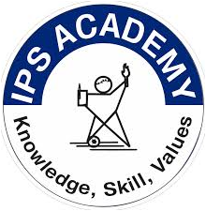
Mind Coders

IPS ACADEMY, INDORE
INSTITUTE OF ENGINEERING & SCIENCE
(A UGC Autonomous Institute Affiliated to RGPV)
DEPARTMENT OF COMPUTER SCIENCE & ENGINEERING – DATA SCIENCE
SESSION: 2026-27
IPS Academy, Indore
Institute of Engineering and Science
(A UGC Autonomous Institute Affiliated to RGPV)
Department of Computer Science & Engineering
(Data Science)


2026-27

This is to certify that the “Internship report” submitted by Ansh Patidar (Enrollment No.: 0808DS231020) is work done by her and submitted during 2026 – 2027 academic year, in partial fulfilment of the requirements for the award of the degree of BACHELOR OF TECHNOLOGY in COMPUTER SCIENCE AND ENGINEERING (DATA SCIENCE) at Mind Coders.

Mr. Pankaj Pateriya | Dr. Kalyani Tiwari | Dr. Neeraj Shrivastava
Assistant Professor | Branch Coordinator | HOD

Dr. Archana Keerti Chowdhary
Principal

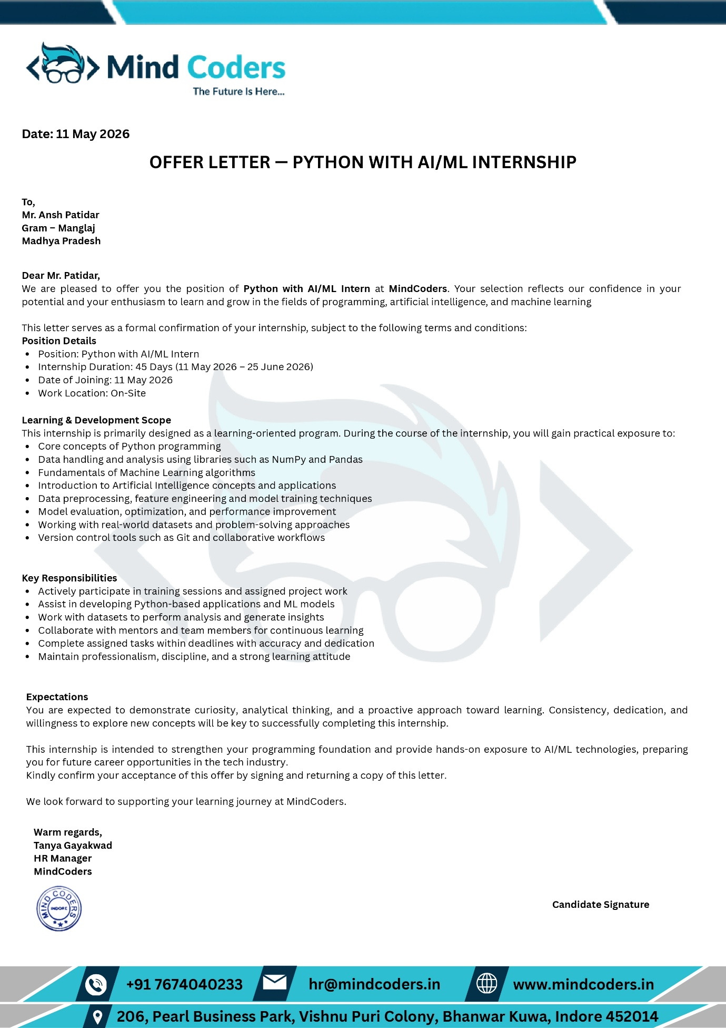
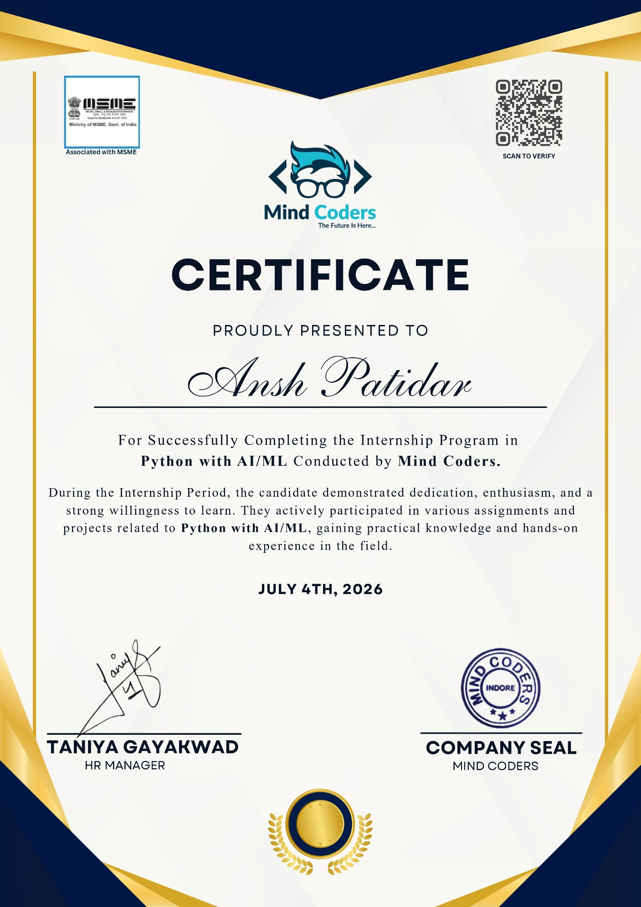

Acknowledgement

I would like to express my heartfelt thanks to my hiring manager, Taniya Gayakwad for his guidance, support, and encouragement during my internship for Python with AI & ML at Mind Coders. Without his endless effort, knowledge, patience, and answers to my numerous questions, this Internship would have never been possible. It has been great honor and pleasure for me to do Internship under his supervision.

My gratitude will not be complete without mention of Dr. Archana Keerti Chowdhary, Principal, IPS Academy, Institute of Engineering & Science, Dr. Neeraj Shrivastava, HOD CSE, IPS Academy, Institute of Engineering & Science and Dr. Kalyani Tiwari, Branch Coordinator CSE(DS), IPS Academy, Institute of Engineering & Science for the encouragement and giving me the opportunity for this internship work.

I also thank my friends who have spread their valuable time for discussion/suggestion on the critical aspects of this report. I want to acknowledge the contribution of my parents and my family members, for their constant motivation and inspiration.
Finally, I thank the almighty God who has been my guardian and a source of strength and hope in this period.

Ansh Patidar (0808DS231020)

Abstract

This internship at Mind Coders, conducted from 11 May 2026 to 25 June 2026, provided valuable hands-on experience in Python programming, Artificial Intelligence (AI), and Machine Learning (ML). The primary objective of the internship was to strengthen my programming fundamentals while gaining practical exposure to AI/ML concepts, data analysis, and real-world problem-solving techniques.

During the internship, I learned the core concepts of Python programming, including variables, data types, control statements, functions, object-oriented programming, file handling, exception handling, and data structures. I also gained practical experience with popular Python libraries such as NumPy, Pandas, and Matplotlib for data manipulation, analysis, and visualization.

The internship introduced me to the fundamentals of Artificial Intelligence and Machine Learning, including data preprocessing, feature engineering, model training, model evaluation, and performance improvement techniques. I worked with real-world datasets to perform data analysis and implement basic machine learning models while understanding the complete workflow of an AI/ML project. Additionally, I became familiar with version control using Git and collaborative development practices.

Throughout the internship, I actively participated in training sessions, completed coding assignments, and worked on practical exercises that enhanced my logical thinking and programming skills. These activities improved my understanding of problem-solving techniques, debugging, code optimization, and writing efficient Python programs.
The internship significantly enhanced my technical knowledge, analytical thinking, and confidence in developing Python-based applications and AI/ML solutions. It also improved my communication skills, teamwork, time management, and ability to work in a professional environment.

Table of Contents

Declaration | i
Offer Letter | ii
Certificate | iii
Acknowledgement | iv
Abstract | v
Table of Contents | vi
CHAPTER 1: INTRODUCTION  - Internship Program  CHAPTER 2: OVERVIEW OF THE ORGRANIZATION | 1  4
- Overview of the Organization  2.1 Brief History  2.2 Business Size  2.3 Product Lines  2.4 Competitors  2.5 Future Plans  CHAPTER 3: PLAN OF INTERNSHIP | 7
3.1 Internship Plan Details
3.2 Department of Internship
3.3 Duration
11

15

CHAPTER 4: PROJECTS
4.1 Technology Stack Worked
4.2 Training Offered
4.3 Implementation

CHAPTER 5: LEARNING EXPERIENCE
5.1 Knowledge Acquired
5.2 Skills Learned
5.3 Values Gained

19

22

24
5.4 Challenges

CHAPTER 6: SWOT ANALYSIS
6.1 Strengths
6.2 Weakness
6.3 Opportunities
6.4 Threats

CHAPTER 7: CONCLUSION

CHAPTER 8: REFERENCES

CHAPTER 1: INTRODUCTION
1. Internship Program

CHAPTER 1: INTRODUCTION

The 45-day internship program in Python with Artificial Intelligence and Machine Learning (AI/ML), conducted at Mind Coders, was designed to bridge the gap between academic learning and industry-oriented practical knowledge. The internship provided a comprehensive understanding of Python programming along with the fundamentals of Artificial Intelligence and Machine Learning through interactive training sessions, practical assignments, and hands-on implementation.

Python served as the primary programming language throughout the internship due to its simplicity, versatility, and extensive use in fields such as Data Science, Artificial Intelligence, Machine Learning, Automation, and Software Development. The training combined theoretical concepts with practical exercises, enabling me to understand how Python is applied in solving real-world problems.

The primary objective of the internship was to strengthen programming fundamentals while introducing modern AI and Machine Learning techniques. During the internship, I gained practical experience in Python programming concepts such as variables, control statements, functions, object-oriented programming, file handling, exception handling, and data structures. I also learned to work with widely used Python libraries including NumPy, Pandas, and Matplotlib for data manipulation, numerical computation, and data visualization.

The internship further introduced me to the core concepts of Artificial Intelligence and Machine Learning, including data preprocessing, feature engineering, supervised learning algorithms, model training, model evaluation, and performance optimization. Practical sessions involved working with real-world datasets to understand the complete machine learning workflow, from data preparation to model development and evaluation.

In addition to technical learning, I became familiar with professional development tools such as Google Colab, Jupyter Notebook, Visual Studio Code, and Git, which are commonly used in software development and collaborative projects. These tools enhanced my coding efficiency and provided exposure to industry-standard development practices.

Throughout the internship, I actively participated in coding exercises, assignments, and practical implementations that strengthened my logical reasoning, analytical thinking, and problem-solving abilities. The internship also emphasized teamwork, communication skills, time management, and maintaining professional ethics while working on technical tasks.
The major areas covered during the internship included:
- Python Programming Fundamentals – Variables, data types, operators, control statements, functions, object-oriented programming, file handling, exception handling, and data structures.
- Data Analysis Using Python Libraries – Data cleaning, manipulation, visualization, and exploratory data analysis using NumPy, Pandas, and Matplotlib.
- Introduction to Artificial Intelligence and Machine Learning – Data preprocessing, feature engineering, machine learning algorithms, model training, evaluation, and performance improvement techniques.
- Version Control and Development Tools – Introduction to Git, Google Colab, Jupyter Notebook, and Visual Studio Code for efficient software development and collaboration.

In addition to these learning modules, several practical assignments and mini-projects were completed to reinforce theoretical concepts through hands-on implementation. These activities significantly improved my programming proficiency and enhanced my confidence in applying Python and AI/ML techniques to solve real-world problems.

Overall, the internship at Mind Coders provided an excellent blend of academic knowledge and industrial exposure. It strengthened my technical foundation in Python and Artificial Intelligence, enhanced my analytical and programming skills, and prepared me for future career opportunities in Software Development, Data Science, Artificial Intelligence, and Machine Learning.

CHAPTER 2:

OVERVIEW OF THE ORGANIZATION

CHAPTER 2: OVERVIEW OF THE ORGANIZATION

2.1 Brief History

Mind Coders is a technology-focused training and software development organization based in Indore, Madhya Pradesh. The organization was established with the objective of providing quality technical education and industry-oriented training to students and professionals. It focuses on bridging the gap between academic learning and industry requirements by offering practical exposure through internships, workshops, certification programs, and live projects.

Over the years, Mind Coders has trained students in emerging technologies such as Python Programming, Artificial Intelligence (AI), Machine Learning (ML), Data Science, Web Development, Cloud Computing, and Cybersecurity. The organization follows a hands-on learning approach that enables students to develop practical skills required in today's IT industry.

During my internship, Mind Coders provided a structured learning environment where theoretical concepts were complemented with practical coding exercises, assignments, and AI/ML-based applications under the guidance of experienced mentors.

2.2 Business Size

Mind Coders operates as a small-to-medium-scale technology training and software development organization. The company consists of experienced trainers, software developers, AI/ML professionals, technical mentors, and administrative staff who work together to deliver quality education and technology solutions.

The organization serves engineering students, graduates, educational institutions, startups, and professionals through both offline and online learning platforms. Its internship programs, workshops, and certification courses are designed to make students industry-ready by emphasizing practical implementation and project-based learning.

2.3 Product Lines

Mind Coders offers a wide range of technical training programs and software services. Its major offerings include:
- Python Programming Training
- Artificial Intelligence and Machine Learning Courses
- Data Science and Data Analytics Programs
- Full Stack Web Development Training
- Cloud Computing and DevOps Fundamentals
- Cybersecurity Awareness and Training
- Internship Programs with Live Projects
- Corporate Skill Development Programs
- Software Development and IT Consulting Services
- Career Guidance and Placement Assistance

These programs combine theoretical knowledge with practical implementation, enabling students to build industry-relevant technical skills.

2.4 Competitors

Mind Coders operates in the technology training and skill development sector, where it competes with several organizations that provide similar technical education and internship opportunities. Some of its major competitors include:
- Codec Technologies
- Cognizance Academy
- Naresh I Technologies
- Internshala Trainings
- Besant Technologies
- QSpiders
- JSpiders
- Great Learning
- Simplilearn
- NIIT

Mind Coders differentiates itself by offering affordable training, personalized mentorship, practical assignments, live projects, and focused career guidance to students.

2.5 Future Plans

Mind Coders aims to expand its presence in the field of technical education and software development by introducing advanced training programs in rapidly growing technologies. The organization's future objectives include:
- Expanding AI and Machine Learning research-based training programs.
- Developing more industry-oriented live projects for students.
- Collaborating with colleges and universities for internship and placement programs.
- Increasing partnerships with IT companies to provide better career opportunities.
- Launching advanced courses in Generative AI, Data Engineering, Cloud Computing, and Cybersecurity.
- Strengthening online learning platforms to reach students across India.
- Promoting innovation through hackathons, coding competitions, and research initiatives.

With continuous innovation and a focus on practical learning, Mind Coders aims to become one of the leading organizations in technical training and skill development while producing highly skilled professionals for the IT industry.

CHAPTER 3:

PLAN OF INTERNSHIP

CHAPTER 3: INTERNSHIP DETAILS

3.1 Internship Plan Details

The internship at Mind Coders was designed to provide practical exposure to Python Programming, Artificial Intelligence (AI), and Machine Learning (ML) through a structured learning approach. The internship focused on developing strong programming fundamentals, analytical thinking, and practical implementation skills using industry-standard tools and technologies. The training combined theoretical concepts with coding assignments, practical exercises, and real-world datasets under the guidance of experienced mentors.
The internship plan consisted of the following phases:

Phase 1: Orientation and Introduction
- Introduction to Mind Coders, its work culture, and internship objectives.
- Overview of Python programming and AI/ML applications.
- Familiarization with development tools such as Google Colab, Jupyter Notebook, Visual Studio Code, and Git.
- Understanding the internship schedule, learning outcomes, and evaluation process.

Phase 2: Python Programming Fundamentals
- Python syntax and programming basics.
- Variables, data types, operators, and control statements.
- Functions and modular programming.
- Object-Oriented Programming (OOP).
- File handling and exception handling.
- Data structures including Lists, Tuples, Dictionaries, and Sets.

Phase 3: Data Analysis and Machine Learning
- Data manipulation using NumPy and Pandas.
- Data visualization using Matplotlib.
- Data preprocessing and cleaning.
- Exploratory Data Analysis (EDA).
- Introduction to Artificial Intelligence and Machine Learning concepts.
- Model training, testing, and evaluation using basic machine learning techniques.

Phase 4: Practical Assignments and Implementation
- Solving Python programming problems.
- Working with real-world datasets.
- Performing data preprocessing and visualization.
- Implementing basic machine learning models.
- Understanding model evaluation and performance improvement techniques.
- Preparing documentation and presenting completed assignments.

3.2 Department of Internship

During the internship, I was placed in the Python & Artificial Intelligence / Machine Learning (AI/ML) Training Department of Mind Coders. This department focuses on developing technical skills in programming, data analysis, artificial intelligence, and machine learning through structured training and practical implementation.

Key Functional Areas
- Python Programming
- Artificial Intelligence Fundamentals
- Machine Learning Concepts
- Data Analysis and Visualization
- Data Preprocessing
- Practical Coding Assignments
- Technical Skill Development
- Industry-Oriented Training Programs

Department Responsibilities
- Conducting technical training sessions.
- Designing internship modules and coding assignments.
- Providing mentorship and technical guidance.
- Assisting interns in solving real-world programming problems.
- Evaluating assignments and monitoring learning progress.
- Promoting industry best practices and professional ethics.

My Role Within the Department
As a Python with AI/ML Intern, my responsibilities included:
- Learning and implementing Python programming concepts.
- Writing Python programs to solve logical and analytical problems.
- Working with NumPy, Pandas, and Matplotlib for data analysis.
- Performing data preprocessing and exploratory data analysis.
- Understanding the workflow of machine learning model development.
- Completing practical assignments and coding exercises.
- Documenting learning outcomes and project work.

This department significantly enhanced my programming skills, analytical thinking, and understanding of Artificial Intelligence and Machine Learning technologies.

3.3 Duration

The internship was successfully completed over a period of 45 days.
- Start Date: 11 May 2026
- End Date: 25 June 2026
- Working Mode: On-Site
- Organization: Mind Coders
- Internship Domain: Python with Artificial Intelligence & Machine Learning (AI/ML)
- Total Duration: 45 Days
During this period, I successfully completed:
- Technical training sessions on Python and AI/ML.
- Practical programming assignments.
- Data analysis and visualization exercises.
- Machine Learning implementation activities.
- Coding assessments and mentor evaluations.
- Documentation of learning outcomes and internship activities.

The internship provided valuable practical exposure to Python programming and Artificial Intelligence while improving my technical knowledge, analytical skills, problem-solving ability, teamwork, and professional communication. It served as an excellent opportunity to understand industry practices and apply classroom concepts to real-world scenarios.

CHAPTER 4:

PROJECTS

CHAPTER 4: PROJECTS

The internship at Mind Coders was designed to provide practical exposure to Python programming, Artificial Intelligence (AI), Machine Learning (ML), and Data Analysis through instructor-led sessions, coding assignments, practical exercises, and hands-on implementation. During the 45-day internship, I completed several programming assignments and practical activities that strengthened my understanding of Python and introduced me to the workflow of AI and Machine Learning.
The internship focused on developing programming skills through regular coding practice, problem-solving exercises, data analysis tasks, and implementation of basic machine learning concepts using industry-standard tools such as Google Colab, Jupyter Notebook, and Python libraries.

4.1 Major Practical Work: Python Programming and Data Analysis
Objective

The objective of this practical work was to develop a strong foundation in Python programming and apply Python libraries for data manipulation, analysis, and visualization.

Description
During this phase of the internship, I practiced Python programming by solving problems related to variables, operators, conditional statements, loops, functions, object-oriented programming, file handling, exception handling, and data structures.
I also learned to work with datasets using NumPy and Pandas, where I performed tasks such as:
- Importing datasets into Python.
- Data cleaning and preprocessing.
- Handling missing values.
- Filtering and sorting records.
- Data aggregation and summarization.
- Performing basic statistical analysis.

For data visualization, I used Matplotlib to generate graphical representations such as:
- Bar Charts
- Line Charts
- Pie Charts
- Histograms
- Scatter Plots

These practical exercises helped me understand how Python is used for data analysis and decision-making.

Technologies Used
- Python
- NumPy
- Pandas
- Matplotlib
- Google Colab
- Jupyter Notebook

Learning Outcome
This practical work strengthened my Python programming skills and improved my understanding of data preprocessing, analysis, visualization, and problem-solving using Python.

4.2 Major Practical Work: Introduction to Artificial Intelligence and Machine Learning

Objective
The objective of this module was to understand the basic workflow of Artificial Intelligence and Machine Learning and learn how machine learning models are developed using Python.

Description
During this part of the internship, I learned the fundamental concepts of Artificial Intelligence and Machine Learning, including:
- Introduction to AI and ML
- Types of Machine Learning
- Data preprocessing
- Feature selection
- Training and testing datasets
- Model evaluation
- Performance measurement

I worked with sample datasets to understand the complete machine learning process. Practical exercises included data preprocessing, splitting datasets, training simple machine learning models, and evaluating their performance using appropriate metrics.
The internship emphasized understanding the complete machine learning pipeline rather than developing highly complex models.

Technologies Used
- Python
- NumPy
- Pandas
- Scikit-learn
- Google Colab

Learning Outcome
This module provided me with a basic understanding of machine learning concepts and helped me understand how data is prepared, models are trained, and predictions are evaluated in real-world applications.

4.3 Programming Assignments and Practical Exercises

Apart from the practical modules, I completed numerous coding assignments that reinforced my understanding of Python programming and AI/ML concepts.
The assignments included:
- Python syntax and basic programming
- Conditional statements and loops
- Functions and recursion
- Object-Oriented Programming (OOP)
- Lists, Tuples, Dictionaries, and Sets
- String manipulation
- File handling
- Exception handling
- Basic data analysis using Pandas
- Data visualization using Matplotlib
- Introduction to machine learning workflows
- Logical and analytical programming problems

These assignments improved my logical thinking, debugging skills, coding efficiency, and confidence in solving programming problems. Regular practice also enhanced my understanding of writing clean, modular, and reusable Python code while following standard programming practices.

CHAPTER 5:

LEARNING EXPERIANCE

CHAPTER 5: LEARNING EXPERIENCE

The 45-day internship at Mind Coders was a valuable learning experience that significantly enhanced my technical knowledge, analytical thinking, and professional skills. Through structured training sessions, coding assignments, and practical implementation, I gained hands-on experience in Python programming, Data Analysis, Artificial Intelligence, and Machine Learning. The internship provided an opportunity to apply theoretical concepts learned in academics to practical scenarios, thereby improving my confidence and problem-solving abilities.
This chapter summarizes the knowledge acquired, skills developed, professional values gained, and challenges encountered during the internship.

5.1 Knowledge Acquired
During the internship, I developed a strong understanding of Python programming and its applications in Data Science, Artificial Intelligence, and Machine Learning. I strengthened my knowledge of core Python concepts, including:
- Variables, data types, operators, and expressions
- Conditional statements and loops
- Functions and modular programming
- Object-Oriented Programming (Classes and Objects)
- File handling and exception handling
- Data structures such as Lists, Tuples, Dictionaries, and Sets
As the internship progressed, I learned how Python libraries simplify data analysis and machine learning tasks. I gained practical knowledge of:
- NumPy for numerical computations
- Pandas for data manipulation and preprocessing
- Matplotlib for data visualization
- Scikit-learn for implementing basic machine learning models
I also understood the complete machine learning workflow, including data preprocessing, feature selection, model training, testing, and evaluation using sample datasets. These practical activities helped me understand how AI and Machine Learning are applied to solve real-world problems.

5.2 Skills Learned
The internship helped me develop both technical and professional skills.

Technical Skills
- Python programming and problem-solving
- Data analysis using NumPy and Pandas
- Data visualization using Matplotlib
- Data cleaning and preprocessing
- Basic Machine Learning implementation using Scikit-learn
- Debugging and code optimization
- Working with Google Colab, Jupyter Notebook, and Visual Studio Code
- Basic understanding of Git and version control
Professional Skills
- Planning and completing assigned tasks within deadlines
- Writing clean, modular, and readable code
- Understanding structured software development practices
- Preparing technical documentation and reports
- Learning through mentor guidance and continuous feedback
Soft Skills
- Improved logical and analytical thinking
- Better communication and presentation skills
- Time management and self-discipline
- Adaptability to new technologies and learning environments
- Teamwork and collaboration during practical sessions
- Increased confidence in solving programming problems independently

5.3 Values Gained
The internship helped me develop several important professional values that will benefit my future career.
I learned the importance of discipline, consistency, and continuous learning while working in a technical environment. Regular coding practice taught me that programming skills improve through persistence and practical implementation rather than theoretical knowledge alone.
Working under the guidance of experienced mentors encouraged me to ask questions, accept constructive feedback, and continuously improve my coding approach. The internship also strengthened my sense of responsibility, professionalism, and commitment towards completing assigned tasks on time.
Most importantly, I developed confidence in learning new technologies independently and understood the importance of lifelong learning in the rapidly evolving fields of Artificial Intelligence and Machine Learning.

5.4 Challenges and Overcoming Them
Like every learning experience, this internship presented several challenges that contributed to my overall growth.
Initially, I found it difficult to understand some advanced Python concepts such as Object-Oriented Programming, exception handling, and working with external libraries. With regular practice, coding exercises, and mentor guidance, I gradually became comfortable implementing these concepts.
Another challenge was understanding data preprocessing and machine learning workflows. Cleaning datasets, handling missing values, and preparing data for model training required careful attention. By practicing on sample datasets and experimenting with different techniques using Pandas and Scikit-learn, I gained a much better understanding of these processes.
Debugging programming errors was also challenging in the beginning. However, consistent practice helped me improve my debugging skills, understand error messages more effectively, and write more efficient and reliable code.
Overall, these challenges strengthened my analytical thinking, patience, and problem-solving abilities. They also increased my confidence in learning new technologies and applying programming concepts to practical situations.

CHAPTER 6:

SWOT ANALYSIS

CHAPTER 6: SWOT ANALYSIS

A SWOT Analysis (Strengths, Weaknesses, Opportunities, and Threats) provides a structured framework to evaluate my overall internship experience at Mind Coders. It helped me assess the knowledge and skills I acquired, identify areas requiring improvement, recognize future career opportunities, and understand the challenges associated with working in the rapidly evolving field of Artificial Intelligence, Machine Learning, and Software Development.

6.1 Strengths
The internship significantly strengthened my technical foundation in Python programming, Data Analysis, and the basics of Artificial Intelligence and Machine Learning. Through regular coding practice and practical assignments, I developed a clear understanding of Python programming concepts, object-oriented programming, data structures, file handling, and exception handling.
I also gained hands-on experience with widely used Python libraries such as NumPy, Pandas, Matplotlib, and Scikit-learn, which enhanced my ability to manipulate, analyze, and visualize data efficiently.
Another important strength I developed was logical thinking and problem-solving ability. Solving programming exercises and working with datasets improved my analytical approach and enabled me to write clean, efficient, and modular code.
The internship also improved my communication skills, self-confidence, and ability to work in a disciplined learning environment. Completing assignments within deadlines and actively participating in training sessions helped me become more organized, responsible, and adaptable.

6.2 Weaknesses
Although the internship greatly enhanced my technical knowledge, I identified a few areas where I need further improvement.
Initially, I found advanced Machine Learning concepts and data preprocessing techniques difficult to understand. I also realized that I need more practical experience in building complete end-to-end AI/ML applications using real-world datasets.
Another area that requires improvement is gaining deeper knowledge of advanced Python frameworks, cloud technologies, and software deployment techniques. While I developed strong programming fundamentals, I recognize the importance of continuously improving my coding efficiency and exploring more advanced technologies.
Time management during multiple assignments was another challenge in the initial stages of the internship. However, regular practice and better planning helped me overcome this difficulty.

6.3 Opportunities
This internship opened several opportunities for my future academic and professional growth.
The knowledge gained in Python programming and Artificial Intelligence has motivated me to pursue advanced learning in Machine Learning, Data Science, Deep Learning, and Generative AI. These technologies are transforming various industries and offer excellent career prospects.
The internship experience has also strengthened my resume and technical portfolio, making me better prepared for campus placements, technical interviews, internships, hackathons, and software development projects.
Furthermore, the practical skills acquired during the internship provide a strong foundation for undertaking advanced projects, research work, certifications, and industry-oriented training in emerging technologies.

6.4 Threats
The technology industry is continuously evolving, with new programming languages, frameworks, libraries, and AI technologies being introduced regularly. Keeping technical knowledge up to date requires continuous learning and practical experience.
Another challenge is the increasing competition among students and professionals in the fields of Software Development, Artificial Intelligence, and Data Science. To remain competitive, it is essential to continuously improve programming skills, build innovative projects, obtain relevant certifications, and stay informed about current industry trends.
However, I believe that continuous learning, practical implementation, and dedication will help me overcome these challenges and achieve my long-term career goals.

CHAPTER 7:

CONCLUSION

CHAPTER 7: CONCLUSION

The 45-day internship at Mind Coders, conducted from 11 May 2026 to 25 June 2026, was a highly enriching and rewarding learning experience that provided me with valuable exposure to Python programming, Artificial Intelligence, Machine Learning, and Data Analysis. The internship played an important role in bridging the gap between academic learning and practical implementation by enabling me to apply theoretical concepts through hands-on coding assignments, practical exercises, and real-world datasets.

Throughout the internship, I strengthened my understanding of Python programming fundamentals, including object-oriented programming, data structures, file handling, exception handling, and problem-solving techniques. I also gained practical experience in using Python libraries such as NumPy, Pandas, Matplotlib, and Scikit-learn for data analysis, visualization, and introductory machine learning tasks. The structured training sessions and continuous guidance from experienced mentors enhanced my technical knowledge and encouraged me to adopt industry-standard programming practices.

In addition to technical learning, the internship contributed significantly to my professional development. It improved my analytical thinking, logical reasoning, debugging skills, time management, communication, and self-learning abilities. Regular assignments and practical exercises taught me the importance of writing clean, efficient, and well-structured code while working systematically to solve programming challenges.

The internship also introduced me to the workflow of Artificial Intelligence and Machine Learning projects, including data preprocessing, model training, testing, and evaluation. This exposure motivated me to explore advanced topics in AI, Data Science, and Software Development and strengthened my interest in pursuing a career in these rapidly growing fields.

Overall, the internship at Mind Coders provided an excellent blend of academic knowledge and practical experience. It enhanced my confidence, expanded my technical capabilities, and prepared me for future academic projects, internships, and professional opportunities in Software Development, Artificial Intelligence, Machine Learning, and Data Science. I sincerely express my gratitude to Mind Coders, my mentors, and my faculty members for their continuous guidance, support, and encouragement throughout this internship. Their mentorship has played a significant role in my technical and professional growth and will continue to inspire me in my future career.

CHAPTER 8:

REFERENCES

CHAPTER 8: REFERENCES

• Python Software Foundation. (2024). Python Documentation. Retrieved on 25/06/2026 from https://docs.python.org/3/
• NumPy Developers. (2024). NumPy Documentation. Retrieved on 25/06/2026 from https://numpy.org/doc/
• Pandas Development Team. (2024). Pandas: Python Data Analysis Library. Retrieved on 25/06/2026 from https://pandas.pydata.org/docs/
• Matplotlib Development Team. (2024). Matplotlib Documentation. Retrieved on 25/06/2026 from https://matplotlib.org/stable/users/index.html
• Scikit-learn Developers. (2024). Scikit-learn: Machine Learning in Python. Retrieved on 25/06/2026 from https://scikit-learn.org/stable/documentation.html
• Google. (2024). Google Colaboratory Documentation. Retrieved on 25/06/2026 from https://colab.research.google.com/
• Jupyter Development Team. (2024). Project Jupyter Documentation. Retrieved on 25/06/2026 from https://docs.jupyter.org/
• McKinney, W. (2022). Python for Data Analysis (3rd Edition). O'Reilly Media.
• Géron, A. (2023). Hands-On Machine Learning with Scikit-Learn, Keras & TensorFlow (3rd Edition). O'Reilly Media.
• VanderPlas, J. (2016). Python Data Science Handbook: Essential Tools for Working with Data. O'Reilly Media.
• Raschka, S., & Mirjalili, V. (2022). Machine Learning with PyTorch and Scikit-Learn. Packt Publishing.
• Mind Coders. (2026). Python & Artificial Intelligence Internship Training Material. Internal Training Notes and Practical Assignments.

