Trekking Management Application V2
Modern Application Development II — Project Report

1. Student Details
Student Name | Ansh Rai
Roll Number | 24f2001193
Email | 24f2001193@ds.study.iitm.ac.in
Project Course Code | BSCS2004P

2. Project Details
Project Title: Trekking Management Application V2 (TMA-V2)
Problem Statement:
To design and develop a web-based trekking management system that simplifies the coordination of trekking activities among Admins, Trek Staff, and Trekkers. The application aims to replace manual methods such as spreadsheets, phone calls, and manual booking records by providing centralized management of treks, staff assignments, participant bookings, slot availability, trek status, and trekking history.
Approach:
The application was developed using Flask as the REST API backend and VueJS as the frontend, following a role-based architecture for three types of users: Admin, Trek Staff, and Trekker. The Admin manages treks, staff, users, bookings, and analytics; Trek Staff manages assigned treks and participants; and Trekkers can explore and book available treks, manage their profiles, and view their booking history.
The application uses SQLite for data storage, JWT authentication for secure role-based access, Redis for caching frequently accessed trek data, and Celery with Redis for asynchronous and scheduled background jobs such as daily trek reminders, monthly admin reports, and CSV export of trekking history. Analytics and visual reports are displayed using Chart.js.
3. AI/LLM Declaration
AI/LLM tools were used as development assistants during the implementation of this project, primarily for code suggestions, debugging, resolving integration issues, and understanding the implementation of advanced features. All generated suggestions were reviewed, tested, and adapted according to the project requirements.
Component / Area | Approx. AI Assistance | Purpose / Role in Project | Notes
Flask REST APIs | 20% | Backend routing and API development | Assistance was mainly used for structuring some role-specific API endpoints and resolving backend errors.
SQLite & SQLAlchemy | 10% | Database models, relationships, and persistence | Used for guidance while defining relationships between Users, Treks, Bookings, and Staff Profiles.
Vue.js & Axios | 25% | Frontend UI and API communication | Assistance was used for Vue component structure, Axios integration, and resolving frontend-backend communication issues.
Authentication & RBAC | 10% | JWT login and role-based authorization | Used for guidance in implementing JWT authentication and protecting Admin, Staff, and Trekker routes.
Redis Caching | 5% | API performance optimization | Assistance was mainly used for cache configuration, expiry, and cache invalidation.
Celery & Background Jobs | 15% | Async CSV export and scheduled jobs | This was one of the more technically difficult areas; assistance was used for Celery configuration, application context issues, task scheduling, and debugging.
Email & Monthly Reports | 5% | Trek reminders and Admin activity reports | Used for resolving Flask-Mail configuration and email delivery issues.
Chart.js Analytics | 5% | Admin dashboard charts and statistics | Used for integrating analytics data with Chart.js visualizations.
Testing & Debugging | 5% | Error identification and correction | Used to diagnose CORS, Celery worker, JWT, Redis, and frontend integration errors.

4. Technologies and Frameworks Used
Technology / Library | Purpose
Flask | Core backend framework used to develop REST APIs
Vue.js | Frontend JavaScript framework used to build the user interface
SQLAlchemy | Object Relational Mapper (ORM) used to interact with the SQLite database
SQLite | Lightweight relational database used to store users, treks, staff profiles, and bookings
Bootstrap 5 | Used for frontend styling and responsive user interface design
JWT (Flask-JWT-Extended) | Used for user authentication and role-based access control
Axios | Used by the Vue.js frontend to communicate with Flask REST APIs
Redis | Used for caching frequently accessed trek data and as a message broker for Celery
Celery | Used for asynchronous and scheduled background jobs
Celery Beat | Used to schedule daily trek reminders and monthly admin activity reports
Flask-Mail | Used to send trek reminder emails and monthly activity reports
Chart.js | Used to display analytics such as trek popularity, booking status, monthly booking trends, and trek status distribution
Flask-Caching | Used to cache frequently accessed API responses with expiration and cache invalidation
Flask-CORS | Enables communication between the Vue.js frontend and Flask backend running on different local ports

5. Database Schema / ER Diagram
Tables:
User — stores account and authentication details for Admin, Trek Staff, and Trekkers, including name, email, password, phone number, role, active status, and blacklist status.
Trek — stores trekking event details such as trek name, location, difficulty, duration, altitude, total slots, available slots, price, assigned staff, trek status, start date, and end date.
Booking — stores trek booking records, including the Trekker, booked trek, booking date, booking status, and payment status.
Staff Profile — stores additional details of Trek Staff members, including experience, specialization, emergency contact, biography, and staff status.
Relationships:
- One-to-Many → User (Trekker) → Booking
- One-to-Many → Trek → Booking
- One-to-One → User (Trek Staff) → Staff Profile
- One-to-Many → User (Trek Staff) → Trek

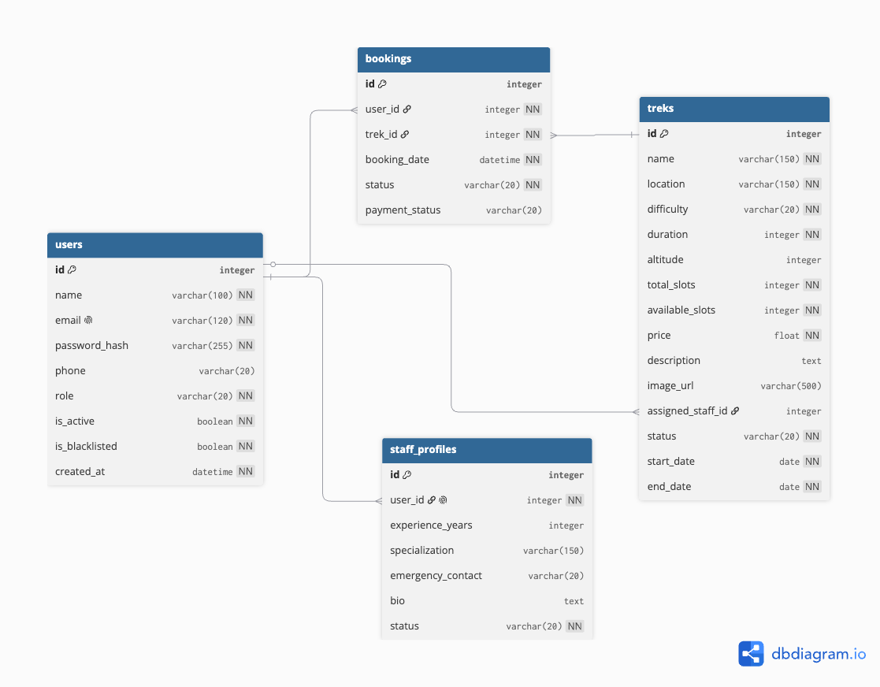

6. API Resource Endpoints
Method | API Endpoint | Purpose
POST | /api/auth/register | Register a new Trekker account
POST | /api/auth/login | Authenticate Admin, Trek Staff, or Trekker and generate JWT token
GET | /api/admin/dashboard | Fetch Admin dashboard statistics
GET | /api/admin/analytics | Fetch trek, booking, and participation analytics for charts
GET / POST | /api/admin/treks | View all treks or create a new trek
GET / PUT / DELETE | /api/admin/treks/<id> | View, update, or delete a specific trek
GET / POST | /api/admin/staff | View existing Trek Staff or create a new staff member
PUT | /api/admin/treks/<id>/assign-staff | Assign a Trek Staff member to a trek
GET | /api/staff/dashboard | Fetch Trek Staff dashboard details
GET / PUT | /api/staff/treks | View and manage treks assigned to the logged-in staff member
GET | /api/trekker/dashboard | Fetch Trekker dashboard information
GET | /api/trekker/treks | View, search, and filter available treks
POST | /api/trekker/treks/<id>/book | Book an available and open trek
GET | /api/trekker/history | View complete trekking and booking history
POST | /api/trekker/export-history | Trigger asynchronous CSV export of trekking history

7. Architecture and Features

Architecture Overview:
app.py – Main Flask application entry point and application configuration.
models.py – Defines SQLAlchemy database models for Users, Staff Profiles, Treks, and Bookings.
/routes – Contains Flask Blueprints and REST API routes for authentication, Admin, Trek Staff, and Trekker functionality.
VueJS Frontend – Provides a single-page, role-based user interface for Admin, Trek Staff, and Trekkers.
Axios – Handles communication between the VueJS frontend and Flask REST APIs.
SQLite Database – Stores user accounts, staff profiles, trek information, bookings, and trekking history.
Redis – Provides caching for frequently accessed trek data and acts as the broker and result backend for Celery.
Celery and Celery Beat – Execute asynchronous and scheduled background tasks.

Implemented Features:
- JWT-based registration, login, and role-based access control
- Separate dashboards for Admin, Trek Staff, and Trekkers
- Admin management of treks, users, staff, and bookings
- Trek Staff assignment and assigned-trek management
- Trek search and filtering by difficulty, location, and duration
- Trek booking, cancellation, booking status, and complete trekking history
- Prevention of duplicate bookings and overbooking
- Trek slot and status management
- User and staff deactivation and blacklisting
- Redis caching with expiry and cache invalidation
- Responsive user interface using Bootstrap

Additional Features:
- Admin analytics dashboard using Chart.js
- Trek popularity and booking trend visualizations
- Daily email reminders for upcoming treks
- Monthly HTML activity report sent to the Admin by email
- Asynchronous CSV export of Trekker booking history
- Celery Beat scheduling for automatic background jobs
8. Video Presentation
Presentation Video Drive Link: https://drive.google.com/file/d/1gkRS4260A1CJhwr1k_P7-CTNq1yuFjx2/view?usp=sharing
The video demonstrates the project approach, major role-based workflows, core features, Redis caching, Celery background jobs, email reminders/reports, CSV export, and analytics.

