Trekking Management Application
Modern Application Development I — Project Report

1. Student Details
Student Name | Ansh Rai
Roll Number | 24f2001193
Email | 24f2001193@ds.study.iitm.ac.in
Project Course Code | BSCS2003P

2. Project Details
Project Title: Trekking Management Application
Problem Statement:
To design and build a web-based application that allows adventure organizations to efficiently manage trekking activities involving administrators, trek staff, and trekkers. The system aims to replace manual coordination methods such as spreadsheets and phone calls by providing centralized management of treks, staff approvals and assignments, participant bookings, available slots, trek status, and booking history.
Approach:
The application was built using Flask as the backend framework, Jinja2 templates with HTML, CSS, and Bootstrap for the frontend, and SQLite with SQLAlchemy for database management. A role-based system was implemented for Admin, Trek Staff, and Trekkers. The Admin manages treks, users, staff approvals, assignments, and bookings; Trek Staff manage their assigned treks and participants; and Trekkers can search, book, cancel, and view their trekking history. The application also prevents overbooking, maintains complete booking records, provides REST API endpoints, and includes statistical visualizations on the Admin dashboard.

3. AI/LLM Declaration
AI/LLM tools were used as development assistance for selected parts of the project. The generated suggestions were reviewed, tested, debugged, and integrated during the development process. The following table summarizes the areas where AI assistance was used.
Component / Area | AI Usage % | Purpose / Role in Project | Notes
Flask Backend & Routing | 20% | Assistance with Flask routes and request handling | Used mainly for structuring role-specific routes and resolving routing errors
SQLite & SQLAlchemy | 15% | Database models, relationships, and queries | Assistance with foreign-key relationships and database operations
HTML & Jinja2 | 15% | Server-side template rendering | Used for dynamic dashboards and role-specific pages
Bootstrap & CSS | 8% | Styling and responsive layout | Assistance with dashboard cards, forms, tables, and responsive design
Authentication & Access Control | 10% | Login, sessions, and role-based authorization | Used for implementing Admin, Trek Staff, and Trekker access restrictions
Admin & Trek Management | 10% | CRUD operations and management functionality | Assistance with trek creation, editing, deletion, staff approval, and assignment
Trekker & Booking Logic | 10% | Booking, cancellation, slot management, and history | Used particularly for preventing overbooking and maintaining booking history
Charts & API Endpoints | 5% | Visualizations and REST API implementation | Assistance with Chart.js integration and JSON API endpoints
Testing & Debugging | 5% | Error identification and test guidance | Used to resolve runtime errors and verify major application workflows
Documentation | 2% | Report structure and technical documentation | Assistance with organizing project information and describing implementation

4. Technologies and Frameworks Used
Technology / Library | Purpose
Flask | Core backend web framework used for routing, request handling, business logic, authentication, and API development
Flask-SQLAlchemy | Flask extension used to integrate SQLAlchemy with the application
SQLAlchemy | Object Relational Mapper (ORM) used to define database models, relationships, and interact with the SQLite database
Jinja2 | Template engine used for rendering dynamic HTML pages based on user roles and application data
HTML5 | Used to structure the web pages and forms
CSS3 | Used for custom styling and improving the user interface
Bootstrap 5 | Used for responsive frontend design, navigation, forms, cards, tables, and other UI components
Chart.js | Used to display statistical visualizations for trek and booking statuses on the Admin dashboard
SQLite | Lightweight relational database used to store users, staff profiles, treks, bookings, and booking history
Werkzeug Security | Used for secure password hashing and password verification
Flask Sessions | Used for user authentication, session management, and role-based access control

5. Database Schema / ER Diagram
Tables:
- User — Stores account and profile details for Admin, Trek Staff, and Trekkers (id, name, email, password, role, contact, is_approved, is_blacklisted).
- StaffProfile — Stores additional information specific to registered trek staff members (id, user_id, experience).
- Trek — Stores details of trekking events created and managed by the Admin and assigned Trek Staff (id, name, location, difficulty, duration, available_slots, assigned_staff_id, status, start_date, end_date).
- Booking — Stores booking records and maintains the booking history of trekkers (id, user_id, trek_id, booking_date, status).
Relationships:
- One-to-One → User → StaffProfile
- One-to-Many → User (Trekker) → Booking
- One-to-Many → Trek → Booking
- One-to-Many → User (Trek Staff) → Trek
ER Diagram:
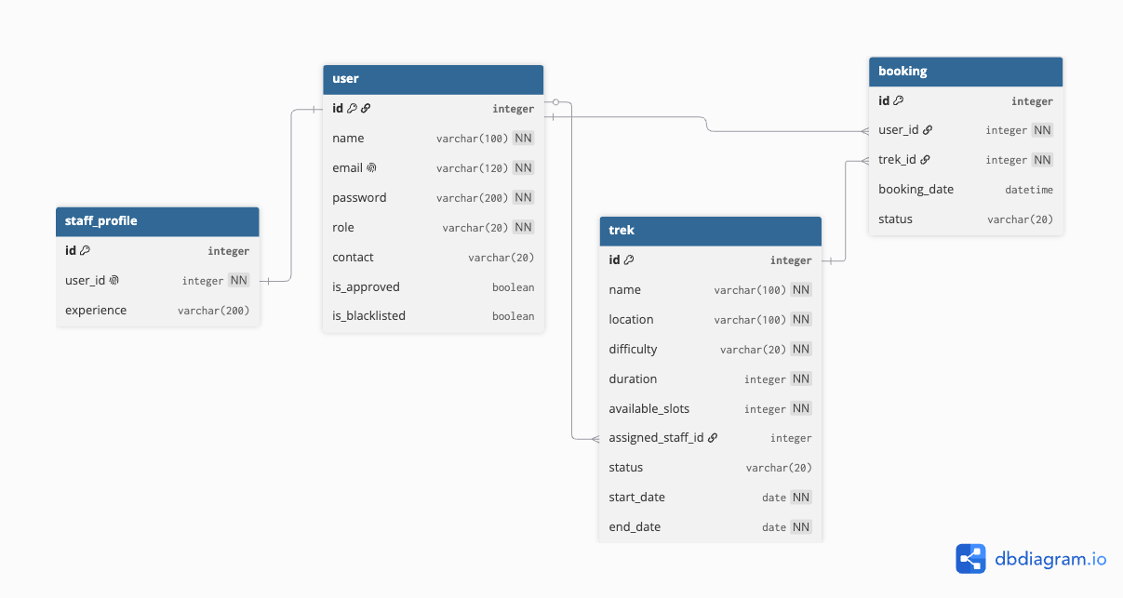

6. API Resource Endpoints
The application provides JSON-based REST API endpoints for retrieving application data and performing CRUD operations on trek resources.
HTTP Method | API Endpoint | Purpose
GET | /api/treks | Retrieve details of all treks
GET | /api/treks/<trek_id> | Retrieve details of a specific trek by ID
POST | /api/treks | Create a new trek
PUT | /api/treks/<trek_id> | Update an existing trek
DELETE | /api/treks/<trek_id> | Delete an existing trek
GET | /api/users | Retrieve details of all registered users
GET | /api/bookings | Retrieve all booking records
The APIs return data in JSON format with appropriate HTTP status codes and error messages. Administrative authentication is required for API operations that modify trek data, including POST, PUT, and DELETE.

7. Architecture and Features

Architecture Overview
- app.py — Main Flask application containing routes, authentication logic, role-based access control, business logic, CRUD operations, API endpoints, and application configuration.
- models.py — Contains the SQLAlchemy database models for User, StaffProfile, Trek, and Booking, along with their relationships.
- templates/ — Contains Jinja2 HTML templates organized into separate Admin, Trek Staff, and Trekker interfaces.
- static/css/ — Contains custom CSS used for application styling alongside Bootstrap 5.
- instance/trekking.db — SQLite database created programmatically when the application starts.

Implemented Features
- Role-based registration and login for Admin, Trek Staff, and Trekkers.
- Pre-existing Admin account created programmatically.
- Admin dashboard with application statistics and Chart.js visualizations.
- Complete trek creation, editing, deletion, and staff assignment by Admin.
- Staff registration with mandatory Admin approval before dashboard access.
- Blacklisting and management of registered users and staff.
- Trek Staff dashboard for managing assigned treks, available slots, trek status, and participants.
- Trekker dashboard for browsing, searching, filtering, booking, and cancelling treks.
- Prevention of overbooking and duplicate active bookings.
- Booking allowed only for treks with Open status and available slots.
- Complete booking and trekking history maintenance.
- User and Trek Staff profile editing.
- Role-based route protection and session management.
- Secure password hashing and verification using Werkzeug.
- JSON REST API endpoints supporting GET, POST, PUT, and DELETE operations.
- Responsive user interface built using Bootstrap 5 and custom CSS.
- Statistical visualizations for trek and booking statuses using Chart.js.

8. Video Presentation Link
Google Drive Link: https://drive.google.com/file/d/1KdoENmT1vGB-VJM9cBymDIfJBd6lGVxY/view?usp=sharing

The video demonstrates the public interface, Admin dashboard and management functions, Trekker booking and history features, Trek Staff management and participant views, statistical visualizations, and JSON API output.

