Parking for college Website

The purpose of this website is to provide an interface to the students so that they can view how many parking slots are available in the college campus and can reserve a parking slot for themselves.

Wamp server was installed for databse by using MariaDB.

In the phpMyAdmin a database test was created. Inside this 2 tables were created called reg and parklot.

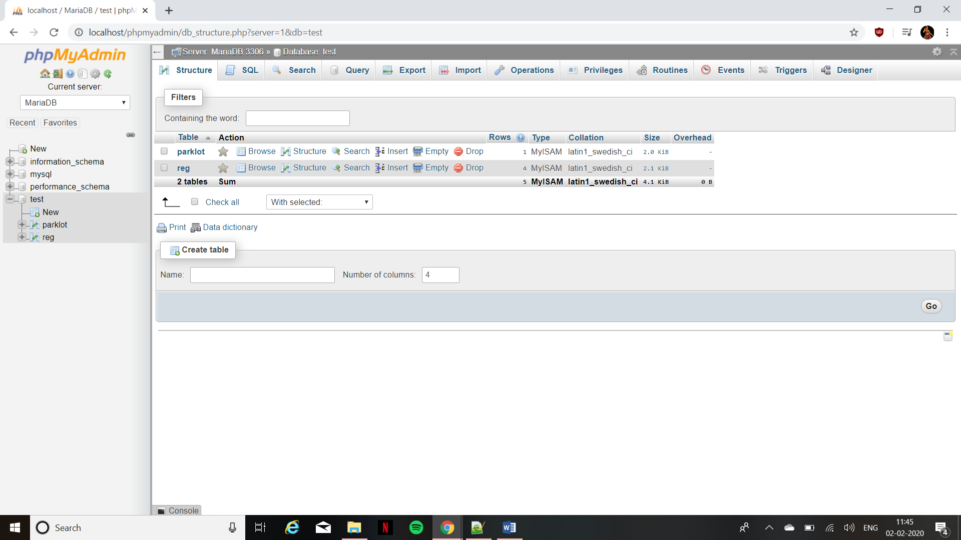

In the table reg it contains email and password(pwd1) as its attributes. Since it is for a college site, the student email id and password to login will be privided to them by the college. These details will already be stored in the database.

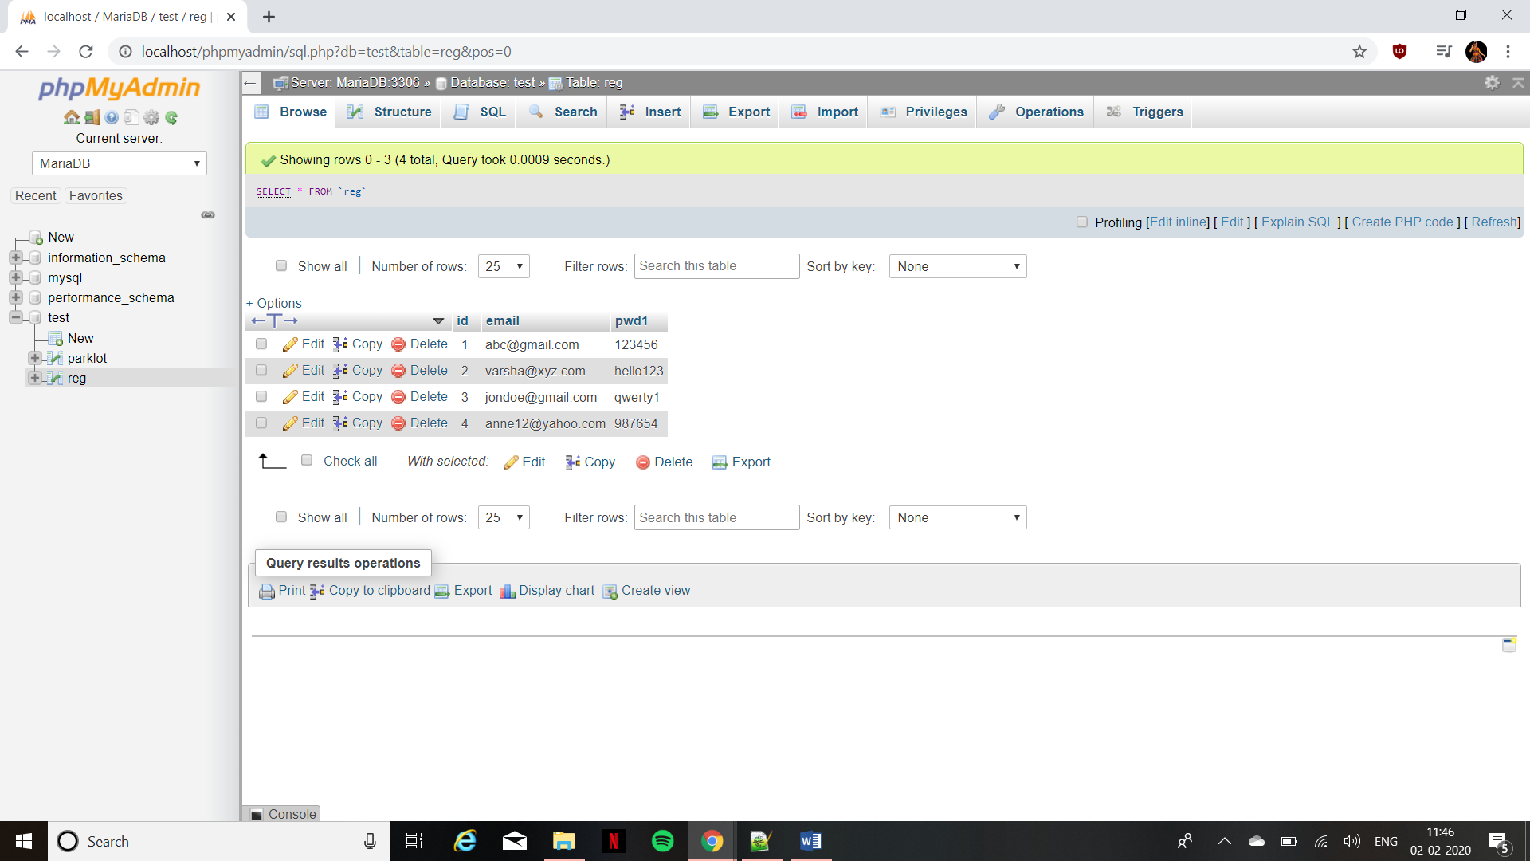

In the table parklot it contains 2 attributes which is open and book to show the available slots and booked slots respectively. The available slot has been been initialized as the total number of parking slots present in the premise and the booked slot has been initialized as 0.

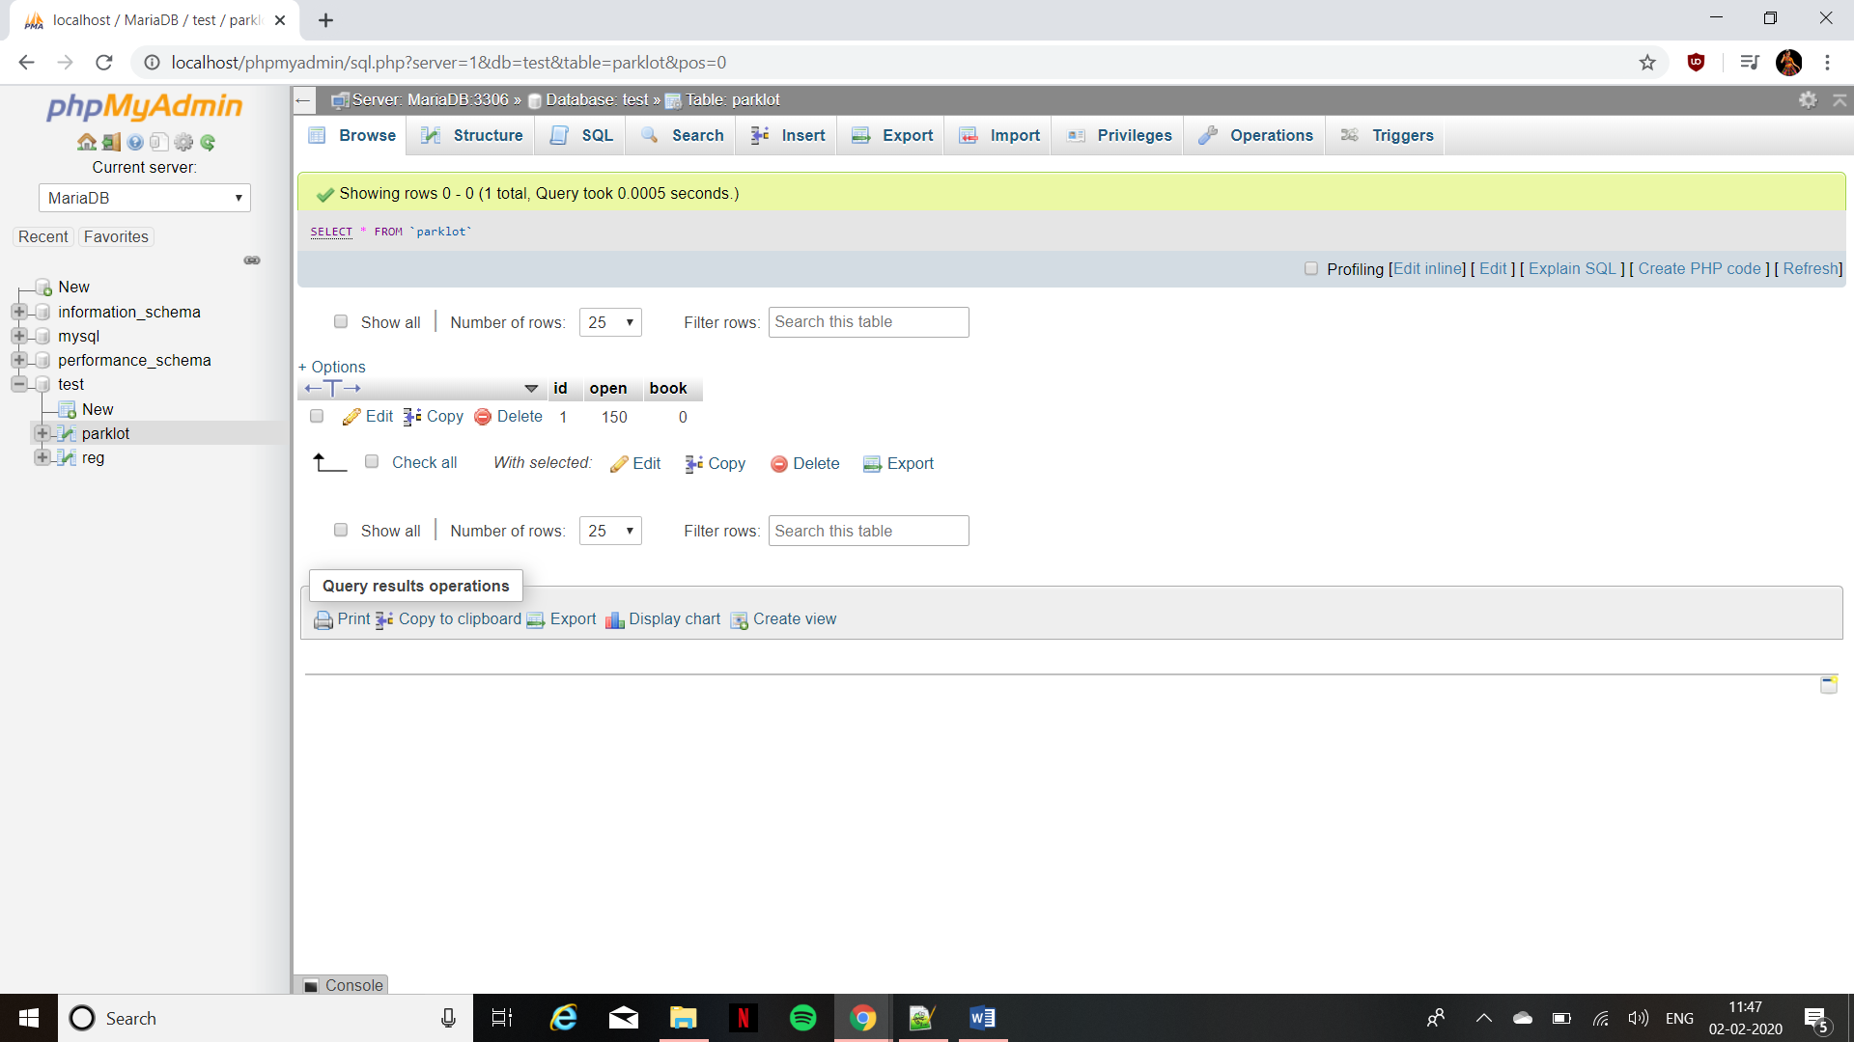

Homepage.html

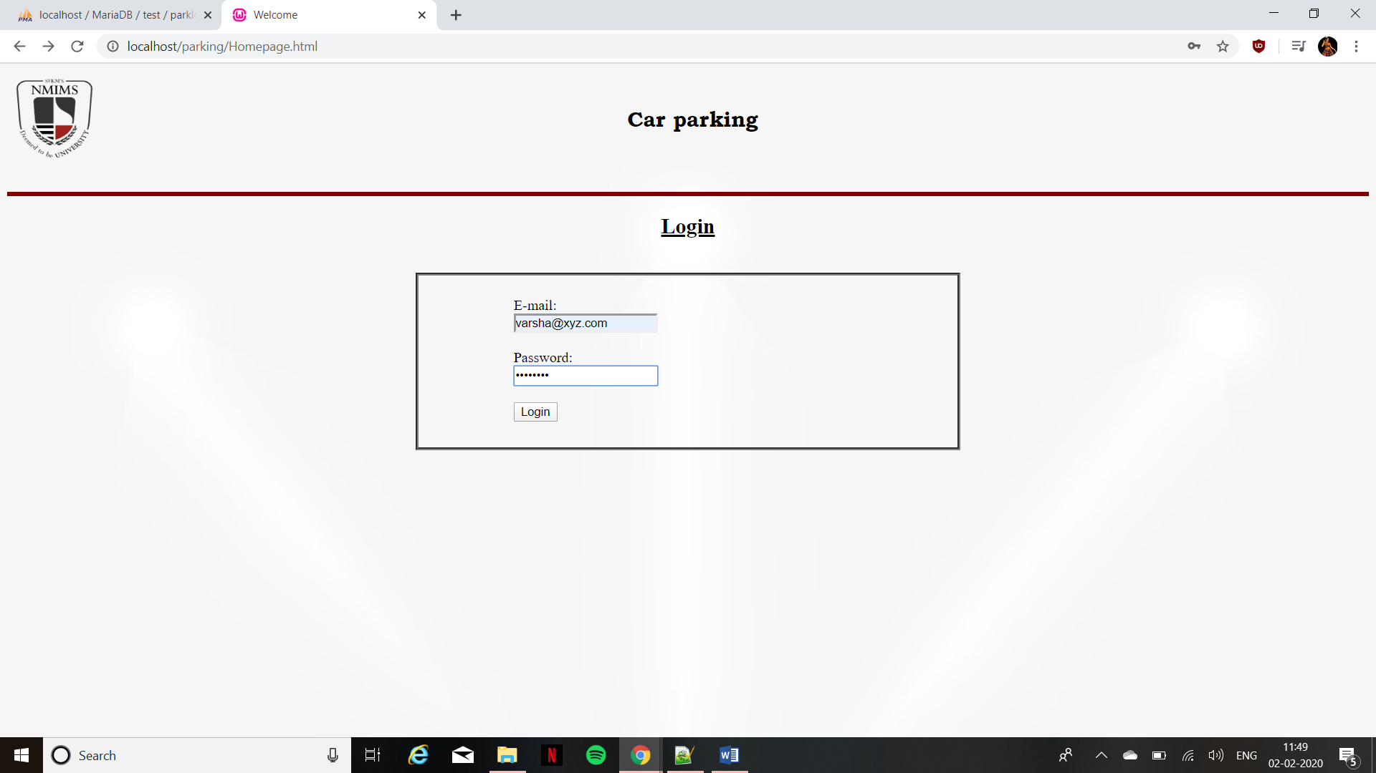

Park.php

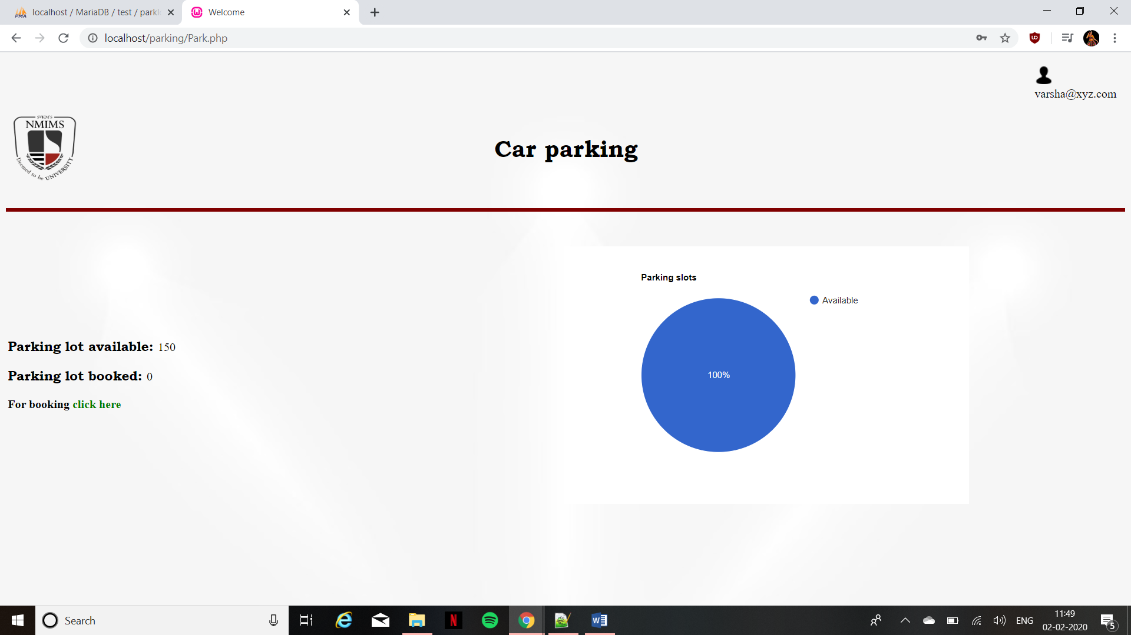

Park.php (cursor pointing towards the link)

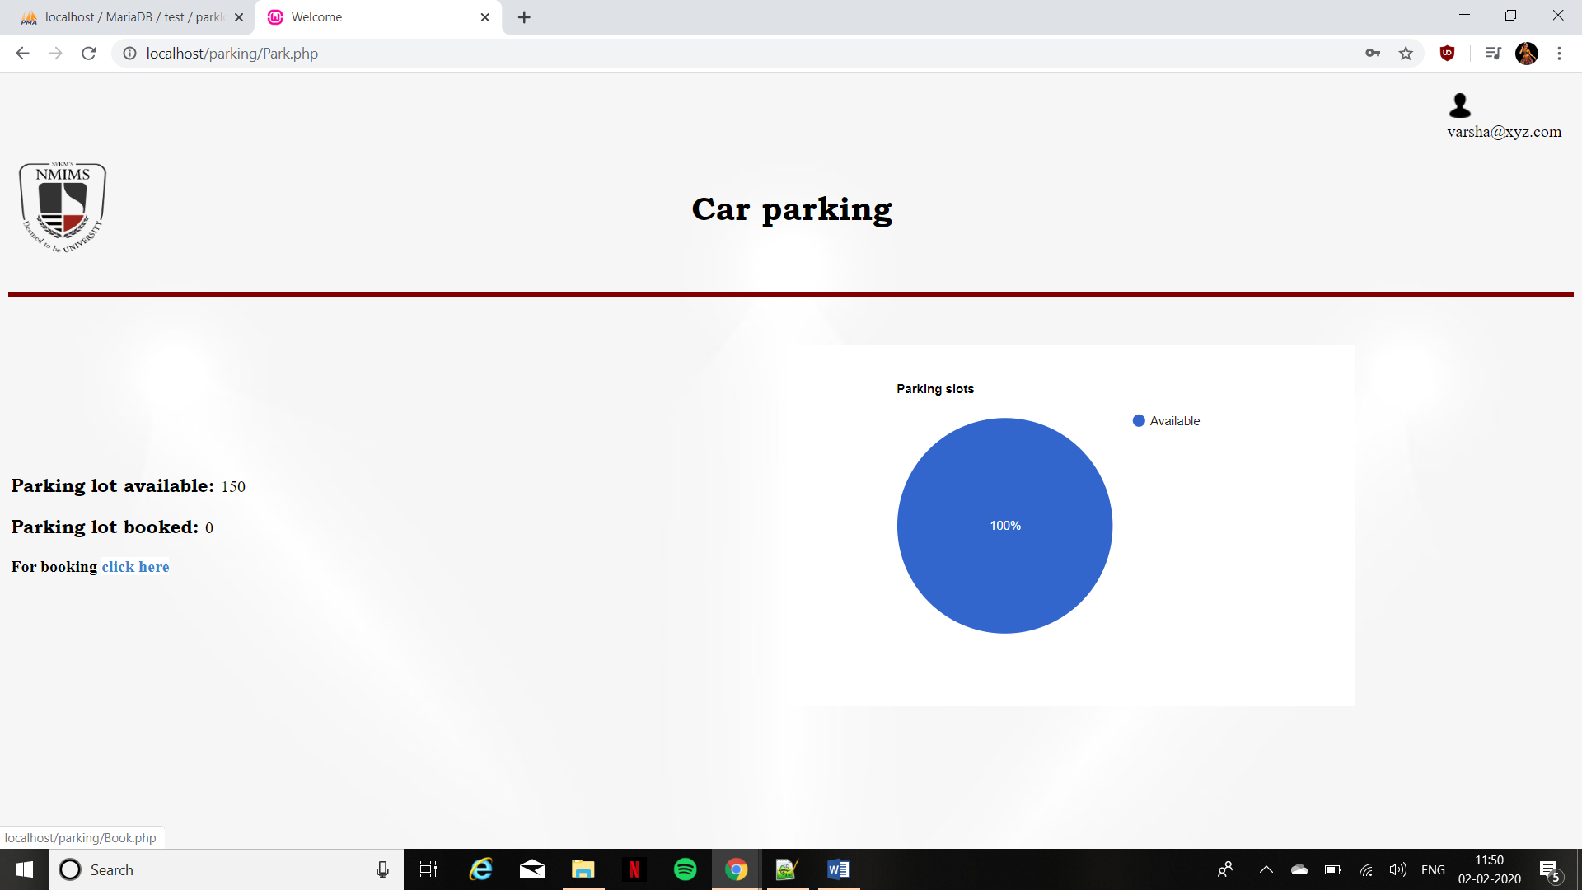

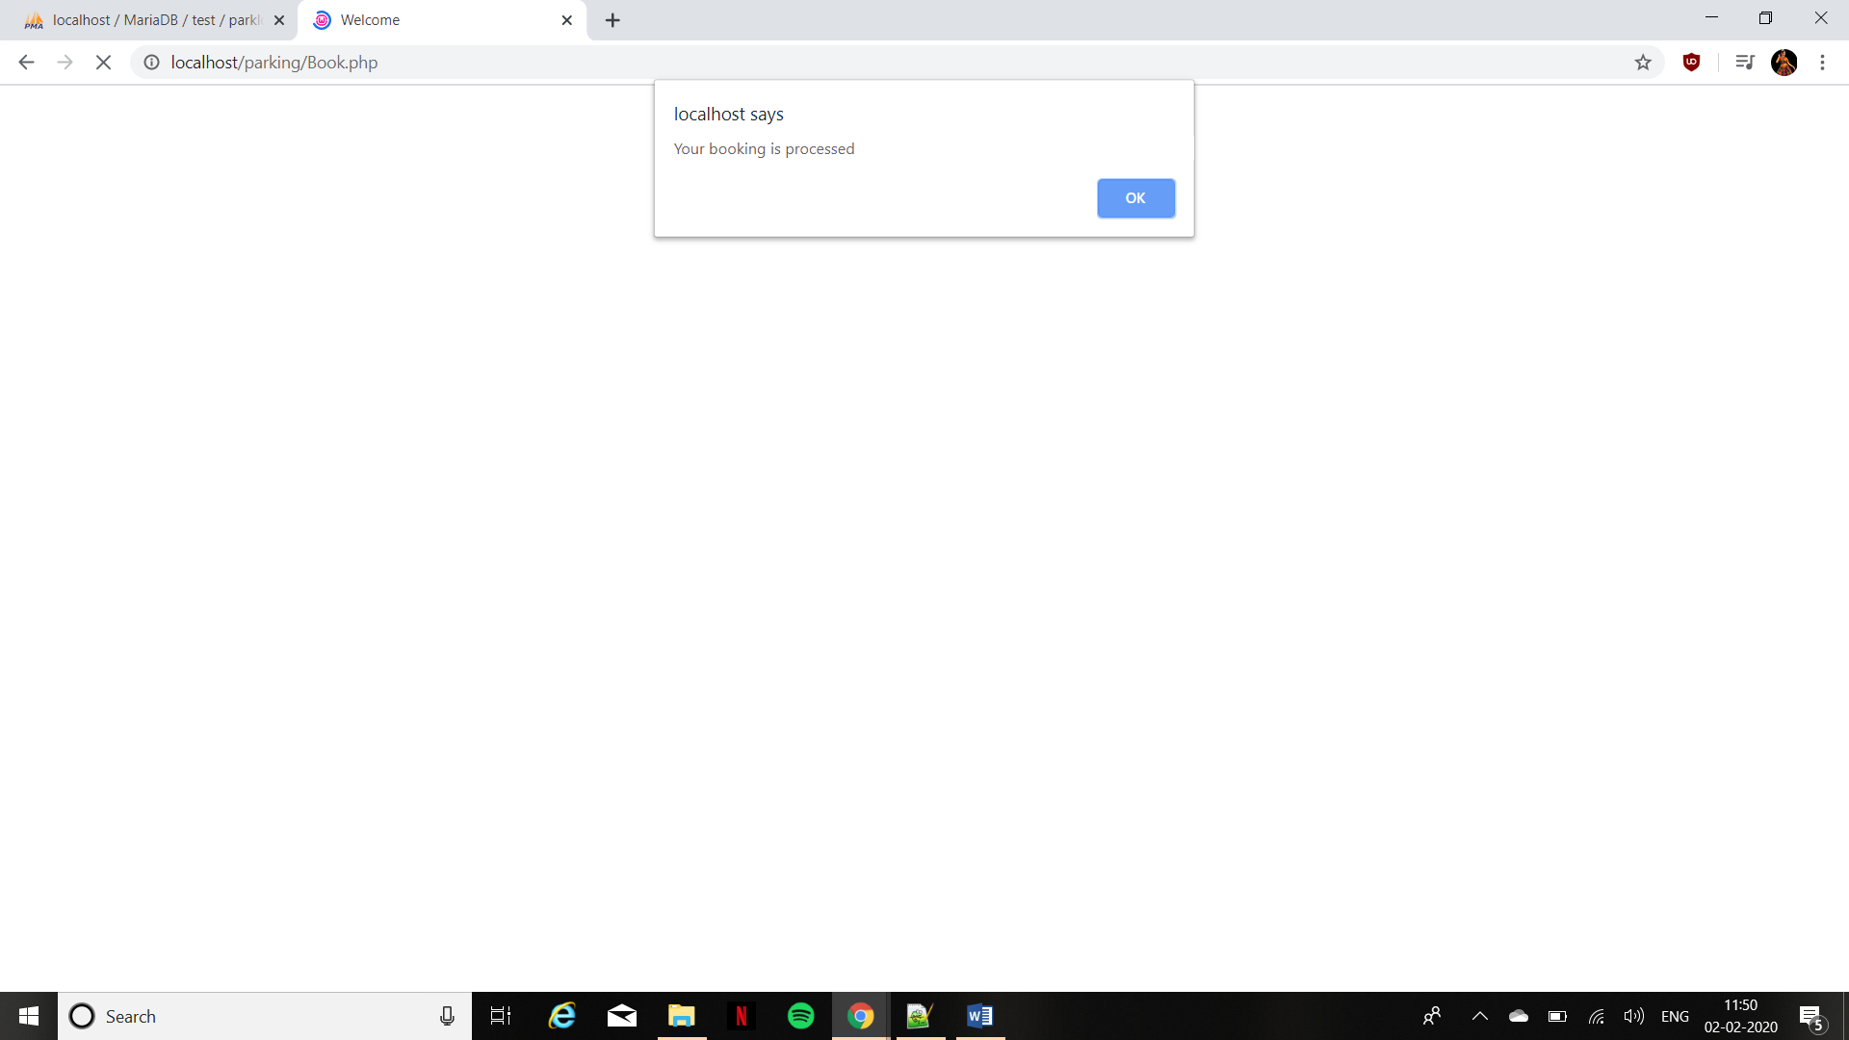

Book.php

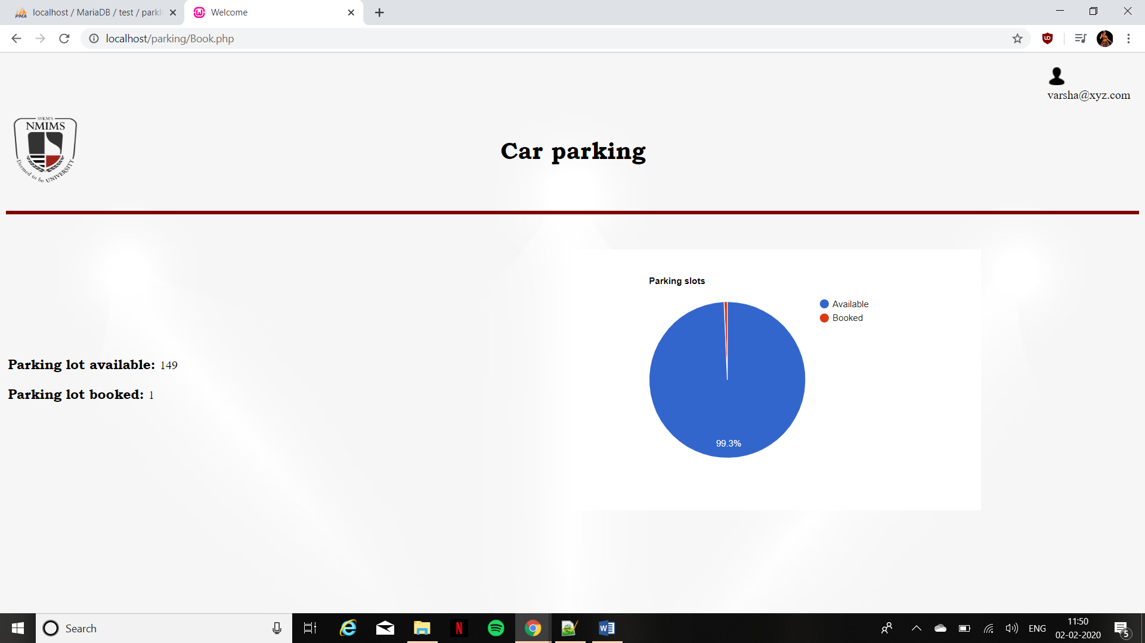

Park.php(login done by another account)

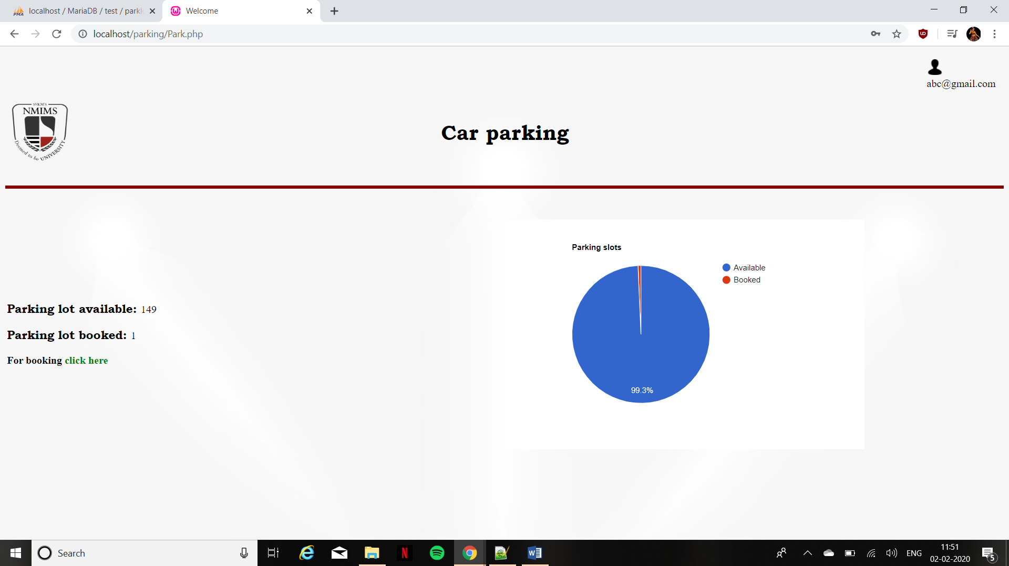

Book.php(Booking done by the other account)

