# Mini Project-II

**SOFTWARE REQUIREMENT SPECIFICATION (SRS)**

#### “RESTROZONE”

Submitted by:

**Mayuri Dhongadi** (23046491245503)

**Nidhi Thool** (23046491245509)

**Ansh Shivhare**(224691245100)

Submitted to:



**Department of Computer Engineering Bajaj Institute of Technology**

**Wardha-442 001 (India)**

**2024-25**

**TABLE OF CONTENTS**

#### Introduction

Purpose

Scope

References

Abbreviations

#### Overall Description

Product Perspective

Product Functions

User Characteristics

**Design and Implementation Constraints**

#### Specific Requirements

Functional Requirements.

Non-Functional Requirements.

#### System Features

5 Features

Assumptions and Dependencies

#### Diagrams

Use Case

Data Flow Diagram

Class Diagram

Object Diagram

#### 

#### Interfaces and Design

User Interface.

Operating Environment.

Hardware Interface.

Software Requirements

#### 

# Introduction

### Purpose:

* + - The purpose of RestroZone is to provide an all-in-one digital platform that simplifies and automates restaurant operations while enhancing the dining experience for customers.
    - It enables restaurant owners to efficiently manage reservations, menu items, orders, payments, and customer feedback through an easy-to-use web interface. At the same time, it allows customers to browse restaurants, book tables, place orders, make payments, and receive personalized suggestions based on AI-driven feedback analysis.
    - By streamlining communication and transactions between customers and restaurants, RestroZone aims to improve service accuracy, reduce wait times, boost customer satisfaction, and support restaurant business growth.

### Scope:

* + **Restaurant and Customer Management:** Enables restaurant owners to register, manage menus, orders, and reservations, while customers can create accounts to browse restaurants and book tables.
  + **Online Ordering and Payments:** Provides a complete food ordering system with secure online payment and real-time order tracking for a seamless customer experience.
  + **Table Booking System:** Allows customers to book tables in advance based on availability, reducing wait times and improving dining efficiency.
  + **Feedback and AI Recommendations:** Collects customer reviews and uses AI to suggest suitable restaurants based on preferences and feedback trends.
  + **User-Friendly Web Platform:** Offers a responsive, easy-to-navigate web interface accessible via desktop and mobile devices for both customers and restaurant owners.

### References:

* + R. A. Egigogo, M. T. Naniya, A. A. Abubakar, and A. Mansir, "Design and Implementation of Computerized Restaurant Table Booking System," Ceddi Journal of Information Systems and Technology (JST), vol. 3, no. 1, pp. 1–9, Apr. 2024, doi: [10.56134/jst.v3i1.64](https://doi.org/10.56134/jst.v3i1.64).
  + 2. M.-C. Yuen, Y.-H. Choi, T.-H. Ng, C.-T. Poon, and K.-C. Fung, "Development of IoT Based Fresh Food Delivery Tracking System Using GPS," in Fuzzy Systems and Data Mining VI, 2020, pp. 397–403, doi: [10.3233/FAIA200718](https://doi.org/10.3233/FAIA200718).
  + U. Mponela, K. Shereef, and Tawarish, "Online Food Ordering System," International Journal of Information Technology and Computer Engineering,vol. 4, no. 2, pp. 43–52, Feb.-Mar. 2024, doi: [10.55529/jijitc.42.43.52](<https://doi.org/10.55529/jijitc.42.43.52>).

H. Kim, S. Jung, and G. Ryu, "A Study on the Restaurant Recommendation Service App Based on AI Chatbot Using Personalization Information," International Journal of Advanced Culture Technology, vol. 8, no. 4, pp. 263–270, 2020, doi: [10.17703/IJACT.2020.8.4.263](https://doi.org/10.17703/IJACT.2020.8.4.263).

Abbreviations:

|  |  |
| --- | --- |
| AI | Artificial intelligence |
| UI | User Interface |
| UX | User Experience |
| API | Application Programming Interface |
| ER | Entity Relationship |
| SQL | Structured Query Language |
| COD | Cash On Delivery |

# Overall Description

### Product Perspective:

RestroZone is a comprehensive web-based restaurant management and customer interaction platform designed to bridge the gap between restaurants and their patrons. Positioned as a centralized system, it integrates multiple modules—such as reservation management, menu handling, online ordering, and feedback processing—into a single, user-friendly interface. The platform is designed to work both as a standalone solution for small to medium restaurants and as an extendable system for larger chains looking to digitalize operations and customer engagement. RestroZone fits into the broader ecosystem of restaurant management software, but it distinguishes itself by incorporating **AI-powered feedback analysis and personalized suggestions** to enhance the customer experience and support decision-making for restaurant owners.

### Product Functions:

### For Restaurant Owners:

* 1. **Menu Management:** Add, update, and organize menu items with names, prices, images, and availability status.
  2. **Reservation Handling:** Monitor and manage table bookings with real-time updates to avoid double bookings.
  3. **Order Management:** View, accept, and process online or in-house orders efficiently through a live dashboard.
  4. **Feedback Analytics:** Use AI to analyze customer reviews and identify trends to improve food and service quality.

### For Customers:

* 1. **Table Booking:** Reserve tables in advance by selecting restaurant, time slot, and number of guests.
  2. **Online Ordering:** Browse digital menus, customize food items, and place orders for dine-in or takeaway.
  3. **Secure Payment Gateway:** Make fast, secure payments through cards, wallets, or UPI directly within the platform.
  4. **Personalized Recommendations:** Get smart suggestions for dishes or restaurants based on your preferences and past reviews.

### User Characteristics:

### For Restaurant Owners:

* Moderate to high digital literacy
* Familiar with day-to-day restaurant operations
* Interested in dashboards, analytics, and process automation
* Require an intuitive admin interface.

### For Customers:

* General public with basic to advanced internet skills
* Prefer mobile-friendly, fast, and intuitive interfaces
* Seek convenience, personalization, and minimal wait times
* Often influenced by recommendations and peer reviews.

### **Design and Implementation Constraints:**

* + **Seamless Responsive Design**: The RestroZone UI has been fully optimized to offer an adaptive experience across both desktop and mobile devices, ensuring ease of use on any screen size.
  + **Scalable System Architecture**: The platform is designed to efficiently handle multiple concurrent users and restaurants, ensuring no performance degradation even during peak usage.
  + **Robust Security Measures**: All transactions, including payments and personal data exchanges, are fully encrypted and secured using the latest security protocols such as HTTPS, SSL, and secure APIs.
  + **Modular Backend**: The backend is built on a modular architecture, allowing for easy integration of future features like loyalty programs or third-party delivery services without disrupting core functionality.
  + **AI-Driven Recommendations & Feedback Analysis**: Leveraging advanced AI techniques, RestroZone analyzes customer feedback and provides personalized restaurant recommendations, enhancing user experience and restaurant decision-making.

# Specific Requirements

### **Functional requirements:**

##### User Registration and Authentication

* Customers and restaurant owners can register, log in, and manage their profiles.
* Role-based access: Admin, Restaurant Owner, Customer.

##### Restaurant Management

* Restaurant owners can add/edit/delete their restaurant profiles.
* Manage menus with categories, images, pricing, and availability.

##### Table Booking System

* Customers can check table availability and book tables for specific times/dates.
* Restaurants can view and manage bookings from the dashboard.

##### Online Ordering and Payments

* Customers can browse menus, customize items, and place orders.
* Integration with payment gateways for secure transactions.
* Real-time order tracking from kitchen to delivery.

##### Customer Feedback System

* Customers can leave reviews and ratings for restaurants and food.
* Restaurant owners can view, respond to, and analyze feedback.

##### AI-Based Recommendations

* + System suggests restaurants or dishes based on user behavior, preferences, and sentiment analysis from reviews.

##### Admin Panel

* + Manage users, monitor activities, and generate platform-wide analytics.

**Non-Functional Requirements:**

##### Performance

* + The system is optimized for high performance, The platform performs efficiently under load, handling thousands of concurrent users with fast response times. Average page load times remain under 2 seconds even during peak usage, ensuring smooth interactions.

##### Reliability

* + RestroZone maintains a 99.9% uptime through cloud-based hosting, load balancing, and automated failover systems. Regular backups and error handling mechanisms ensure data integrity and system reliability.

##### Security

* + The system uses HTTPS protocols, secure APIs, and SSL encryption to safeguard all user data and transactions. Role-based access control and token-based authentication (e.g., JWT) ensure that sensitive data is accessible only to authorized users.

##### User-Friendly Interface

* + RestroZone features a clean, intuitive, and responsive user interface that ensures a seamless experience across desktop and mobile devices. The consistent design allows users of all technical levels to navigate the platform effortlessly.

.

##### Cross-Browser & Device Compatibility

* + The platform runs consistently across major browsers including Chrome, Firefox, Safari, and Edge, and is fully functional on both Android and iOS devices.

##### Scalability

* + RestroZone is built on a scalable architecture that supports the growing number of users, restaurants, and transactions. The modular system design allows effortless addition of new features and scaling without downtime.

# System Features

##### Restaurant & Menu Management

* + **Input**: Restaurant details (name, location, timings), menu items (name, category, price, image, availability).
  + **Processes**: Stores and organizes restaurant data, allows real-time updates and item availability management.
  + **Output**: Dynamic restaurant profiles with up-to-date menu listings visible to customers.
  + **User Interaction**: Restaurant owners use a dashboard with form-based inputs and image uploads for menus.

##### Smart Table Reservation System

* + **Input**: Date, time, number of guests, selected restaurant.
  + **Processes**: Checks table availability, prevents double bookings, sends confirmation to both user and restaurant.
  + **Output**: Booking confirmation with details and status tracking.
  + **User Interaction**: Customers select booking preferences through an interactive calendar and dropdown menu interface.

##### Online Ordering and Real-Time Tracking

* + **Input**: Customer-selected menu items, quantity, special instructions, delivery or pickup option.
  + **Processes**: Creates and manages orders, updates order status (pending, preparing, completed), tracks delivery.
  + **Output**: Order summary, real-time order status updates, and estimated delivery time.
  + **User Interaction**: Customers interact through a step-by-step ordering interface with progress indicators.

##### Secure Online Payments

* + **Input**: Order amount, payment method (credit/debit card, digital wallets, etc.), and transaction details.
  + **Processes**: Processes payment via secure third-party gateway, verifies payment success/failure.
  + **Output**: Payment confirmation or error message; order receipt.
  + **User Interaction**: Customers are redirected to a secure payment interface with confirmation on return.

##### AI-Powered Feedback & Recommendations

* + **Input**: Customer reviews, ratings, past orders, preferences.
  + **Processes**: Analyzes feedback using sentiment analysis, identifies trends, recommends dishes or restaurants.
  + **Output**: Personalized suggestions and restaurant rankings based on user behavior and sentiment scores.
  + **User Interaction**: Customers input feedback via rating scales and comments; recommendations appear automatically on dashboard/homepage.

**Assumptions and Dependencies**

**Assumptions**

* **Stable Internet and Modern Browsers**: Users are assumed to have access to reliable internet connections and use up-to-date web browsers to ensure full platform functionality.
* **Active Restaurant Participation**: Restaurant owners are expected to manage their profiles, menus, operational hours, and table availability through the RestroZone dashboard.
* **Payment Gateway Availability**: It is assumed that supported payment gateways (like Stripe or Razorpay) are operational in the regions where the platform is being used.
* **Genuine Customer Feedback**: Customers are expected to provide honest reviews and ratings, which are essential for improving the AI-driven recommendation engine.

**Dependencies**

* **Third-Party Services**: The platform relies on external APIs such as payment gateways, location services (Google Maps) and communication tools (email/SMS).
* **Web Browser Compatibility**: RestroZone depends on consistent performance across modern browsers like Chrome, Firefox, Safari, and Edge.
* **Cloud Hosting Infrastructure**: The system's uptime, scalability, and data storage depend on reliable cloud services like AWS or Azure.
* **AI/ML Frameworks**: Implementation of personalized recommendations and feedback analysis depends on libraries like TensorFlow or Scikit-learn.

**5. Diagrams**

**Use Case**

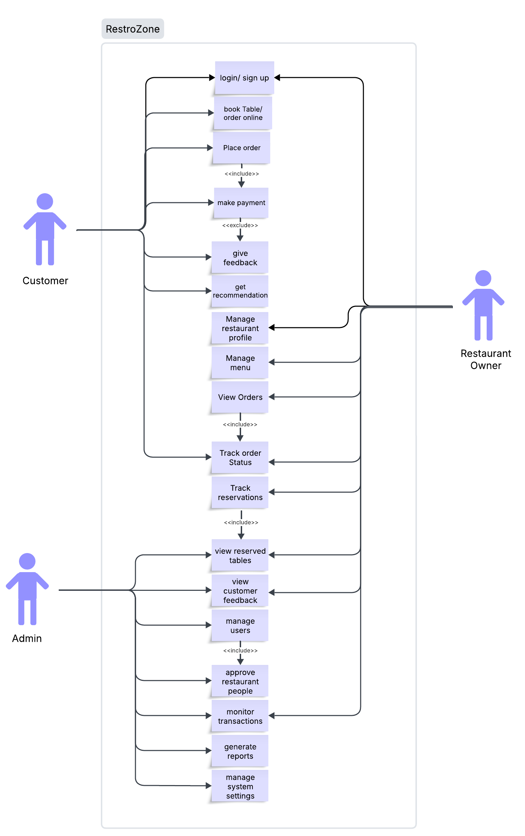

# Data Flow Diagram

# Untitled Diagram.drawio.png

# 6. Interfaced and design

### 6.1 Interfaces & Designing:

The user interface and design can be implemented using the following technologies

|  |  |
| --- | --- |
| HTML | HTML or HyperText Markup Language is the standard language used in producing or creating web pages. It gives the basic structure of the website. |
| CSS | CSS is used to style and lay out web pages. This includes design, colors, and fonts on the website. |
| JavaScript | JavaScript is an object-oriented, cross-platform scripting language that is lightweight and used to create dynamism on a web page interactively. Users can interact with the website appropriately and document client- side scripts. |
| React | A JavaScript library used to successfully develop user interfaces, mostly single-page applications. It allows the website to develop reusable UI components, thus helping effectively manage the state of the application. |
| Bootstrap | A popular front-end framework used to design responsive and mobile-first websites using pre-built components and grid systems. |

6.2 Operating Environment:

|  |  |  |
| --- | --- | --- |
| Particulars | Client System | Server System |
| Operating System | Windows/Linux/Android/iOS | Windows/Linux |
| Processor | Intel or AMD | Intel or AMD |
| Hard Disk | 1GB | 1TB |
| RAM | 512 MB | 8 GB |
| Browser | Chrome / Firefox / Edge / Safari | N/A |
| Network | Internet connection | High-speed internet / Ethernet |

## 6.3 Hardware Requirements

* + **Client Device Compatibility:** Supports desktops, laptops, tablets, and smartphones. Minimum screen resolution of 1024x768 pixels is required.
  + **Processor Requirement:** Client systems require Intel i3 or AMD Ryzen 3 or higher. Servers should run on Intel i7/Xeon or AMD Ryzen 7+.
  + **Memory (RAM):** Clients must have a minimum of 1 GB RAM for smooth use. Servers need at least 8 GB RAM for handling multiple requests.
  + **Storage Space:** Clients need at least 1 GB of free disk space available. Servers require 1 TB for storing logs, data, and backups.
  + **Network Interface:** Devices must have stable internet connectivity. Servers should use high-speed Ethernet or fiber links.

## 6.4 Software Requirements

* **Operating Systems:** Client systems must run Windows, Linux, Android, or iOS. Server systems can use Ubuntu 20.04 or Windows Server 2019+.
* **Web Browser Support:** Clients should use modern browsers like Chrome or Firefox. Also supports Edge and Safari in latest versions.
* **Backend Technologies:** Server backend is developed using Node.js and Express. AI features use Python frameworks like Flask and scikit-learn.
* **Frontend Technologies:** UI is built using HTML, CSS, JavaScript, and React.js. Styling is enhanced using Tailwind CSS or Bootstrap.
* **Database & Tools:** MongoDB is used for storing application data efficiently. Version control and collaboration managed via GitHub.

## **Conclusion**

RestroZone aims to bridge the gap between restaurants and customers through a streamlined digital interface that supports online ordering, table reservations, secure payments, and AI-driven feedback and recommendations. RestroZone presents a detailed framework for the development of a web-based platform designed to optimize restaurant management and enhance the overall dining experience for customers.

## 