ASSIGMENT-1  
  
MODULE-1.

* **1-QUESTION:** What is software?what is software engineering?
* **1-ANSWER:** Software is colloection of programs and program is colloection of instruction given to the computer.Software engineering is defined as a process of analyzing user requirements and then designing, building, and testing software application which will satisfy those requirements.
* **2-QUESTION:** Explain types of software?
* **2-ANSWER :** The two main categories of software are application software and system software. An application is software that fulfills a specific need or performs tasks. System software is designed to run a computer's hardware and provides a platform for applications to run on top of.

QUESTION-3 : What is SDLC? Explain each phase of SDLC

* ANSWER .2 : SDLC means THE SOFTWARE DEVLOPMENT LIFE CYCLE.The SDLC is a process used by software development organizations to plan, design, develop, test, deploy, and maintain software applications.

**SDLC (Software Development Life Cycle)** is used in Every Software Development Company because it is the root of the Development Cycle.

**The SDLC typically includes the following phases:**

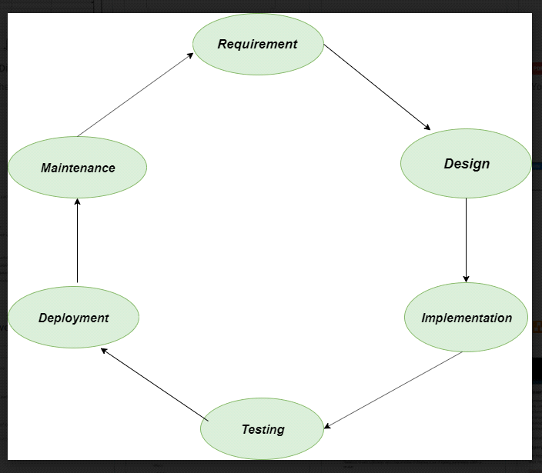

**1. Requirements gathering and analysis:** This phase involves gathering information about the software requirements from stakeholders, such as customers, end-users, and business analysts.

**2. Design:** In this phase, the software design is created, which includes the overall architecture of the software, data structures, and interfaces. It has two steps:

* **High-level design (HLD):** It gives the architecture of software products.
* **Low-level design (LLD):** It describes how each and every feature in the product should work and every component.

**3. Implementation or coding:** The design is then implemented in code, usually in several iterations, and this phase is also called as Development.

* This is the longest phase in SDLC model.
* This phase consists of Front end + Middleware + Back-end.
* In front-end: Development of coding is done even SEO settings are done.
* In Middleware: They connect both the front end and back end.
* In the back-end: A database is created.

**4. Testing:** The software is thoroughly tested to ensure that it meets the requirements and works correctly.

**5. Deployment:** After successful testing, The software is deployed to a production environment and made available to end-users.

**6. Maintenance:** This phase includes ongoing support, bug fixes, and updates to the software.

**3-QUESTION :**What is DFD? Create a DFD diagram on Flipkart.

**3-ANSWER:** DFD means data flow diagram.A data flow diagram is a graphical view

of how data is processed in a system in terms of input and output.

**Data flow diagram(DFD) for Flipkart:**

A data flow diagram is a graphical view of how data is processed in a system in terms of input and output.

**The Data flow diagram (DFD) contains some symbol for drawing the data flow diagram.**

|  |  |
| --- | --- |
| Symbols | Description |
|  | **Data Flow** – Data flow are pipelines through the packets of information flow. |
|  | **Process :**A Process or task performed by the system. |
|  | **Entity :**Entity are object of the system. A source or destination data of a system. |
|  | **Data Store :** A place where data to be stored. |

**Context level DFD – 0 level**

The context level data flow diagram (dfd) is describe the whole system. The (o) level dfd describe the all user module who operate the system. Below data flow diagram of online shopping site shows the two user can operate the system Admin and Member user.

Request for login

**User**

**ADMIN**

Request for registration

Response Response

### 1st Level Admin  Side DFD:

The Admin side DFD describe the functionality of Admin, Admin is a owner of the website. Admin can first add category of item and then add items by category wise.and admin and manageorderandpayment .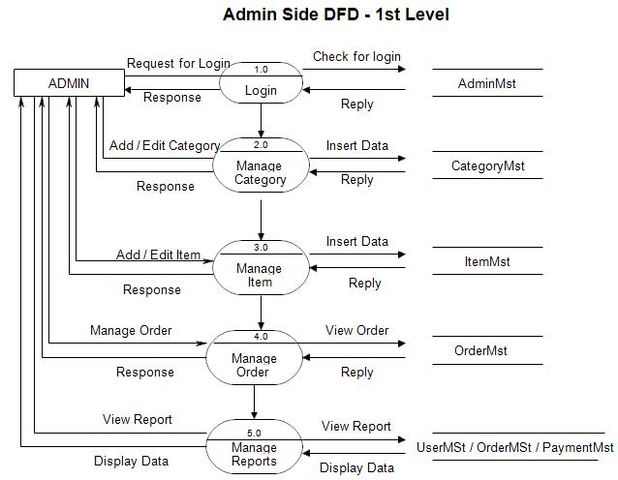

### 2nd Level – Admin side DFD (3.0)

### 

### 2nd Level – Admin side DFD (4.0)

### 

### 2nd Level – Admin side DFD (5.0):

### 

## 1st level – User side Data flow Diagram

The user is all people who operate or visit our website. User is a customer of a website. User can first select product for buy, user must have to register in our system for purchase any item from our website. after register he can login to site and buy item by making online payment through any bank debit card or credit card.

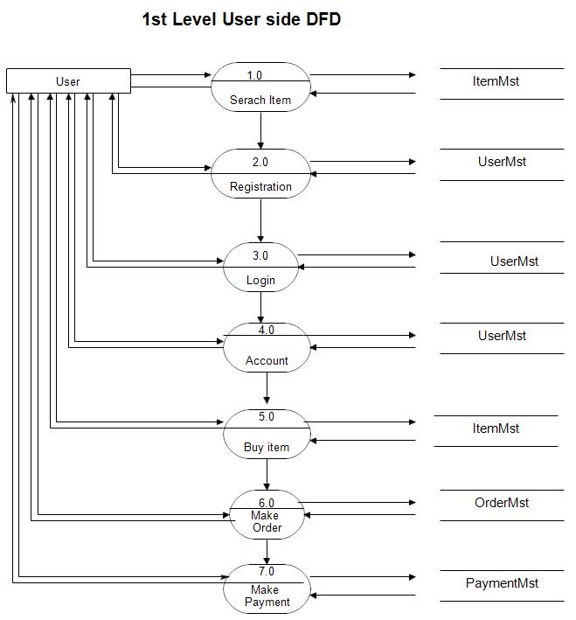

### 

### 

### 4-Question: What is Flow chart? Create a flowchart to make addition of two numbers

**4-Answer:** A flowchart is a diagram that depicts a process, system or computer algorithm. They are widely used in multiple fields to document, study, plan, improve

Flowchart to Add two Numbers

**Inp**ut No-1,No-2

Sum=no 1+no2

Print sum

**5-Question :** What is Use case Diagram? Create a use-case on bill payment on paytm.

**5-Answer :** A use case diagram is a way to summarize details of a system and the users within that system. It is generally shown as a graphic depiction of interactions among different elements in a system. Use case diagrams will specify the events in a system and how those events flow, however, use case diagram does not describe how those events are implemented.

**use-case Diagram on bill payment on paytm.**

